Project_HousePrediction_Initial Data Exploration

Hyunkyung Kim

October 11, 2018

#### Import Data and Save a Copy

housedata - original data housedatac - working copy of the data

housedata<-read.csv("C:\\Users\\Hyunkyung Kim\\Desktop\\CKME999\\136\\dataset\\all\\train.csv")  
  
housedatac<-housedata

#### Investigating the variables.

str(housedata)

## 'data.frame': 1460 obs. of 81 variables:  
## $ Id : int 1 2 3 4 5 6 7 8 9 10 ...  
## $ MSSubClass : int 60 20 60 70 60 50 20 60 50 190 ...  
## $ MSZoning : Factor w/ 5 levels "C (all)","FV",..: 4 4 4 4 4 4 4 4 5 4 ...  
## $ LotFrontage : int 65 80 68 60 84 85 75 NA 51 50 ...  
## $ LotArea : int 8450 9600 11250 9550 14260 14115 10084 10382 6120 7420 ...  
## $ Street : Factor w/ 2 levels "Grvl","Pave": 2 2 2 2 2 2 2 2 2 2 ...  
## $ Alley : Factor w/ 2 levels "Grvl","Pave": NA NA NA NA NA NA NA NA NA NA ...  
## $ LotShape : Factor w/ 4 levels "IR1","IR2","IR3",..: 4 4 1 1 1 1 4 1 4 4 ...  
## $ LandContour : Factor w/ 4 levels "Bnk","HLS","Low",..: 4 4 4 4 4 4 4 4 4 4 ...  
## $ Utilities : Factor w/ 2 levels "AllPub","NoSeWa": 1 1 1 1 1 1 1 1 1 1 ...  
## $ LotConfig : Factor w/ 5 levels "Corner","CulDSac",..: 5 3 5 1 3 5 5 1 5 1 ...  
## $ LandSlope : Factor w/ 3 levels "Gtl","Mod","Sev": 1 1 1 1 1 1 1 1 1 1 ...  
## $ Neighborhood : Factor w/ 25 levels "Blmngtn","Blueste",..: 6 25 6 7 14 12 21 17 18 4 ...  
## $ Condition1 : Factor w/ 9 levels "Artery","Feedr",..: 3 2 3 3 3 3 3 5 1 1 ...  
## $ Condition2 : Factor w/ 8 levels "Artery","Feedr",..: 3 3 3 3 3 3 3 3 3 1 ...  
## $ BldgType : Factor w/ 5 levels "1Fam","2fmCon",..: 1 1 1 1 1 1 1 1 1 2 ...  
## $ HouseStyle : Factor w/ 8 levels "1.5Fin","1.5Unf",..: 6 3 6 6 6 1 3 6 1 2 ...  
## $ OverallQual : int 7 6 7 7 8 5 8 7 7 5 ...  
## $ OverallCond : int 5 8 5 5 5 5 5 6 5 6 ...  
## $ YearBuilt : int 2003 1976 2001 1915 2000 1993 2004 1973 1931 1939 ...  
## $ YearRemodAdd : int 2003 1976 2002 1970 2000 1995 2005 1973 1950 1950 ...  
## $ RoofStyle : Factor w/ 6 levels "Flat","Gable",..: 2 2 2 2 2 2 2 2 2 2 ...  
## $ RoofMatl : Factor w/ 8 levels "ClyTile","CompShg",..: 2 2 2 2 2 2 2 2 2 2 ...  
## $ Exterior1st : Factor w/ 15 levels "AsbShng","AsphShn",..: 13 9 13 14 13 13 13 7 4 9 ...  
## $ Exterior2nd : Factor w/ 16 levels "AsbShng","AsphShn",..: 14 9 14 16 14 14 14 7 16 9 ...  
## $ MasVnrType : Factor w/ 4 levels "BrkCmn","BrkFace",..: 2 3 2 3 2 3 4 4 3 3 ...  
## $ MasVnrArea : int 196 0 162 0 350 0 186 240 0 0 ...  
## $ ExterQual : Factor w/ 4 levels "Ex","Fa","Gd",..: 3 4 3 4 3 4 3 4 4 4 ...  
## $ ExterCond : Factor w/ 5 levels "Ex","Fa","Gd",..: 5 5 5 5 5 5 5 5 5 5 ...  
## $ Foundation : Factor w/ 6 levels "BrkTil","CBlock",..: 3 2 3 1 3 6 3 2 1 1 ...  
## $ BsmtQual : Factor w/ 4 levels "Ex","Fa","Gd",..: 3 3 3 4 3 3 1 3 4 4 ...  
## $ BsmtCond : Factor w/ 4 levels "Fa","Gd","Po",..: 4 4 4 2 4 4 4 4 4 4 ...  
## $ BsmtExposure : Factor w/ 4 levels "Av","Gd","Mn",..: 4 2 3 4 1 4 1 3 4 4 ...  
## $ BsmtFinType1 : Factor w/ 6 levels "ALQ","BLQ","GLQ",..: 3 1 3 1 3 3 3 1 6 3 ...  
## $ BsmtFinSF1 : int 706 978 486 216 655 732 1369 859 0 851 ...  
## $ BsmtFinType2 : Factor w/ 6 levels "ALQ","BLQ","GLQ",..: 6 6 6 6 6 6 6 2 6 6 ...  
## $ BsmtFinSF2 : int 0 0 0 0 0 0 0 32 0 0 ...  
## $ BsmtUnfSF : int 150 284 434 540 490 64 317 216 952 140 ...  
## $ TotalBsmtSF : int 856 1262 920 756 1145 796 1686 1107 952 991 ...  
## $ Heating : Factor w/ 6 levels "Floor","GasA",..: 2 2 2 2 2 2 2 2 2 2 ...  
## $ HeatingQC : Factor w/ 5 levels "Ex","Fa","Gd",..: 1 1 1 3 1 1 1 1 3 1 ...  
## $ CentralAir : Factor w/ 2 levels "N","Y": 2 2 2 2 2 2 2 2 2 2 ...  
## $ Electrical : Factor w/ 5 levels "FuseA","FuseF",..: 5 5 5 5 5 5 5 5 2 5 ...  
## $ X1stFlrSF : int 856 1262 920 961 1145 796 1694 1107 1022 1077 ...  
## $ X2ndFlrSF : int 854 0 866 756 1053 566 0 983 752 0 ...  
## $ LowQualFinSF : int 0 0 0 0 0 0 0 0 0 0 ...  
## $ GrLivArea : int 1710 1262 1786 1717 2198 1362 1694 2090 1774 1077 ...  
## $ BsmtFullBath : int 1 0 1 1 1 1 1 1 0 1 ...  
## $ BsmtHalfBath : int 0 1 0 0 0 0 0 0 0 0 ...  
## $ FullBath : int 2 2 2 1 2 1 2 2 2 1 ...  
## $ HalfBath : int 1 0 1 0 1 1 0 1 0 0 ...  
## $ BedroomAbvGr : int 3 3 3 3 4 1 3 3 2 2 ...  
## $ KitchenAbvGr : int 1 1 1 1 1 1 1 1 2 2 ...  
## $ KitchenQual : Factor w/ 4 levels "Ex","Fa","Gd",..: 3 4 3 3 3 4 3 4 4 4 ...  
## $ TotRmsAbvGrd : int 8 6 6 7 9 5 7 7 8 5 ...  
## $ Functional : Factor w/ 7 levels "Maj1","Maj2",..: 7 7 7 7 7 7 7 7 3 7 ...  
## $ Fireplaces : int 0 1 1 1 1 0 1 2 2 2 ...  
## $ FireplaceQu : Factor w/ 5 levels "Ex","Fa","Gd",..: NA 5 5 3 5 NA 3 5 5 5 ...  
## $ GarageType : Factor w/ 6 levels "2Types","Attchd",..: 2 2 2 6 2 2 2 2 6 2 ...  
## $ GarageYrBlt : int 2003 1976 2001 1998 2000 1993 2004 1973 1931 1939 ...  
## $ GarageFinish : Factor w/ 3 levels "Fin","RFn","Unf": 2 2 2 3 2 3 2 2 3 2 ...  
## $ GarageCars : int 2 2 2 3 3 2 2 2 2 1 ...  
## $ GarageArea : int 548 460 608 642 836 480 636 484 468 205 ...  
## $ GarageQual : Factor w/ 5 levels "Ex","Fa","Gd",..: 5 5 5 5 5 5 5 5 2 3 ...  
## $ GarageCond : Factor w/ 5 levels "Ex","Fa","Gd",..: 5 5 5 5 5 5 5 5 5 5 ...  
## $ PavedDrive : Factor w/ 3 levels "N","P","Y": 3 3 3 3 3 3 3 3 3 3 ...  
## $ WoodDeckSF : int 0 298 0 0 192 40 255 235 90 0 ...  
## $ OpenPorchSF : int 61 0 42 35 84 30 57 204 0 4 ...  
## $ EnclosedPorch: int 0 0 0 272 0 0 0 228 205 0 ...  
## $ X3SsnPorch : int 0 0 0 0 0 320 0 0 0 0 ...  
## $ ScreenPorch : int 0 0 0 0 0 0 0 0 0 0 ...  
## $ PoolArea : int 0 0 0 0 0 0 0 0 0 0 ...  
## $ PoolQC : Factor w/ 3 levels "Ex","Fa","Gd": NA NA NA NA NA NA NA NA NA NA ...  
## $ Fence : Factor w/ 4 levels "GdPrv","GdWo",..: NA NA NA NA NA 3 NA NA NA NA ...  
## $ MiscFeature : Factor w/ 4 levels "Gar2","Othr",..: NA NA NA NA NA 3 NA 3 NA NA ...  
## $ MiscVal : int 0 0 0 0 0 700 0 350 0 0 ...  
## $ MoSold : int 2 5 9 2 12 10 8 11 4 1 ...  
## $ YrSold : int 2008 2007 2008 2006 2008 2009 2007 2009 2008 2008 ...  
## $ SaleType : Factor w/ 9 levels "COD","Con","ConLD",..: 9 9 9 9 9 9 9 9 9 9 ...  
## $ SaleCondition: Factor w/ 6 levels "Abnorml","AdjLand",..: 5 5 5 1 5 5 5 5 1 5 ...  
## $ SalePrice : int 208500 181500 223500 140000 250000 143000 307000 200000 129900 118000 ...

#### Checking for duplicates & uniques : Both 1460 rows - meaning No duplicate

#### Display features that has non zero N/As.

nrow(housedata[,-1])

## [1] 1460

nrow(unique(housedata[,-1]))

## [1] 1460

NAs<-colSums(is.na(housedata))  
NAs[NAs>0]

## LotFrontage Alley MasVnrType MasVnrArea BsmtQual   
## 259 1369 8 8 37   
## BsmtCond BsmtExposure BsmtFinType1 BsmtFinType2 Electrical   
## 37 38 37 38 1   
## FireplaceQu GarageType GarageYrBlt GarageFinish GarageQual   
## 690 81 81 81 81   
## GarageCond PoolQC Fence MiscFeature   
## 81 1453 1179 1406

Number of rows = # of unique rows : no duplicate data Features that has N/As are displayed - Will work with that in the next step.

### Data Description

Checking Min/Max/quartiles for numerical, and table for categorical variables.

summary(housedata)

## Id MSSubClass MSZoning LotFrontage   
## Min. : 1.0 Min. : 20.0 C (all): 10 Min. : 21.00   
## 1st Qu.: 365.8 1st Qu.: 20.0 FV : 65 1st Qu.: 59.00   
## Median : 730.5 Median : 50.0 RH : 16 Median : 69.00   
## Mean : 730.5 Mean : 56.9 RL :1151 Mean : 70.05   
## 3rd Qu.:1095.2 3rd Qu.: 70.0 RM : 218 3rd Qu.: 80.00   
## Max. :1460.0 Max. :190.0 Max. :313.00   
## NA's :259   
## LotArea Street Alley LotShape LandContour  
## Min. : 1300 Grvl: 6 Grvl: 50 IR1:484 Bnk: 63   
## 1st Qu.: 7554 Pave:1454 Pave: 41 IR2: 41 HLS: 50   
## Median : 9478 NA's:1369 IR3: 10 Low: 36   
## Mean : 10517 Reg:925 Lvl:1311   
## 3rd Qu.: 11602   
## Max. :215245   
##   
## Utilities LotConfig LandSlope Neighborhood Condition1   
## AllPub:1459 Corner : 263 Gtl:1382 NAmes :225 Norm :1260   
## NoSeWa: 1 CulDSac: 94 Mod: 65 CollgCr:150 Feedr : 81   
## FR2 : 47 Sev: 13 OldTown:113 Artery : 48   
## FR3 : 4 Edwards:100 RRAn : 26   
## Inside :1052 Somerst: 86 PosN : 19   
## Gilbert: 79 RRAe : 11   
## (Other):707 (Other): 15   
## Condition2 BldgType HouseStyle OverallQual   
## Norm :1445 1Fam :1220 1Story :726 Min. : 1.000   
## Feedr : 6 2fmCon: 31 2Story :445 1st Qu.: 5.000   
## Artery : 2 Duplex: 52 1.5Fin :154 Median : 6.000   
## PosN : 2 Twnhs : 43 SLvl : 65 Mean : 6.099   
## RRNn : 2 TwnhsE: 114 SFoyer : 37 3rd Qu.: 7.000   
## PosA : 1 1.5Unf : 14 Max. :10.000   
## (Other): 2 (Other): 19   
## OverallCond YearBuilt YearRemodAdd RoofStyle   
## Min. :1.000 Min. :1872 Min. :1950 Flat : 13   
## 1st Qu.:5.000 1st Qu.:1954 1st Qu.:1967 Gable :1141   
## Median :5.000 Median :1973 Median :1994 Gambrel: 11   
## Mean :5.575 Mean :1971 Mean :1985 Hip : 286   
## 3rd Qu.:6.000 3rd Qu.:2000 3rd Qu.:2004 Mansard: 7   
## Max. :9.000 Max. :2010 Max. :2010 Shed : 2   
##   
## RoofMatl Exterior1st Exterior2nd MasVnrType MasVnrArea   
## CompShg:1434 VinylSd:515 VinylSd:504 BrkCmn : 15 Min. : 0.0   
## Tar&Grv: 11 HdBoard:222 MetalSd:214 BrkFace:445 1st Qu.: 0.0   
## WdShngl: 6 MetalSd:220 HdBoard:207 None :864 Median : 0.0   
## WdShake: 5 Wd Sdng:206 Wd Sdng:197 Stone :128 Mean : 103.7   
## ClyTile: 1 Plywood:108 Plywood:142 NA's : 8 3rd Qu.: 166.0   
## Membran: 1 CemntBd: 61 CmentBd: 60 Max. :1600.0   
## (Other): 2 (Other):128 (Other):136 NA's :8   
## ExterQual ExterCond Foundation BsmtQual BsmtCond BsmtExposure  
## Ex: 52 Ex: 3 BrkTil:146 Ex :121 Fa : 45 Av :221   
## Fa: 14 Fa: 28 CBlock:634 Fa : 35 Gd : 65 Gd :134   
## Gd:488 Gd: 146 PConc :647 Gd :618 Po : 2 Mn :114   
## TA:906 Po: 1 Slab : 24 TA :649 TA :1311 No :953   
## TA:1282 Stone : 6 NA's: 37 NA's: 37 NA's: 38   
## Wood : 3   
##   
## BsmtFinType1 BsmtFinSF1 BsmtFinType2 BsmtFinSF2   
## ALQ :220 Min. : 0.0 ALQ : 19 Min. : 0.00   
## BLQ :148 1st Qu.: 0.0 BLQ : 33 1st Qu.: 0.00   
## GLQ :418 Median : 383.5 GLQ : 14 Median : 0.00   
## LwQ : 74 Mean : 443.6 LwQ : 46 Mean : 46.55   
## Rec :133 3rd Qu.: 712.2 Rec : 54 3rd Qu.: 0.00   
## Unf :430 Max. :5644.0 Unf :1256 Max. :1474.00   
## NA's: 37 NA's: 38   
## BsmtUnfSF TotalBsmtSF Heating HeatingQC CentralAir  
## Min. : 0.0 Min. : 0.0 Floor: 1 Ex:741 N: 95   
## 1st Qu.: 223.0 1st Qu.: 795.8 GasA :1428 Fa: 49 Y:1365   
## Median : 477.5 Median : 991.5 GasW : 18 Gd:241   
## Mean : 567.2 Mean :1057.4 Grav : 7 Po: 1   
## 3rd Qu.: 808.0 3rd Qu.:1298.2 OthW : 2 TA:428   
## Max. :2336.0 Max. :6110.0 Wall : 4   
##   
## Electrical X1stFlrSF X2ndFlrSF LowQualFinSF   
## FuseA: 94 Min. : 334 Min. : 0 Min. : 0.000   
## FuseF: 27 1st Qu.: 882 1st Qu.: 0 1st Qu.: 0.000   
## FuseP: 3 Median :1087 Median : 0 Median : 0.000   
## Mix : 1 Mean :1163 Mean : 347 Mean : 5.845   
## SBrkr:1334 3rd Qu.:1391 3rd Qu.: 728 3rd Qu.: 0.000   
## NA's : 1 Max. :4692 Max. :2065 Max. :572.000   
##   
## GrLivArea BsmtFullBath BsmtHalfBath FullBath   
## Min. : 334 Min. :0.0000 Min. :0.00000 Min. :0.000   
## 1st Qu.:1130 1st Qu.:0.0000 1st Qu.:0.00000 1st Qu.:1.000   
## Median :1464 Median :0.0000 Median :0.00000 Median :2.000   
## Mean :1515 Mean :0.4253 Mean :0.05753 Mean :1.565   
## 3rd Qu.:1777 3rd Qu.:1.0000 3rd Qu.:0.00000 3rd Qu.:2.000   
## Max. :5642 Max. :3.0000 Max. :2.00000 Max. :3.000   
##   
## HalfBath BedroomAbvGr KitchenAbvGr KitchenQual  
## Min. :0.0000 Min. :0.000 Min. :0.000 Ex:100   
## 1st Qu.:0.0000 1st Qu.:2.000 1st Qu.:1.000 Fa: 39   
## Median :0.0000 Median :3.000 Median :1.000 Gd:586   
## Mean :0.3829 Mean :2.866 Mean :1.047 TA:735   
## 3rd Qu.:1.0000 3rd Qu.:3.000 3rd Qu.:1.000   
## Max. :2.0000 Max. :8.000 Max. :3.000   
##   
## TotRmsAbvGrd Functional Fireplaces FireplaceQu GarageType   
## Min. : 2.000 Maj1: 14 Min. :0.000 Ex : 24 2Types : 6   
## 1st Qu.: 5.000 Maj2: 5 1st Qu.:0.000 Fa : 33 Attchd :870   
## Median : 6.000 Min1: 31 Median :1.000 Gd :380 Basment: 19   
## Mean : 6.518 Min2: 34 Mean :0.613 Po : 20 BuiltIn: 88   
## 3rd Qu.: 7.000 Mod : 15 3rd Qu.:1.000 TA :313 CarPort: 9   
## Max. :14.000 Sev : 1 Max. :3.000 NA's:690 Detchd :387   
## Typ :1360 NA's : 81   
## GarageYrBlt GarageFinish GarageCars GarageArea GarageQual   
## Min. :1900 Fin :352 Min. :0.000 Min. : 0.0 Ex : 3   
## 1st Qu.:1961 RFn :422 1st Qu.:1.000 1st Qu.: 334.5 Fa : 48   
## Median :1980 Unf :605 Median :2.000 Median : 480.0 Gd : 14   
## Mean :1979 NA's: 81 Mean :1.767 Mean : 473.0 Po : 3   
## 3rd Qu.:2002 3rd Qu.:2.000 3rd Qu.: 576.0 TA :1311   
## Max. :2010 Max. :4.000 Max. :1418.0 NA's: 81   
## NA's :81   
## GarageCond PavedDrive WoodDeckSF OpenPorchSF EnclosedPorch   
## Ex : 2 N: 90 Min. : 0.00 Min. : 0.00 Min. : 0.00   
## Fa : 35 P: 30 1st Qu.: 0.00 1st Qu.: 0.00 1st Qu.: 0.00   
## Gd : 9 Y:1340 Median : 0.00 Median : 25.00 Median : 0.00   
## Po : 7 Mean : 94.24 Mean : 46.66 Mean : 21.95   
## TA :1326 3rd Qu.:168.00 3rd Qu.: 68.00 3rd Qu.: 0.00   
## NA's: 81 Max. :857.00 Max. :547.00 Max. :552.00   
##   
## X3SsnPorch ScreenPorch PoolArea PoolQC   
## Min. : 0.00 Min. : 0.00 Min. : 0.000 Ex : 2   
## 1st Qu.: 0.00 1st Qu.: 0.00 1st Qu.: 0.000 Fa : 2   
## Median : 0.00 Median : 0.00 Median : 0.000 Gd : 3   
## Mean : 3.41 Mean : 15.06 Mean : 2.759 NA's:1453   
## 3rd Qu.: 0.00 3rd Qu.: 0.00 3rd Qu.: 0.000   
## Max. :508.00 Max. :480.00 Max. :738.000   
##   
## Fence MiscFeature MiscVal MoSold   
## GdPrv: 59 Gar2: 2 Min. : 0.00 Min. : 1.000   
## GdWo : 54 Othr: 2 1st Qu.: 0.00 1st Qu.: 5.000   
## MnPrv: 157 Shed: 49 Median : 0.00 Median : 6.000   
## MnWw : 11 TenC: 1 Mean : 43.49 Mean : 6.322   
## NA's :1179 NA's:1406 3rd Qu.: 0.00 3rd Qu.: 8.000   
## Max. :15500.00 Max. :12.000   
##   
## YrSold SaleType SaleCondition SalePrice   
## Min. :2006 WD :1267 Abnorml: 101 Min. : 34900   
## 1st Qu.:2007 New : 122 AdjLand: 4 1st Qu.:129975   
## Median :2008 COD : 43 Alloca : 12 Median :163000   
## Mean :2008 ConLD : 9 Family : 20 Mean :180921   
## 3rd Qu.:2009 ConLI : 5 Normal :1198 3rd Qu.:214000   
## Max. :2010 ConLw : 5 Partial: 125 Max. :755000   
## (Other): 9

### Data Visualization & basic transformation

Before this, going to do some very basic data cleaning

#### CLEANING DATA

1. Remove ID ID is not really relative data here. It just identifies the rows.

housedatac<-select(housedatac, -c(Id))

2.. MSSubClass to factor. MSSubclass is actually categorical - represented as numeric. Need to change to factor.

housedatac$MSSubClass<-as.factor(housedatac$MSSubClass)

MSSubClass: Identifies the type of dwelling involved in the sale.

* 20 1-STORY 1946 & NEWER ALL STYLES
* 30 1-STORY 1945 & OLDER
* 40 1-STORY W/FINISHED ATTIC ALL AGES
* 45 1-1/2 STORY - UNFINISHED ALL AGES
* 50 1-1/2 STORY FINISHED ALL AGES
* 60 2-STORY 1946 & NEWER
* 70 2-STORY 1945 & OLDER
* 75 2-1/2 STORY ALL AGES
* 80 SPLIT OR MULTI-LEVEL
* 85 SPLIT FOYER
* 90 DUPLEX - ALL STYLES AND AGES
* 120 1-STORY PUD (Planned Unit Development) - 1946 & NEWER
* 150 1-1/2 STORY PUD - ALL AGES
* 160 2-STORY PUD - 1946 & NEWER
* 180 PUD - MULTILEVEL - INCL SPLIT LEV/FOYER
* 190 2 FAMILY CONVERSION - ALL STYLES AND AGES

1. Dividing into numerical and categorical columns to visualize some data.

* Numeric

# Numerical into nums  
nums <- unlist(lapply(housedatac, is.numeric))   
housedata_num<-housedatac[ , nums]  
  
colnames(housedata_num)

## [1] "LotFrontage" "LotArea" "OverallQual" "OverallCond"   
## [5] "YearBuilt" "YearRemodAdd" "MasVnrArea" "BsmtFinSF1"   
## [9] "BsmtFinSF2" "BsmtUnfSF" "TotalBsmtSF" "X1stFlrSF"   
## [13] "X2ndFlrSF" "LowQualFinSF" "GrLivArea" "BsmtFullBath"   
## [17] "BsmtHalfBath" "FullBath" "HalfBath" "BedroomAbvGr"   
## [21] "KitchenAbvGr" "TotRmsAbvGrd" "Fireplaces" "GarageYrBlt"   
## [25] "GarageCars" "GarageArea" "WoodDeckSF" "OpenPorchSF"   
## [29] "EnclosedPorch" "X3SsnPorch" "ScreenPorch" "PoolArea"   
## [33] "MiscVal" "MoSold" "YrSold" "SalePrice"

* Categorical

# Categorical into cat.   
  
cats <-unlist(lapply(housedatac,is.factor))  
housedata_cat<-housedatac[,cats]  
  
  
colnames(housedata_cat)

## [1] "MSSubClass" "MSZoning" "Street" "Alley"   
## [5] "LotShape" "LandContour" "Utilities" "LotConfig"   
## [9] "LandSlope" "Neighborhood" "Condition1" "Condition2"   
## [13] "BldgType" "HouseStyle" "RoofStyle" "RoofMatl"   
## [17] "Exterior1st" "Exterior2nd" "MasVnrType" "ExterQual"   
## [21] "ExterCond" "Foundation" "BsmtQual" "BsmtCond"   
## [25] "BsmtExposure" "BsmtFinType1" "BsmtFinType2" "Heating"   
## [29] "HeatingQC" "CentralAir" "Electrical" "KitchenQual"   
## [33] "Functional" "FireplaceQu" "GarageType" "GarageFinish"   
## [37] "GarageQual" "GarageCond" "PavedDrive" "PoolQC"   
## [41] "Fence" "MiscFeature" "SaleType" "SaleCondition"

In step2, will go through ordinal variables and make some changes to this structure.

### Plot numerical - Histogram

#sapply(housedata_num, hist,main=colnames(housedata_num), )  
par(mfrow=c(2,3))  
mapply(hist,as.data.frame(housedata_num),main=colnames(housedata_num),xlab='' ,breaks=20, col="blue")

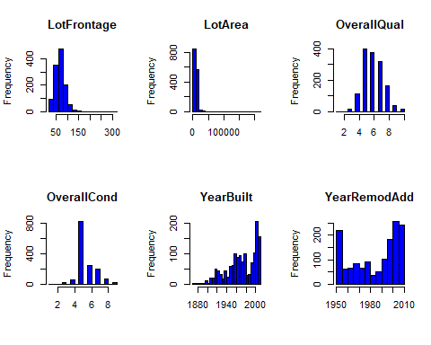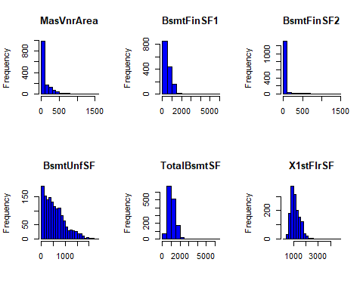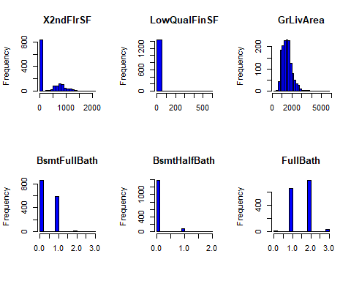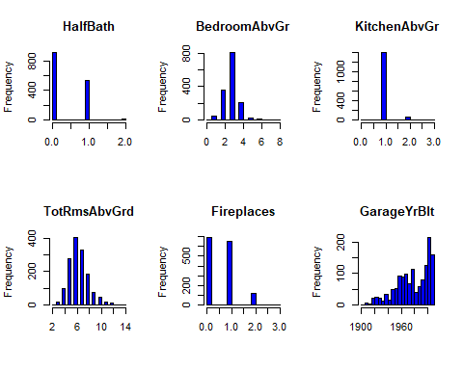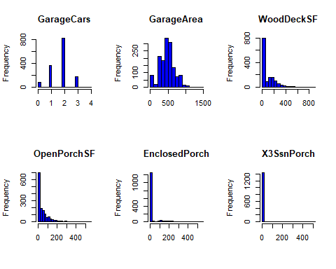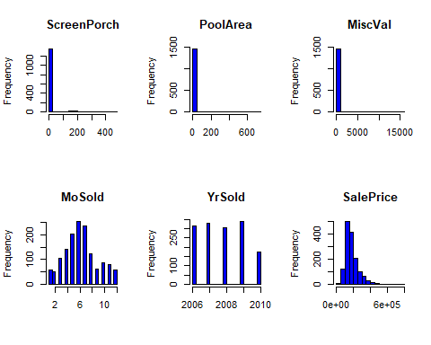

## LotFrontage LotArea OverallQual   
## breaks Integer,16 Numeric,23 Numeric,19   
## counts Integer,15 Integer,22 Integer,18   
## density Numeric,15 Numeric,22 Numeric,18   
## mids Numeric,15 Numeric,22 Numeric,18   
## xname "dots[[1L]][[1L]]" "dots[[1L]][[2L]]" "dots[[1L]][[3L]]"  
## equidist TRUE TRUE TRUE   
## OverallCond YearBuilt YearRemodAdd   
## breaks Numeric,17 Integer,29 Integer,13   
## counts Integer,16 Integer,28 Integer,12   
## density Numeric,16 Numeric,28 Numeric,12   
## mids Numeric,16 Numeric,28 Numeric,12   
## xname "dots[[1L]][[4L]]" "dots[[1L]][[5L]]" "dots[[1L]][[6L]]"  
## equidist TRUE TRUE TRUE   
## MasVnrArea BsmtFinSF1 BsmtFinSF2   
## breaks Numeric,17 Numeric,13 Numeric,16   
## counts Integer,16 Integer,12 Integer,15   
## density Numeric,16 Numeric,12 Numeric,15   
## mids Numeric,16 Numeric,12 Numeric,15   
## xname "dots[[1L]][[7L]]" "dots[[1L]][[8L]]" "dots[[1L]][[9L]]"  
## equidist TRUE TRUE TRUE   
## BsmtUnfSF TotalBsmtSF X1stFlrSF   
## breaks Numeric,25 Numeric,14 Integer,24   
## counts Integer,24 Integer,13 Integer,23   
## density Numeric,24 Numeric,13 Numeric,23   
## mids Numeric,24 Numeric,13 Numeric,23   
## xname "dots[[1L]][[10L]]" "dots[[1L]][[11L]]" "dots[[1L]][[12L]]"  
## equidist TRUE TRUE TRUE   
## X2ndFlrSF LowQualFinSF GrLivArea   
## breaks Numeric,22 Numeric,13 Integer,29   
## counts Integer,21 Integer,12 Integer,28   
## density Numeric,21 Numeric,12 Numeric,28   
## mids Numeric,21 Numeric,12 Numeric,28   
## xname "dots[[1L]][[13L]]" "dots[[1L]][[14L]]" "dots[[1L]][[15L]]"  
## equidist TRUE TRUE TRUE   
## BsmtFullBath BsmtHalfBath FullBath   
## breaks Numeric,16 Numeric,21 Numeric,16   
## counts Integer,15 Integer,20 Integer,15   
## density Numeric,15 Numeric,20 Numeric,15   
## mids Numeric,15 Numeric,20 Numeric,15   
## xname "dots[[1L]][[16L]]" "dots[[1L]][[17L]]" "dots[[1L]][[18L]]"  
## equidist TRUE TRUE TRUE   
## HalfBath BedroomAbvGr KitchenAbvGr   
## breaks Numeric,21 Numeric,17 Numeric,16   
## counts Integer,20 Integer,16 Integer,15   
## density Numeric,20 Numeric,16 Numeric,15   
## mids Numeric,20 Numeric,16 Numeric,15   
## xname "dots[[1L]][[19L]]" "dots[[1L]][[20L]]" "dots[[1L]][[21L]]"  
## equidist TRUE TRUE TRUE   
## TotRmsAbvGrd Fireplaces GarageYrBlt   
## breaks Numeric,25 Numeric,16 Integer,23   
## counts Integer,24 Integer,15 Integer,22   
## density Numeric,24 Numeric,15 Numeric,22   
## mids Numeric,24 Numeric,15 Numeric,22   
## xname "dots[[1L]][[22L]]" "dots[[1L]][[23L]]" "dots[[1L]][[24L]]"  
## equidist TRUE TRUE TRUE   
## GarageCars GarageArea WoodDeckSF   
## breaks Numeric,21 Numeric,16 Numeric,19   
## counts Integer,20 Integer,15 Integer,18   
## density Numeric,20 Numeric,15 Numeric,18   
## mids Numeric,20 Numeric,15 Numeric,18   
## xname "dots[[1L]][[25L]]" "dots[[1L]][[26L]]" "dots[[1L]][[27L]]"  
## equidist TRUE TRUE TRUE   
## OpenPorchSF EnclosedPorch X3SsnPorch   
## breaks Numeric,29 Numeric,29 Numeric,27   
## counts Integer,28 Integer,28 Integer,26   
## density Numeric,28 Numeric,28 Numeric,26   
## mids Numeric,28 Numeric,28 Numeric,26   
## xname "dots[[1L]][[28L]]" "dots[[1L]][[29L]]" "dots[[1L]][[30L]]"  
## equidist TRUE TRUE TRUE   
## ScreenPorch PoolArea MiscVal   
## breaks Numeric,25 Numeric,16 Numeric,17   
## counts Integer,24 Integer,15 Integer,16   
## density Numeric,24 Numeric,15 Numeric,16   
## mids Numeric,24 Numeric,15 Numeric,16   
## xname "dots[[1L]][[31L]]" "dots[[1L]][[32L]]" "dots[[1L]][[33L]]"  
## equidist TRUE TRUE TRUE   
## MoSold YrSold SalePrice   
## breaks Numeric,23 Numeric,21 Numeric,17   
## counts Integer,22 Integer,20 Integer,16   
## density Numeric,22 Numeric,20 Numeric,16   
## mids Numeric,22 Numeric,20 Numeric,16   
## xname "dots[[1L]][[34L]]" "dots[[1L]][[35L]]" "dots[[1L]][[36L]]"  
## equidist TRUE TRUE TRUE

Many of the distributions are skewed - including salePrice Log transformation would be beneficial.

### Skewness Test

Originally used Shapiro wilk test, but this only works well with n<50 and thus all my distributions showed as not-normal. Skewness - between -0.5 to 0.5 normal, absolute value between 0.5 and 1 moderately skewed. Abs value above 1 is highly skewed. Kurtosis - Kurtosis tells you the height and sharpness of the central peak, relative to that of a standard bell curve.

#skewness.test(housedata_num$SalePrice)  
Check<-describe(housedata_num)[,c(11,12)]  
Check

## skew kurtosis  
## LotFrontage 2.16 17.34  
## LotArea 12.18 202.26  
## OverallQual 0.22 0.09  
## OverallCond 0.69 1.09  
## YearBuilt -0.61 -0.45  
## YearRemodAdd -0.50 -1.27  
## MasVnrArea 2.66 10.03  
## BsmtFinSF1 1.68 11.06  
## BsmtFinSF2 4.25 20.01  
## BsmtUnfSF 0.92 0.46  
## TotalBsmtSF 1.52 13.18  
## X1stFlrSF 1.37 5.71  
## X2ndFlrSF 0.81 -0.56  
## LowQualFinSF 8.99 82.83  
## GrLivArea 1.36 4.86  
## BsmtFullBath 0.59 -0.84  
## BsmtHalfBath 4.09 16.31  
## FullBath 0.04 -0.86  
## HalfBath 0.67 -1.08  
## BedroomAbvGr 0.21 2.21  
## KitchenAbvGr 4.48 21.42  
## TotRmsAbvGrd 0.67 0.87  
## Fireplaces 0.65 -0.22  
## GarageYrBlt -0.65 -0.42  
## GarageCars -0.34 0.21  
## GarageArea 0.18 0.90  
## WoodDeckSF 1.54 2.97  
## OpenPorchSF 2.36 8.44  
## EnclosedPorch 3.08 10.37  
## X3SsnPorch 10.28 123.06  
## ScreenPorch 4.11 18.34  
## PoolArea 14.80 222.19  
## MiscVal 24.43 697.64  
## MoSold 0.21 -0.41  
## YrSold 0.10 -1.19  
## SalePrice 1.88 6.50

Below items all high skewness and may need transformation.

* LotFrontage 2.16 17.34
* LotArea 12.18 202.26
* MasVnrArea 2.66 10.03
* BsmtFinSF1 1.68 11.06
* BsmtFinSF2 4.25 20.01
* TotalBsmtSF 1.52 13.18
* X1stFlrSF 1.37 5.71
* LowQualFinSF 8.99 82.83
* GrLivArea 1.36 4.86
* BsmtHalfBath 4.09 16.31
* KitchenAbvGr 4.48 21.42
* OpenPorchSF 2.36 8.44
* EnclosedPorch 3.08 10.37
* X3SsnPorch 10.28 123.06
* ScreenPorch 4.11 18.34
* PoolArea 14.80 222.19
* MiscVal 24.43 697.64
* SalePrice 1.88 6.50

#### Subset non-normal variables.

H_SkewedVar<-select(housedata_num,c(  
   
LotFrontage,  
LotArea,  
MasVnrArea,  
BsmtFinSF1,  
BsmtFinSF2,  
TotalBsmtSF,  
X1stFlrSF,  
LowQualFinSF,  
GrLivArea,  
BsmtHalfBath,  
KitchenAbvGr,  
OpenPorchSF,  
EnclosedPorch,  
X3SsnPorch,  
ScreenPorch,  
PoolArea,  
MiscVal,  
SalePrice))

#### Apply Log base 10 and check skewness.

(log10(x+1) because there are some x=0 values)

describe(H_SkewedVar)[,c(11,12)]

## skew kurtosis  
## LotFrontage 2.16 17.34  
## LotArea 12.18 202.26  
## MasVnrArea 2.66 10.03  
## BsmtFinSF1 1.68 11.06  
## BsmtFinSF2 4.25 20.01  
## TotalBsmtSF 1.52 13.18  
## X1stFlrSF 1.37 5.71  
## LowQualFinSF 8.99 82.83  
## GrLivArea 1.36 4.86  
## BsmtHalfBath 4.09 16.31  
## KitchenAbvGr 4.48 21.42  
## OpenPorchSF 2.36 8.44  
## EnclosedPorch 3.08 10.37  
## X3SsnPorch 10.28 123.06  
## ScreenPorch 4.11 18.34  
## PoolArea 14.80 222.19  
## MiscVal 24.43 697.64  
## SalePrice 1.88 6.50

describe(log10(H_SkewedVar+1),)[,c(11,12)]

## skew kurtosis  
## LotFrontage -0.73 2.29  
## LotArea -0.14 4.68  
## MasVnrArea 0.49 -1.63  
## BsmtFinSF1 -0.62 -1.48  
## BsmtFinSF2 2.52 4.52  
## TotalBsmtSF -5.14 27.60  
## X1stFlrSF 0.08 0.14  
## LowQualFinSF 7.44 54.12  
## GrLivArea -0.01 0.27  
## BsmtHalfBath 3.92 13.78  
## KitchenAbvGr 3.86 19.95  
## OpenPorchSF -0.02 -1.78  
## EnclosedPorch 2.11 2.55  
## X3SsnPorch 7.72 58.13  
## ScreenPorch 3.14 7.98  
## PoolArea 14.33 203.69  
## MiscVal 5.16 25.31  
## SalePrice 0.12 0.80

The Log transformation significantly improved skewness for below.

skew kurtosis

* LotFrontage -0.73 2.29
* LotArea -0.14 4.68
* MasVnrArea 0.49 -1.63
* BsmtFinSF1 -0.62 -1.48
* BsmtFinSF2 2.52 4.52
* X1stFlrSF 0.08 0.14
* GrLivArea -0.01 0.27
* OpenPorchSF -0.02 -1.78
* SalePrice 0.12 0.80

Below didn’t help much with log transformation

* LowQualFinSF 7.44
* BsmtHalfBath 3.92 13.78
* KitchenAbvGr 4.48 21.42
* X3SsnPorch 7.72 58.13
* ScreenPorch 3.14 7.98
* PoolArea 14.33 203.69
* MiscVal 5.16 25.31

#### Plot Histogram to see if this matches with the skewness changes.

par(mfrow=c(1,2))  
for (i in 1:18){  
hist(H_SkewedVar[,i],main=colnames(H_SkewedVar[i]),xlab='' ,breaks=20, col="green")  
# lines(density(H_SkewedVar[,i], na.rm=T),col="green")  
hist(log10(H_SkewedVar[,i]+1),main=paste("Log of ",colnames(H_SkewedVar[i])),xlab='' ,breaks=20, col="yellow")  
# lines(density(log10(H_SkewedVar[,i]), na.rm=T),col="yellow")  
}

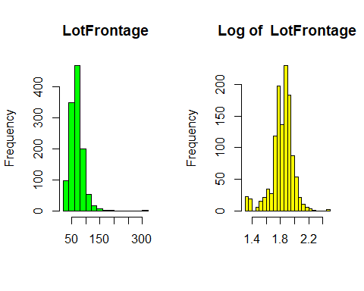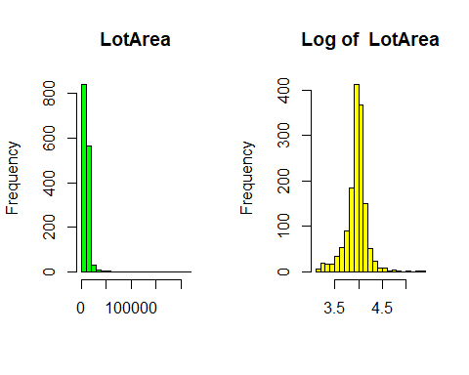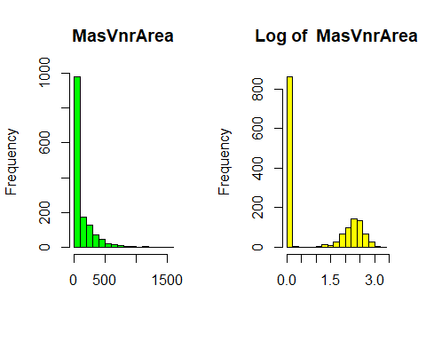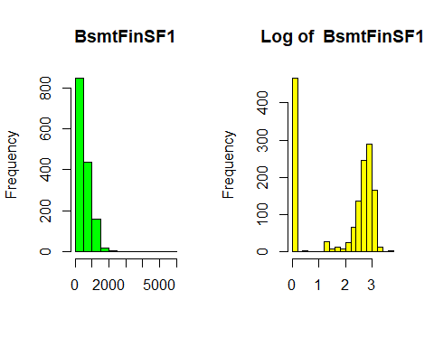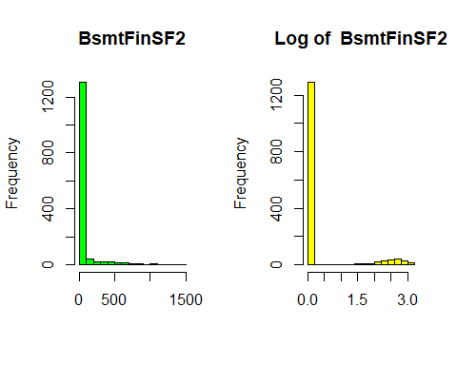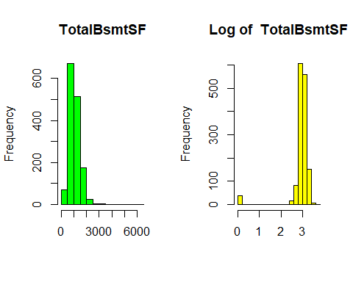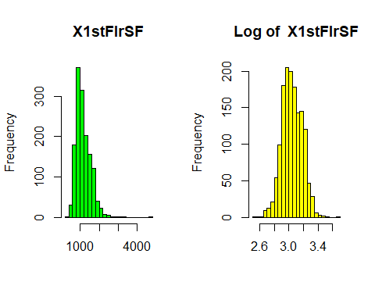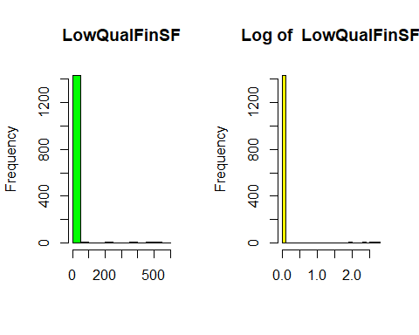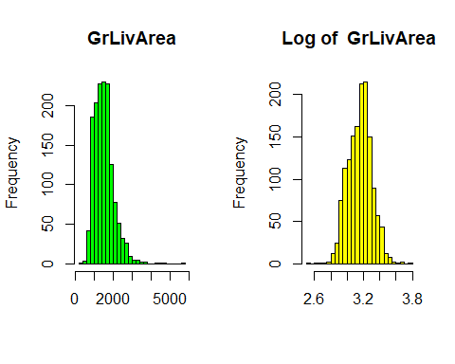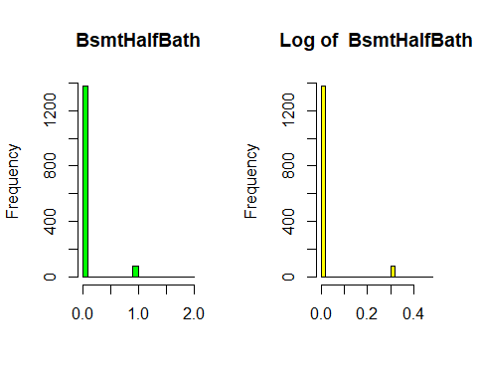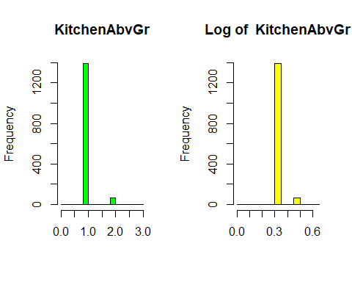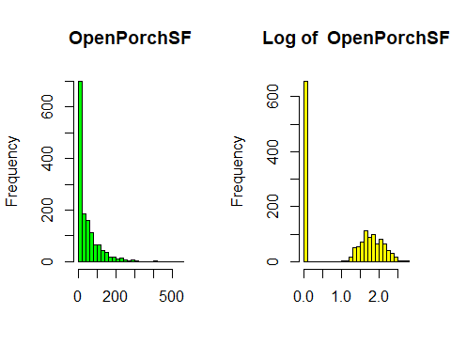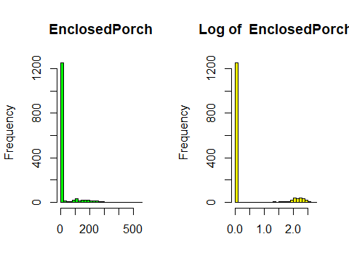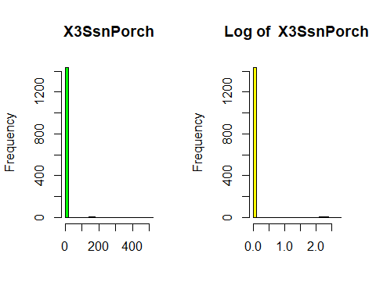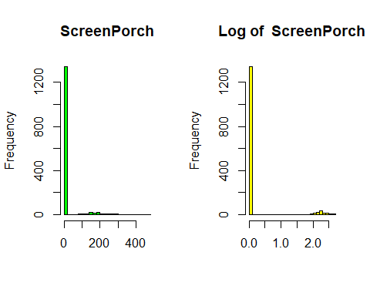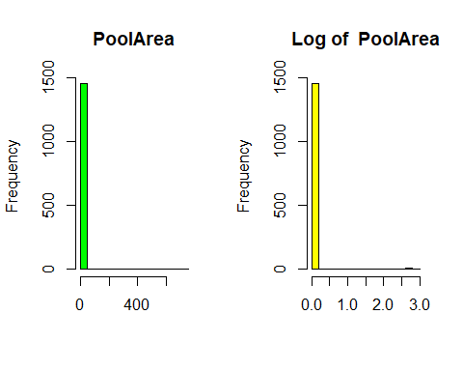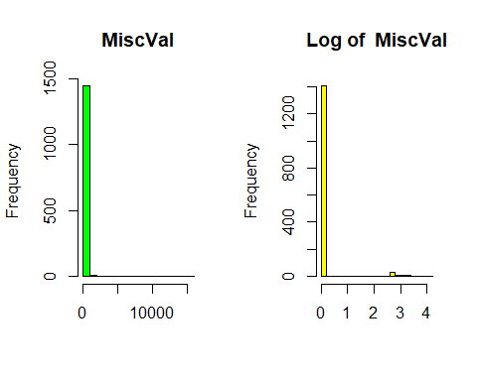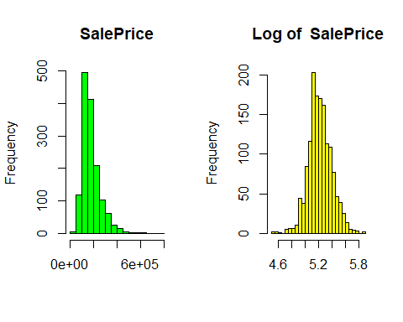

Looks like it matches with the skewness values.

skew kurtosis

LotArea -0.14 4.68 MasVnrArea 0.49 -1.63 BsmtFinSF1 -0.62 -1.48 BsmtFinSF2 2.52 4.52 X1stFlrSF 0.08 0.14 GrLivArea -0.01 0.27 OpenPorchSF -0.02 -1.78 SalePrice 0.12 0.80

### Plot numerical 2 - Boxplot to check outliers

An outlier is defined as above 1.5 interqurtile range above the upper quartile(Q3) and below 1.5 of lower quartile(Q1). Looking at the boxplot, there are too many outliers. Many are because the distribution is skewed, and some because majority of the distribution are packed into very small range (variance is very small).

par(mfrow=c(1,5))  
  
  
# The mapply() function stands for 'multivariate' apply. Its purpose is to be able to vectorize arguments to a function that is not usually accepting vectors as arguments. In short, mapply() applies a Function to Multiple List or multiple Vector Arguments.  
  
mapply(boxplot,data.frame(housedata_num),main=colnames(housedata_num) )

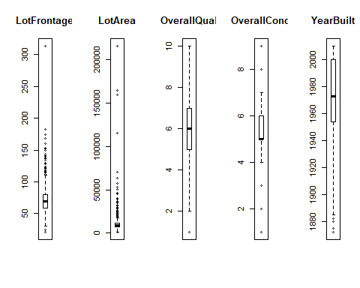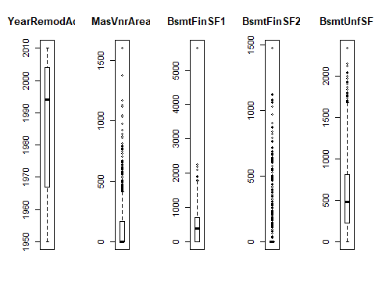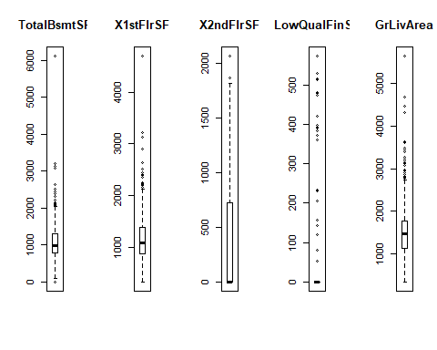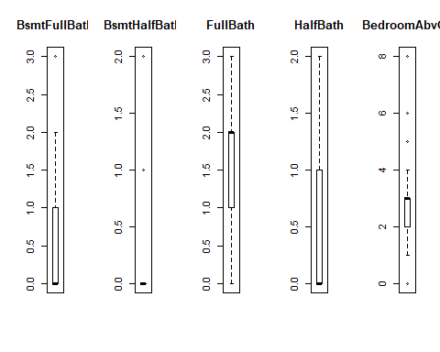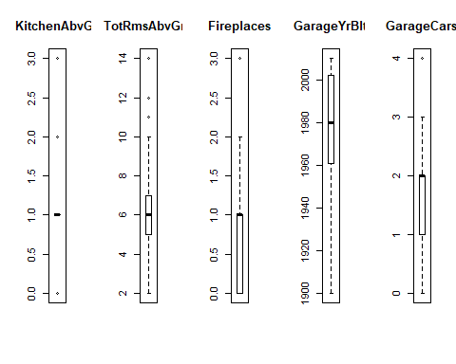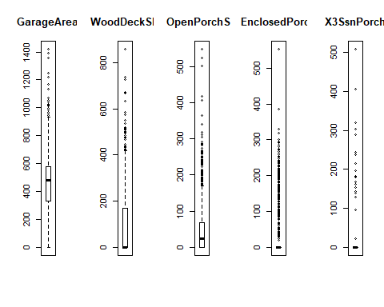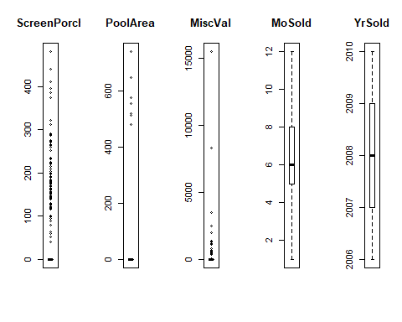

## LotFrontage LotArea OverallQual OverallCond YearBuilt  
## stats Numeric,5 Numeric,5 Numeric,5 Numeric,5 Numeric,5  
## n 1201 1460 1460 1460 1460   
## conf Numeric,2 Numeric,2 Numeric,2 Numeric,2 Numeric,2  
## out Numeric,88 Numeric,68 Numeric,2 Numeric,125 Numeric,7  
## group Numeric,88 Numeric,68 Numeric,2 Numeric,125 Numeric,7  
## names "" "" "" "" ""   
## YearRemodAdd MasVnrArea BsmtFinSF1 BsmtFinSF2 BsmtUnfSF   
## stats Numeric,5 Numeric,5 Numeric,5 Numeric,5 Numeric,5   
## n 1460 1452 1460 1460 1460   
## conf Numeric,2 Numeric,2 Numeric,2 Numeric,2 Numeric,2   
## out Numeric,0 Numeric,96 Numeric,7 Numeric,167 Numeric,29  
## group Numeric,0 Numeric,96 Numeric,7 Numeric,167 Numeric,29  
## names "" "" "" "" ""   
## TotalBsmtSF X1stFlrSF X2ndFlrSF LowQualFinSF GrLivArea   
## stats Numeric,5 Numeric,5 Numeric,5 Numeric,5 Numeric,5   
## n 1460 1460 1460 1460 1460   
## conf Numeric,2 Numeric,2 Numeric,2 Numeric,2 Numeric,2   
## out Numeric,61 Numeric,20 Numeric,2 Numeric,26 Numeric,31  
## group Numeric,61 Numeric,20 Numeric,2 Numeric,26 Numeric,31  
## names "" "" "" "" ""   
## BsmtFullBath BsmtHalfBath FullBath HalfBath BedroomAbvGr  
## stats Numeric,5 Numeric,5 Numeric,5 Numeric,5 Numeric,5   
## n 1460 1460 1460 1460 1460   
## conf Numeric,2 Numeric,2 Numeric,2 Numeric,2 Numeric,2   
## out 3 Numeric,82 Numeric,0 Numeric,0 Numeric,35   
## group 1 Numeric,82 Numeric,0 Numeric,0 Numeric,35   
## names "" "" "" "" ""   
## KitchenAbvGr TotRmsAbvGrd Fireplaces GarageYrBlt GarageCars  
## stats Numeric,5 Numeric,5 Numeric,5 Numeric,5 Numeric,5   
## n 1460 1460 1460 1379 1460   
## conf Numeric,2 Numeric,2 Numeric,2 Numeric,2 Numeric,2   
## out Numeric,68 Numeric,30 Numeric,5 Numeric,0 Numeric,5   
## group Numeric,68 Numeric,30 Numeric,5 Numeric,0 Numeric,5   
## names "" "" "" "" ""   
## GarageArea WoodDeckSF OpenPorchSF EnclosedPorch X3SsnPorch  
## stats Numeric,5 Numeric,5 Numeric,5 Numeric,5 Numeric,5   
## n 1460 1460 1460 1460 1460   
## conf Numeric,2 Numeric,2 Numeric,2 Numeric,2 Numeric,2   
## out Numeric,21 Numeric,32 Numeric,77 Numeric,208 Numeric,24  
## group Numeric,21 Numeric,32 Numeric,77 Numeric,208 Numeric,24  
## names "" "" "" "" ""   
## ScreenPorch PoolArea MiscVal MoSold YrSold SalePrice   
## stats Numeric,5 Numeric,5 Numeric,5 Numeric,5 Numeric,5 Numeric,5   
## n 1460 1460 1460 1460 1460 1460   
## conf Numeric,2 Numeric,2 Numeric,2 Numeric,2 Numeric,2 Numeric,2   
## out Numeric,116 Numeric,7 Numeric,52 Numeric,0 Numeric,0 Numeric,61  
## group Numeric,116 Numeric,7 Numeric,52 Numeric,0 Numeric,0 Numeric,61  
## names "" "" "" "" "" ""

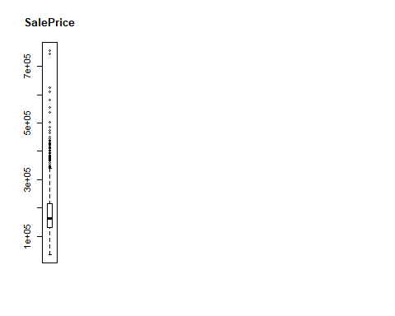

### Print Outliers

#boxplot.stats(housedata_num[,1])  
for (i in 1:36)  
{  
(a<-boxplot.stats(housedata_num[,i]))  
   
print(colnames(housedata_num)[i])  
print(a$out)}

## [1] "LotFrontage"  
## [1] 112 115 24 21 121 122 24 120 134 141 24 24 174 21 21 174 21  
## [18] 21 120 129 140 120 118 116 150 21 130 21 24 21 137 21 21 24  
## [35] 130 24 21 21 21 120 24 24 144 114 24 21 128 116 149 21 313  
## [52] 24 24 24 122 130 121 21 115 21 21 21 120 24 24 24 114 168  
## [69] 182 134 24 120 118 138 160 24 152 21 124 21 313 24 153 120 129  
## [86] 124 21 21  
## [1] "LotArea"  
## [1] 50271 19900 21000 21453 19378 31770 22950 25419 159000 19296  
## [11] 39104 19138 18386 215245 164660 20431 18800 53107 34650 22420  
## [21] 21750 70761 53227 40094 32668 21872 21780 25095 46589 20896  
## [31] 18450 21535 26178 115149 21695 53504 21384 28698 45600 17920  
## [41] 25286 27650 24090 25000 1300 21286 21750 29959 18000 23257  
## [51] 17755 35760 18030 35133 32463 18890 24682 23595 17871 36500  
## [61] 63887 20781 25339 57200 20544 19690 21930 26142  
## [1] "OverallQual"  
## [1] 1 1  
## [1] "OverallCond"  
## [1] 8 8 8 2 3 8 8 8 8 9 8 9 9 3 9 8 2 8 8 9 8 3 8 8 8 1 2 3 3 8 2 8 3 8 8  
## [36] 8 8 9 8 8 8 8 9 9 3 8 3 8 9 8 8 8 3 3 3 2 8 8 9 8 8 9 8 9 3 8 8 8 8 8  
## [71] 8 8 8 8 8 3 8 3 8 8 8 9 8 9 8 3 8 3 8 3 3 8 3 8 8 3 9 3 8 3 9 8 8 8 8  
## [106] 8 8 8 9 3 8 8 8 8 9 8 3 9 9 3 8 8 8 9 9  
## [1] "YearBuilt"  
## [1] 1880 1880 1880 1882 1880 1875 1872  
## [1] "YearRemodAdd"  
## integer(0)  
## [1] "MasVnrArea"  
## [1] 640 650 456 1031 573 1115 576 443 468 600 768 480 1129 436  
## [15] 456 664 653 491 748 456 922 506 604 472 481 1600 616 870  
## [29] 530 500 510 650 432 473 772 435 562 921 762 594 479 584  
## [43] 420 459 452 513 472 660 528 464 1170 630 466 651 442 894  
## [57] 513 673 603 860 424 1047 442 816 760 541 423 424 975 450  
## [71] 423 571 480 425 660 1378 456 425 420 766 554 632 567 451  
## [85] 621 788 796 428 564 579 705 731 420 448 426 438  
## [1] "BsmtFinSF1"  
## [1] 1810 1880 1904 2260 2188 2096 5644  
## [1] "BsmtFinSF2"  
## [1] 32 668 486 93 491 506 712 362 41 169 869 150 670 28  
## [15] 1080 181 768 215 374 208 441 184 279 306 180 712 580 690  
## [29] 692 228 125 1063 620 175 820 1474 264 479 147 232 380 544  
## [43] 294 258 121 180 391 531 344 539 713 210 311 1120 165 532  
## [57] 279 96 495 180 174 1127 139 202 645 123 551 219 606 147  
## [71] 612 480 182 132 336 468 287 35 499 180 180 723 119 182  
## [85] 40 551 117 239 80 472 64 1057 127 630 480 128 377 764  
## [99] 345 539 1085 435 823 500 290 324 634 411 841 1061 93 466  
## [113] 396 354 294 149 193 117 273 465 400 468 41 682 64 557  
## [127] 230 106 791 240 287 547 391 469 177 108 374 600 492 211  
## [141] 168 96 1031 438 375 144 81 906 608 276 661 68 173 972  
## [155] 105 420 469 546 334 352 872 374 110 627 163 1029 290  
## [1] "BsmtUnfSF"  
## [1] 1777 1768 1907 1686 2336 1694 2121 1869 2153 1969 1709 2042 1774 2046  
## [15] 1836 1935 1926 1734 1800 1753 1905 1800 1710 1752 1694 1689 2002 1753  
## [29] 1795  
## [1] "TotalBsmtSF"  
## [1] 0 0 2223 0 0 0 2216 0 2392 0 2121 2136 3206 0  
## [15] 0 0 0 3094 2153 3200 0 3138 0 0 0 0 2109 2077  
## [29] 2444 0 0 0 0 2078 0 2217 0 0 2330 0 0 0  
## [43] 0 2524 0 0 0 0 0 2396 2158 0 0 2136 0 2076  
## [57] 2110 6110 0 2633 0  
## [1] "X1stFlrSF"  
## [1] 2207 2223 2259 2158 2234 2392 2402 3228 3138 2515 2444 2217 2364 2898  
## [15] 2524 2411 2196 4692 2156 2633  
## [1] "X2ndFlrSF"  
## [1] 1872 2065  
## [1] "LowQualFinSF"  
## [1] 360 513 234 528 572 144 392 371 390 420 473 156 515 360 80 80 53  
## [18] 232 481 120 514 397 479 205 80 384  
## [1] "GrLivArea"  
## [1] 2945 3222 3608 3112 2794 3493 2978 3228 4676 2775 3194 3395 4316 3279  
## [15] 3140 2822 2872 2898 3082 2868 2828 3627 3086 2872 4476 3447 5642 2810  
## [29] 2792 3238 2784  
## [1] "BsmtFullBath"  
## [1] 3  
## [1] "BsmtHalfBath"  
## [1] 1 1 1 1 1 1 1 1 1 1 1 1 1 1 1 1 1 1 1 1 1 1 1 1 1 1 1 1 1 1 1 1 1 1 1  
## [36] 2 1 1 1 1 1 1 1 1 1 1 1 1 1 1 1 1 1 1 1 2 1 1 1 1 1 1 1 1 1 1 1 1 1 1  
## [71] 1 1 1 1 1 1 1 1 1 1 1 1  
## [1] "FullBath"  
## integer(0)  
## [1] "HalfBath"  
## integer(0)  
## [1] "BedroomAbvGr"  
## [1] 0 5 5 6 0 5 6 5 5 6 5 6 5 0 8 5 6 5 5 6 5 5 5 5 5 5 5 0 0 5 0 5 6 5 5  
## [1] "KitchenAbvGr"  
## [1] 2 2 2 2 3 2 2 2 2 2 2 2 2 2 2 2 2 2 2 2 2 2 2 2 2 2 2 2 2 2 2 2 2 3 2  
## [36] 2 2 2 2 2 2 2 2 2 0 2 2 2 2 2 2 2 2 2 2 2 2 2 2 2 2 2 2 2 2 2 2 2  
## [1] "TotRmsAbvGrd"  
## [1] 11 11 12 11 11 11 11 14 11 12 11 12 11 11 12 11 12 11 12 11 11 12 12  
## [24] 11 11 12 12 12 11 11  
## [1] "Fireplaces"  
## [1] 3 3 3 3 3  
## [1] "GarageYrBlt"  
## integer(0)  
## [1] "GarageCars"  
## [1] 4 4 4 4 4  
## [1] "GarageArea"  
## [1] 1166 968 1053 1025 947 1390 1134 983 1020 1220 1248 1043 1052 995  
## [15] 1356 1052 954 1014 1418 968 1069  
## [1] "WoodDeckSF"  
## [1] 857 576 476 574 441 468 670 495 536 519 466 517 426 503 486 486 511  
## [18] 421 550 509 474 728 436 431 448 439 635 500 668 586 431 736  
## [1] "OpenPorchSF"  
## [1] 204 213 258 199 234 184 205 228 238 260 198 172 208 228 184 250 175  
## [18] 195 214 231 192 187 176 523 285 406 182 502 274 172 243 235 312 267  
## [35] 265 288 341 204 174 247 291 312 418 240 364 188 207 234 192 191 252  
## [52] 189 282 224 319 244 185 200 180 263 304 234 240 192 229 211 198 287  
## [69] 292 207 241 547 211 184 262 210 236  
## [1] "EnclosedPorch"  
## [1] 272 228 205 176 205 87 172 102 37 144 64 114 202 128 156 44 77  
## [18] 144 192 144 140 180 228 128 183 39 184 40 552 30 126 96 60 150  
## [35] 120 202 77 112 252 52 224 234 144 244 268 137 24 108 294 177 218  
## [52] 242 91 112 160 130 184 126 169 105 34 96 248 236 120 32 80 115  
## [69] 291 184 116 158 112 210 36 156 144 200 84 148 116 120 136 102 240  
## [86] 54 112 39 100 36 189 293 164 40 216 239 112 252 240 180 67 90  
## [103] 120 56 112 129 40 98 143 216 234 112 112 70 386 154 185 156 156  
## [120] 134 196 264 185 275 96 120 112 116 230 254 68 194 192 34 150 164  
## [137] 112 224 32 318 244 48 94 138 108 112 226 192 174 228 19 170 220  
## [154] 128 80 115 137 192 252 112 96 176 216 176 214 280 96 116 102 190  
## [171] 236 192 84 330 208 145 259 126 264 81 164 42 123 162 100 286 190  
## [188] 168 20 301 198 96 221 112 212 50 150 168 112 160 114 216 154 99  
## [205] 158 216 252 112  
## [1] "X3SsnPorch"  
## [1] 320 407 130 180 168 180 140 508 238 245 196 144 144 182 168 162 23  
## [18] 168 216 96 216 153 290 304  
## [1] "ScreenPorch"  
## [1] 176 198 291 252 99 184 168 130 142 192 410 224 266 170 154 153 144  
## [18] 142 128 259 160 198 271 234 184 374 192 185 182 90 144 224 396 170  
## [35] 176 140 276 192 180 161 168 145 200 122 95 144 120 60 120 126 189  
## [52] 260 147 385 287 200 156 100 180 216 210 197 204 192 225 192 152 175  
## [69] 126 312 222 265 224 322 120 190 233 63 147 180 53 143 189 189 189  
## [86] 192 160 160 126 100 273 180 90 288 263 224 147 120 80 163 90 288  
## [103] 116 259 224 216 480 120 178 440 155 168 220 119 165 40  
## [1] "PoolArea"  
## [1] 512 648 576 555 480 519 738  
## [1] "MiscVal"  
## [1] 700 350 700 500 400 700 480 400 400 450 450  
## [12] 500 450 700 400 15500 1200 800 480 400 2000 2000  
## [23] 600 500 600 600 3500 500 400 450 500 1300 1200  
## [34] 500 400 54 500 400 400 2000 620 400 560 500  
## [45] 700 1400 400 8300 600 1150 2000 2500  
## [1] "MoSold"  
## integer(0)  
## [1] "YrSold"  
## integer(0)  
## [1] "SalePrice"  
## [1] 345000 385000 438780 383970 372402 412500 501837 475000 386250 403000  
## [11] 415298 360000 375000 342643 354000 377426 437154 394432 426000 555000  
## [21] 440000 380000 374000 430000 402861 446261 369900 451950 359100 345000  
## [31] 370878 350000 402000 423000 372500 392000 755000 361919 341000 538000  
## [41] 395000 485000 582933 385000 350000 611657 395192 348000 556581 424870  
## [51] 625000 392500 745000 367294 465000 378500 381000 410000 466500 377500  
## [61] 394617

Looking through these values, most of them looks to be biproduct of skewed distribution or extremely small variance. Will look this into a little more after cleaning up the data using cook’s distance.

### Check to see relationship with response variable - house price VS ind. variables.

par(mfrow=c(2,3))  
for (i in 2:79)  
(  
plot(housedata[,i],housedata$SalePrice, las=2, main=colnames(housedata[i]), xlab='', col='grey')  
)

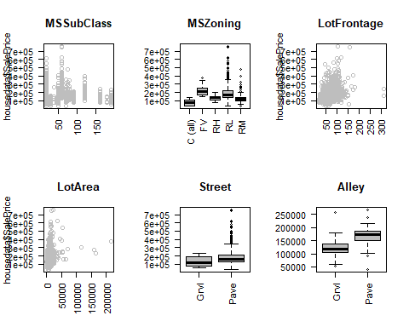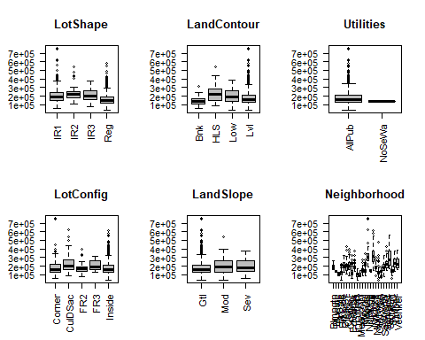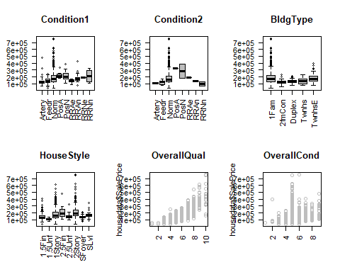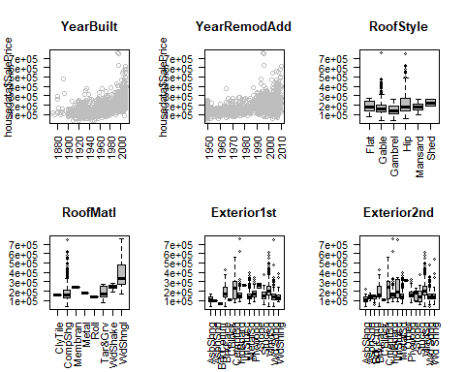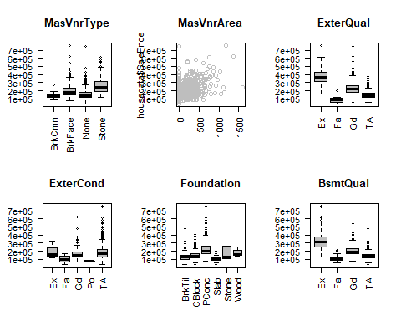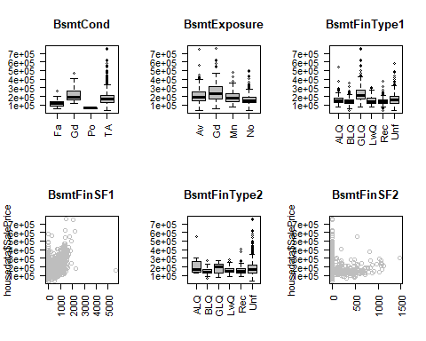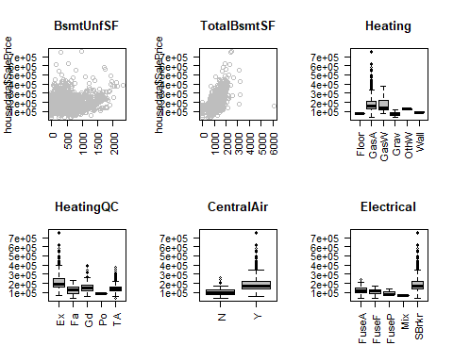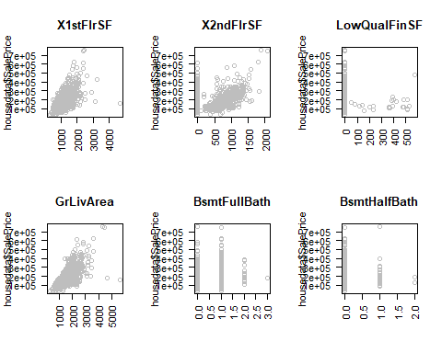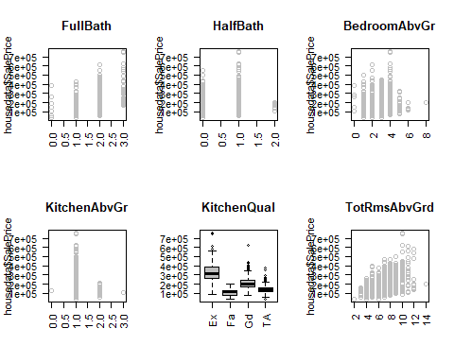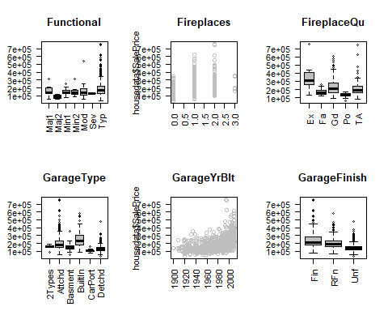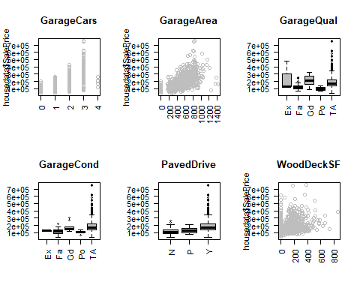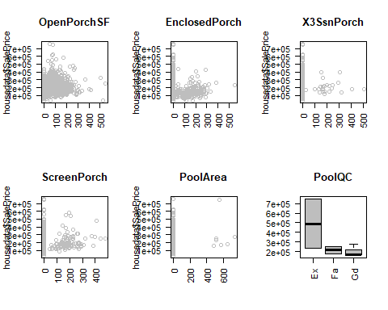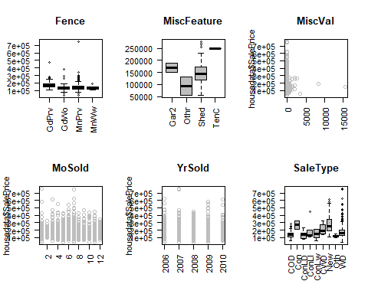

Can see definate relationships here. House Prices increase with Lot Frontage, Lot Area, Overall Quality, Year Built, Year Remodel, BsmtFinSF1, TotalBsmtSF, X1stFlrSF, X2ndFlrSF, # of FullBath, TotRmsAbvGrd,KitchenQual, GarageYrBlt, GarageCars, GarageArea, WoodDeckSF, etc.

### Checking Correlations between Independent Variables

Using spearman because many of our variables are not normal.

cor(housedata_num,use="complete.obs", method='spearman')

## LotFrontage LotArea OverallQual OverallCond  
## LotFrontage 1.0000000000 0.64436154 0.24008405 -0.069072924  
## LotArea 0.6443615430 1.00000000 0.27885345 -0.088291269  
## OverallQual 0.2400840531 0.27885345 1.00000000 -0.234850009  
## OverallCond -0.0690729241 -0.08829127 -0.23485001 1.000000000  
## YearBuilt 0.1749910491 0.13128094 0.66393187 -0.453285876  
## YearRemodAdd 0.1125724029 0.12215453 0.59165419 -0.097301007  
## MasVnrArea 0.2548257439 0.17379506 0.42994108 -0.218477063  
## BsmtFinSF1 0.1561913951 0.14435735 0.12571321 -0.012018369  
## BsmtFinSF2 0.0507176625 0.02144473 -0.13324890 0.110054962  
## BsmtUnfSF 0.1026648516 0.09935269 0.29049024 -0.144815183  
## TotalBsmtSF 0.3711624304 0.36042189 0.50014015 -0.243558659  
## X1stFlrSF 0.4101593659 0.41960646 0.44944825 -0.189691784  
## X2ndFlrSF 0.0524942879 0.13632122 0.26104972 -0.016963283  
## LowQualFinSF -0.0505368659 -0.02056586 -0.02632446 0.034550601  
## GrLivArea 0.3623017426 0.45698925 0.62075325 -0.184906470  
## BsmtFullBath 0.0957102680 0.10049548 0.11185274 -0.056597923  
## BsmtHalfBath -0.0009884616 -0.01080862 -0.06528073 0.126624347  
## FullBath 0.2079144047 0.23270443 0.60532881 -0.295229283  
## HalfBath 0.0867115850 0.15379215 0.26908590 -0.083215943  
## BedroomAbvGr 0.3276698150 0.33715069 0.12169997 -0.002472406  
## KitchenAbvGr -0.0059603190 -0.02968873 -0.18258511 -0.105298357  
## TotRmsAbvGrd 0.3610374056 0.42633210 0.45022129 -0.135635588  
## Fireplaces 0.2350587665 0.33789026 0.43316874 -0.041139036  
## GarageYrBlt 0.1149244614 0.11010050 0.63266717 -0.401291480  
## GarageCars 0.3413303267 0.34109772 0.59364757 -0.316159374  
## GarageArea 0.3703701038 0.35599905 0.53027865 -0.260390407  
## WoodDeckSF 0.1020957595 0.16802967 0.30227528 -0.052770647  
## OpenPorchSF 0.1793140525 0.18991125 0.45885277 -0.200632164  
## EnclosedPorch -0.0976292472 -0.07993287 -0.20052338 0.110328966  
## X3SsnPorch 0.0623898717 0.04470101 0.01547530 0.009856910  
## ScreenPorch 0.0367199004 0.10682888 0.03292948 0.107517740  
## PoolArea 0.0860921624 0.08685056 0.06578001 -0.023172667  
## MiscVal 0.0207394372 0.04701516 -0.10732995 0.108376809  
## MoSold 0.0305732569 0.01173592 0.07992739 -0.015541322  
## YrSold 0.0076572524 -0.02530713 -0.01030941 0.041029181  
## SalePrice 0.3996569514 0.46028741 0.82710824 -0.174954934  
## YearBuilt YearRemodAdd MasVnrArea BsmtFinSF1  
## LotFrontage 0.1749910491 0.112572403 0.254825744 0.156191395  
## LotArea 0.1312809411 0.122154528 0.173795062 0.144357349  
## OverallQual 0.6639318684 0.591654188 0.429941084 0.125713206  
## OverallCond -0.4532858756 -0.097301007 -0.218477063 -0.012018369  
## YearBuilt 1.0000000000 0.730853110 0.425485771 0.165970844  
## YearRemodAdd 0.7308531105 1.000000000 0.262924835 0.049455279  
## MasVnrArea 0.4254857705 0.262924835 1.000000000 0.236420516  
## BsmtFinSF1 0.1659708443 0.049455279 0.236420516 1.000000000  
## BsmtFinSF2 -0.1222026052 -0.126092469 -0.071561654 0.065509767  
## BsmtUnfSF 0.1717265356 0.195982824 0.082558734 -0.595562782  
## TotalBsmtSF 0.4553712555 0.342818103 0.389679664 0.391192733  
## X1stFlrSF 0.3307112127 0.290261699 0.377821545 0.324099436  
## X2ndFlrSF -0.0003047781 0.033900558 0.054817554 -0.189395375  
## LowQualFinSF -0.1182972945 -0.049010374 -0.099228290 -0.067831402  
## GrLivArea 0.2990370074 0.293263578 0.344006036 0.059425782  
## BsmtFullBath 0.1515273868 0.093558480 0.143593672 0.674398591  
## BsmtHalfBath -0.0752161601 -0.045372860 -0.006664976 0.090677191  
## FullBath 0.5677105014 0.467212486 0.306071781 0.001472189  
## HalfBath 0.2120053123 0.129045365 0.149984263 -0.023180761  
## BedroomAbvGr -0.0369216046 -0.080779607 0.109417542 -0.083442810  
## KitchenAbvGr -0.1509401322 -0.178517673 -0.036494620 -0.088603536  
## TotRmsAbvGrd 0.2040950314 0.197404528 0.296649476 -0.029543442  
## Fireplaces 0.1668439232 0.139463911 0.253584164 0.188202808  
## GarageYrBlt 0.8927077331 0.740592061 0.348486318 0.082764465  
## GarageCars 0.6011012262 0.492888530 0.396932750 0.133503072  
## GarageArea 0.5380341421 0.439150316 0.364521183 0.200467636  
## WoodDeckSF 0.2994071607 0.261491485 0.204879535 0.174923779  
## OpenPorchSF 0.4421110389 0.384326792 0.230627560 0.086836515  
## EnclosedPorch -0.4153538745 -0.267526111 -0.196440656 -0.151555666  
## X3SsnPorch 0.0193667880 0.030931795 0.044434329 0.036169664  
## ScreenPorch -0.0799940411 -0.038799487 0.033942816 0.078383880  
## PoolArea 0.0105691057 0.009272607 0.014386412 0.086986654  
## MiscVal -0.1173028153 -0.100067923 -0.094631831 0.010187895  
## MoSold 0.0213327029 0.025676337 0.029048504 -0.008925338  
## YrSold -0.0046510171 0.050791355 -0.011500579 0.014983327  
## SalePrice 0.6701983700 0.617311189 0.435443677 0.285329793  
## BsmtFinSF2 BsmtUnfSF TotalBsmtSF X1stFlrSF  
## LotFrontage 0.050717663 0.102664852 0.371162430 0.410159366  
## LotArea 0.021444732 0.099352687 0.360421891 0.419606462  
## OverallQual -0.133248897 0.290490242 0.500140154 0.449448245  
## OverallCond 0.110054962 -0.144815183 -0.243558659 -0.189691784  
## YearBuilt -0.122202605 0.171726536 0.455371255 0.330711213  
## YearRemodAdd -0.126092469 0.195982824 0.342818103 0.290261699  
## MasVnrArea -0.071561654 0.082558734 0.389679664 0.377821545  
## BsmtFinSF1 0.065509767 -0.595562782 0.391192733 0.324099436  
## BsmtFinSF2 1.000000000 -0.294576597 0.041040989 0.029313173  
## BsmtUnfSF -0.294576597 1.000000000 0.338722939 0.227874470  
## TotalBsmtSF 0.041040989 0.338722939 1.000000000 0.839877975  
## X1stFlrSF 0.029313173 0.227874470 0.839877975 1.000000000  
## X2ndFlrSF -0.121873067 0.044758217 -0.302324596 -0.302256239  
## LowQualFinSF 0.004304572 0.004235821 -0.089415311 -0.050472084  
## GrLivArea -0.097353408 0.242976508 0.370490663 0.477355952  
## BsmtFullBath 0.159750855 -0.457770811 0.296196670 0.244145012  
## BsmtHalfBath 0.091965341 -0.110764767 -0.018035495 -0.002438725  
## FullBath -0.124438016 0.268350504 0.345973505 0.368985245  
## HalfBath -0.057573583 -0.023604508 -0.126497595 -0.179842722  
## BedroomAbvGr 0.007525140 0.132639841 0.046973860 0.115589535  
## KitchenAbvGr -0.058900663 -0.026200836 -0.041696014 0.086706711  
## TotRmsAbvGrd -0.100899621 0.229519580 0.236645419 0.352118505  
## Fireplaces 0.002670659 0.071630353 0.328306925 0.391655841  
## GarageYrBlt -0.145341137 0.209607477 0.385349349 0.285489869  
## GarageCars -0.110580365 0.204513211 0.477102844 0.462872297  
## GarageArea -0.050814936 0.146350368 0.499281734 0.489323943  
## WoodDeckSF 0.045529152 -0.021810468 0.238384210 0.226807371  
## OpenPorchSF -0.090767878 0.163910596 0.310282171 0.253944843  
## EnclosedPorch 0.037317210 0.018886754 -0.195629093 -0.156584494  
## X3SsnPorch -0.024518933 0.022902517 0.048304585 0.050413909  
## ScreenPorch 0.039760171 -0.014195470 0.079378295 0.101152573  
## PoolArea 0.091224798 -0.056655367 0.070588661 0.070350280  
## MiscVal 0.018661546 -0.042736789 -0.063806227 -0.047238000  
## MoSold -0.060286644 0.025457811 0.019426598 0.044991883  
## YrSold 0.036695437 -0.027446064 -0.008978755 -0.015761290  
## SalePrice -0.076097825 0.201583146 0.618297886 0.582929810  
## X2ndFlrSF LowQualFinSF GrLivArea BsmtFullBath  
## LotFrontage 0.0524942879 -0.0505368659 0.36230174 0.095710268  
## LotArea 0.1363212181 -0.0205658645 0.45698925 0.100495484  
## OverallQual 0.2610497237 -0.0263244611 0.62075325 0.111852744  
## OverallCond -0.0169632826 0.0345506009 -0.18490647 -0.056597923  
## YearBuilt -0.0003047781 -0.1182972945 0.29903701 0.151527387  
## YearRemodAdd 0.0339005576 -0.0490103736 0.29326358 0.093558480  
## MasVnrArea 0.0548175541 -0.0992282901 0.34400604 0.143593672  
## BsmtFinSF1 -0.1893953753 -0.0678314018 0.05942578 0.674398591  
## BsmtFinSF2 -0.1218730670 0.0043045717 -0.09735341 0.159750855  
## BsmtUnfSF 0.0447582169 0.0042358211 0.24297651 -0.457770811  
## TotalBsmtSF -0.3023245960 -0.0894153108 0.37049066 0.296196670  
## X1stFlrSF -0.3022562390 -0.0504720836 0.47735595 0.244145012  
## X2ndFlrSF 1.0000000000 0.0486235981 0.63605365 -0.168995104  
## LowQualFinSF 0.0486235981 1.0000000000 0.03941525 -0.042711209  
## GrLivArea 0.6360536500 0.0394152519 1.00000000 0.027019207  
## BsmtFullBath -0.1689951043 -0.0427112092 0.02701921 1.000000000  
## BsmtHalfBath -0.0333066710 0.0025545202 -0.05303238 -0.141587489  
## FullBath 0.3618525345 -0.0106333232 0.64526788 -0.039813488  
## HalfBath 0.6253557214 0.0083894435 0.42059827 -0.039045569  
## BedroomAbvGr 0.5110462045 0.0157780267 0.53191648 -0.097265496  
## KitchenAbvGr 0.0487330406 -0.0259574290 0.11832523 -0.055074367  
## TotRmsAbvGrd 0.5810123707 0.0122257280 0.82767979 -0.035088921  
## Fireplaces 0.1877894772 -0.0195792220 0.48233093 0.109448583  
## GarageYrBlt 0.0437806504 -0.0374235875 0.30111666 0.099306670  
## GarageCars 0.1395414342 -0.0318513980 0.50952492 0.132195453  
## GarageArea 0.0812539747 -0.0146065686 0.46539364 0.194232917  
## WoodDeckSF 0.0901093829 -0.0455740252 0.24891999 0.151001396  
## OpenPorchSF 0.2002104280 0.0124866618 0.40116818 0.104174804  
## EnclosedPorch 0.0577403115 0.0166793036 -0.07155494 -0.069209765  
## X3SsnPorch -0.0265261776 0.0411341615 0.01636702 -0.004963405  
## ScreenPorch 0.0172920968 -0.0090294951 0.08909547 0.030869612  
## PoolArea 0.0664114701 0.0912017662 0.06522928 0.097319847  
## MiscVal -0.0299783732 0.0622955610 -0.07936888 0.016346189  
## MoSold 0.0514682375 -0.0006644359 0.08515333 -0.031206461  
## YrSold -0.0217672068 -0.0192163798 -0.01601950 0.055227663  
## SalePrice 0.2636923430 -0.0534196348 0.72497669 0.228001195  
## BsmtHalfBath FullBath HalfBath BedroomAbvGr  
## LotFrontage -0.0009884616 0.207914405 0.086711585 0.327669815  
## LotArea -0.0108086164 0.232704430 0.153792147 0.337150691  
## OverallQual -0.0652807325 0.605328808 0.269085905 0.121699971  
## OverallCond 0.1266243475 -0.295229283 -0.083215943 -0.002472406  
## YearBuilt -0.0752161601 0.567710501 0.212005312 -0.036921605  
## YearRemodAdd -0.0453728599 0.467212486 0.129045365 -0.080779607  
## MasVnrArea -0.0066649764 0.306071781 0.149984263 0.109417542  
## BsmtFinSF1 0.0906771913 0.001472189 -0.023180761 -0.083442810  
## BsmtFinSF2 0.0919653406 -0.124438016 -0.057573583 0.007525140  
## BsmtUnfSF -0.1107647666 0.268350504 -0.023604508 0.132639841  
## TotalBsmtSF -0.0180354949 0.345973505 -0.126497595 0.046973860  
## X1stFlrSF -0.0024387252 0.368985245 -0.179842722 0.115589535  
## X2ndFlrSF -0.0333066710 0.361852535 0.625355721 0.511046204  
## LowQualFinSF 0.0025545202 -0.010633323 0.008389444 0.015778027  
## GrLivArea -0.0530323820 0.645267881 0.420598273 0.531916481  
## BsmtFullBath -0.1415874891 -0.039813488 -0.039045569 -0.097265496  
## BsmtHalfBath 1.0000000000 -0.082501598 -0.028061366 0.024842309  
## FullBath -0.0825015983 1.000000000 0.124288926 0.311891841  
## HalfBath -0.0280613662 0.124288926 1.000000000 0.274207599  
## BedroomAbvGr 0.0248423091 0.311891841 0.274207599 1.000000000  
## KitchenAbvGr -0.0110093387 0.122242067 -0.115170146 0.150573097  
## TotRmsAbvGrd -0.0544288956 0.546450657 0.353408624 0.652004681  
## Fireplaces 0.0323297696 0.268739961 0.212271790 0.159547811  
## GarageYrBlt -0.0903053650 0.555989021 0.166465199 -0.040597341  
## GarageCars -0.0616718084 0.545065468 0.188727249 0.142951469  
## GarageArea -0.0494521515 0.472821175 0.114172960 0.132319982  
## WoodDeckSF 0.0624413721 0.260847826 0.112320643 0.084445141  
## OpenPorchSF -0.0786393834 0.394750044 0.246707280 0.081954835  
## EnclosedPorch -0.0366503950 -0.196792395 -0.117676999 0.006239924  
## X3SsnPorch 0.0940222919 0.036521668 0.002922579 -0.019547495  
## ScreenPorch 0.0093612978 -0.026848815 0.058725619 0.051641963  
## PoolArea 0.0361075137 0.040220228 0.043386207 0.070511913  
## MiscVal 0.0031499295 -0.083238890 -0.062615754 -0.008164026  
## MoSold 0.0332711266 0.079984189 0.002701294 0.034631945  
## YrSold -0.0475053838 0.008607973 -0.018867453 -0.026042899  
## SalePrice -0.0394004392 0.651157919 0.319917623 0.234986242  
## KitchenAbvGr TotRmsAbvGrd Fireplaces GarageYrBlt  
## LotFrontage -0.005960319 0.36103741 0.235058767 0.114924461  
## LotArea -0.029688728 0.42633210 0.337890257 0.110100499  
## OverallQual -0.182585115 0.45022129 0.433168740 0.632667167  
## OverallCond -0.105298357 -0.13563559 -0.041139036 -0.401291480  
## YearBuilt -0.150940132 0.20409503 0.166843923 0.892707733  
## YearRemodAdd -0.178517673 0.19740453 0.139463911 0.740592061  
## MasVnrArea -0.036494620 0.29664948 0.253584164 0.348486318  
## BsmtFinSF1 -0.088603536 -0.02954344 0.188202808 0.082764465  
## BsmtFinSF2 -0.058900663 -0.10089962 0.002670659 -0.145341137  
## BsmtUnfSF -0.026200836 0.22951958 0.071630353 0.209607477  
## TotalBsmtSF -0.041696014 0.23664542 0.328306925 0.385349349  
## X1stFlrSF 0.086706711 0.35211850 0.391655841 0.285489869  
## X2ndFlrSF 0.048733041 0.58101237 0.187789477 0.043780650  
## LowQualFinSF -0.025957429 0.01222573 -0.019579222 -0.037423588  
## GrLivArea 0.118325230 0.82767979 0.482330931 0.301116657  
## BsmtFullBath -0.055074367 -0.03508892 0.109448583 0.099306670  
## BsmtHalfBath -0.011009339 -0.05442890 0.032329770 -0.090305365  
## FullBath 0.122242067 0.54645066 0.268739961 0.555989021  
## HalfBath -0.115170146 0.35340862 0.212271790 0.166465199  
## BedroomAbvGr 0.150573097 0.65200468 0.159547811 -0.040597341  
## KitchenAbvGr 1.000000000 0.20032207 -0.123670258 -0.124936843  
## TotRmsAbvGrd 0.200322068 1.00000000 0.364488649 0.219646027  
## Fireplaces -0.123670258 0.36448865 1.000000000 0.111077271  
## GarageYrBlt -0.124936843 0.21964603 0.111077271 1.000000000  
## GarageCars 0.053060375 0.41807971 0.279547716 0.645409535  
## GarageArea 0.037465647 0.35338919 0.213415025 0.628694804  
## WoodDeckSF -0.113414925 0.18970117 0.194809273 0.303309856  
## OpenPorchSF -0.112517508 0.28475555 0.221935283 0.441457956  
## EnclosedPorch 0.017777155 -0.05083680 -0.065138425 -0.341520132  
## X3SsnPorch -0.026721950 -0.01547977 0.022247711 0.015156258  
## ScreenPorch -0.048762938 0.03662590 0.186523520 -0.086250685  
## PoolArea -0.015345274 0.05739577 0.095610078 -0.002183041  
## MiscVal 0.014953729 -0.03538104 -0.040695422 -0.067630238  
## MoSold 0.024545989 0.04394030 0.051081230 0.017966227  
## YrSold 0.025878307 -0.03238604 -0.040779394 0.006837074  
## SalePrice -0.176453156 0.53840571 0.503902461 0.626219262  
## GarageCars GarageArea WoodDeckSF OpenPorchSF  
## LotFrontage 0.341330327 0.370370104 0.102095760 0.179314052  
## LotArea 0.341097718 0.355999054 0.168029666 0.189911247  
## OverallQual 0.593647572 0.530278646 0.302275283 0.458852767  
## OverallCond -0.316159374 -0.260390407 -0.052770647 -0.200632164  
## YearBuilt 0.601101226 0.538034142 0.299407161 0.442111039  
## YearRemodAdd 0.492888530 0.439150316 0.261491485 0.384326792  
## MasVnrArea 0.396932750 0.364521183 0.204879535 0.230627560  
## BsmtFinSF1 0.133503072 0.200467636 0.174923779 0.086836515  
## BsmtFinSF2 -0.110580365 -0.050814936 0.045529152 -0.090767878  
## BsmtUnfSF 0.204513211 0.146350368 -0.021810468 0.163910596  
## TotalBsmtSF 0.477102844 0.499281734 0.238384210 0.310282171  
## X1stFlrSF 0.462872297 0.489323943 0.226807371 0.253944843  
## X2ndFlrSF 0.139541434 0.081253975 0.090109383 0.200210428  
## LowQualFinSF -0.031851398 -0.014606569 -0.045574025 0.012486662  
## GrLivArea 0.509524917 0.465393635 0.248919989 0.401168185  
## BsmtFullBath 0.132195453 0.194232917 0.151001396 0.104174804  
## BsmtHalfBath -0.061671808 -0.049452152 0.062441372 -0.078639383  
## FullBath 0.545065468 0.472821175 0.260847826 0.394750044  
## HalfBath 0.188727249 0.114172960 0.112320643 0.246707280  
## BedroomAbvGr 0.142951469 0.132319982 0.084445141 0.081954835  
## KitchenAbvGr 0.053060375 0.037465647 -0.113414925 -0.112517508  
## TotRmsAbvGrd 0.418079706 0.353389195 0.189701171 0.284755555  
## Fireplaces 0.279547716 0.213415025 0.194809273 0.221935283  
## GarageYrBlt 0.645409535 0.628694804 0.303309856 0.441457956  
## GarageCars 1.000000000 0.838992979 0.260239830 0.365683339  
## GarageArea 0.838992979 1.000000000 0.251880805 0.376673857  
## WoodDeckSF 0.260239830 0.251880805 1.000000000 0.146594212  
## OpenPorchSF 0.365683339 0.376673857 0.146594212 1.000000000  
## EnclosedPorch -0.215437648 -0.182923212 -0.142213773 -0.208606090  
## X3SsnPorch 0.017798899 0.017395654 -0.044511050 0.008117841  
## ScreenPorch 0.004322419 0.008600182 -0.099112821 0.014074926  
## PoolArea 0.014738770 0.052321922 0.039950711 0.023601592  
## MiscVal -0.070198330 -0.032377680 -0.002552037 -0.034819899  
## MoSold 0.055704107 0.041401128 0.061306262 0.074300709  
## YrSold -0.032516074 -0.010131796 0.015724947 -0.051979894  
## SalePrice 0.668072170 0.631302788 0.366395457 0.507618069  
## EnclosedPorch X3SsnPorch ScreenPorch PoolArea  
## LotFrontage -0.097629247 0.062389872 0.036719900 0.086092162  
## LotArea -0.079932870 0.044701006 0.106828879 0.086850564  
## OverallQual -0.200523384 0.015475303 0.032929482 0.065780007  
## OverallCond 0.110328966 0.009856910 0.107517740 -0.023172667  
## YearBuilt -0.415353875 0.019366788 -0.079994041 0.010569106  
## YearRemodAdd -0.267526111 0.030931795 -0.038799487 0.009272607  
## MasVnrArea -0.196440656 0.044434329 0.033942816 0.014386412  
## BsmtFinSF1 -0.151555666 0.036169664 0.078383880 0.086986654  
## BsmtFinSF2 0.037317210 -0.024518933 0.039760171 0.091224798  
## BsmtUnfSF 0.018886754 0.022902517 -0.014195470 -0.056655367  
## TotalBsmtSF -0.195629093 0.048304585 0.079378295 0.070588661  
## X1stFlrSF -0.156584494 0.050413909 0.101152573 0.070350280  
## X2ndFlrSF 0.057740311 -0.026526178 0.017292097 0.066411470  
## LowQualFinSF 0.016679304 0.041134161 -0.009029495 0.091201766  
## GrLivArea -0.071554944 0.016367017 0.089095467 0.065229280  
## BsmtFullBath -0.069209765 -0.004963405 0.030869612 0.097319847  
## BsmtHalfBath -0.036650395 0.094022292 0.009361298 0.036107514  
## FullBath -0.196792395 0.036521668 -0.026848815 0.040220228  
## HalfBath -0.117676999 0.002922579 0.058725619 0.043386207  
## BedroomAbvGr 0.006239924 -0.019547495 0.051641963 0.070511913  
## KitchenAbvGr 0.017777155 -0.026721950 -0.048762938 -0.015345274  
## TotRmsAbvGrd -0.050836796 -0.015479774 0.036625903 0.057395772  
## Fireplaces -0.065138425 0.022247711 0.186523520 0.095610078  
## GarageYrBlt -0.341520132 0.015156258 -0.086250685 -0.002183041  
## GarageCars -0.215437648 0.017798899 0.004322419 0.014738770  
## GarageArea -0.182923212 0.017395654 0.008600182 0.052321922  
## WoodDeckSF -0.142213773 -0.044511050 -0.099112821 0.039950711  
## OpenPorchSF -0.208606090 0.008117841 0.014074926 0.023601592  
## EnclosedPorch 1.000000000 -0.033380271 -0.073900666 0.010196863  
## X3SsnPorch -0.033380271 1.000000000 -0.038819591 -0.009370566  
## ScreenPorch -0.073900666 -0.038819591 1.000000000 0.025105110  
## PoolArea 0.010196863 -0.009370566 0.025105110 1.000000000  
## MiscVal 0.049566493 0.019789381 0.044549580 0.060087423  
## MoSold -0.060959277 0.028781407 0.013141836 -0.040743258  
## YrSold 0.011727778 0.004975673 0.008075427 -0.053332198  
## SalePrice -0.241361901 0.044933771 0.100215658 0.052573200  
## MiscVal MoSold YrSold SalePrice  
## LotFrontage 0.020739437 0.0305732569 0.007657252 0.39965695  
## LotArea 0.047015162 0.0117359217 -0.025307127 0.46028741  
## OverallQual -0.107329952 0.0799273853 -0.010309413 0.82710824  
## OverallCond 0.108376809 -0.0155413220 0.041029181 -0.17495493  
## YearBuilt -0.117302815 0.0213327029 -0.004651017 0.67019837  
## YearRemodAdd -0.100067923 0.0256763370 0.050791355 0.61731119  
## MasVnrArea -0.094631831 0.0290485037 -0.011500579 0.43544368  
## BsmtFinSF1 0.010187895 -0.0089253379 0.014983327 0.28532979  
## BsmtFinSF2 0.018661546 -0.0602866436 0.036695437 -0.07609782  
## BsmtUnfSF -0.042736789 0.0254578108 -0.027446064 0.20158315  
## TotalBsmtSF -0.063806227 0.0194265979 -0.008978755 0.61829789  
## X1stFlrSF -0.047238000 0.0449918826 -0.015761290 0.58292981  
## X2ndFlrSF -0.029978373 0.0514682375 -0.021767207 0.26369234  
## LowQualFinSF 0.062295561 -0.0006644359 -0.019216380 -0.05341963  
## GrLivArea -0.079368880 0.0851533307 -0.016019501 0.72497669  
## BsmtFullBath 0.016346189 -0.0312064611 0.055227663 0.22800120  
## BsmtHalfBath 0.003149930 0.0332711266 -0.047505384 -0.03940044  
## FullBath -0.083238890 0.0799841890 0.008607973 0.65115792  
## HalfBath -0.062615754 0.0027012937 -0.018867453 0.31991762  
## BedroomAbvGr -0.008164026 0.0346319446 -0.026042899 0.23498624  
## KitchenAbvGr 0.014953729 0.0245459894 0.025878307 -0.17645316  
## TotRmsAbvGrd -0.035381040 0.0439403045 -0.032386036 0.53840571  
## Fireplaces -0.040695422 0.0510812301 -0.040779394 0.50390246  
## GarageYrBlt -0.067630238 0.0179662273 0.006837074 0.62621926  
## GarageCars -0.070198330 0.0557041072 -0.032516074 0.66807217  
## GarageArea -0.032377680 0.0414011276 -0.010131796 0.63130279  
## WoodDeckSF -0.002552037 0.0613062616 0.015724947 0.36639546  
## OpenPorchSF -0.034819899 0.0743007085 -0.051979894 0.50761807  
## EnclosedPorch 0.049566493 -0.0609592771 0.011727778 -0.24136190  
## X3SsnPorch 0.019789381 0.0287814070 0.004975673 0.04493377  
## ScreenPorch 0.044549580 0.0131418364 0.008075427 0.10021566  
## PoolArea 0.060087423 -0.0407432575 -0.053332198 0.05257320  
## MiscVal 1.000000000 0.0156824735 0.036579022 -0.09190581  
## MoSold 0.015682473 1.0000000000 -0.154791117 0.08191427  
## YrSold 0.036579022 -0.1547911173 1.000000000 -0.01765020  
## SalePrice -0.091905807 0.0819142656 -0.017650201 1.00000000

corrplot(cor(housedata_num,use="complete.obs", method='spearman'), method="ellipse", cex.axis=0.8)

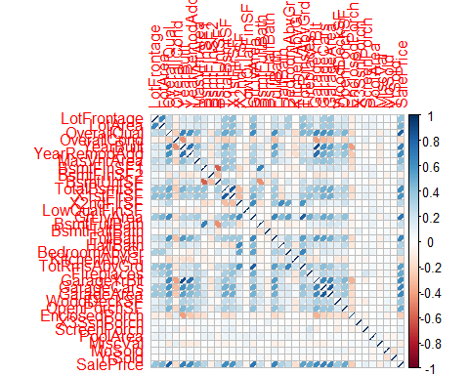

corrplot(cor(housedata_num,use="complete.obs", method='spearman'), method="number", cex.axis=0.8)

