**GRADE 8- GEOGRAPHY**

**FORMATIVE ASSESSMENT 3**

**UNIT 4**

**TASK 1:** CRITERION A (KNOWING AND UNDERSTANDING); CRITERION C (COMMUNICATING)

1. You work for the advertising department of an international non-government organization (NGO)that educates people about the topic of "CONSERVATION OF FOOD, WATER AND ENERGY". You have been asked to create informative Frequently Asked Questions (FAQs) that will be used on the NGO’s web page. The web page will be a part of an awareness campaign aimed at the general public to explain the topic of trade.

Your FAQs must:

* include arguments for exploitation of various resources (food, water and energy) which leads to global disparity.
* include arguments against exploitation of various resources (food, water and energy) which helps in reducing global disparity.
* include questions and answers that consider balanced arguments for and against exploitation, utilization and production of food, water and energy resources as a method for reducing global disparities
* refer to at least two different types of nations (LEDC and MEDC) that are helping to save the mentioned resources.
* use informative language that is suitable for the general public
* use examples from your MYP geography studies.

You must include a minimum of four questions and answers, up to a maximum of six questions and answers.

**TASK 2:** CRITERION A (KNOWING AND UNDERSTANDING); CRITERION C (COMMUNICATING); CRITERION D (THINKING CRITICALLY)

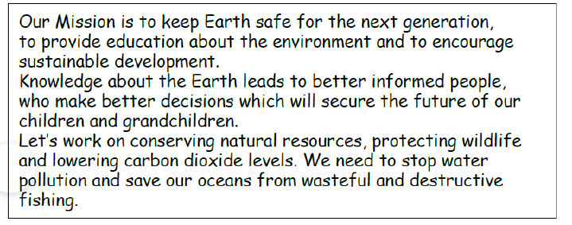

1. **Define** the term “Conservation”.
2. **Explain** why it is important to encourage sustainable development.
3. Using the above given Image 1, **identify** three environmental issues about which the organization is concerned.
4. Using the your MYP studies and your knowledge about Conserving the Natural Environment, write an essay **analyzing** the impacts of various human actions/activities on the environment…

You must consider adding the following aspects-

- Tourism as a human activity affecting the environment.

- Exploitation of various resources by the humans affecting the environment

- Add evidence from the past where marine life/wildlife/natural reserves have also been affected due to human interventions