RCD WS –2
Grade 8
Criteria A
Q Explain why is equipment accuracy especially important for scientific investigations?
A: Equipment accuracy is one of the most important factors in a scientific experiment. In order to have a successful experiment, you will require the most accurate result. Accurate results are especially important because inaccuracy can cause values and results that are off which can lead to completely different results altogether: If you are carrying out a scientific experiment which requires results which needs to be accurate to the picometer, you will need to have exactly accurate results. If not accurate, the results can be as off as “1 : 100” (ratio). Another important reason to have completely accurate results is the sum of the individual results: If an experiment contains 10 values and all of them are slightly off, you might not re-test and fix the inaccuracy, but this is a mistake. This is because, when all the inaccuracies are added together, it will still make a large impact on the experiment. In conclusion, even a small inaccuracy in a scientific experiment can change the result altogether and this is why we need to have the most accurate results possible.
Q Distinguish between
- complete and incomplete combustion
Ans: Complete and incomplete combustion are 2 types of combustion (burning).
Complete combustion is the successful combustion or burning of a material with sufficient oxygen while incomplete combustion is the partial combustion reaction of a material due to lack of oxygen. As said in the names, complete combustion is the most common combustion and is the “successful” combustion whereas incomplete combustion is only partially successful and is the less common one of the two.
- temperature and heat
Ans: Temperature is the measure of the average thermal energy in a system or body whereas heat is a form of energy which is transferred between two objects with different temperatures.
- Exothermic and endothermic processes
Ans: Exothermic and Endothermic processes are the two types of chemical processes or reactions:
- Exothermic Processes are processes which transfer or emit energy to the surroundings.
- Endothermic processes are processes which absorb or take-in heat from their surroundings.
- An example of an Exothermic process is combustion or burning because it releases energy.
- An example of an Endothermic process is the ventilation of organisms (breathing in) because when an organism inhales, it takes in substances.

Q How many joules of heat are needed to raise the temperature of 10.0 g of aluminum from 22°C to 55°C, if the specific heat of aluminum is 0.90 J/g°C?
A: Given: Mass of aluminum (10.0g) and ∆t (55°C – 22°C) and Specific heat(0.90 J/g C)
Formula for heat: Q= mass x specific heat x change in temperature (∆t)
Thus, Q = (10.0g) x (0.90 J/g°C) x (33°C)
Q = 297 J
Ans: 297 Joules
Q 25.0 g of mercury is heated from 25°C to 155°C and absorbs 455 joules of heat in the process. Calculate the specific heat capacity of mercury.
A: Find specific heat capacity.
Given: ∆t/change in temperature(155C – 25C) and Q/heat (455 J) and mass (25.0g)
Formula for specific heat: specific heat capacity= Q ÷ ∆t x mass
Thus: c= 455 J ÷ (155°C -25°C) x (25.0g)
C= 455 J ÷ 130°C x 25.0g
C= 87.5

Q SOME SOLVED QUESTIONS
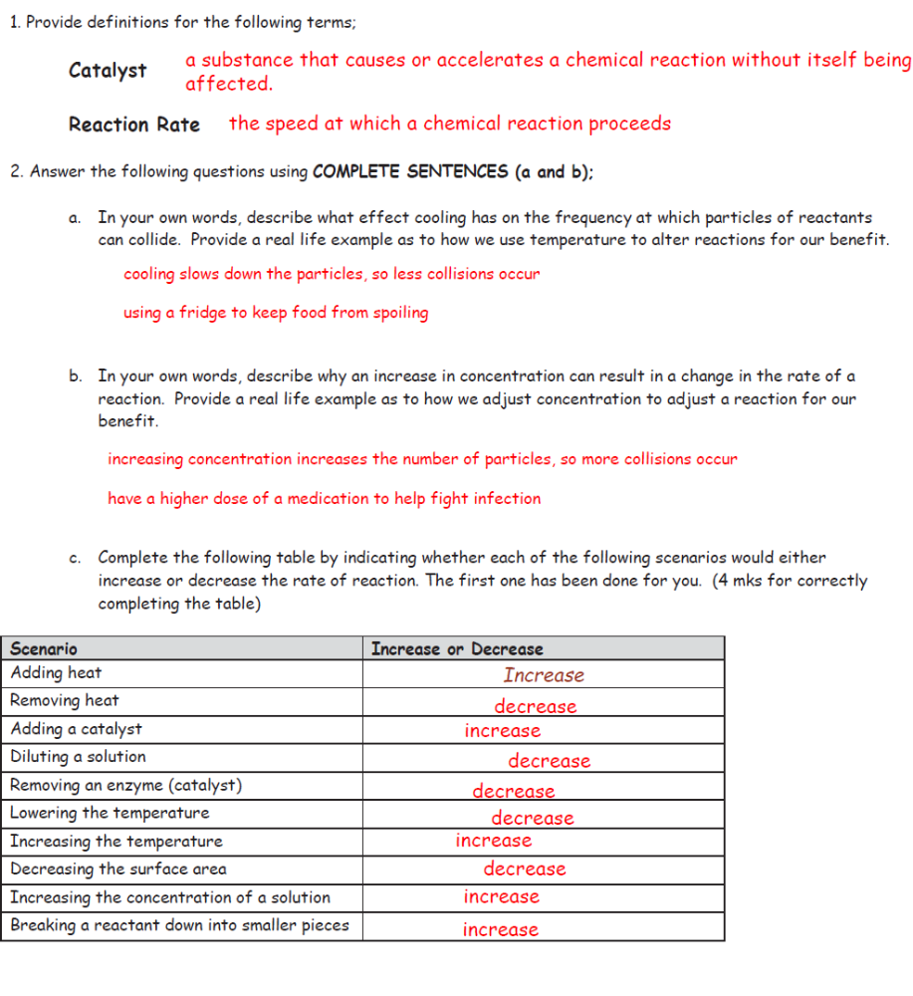

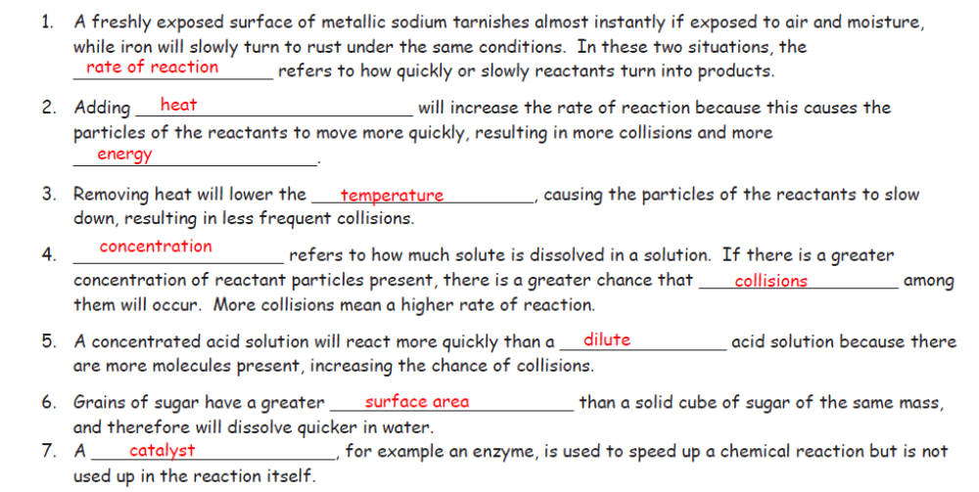

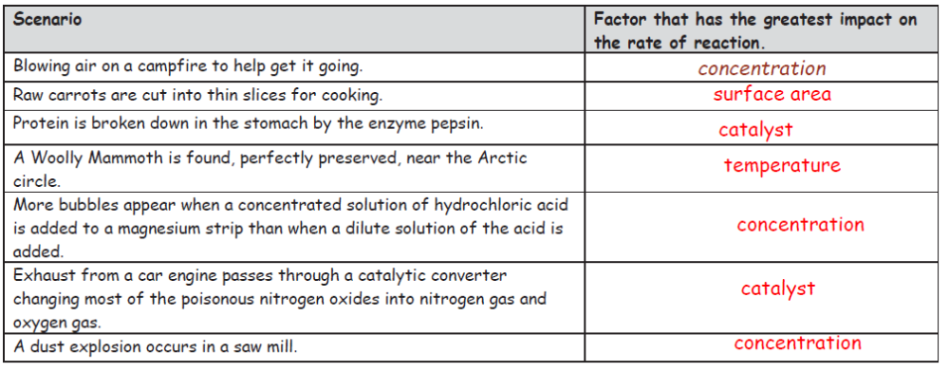
NOTES ON EXPERIMENT
Plan an experiment to investigate the effect of changing the concentration of sodium thiosulphate on the reaction between hydrochloric acid and sodium thiosulphate.
Apparatus: 1 conical flask 2 burettes 1 pipette Light gate/computer Sodium Thiosulphate Hydrochloric acid Distilled water
Safety Goggles 3 stands
From my preliminary experiment I have a basic idea of what the results will be like. As concentration rises, reaction rate should rise accordingly.
I can then measure out 5cm of hydrochloric acid using a pipette.
Once the light gate is positioned around the conical flask, I can put in the hydrochloric acid and sodium thiosulphate, swirl them around and turn on the light gate.
When enough sulphur has formed (when the cross disappeared in the preliminaries) the light gate will sense this and record the time.
Once I have this time I can record it and continue to do the experiment with all the other concentrations and repeat each one three times for reliability.
To make the test as fair as possible I will only vary one variable, keeping the rest constant.
I will vary the concentration of the sodium thiosulphate only keeping the concentration of the hydrochloric acid, volume of dilute sodium thiosulphate, volume of hydrochloric acid, and temperature the same.
I will also wash the conical flask after each experiment to make sure that I tried my hardest to stop it from getting contaminated and altering the results in any way.

Criteria C
Refer to the given diagram and answer the questions with reference to the graph
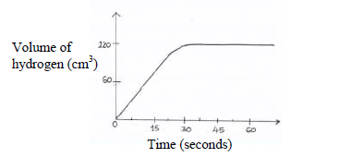
Q Find the volume of Hydrogen collected after 15 seconds.
Q.
S.No | Time in seconds | Volume of hydrogen from given graph
 | 30 | 120
 | 45 | 120
 | 60 | 120
 | Average volume of hydrogen | 120

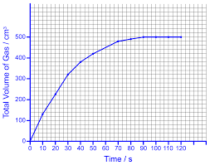
NOTE VERY IMPORTANT
- Observe the curved shape of the graph
- The slope of the graph tells you how fast the reaction rate is going
- The slope keeps changing until the curve flattens out---which tells us that the reaction keeps changing
- The curve is steepest at the start so the reaction is fastest then ( greatest rate)
- The curve becomes less steep as time passes showing that the reaction is slowing down
- Whwn the curve goes flat it means that the reaction has stopped and the reaction rate is zero.

How does collision theory explain the rate of reactions?
Collision theory states that the rate of a chemical reaction is proportional to the number of collisions between reactant molecules. The more often reactant molecules collide, the more often they react with one another, and the faster the reaction rate. ... Effective collisions are those that result in a chemical reaction.
How does Collision Theory increase rate of reaction?
Increasing the surface area of a reactant increases the frequency of collisions and increases the reaction rate. Several smaller particles have more surface area than one large particle. The more surface area that is available for particles to collide, the faster the reaction will occur

How does temperature affect collision theory?
Increasing the temperature makes molecules move faster, increasing the frequency of collisions. ... The collision theory says: Reactions occur when molecules collide with a certain minimum kinetic energy. The more frequent these collisions, the faster the rate of reaction.

Practical
Investigate the effects of changing the conditions of a reaction on the rates of chemical reactions by measuring the production of a gas.
It is important in this practical to use appropriate apparatus to make and record a range of measurements accurately, including mass, time and volume. This includes the safe use of apparatus, and monitoring chemical changes.
This outlines one way to carry out the practical. It is also possible to collect the gas in an inverted measuring cylinder in place of the gas syringe. Eye protection must be worn.

Aims
To investigate the effect of changing the conditions on the rate of a reaction.
Magnesium reacts with dilute hydrochloric acid to produce hydrogen:
magnesium + hydrochloric acid → magnesium chloride + hydrogen
Mg(s) + 2HCl(aq) → MgCl₂(aq) + H₂(g)
The volume of hydrogen gas produced can be measured using a gas syringe.

Changing the concentration of acid

Method
- Support a gas syringe with a stand, boss and clamp.
- Using a measuring cylinder, add 50 cm³ of dilute hydrochloric acid to a conical flask.
- Add a 3 cm piece of magnesium ribbon to the flask. Immediately connect the gas syringe and start a stop clock.
- Record the volume of gas produced every 5 seconds. Continue timing until no more gas is given off.
- When the reaction is complete, clean the apparatus as directed by your teacher.
- Repeat steps 1 to 5 with different concentrations of hydrochloric acid.

Extending the experiment
It is also possible to use this experiment to investigate the effect of temperature on the rate of the reaction. The experiment is carried out in the same way, but:
- keep the concentration of acid the same - it is best to use a more dilute solution, or else the reaction will be too fast to measure at higher temperatures
- warm the acid to different temperatures using a hot water bath, or a Bunsen burner, tripod and gauze
- measure and record the temperature of the acid
- describe the effect of increasing the temperature on the mean rate of reaction

Hazards, risks and precautions
Evaluate the hazards and the precautions needed to reduce the risk of harm. For example:
Hazard | Harm | Precaution
Hot hydrochloric acid | Causes skin and eye irritation; burns to the skin | Wear gloves and eye protection; do not heat above 60°C
Fizzing in the reaction mixture | Spray or foam escaping, which may damage skin and eyes | Use a large conical flask so there is plenty of space inside; do not look over the top when adding the magnesium ribbon

Aims
To investigate the effect of changing the temperature on the rate of a reaction.
Sodium thiosulfate solution reacts with dilute hydrochloric acid:
sodium thiosulfate + hydrochloric acid → sodium chloride + water + sulfur dioxide + sulfur
Na₂S₂O₃(s) + 2HCl(aq) → 2NaCl(aq) + H₂O(l) + SO₂(g) + S(s)
The sulfur forms a cloudy yellow-white precipitate during the reaction. The time taken for this to achieve a given cloudiness provides a way to measure the reaction time.

Method
- Using a measuring cylinder, add 50 cm³ of dilute sodium thiosulfate solution to a conical flask.
- Place the conical flask on a piece of paper with a black cross drawn on it.
- Using a different measuring cylinder, add 10 cm³ of dilute hydrochloric acid to the conical flask. Immediately swirl the flask to mix its contents, and start a stop clock.
- Measure and record the temperature of the reaction mixture.
- Look down through the reaction mixture. When you can no longer see the cross, record the time on the stop clock.
- Clean the apparatus as directed by your teacher.
- Repeat steps 1 to 6 with different starting temperatures of sodium thiosulfate solution. The sodium thiosulfate solution is heated by placing it in a hot water bath for different lengths of time.

Results
Record the results in a table. This table gives some example results.
Temperature of reaction mixture | Reaction time | Rate1000time(/s)
18°C | 80 (s) | 12.5
29°C | 57 (s) | 17.5
42°C | 32 (s) | 31.3
49°C | 20 (s) | 50.0

Analysis
- Calculate 1000/time for each temperature. This value is proportional to the rate of reaction.
- Plot a graph to show:
  - reaction rate (/s) on the vertical axis
  - temperature (°C) on the horizontal axis
  - a curve of best fit
Question
Describe the effect of increasing the temperature of the reaction mixture on the rate of reaction. Use your graph to help you.
Suggest a reason why the same person should look at the black cross each time.
Different people may decide that they cannot see the cross at different amounts of cloudiness, leading to errors in deciding when to take the reaction time.

Hazards, risks and precautions
Evaluate the hazards and the precautions needed to reduce the risk of harm. For example:
Hazard | Harm | Precaution
Hot sodium thiosulfate solution | Burns to the skin | Do not heat above 60°C
Sulfur dioxide | Can cause irritation to the eyes and lungs, particularly to people with asthma | Make sure the laboratory is well ventilated avoid breathing directly over the top of the flask

Q Define conductors and insulators
Conductors are objects or systems which allow the flow of electricity through the particles or molecules of their body. Conductors usually have more free valence electrons which are able to transfer electricity. Examples of conductors include iron, copper, gold and silver and conductor are mostly metal.
Insulators are objects or systems which do not permit the flow of electricity through the molecules in their particles. Insulators usually contain less valence electrons and the molecules in their body are tightly packed which is why there is less conduction of electricity. A few examples of conductors are wood, plastic, paper, and leather.
Q List the different types of insulators.
There are 3 types of insulators:
1. Pin Insulator: Cheap and economical insulators which can only hold up to 33kV.
2. Suspension Insulator: An array of discs stacked upon another (shape) which is called a string. Each disc is a suspension unit and is designed for low voltages of about 11kV. The more suspension discs, the higher the voltage it can withstand. There is a conductor attached at the lower end of the discs.
3. Strain Insulator: An array of horizontal insulators like the suspension insulator but arranged horizontally. These insulators are used when there is a sharp curve in the wiring or a dead end.

***********************************************************************

