**Brave Llama Games GDD**

**for**

**Clumsy Bat**

# Game Overview

Clumsy bat is a deceivingly cute and playful 2D side-scrolling avoidance game. In concept, Clumsy Bat is a spin-off of Flappy Bird, with added abilities, obstacles, and RPG elements. It is designed for touch-screen mobile devices to accept gestures to control the character to get to the end of each level unscathed.

Players will need to brave the perilous caves full of spikes, vision impairing mushrooms and spiders, and collect the ever-useful essence from moths scattered throughout the cave. Then they will find and solve puzzles to unlock abilities such as Hypersonic and Rush. Only with these abilities will Clumsy make it through to the end and save the Gnome Village from certain corruption.

# Team and Contact details

**Main Contact (liaison)**

Dan Szabo [d.szabo87@gmail.com](mailto:d.szabo87@gmail.com)

**Team Members & Responsibilities**

Scott Robinson Artist

Dan Szabo Programmer, Designer, Technical Artist

Contents

1. Game Mechanics 4

1.1. Mechanics Concept 4

1.2. Player Abilities 4

1.2.1. Flap 4

1.2.2. Perch 5

1.2.3. Lantern light 7

1.2.4. Hypersonic 7

1.2.5. Dash 8

1.3. Crystal Shrines 9

1.3.1. The first crystal shrine 9

1.3.2. The second crystal shrine 9

1.3.3. The third (and final) crystal shrine 10

1.4. Obstacles 11

1.4.1. Stalactites / Spikes 11

1.4.2. Mushrooms 12

1.4.3. Spiders 12

1.5. Bosses 12

1.5.1. King Rockbreath - First Encounter 13

1.5.2. King Rockbreath - Second Encounter 14

1.6. In-Game Collectables 15

1.6.1. Moths (Green, Gold, Blue) 15

2. Marketing 16

3. Visual Style 16

4. Audio Style 18

Mood: 18

5. UI 19

6. Game Play 19

6.1.1. Game Modes 19

6.1.2. Win Conditions 19

6.1.3. Lose conditions 19

6.1.4. Score 19

6.1.5. Achievements 20

7. Story 20

# Game Mechanics

This section covers the list of rules as to how the game works and what the player can do.

## Mechanics Concept

The core concept of the game is to avoid obstacles (inanimate or otherwise) and collect moths to trigger abilities to reach the end of the level

* The player taps the screen to make the bat flap once
* Gameplay ends when:
  + Clumsy reaches the end of the level
  + Clumsy collides with an enemy object
* Clumsy consumes moths with his lantern when he moves close to them
  + Eating a moth will fuel the lantern and maximise the light after a short delay
  + The lantern will stay maximised for 7 seconds, and then diminish over 4 seconds

## Player Abilities

There are five (5) abilities / mechanics that are activated by the player throughout the game, summarised in the table below.

|  |  |  |
| --- | --- | --- |
| **Section** | **Ability** | **How to activate** |
| 3.2.1 | Flap | Activated by tapping the screen |
| 3.2.2 | Perch | Automatic when landing on the floor, activated by holding tap when |
| 3.2.3 | Lantern Light | Activated automatically when a moth is collected |
| 3.2.4 | Hypersonic* | Activated when a gold moth is collected and the player has unlocked the hypersonic ability |
| 3.2.5 | Rush* | Activated by swiping the screen (right only in normal levels, left and right in boss and crystal levels) |

* Hypersonic and Rush abilities are activated at the shrines (aka crystal levels) by solving a puzzle.

All other abilities are available from the start of the game.

### Flap

*Everyone gets somewhere somehow. Sometimes, it’s clumsy!*

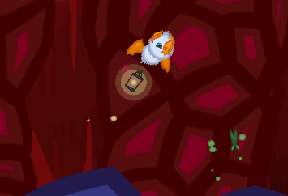

|  |  |
| --- | --- |
| **Description** | The ability used by the player to move through the levels. |
| **Triggered by** | Tapping the screen |
| **Trigger conditions** | The player is alive, is not stunned, and is not perched on the ceiling. Also, the game must not be paused. |
| **Unlocked by** | Available from the start of the game |
| **Effect / intention** | * In normal levels, flap will automatically move the player to the right at a speed of 5m/s. * In boss levels, flap will cause the player to move left or right at an initial speed of 4m/s, depending on whether the player tapped the left or right half of the screen. * Flap will always move the player upwards by instantaneously setting the vertical velocity of the player to 9m/s. |

### Perch

*When the player needs to hang out or just lay low*

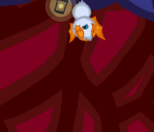

|  |  |
| --- | --- |
| **Description** | The ability used by the player to move through the levels. |
| **Triggered by** | 1. Landing on the floor. Tapping the screen will cause the player to un-perch and move upwards without any horizontal movement until the next tap. 2. Holding a finger on the screen while colliding with the ceiling. Releasing the finger from the screen will allow the player to un-perch and drop from the ceiling. |
| **Trigger conditions** | The player is alive and is not stunned. After un-perching from the floor, the player will not be able to perch again for 0.38 seconds. |
| **Unlocked by** | Available from the start of the game |
| **Effect / intention** | * The player will stop moving. * When perched, the lantern fades three times slower than normal. * Allows the player to avoid certain obstacles, or just time to think. |

### Lantern light

*Allows the player to see like a bat. That’s how game logic works!*

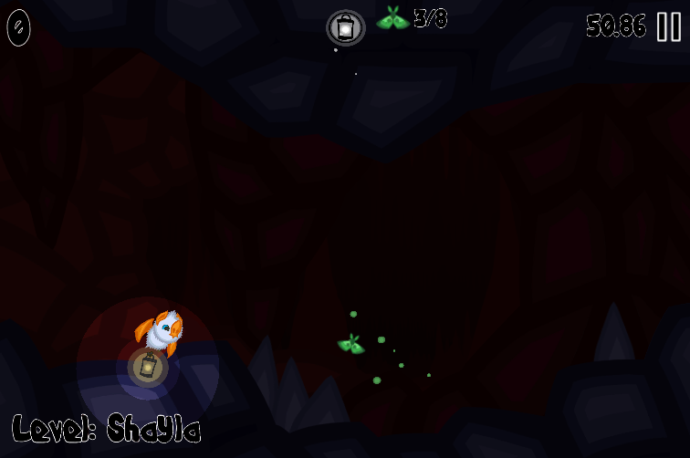 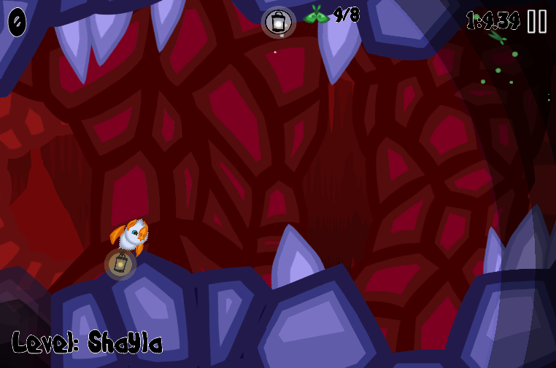

|  |  |
| --- | --- |
| **Description** | The field of view represented by a ring of light centred at the lantern. |
| **Triggered by** | Consuming any type of moth |
| **Trigger conditions** | None |
| **Unlocked by** | Available from the start of the game |
| **Effect / intention** | * + Upon activation, the light ring will grow to cover approximately 90-95% of the screen over 0.7 seconds.   + The light ring will stay at maximum size for 7 seconds   + The light ring will then shrink to the size of the player over 4 seconds |
| **Other notes** | * The only object that can alter the maximum size of the light ring is the mushroom spore, which temporarily shrinks the size of the light ring to the minimum value for 5 seconds. * When perched, the lantern fades three times slower than normal. |

### Hypersonic

*The lantern unleashes a devastating wave of sonic energy, destroying objects in its wake.*

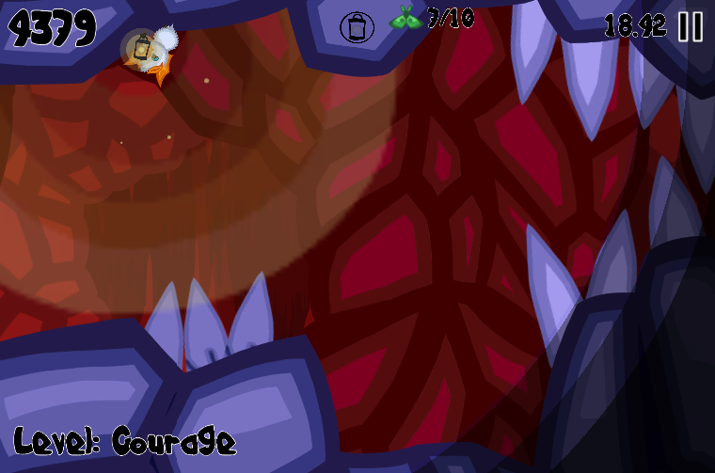 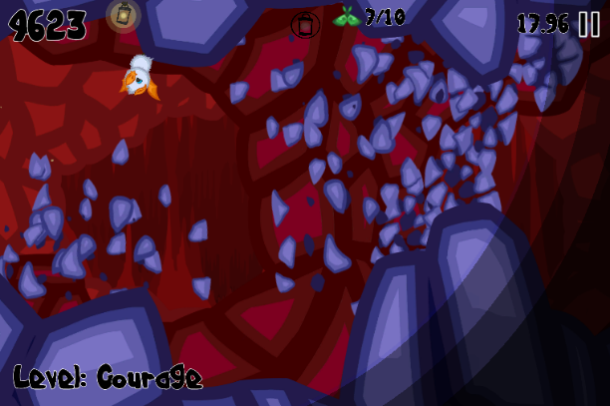

|  |  |
| --- | --- |
| **Description** | Sends a ring of sound energy originating at the player and covering approx. 110% of the screen size. |
| **Triggered by** | Consuming a gold moth |
| **Trigger conditions** | The hypersonic ability has been unlocked at the first crystal shrine. |
| **Unlocked by** | Reaching the first crystal shrine and solving the puzzle. |
| **Effect / intention** | Destroys stalactites and damages most bosses. |

### Dash

Dash allows the player to reach impressive speeds – if only for 0.33 seconds.



|  |  |
| --- | --- |
| **Description** | Increases the player’s speed for 0.33 seconds while performing a barrel roll. |
| **Triggered by** | Swiping the screen to the right in normal levels, or swiping left or right in boss and crystal levels. |
| **Trigger conditions** | The ability has been unlocked at the second crystal shrine.  The dash cooldown has expired and displayed in the HUD. |
| **Unlocked by** | Reaching the second crystal shrine and solving the puzzle. |
| **Effect / intention** | Increases the player’s speed to 15m/s for 0.33 seconds.  Allows clumsy to fit through small openings and gain higher scores in normal levels. |

## Crystal Shrines

There are 3 Crystal shrines in the world of Clumsy Bat. Each shrine can be found in a hidden path in specific sections of the world. These are shown in the level map as a secondary path. Each shrine offers a puzzle challenge and provides a unique ability for Clumsy to activate in levels by consuming the coloured moths.

### The first crystal shrine

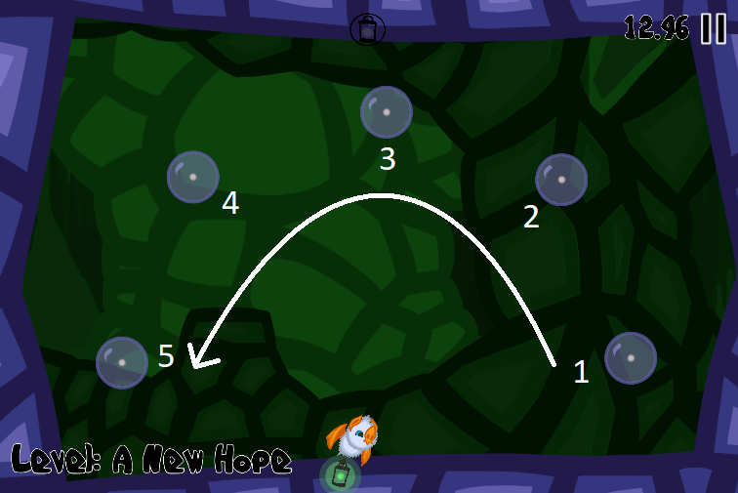

|  |  |
| --- | --- |
| **Story Purpose** | Activating the crystals will release their energy to be absorbed by the lantern, granting the hypersonic ability. |
| **Puzzle mechanic** | To complete the level, the player will need to trigger the crystals in order, from right to left as shown in the screenshot above |
| **Mechanics**  **Intention** | To teach the player to move left and right when locked in the room such as this, preparing them for boss fights. |

### The second crystal shrine

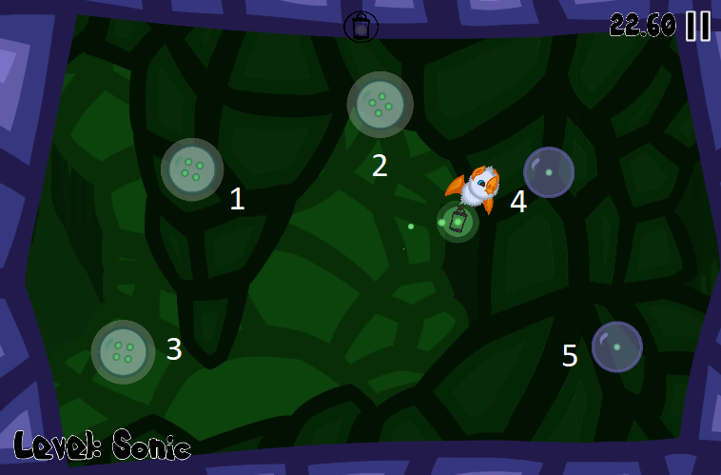

|  |  |
| --- | --- |
| **Story Purpose** | Similar to the first shrine, the crystals will gain an ability. This time, the dash ability will allow the player to get through some tight spaces or avoid otherwise unavoidable obstacles. |
| **Puzzle mechanic** | This shrine’s puzzle builds on the first and changes the order. To complete the level, the player will need to trigger the crystals in the order shown in the screenshot above. |
| **Mechanics**  **Intention** | To give the player a slightly harder challenge.  Undefined: this mechanic could be used in the final boss fight |

### The third (and final) crystal shrine

Currently undefined. Could be used as a boss fight, or a precursor to the final boss fight.

## Obstacles

There are three kinds of obstacles and one (or two) boss(es) – 3 encounters each with different mechanics - in this game. Bosses are covered in <insert section>

### Stalactites / Spikes

Common obstacle scattered throughout the caves, and the first obstacle introduced to the player.

 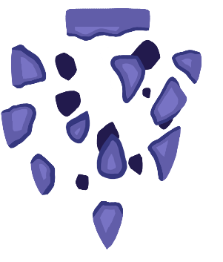

Normal Crumbled

**Stalactite Properties:**

* Can be one of two types
  + Static: does not move, but will crack if hit
  + Unstable: will fall when the player gets into proximity
* Hitting a stalactite causes the player to take damage.
* They do not interact with any object other than the player
* Can be destroyed by the hypersonic ability

For all intents and purposes, an unstable stalactite is essentially a stalactite which is on the lower cave. Placement of the stalactite can be set in the level editor as shown below. Note that this position doesn’t take into account and speed modifiers (e.g. Dash or perch), and is based on the level speed (of 5m/s).

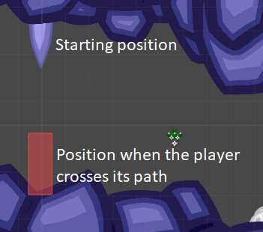

### Mushrooms

The second obstacle introduced to the player. All mushrooms release a spore when Clumsy gets in proximity. The spore, if intersected, will cause Clumsy to have a reduced lantern vision for 5 seconds, even when collecting additional moths.

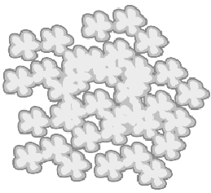

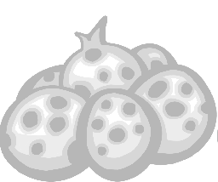

**Mushroom properties:**

* Releases spores when the player is 10m away.
  + Spores are shot into the air, taking 0.29 seconds
  + The spore will then explode and remain for 1 second
* All mushrooms release a spore.
* Spores reduce visibility for 5 seconds.
* Mushrooms do not damage the player.

### Spiders

The third obstacle introduced to the player. Spiders will drop down or swing towards the player.

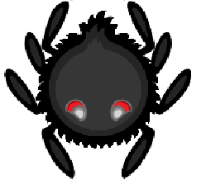

**Spider properties:**

* There are two movement types for spiders:
  + Drop: the spider will descend at a stuttered rate (to be determined by further playtesting)
  + Swing: the spider will swing like pendulum when the player is in proximity
* Touching a spider will damage the player.
* Hypersonic will cause spiders to fall downward, harmlessly, removing them from the level.

## Bosses

The first (and currently the only – may add Nomee as a second/final boss type) boss, who Clumsy will face multiple times throughout the adventure. Each time, King Rockbreath’s abilities will get stronger and more difficult.

### King Rockbreath - First Encounter

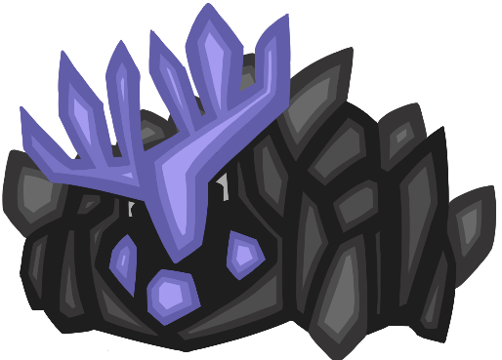

|  |  |
| --- | --- |
| **Story Purpose** | King Rockbreath has eaten all the moth essence, granting him annoyingly powerful abilities that Clumsy must overcome. |
| **Hit Points** | 4 |
| **Boss abilities** | King Rockbreath’s first encounter has a simple behaviour tree based on a timer.  Every 4 seconds, the boss will alternate between:   * Charging in the direction of the player. Upon colliding with the wall, a stalactite and a moth crystal will form on the ceiling * Stomping the ground, causing the stalactite and moth crystal to fall. Collecting the moth crystal activates hypersonic, damaging King Rockbreath. |
| **Mechanics**  **Intention** | The first encounter is simple, while not foolproof. The intention is to teach the player to move around the level while avoiding some harmful mechanics and collecting moths. |

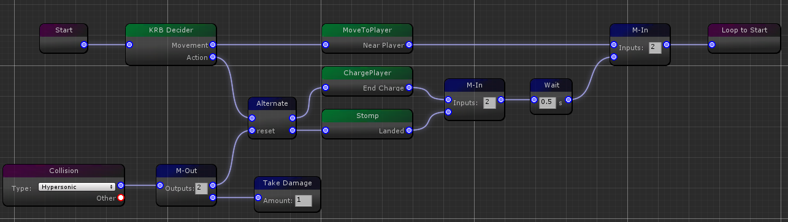

### King Rockbreath - Second Encounter

|  |  |
| --- | --- |
| **Story Purpose** | King Rockbreath has eaten all the moth essence, granting him annoyingly powerful abilities that Clumsy must overcome. |
| **Boss abilities** | This is a WIP. Current ability is to form a ceiling of stalactites. The player will need to find a break in the falling stalactites to survive. |
| **Mechanics**  **Intention** | Significantly more difficult than the first encounter, the player will need to use more advanced manoeuvres to avoid the chaos caused by King Rockbreath. |

<Insert high level State Machine diagram>

## In-Game Collectables

### Moths (Green, Gold, Blue)

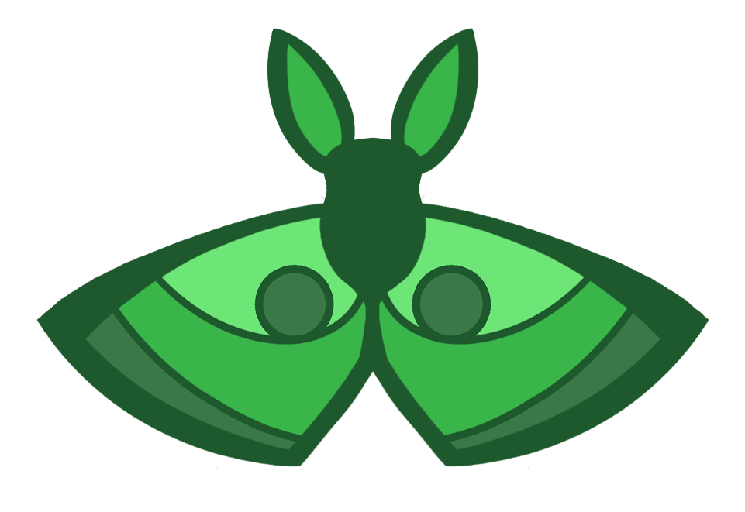

<insert gold and blue coloured moth images>

Tabularise:

Gold moths: activate hypersonic

Blue moths: mechanic may be depreciated? Maybe just placed in difficult to reach places in the level?

# Marketing

N/A – not for profit

# Visual Style

Artwork for Clumsy Bat, including the game’s icon, title graphic, menus, in-game screenshots and other objects.

Note that the cave background will change colour as the player progresses through the story mode.

**Game Icon**

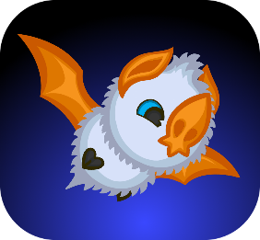

**Main Menu**

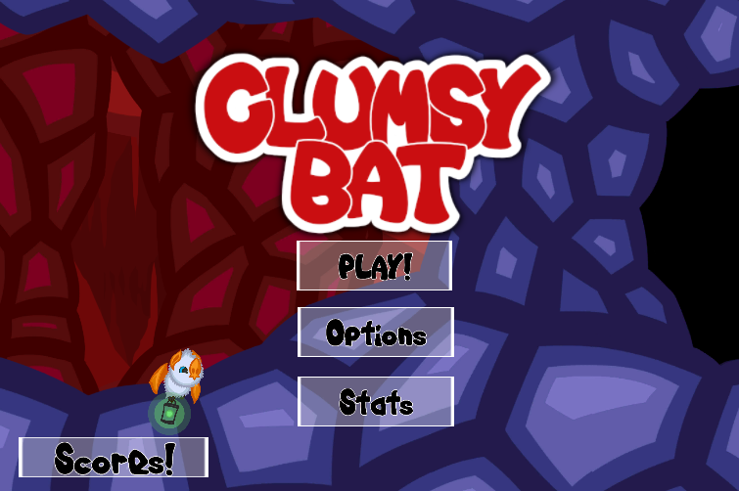

**Level Select**

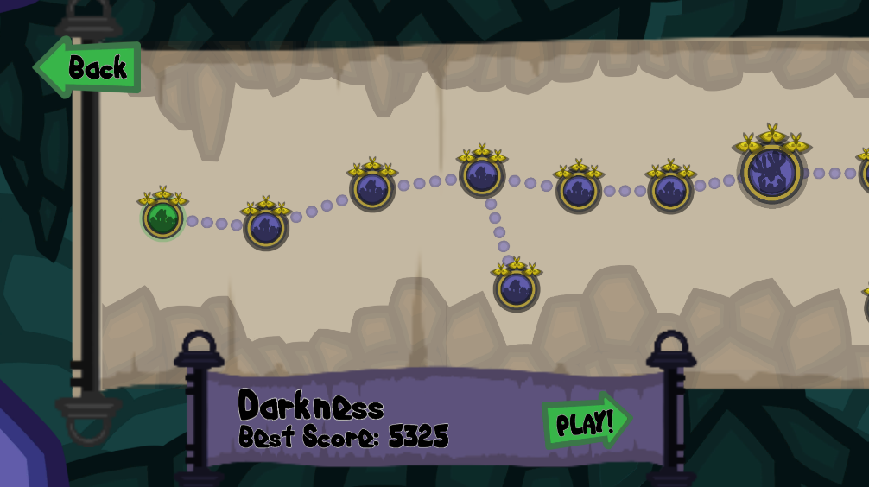

**In-Game 1**

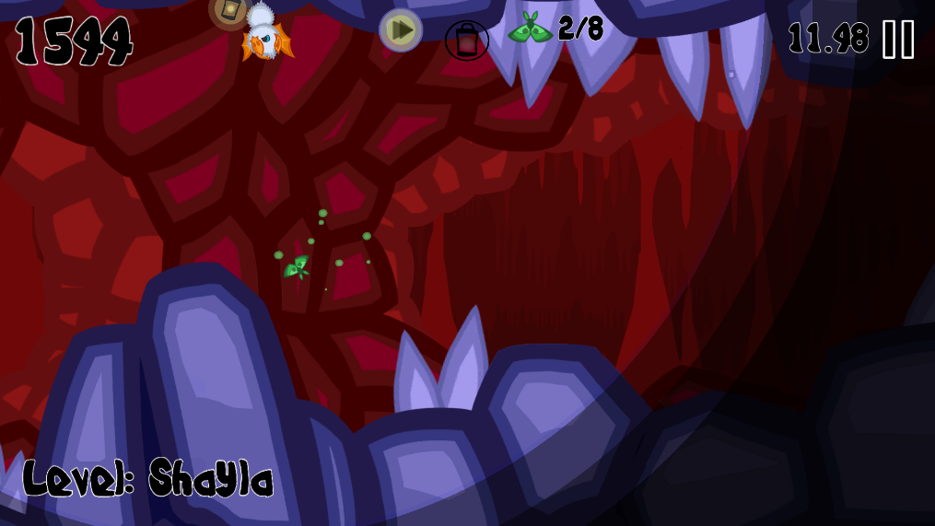

**In-Game 2**

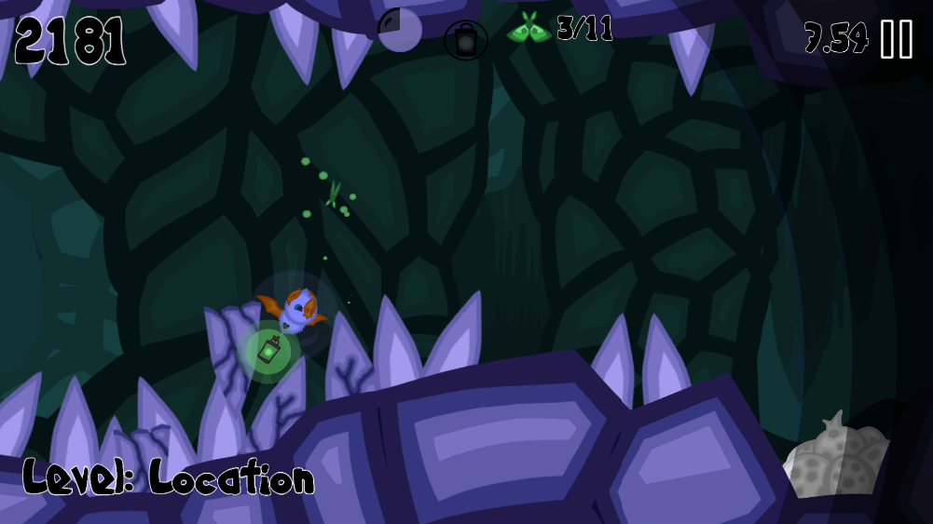

**In-Game Dialogue**

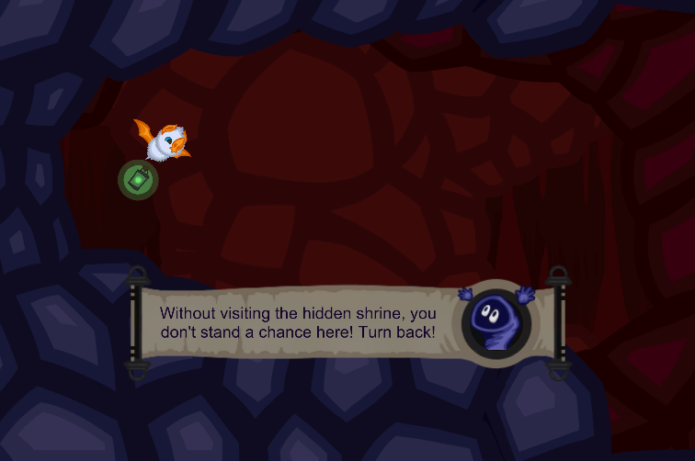

**Puzzle Level Win-Sequence**

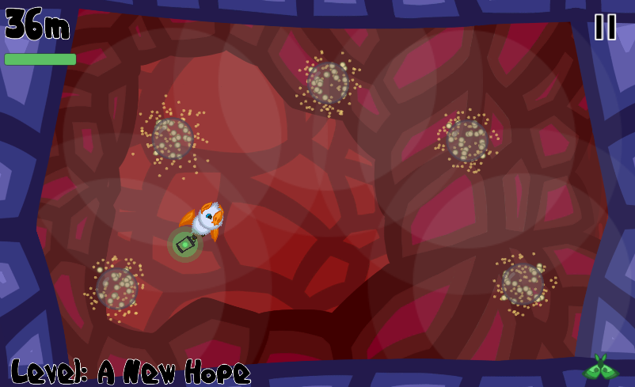

**Boss Level**

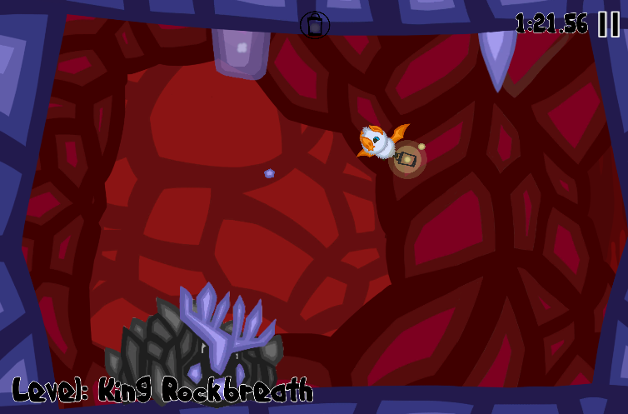

# Audio Style

## Mood:

The music should feel **echoic**, but not dreary. The game is cartoony and playful and we want to evoke the feeling of **fun and playfulness**, with **hints of dissonance** to tease inevitable difficulty of the later levels of the game.

During the boss levels, the music should be more intense while maintaining the feel of playfulness.

Optionally, during puzzle levels, the music can be more relaxed.

Refer to the Music Brief (in the same documents folder as this) for detailed information and assets for the sound and music of Clumsy Bat.

# UI

<insert screenshots and descriptions of Main Menu, Level Select, Options, Level completion, gameover and in-game HUD.

# Game Play

Game controller: touch input (tap and swipe)

### Game Modes

To be updated

|  |  |
| --- | --- |
| List A |  |
| Mode | Description |
| Normal | Levels are generated statically (so the user can memorise the pattern to beat it)  Levels are played in a story-like order  Progression through levels involves collecting upgrades (described in mechanics) in order to pass to the next area  Includes boss fights  Includes villages  Includes NPCs to assist |
| List B |  |
| Survival | Endless  Randomly generated cave sections and obstacles |
| List C |  |
| Antigravity | Endless survival, but clumsy ‘falls’ upwards instead of down |
| Hunger Game | Instead of light decreasing, clumsy’s energy decreases.  Eat moths to stay alive! |
| Arachnophobia | So many spiders (TBD) |

### Win Conditions

|  |  |  |
| --- | --- | --- |
| Win definition | Achieved by |  |
| Normal Level | Player reaching the cave at the end of the level |  |
| Boss Level | Successfully triggering the boss mechanic three times |  |
| Crystal Shrine Level | Solve the crystal puzzle |  |
| Game | TBD  Defeat the final boss? (using all the skills and tricks learned along the way) |  |

### Lose conditions

* Clumsy runs out of shields and is damaged by an obstacle

### Score

* In endless mode, score is measured by:
  + Distance
  + Moths eaten
  + Time taken

### Achievements

TBD

# Story

Clumsy bat entered a cave, as bats are wont to do and finds a strange green-glowing lantern. Clumsy then hears the voice of Nomee, leader of the gnomes, who urges Clumsy to save his village from the evil within the cave.

To do so, he will need to collect moth essence to fuel the lantern. Essence is collected from moths and is an arcane substance that can provide unknowingly powerful abilities.

Clumsy is tasked with the objective to find the hidden shrines, collect abilities, and destroy the evil bosses that threaten to consume all the power, taking over the cave and the gnome village.

Idea: Unbeknownst to Clumsy, the gnome leader is just as evil, and upon rescuing him from the evil bosses and restoring power to the gnome village, Nomee reveals his dire intentions to harness the essence for his own evil deeds.

In a final battle, Clumsy will need to destroy Nomee and restore balance to the caves once and for all.