Chapter 4

Entity-Relationship (ER) Modeling

Review Questions

- What two conditions must be met before an entity can be classified as a weak entity? Give an example of a weak entity.
The entity must be existence-dependent on its parent entity and the primary key is a foreign key
COURSE(CRS_CODE, DEPT_CODE…)
CLASS( CLASS_CODE, CRS_CODE, CLASS_SECTION…)
Class is dependent on course. Won’t be able to have a class without a course.
- What is a strong (or identifying) relationship, and how is it depicted in a Crow’s Foot ERD?
When the primary key of the related entity contains a primary key component of the parent entity
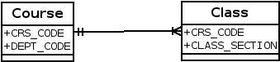

- Given the business rule “an employee may have many degrees,” discuss its effect on attributes, entities, and relationships. (Hint: Remember what a multivalued attribute is and how it might be implemented.)
Suppose that an employee has the following degrees: BA, BS, and MBA. These degrees could be stored in a single string asa multivalued attribute named EMP_DEGREE in an EMPLOYEE table such as the one shown next: 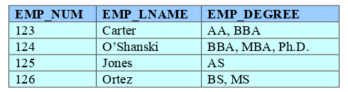
Although the preceding solution has no obvious design flaws, it is likely to yield reporting problems. For example, suppose you want to get a count for all employees who have BBA degrees. You could, of course, do an “in-string” search to find all of the BBA values within the EMP_DEGREE strings. But such a solution is cumbersome from a reporting point of view. Query simplicity is a valuable thing to application developers –and to end users who like maximum query execution speeds. Database designers ought to pay some attention to the competing database interests that exist in the data environment. One –very poor –solution is to create a field for each expected value. This “solution is shown next: 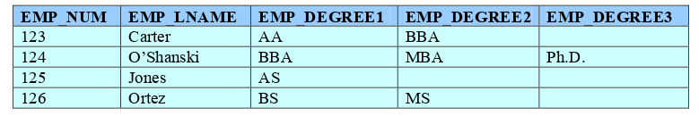
his “solution yields nulls for all employees who have fewer than three degrees. And if even one employee earns a fourth degree, the table structure must be altered to accommodate the new data value. (One piece of evidence ofpoor design is the need to alter table structures in response to the need to add data of an existing type.) In addition, the query simplicity is not enhanced by the fact that any degree can be listed in any column. For example, a BA degree might be listed in the second column, after an “associate of arts (AA) degree has been entered in EMP_DEGREE1. One might simplify the query environment by creating a set of attributes that define the data entry, thus producing the following results:
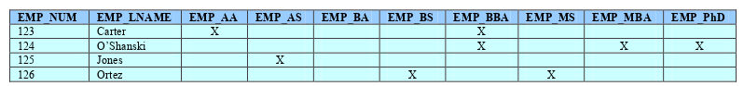
This “solution” clearly proliferates the nulls at an ever-increasing pace. The only reasonable solution is to create a new DEGREE entity that stores each degree in a separate record, this producing the following tables. (There is a 1:M relationship between EMPLOYEE and DEGREE. Note that the EMP_NUM can occur more than once in the DEGREE table. The DEGREE table’s PK is EMP_NUM + DEGREE_CODE. This solution also makes it possible to record the date on which the degree was earned, the institution from which it was earned, and so on.
- What is a composite entity, and when is it used?
A composite entity is generally used to transform M:N relationships into 1:M relationships. A composite entity, also known as a bridge entity, is one that has a primary key composed of multiple attributes. The PK attributes are inherited from the entities that it relates to one another.
- Suppose you are working within the framework of the conceptual model in Figure Q4.5.

Figure Q4.5 The Conceptual Model for Question 5
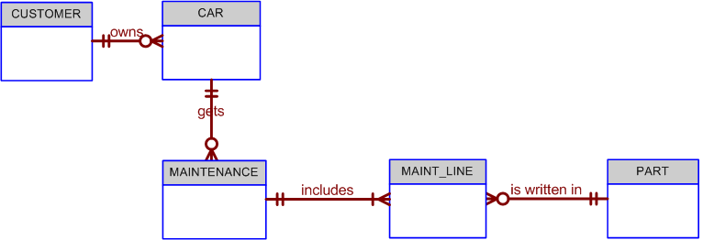

Given the conceptual model in Figure Q4.5:

  - Write the business rules that are reflected in it.

  - Identify all of the cardinalities.
Write the business rules that are reflected in it.Even a simple ERD such as the one shown in Figure Q4.5 is based on many business rules. Make sure that each business rule is written on a separate line and that all of its details are spelled out. In this case, the business rules are derived from the ERD in a “reverse-engineering” procedure designed to document the database design. In a real world database design situation, the ERD is generated on the basis of business rules that are written before the first entity box is drawn. (Remember that the business rules are derived from a carefully and precisely written description of operations.)Given the ERD shown in Figure Q4.5, you can identify the following business rules:
1. A Customer can own many cars.
2. Some customers do not own cars.
3. A car is owned by one and only one customer.
4. A car may generate one or more maintenance records.
5. Each maintenance record is generated by one and only one car.
6. Some cars have not (yet) generated a maintenance procedure.
7. Each maintenance procedure can use many parts. (Comment: A maintenance procedure may include multiple maintenance actions, each one of which may or may not use parts. For example, 10,000-mile check may include the installation of a new oil filter and a new air filter. But tightening an alternator belt does not require a part.)
8. A part may be used in many maintenance records.(Comment: Each time an oil change is made, an oil filter is used. Therefore, many oil filters may be used during some period of time. Naturally, you are not using the same oil filter each time –but the part classified as “oil filter” shows up in many maintenance records as time passes.)Note that the apparent M:N relationship between MAINTENANCE and PART has been resolved through the use of the composite entity named MAINT_LINE. The MAINT_LINE entity ensures that the M:N relationship between MAINTENANCE and PART has been broken up to produce the two 1:M relationships shown in business rules 9 and 10.
9.Each maintenance procedure generates one or more maintenance lines.
10.Each part may appear in many maintenance lines. (Review the comment in business rule 8.)

- What is a recursive relationship? Given an example.
A recursive relationship exists when an entity is related to itself. For example, a COURSE may be a prerequisite to a COURSE.(See Section 4.1.10, “Recursive Relationships,” for additional examples.

- How would you (graphically) identify each of the following ERM components in a Crow’s Foot model?

- an entity
- the cardinality (0,N)
- a weak relationship
- a strong relationship
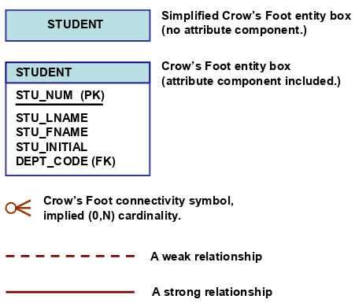
an entity An entity is represented by a rectangle containing the entity name. (Remember that, in ER modeling, the word "entity" actually refers to the entity set.)The Crow’s Foot ERD –as represented in Visio Professional –does not distinguish among the various entity types such as weak entities and composite entities. Instead, the Crow’s Foot ERD uses relationship types –strong or weak –to indicate the nature of the relationships between entities. For example, a strong relationship indicates the existence of a weak entity. A composite entity is defined by the fact that at least one of the PK attributes is also a foreign key. Therefore, the Visio Crow’s Foot ERD composite and weak entities are not differentiated –whether or not an entity is weak or composite depends on the definition of the business rule(s) that describe the relationships. In any case, two conditions must be met before an entity can be classified as weak:1. The entity must be existence-dependent on its parent entity 2. The entity must inherit at least part of its primary key from its parent entity.
  - Chapter 4 Entity Relationship (ER) Modeling 101b.the cardinality (0,N)Cardinalities are implied through the use of Crow’s Foot symbols. For example, note the implied (0,N) cardinality in Figure Q4.7.c.a weak relationship A weak relationship exists when the PK of the related entity does not contain at least one of the PK attributes of the parent entity. For example, if the PK of a COURSE entity is CRS_CODE and the PK of the related CLASS entity is CLASS_CODE, the relationship between COURSE and CLASS is weak. (Note that the CLASS PK does not include the CRS_CODE attribute.)A weak relationship is indicated by a dashed line in the (Visio) ERD.d.a strong relationship A strong relationship exists when the PK of the related entity contains at least one of the PK attributes of the parent entity. For example, if the PK of a COURSE entity is CRS_CODE and the PK of the related CLASS entity is CRS_CODE + CLASS_SECTION, the relationship between COURSE and CLASS is strong. (Note that the CLASS PK includes the CRS_CODE attribute.)A strong relationship is indicated by a solid line in the (Visio) ERD.

- Discuss the difference between a composite key and a composite attribute. How would each be indicated in an ERD?
A composite key is one that consists of more than one attribute. If the ER diagram contains the attribute names for each of its entities, a composite key is indicated in the ER diagram by the fact that more than one attribute name is underlined to indicate its participation in the primary key.A composite attribute is one that can be subdivided to yield meaningful attributes for each of its components. For example, the composite attribute CUS_NAME can be subdivided to yield the CUS_FNAME, CUS_INITIAL, and CUS_LNAME attributes. There is no ER convention that enables us to indicate that an attribute is a composite attribute.
- What two courses of action are available to a designer when encountering a multivalued attribute?
The discussion that accompanies the answer to question 3 is valid as an answer to this question
- What is a derived attribute? Give an example.
A derived attribute is an attribute whose value is calculated (derived) from other attributes. The derived attribute need not be physically stored within the database; instead, it can be derived by using an algorithm. For example, an employee’s age, EMP_AGE, may be found by computing the integer valueof the difference between the current date and the EMP_DOB. If you use MS Access, you would use INT((DATE() –EMP_DOB)/365). Similarly, a sales clerk's total gross pay may be computed by adding a computed sales commission to base pay. For instance, if the sales clerk's commission is 1%, the gross pay may be computed byEMP_GROSSPAY = INV_SALES*1.01 + EMP_BASEPAYOr the invoice line item amount may be calculated by LINE_TOTAL = LINE_UNITS*PROD_PRICE

- How is a relationship between entities indicated in an ERD? Give an example, using the Crow’s Foot notation.
Use Figure Q4.7 as the basis for your answer. Note the distinction between the dashed and solid relationship lines, then tie this distinction to the answers to question 7c and 7d

- Discuss two ways in which the 1:M relationship between COURSE and CLASS can be implemented. (Hint: Think about relationship strength.)
weakly by having course_id as FK in CLASS with class having its own unique PK or strongly by having course_ID composite with another attribute to make a unique key

- How is a composite entity represented in an ERD, and what is its function? Illustrate the Crow’s Foot model.
the composite entity contains at least the primary key attributes of each of the entities that are connected by it. relational database models should not contain M:N relationships - and the composite entity can be used to break up such relationships into 1:M relationships
- What three (often conflicting) database requirements must be addressed in database design?
Database design must reconcile the following requirements:Design elegance requires that the design must adhere to design rules concerning nulls, derived attributes, redundancies, relationship types, and so on.Information requirements are dictated by the end users Operational (transaction) speed requirements are also dictated by the end users.Clearly, an elegant database design that fails to address end user information requirements or one that forms the basis for an implementation whose use progresses at a snail's pace has little practical use.
- Briefly, but precisely, explain the difference between single-valued attributes and simple attributes. Give an example of each.
A single -valued attribute is one that can have only one value. For example, a person has only one first name and only one social security number. A simple attribute is one that cannot be decomposed into its component pieces. For example, a person's sex is classified as either M or F and there is no reasonable way to decompose M or F.
- What are multivalued attributes, and how can they be handled within the database design
Multivalued attributes can have many values，Attributes Just like M:N relationships, multivalued attributes should be broken down further. Create new attributes new entity .
- Write the ten cardinalities that are appropriate for this ERD.
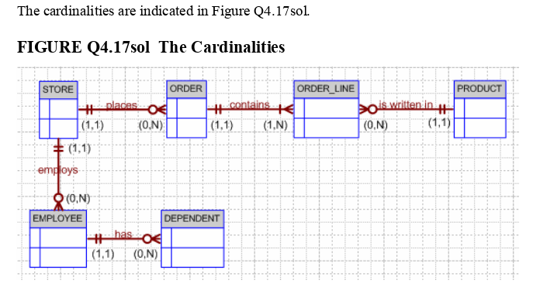

- Write the business rules reflected in this ERD.
The following business rules are reflected in the ERD:A store may place many orders. (Note the use of “may” –which is reflected in the ORDER optionality.)An order must be placed by a store. (Note that STORE is mandatory to ORDER. In this ERD, the order environment apparently reflects a wholesale environment.)An order contains at least one order line. (Note that ORDER_LINE is mandatory to ORDER, and vice-versa.)
  - Each order line is contained in one and only one order. (Discussion: Although a given item –such as a hammer –may be found in many orders, a specific hammer sold to a specific storeEach order line is contained in one and only one order. (Discussion: Although a given item –such as a hammer –may be found in many orders, a specifichammer sold to a specificstore is found in only one order.)Each order line has a specific product written in it.A product may be written in many orders. (Discussion: Many stores can order one or more specific products, but a product that is not in demand may never be sold to a store and will, therefore, not show up in any order line--note that ORDER_LINE is optional to PRODUCT. Also, note that each order line may indicate more than one of a specific item. For example, the item may be “hammer” and the number sold may be 1 or 2, or 500. The ORDER_LINE entity would have at least the following attributes: ORDER_NUM, ORDLINE_NUM, PROD_CODE, ORDLINE_PRICE, ORDLINE_QUANTITY. The ORDER_LINE composite PK would be ORDER_NUM + ORDLINE_NUM. You might add the derived attribute ORDLINE_AMOUNT, which would be the result of multiplying ORDLINE_PRICE andORDLINE_QUANTITY.)A store may employ many employees. (Discussion: A new store may not yet have any employees, yet the database may already include the new store information ... location, type, and so on. If you made the EMPLOYEE entity mandatory to STORE, you would have to create an employee for that store before you had even hired one.)Each employee is employed by one (and only one) store.An employee may have one or more dependents. (Discussion: You cannot requirean employee to have dependents, so DEPENDENT is optional to EMPLOYEE. Note the use of the word “may” in the relationship.)A dependent must be related to an employee. (Discussion: It makes no sense to keep track of dependents of people who are not even employees. Therefore, EMPLOYEE is mandatory to DEPENDENT.) is found in only one order.)Each order line has a specific product written in it.A product may be written in many orders. (Discussion: Many stores can order one or more specific products, but a product that is not in demand may never be sold to a store and will, therefore, not show up in any order line--note that ORDER_LINE is optional to PRODUCT. Also, note that each order line may indicate more than one of a specific item. For example, the item may be “hammer” and the number sold may be 1 or 2, or 500. The ORDER_LINE entity would have at least the following attributes: ORDER_NUM, ORDLINE_NUM, PROD_CODE, ORDLINE_PRICE, ORDLINE_QUANTITY. The ORDER_LINE composite PK would be ORDER_NUM + ORDLINE_NUM. You might add the derived attribute ORDLINE_AMOUNT, which would be the result of multiplying ORDLINE_PRICE andORDLINE_QUANTITY.)A store may employ many employees. (Discussion: A new store may not yet have any employees, yet the database may already include the new store information ... location, type, and so on. If you made the EMPLOYEE entity mandatory to STORE, you would have to create an employee for that store before you had even hired one.)Each employee is employed by one (and only one) store.An employee may have one or more dependents. (Discussion: You cannot require employee to have dependents, so DEPENDENT is optional to EMPLOYEE. Note the use of the word “may” in the relationship.)A dependent must be related to an employee. (Discussion: It makes no sense to keep track of dependents of people who are not even employees. Therefore, EMPLOYEE is mandatory to DEPENDENT.)

- What two attributes must be contained in the composite entity between STORE and PRODUCT? Use proper terminology in your answer.
The composite entity must at least include the primary keys of the entities it references. The combination of these attributes may be designated to be the composite entity's (composite) primary key. Each of the (composite) primary key attributes is a foreign key that references the entities for which the composite entity serves as a bridge.As you discuss the model in Figure Q4.17 sol, note that an order is represented by two entities, ORDER and ORDER_LINE. Note also that the STORE’s 1:M relationship with ORDER and the ORDER’s 1:M relationship with ORDER_LINE reflect the conceptual M:N relationship between STORE and PRODUCT. The original business rules probably read:A store can order many products. A product can be ordered by many stores.
- Describe precisely the composition of the DEPENDENT weak entity’s primary key. Use proper terminology in your answer.
Use proper terminology in your answer.The DEPENDENT entity will have a composite PK that includes the EMPLOYEE entity’s PKand one of its attributes. For example, if the EMPLOYEE entity’s PK is EMP_NUM, the DEPENDENT entity’s PK might be EMP_NUM + DEP_NUM.

21. The local city youth league needs a database system to help track children that sign up to play soccer. Data needs to be kept on each team and the children that will be playing on each team and their parents. Also, data needs to be kept on the coaches for each team. Draw the data model described below.
Entities required: Team, Player, Coach, and Parent.
Attributes required:
Team: Team ID number, Team name, and Team colors.
Player: Player ID number, Player first name, Player last name, and Player age.
Coach: Coach ID number, Coach first name, Coach last name, and Coach home phone number.
Parent: Parent ID number, Parent last name, Parent first name, Home phone number, and Home Address (Street, City, State, and ZIP Code).
The following relationships must be defined:
- Team is related to Player.
- Team is related to Coach.
- Player is related to Parent.
Connectivities and participations are defined as follows:
- A Team may or may not have a Player.
- A Player must have a Team.
- A Team may have many Players.
- A Player has only one Team.
- A Team may or may not have a Coach.
- A Coach must have a Team.
- A Team may have many Coaches.
- A Coach has only one Team.
- A Player must have a Parent.
- A Parent must have a Player.
- A Player may have many Parents.
- A Parent may have many Players.
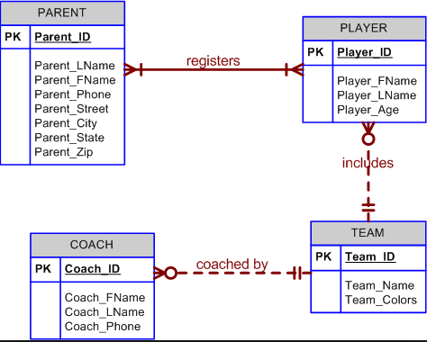

Problems

1. Use the following business rules to create a Crow’s Foot ERD. Write all appropriate connectivities and cardinalities in the ERD.
- A department employs many employees, but each employee is employed by one department.
- Some employees, known as “rovers,” are not assigned to any department.
- A division operates many departments, but each department is operated by one division.
- An employee may be assigned many projects, and a project may have many employees assigned to it.
- A project must have at least one employee assigned to it.
- One of the employees manages each department, and each department is managed by only one employee.
- One of the employees runs each division, and each division is run by only one employee.
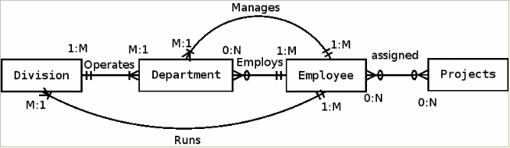

7. United Helpers is a nonprofit organization that provides aid to people after natural disasters. Based on the following brief description of operations, create the appropriate fully labeled Crow’s Foot ERD.
- Individuals volunteer their time to carry out the tasks of the organization. For each volunteer, their name, address, and telephone number are tracked. Each volunteer may be assigned to several tasks during the time that they are doing volunteer work, and some tasks require many volunteers. It is possible for a volunteer to be in the system without having been assigned a task yet. It is possible to have tasks that no one has been assigned. When a volunteer is assigned to a task, the system should track the start time and end time of that assignment.
- For each task, there is a task code, task description, task type, and a task status. For example, there may be a task with task code “101,” description of “answer the telephone,” a type of “recurring,” and a status of “ongoing.” There could be another task with a code of “102,” description of “prepare 5000 packages of basic medical supplies,” a type of “packing,” and a status of “open.”
- For all tasks of type “packing,” there is a packing list that specifies the contents of the packages. There are many different packing lists to produce different packages, such as basic medical packages, child care packages, food packages, etc. Each packing list has a packing list ID number, packing list name, and a packing list description, which describes the items that ideally go into making that type of package. Every packing task is associated with only one packing list. A packing list may not be associated with any tasks, or may be associated with many tasks. Tasks that are not packing tasks are not associated with any packing list.
- Packing tasks result in the creation of packages. Each individual package of supplies that is produced by the organization is tracked. Each package is assigned an ID number. The date the package was created, and total weight of the package is recorded. A given package is associated with only one task. Some tasks (e.g., “answer the phones”) will not have produced any packages, while other tasks (e.g., “prepare 5000 packages of basic medical supplies”) will be associated with many packages.
- The packing list describes the ideal contents of each package, but it is not always possible to include the ideal number of each item. Therefore, the actual items included in each package should be tracked. A package can contain many different items, and a given item can be used in many different packages.
- Each item that the organization provides has an item ID number, item description, item value, and item quantity on hand stored in the system. Along with tracking the actual items that are placed in each package, the quantity of each item placed in the package must be tracked as well. For example, a packing list may state that basic medical packages should include 100 bandages, 4 bottles of iodine, and 4 bottles of hydrogen peroxide. However, because of the limited supply of items, a given package may include only 10 bandages, 1 bottle of iodine, and no hydrogen peroxide. The fact that this package includes bandages and iodine needs to be recorded along with the quantity of each item included. It is possible for the organization to have items that have not been included in any package yet, but every package will contain at least one item.

10. Luxury-Oriented Scenic Tours (LOST) provides guided tours to groups of visitors to the Washington D.C. area. In recent years, LOST has grown quickly and is having difficulty keeping up with all of the various information needs of the company. The company’s operations are as follows.
- LOST offers many different tours. For each tour, the tour name, approximate length (in hours), and fee charged is needed. Guides are identified by an employee ID, but the system should also record a guide’s name, home address, and date of hire. Guides take a test to be qualified to lead specific tours. It is important to know which guides are qualified to lead which tours and the date that they completed the qualification test for each tour. A guide may be qualified to lead many different tours. A tour can have many different qualified guides. New guides may or may not be qualified to lead any tours, just as a new tour may or may not have any qualified guides.
- Every tour must be designed to visit at least three locations. For each location, a name, type, and official description are kept. Some locations (such as the White House) are visited by more than one tour, while others (such as Arlington Cemetery) are visited by a single tour. All locations are visited by at least one tour. The order in which the tour visits each location should be tracked as well.
- When a tour is actually given, that is referred to as an “outing.” LOST schedules outings well in advance so they can be advertised and so employees can understand their upcoming work schedules. A tour can have many scheduled outings, although newly designed tours may not have any outings scheduled. Each outing is for a single tour and is scheduled for a particular date and time. All outings must be associated with a tour. All tours at LOST are guided tours, so a guide must be assigned to each outing. Each outing has one and only one guide. Guides are occasionally asked to lead an outing of a tour even if they are not officially qualified to lead that tour. Newly hired guides may not have ever been scheduled to lead any outings. Tourists, called “clients” by LOST, pay to join a scheduled outing. For each client, the name and telephone number are recorded. Clients may sign up to join many different outings, and each outing can have many clients. Information is kept only on clients who have signed up for at least one outing, although newly scheduled outings may not have any clients signed up yet.
      - Create a Crow’s Foot notation ERD to support LOST operations.

      - The operations provided state that it is possible for a guide to lead an outing of a tour even if the guide is not officially qualified to lead outings of that tour. Imagine that the business rules instead specified that a guide is never, under any circumstance, allowed to lead an outing unless he or she is qualified to lead outings of that tour. How could the data model in part a) be modified to enforce this new constraint?
Between outing and guide, there should be a composite attribute between the two called Qualified Guides so that, if they’re not qualified, they aren’t able to lead an outing.

Case 11

11. The administrators of Tiny College are so pleased with your design and implementation of their student registration/tracking system that they want you to expand the design to include the database for their motor vehicle pool. A brief description of operations follows:

A brief description of operations follows:
- Faculty members may use the vehicles owned by Tiny College for officially sanctioned travel. For example, the vehicles may be used by faculty members to travel to off-campus learning centers, to travel to locations at which research papers are presented, to transport students to officially sanctioned locations, and to travel for public service purposes. The vehicles used for such purposes are managed by Tiny College’s Travel Far But Slowly (TFBS) Center.
- Using reservation forms, each department can reserve vehicles for its faculty, who are responsible for filling out the appropriate trip completion form at the end of a trip. The reservation form includes the expected departure date, vehicle type required, destination, and name of the authorized faculty member. The faculty member arriving to pick up a vehicle must sign a checkout form to log out the vehicle and pick up a trip completion form. (The TFBS employee who releases the vehicle for use also signs the checkout form.) The faculty member’s trip completion form includes the faculty member’s identification code, the vehicle’s identification, the odometer readings at the start and end of the trip, maintenance complaints (if any), gallons of fuel purchased (if any), and the Tiny College credit card number used to pay for the fuel. If fuel is purchased, the credit card receipt must be stapled to the trip completion form. Upon receipt of the faculty trip completion form, the faculty member’s department is billed at a mileage rate based on the vehicle type (sedan, station wagon, panel truck, minivan, or minibus) used. (Hint: Do not use more entities than are necessary. Remember the difference between attributes and entities!)
- All vehicle maintenance is performed by TFBS. Each time a vehicle requires maintenance, a maintenance log entry is completed on a prenumbered maintenance log form. The maintenance log form includes the vehicle identification, a brief description of the type of maintenance required, the initial log entry date, the date on which the maintenance was completed, and the identification of the mechanic who released the vehicle back into service. (Only mechanics who have an inspection authorization may release the vehicle back into service.)
- As soon as the log form has been initiated, the log form’s number is transferred to a maintenance detail form; the log form’s number is also forwarded to the parts department manager, who fills out a parts usage form on which the maintenance log number is recorded. The maintenance detail form contains separate lines for each maintenance item performed, for the parts used, and for identification of the mechanic who performed the maintenance item. When all maintenance items have been completed, the maintenance detail form is stapled to the maintenance log form, the maintenance log form’s completion date is filled out, and the mechanic who releases the vehicle back into service signs the form. The stapled forms are then filed, to be used later as the source for various maintenance reports.
- TFBS maintains a parts inventory, including oil, oil filters, air filters, and belts of various types. The parts inventory is checked daily to monitor parts usage and to reorder parts that reach the “minimum quantity on hand” level. To track parts usage, the parts manager requires each mechanic to sign out the parts that are used to perform each vehicle’s maintenance; the parts manager records the maintenance log number under which the part is used.
- Each month TFBS issues a set of reports. The reports include the mileage driven by vehicle, by department, and by faculty members within a department. In addition, various revenue reports are generated by vehicle and department. A detailed parts usage report is also filed each month. Finally, a vehicle maintenance summary is created each month.

Given that brief summary of operations, draw the appropriate (and fully labeled) ERD. Use the Chen methodology to indicate entities, relationships, connectivities, and cardinalities.

