哈尔滨工业大学

<<数据库系统>>
实验报告之二

(2017年度春季学期)

姓名： | 赵浩宁
学号： | 1140310226
学院： | 计算机学院
教师： | 邹兆年

实验二 使用高级语言操作MySQL数据库

实验目的
学会使用高级语言访问MySQL数据库，并进行查询

二、实验环境
Windows XP操作系统、MySQL关系数据库管理系统、MinGW编译器或Microsoft Visual C++编译器。
本次实验主要利用C语言访问MySQL数据库，也可以使用JAVA，PHP等其他语言。

三、实验过程及结果

3.1 实验任务
待执行的9个查询为如下：
1：参加了项目编号为%PNO%的项目的员工号，其中%PNO%为C语言编写的程序的输入参数；
pno = raw_input("请输入项目编号:") # 参加了项目编号为%PNO%的项目的员工号
tmp = 'select distinct essn from employee natural join project where pno = "' + pno + '"'
a1 = cur.execute(tmp)
info = cur.fetchmany(a1)
print
"参加了项目编号为" + pno + "的员工编号为："
for i in info:
print i[0]
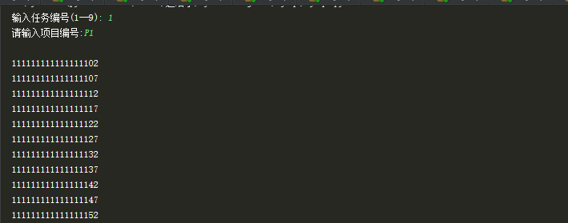
2：参加了项目名为%PNAME%的员工名字，其中%PNAME%为C语言编写的程序的输入参数；
pname = raw_input("请输入项目名称:") # 参加了项目名为%PNAME%的员工名字
tmp = 'select distinct ename from employee natural join project where pname = "' + pname + '"'
a2 = cur.execute(tmp.decode("gbk").encode("utf8"))
info = cur.fetchmany(a2)
print
"参加了项目名" + pname + "的员工名字有："
for i in info:
print i[0]
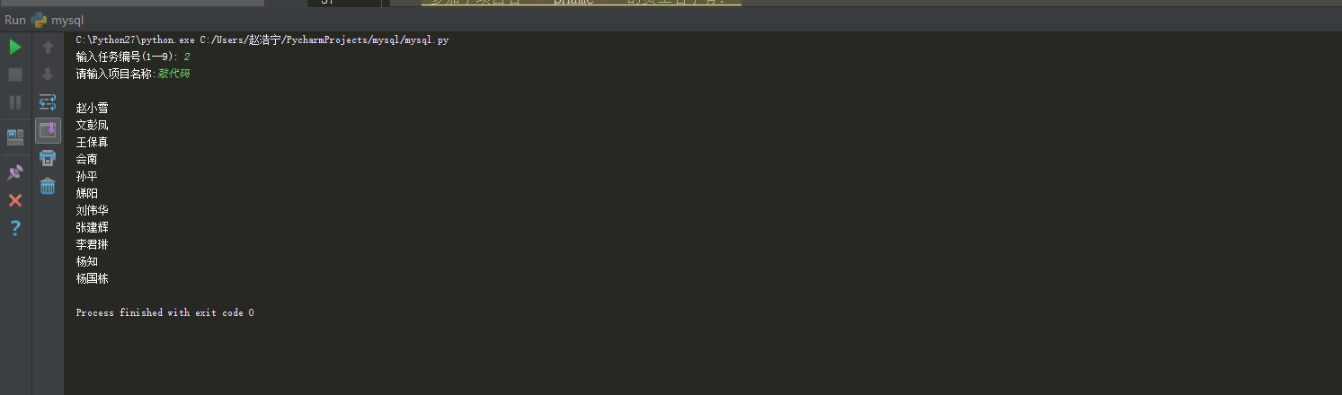
3：在%DNAME%工作的所有工作人员的名字和地址，其中%DNAME%为C语言编写的程序的输入参数；
dname = raw_input("请输入部门名称:") # 在%DNAME%工作的所有工作人员的名字和地址
tmp = 'select distinct ename, address from department natural join employee where dname = "' + dname + '"'
a3 = cur.execute(tmp.decode("gbk").encode("utf8"))
info = cur.fetchmany(a3)
print
"在" + dname + "部门工作的员工名和地址如下（姓名、地址交替出现）："
for i in info:
print i[0].decode("utf8")+' '+ i[1].decode("utf8")
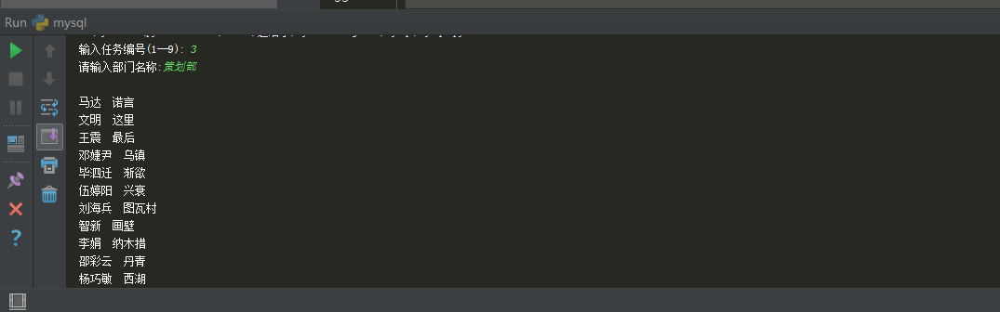
4：在%DNAME%工作且工资低于%SALARY%元的员工名字和地址，其中%DNAME%和%SALARY%为C语言编写的程序的输入参数；
dname = raw_input("请输入部门名称:") # 在%DNAME%工作且工资低于%SALARY%元的员工名字和地址
salary = input("请输入工资钱数:")
tmp = 'select distinct ename, address, dname, salary from department natural join employee where dname = "' + dname + '" ' + ' and salary < ' + str(salary);
a4 = cur.execute(tmp.decode("gbk").encode("utf8"))
info = cur.fetchmany(a4)
print
"在" + dname + "部门工作且工资低于" + str(salary) + "的员工名和地址如下（姓名、地址交替出现）："
for i in info:
print i[0].decode("utf8") + ' ' + i[1].decode("utf8")+ ' ' + i[2].decode("utf8")+ ' ' + str(i[3])
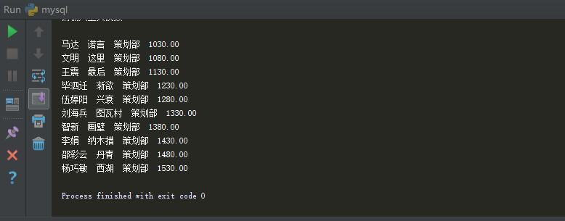
5：没有参加项目编号为%PNO%的项目的员工姓名，其中%PNO%为C语言编写的程序的输入参数；
pno = raw_input("请输入项目编号:") # 没有参加项目编号为%PNO%的项目的员工姓名
a5 = cur.execute('select distinct ename from employee where essn not in (select essn from works_on where pno= "'+pno+'")')
info = cur.fetchmany(a5)
print
"没有参加项目编号为：" + pno + "的员工姓名如下："
for i in info:
print i[0].decode("utf8")
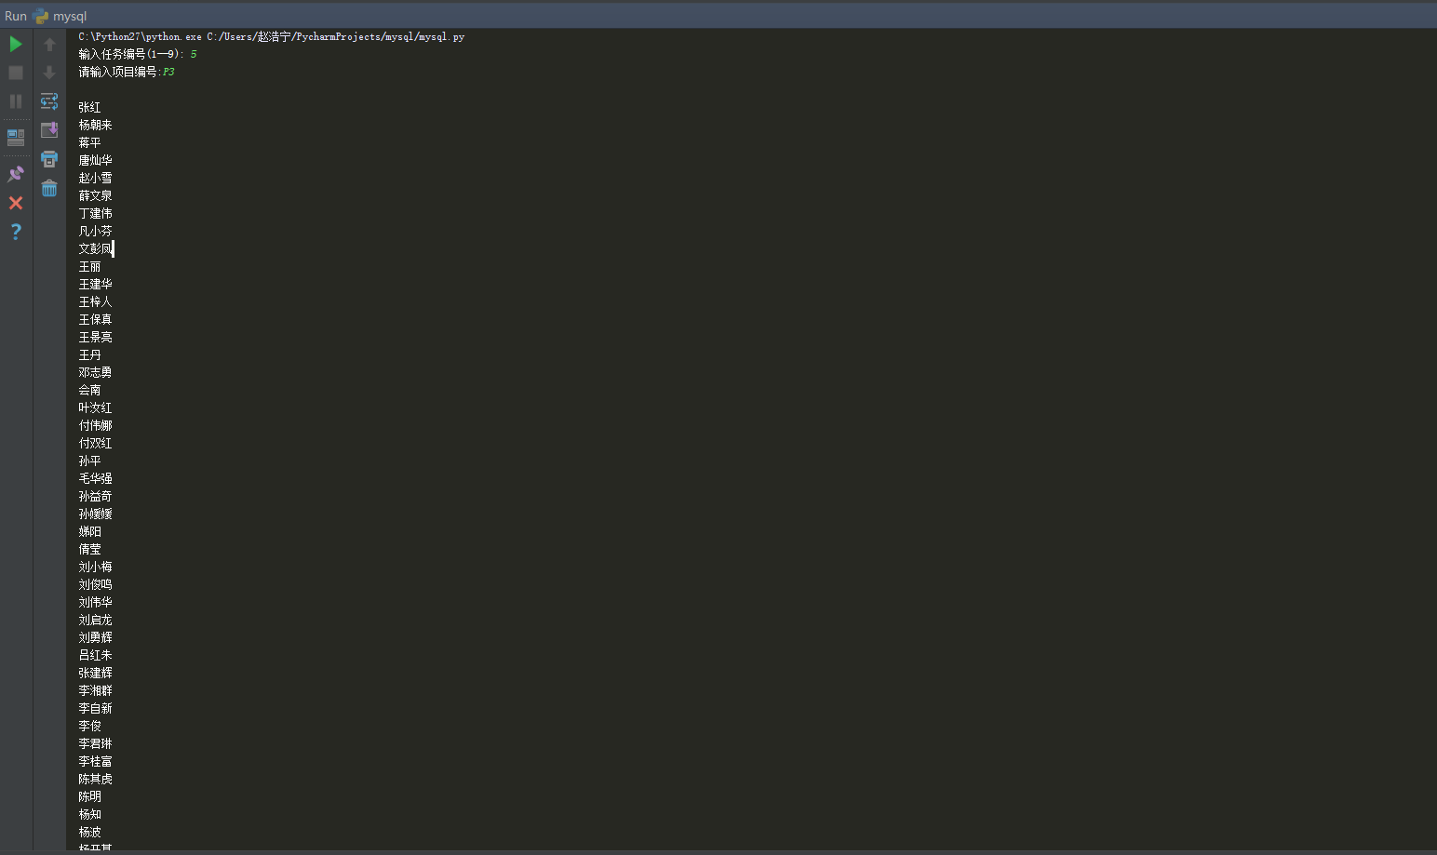
6：由%ENAME%领导的工作人员的姓名和所在部门的名字，其中%ENAME%为C语言编写的程序的输入参数；
ename = raw_input("请输入领导名字") #由%ENAME%领导的工作人员的姓名和所在部门的名字
# ename.decode("gbk").encode("utf8")
#a6 = cur.execute('select ename,dname from employee natural join department where mgrssn = (select essn from employee where ename ="' + ename +'")')
cmd = 'select ename, dname from employee natural join department where mgrssn = (select essn from employee where ename = "张红")'
print cmd
a6 = cur.execute(cmd)
info = cur.fetchmany(a6)
print"由"+ename+"领导的工作人员姓名、所在部门名字如下（姓名、部门名字交替出现）："
for i in info:
print i[0].decode("utf8") + ' ' + i[1].decode("utf8")
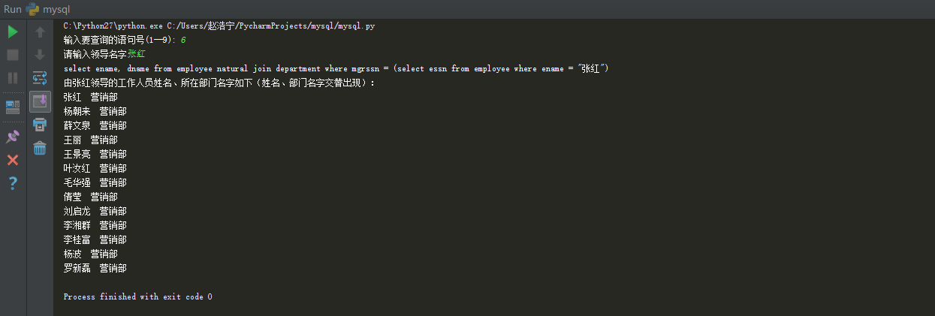

7：至少参加了项目编号为%PNO1%和%PNO2%的项目的员工号，其中%PNO1%和%PNO2%为C语言编写的程序的输入参数；
pno1 = raw_input("请输入第一个项目编号:") # 至少参加了项目编号为%PNO1%和%PNO2%的项目的员工号
pno2 = raw_input("请输入第二个项目编号:")
strall = "select essn from employee where essn in (select essn from works_on where " + "pno=" + "'" + pno1 + "'" \
+ " and essn in (select essn from works_on where pno=" + "'" + pno2 + "'))"
a7 = cur.execute(strall)
info = cur.fetchmany(a7)
print
"至少参加了项目编号为" + pno1 + "和" + pno2 + "的员工编号为："
for i in info:
print i[0]
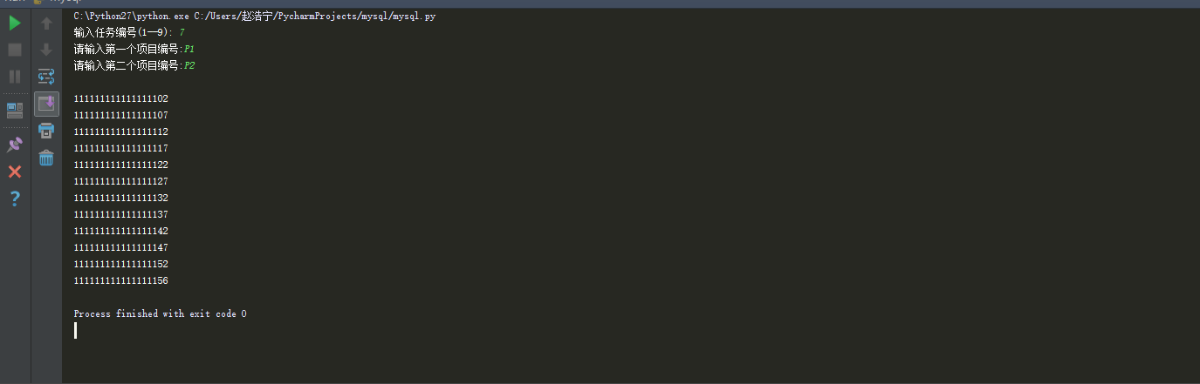
8：员工平均工资低于%SALARY%元的部门名称，其中%SALARY%为C语言编写的程序的输入参数；
salary_raw = input("请输入工资钱数:") # 员工平均工资低于%SALARY%元的部门名称
salary = float(salary_raw)
st = "select dname from employee natural join department group by dname having avg(salary)<"+str(salary_raw)
a8 = cur.execute(st)
# print 1--9
info = cur.fetchmany(a8)
print
"员工平均工资低于" + str(salary) + "的部门名称有："
for i in info:
print i[0].decode("utf8")
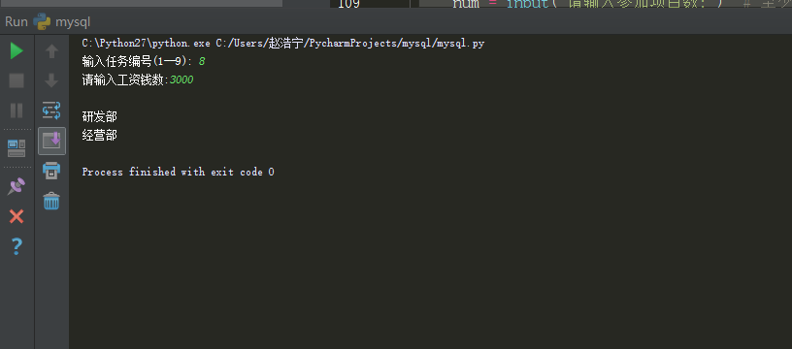
9：至少参与了%N%个项目且工作总时间不超过%HOURS%小时的员工名字，其中%N%和%SALARY%为C语言编写的程序的输入参数；
num = input("请输入参加项目数:") # 至少参与了%N%个项目且工作总时间不超过%HOURS%小时的员工名字
hours = input("工作总时间:")
strall = "select employee.ename from employee where essn in (select essn from works_on \
group by essn having count(*)>" + str(num) + " and sum(hours)<=" + str(hours) + ")"
a9 = cur.execute(strall)
info = cur.fetchmany(a9)
print
"参加了多于" + str(num) + "个项目且工作总时间低于" + str(hours) + "的员工姓名如下："
for i in info:
print i[0].decode("utf8")

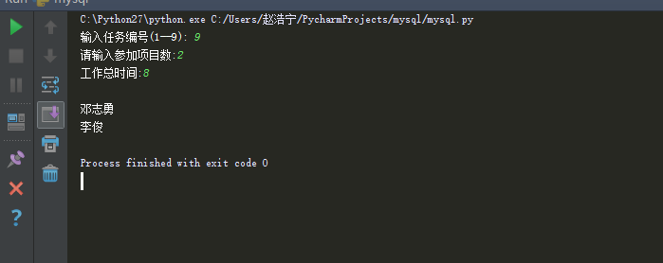

四、实验心得
学习使用了Python的数据库文件MYSQLdb的使用，相比其他高级语言，python对数据库的操作非常简单和方便，几行代码就能完成C++几十行代码的工作量，对今后学习奠定了良好的基础。同时温习了Python的相关语法和使用。

五、实验代码
#coding=utf-8

import MySQLdb
import sys
reload(sys)
sys.setdefaultencoding('utf-8')

conn = MySQLdb.connect(
host="localhost",
port=3306,
user="root",
passwd="1996210zhn",
db="company",
charset='utf8'
)
cur = conn.cursor() #操作游标

flag = input("输入要查询的语句号: ")
if flag == 1:
pno = raw_input("请输入项目编号:") # 参加了项目编号为%PNO%的项目的员工号
tmp = 'select distinct essn from employee natural join project where pno = "' + pno + '"'
a1 = cur.execute(tmp)
info = cur.fetchmany(a1)
print"参加了项目编号为" + pno + "的员工编号为："
for i in info:
print i[0]

elif flag == 2:
pname = raw_input("请输入项目名称:") # 参加了项目名为%PNAME%的员工名字
tmp = 'select distinct ename from employee natural join project where pname = "' + pname + '"'
a2 = cur.execute(tmp)
info = cur.fetchmany(a2)
print"参加了项目名" + pname + "的员工名字有："
for i in info:
print i[0]

elif flag == 3:
dname = raw_input("请输入部门名称:") # 在%DNAME%工作的所有工作人员的名字和地址
tmp = 'select distinct ename, address from department natural join employee where dname = "' + dname + '"'
a3 = cur.execute(tmp)
info = cur.fetchmany(a3)
print"在" + dname + "部门工作的员工名和地址如下（姓名、地址交替出现）："
for i in info:
print i[0].decode("utf8")+' '+ i[1].decode("utf8")

elif flag == 4:
dname = raw_input("请输入部门名称:") # 在%DNAME%工作且工资低于%SALARY%元的员工名字和地址
salary = input("请输入工资钱数:")
tmp = 'select distinct ename, address, dname, salary from department natural join employee where dname = "' + dname + '" ' + ' and salary < ' + str(salary);
a4 = cur.execute(tmp)
info = cur.fetchmany(a4)
print"在" + dname + "部门工作且工资低于" + str(salary) + "的员工名和地址如下（姓名、地址交替出现）："
for i in info:
print i[0].decode("utf8") + ' ' + i[1].decode("utf8")+ ' ' + i[2].decode("utf8")+ ' ' + str(i[3])

elif flag == 5:
pno = raw_input("请输入项目编号:") # 没有参加项目编号为%PNO%的项目的员工姓名
a5 = cur.execute('select distinct ename from employee where essn not in (select essn from works_on where pno= "'+pno+'")')
info = cur.fetchmany(a5)
print"没有参加项目编号为：" + pno + "的员工姓名如下："
for i in info:
print i[0].decode("utf8")

elif flag == 6:
ename = raw_input("请输入领导名字") #由%ENAME%领导的工作人员的姓名和所在部门的名字
# ename.decode("gbk").encode("utf8")
#a6 = cur.execute('select ename,dname from employee natural join department where mgrssn = (select essn from employee where ename ="' + ename +'")')
cmd = 'select ename, dname from employee natural join department where mgrssn = (select essn from employee where ename = "张红")'
print cmd
a6 = cur.execute(cmd)
info = cur.fetchmany(a6)
print"由"+ename+"领导的工作人员姓名、所在部门名字如下（姓名、部门名字交替出现）："
for i in info:
print i[0].decode("utf8") + ' ' + i[1].decode("utf8")

elif flag == 7:
pno1 = raw_input("请输入第一个项目编号:") # 至少参加了项目编号为%PNO1%和%PNO2%的项目的员工号
pno2 = raw_input("请输入第二个项目编号:")
strall = "select essn from employee where essn in (select essn from works_on where " + "pno=" + "'" + pno1 + "'" \
+ " and essn in (select essn from works_on where pno=" + "'" + pno2 + "'))"
a7 = cur.execute(strall)
info = cur.fetchmany(a7)
print"至少参加了项目编号为" + pno1 + "和" + pno2 + "的员工编号为："
for i in info:
print i[0]

elif flag == 8:
salary_raw = input("请输入工资钱数:") # 员工平均工资低于%SALARY%元的部门名称
salary = float(salary_raw)
st = "select dname from employee natural join department group by dname having avg(salary)<"+str(salary_raw)
a8 = cur.execute(st)
# print 1--9
info = cur.fetchmany(a8)
print"员工平均工资低于" + str(salary) + "的部门名称有："
for i in info:
print i[0].decode("utf8")

elif flag == 9:
num = input("请输入参加项目数:") # 至少参与了%N%个项目且工作总时间不超过%HOURS%小时的员工名字
hours = input("工作总时间:")
strall = "select employee.ename from employee where essn in (select essn from works_on \
group by essn having count(*)>" + str(num) + " and sum(hours)<=" + str(hours) + ")"
a9 = cur.execute(strall)
info = cur.fetchmany(a9)
print"参加了多于" + str(num) + "个项目且工作总时间低于" + str(hours) + "的员工姓名如下："
for i in info:
print i[0].decode("utf8")

else:
print
"没有您输入的查询！"
conn.commit()
cur.close()
conn.close()

