Project Title - Fire Weather Index Prediction(FWI) Using Machine Learning

Project Statement:

Wildfires pose a significant threat to ecosystems, human life, and property. The Fire Weather Index (FWI) is a crucial tool used by meteorological and environmental agencies worldwide to estimate wildfire potential. This project aims to build a machine learning model that predicts FWI based on real-time environmental data, enabling proactive wildfire risk management. The model is trained using Ridge Regression, deployed via a Flask web application, and supports early warning systems for wildfire hazards.

Outcomes:

• A predictive ML model trained using Ridge Regression to forecast FWI.
• A pre-processing pipeline using StandardScaler for normalization.
• A Flask-based web app where users can input environmental values and get FWI prediction.
• A system that can help forest departments, emergency planners, and climate researchers make data driven decisions.

Modules to be implemented

• Data Collection
• Data Exploration (EDA) and Data Preprocessing
• Feature Engineering and Scaling
• Model Training using Ridge Regression
• Evaluation and Optimization
• Deployment via Flask App
• Presentation and Documentation

Submitted by: Gayatri Autade

Guided by: Mr. Praveen Sir

Milestone 1 – Data Collection & Preprocessing

- Import Required Libraries

import pandas as pd
import numpy as np
import matplotlib.pyplot as plt
from sklearn.preprocessing import LabelEncoder
import seaborn as sns
import math

- Load the Dataset

data=pd.read_csv("C:/Users/autad/Downloads/FWI Dataset.csv")
print(data.head())

Output -

day month year Temperature RH Ws Rain FFMC DMC DC ISI BUI \
0 1 6 2012 29 57 18 0.0 65.7 3.4 7.6 1.3 3.4
1 2 6 2012 29 61 13 1.3 64.4 4.1 7.6 1.0 3.9
2 3 6 2012 26 82 22 13.1 47.1 2.5 7.1 0.3 2.7
3 4 6 2012 25 89 13 2.5 28.6 1.3 6.9 0.0 1.7
4 5 6 2012 27 77 16 0.0 64.8 3.0 14.2 1.2 3.9

FWI Classes Region
0 0.5 not fire Bejaia
1 0.4 not fire Bejaia
2 0.1 not fire Bejaia
3 0 not fire Bejaia
4 0.5 not fire Bejaia

- Initial Inspection of the Dataset

data.info()
data.describe()
data.isnull().sum()

- Fix Data Type Issues

# Handling Missing Values

data['DC'] = data['DC'].astype(str).str.replace(' ', '', regex=False)
data['FWI'] = data['FWI'].astype(str).str.replace(' ', '', regex=False)

data['DC'] = pd.to_numeric(data['DC'], errors='coerce')
data['FWI'] = pd.to_numeric(data['FWI'], errors='coerce')
data.info()

Output -

Data columns (total 15 columns):
# Column Non-Null Count Dtype
--- ------ -------------- -----
0 day 244 non-null int64
1 month 244 non-null int64
2 year 244 non-null int64
3 Temperature 244 non-null int64
4 RH 244 non-null int64
5 Ws 244 non-null int64
6 Rain 244 non-null float64
7 FFMC 244 non-null float64
8 DMC 244 non-null float64
9 DC 244 non-null float64
10 ISI 244 non-null float64
11 BUI 244 non-null float64
12 FWI 244 non-null float64
13 Classes 243 non-null object
14 Region 244 non-null object
dtypes: float64(7), int64(6), object(2)
memory usage: 28.7+ KB

- Identify rows with missing values

null_rows = data[data.isnull().any(axis=1)]
print("Rows with missing values:\n", null_rows)

Output -
Rows with missing values:
day month year Temperature RH Ws Rain FFMC DMC DC ISI \
165 14 7 2012 37 37 18 0.2 88.9 12.9 14.69 12.5

BUI FWI Classes Region
165 10.4 0.4 NaN Sidi-Bel Abbes

- Fill missing values using mode

for col in data.columns:
data.loc[:, col] = data[col].fillna(data[col].mode()[0])

# Drop remaining missing values
data.dropna(inplace=True)

data.isnull().sum()

Output -

day 0
month 0
year 0
Temperature 0
RH 0
Ws 0
Rain 0
FFMC 0
DMC 0
DC 0
ISI 0
BUI 0
FWI 0
Classes 0
Region 0
dtype: int64

- Outlier Detection Using Boxplots

plt.figure(figsize=(12, 8))
sns.boxplot(data=data)
plt.xticks(rotation=45)
plt.title("Outlier Detection Using Boxplot")
plt.show()

Output -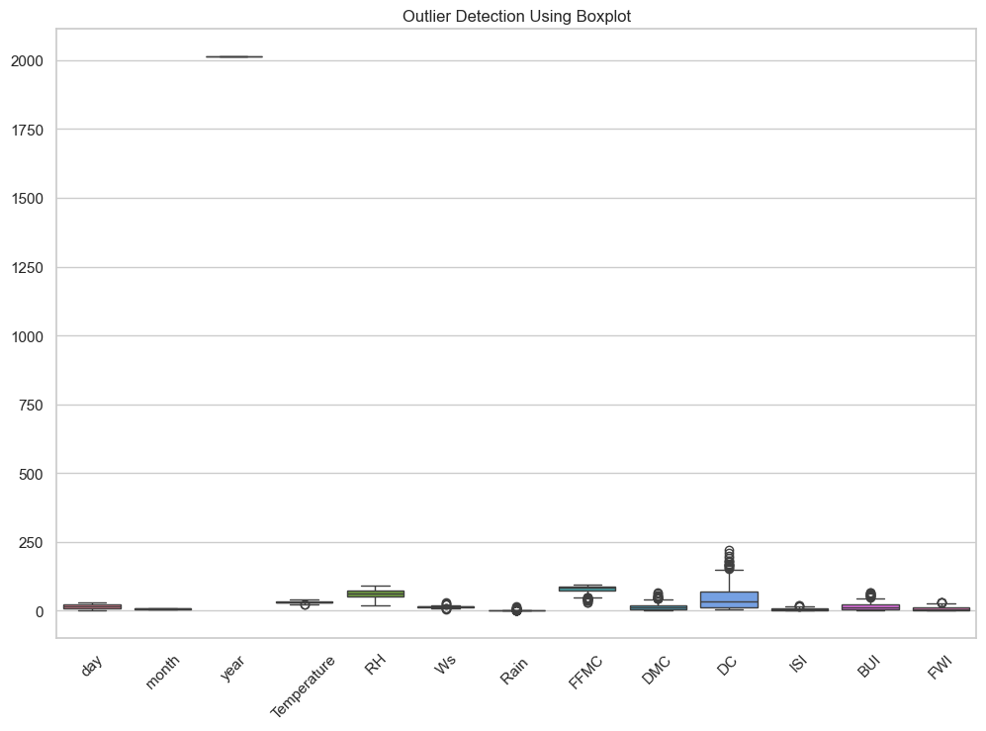

- Histograms for All Features

data.hist(figsize=(12, 10), bins=15,color='skyblue', edgecolor='black')
plt.suptitle("Histogram of All Features")
plt.show()

Output -

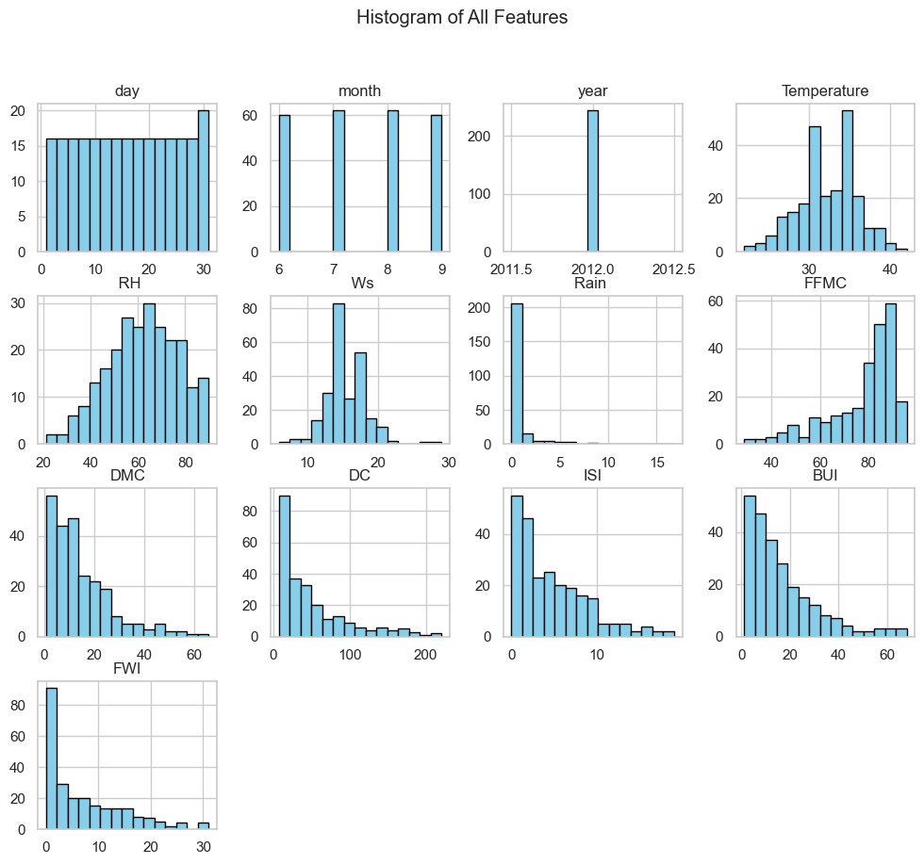

- density plots for numerical features

# Select numerical columns
num_cols = sorted([col for col in data.columns if data[col].dtype != "object"])

valid_cols = []

# Filter out columns with zero variance
for col in num_cols:
if data[col].nunique() > 1:
valid_cols.append(col)

cols = 3
rows = math.ceil(len(valid_cols) / cols)

plt.figure(figsize=(16, 4 * rows))

for i, col in enumerate(valid_cols, start=1):
plt.subplot(rows, cols, i)
sns.kdeplot(data[col], fill=True)
plt.title(f"Density Plot - {col}")
plt.xlabel(col)
plt.ylabel("Density")

plt.tight_layout()
plt.show()

Output -
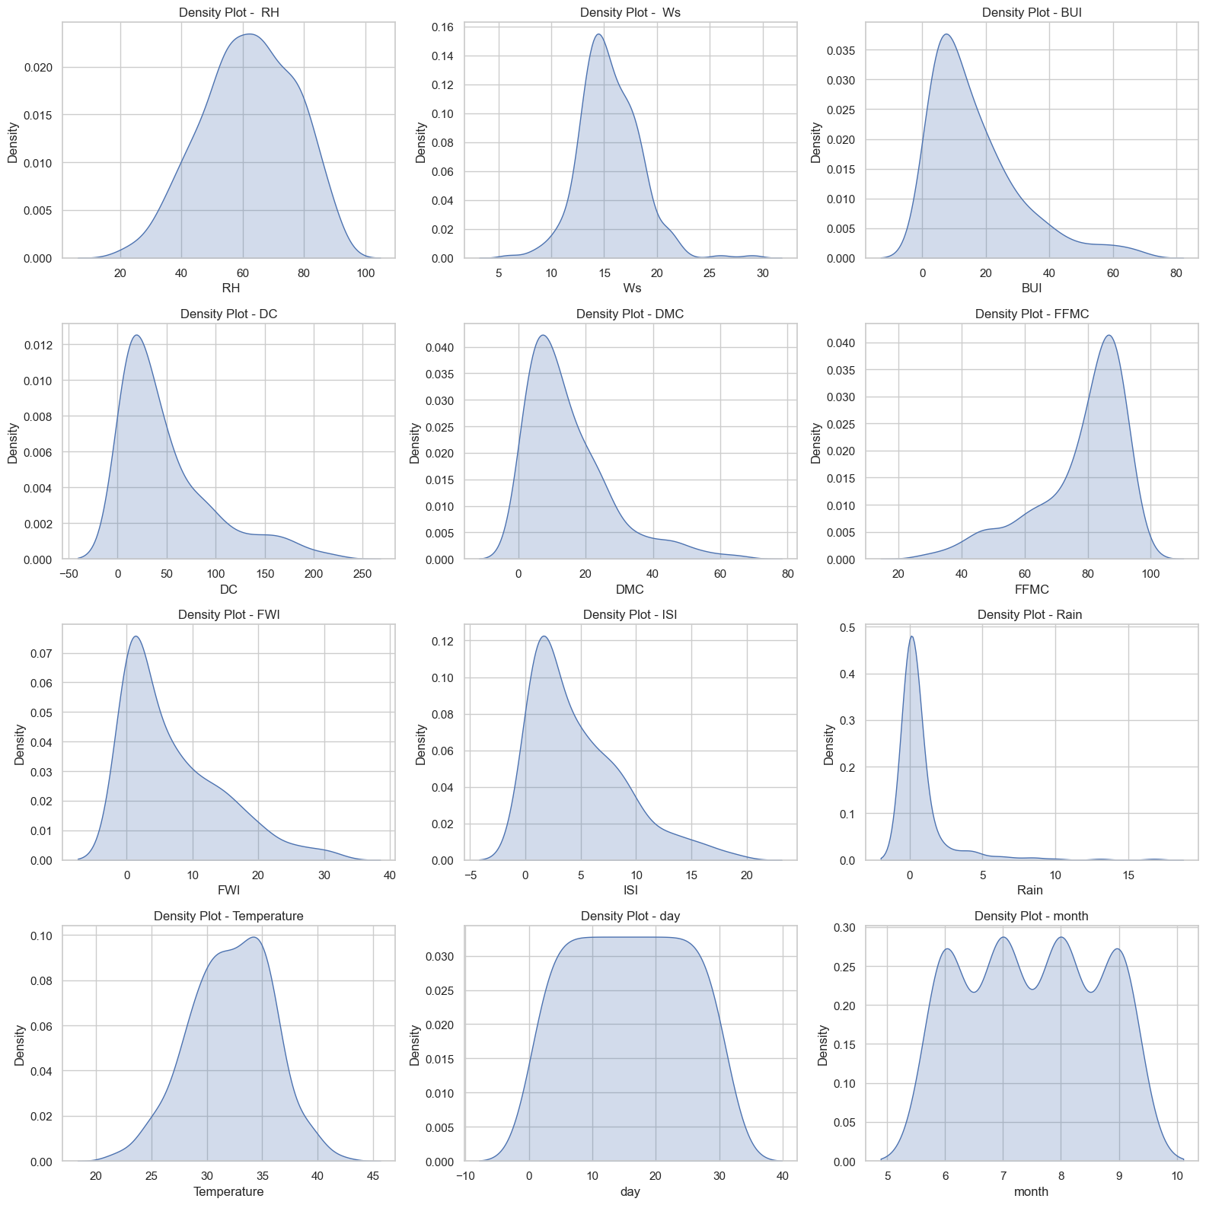

- Scatter Plots of Numerical Features vs FWI

um_cols = [col for col in data.select_dtypes(include=['float64', 'int64']).columns if col != "FWI"]

palette = sns.color_palette("husl", len(num_cols)) # colorful palette
cols = 3
rows = math.ceil(len(num_cols) / cols)

plt.figure(figsize=(15, 5 * rows))

for i, col in enumerate(num_cols, start=1):
plt.subplot(rows, cols, i)
sns.scatterplot(x=data[col], y=data["FWI"], color=palette[i-1])
plt.xlabel(col)
plt.ylabel("FWI")
plt.title(f"{col} vs FWI")

plt.tight_layout()
plt.show()

Output -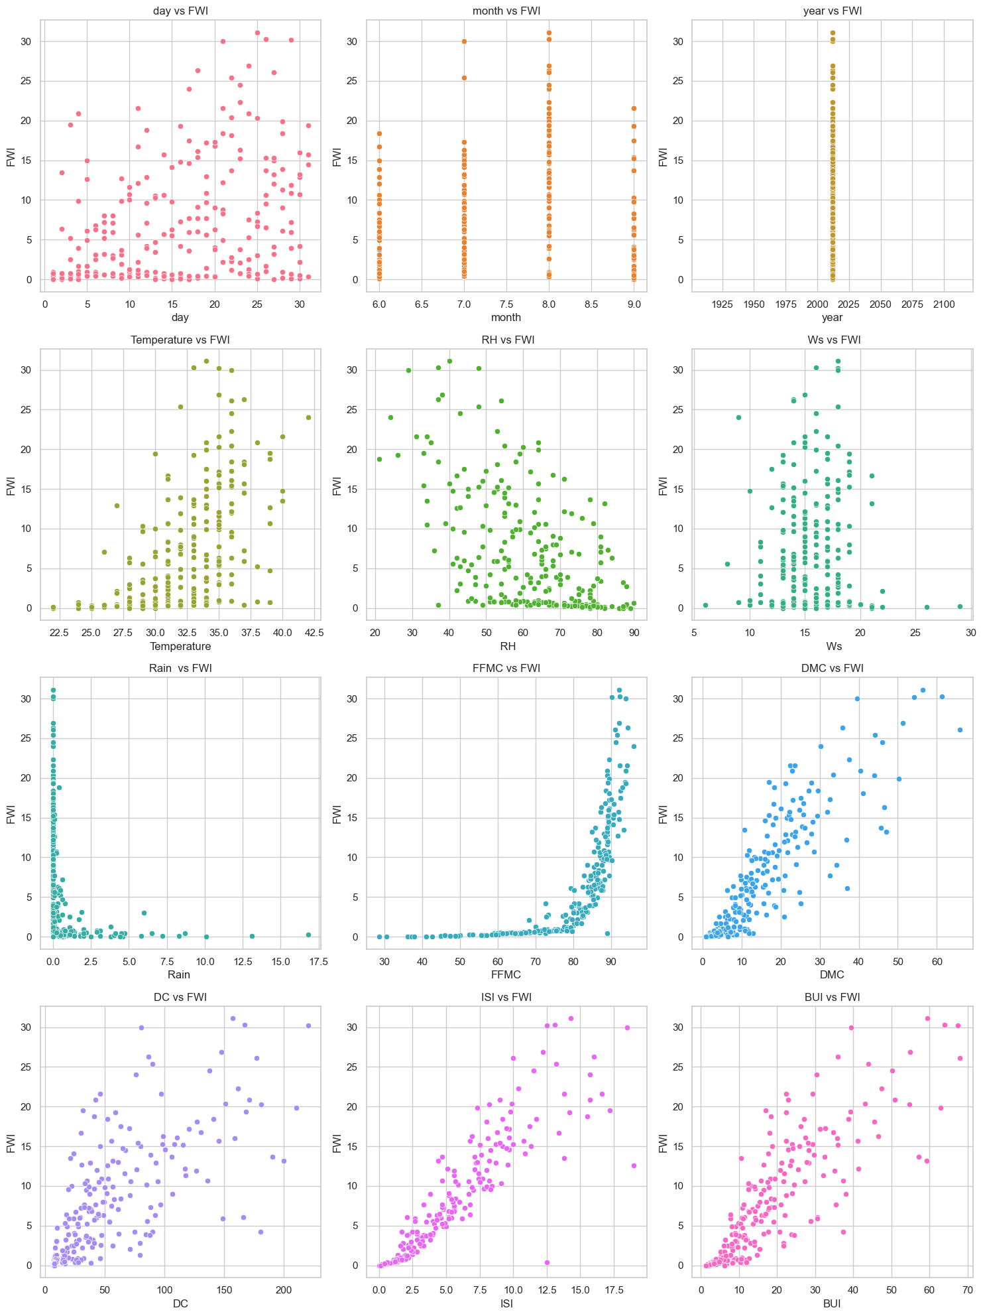

- Correlation Heatmap

plt.figure(figsize=(7, 8))
corr = data.select_dtypes(include=['float64','int64']).corr()

mask = np.triu(np.ones_like(corr, dtype=bool))

ax = sns.heatmap(
corr,
annot=True,
cmap="coolwarm",
fmt=".2f",
mask=mask,
linewidths=0.5,
annot_kws={"size": 10}
)

plt.xticks(rotation=45, ha="right", fontsize=10)
plt.yticks(fontsize=10)

plt.title("Correlation Heatmap (Upper Triangle)", fontsize=14)
plt.tight_layout()
plt.show()

Output -
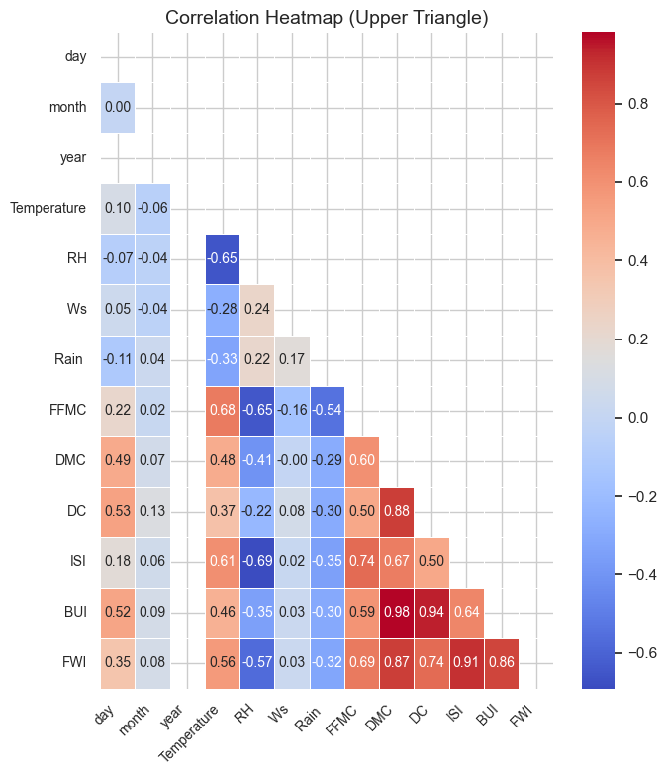

- Encoding Categorical Variables

if "Region" in data.columns:
le = LabelEncoder()
data["Region"] = le.fit_transform(data["Region"])

- Save the Dataset

data.to_csv("cleaned_FWI_dataset.csv", index=False)
print("Cleaned dataset saved successfully!")

Output -

Cleaned dataset saved successfully!

Milestone 2 - Week 3-4

Module 3: Feature Engineering and Scaling

- Imports

import pandas as pd
from sklearn.model_selection import train_test_split
import pickle
from sklearn.preprocessing import StandardScaler
data=pd.read_csv('cleaned_FWI_dataset.csv')

- Select Feachers

# Select only numeric columns (exclude 'Classes')
numeric_data = data.select_dtypes(include=['int64', 'float64'])
corr = numeric_data.corr()
threshold = 0.3
selected_features = corr['FWI'][abs(corr['FWI']) > threshold].index.tolist()
selected_features.remove('FWI')
selected_features

Output –

['day', 'Temperature', ' RH', 'Rain ', 'FFMC', 'DMC', 'DC', 'ISI', 'BUI']

- Split Datasets into Feachers and Target

X = data[selected_features]
y = data['FWI']
print("Input Features Shape:", X.shape)
print("Target Shape:", y.shape)

Output –

Input Features Shape: (244, 9)
Target Shape: (244,)

- Split the dataset into train and test

X_train, X_test, y_train, y_test = train_test_split(
X, y,
test_size=0.2,
random_state=42
)
print("Training Data:", X_train.shape)
print("Testing Data:", X_test.shape)

Output -

Training Data: (195, 9)
Testing Data: (49, 9)

- Feature Scaling using StandardScaler

scaler = StandardScaler()
X_train_scaled = scaler.fit_transform(X_train)
X_test_scaled = scaler.transform(X_test)

- Save the Scaler for Deployment

with open("scaler.pkl", "wb") as file:
pickle.dump(scaler, file)
# Verify Scaling
print("Scaled Training Data Sample:\n", X_train_scaled[:5])
print("Scaled Testing Data Sample:\n", X_test_scaled[:5])

Output -

Scaled Training Data Sample:
[[-0.08970416 -0.00689226 -0.75106006 -0.37323064 0.75250838 0.05482497
-0.02118058 0.47497183 0.03023485]]
Scaled Testing Data Sample:
[[ 1.03159787 -0.27569035 0.12070608 -0.37323064 0.61213517 -0.08272731
0.25217046 0.19245173 0.06361987]]

Module 3: Model Training using Ridge Regression

- Train the Ridge Regression Model

ridge_model = Ridge(alpha=1.0)
ridge_model.fit(X_train_scaled, y_train)

- Hyperparameter Tuning

alphas = [0.01, 0.1, 1, 10, 100]
results = {}

for a in alphas:
model = Ridge(alpha=a)
model.fit(X_train_scaled, y_train)
y_pred = model.predict(X_test_scaled)
results[a] = r2_score(y_test, y_pred)
results

Output –

{0.01: 0.9862989285583842,
0.1: 0.9863565713829123,
1: 0.9860021470799126,
10: 0.9754134485119687,
100: 0.8890275614195375}

- Model Evaluation

y_train_pred = ridge_model.predict(X_train_scaled)
y_test_pred = ridge_model.predict(X_test_scaled)
print("Training R² Score:", r2_score(y_train, y_train_pred))
print("Testing R² Score:", r2_score(y_test, y_test_pred))
print("Testing MSE:", mean_squared_error(y_test, y_test_pred))

Output –

Training R² Score: 0.9558863792898478
Testing R² Score: 0.9860021470799126
Testing MSE: 0.5455797557324075

23. Save model

with open("ridge.pkl", "wb") as file:
pickle.dump(ridge_model, file)

