**Name:Diwakar A S**

**SOFTWARE REQUIREMENTS SPECIFICATION DOCUMENTATION FOR ONLINE SHOPPING MART**

**INTRODUCTION**

**ABSTRACT**

The Online Shopping System Software requirements Specification (SRS) report outlines

the essential specifications and requirements needed to develop a dependable and user-

friendly online shopping platform. In the current digital era, e-commerce has become an

essential part of the retail environment. This SRS document offers the framework for

creating an efficient and user-friendly online purchasing experience for both

administrators and customers.

This project's main goal is to design, develop, and implement an online shopping system

that satisfies the diverse demands of modern consumers. This system will offer a wide

range of products, user-friendly interfaces, secure payment options, and efficient order

management for clients. It will also give administrators access to comprehensive inventory

and sales administration tools.

The Online Shopping System Software requirements Specification (SRS) report outlines

the essential specifications and requirements needed to develop a dependable and user-

friendly online shopping platform. In the current digital era, e-commerce has become an

essential part of the retail environment. This SRS document offers the framework for

creating an efficient and user-friendly online purchasing experience for both

administrators and customers.

This project's main goal is to design, develop, and implement an online shopping system

that satisfies the diverse demands of modern consumers. This system will offer a wide

range of products, user-friendly interfaces, secure payment options, and efficient order

management for clients. It will also give administrators access to comprehensive inventory

and sales administration tools.

The Online Shopping System Software requirements Specification (SRS) report outlines

the essential specifications and requirements needed to develop a dependable and user-

friendly online shopping platform. In the current digital era, e-commerce has become an

essential part of the retail environment. This SRS document offers the framework for

creating an efficient and user-friendly online purchasing experience for both

administrators and customers.

This project's main goal is to design, develop, and implement an online shopping system

that satisfies the diverse demands of modern consumers. This system will offer a wide

range of products, user-friendly interfaces, secure payment options, and efficient order

management for clients. It will also give administrators access to comprehensive inventory

and sales administration tools.

The Online Shopping System Software requirements Specification (SRS) report outlines

the essential specifications and requirements needed to develop a dependable and user-

friendly online shopping platform. In the current digital era, e-commerce has become an

essential part of the retail environment. This SRS document offers the framework for

creating an efficient and user-friendly online purchasing experience for both

administrators and customers.

This project's main goal is to design, develop, and implement an online shopping system

that satisfies the diverse demands of modern consumers. This system will offer a wide

range of products, user-friendly interfaces, secure payment options, and efficient order

management for clients. It will also give administrators access to comprehensive inventory

and sales administration tools.

Online Shopping System Software requirements Specification is essential for specifications and requirements needed to develop a userfriendly and easy access online shopping platform. In the current digital era, e-commerce has become an essential part of the everyone’s life. This SRS document offers the framework for an efficient and user-friendly online purchasing experience for both admins and customers.

SRS main goal is to design, develop, and implement an online shopping system that satisfies the modern consumers. This system will offer a wide range of products, user-friendly interfaces, secure payment options, and efficient or management for clients. It will also give administrators access to comprehensive inventory and sales administration tools.

**SYSTEM REQUIREMENTS**

**FUNCTIONAL REQUIREMENT**

* User registration and Login
* Browse products
* Add to cart
* Check in products
* Payment gateway
* Address checkout
* Logout

**NON-FUNCTIONAL REQUIREMENT**

* Interface
* Scalability
* Performance
* Security
* Technical issues

**MODULAR DESCRIPTION**

1. **Login**-User can able to sign-in with valid email id and Password, user can also navigate through websites for browsing the products.
2. **Add to Cart**-User can able to view all the items and their respective prices and discounts, they can add to cart for further process.
3. **Checkout-**User can check for their products, delivery address and total amount for payment.
4. **Payment**-User was sent to secured payment gateway for payment process. User can check the address and expected date of delivery.
5. **Logout**-After completion of buying items, user can logout their account from website.

**SYSTEM ARCHITECTURE**

**FLOW CHART**

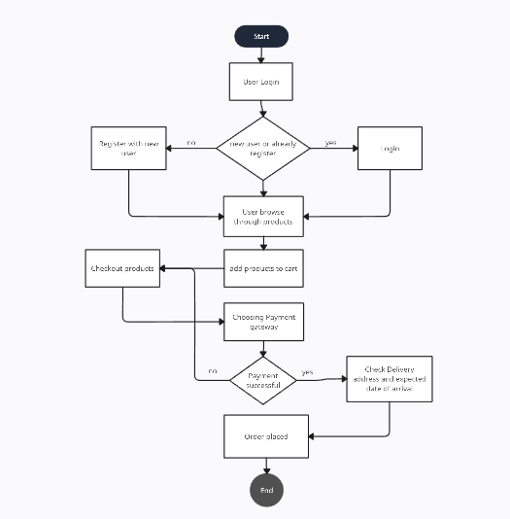

**USE CASE DIAGRAM**

This use case diagram illustrates the connections between customers and administrators.

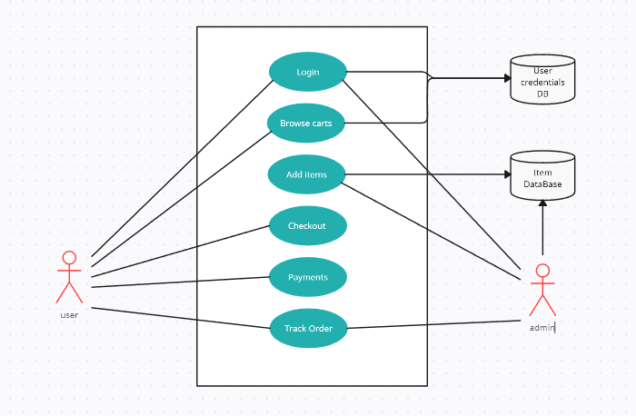

**CLASS DIAGRAM**

In this class diagram, the relationships between buyers and administrators are depicted.

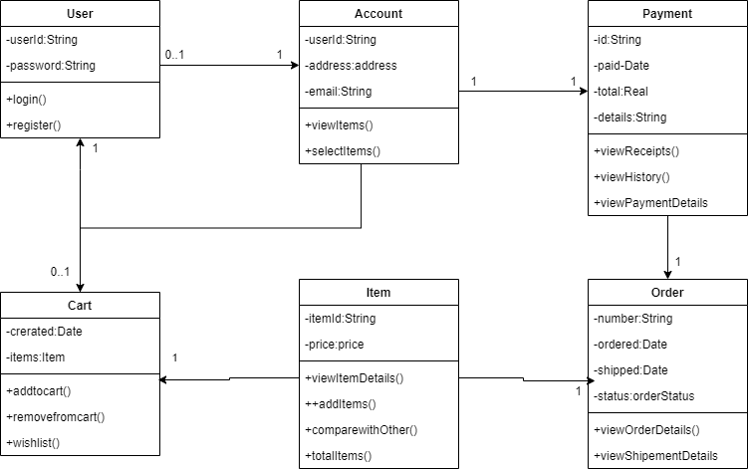

**SEQUENCE DIAGRAM**

   In this sequence diagram, the interactions between buyers and administrators are illustrated.

