**RAHUL M.S**

**SOLUTIONS**

**TABLE-1(PROGRAMMER):**

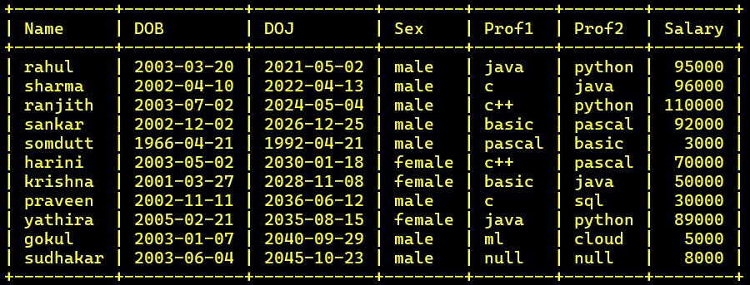

**TABLE-2(SOFTWARE):**

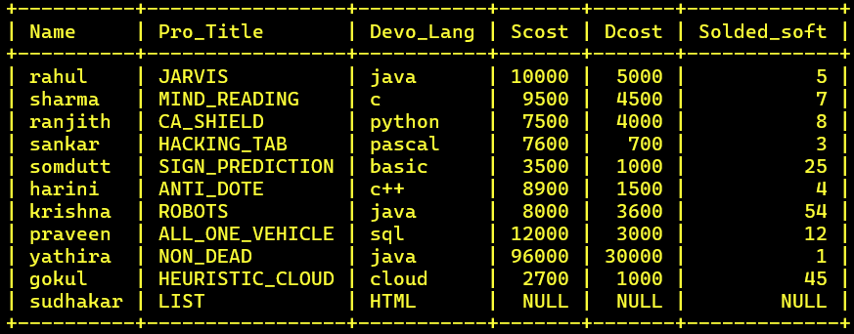

**TABLE-3(STUDIES):**

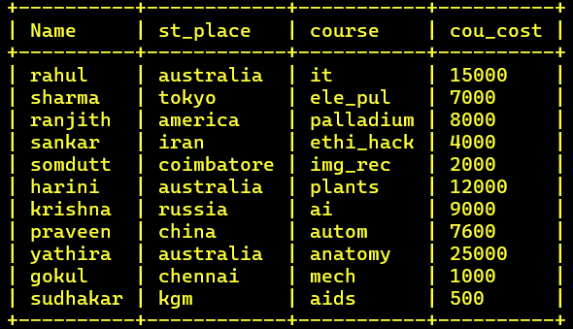

**QUERIES 1:**

**1. Find out the SELLING COST AVERAGE for the packages developed in PASCAL?**

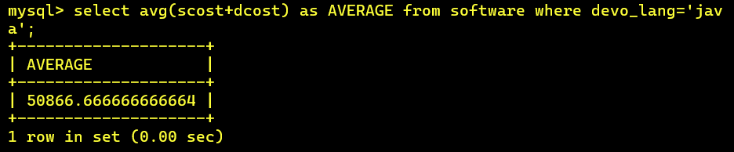

**2. Display the names and ages of all programmers**.

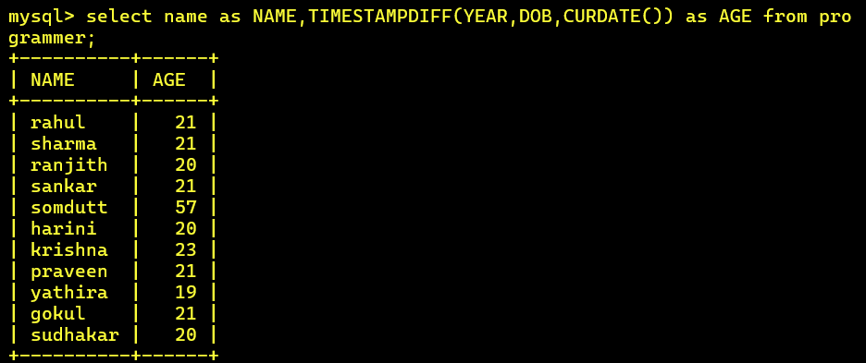

**3.** **Display the names and ages of all the programmers who have undergone training in DCS course.**

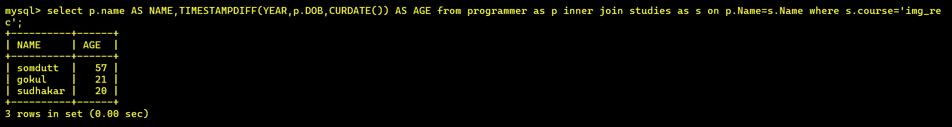

**4.** **What is the highest numbers of copies sold by a package?**

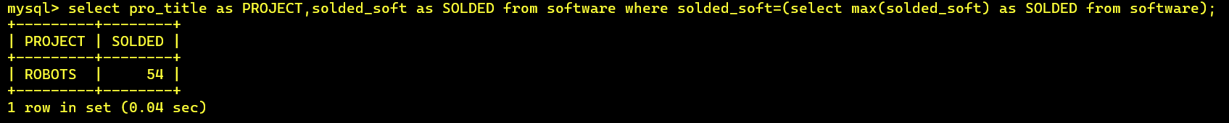

**5.** **Display the names and date of birth of all the programmer born in JANUARY.**

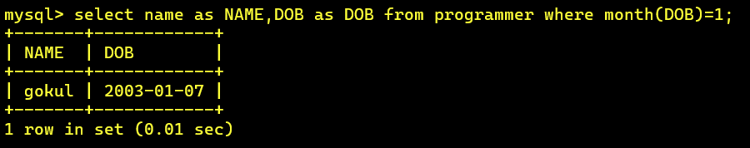

**6. Display lowest course fee.**

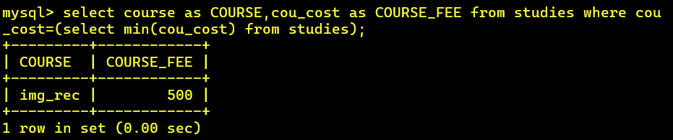

**7.** **How many programmer has done PGDCA course**.

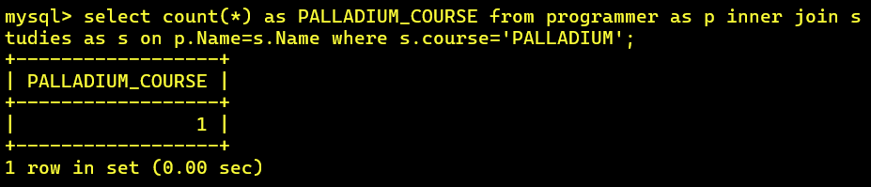

**8. How much revenue has been earned through sales of packages in C.**

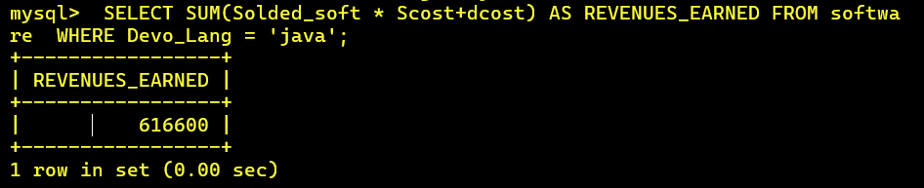

**9.** **Display the details of software developed by Ramesh?**

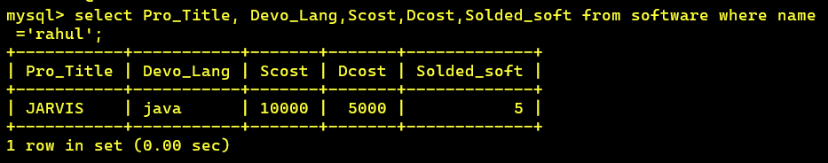

**10.** **How many programmers studied at SABHARI.**

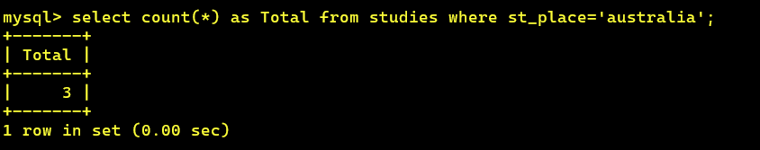

**11.** **Display the details of PACKAGES whose sales crossed the 20000 mark**.

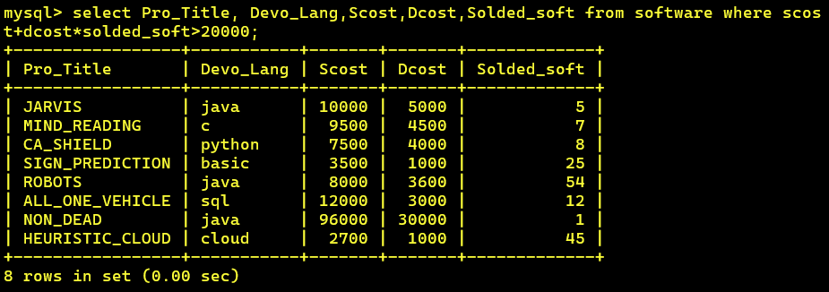

**12. ) Find out the number of copies which should be sold in order to recover the development cost of each package.**

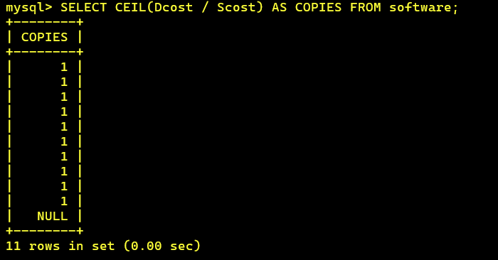

**13) What is the price of the costliest software developed in BASIC?**

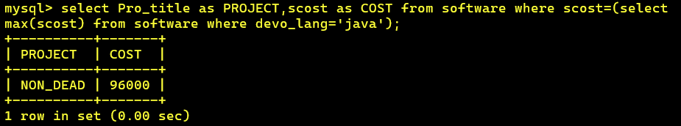

**14) Display the details of packages for which development cost has been recovered.**

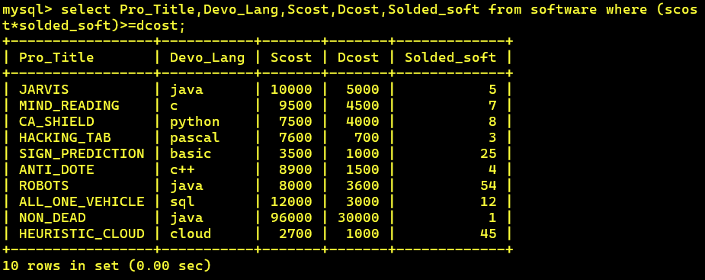

**15) How many packages were developed in dbase?**

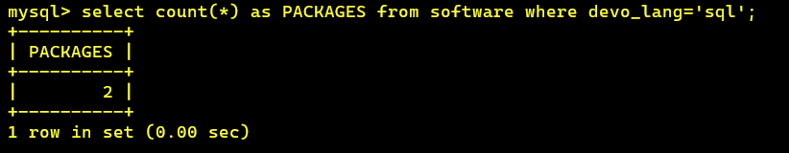

**16) How many programmers studies at paragathi?**

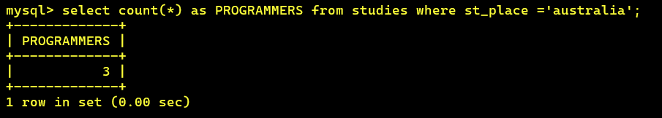

**17) How many programmers paid 5000 to 10000 for their course?**

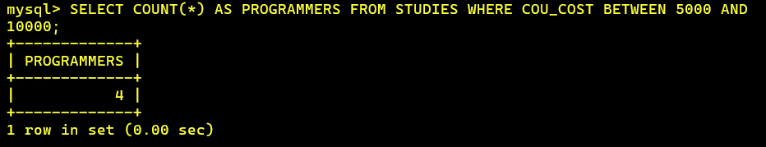

**18) What is the average course fee?**

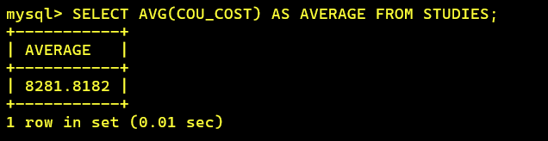

**19) Display the details of programmers knowing c?**

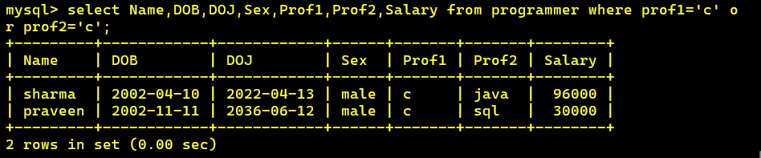

**20) How many programmers know either Cobol or Pascal?**

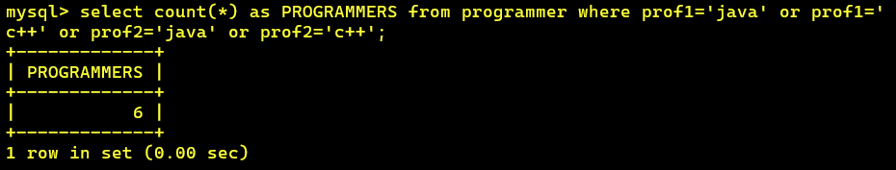

**21) How many programmers don't know Pascal & C?**

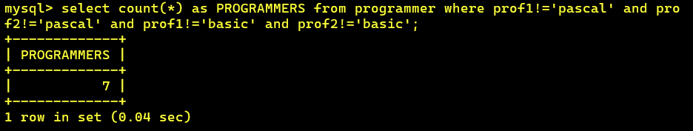

**22) How old is the oldest male programmers?**

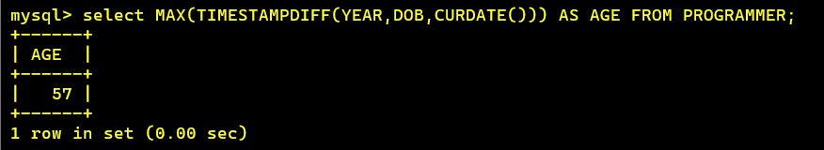

**23) What is the average age of female programmers?**

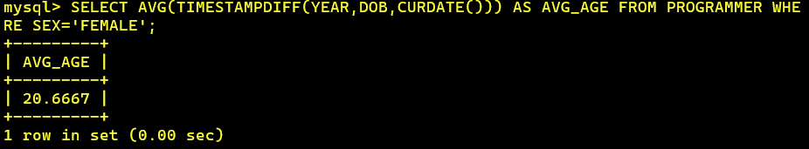

**24) Calculate the experience in years for each programmers and display along with the names in descending order?**

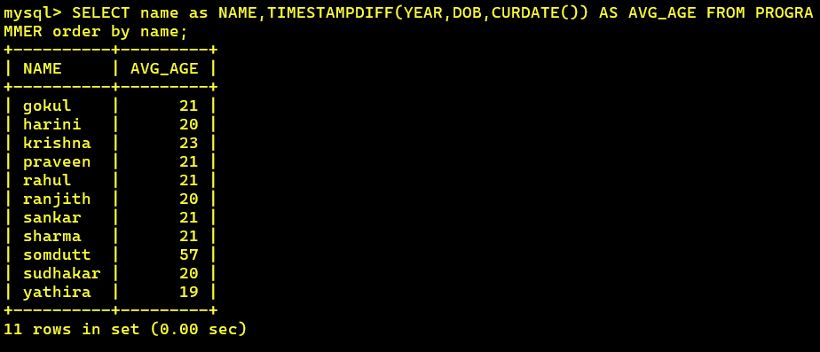

**25) Who are the programmers who celebrate their birthday during the current month?**

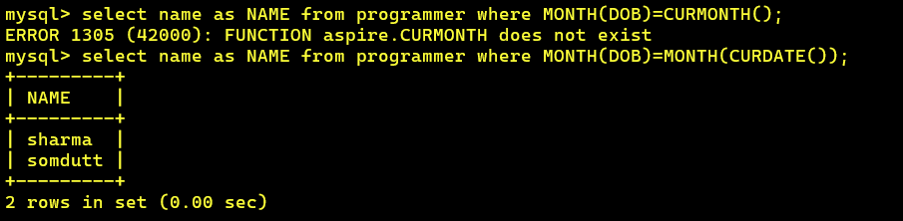

**26) How many female programmers are there?**

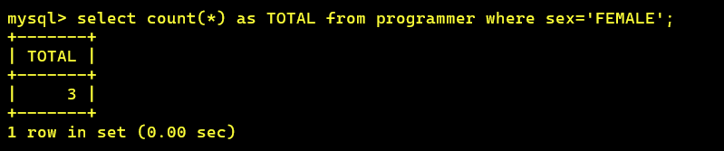

**27) What are the languages known by the male programmers?**

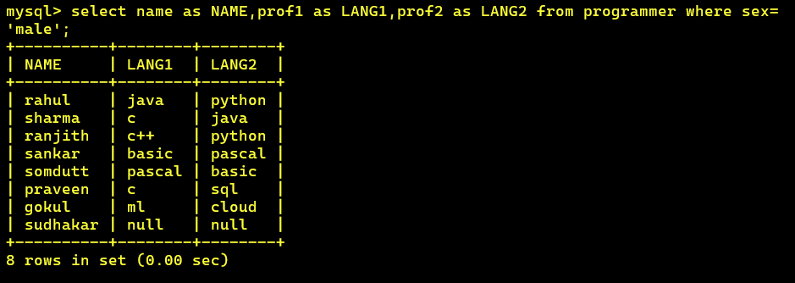

**28) What is the Average salary?**

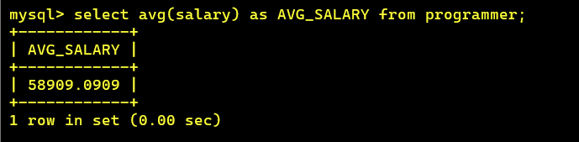

**29) How many people draw 2000 to 4000?**

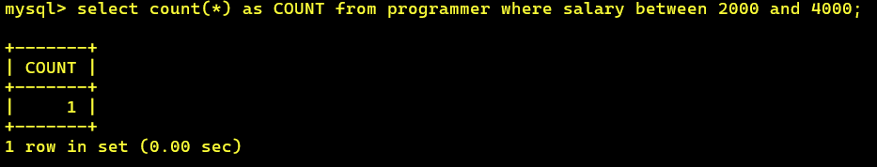

**30) Display the details of those who don't know Clipper, Cobol or Pascal?**

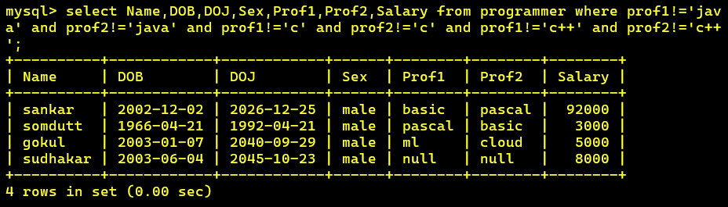

**31) How many Female programmers knowing C are above 24 years of age?**

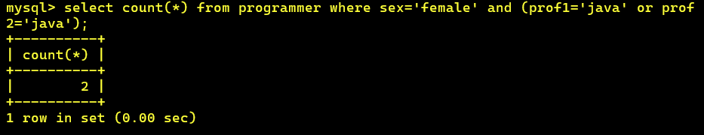

**32) Who are the programmers who will be celebrating their Birthday within a week?**

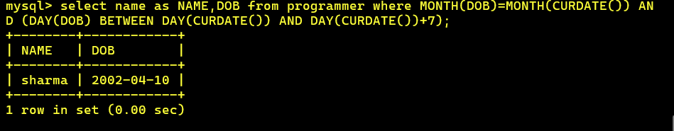

**33 Display the details of those with less than a year's experience?**

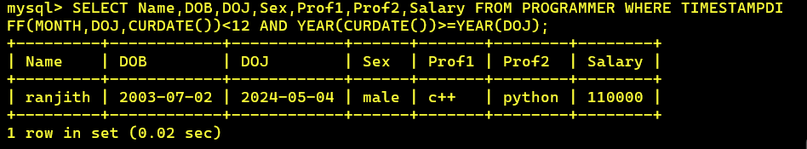

**34 Display the details of those who will be completing 2 years of service this year?**

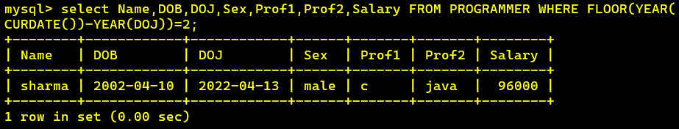

**35 Calculate the amount to be recovered for those packages whose development cost has not been recovered?**

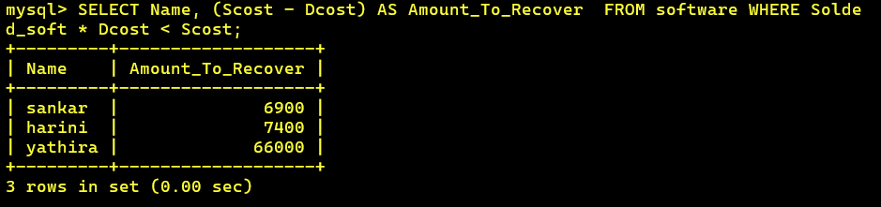

**36) List the packages which have not been sold so far?**

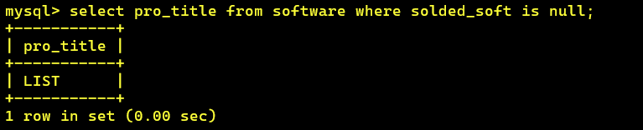

**37) Find out the cost of the software developed by Mary?**

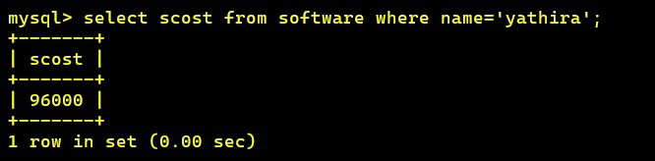

**38) Display the institute’s names from the studies table without duplicates?**

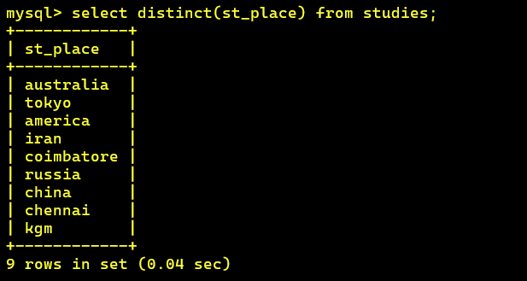

**39) How many different courses are mentioned in the studies table?**

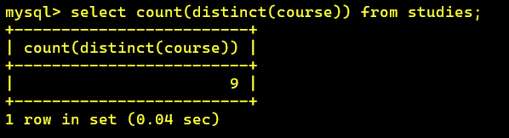

**40) Display the names of the programmers whose names contain 2 occurrences of the letter A?**

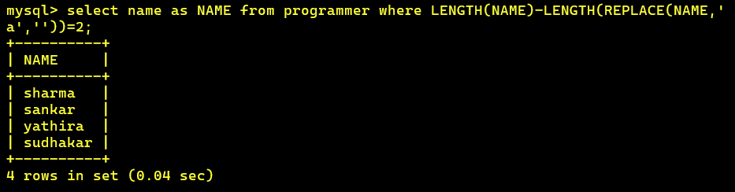

**41) Display the names of programmers whose names contain unto 5 characters?**

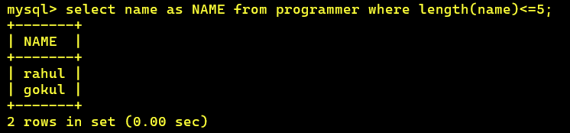

**42) How many female programmers knowing COBOL have more than 2 years experience?**

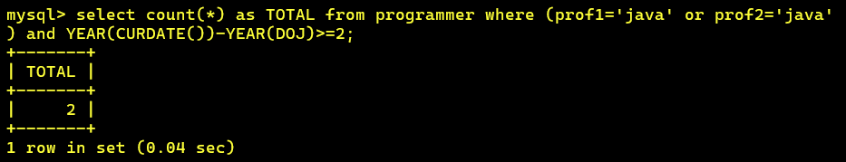

**43) What is the length of the shortest name in the programmer table?**

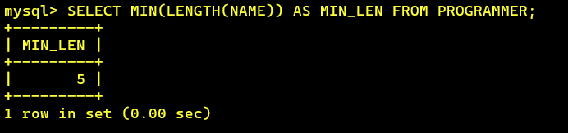

**44) What is the average development cost of a package developed in COBOL?**

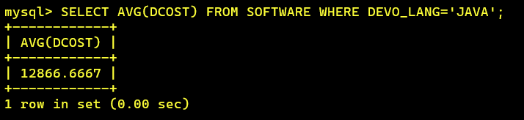

**45) Display the name, sex, dob (DD/MM/YY format), doj for all the programmers without using conversion function?**

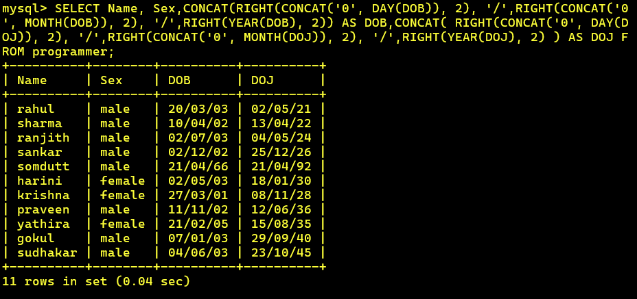

**46) Who are the programmers who were born on the last day of the month?**



**47) What is the amount paid in salaries of the male programmers who do not know Cobol?**



**48) Display the title, scost, dcost and difference between scost and dcost in descending order of difference?**

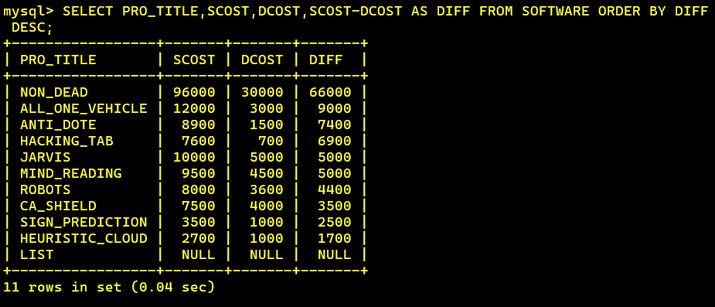

**49) Display the name, dob, doj of those month of birth and month of joining are same?**

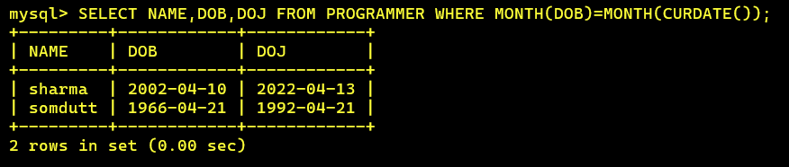

**50) Display the names of the packages whose names contain more than 1 word?**

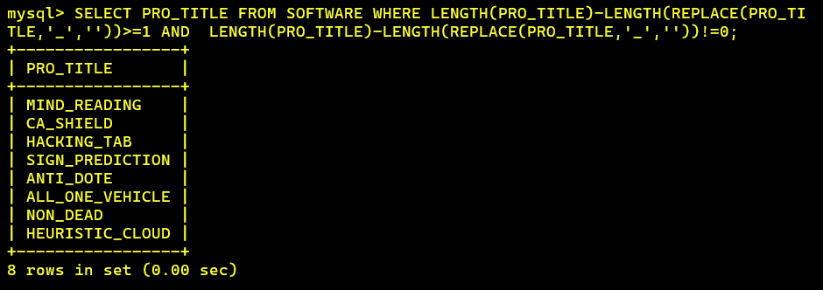

**QUERIES-2:**

**1)Display THE NUMBER OF packages developed in EACH language.**

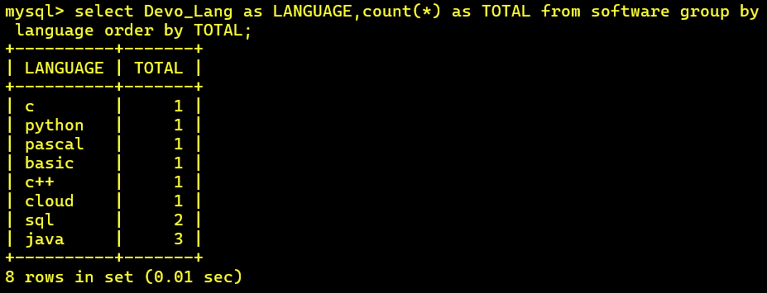

**2) Display THE NUMBER OF packages developed by EACH person.**

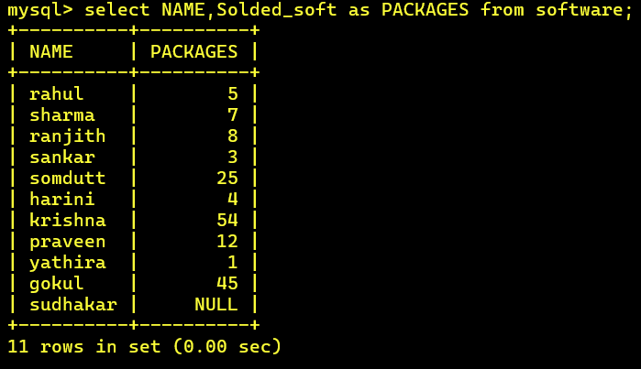

**3) Display THE NUMBER OF male and female programmer.**

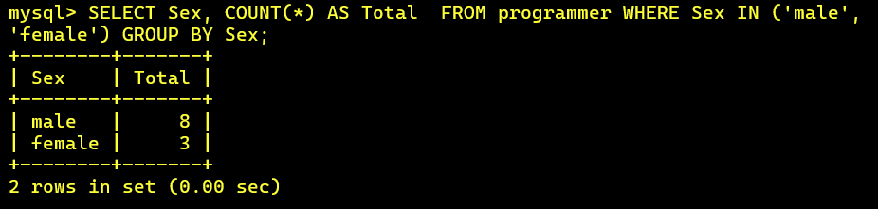

**4) Display THE COSTLIEST packages and HIGEST selling developed in EACH language.**

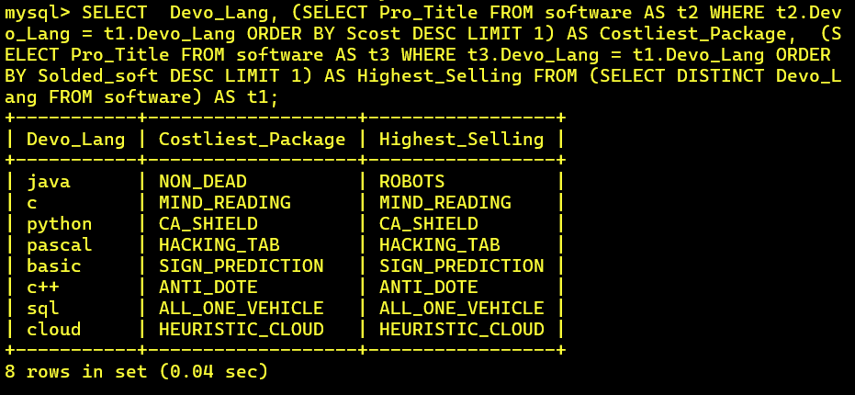

**5) Display THE NUMBER OF people BORN in EACH YEAR.**

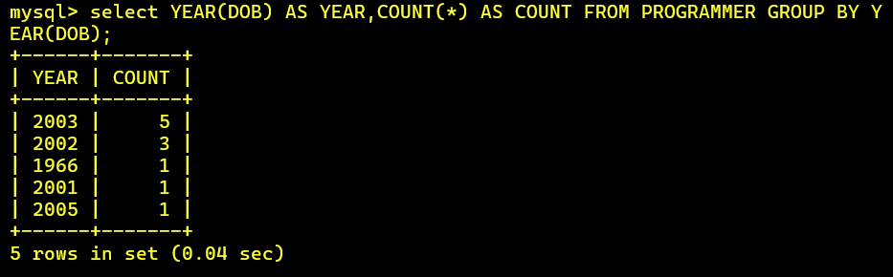

**6) Display THE NUMBER OF people JOINED in EACH YEAR.**

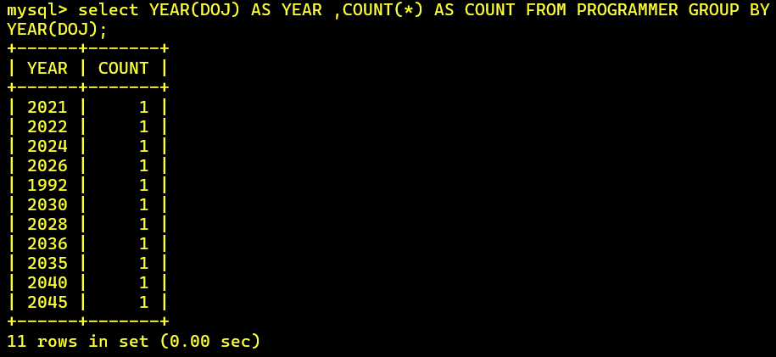

**7) Display THE NUMBER OF people BORN in EACH MONTH.**

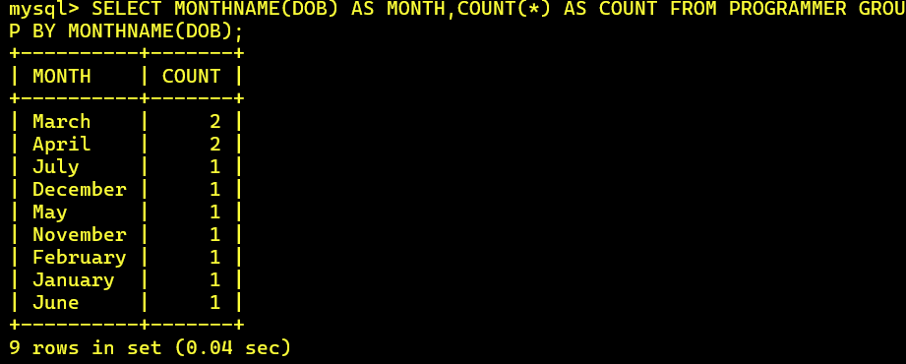

**8) Display THE NUMBER OF people JOINED in EACH MONTH.**

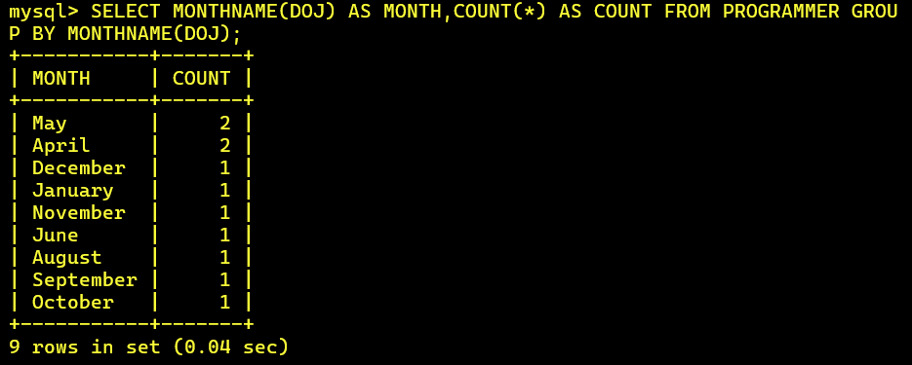

**9) Display the language wise COUNTS of prof1.**

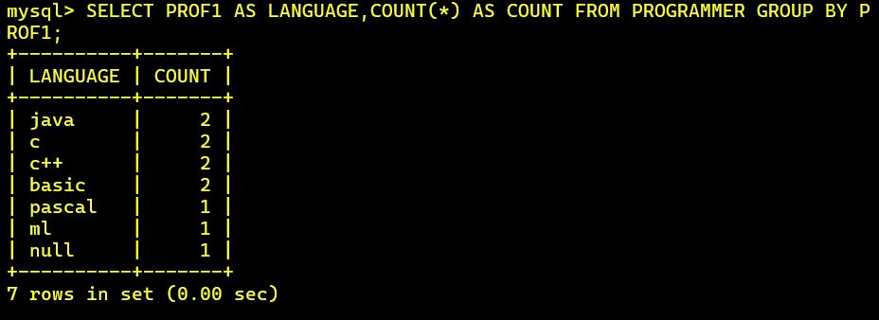

**10) Display the language wise COUNTS of prof2.**

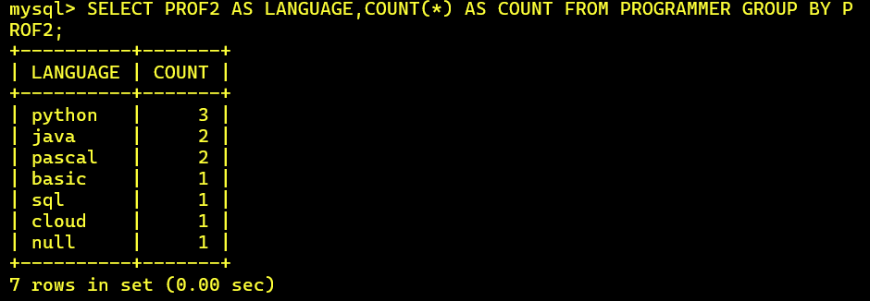

**11) Display THE NUMBER OF people in EACH salary group.**

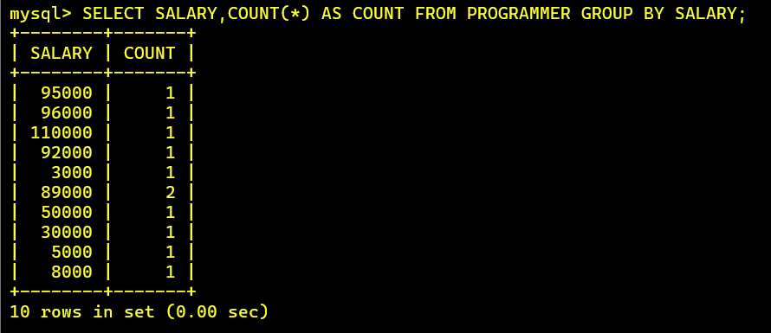

**12) Display THE NUMBER OF people who studied in EACH institute.**

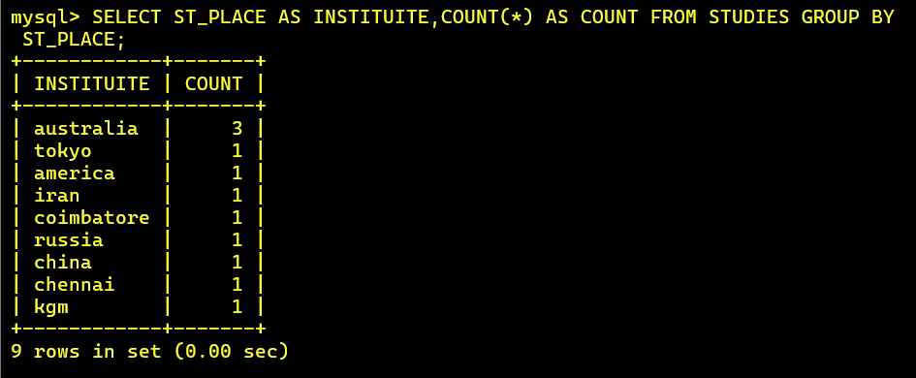

**13) Display THE NUMBER OF people who studied in EACH course.**

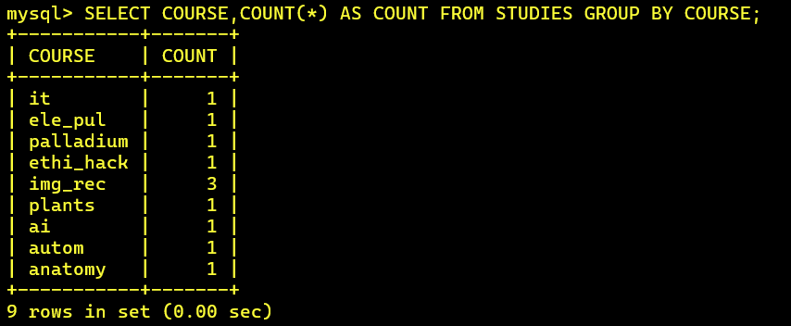

**14) Display the TOTAL development COST of the packages developed in EACH language.**

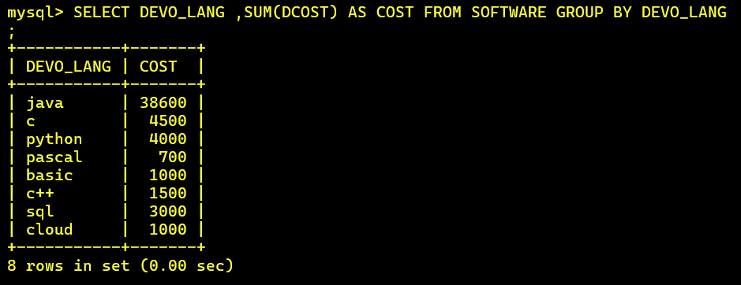

**15) Display the selling cost of the package developed in EACH language.**

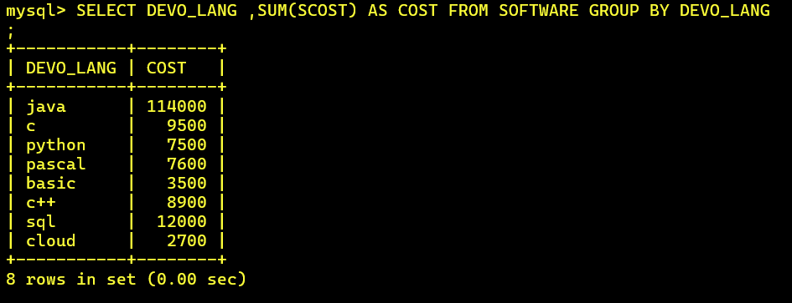

**16) Display the cost of the package developed by EACH programmer.**

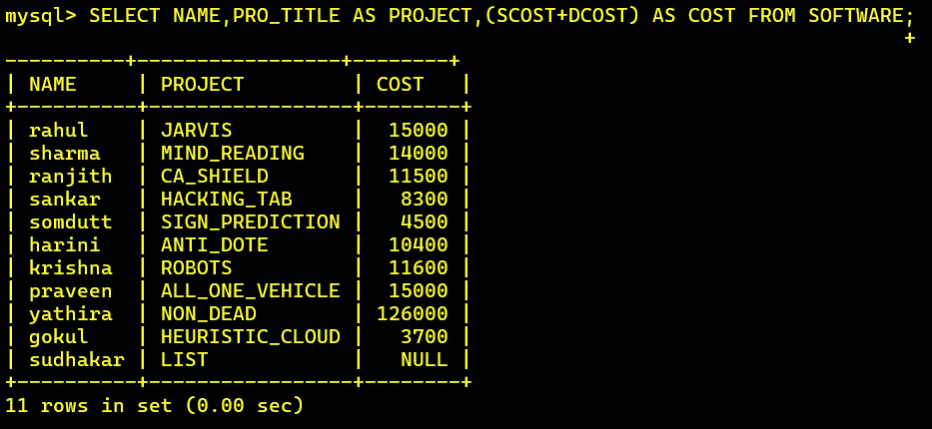

**17) Display the sales values of the package developed in EACH programmer.**

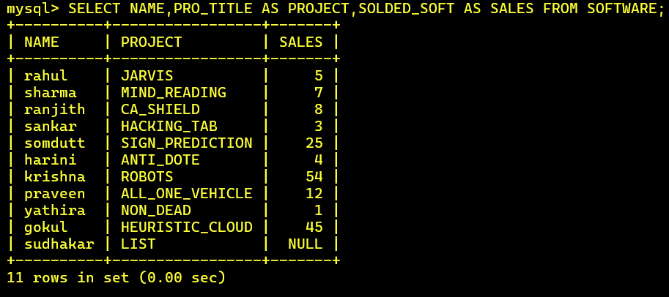

**18) Display the NUMBER of packages developed by EACH programmer.**

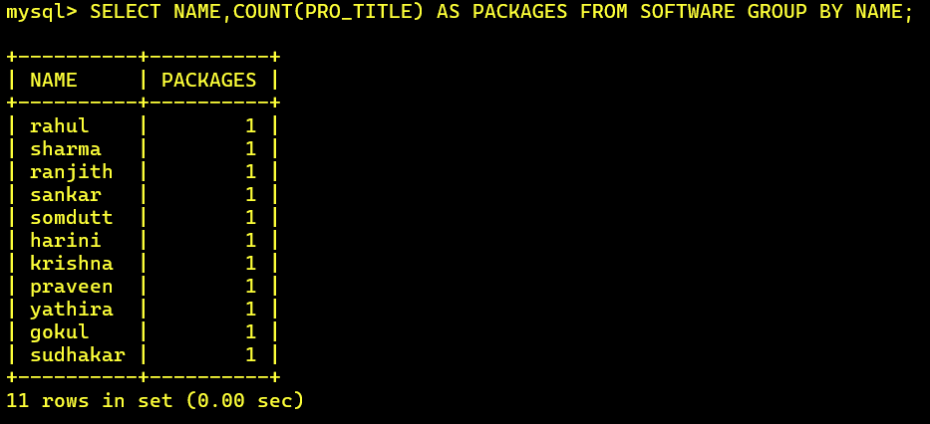

**19) Display the sales COST of packages developed by EACH programmer language wise.**

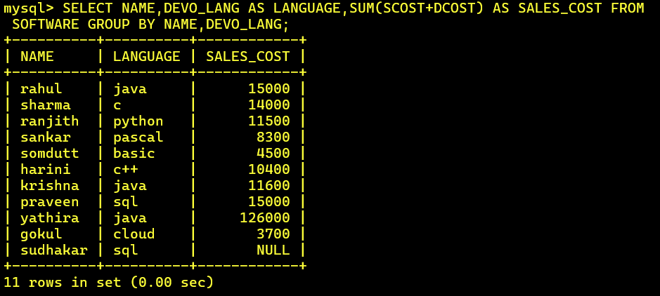

**20) Display EACH programmers name, costliest package and cheapest packages developed by Him/Her.**

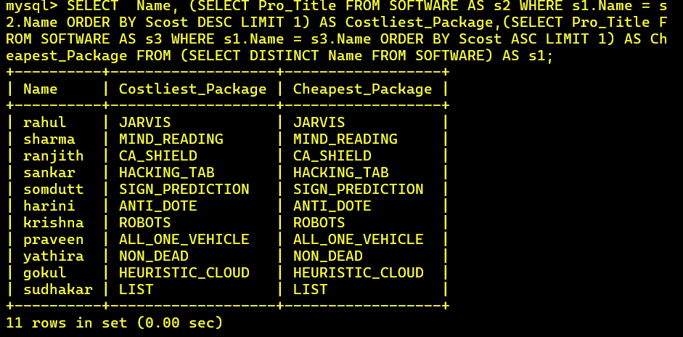

**21) Display EACH language name with AVERAGE development cost, AVERAGE cost, selling cost and AVERAGE price per copy.**

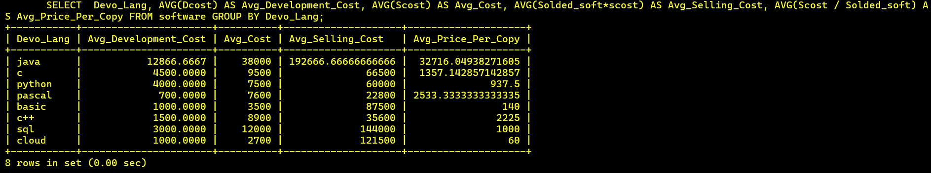

**22) Display EACH institute name with NUMBER of courses, AVERAGE cost per course.**

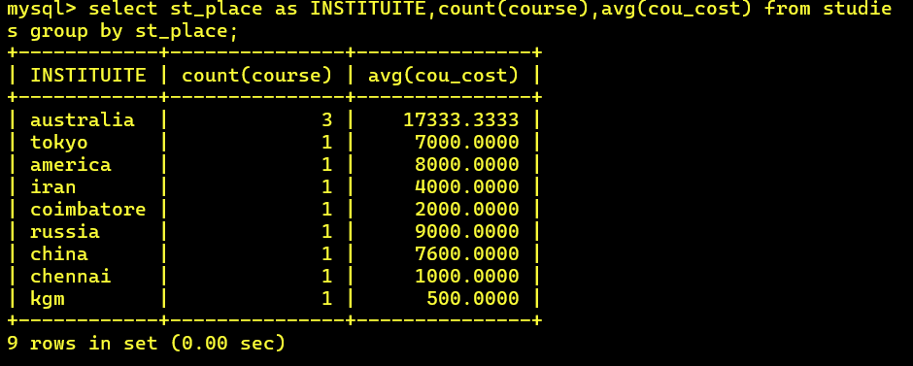

**23) Display EACH institute name with NUMBER of students.**

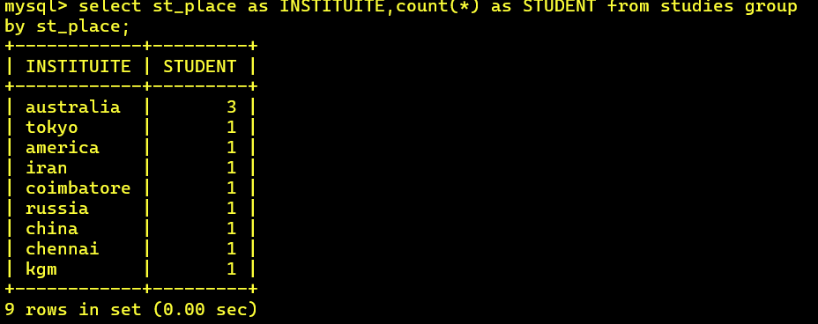

**24) Display names of male and female programmers**.

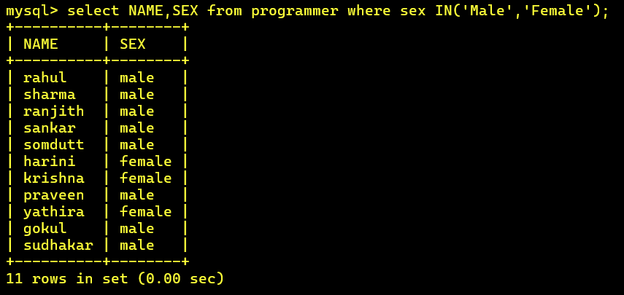

**25) Display the programmer's name and their packages.**

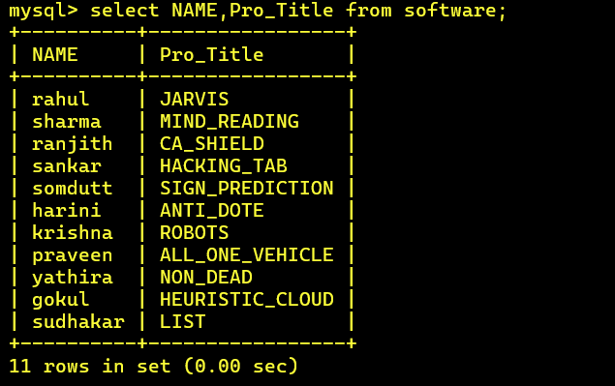

**26) Display the NUMBER of packages in EACH language.**

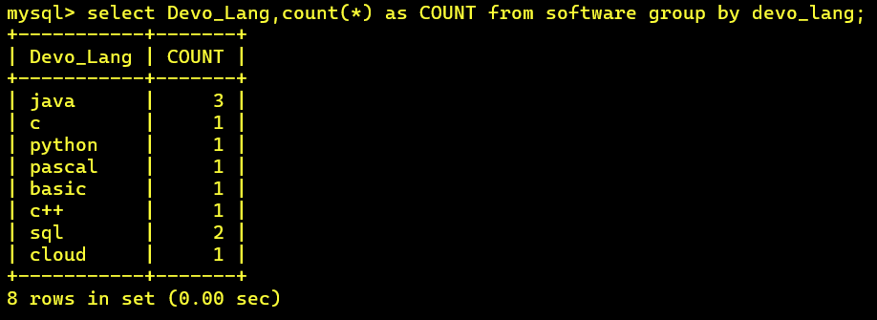

**27) Display the NUMBER of packages in EACH language for which development cost is less than 1000.**

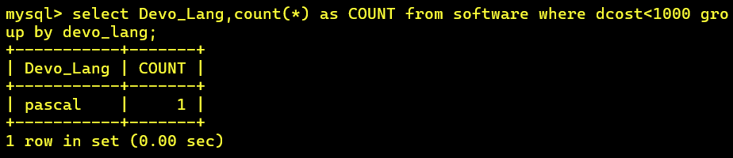

**28) Display the AVERAGE difference BETWEEN scost and dcost for EACH language.**

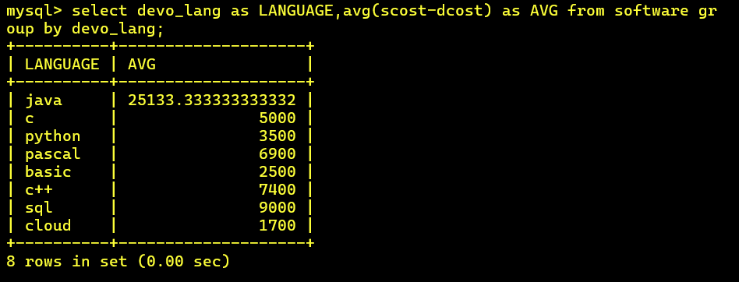

**29) Display the TOTAL scost, dcsot and amount TOBE recovered for EACH programmer for whose dcost HAS NOT YET BEEN recovered.**

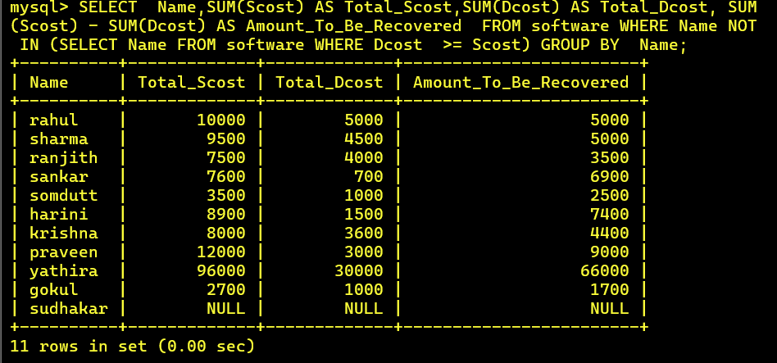

**30) Display highest, lowest and average salaries for THOSE earning MORE than 2000**.

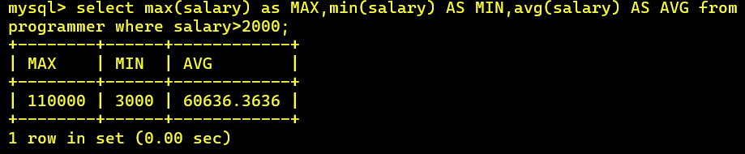

**QUERIES-3:**

**1) Who is the highest paid C programmer?**

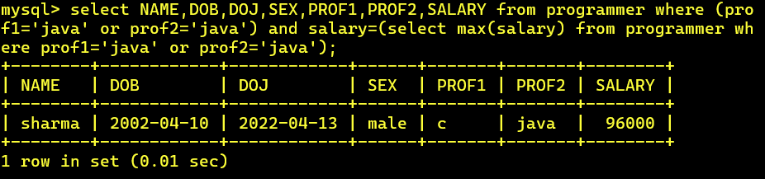

**2) Who is the highest paid female cobol programmer?**

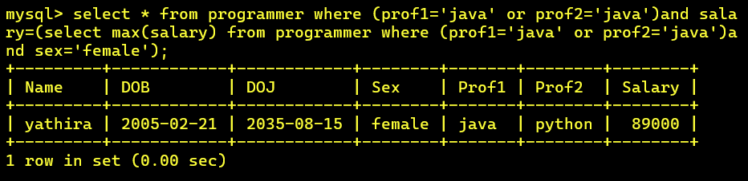

**3) Display the name of the HIGEST paid programmer for EACH language (prof1)**

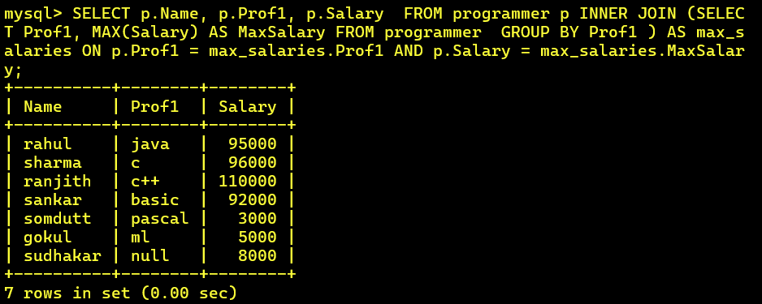

**4) Who is the LEAST experienced programmer?**

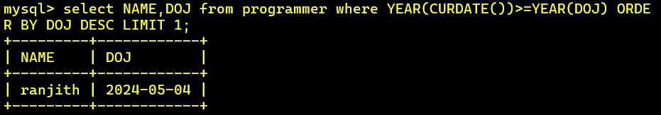

**5) Who is the MOST experienced programmer?**

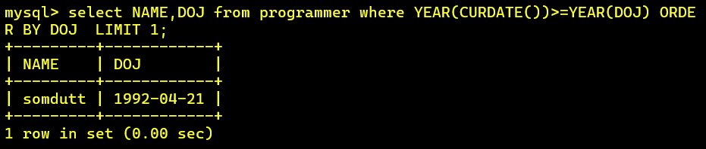

**6) Which language is known by ONLY ONE programmer?**

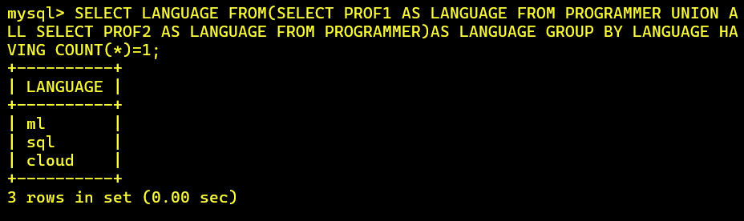

**7) Who is the YOUNGEST programmer knowing DBASE?**

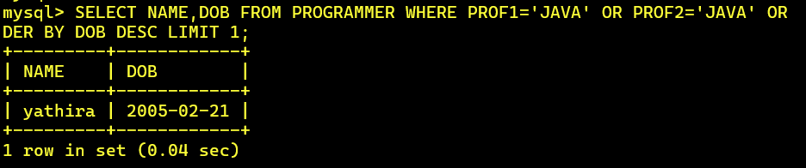

**8) Which institute has MOST NUMBER of students?**

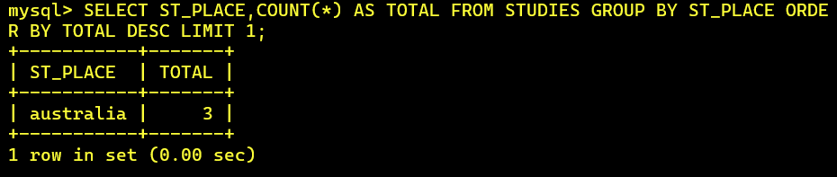

**9) Who is the above programmer?**

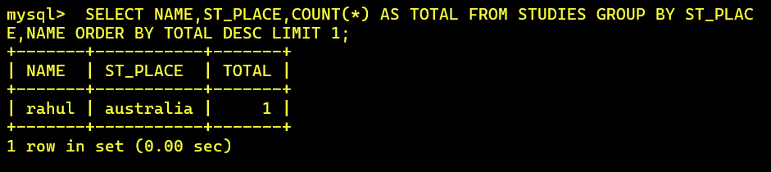

**10) Which female programmer earns MORE than 3000/- but DOES NOT know C, C++, Oracle or Dbase?**

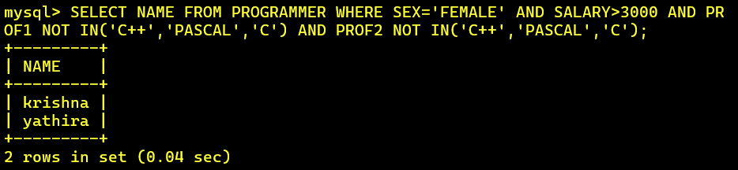

**11) Which is the COSTLIEST course?**

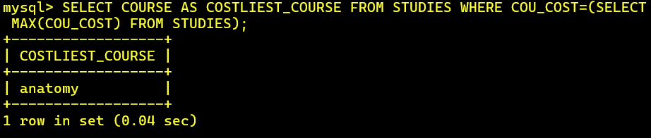

**12) Which course has been done by MOST of the students?**

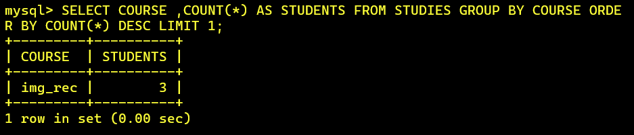

**13) Display name of the institute and course Which has below AVERAGE course fee?**

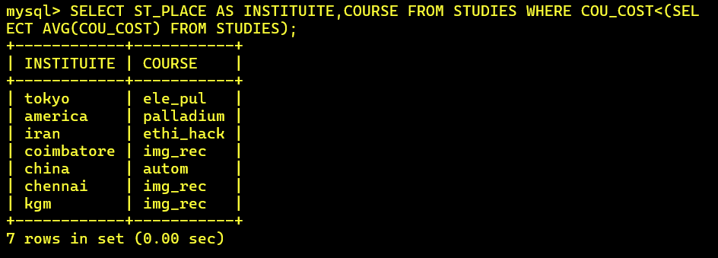

**14) Which institute conducts COSTLIEST course?**

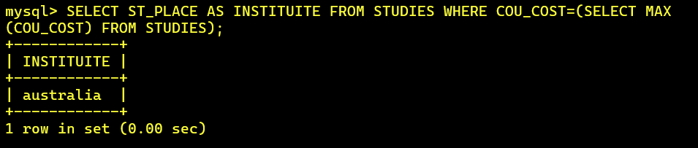

**15) Which course has below AVERAGE number of students?**

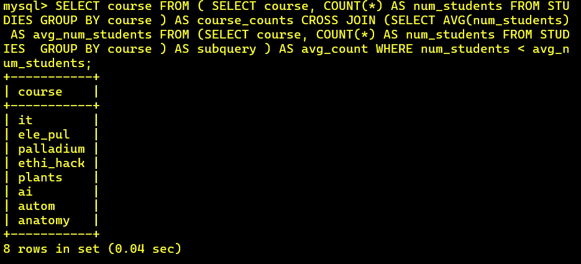

**16) Which institute conducts the above course?**

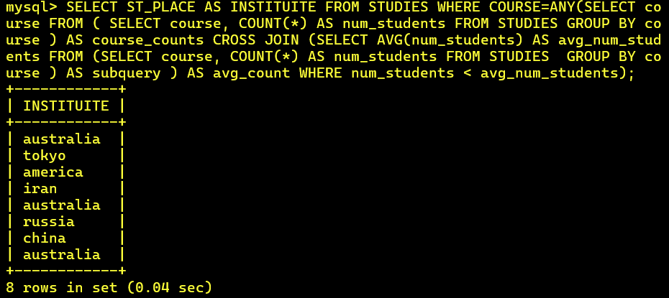

**17) Display names of the course WHOSE fees are within 1000(+ or -) of the AVERAGE fee.**

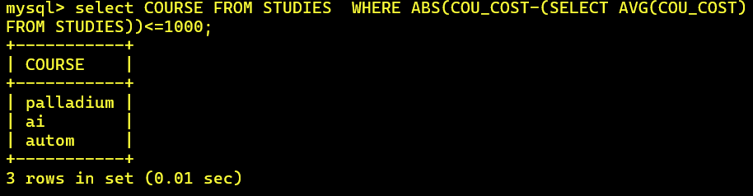

**18) Which package has the HIGEST development cost?**

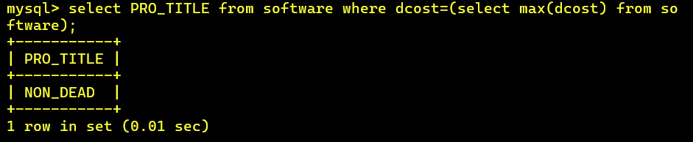

**19) Which package has the LOWEST selling cost?**

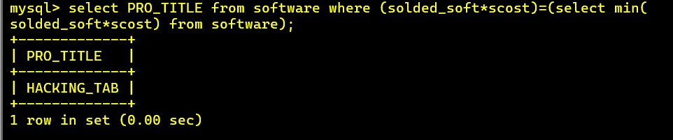

**20) Who developed the package, which has sold the LEAST number of copies?**

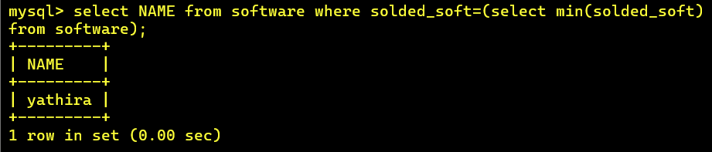

**21) Which language was used to develop the package WHICH has the HIGEST sales amount?**

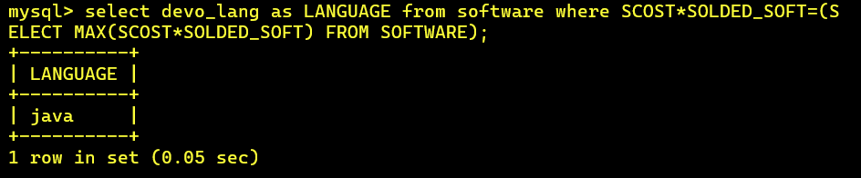

**22) How many copies of the package that has the LEAST DIFFRENCE between development and selling cost were sold?**

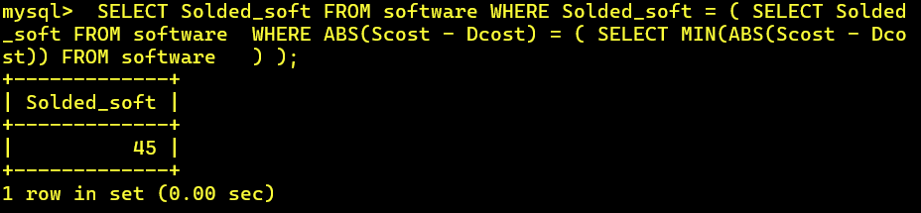

**23) Which is the COSTLIEAST package developed in PASCAL?**

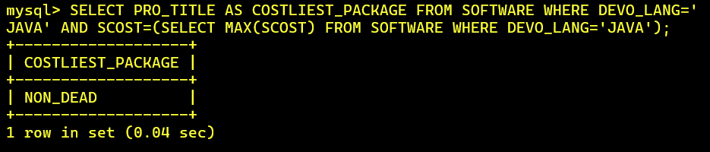

**24) Which language was used to develop the MOST NUMBER of package?**

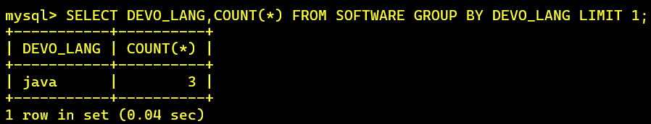

**25) Which programmer has developed the HIGEST NUMBER of package?**

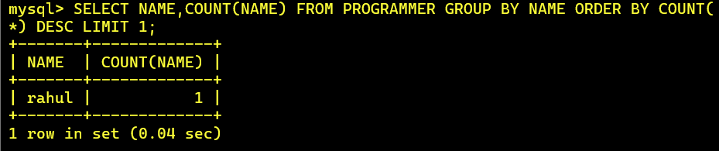

**26) Who is the author of the COSTLIEST package?**

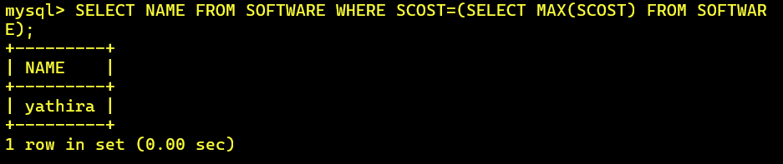

**27) Display names of packages WHICH have been sold LESS THAN the AVERAGE number of copies?**

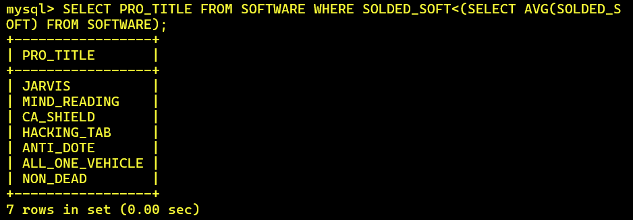

**28) Who are the female programmers earning MORE than the HIGEST paid male programmers?**



**29) Which language has been stated as prof1 by MOST of the programmers?**

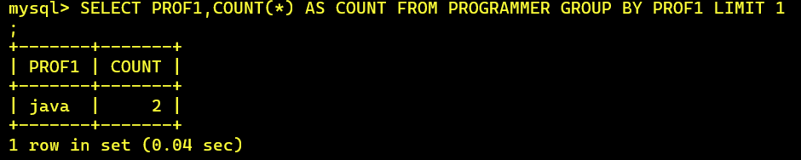

**30) Who are the authors of packages, WHICH have recovered MORE THAN double the development cost?**

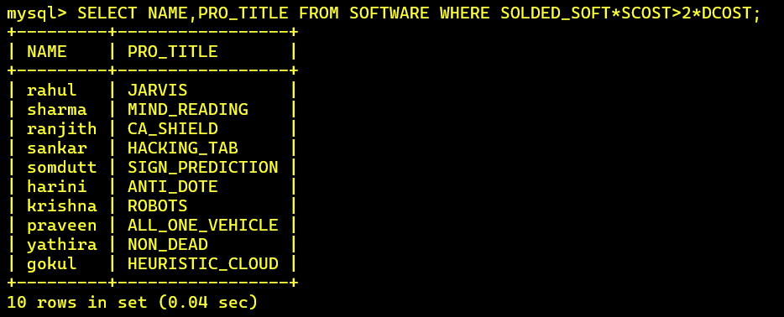

**31) Display programmer names and CHEAPEST package developed by them in EACH language?**

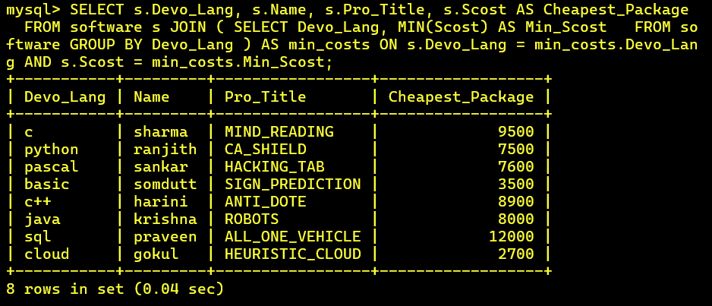

**32) Who is the YOUNGEST male programmer born in 1965?**

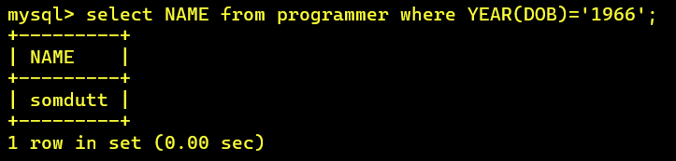

**33) Display language used by EACH programmer to develop the HIGEST selling and LOWEST selling package.**

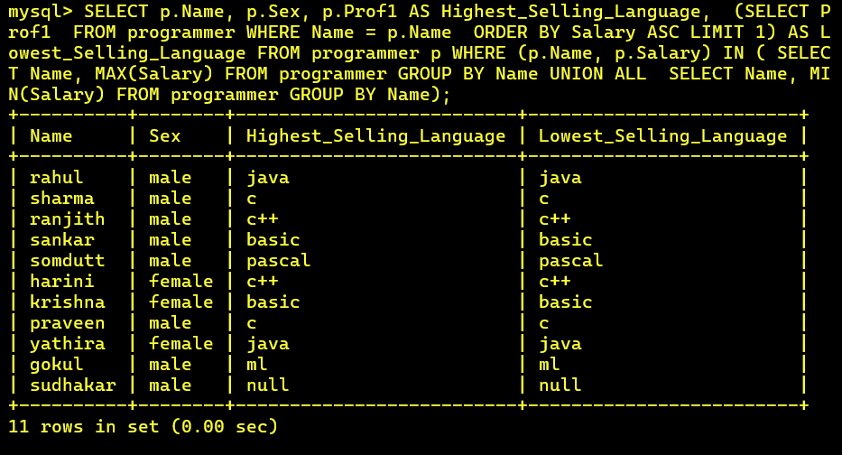

**34) Who is the OLDEST female programmer WHO joined in 1992**

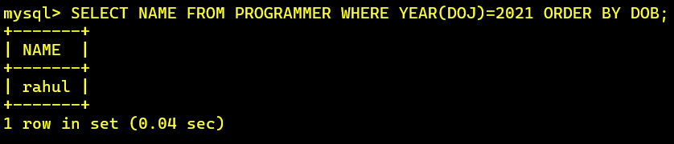

**35) In WHICH year where the MOST NUMBER of programmer born?**

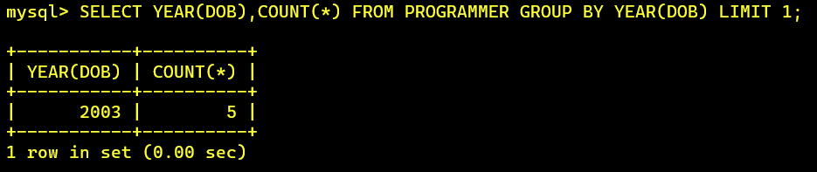

**36) In WHICH month did MOST NUMBRER of programmer join?**

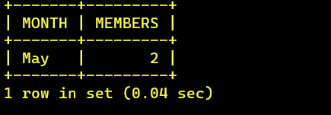

**37) In WHICH language are MOST of the programmer's proficient?**

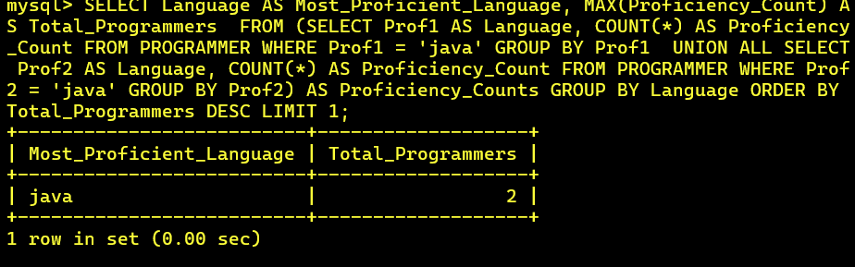

**38) Who are the male programmers earning BELOW the AVERAGE salary of female programmers?**

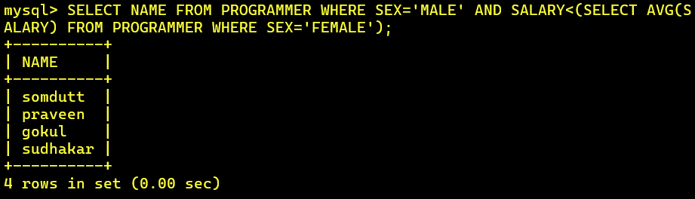

**QUERIES-4:**

**1) Display the details of THOSE WHO are drawing the same salary.**

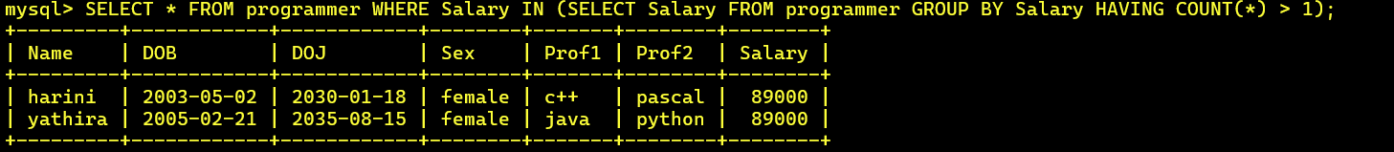

**2) Display the details of software developed by male programmers earning MORE than 3000.**

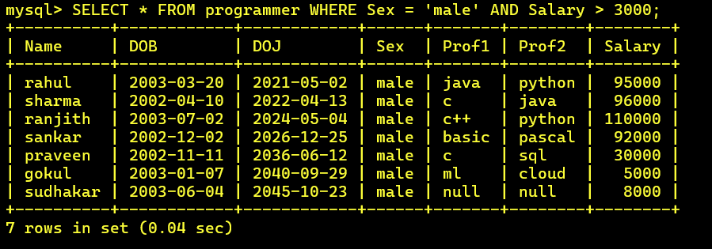

**3) Display details of packages developed in PASCAL by female programmers.**

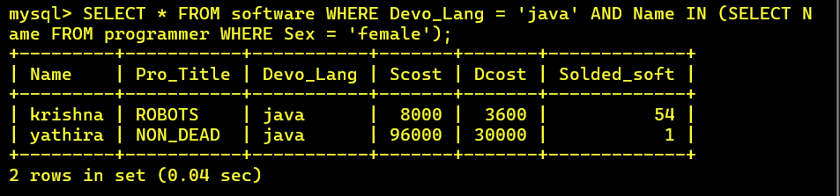

**4) Display the details of the programmer WHO joined BEFORE 1990.**

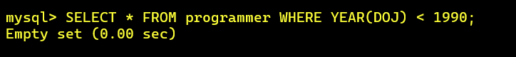

**5) Display details of software developed in C by female programmers of PRAGATHI.**

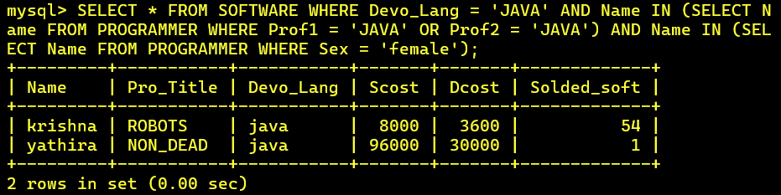

**6) Display NUMBER of packages NUMBER of copies sold and sales value of EACH programmer Institute-wise.**

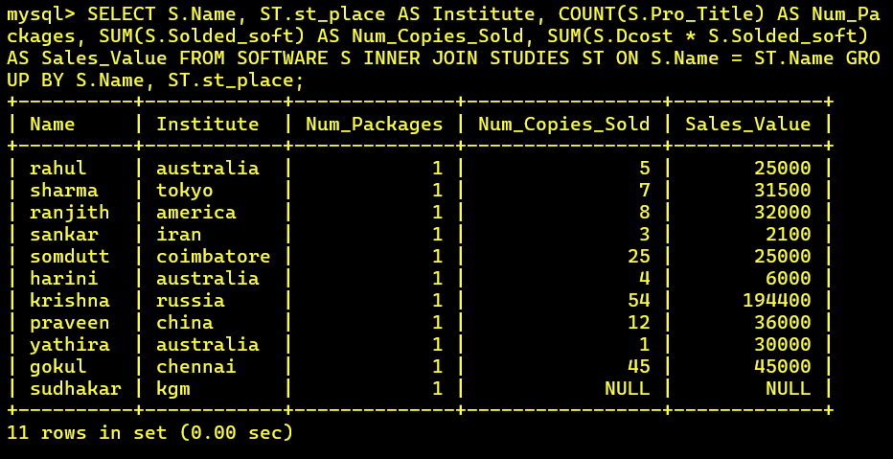

**7) Display details of software developed in DBASE by male programmers WHO belong to the institute on which MOST NUMBER OF programmer’s studies.**

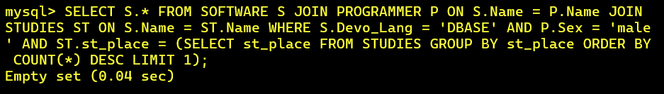

**8) Display the details of the software that was developed by male programmers born BEFORE 1965 and female programmers born AFTER 1975.**

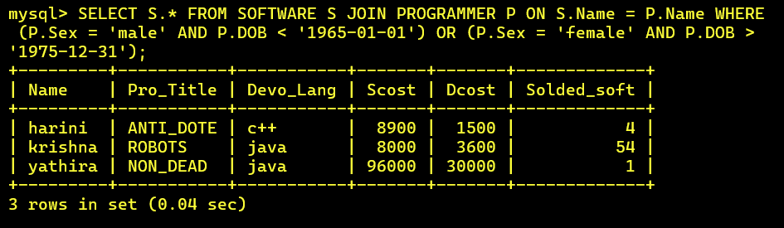

**9) Display the details of the software that was developed in the language that is NOT the programmer’s first proficiency.**

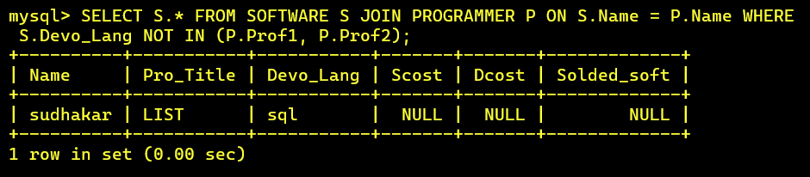

**10) Display details of software that was developed in the language which is NEITHER first NOR second proficiency of the programmer.**

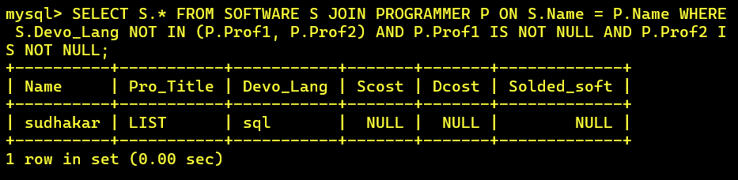

**11) Display details of software developed by male students of SABHARI.**

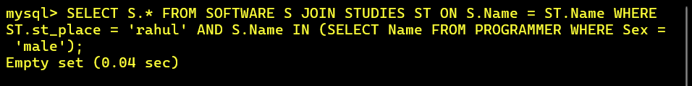

**12) Display the names of programmers WHO HAVE NOT developed any package.**



**13) What is the total cost of the software developed by the programmers by APPLE?**

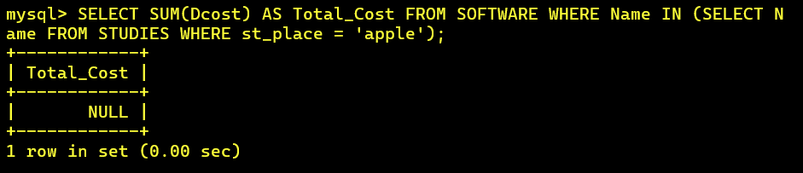

**14) Who are the programmers WHO JOINED in the same day?**



**15) Who are the programmers WHO HAVE THE SAME PROF2?**

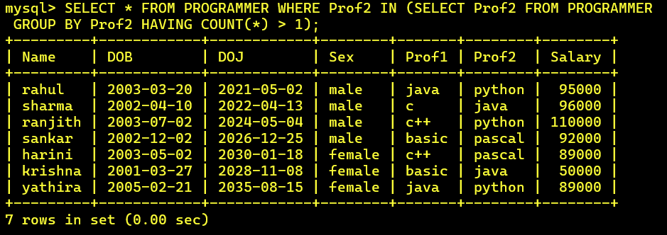

**16) Display the total sales values of software, institutes-wise.**

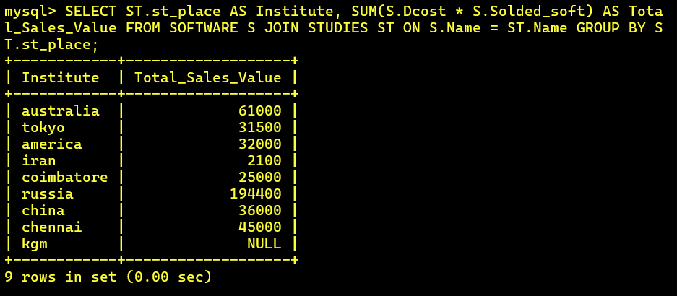

**17) In which institutes did the person who developed the COSTLIEST package study?**

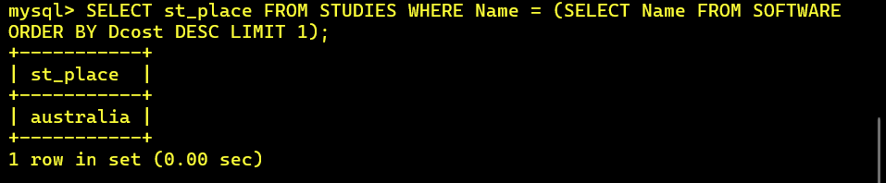

**18) Which language listed in prof1 and prof2 HAS NOT BEEN used to develop any package?**

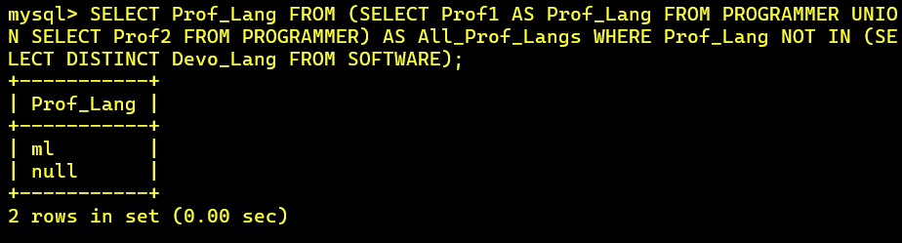

**19) How much does the person WHO developed the HIGHEST selling package earn and WHAT course did he/she undergo?**

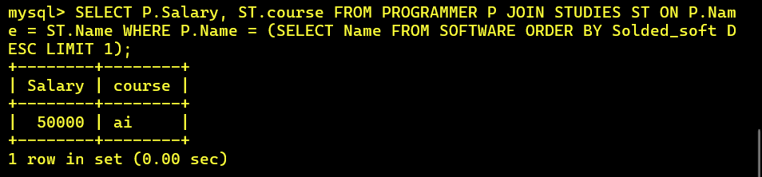

**20) How many months will it take for each programmer to recover the cost of the course underwent?**

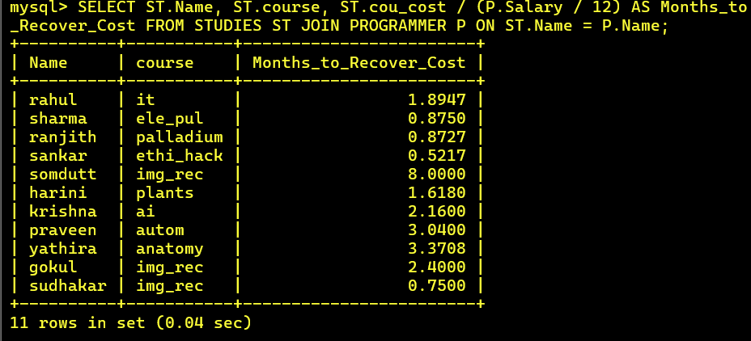

**21) Which is the COSTLIEST package developed by a person with under 3 year’s expenences?**

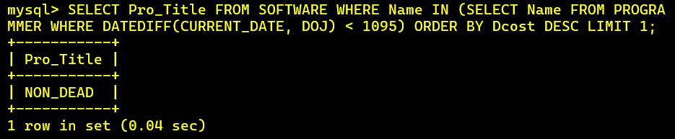

**22) What is the AVERAGE salary for those WHOSE software's sales value is more than 50,000?**

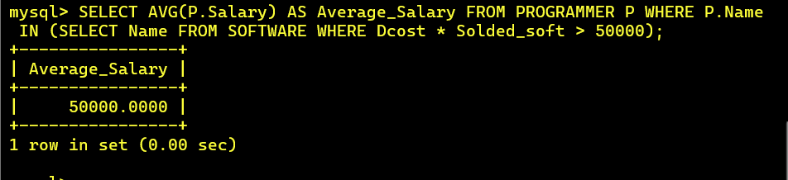

**23) How many packages were developed by the students WHO studied in the institute that Charge the LOWEST course fee?**

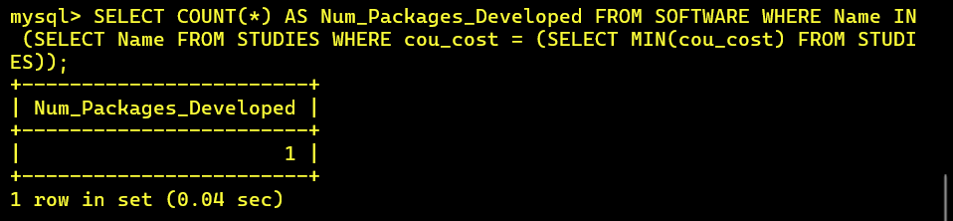

**24) How many packages were developed by the person WHO developed the CHEAPEST package? Where did he\she study?**

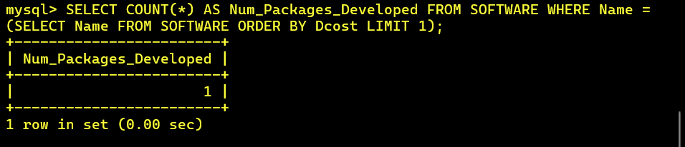

**25) How many packages were developed by female programmers earning MORE than the HIGHEST paid male programmer?**

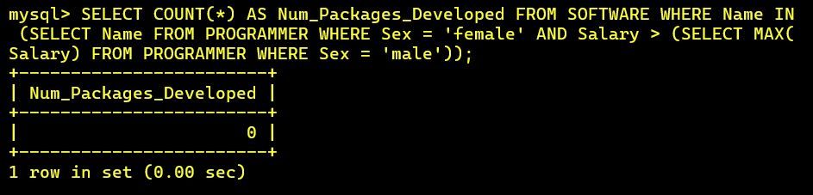

**26) How many packages were developed by the MOST experienced programmers from BDPS?**

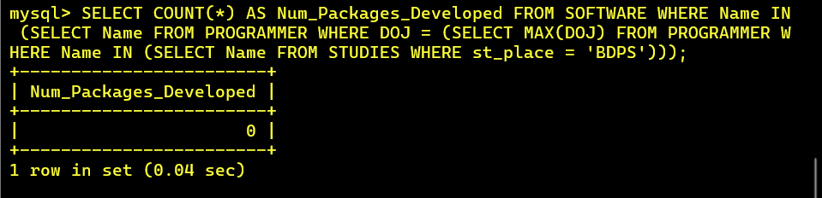

**27) List the programmers (from software table) and institutes they studied, including those WHO DIDN'T develop any package.**

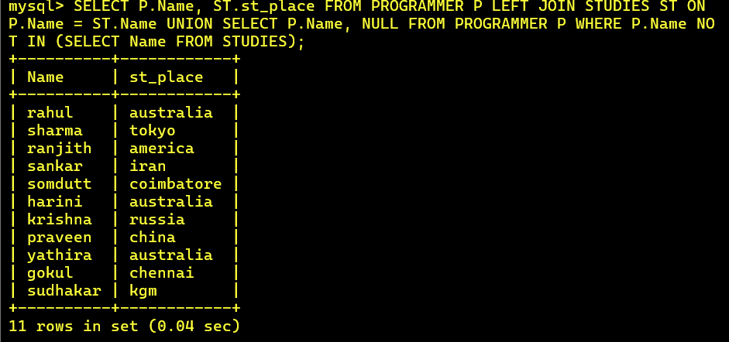

**28) List each profit with the number of programmers having that prof1 and the number of packages developed in that prof1.**

**29) List programmer names (from programmer table) and number of packages EACH developed.**

**30) List all the details of programmers who have done a course at S.S.I.L.**