**SFCC_PRIOS INTEGRATION**

***Version 17.1.0***



**Table of Contents**

1. Summary 3

2. Component Overview 4

2.1 Functional Overview 4

2.2 Use Cases 8

2.3 Limitations, Constraints 10

2.4 Compatibility 10

2.5 Privacy, Payment 10

3. Implementation Guide 11

3.1 Setup 11

3.2 Configuration 11

3.3 Custom Code 12

3.4 External Interfaces 12

3.5 Firewall Requirements 12

3.6 Testing 12

4. Operations, Maintenance 14

4.1 Data Storage 14

4.2 Availability 14

4.3 Support 14

5. User Guide 15

5.1 Roles, Responsibilities 15

5.2 Business Manager 15

5.3 Storefront Functionality 16

6. Known Issues 17

7. Release History 18

# Summary

The Submitted Link Cartridge Enables the SFCC users to seamlessly connect with Prios which is an Instore digital Mobile application. As a first version, Prios will have the basic functionalities of a Mobile commerce application for IOS. Subsequently the Link Cartridge and Prios will be extended to support Instore digital features also.

Through SFCC and PRIOS integration, customers can manage consumer interactions across all digital touch points globally, enabling a seamless and consistent brand experience on any channel. Our platform is built to support digital commerce best practices and can be customized to individual needs, with full access to a sophisticated Omni-channel marketing and merchandising engine and open development environment.

# Component Overview

## Functional Overview

Prios is a ready to Plug-in Salesforce Commerce Mcommerce solution built on IOS. The Solution gives the client the ability to extend their e-shop on Mobile and also customize it to their need. Our framework gives clients the option to customize the solution to suite their business as well as help them add Mcommerce capability in a short span of time.

Prios brings enormous value to Commerce Cloud customers where it not only enables Mcommerce but also extends the app to enable instore digital experience. Apart from the Mcommerce functionality like the Searching, Carting and Paying. It also enables the shops to integrate their Offline store stocks, beacon base instore Marketing and Offline buying, visit a physical store, scan a product bar code, add to cart and then do a check out.

The current solution aims to connect the storefront with PRIOS mobile app with the help of out of box OCAPIs available in SFCC. This cartridge provides the features which are not available out of the box in SFCC.

Presently the customizations include:

* Adding product image in the response when adding item to cart.
* Adding product image in response when fetching the basket.
* Adding custom attribute i.e. Brand of the product on hit of the search products API.



**Screenshots of the Prios Mobile App:**

|  |  |
| --- | --- |
| ***C:\Users\kiran.banerjee\Desktop\Prios Screenshots\Home.PNG***  ***Home Page 1*** | ***C:\Users\kiran.banerjee\Desktop\Prios Screenshots\HomePage -OnlineMode.PNG***  ***Home Page 2*** |
| ***C:\Users\kiran.banerjee\Desktop\Prios Screenshots\Menu.PNG***  ***Menu*** | ***C:\Users\kiran.banerjee\Desktop\Prios Screenshots\Product List.PNG***  ***Product List*** |
| ***C:\Users\kiran.banerjee\Desktop\Prios Screenshots\Product Detail1.PNG***  ***Product Details Page 1*** | ***C:\Users\kiran.banerjee\Desktop\Prios Screenshots\Product Detail2.PNG***  ***Product Details Page 2*** |
| ***C:\Users\kiran.banerjee\Desktop\Prios Screenshots\CartPageInOnline.PNG***  ***Cart Page*** | ***C:\Users\kiran.banerjee\Desktop\Prios Screenshots\CheckoutPage.PNG***  ***Place Order Page*** |

## Use Cases

**Use Case for the customized APIs:**

**Use Case – 1 (Add Item to Cart API):**

|  |  |
| --- | --- |
| Add Item to Cart API | On adding Item to Basket, product image should also come in response. |
| Goal in Context | While adding individual products in the Cart the product’s image should be added in the response. |
| Preconditions | User should be able to add products to cart, and those products should have “small” size image configured in it. |
| Success End Condition | After the product is added to cart successfully the product image URL should also be present in the response. |
| Failed End Condition | Either the product is not added in cart or in spite of product being added image URL in not updated. |
| Primary Actor | Customer |
| Trigger | On adding a product to Cart. |
| Description | When a product is being added to cart its image URL should also be present in the response. |

**Use Case – 2 (Get basket API):**

|  |  |
| --- | --- |
| Get basket API | On fetching the Basket, product image should also come in response. |
| Goal in Context | While fetching the basket, the product’s image should be present in the response. |
| Preconditions | There should be added products in the basket and those products should have “small” size image configured in it. |
| Success End Condition | When the basket is fetched the product image URL should also be present in the response. |
| Failed End Condition | Either the basket is not fetched or the basket is fetched but the added image URL in not present in response. |
| Primary Actor | Customer |
| Trigger | On clicking on show Cart. |
| Description | When the customer clicks on show cart, along with the basket object, the image URL should also be present in the response. |

**Use Case – 3 (Search Products API):**

|  |  |
| --- | --- |
| Search Products API | Brand name should also come in the response of Search Product API. |
| Goal in Context | On searching for a product in the search box or on clicking in the sub category along with the products its brand should also come in the response. |
| Preconditions | Products should be configured in the catalog. Keyword searched in the search box should match with any products or the sub category in which it is clicked should have some products assigned to it. |
| Success End Condition | The productile page should be displayed and each product should have the brand associated with it. |
| Failed End Condition | The productile page is not displayed or the products don’t have the brand associated with it. |
| Primary Actor | Customer |
| Trigger | On searching with a keyword on the search box or clicking the subcategory. |
| Description | On searching for a product in the search box or on clicking in the sub category along with the products its brand should also come in the response. |

**Use Case for the Out of the Box APIs:**

Details regarding all the other out of the box APIs which are used in our integration are available here:



## Limitations, Constraints

As a first version, Prios will have only the basic functionalities of a Mobile commerce application.

It is available only for iOS as of now.

Subsequently the Link Cartridge and Prios will be extended to support Instore digital features also.

Features such as Promotions, Password Reset, Wishlist will be available in upcoming versions.

## Compatibility

Available since Commerce Cloud 17.8

Cartridge developed in SiteGenesis 103.1.11

## Privacy, Payment

NA

# Implementation Guide

## Setup

This integration provides a cartridge int_aspiresystems. This cartridge must be deployed on any instance where connection with Prios Mobile App has to be made. On being deployed on any instance with proper OCAPI setting, that instance can be connected with the Prios Mobile app.

## Configuration

In order to configure Prios Mobile App with your SFCC Instance, follow these steps:

**Step 1:** Add the int_aspiresystems cartridge in your UX Studio Workspace and connect to SFCC server

1. In Eclipse, select File > Import > Import Existing Projects into Workspace, and browse to the int_aspiresystems cartridge included with this document.
2. This document assumes that the developer already has a working connection to his their SFCC instance and can add the project to this connection.

For help with these setups, please refer to “Getting Started for Developers” on the SFCC InfoCenter.

**Step 2:** Add the cartridge to your site’s cartridge path in Business Manager

1. Log in to Business Manager.
2. Browse to Administration > Sites > Manage Sites and select the site you want to edit.
3. Click the Settings tab and add : int_aspiresystems ( note the colon) to the cartridge path.
4. Click Apply
5. Confirm that int_aspiresystems is listed in the “Effective Cartridge Path”.

**Step 3:** Add the Open Commerce API settings in Business Manager

1. Log in to Business Manager.
2. Browse to Administration > Site Development > Open Commerce API Settings.
3. Select Shop form the type dropdown, and enter the valid shop API details



Note: Replace the “client_id” with the actual value, and

Replace the “allowed_origins” with your sandboxes URL.

1. Select Data form the type dropdown, and enter the valid data API details



Note: Replace the “client_id” with the actual value, and

Replace the “allowed_origins” with your sandboxes URL.

1. Save the data.

## Custom Code

NA

## External Interfaces

NA

## Firewall Requirements

NA

## Testing

For testing purposes you can use a default Client ID as “aaaaaaaaaaaaaaaaaaaaaaaaaaaaaa”.

For checking response of the Open Commerce APIs outside of the Mobile APP, we can use postman tool.

We can download the chrome extension for POSTMAN.

After that we need to create a new Tab and Add the URL along with its HTTP Method.

Then we will add the required Headers i.e. (Authorization, Origin and Content-Type).

If that URL requires a body we can add that in the body by selecting raw (If it requires JSON input).

We can also Import/export Postman Collections having all the API details in JSON format.

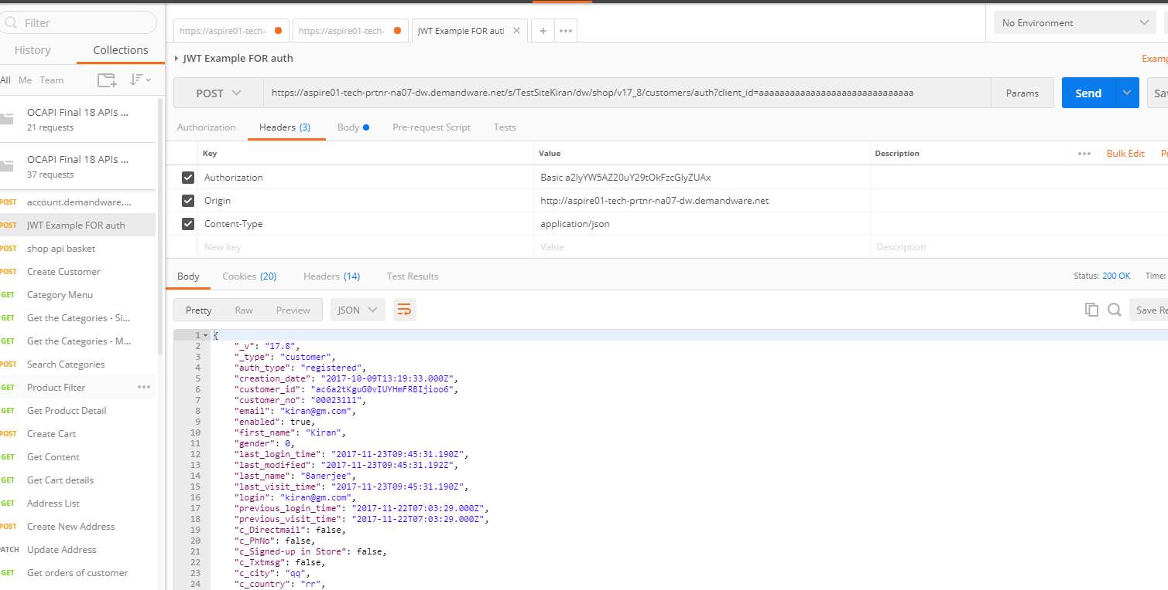

# Operations, Maintenance

## Data Storage

No Custom Objects or separate Data Storage is being used for this Integration.

## Availability

Since this Integration is based on Open Commerce API and no External Service is being used so there will be continuous uptime.

## Support

For Support Purpose, please contactsfcc@aspiresys.com.

# User Guide

## Roles, Responsibilities

Apart from the Cartridge Integration no other recurring task is there.

## Business Manager

We need to configure the Shop and Data JSONs in the Open Commerce API Settings under Administration.

For SHOP API:

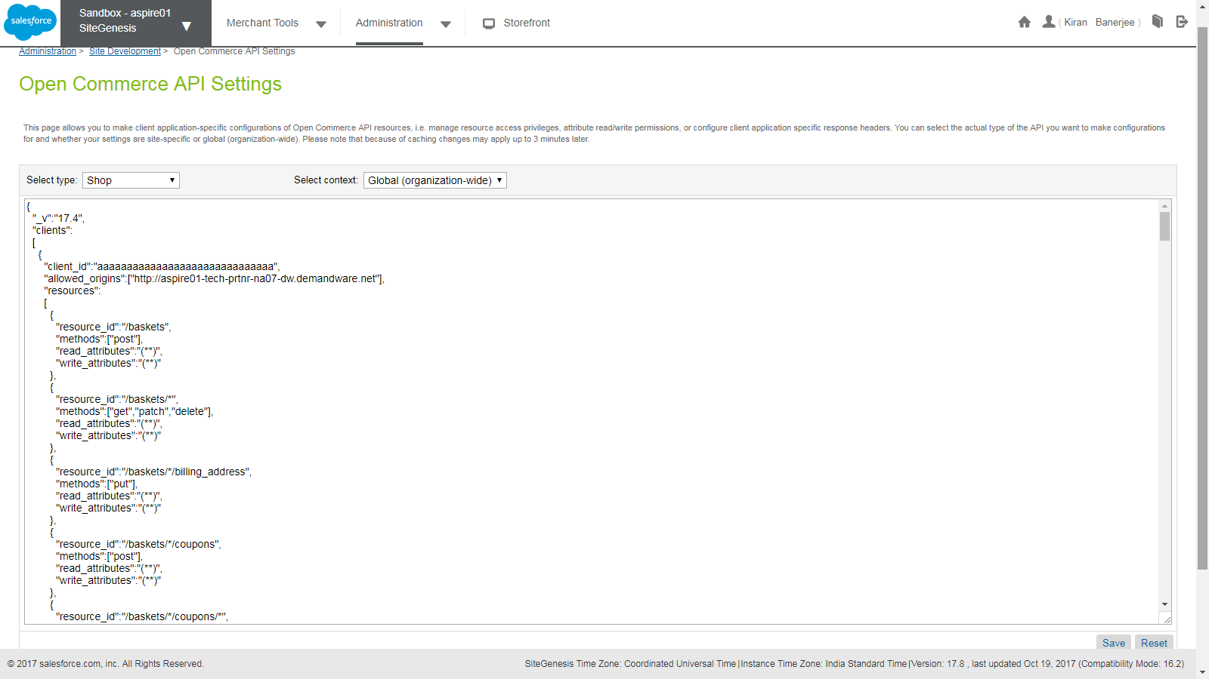

For DATA API:

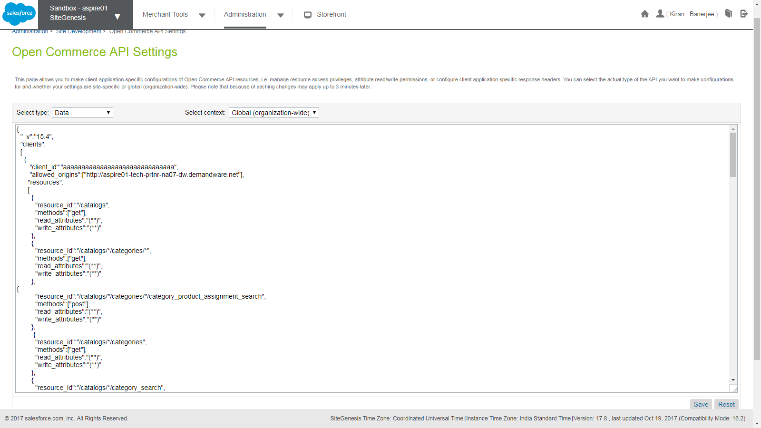

## Storefront Functionality

Since this is a Mobile App Integration, there are no changes in the storefront.

# Known Issues

There are no known issues with respect to storefront.

PRIOS Mobile app is compatible with iOS version 8 and above.

It is not yet available for Android.

# Release History

|  |  |  |
| --- | --- | --- |
| **Version** | **Date** | **Changes** |
| 17.1.0 | Nov 27, 2017 | Initial release |