**SFCC_PRIOS INTEGRATION**

***Version 19.1.0***



**Table of Contents**

1. Summary 3

2. Component Overview 4

2.1 Functional Overview 4

2.2 Use Cases 8

2.3 Limitations, Constraints 10

2.4 Compatibility 11

2.5 Privacy, Payment 11

3. Implementation Guide 11

3.1 Setup 11

3.2 Configuration 11

3.3 Custom Code 12

3.4 External Interfaces 12

3.5 Firewall Requirements 12

3.6 Testing 12

4. Operations, Maintenance 13

4.1 Data Storage 13

4.2 Availability 13

4.3 Support 13

5. User Guide 14

5.1 Roles, Responsibilities 14

5.2 Business Manager 14

5.3 Storefront Functionality 15

6. Known Issues 15

7. Release History 15

# Summary

The submitted Link Cartridge enables SFCC users to seamlessly connect with PRIOS, an Instore digital mobile application. As a second version, PRIOS will have basic and some additional functionalities of a mobile commerce application for IOS. Subsequently, the Link Cartridge and PRIOS will be extended to support Instore digital features also.

Through SFCC and PRIOS integration, customers can manage consumer interactions across all digital touch points globally, enabling a seamless and consistent brand experience on any channel. Our platform is built to support digital commerce best practices and can be customized to individual needs, with full access to a sophisticated Omni-channel marketing and merchandising engine and open development environment.

# Component Overview

## Functional Overview

PRIOS is a ready to Plug-in Salesforce Commerce M-Commerce solution built on IOS. The solution gives the client the ability to extend their e-shop on mobile and also customize it to their need. Our framework gives clients the option to customize the solution to suit their business as well as help them add M-Commerce capability in a short span of time.

PRIOS brings enormous value to Commerce Cloud customers where it not only enables M-Commerce but also extends the app to enable instore digital experience. Apart from the M-Commerce functionality like Search, Cart Management and Payments, the app also enables the stores to integrate their Offline store stocks, beacon base instore Marketing and Offline buying, visit a physical store, scan a product bar-code, add to cart and then do a check out.

The current solution aims to connect the storefront with PRIOS mobile app with the help of out of box OCAPI API’s available in SFCC. This cartridge provides the features unavailable out of the box in SFCC.

Currently, the customizations include the following:

* Adding product image in the response when adding product to cart
* Adding product image in response while fetching the cart
* Adding custom attribute i.e. Brand of the product on hit of the search products API
* Allowing customer to reset password



**Screenshots of the Prios Mobile App:**

|  |  |
| --- | --- |
| ***C:\Users\kiran.banerjee\Desktop\Prios Screenshots\Home.PNG***  ***Home Page 1*** | ***C:\Users\kiran.banerjee\Desktop\Prios Screenshots\HomePage -OnlineMode.PNG***  ***Home Page 2*** |
| ***C:\Users\kiran.banerjee\Desktop\Prios Screenshots\Menu.PNG***  ***Menu*** | ***C:\Users\kiran.banerjee\Desktop\Prios Screenshots\Product List.PNG***  ***Product List*** |
| ***C:\Users\kiran.banerjee\Desktop\Prios Screenshots\Product Detail1.PNG***  ***Product Details Page 1*** | ***C:\Users\kiran.banerjee\Desktop\Prios Screenshots\Product Detail2.PNG***  ***Product Details Page 2*** |
| ***C:\Users\kiran.banerjee\Desktop\Prios Screenshots\CartPageInOnline.PNG***  ***Cart Page*** | ***C:\Users\kiran.banerjee\Desktop\Prios Screenshots\CheckoutPage.PNG***  ***Place Order Page*** |

## Use Cases

**Use Case for the customized APIs:**

**Use Case – 1 (Add Item to Cart API):**

|  |  |
| --- | --- |
| Add Item to Cart API | On adding a product to the Basket, product image should be available in response. |
| Goal in Context | While adding individual products into the Cart the product’s image should be added in the response. |
| Pre-conditions | User should be able to add products to the Cart, and those products should have “small” size image configured. |
| Success End Condition | After the product is added to Cart successfully, the product image URL should be available in the response. |
| Failed End Condition | Either the product is not added in the Cart (or) in spite of product being added image URL in not updated. |
| Primary Actor | Customer |
| Trigger | On adding a product to Cart. |
| Description | When a product is being added to cart its image URL should also be present in the response. |

**Use Case – 2 (Get basket API):**

|  |  |
| --- | --- |
| Get basket API | On fetching the Basket, product image should also be available in response. |
| Goal in Context | While fetching the basket, the product’s image should be available in the response. |
| Pre-conditions | There should be added products in the basket and those products should have “small” size image configured. |
| Success End Condition | When the basket is fetched, the product image URL should be available in the response. |
| Failed End Condition | Either the basket is not fetched (or) the basket is fetched but the added image URL in not present in response. |
| Primary Actor | Customer |
| Trigger | On clicking on show Cart. |
| Description | When the customer selects show cart, along with the basket object, the image URL should also be present in the response. |

**Use Case – 3 (Search Products API):**

|  |  |
| --- | --- |
| Search Products API | Brand name should also come in the response of Search Product API. |
| Goal in Context | On search of a product in the search box (or) on clicking in the sub category along with the products its brand should also come in the response. |
| Pre-conditions | Products should be configured in the catalog. Keyword searched in the search box should match with any products (or) the sub category in which it is selected should have some products assigned to it. |
| Success End Condition | The product tile page should be displayed and each product should have the brand associated with it. |
| Failed End Condition | The product tile page is not displayed (or) the products don’t have the brand associated with it. |
| Primary Actor | Customer |
| Trigger | On searching with a keyword on the search box or clicking the subcategory. |
| Description | On searching for a product in the search box (or) on clicking in the sub category along with the products its brand should also come in the response. |

**Use Case – 4 (Starts a password reset process API):**

|  |  |
| --- | --- |
| Starts a password reset process API | On selecting reset password, an email will be triggered to the registered mail id of customer which will contain the reset link of setting up the new password. |
| Goal in Context | Have to send an email to respective mail ID that is passed with identification parameter in the body of the API that contains the link which contains the form to change the password. |
| Pre-conditions | Having OAuth token with the registered username, password and client id. |
| Success End Condition | An email will be triggered to the registered mail id of customer which will contain the reset link of setting up the new password. |
| Failed End Condition | An email will not be triggered to the registered mail id of customer. |
| Primary Actor | Customer |
| Trigger | On selecting reset password button. |
| Description | When the customer selects reset password, an email will be triggered to the registered mail id of customer consisting the reset link of setting up the new password. |

**Use Case for the Out of the Box APIs:**

Details regarding the out of the box APIs used in our integration are available here:



## Limitations, Constraints

As a second version, PRIOS will have the basic and some (coupon, promotions, password reset & wish list) additional functionalities of a Mobile commerce application.

It is available only for iOS as of now.

Subsequently the Link Cartridge and PRIOS will be extended to support additional Instore digital features.

## Compatibility

Available since Commerce Cloud 17.8

Cartridge developed in SiteGenesis [103.1.3](https://xchange.demandware.com/docs/DOC-38866)

## Privacy, Payment

NA

# Implementation Guide

## Setup

This integration provides a cartridge int_aspiresystems. This cartridge must be deployed on any instance where connection with PRIOS Mobile App has to be made. On being deployed on any instance with proper OCAPI setting, the instance can be connected with the PRIOS Mobile app.

## Configuration

In order to configure PRIOS Mobile App with your SFCC Instance, follow these steps:

**Step 1:** Add the int_aspiresystems cartridge in your UX Studio Workspace and connect to SFCC server

1. In Eclipse, select File > Import > Import Existing Projects into Workspace, and browse to the int_aspiresystems cartridge included with this document
2. This document assumes that the developer already has a working connection to their SFCC instance and can add the project to this connection

For help with these setups, please refer to “Getting Started for Developers” on the SFCC Info Center.

**Step 2:** Add the cartridge to your site cartridge path in Business Manager

1. Log in to Business Manager
2. Browse to Administration > Sites > Manage Sites and select the site you want to edit
3. Click the Settings tab and add :int_aspiresystems (note the colon) to the cartridge path.
4. Click Apply
5. Confirm that int_aspiresystems is listed in the “Effective Cartridge Path”

**Step 3:** Add the Open Commerce API settings in Business Manager

1. Log in to Business Manager
2. Browse to Administration > Site Development > Open Commerce API Settings
3. Select Shop form the type dropdown, and enter the valid shop API details



Note: Replace the “client_id” with the actual value and replace the “allowed_origins” with your sandboxes URL.

1. Select Data form the type dropdown, and enter the valid data API details



Note: Replace the “client_id” with the actual value and replace the “allowed_origins” with your sandboxes URL.

1. Save the data.

## Custom Code

NA

## External Interfaces

NA

## Firewall Requirements

NA

## Testing

For testing purposes you can use a default Client ID as “aaaaaaaaaaaaaaaaaaaaaaaaaaaaaa”.

For checking response of the Open Commerce API’s outside of the Mobile APP, we can use postman tool.

We can download the chrome extension for POSTMAN.

Further, create a new Tab and Add the URL along with its HTTP Method.

Further add the required Headers i.e. (Authorization, Origin and Content-Type).

If that URL requires a body, add that in the body by selecting raw (If it requires JSON input).

We can import/export Postman Collections having all the API details in JSON format.

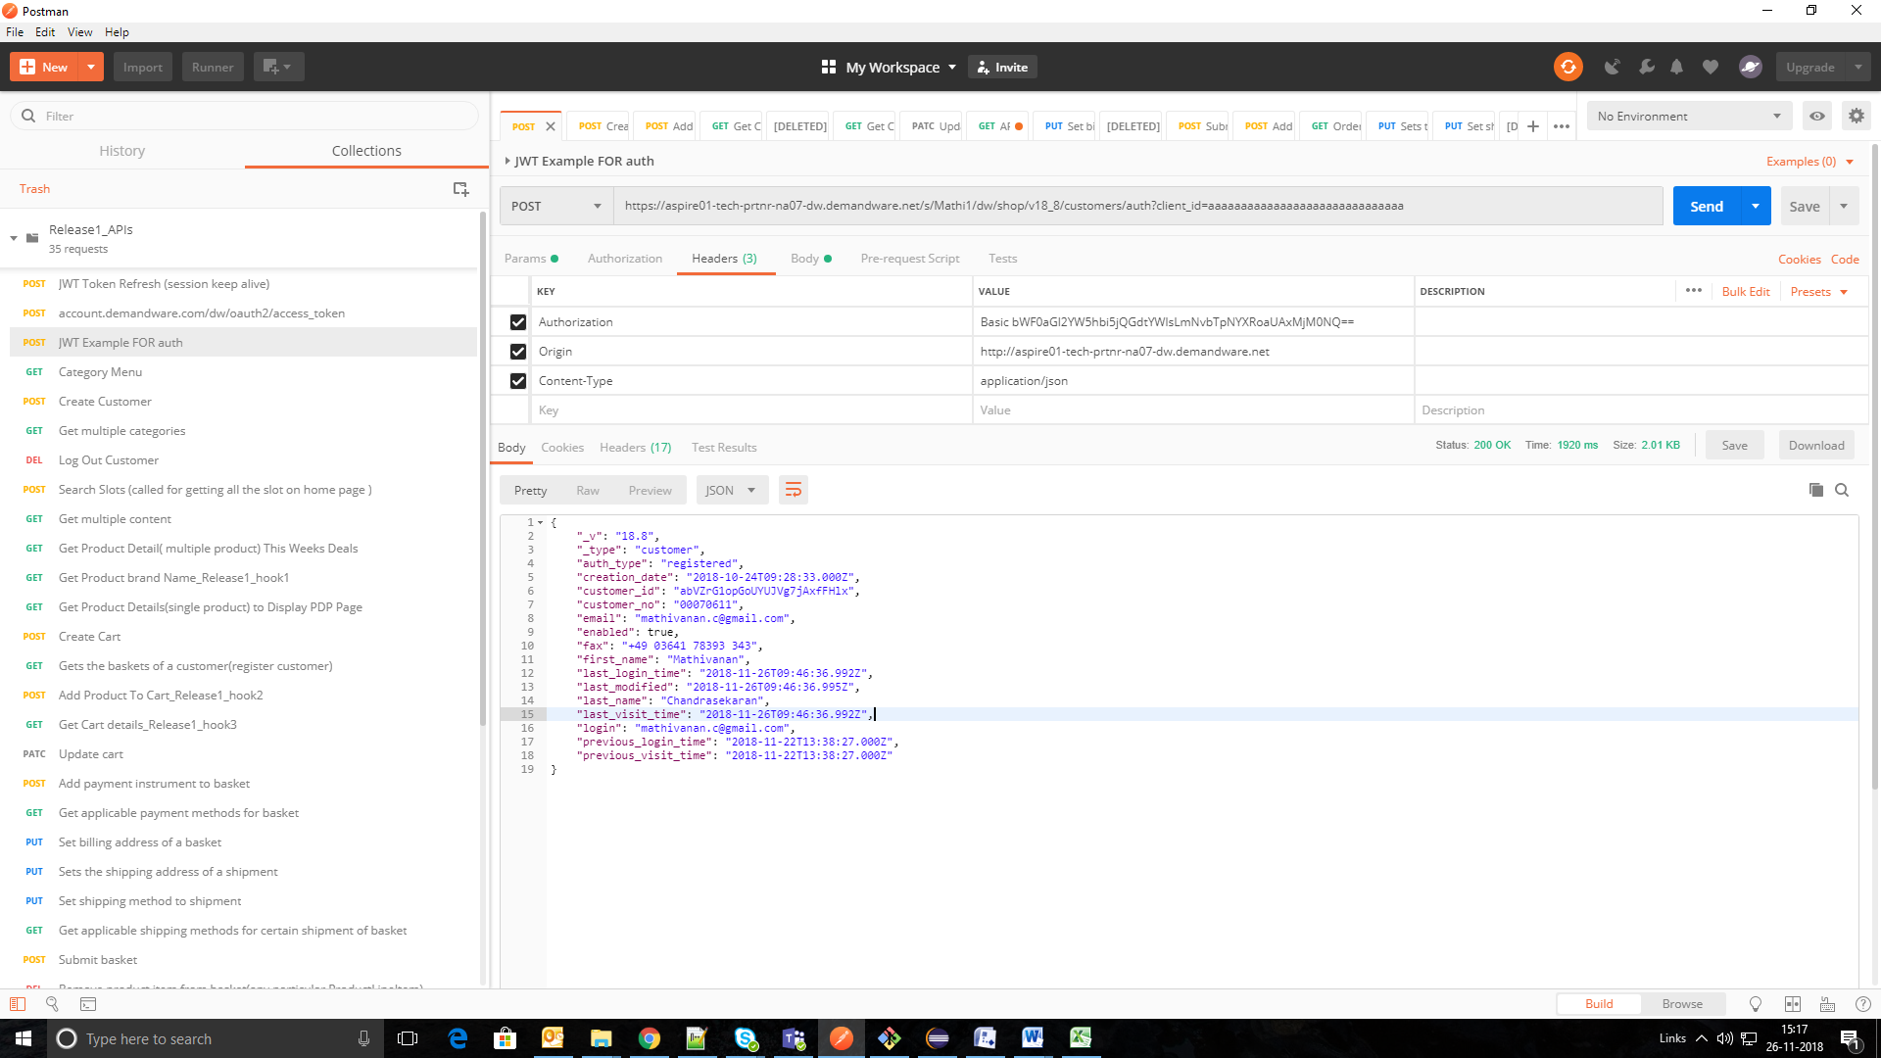

# Operations, Maintenance

## Data Storage

Created global custom object for custom object type PriosNewsLetterSubscription to store email id for the customer and it would be used for email subscription.

## Availability

Since this Integration is based on Open Commerce API and no External Service is being used so there will be continuous uptime.

## Support

For Support Purpose, please contactsfcc@aspiresys.com.

# User Guide

## Roles, Responsibilities

Apart from the Cartridge Integration, no other recurring task is required.

## Business Manager

Configure the Shop and Data JSONs in the Open Commerce API Settings under Administration.

For SHOP API:

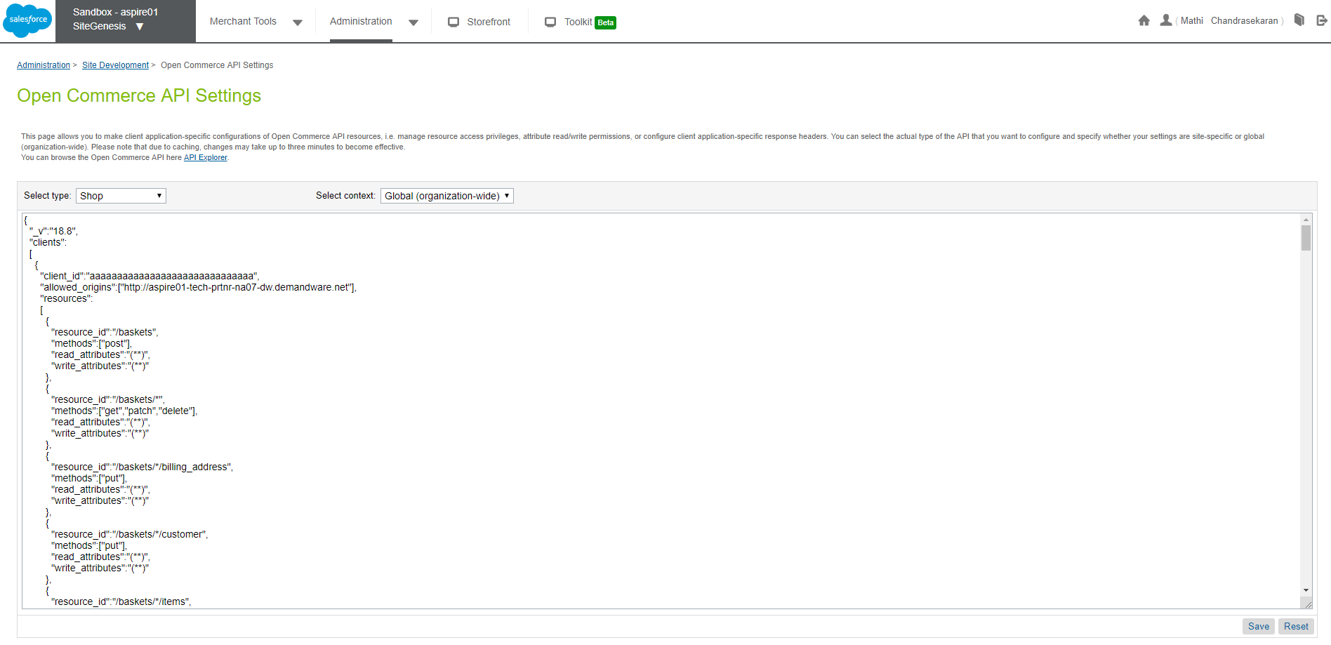

For DATA API:

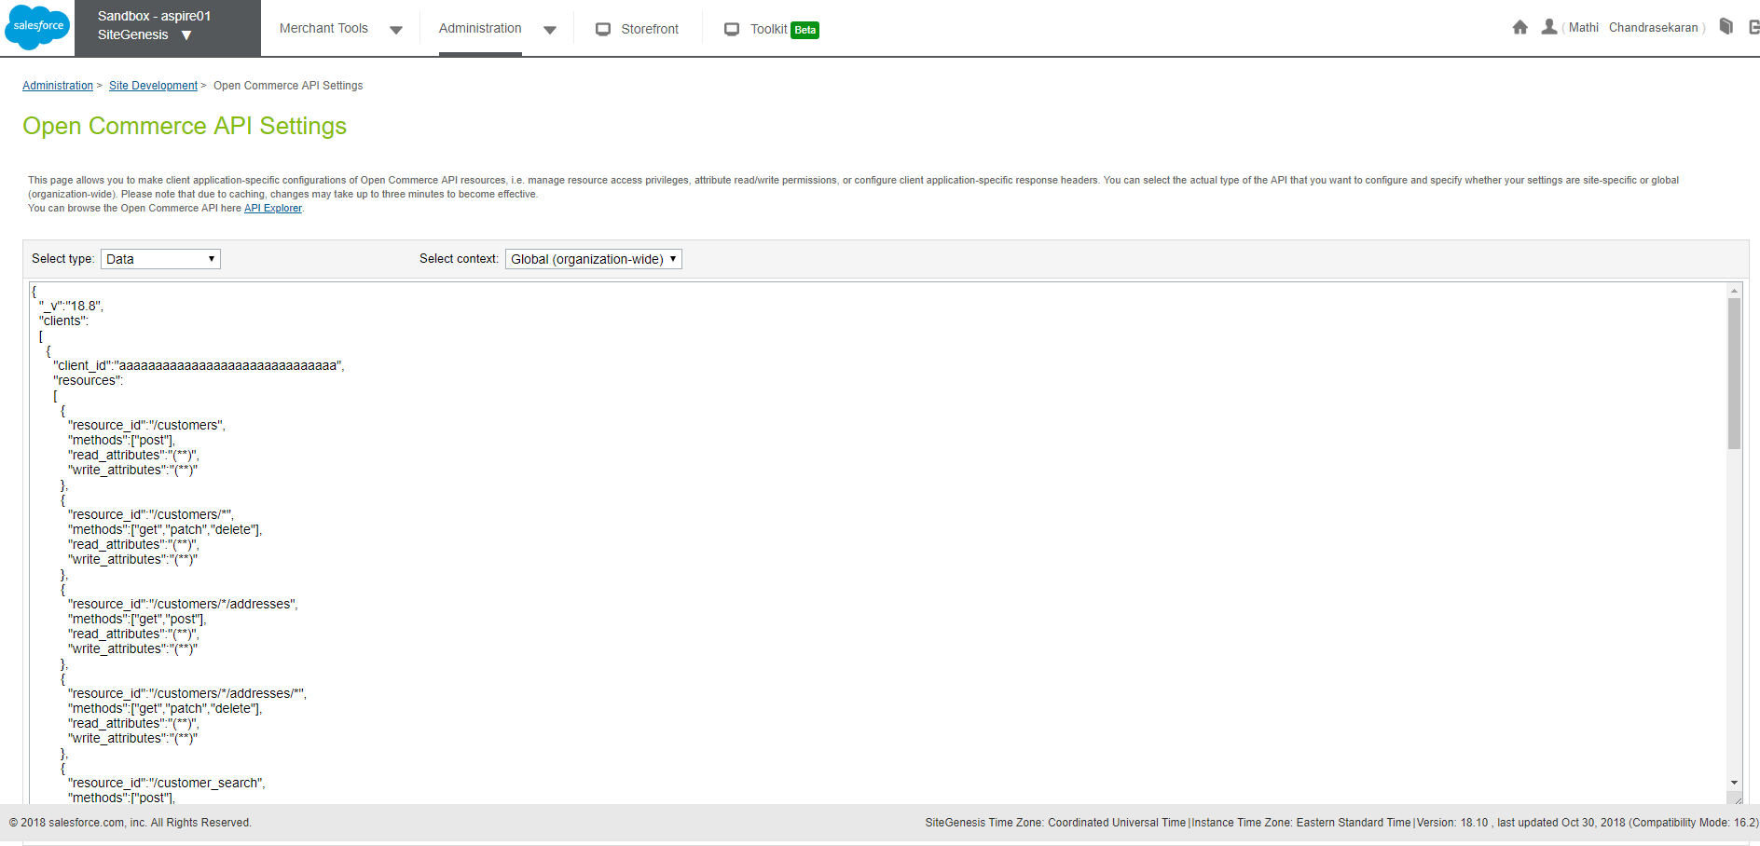

## Storefront Functionality

Since this is a Mobile App Integration, there are no changes in the storefront.

# Known Issues

There are no known issues with respect to storefront. PRIOS Mobile app is compatible with iOS version 9 and above. It is not yet available for Android.

# Release History

|  |  |  |
| --- | --- | --- |
| **Version** | **Date** | **Changes** |
| 17.1.0 | Nov 27, 2017 | Initial release |
| 19.1.0 | Feb 07, 2019 | Second release |