## Steps to install Chemical Development Kit (CDK)

**CDK - python wrapper**

Github repository: <https://github.com/sebotic/cdk_pywrapper>

1. git clone <https://github.com/sebotic/cdk_pywrapper.git>
2. cd cdk_pywrapper
3. pip3 install py4j –user
4. pip3 install . –user
5. open python in directory ~/cdk_pywrapper/cdk_pywrapper/cdk

Example of the use of CDK in python:

>>> from cdk_pywrapper.cdk_pywrapper import Compound

>>> smiles = 'CCN1C2=CC=CC=C2SC1=CC=CC=CC3=[N+](C4=CC=CC=C4S3)CC.[I-]'

>>> cmpnd = Compound(compound_string=smiles, identifier_type='smiles')

>>> ikey = cmpnd.get_inchi_key()

>>> print(ikey)

MNQDKWZEUULFPX-UHFFFAOYSA-M

Note: The python wrapper Cinfony (<http://cinfony.github.io/install_linux.html>) does not work for CDK but does work for RDkit.

**CDK - java**

First install JDK (required to use Netbeans):

http://www.oracle.com/technetwork/java/javase/downloads/jdk-netbeans-jsp-142931.html

Use CDk in NetBeans

1. Download the NetBeans sh  file (for linux) from https://netbeans.org/downloads/
2. To allow the installation: chmod +x netbeans-8.2-linux.sh
3. To install NetBeans: ./netbeans-8.2-linux.sh
4. To run NetBeans: ~/netbeans-8.2/bin/netbeans &
5. Download CDK jar file (for example <https://sourceforge.net/projects/cdk/files/>)
6. In NetBeans: Project properties -->  Add libraries --> add JAR/folder

Example of the use of CDK in java: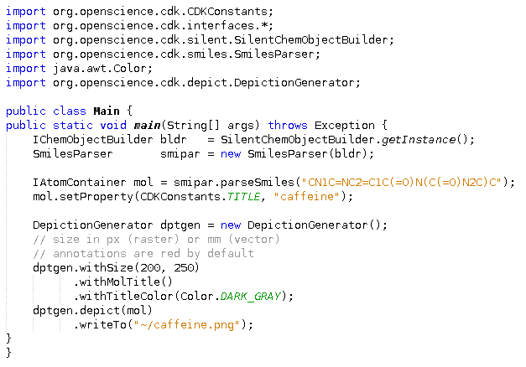

Result:

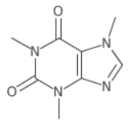

To download the CDK library (not necessary to use CDK)

First install Apache Maven:

1. <https://maven.apache.org/download.cgi>
2. apache-maven-3.5.3-bin.tar.gz
3. tar xvf apache-maven-3.5.3-bin.tar.gz
4. Add apache-maven-3.5.3 to classpath

Install CDK:

1. Follow the instruction from the Github repositories below:
2. <https://github.com/cdk/cdk>
3. <https://github.com/cdk/cdk-build-util>
4. <https://github.com/cdk/cdk/wiki/Building-CDK> (Requires Netbeans or another IDE)