Project Update

18 July 2019

**Background**

A discussion between Danilo and I started because of the initial design we agreed on last week: a full factorial design for each solvent.  Since there are 7 variables besides solvents (temperature, acid conc., cat. load, co-cat., co-cat. load, alkene-amine ratio, aldhyde-amine ratio), a full factorial design requires **128 experiments per solvent** (2^7=128).  We all know that is too much.

Even a fractional factorial design of five main factors requires 32 experiments (2^5=32).

There are at least two ways to get around this issue

1. Make the experimental setup more automated (i.e., being able to run more experiments quickly)
2. Reduce the number of experiments required for initial design (and hopefully the optimization)

**Automation Ideas**

Danilo explained that there are two barriers to automating the setup:

1. **The packed bed of molecular sieves**: It isn't 100% efficient and degrades over time
2. **Dead volume between reactions**: A large volume of solvent could be required to equilibrate the system when conditions change

To address the first automation issue, Danilo had the idea that we could **start with the prealkylated amine**, which would completely avoid the water-producing aldol condensation step. This reaction is described on page 89 of the SI in Matt Gaunt's paper (shown below for convenience). Danilo has ordered the necessary chemicals for the reaction and hopes to run it when he returns next week.

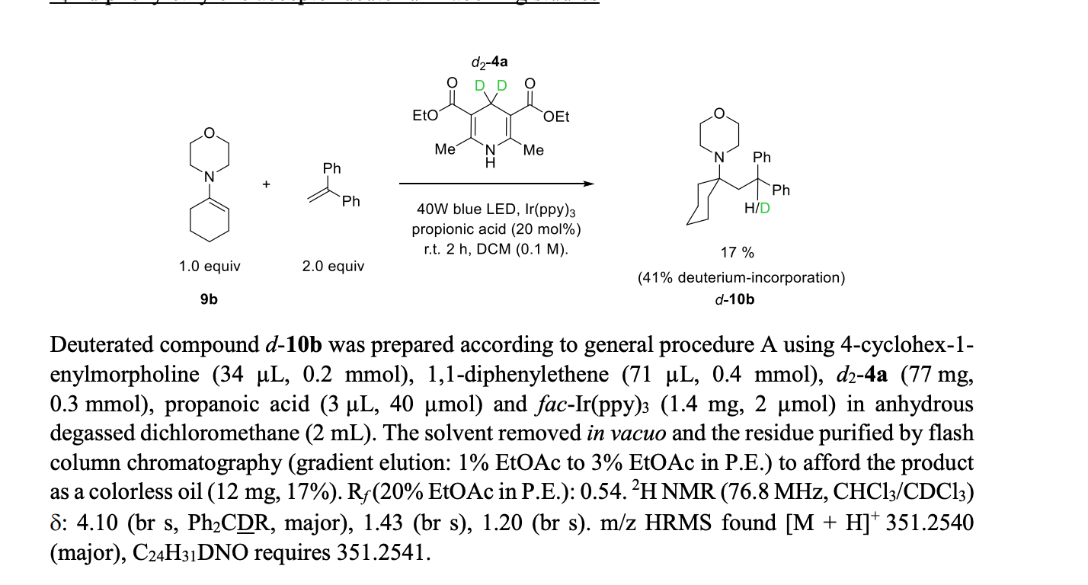

Unfortunately, going down this route will require tedious isolation of the new product, but maybe automated column chromatography or a HPLC prep column could help here?  However, this path has the added benefit of **reducing the number of experimental variables to six**.

We didn't have a concrete idea of how to solve the issue of equilibration time. Danilo and I didn't discuss this, but I just remembered that Richard Bourne has a [paper on gathering kinetic data from transient flow experiments](https://pubs.rsc.org/en/content/articlehtml/2016/re/c6re00109b).  Applying some of the lessons from that paper might allow us to skip some of the equilibration steps. Could you look into that Perman?

**Design of Experiments Ideas**

We can use a fractional factorial DoE.  For example, I think we could probably get down to around 20 conditions per solvent if we're strategic. Additionally, I would like to work with Artur to run some simulations (similar to what I did for my thesis) to figure out what works best for these types of problems.