**COMCAST_TELECOM_COMPLAINTS**

Import libraries

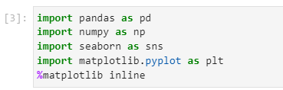

Import data into Python environment.

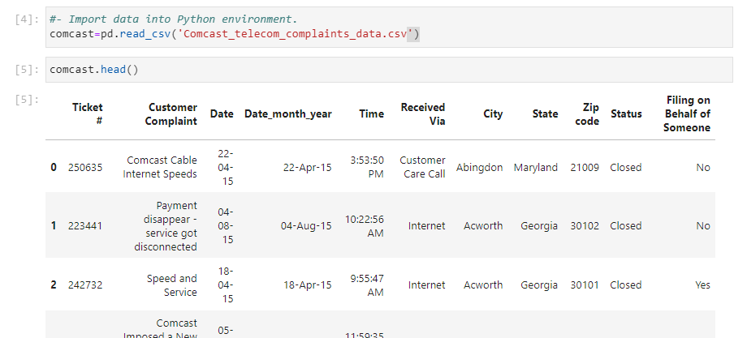

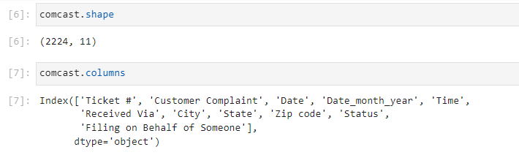

Provide the trend chart for the number of complaints at monthly and daily granularity levels.

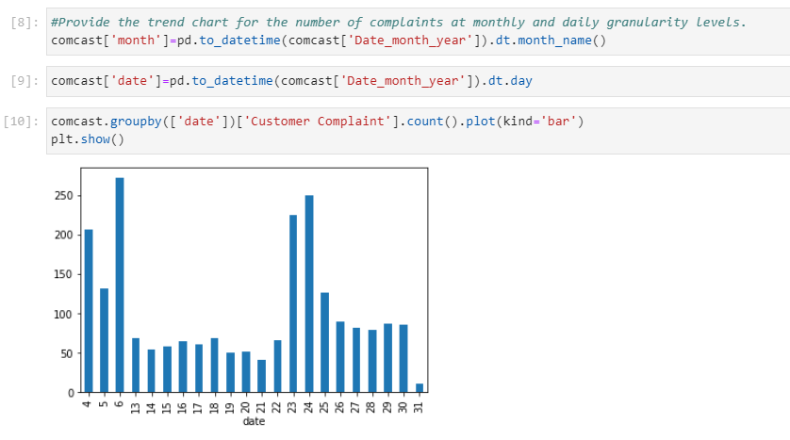

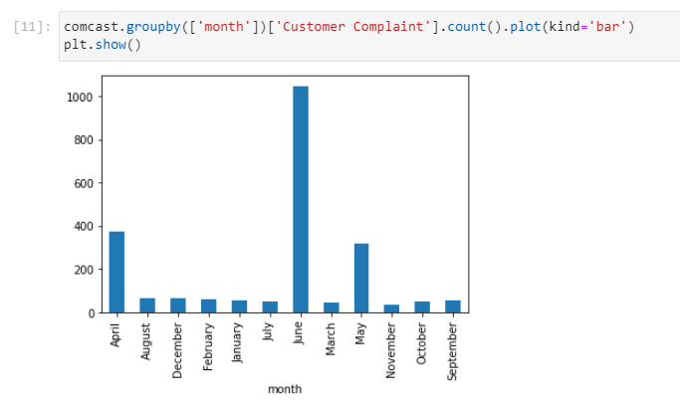Provide a table with the frequency of complaint types.

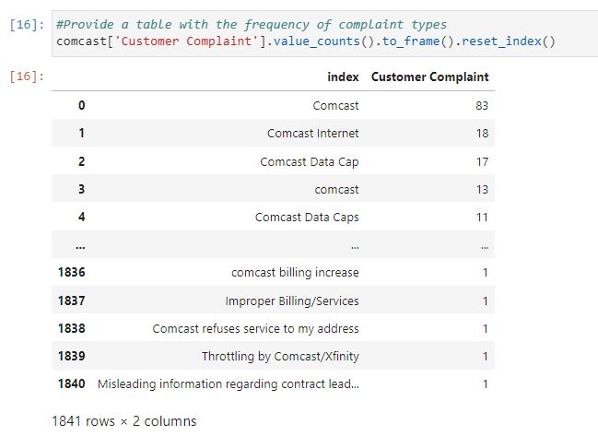

Which complaint types are maximum i.e., around internet, network issues, or across any other domains.

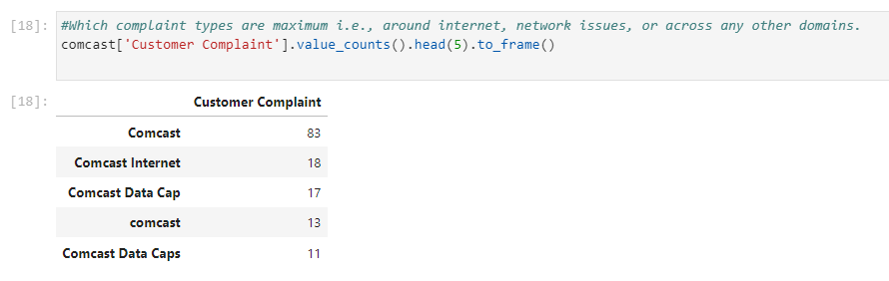

Insight: Comcast complaints are maximum

Create a new categorical variable with value as Open and Closed. Open & Pending is to be categorized as Open and Closed & Solved is to be categorized as Closed.

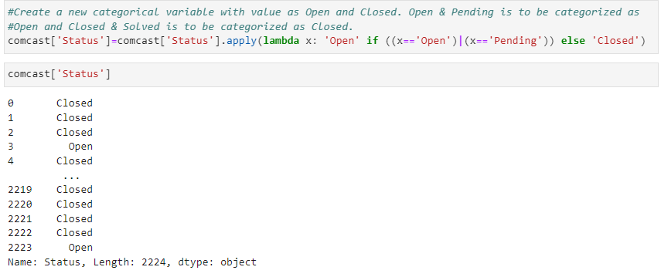

Provide state wise status of complaints in a stacked bar chart. Use the categorized variable from Q3. Provide insights on:

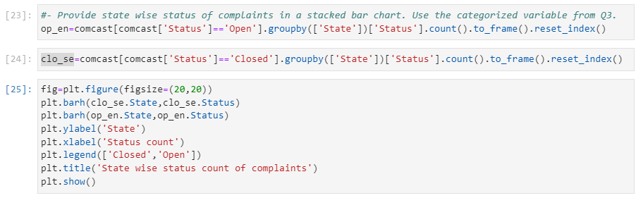

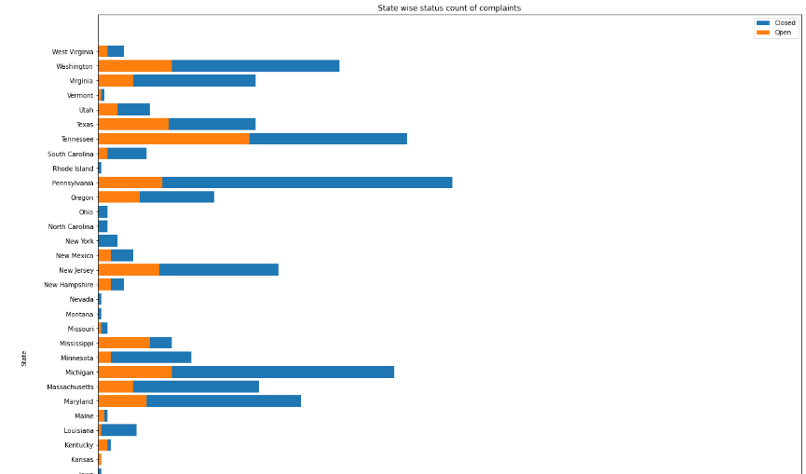

Which state has the maximum complaints?

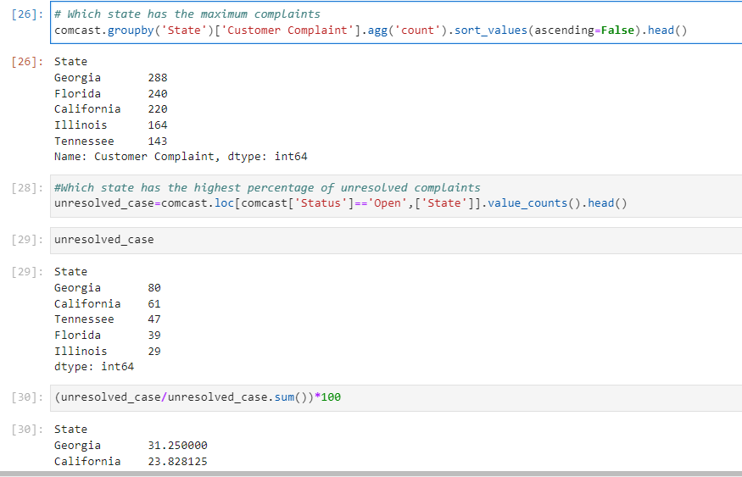

Insights:

Georgia has maximum complaints of about 288.

Georgia has highest unresolved cases with 31.25%

The percentage resolved cases are 50% via Customer care call and 49.38% via Internet calls.

Which state has the highest percentage of unresolved complaints?

Provide the percentage of complaints resolved until date, which were received through the Internet and customer care calls.

