模块（子系统）描述1.0
- 登录
成员列表：
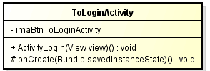
ActivityLogin(View view) | ToLoginActivity
imaBtn | ToLoginActivity | private
onCreate(Bundle savedInstanceState) | ToLoginActivity | protected
- 注册
成员列表：
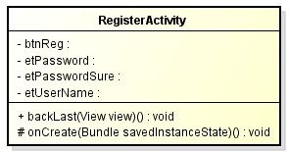
backLast(View view) | RegisterActivity
btnReg | RegisterActivity | private
etPassword | RegisterActivity | private
etPasswordSure | RegisterActivity | private
etUserName | RegisterActivity | private
onCreate(Bundle savedInstanceState) | RegisterActivity | protected

- 下单
成员列表：
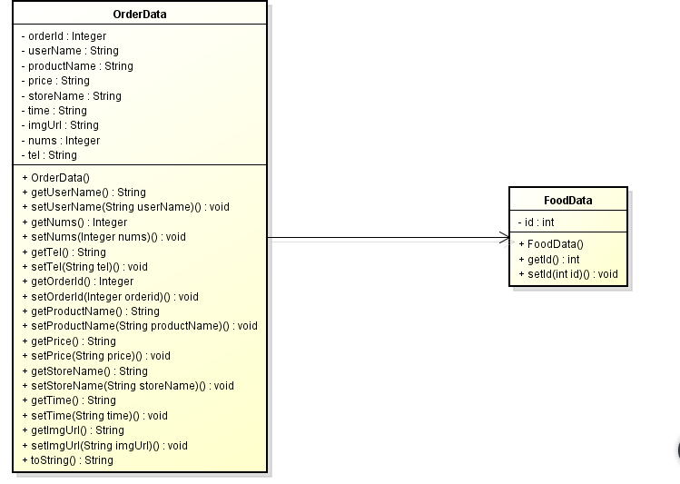
getImgUrl() | OrderData
getNums() | OrderData
getOrderId() | OrderData
getPrice() | OrderData
getProductName() | OrderData
getStoreName() | OrderData
getTel() | OrderData
getTime() | OrderData
getUserName() | OrderData
imgUrl | OrderData | private
nums | OrderData | private
OrderData(String userName, String productName, String price, String storeName, String time, String imgUrl, Integer nums, String tel) | OrderData
OrderData(Integer orderId, String userName, String productName, String price, String storeName, String time, String imgUrl, Integer nums, String tel) | OrderData
orderId | OrderData | private
price | OrderData | private
productName | OrderData | private
setImgUrl(String imgUrl) | OrderData
setNums(Integer nums) | OrderData
setOrderId(Integer orderId) | OrderData
setPrice(String price) | OrderData
setProductName(String productName) | OrderData
setStoreName(String storeName) | OrderData
setTel(String tel) | OrderData
setTime(String time) | OrderData
setUserName(String userName) | OrderData
storeName | OrderData | private
tel | OrderData | private
time | OrderData | private
toString() | OrderData
userName | OrderData | private

- 显示、删除订单
成员列表：
getIconRes() | PagerData
getName() | PagerData
iconRes | PagerData
name | PagerData
PagerData(String name, int iconRes) | PagerData
setIconRes(int iconRes) | PagerData
setName(String name) | PagerData

- 查看电影
成员列表：
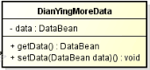
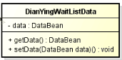
getCount() | DianyingMoreAdapter
getItem(int i) | DianyingMoreAdapter
getItemId(int i) | DianyingMoreAdapter
getView(int i, View view,ViewGroup viewGroup) | DianyingMoreAdapter
mHotBeen | DianyingMoreAdapter | private
setmHotBeen(List< DianyingMoreData.DataBean.HotBean> mHotBeen) | DianyingMoreAdapter

back | DianYingActivity | private
hot | DianYingActivity | private
initGridView() | DianYingActivity
initPullToRefreshListView() | DianYingActivity
initView() | DianYingActivity | private
initViewPager() | DianYingActivity
mFlyBanner | DianYingActivity | private
mGridView | DianYingActivity | private
mGridView1 | DianYingActivity | private
mLinearLayout | DianYingActivity |  | private
mListView | DianYingActivity | private
more | DianYingActivity | private
mPullToRefreshListView | DianYingActivity | private
mRecyclerView | DianYingActivity | private
mXBanner | DianYingActivity | private
mXBanner2 | DianYingActivity | private
onClick(View view) | DianYingActivity
onCreate(@Nullable Bundle savedInstanceState) | DianYingActivity | protected
search | DianYingActivity | private
wait | DianYingActivity | private

- 浏览商品
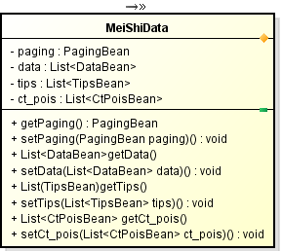
context | FoodDetailsAdapter | private
foodDataList | FoodDetailsAdapter | private
FoodDetailsAdapter(List<FoodData> foodDataList, Context content) | FoodDetailsAdapter
getItemCount() | FoodDetailsAdapter
onBindViewHolder(FoodDetailsHolder holder, int position) | FoodDetailsAdapter
onCreateViewHolder(ViewGroup parent, int viewType) | FoodDetailsAdapter

