http://braindigit.com/Modules/Logo/image/braindigit-logo_675048.png

Version [0.0]

September 19, 2013

|  |
| --- |
| All Rights Reserved  This document is the property of Braindigit IT Solutions Pvt. Ltd. No part of this document may be copied or reproduced in any form or by any means, electronic, mechanical or otherwise without the prior written permission of Braindigit IT Solutions Pvt. Ltd. |
| Braindigit IT Solutions Pvt. Ltd. Gyaneshwor - 33 Kathmandu, Nepal |

PROJECT REQUIREMENT SPECIFICATION DOCUMENT

[Task to Do]

[Sona Banjadey]

1. Project Overview
   1. Objectives

The objective of task to do module is that, user can save his or her own task as requirement

1. Project Requirements
   1. Project Category

Existing Product Enhancement

SageFrame

New Module Development

* 1. Functional Requirements
     1. Required for Customizing:

Targeted version for 2.5

* + 1. Feature:

|  |  |
| --- | --- |
| ***Feature Title*** | ***Feature Description*** |
| *User can add* | *User can add his new task* |
| *User* | *User has full authorize to edit delete his own task* |
| *Only five data* | *Only five data is viewed at a time. Increase with 5 each time when he scroll* |

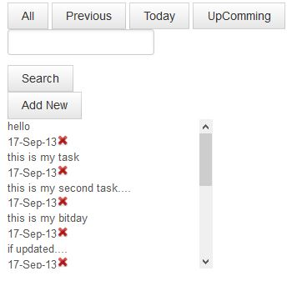

*On clicking your task you get to edit it.*

