**2 a) Explore various Flutter widgets (Text, Image, Container, etc.).**

import 'package:flutter/material.dart';  
  
void main() {  
 runApp(MyApp());  
}  
  
class MyApp extends StatefulWidget {  
 const MyApp({super.key});  
  
 @override  
 State<MyApp> createState() => _MyAppState();  
}  
  
class _MyAppState extends State<MyApp> {  
 @override  
 Widget build(BuildContext context) {  
 return MaterialApp(  
 home: Scaffold(  
 appBar: AppBar(  
 title: Text('Image'),  
 ),  
 body: Center(  
 child: Container(  
 height: 200,  
 width: 300,  
 child: Image.network('img_src'),  
 ),  
 ),  
 ));  
 }  
}

**OUTPUT**

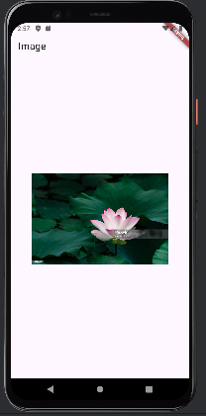

**2 b) Implement different layout structures using Row, Column, and Stack widgets.**

import 'package:flutter/material.dart';  
  
void main() {  
 runApp(MyApp());  
}  
  
class MyApp extends StatelessWidget {  
 @override  
 Widget build(BuildContext context) {

return MaterialApp(  
 home: Scaffold(  
 appBar: AppBar(title: Text('Combined Layout Example')),  
 body: Center(  
 child: Column(  
 *//mainAxisAlignment: MainAxisAlignment.center,* children: <Widget>[  
 Row(  
 *//mainAxisAlignment: MainAxisAlignment.spaceAround,* children: <Widget>[  
 Container(color: Colors.*red*, width: 50, height: 50),  
 Container(color: Colors.*green*, width: 50, height: 50),  
 Container(color: Colors.*blue*, width: 50, height: 50),  
 ],  
 ),  
 SizedBox(height: 20),  
 Stack(  
 alignment: Alignment.*center*,  
 children: <Widget>[  
 Container(color: Colors.*red*, width: 200, height: 200),  
 Container(color: Colors.*green*, width: 150, height: 150),  
 Container(color: Colors.*blue*, width: 100, height: 100),  
 ],  
 ),  
 ],  
 ),  
 ),  
 ),  
 );  
 }  
}

**OUTPUT**

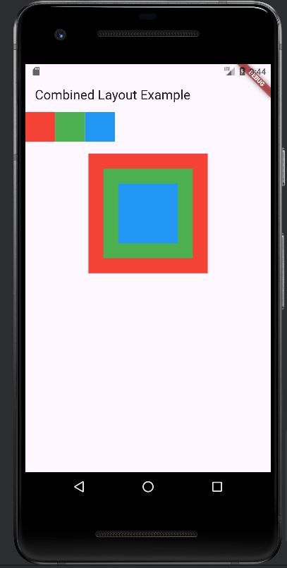

**3 a) Design a responsive UI that adapts to different screen sizes**

import 'package:flutter/material.dart';  
  
*//main function*void main() {  
 runApp(MyApp()); *//leets change it*}  
  
*//stateless widget class*class MyApp extends StatelessWidget {  
 const MyApp({super.key});  
  
 @override  
 Widget build(BuildContext context) {  
 return SafeArea(  
 child: MaterialApp(  
 home: Text('CSE'),  
 ),  
 );  
 }  
}

**OUTPUT**

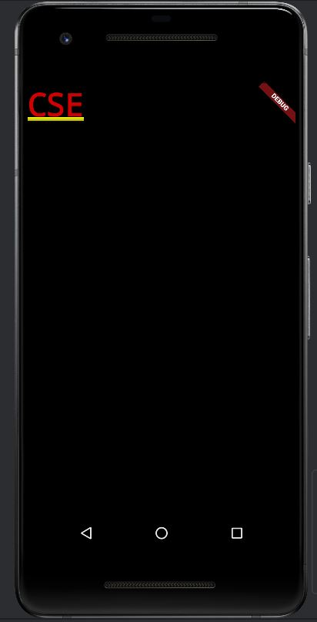

**3 b) Implement media queries and breakpoints for responsiveness.**

import 'package:flutter/material.dart';  
  
void main() {  
  runApp(MyApp());  
}  
  
class MyApp extends StatelessWidget {  
  @override  
  Widget build(BuildContext context) {  
    return MaterialApp(  
      home: ResponsiveLayout(),  
    );  
  }  
}  
  
class ResponsiveLayout extends StatelessWidget {  
  @override  
  Widget build(BuildContext context) {  
    var mediaQueryData = MediaQuery.of(context);  
    var screenWidth = mediaQueryData.size.width;  
  
    if (screenWidth < 600) {  
      return Scaffold(  
        appBar: AppBar(title: Text('Mobile Layout')),  
        body: _buildNarrowContainers(),  
      );  
    } else if (screenWidth < 1200) {  
      return Scaffold(  
        appBar: AppBar(title: Text('Tablet Layout')),  
        body: _buildMediumContainers(),  
      );  
    } else {  
      return Scaffold(  
        appBar: AppBar(title: Text('Desktop Layout')),  
        body: _buildWideContainers(),  
      );  
    }  
  }  
  
  Widget _buildNarrowContainers() {  
    return Column(  
      mainAxisAlignment: MainAxisAlignment.center,  
      children: <Widget>[  
        Container(color: Colors.red, width: 100, height: 100),  
        Container(color: Colors.green, width: 100, height: 100),  
        Container(color: Colors.blue, width: 100, height: 100),  
      ],  
    );  
  }  
  
  Widget _buildMediumContainers() {  
    return Row(  
      mainAxisAlignment: MainAxisAlignment.center,  
      children: <Widget>[  
        Container(color: Colors.red, width: 100, height: 100),  
        Container(color: Colors.green, width: 100, height: 100),  
        Container(color: Colors.blue, width: 100, height: 100),  
      ],  
    );  
  }  
  
  Widget _buildWideContainers() {  
    return GridView.count(  
      crossAxisCount: 3,  
      mainAxisSpacing: 10,  
      crossAxisSpacing: 10,  
      children: <Widget>[  
        Container(color: Colors.red, width: 100, height: 100),  
        Container(color: Colors.green, width: 100, height: 100),  
        Container(color: Colors.blue, width: 100, height: 100),  
      ],  
    );  
  }  
}

**OUTPUT**

