**4 a) Set up navigation between different screens using Navigator.**

void main()

{

runApp(MyApp());

}

class MyApp extends StatelessWidget

{

const MyApp({super.key});

@override

Widget build(BuildContext context)

{

return MaterialApp(

initialRoute:'/',routes:{

'/':(context) => HomeScreen(),

'/Second':(context) => SecondScreen(),

},

);

}

}

//sclass

class HomeScreen ectends StatelessWidget{

const HomeScreen({super.key});

@override

Widget build(BuildContext context)

{

return Scaffold(

appBar:AppBar(

title:Text('HomeScreen'),

),

body:Center(

child:ElevatedButton(

onPressed:()

{

Navigator.push(context,'/Second');

}

child:Text('Go to second Screen'),

),

),

);

}

}

//tclass

class SecondScreen extends StatelessWidget{

const SecondScreen({super.key});

@override

Widget build(BuildContext context)

{

return Scaffold(

appBar:AppBar(

title:Text('SecondScreen'),

),

body:ElevatedButton(

onPressed:()

{

Navigator.pop(context);

},

child:Text('Go to second Screen'),

),

);

}

} MaterialPageRoute(builder: (context) => SecondScreen()),  
 );  
 },  
 child: Text('Go to Second Screen'),  
 ),  
 ),  
 );  
 }  
}  
  
*//3rd claas SecondScreen- second page*class SecondScreen extends StatelessWidget {  
 const SecondScreen({super.key});  
  
 @override  
 Widget build(BuildContext context) {  
 return Scaffold(  
 appBar: AppBar(  
 title: Text('Second screen'),  
 ),  
 body: ElevatedButton(  
 onPressed: () {  
 Navigator.*pop*(context);  
 },  
 child: Text('Go back to Home screen'),  
 ),  
 );  
 }

}

**OUTPUT**

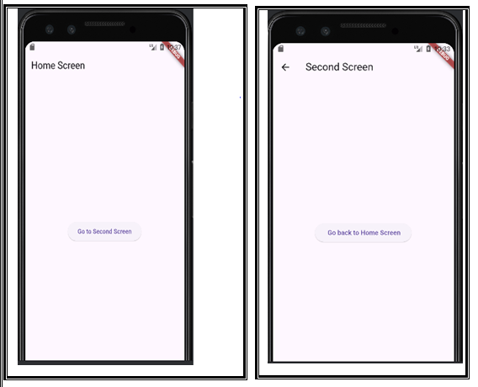

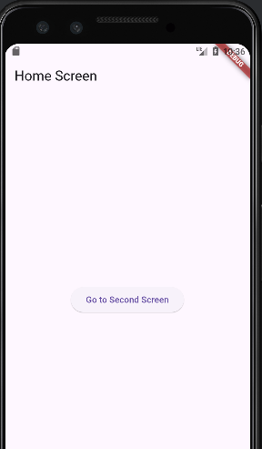

**4 b) Implement navigation with named routes.**

import 'package:flutter/material.dart';  
  
void main() {  
 runApp(MyApp());  
}  
  
*//1st MyApp class - hub class*class MyApp extends StatelessWidget {  
 const MyApp({super.key});  
  
 @override  
 Widget build(BuildContext context) {  
 return MaterialApp(  
 initialRoute: '/',  
 routes: {  
 '/': (context) => HomeScreen(),  
 '/second': (context) => SecondScreen(),  
 },  
 );  
 }  
}  
  
*//Class HomeScreen- first page in app*class HomeScreen extends StatelessWidget {  
 const HomeScreen({super.key});  
  
 @override  
 Widget build(BuildContext context) {  
 return Scaffold(  
 appBar: AppBar(  
 title: Text('Home screen'),  
 ),  
 body: Center(  
 child: ElevatedButton(  
 onPressed: () {  
 Navigator.*pushNamed*(context, '/second');  
 },  
 child: Text('Go to Second Screen'),  
 ),  
 ),  
 );  
 }  
}  
  
*//3rd claas SecondScreen- second page*class SecondScreen extends StatelessWidget {  
 const SecondScreen({super.key});  
  
 @override  
 Widget build(BuildContext context) {  
 return Scaffold(  
 appBar: AppBar(  
 title: Text('Second screen'),  
 ),  
 body: ElevatedButton(  
 onPressed: () {  
 Navigator.*pop*(context);  
 },  
 child: Text('Go back to Home screen'),  
 ),  
 );  
 }

|  |
| --- |
|  |

|  |
| --- |
|  |

}

**6 a) Create custom widgets for specific UI elements.**

import 'package:flutter/material.dart';  
  
void main() {  
 runApp(MyApp());  
}  
  
class MyApp extends StatelessWidget {  
 const MyApp({super.key});  
  
 @override  
 Widget build(BuildContext context) {  
 return MaterialApp(  
 home: HomeScreen(),  
 );  
 }  
}  
  
*//Home screen - class*class HomeScreen extends StatelessWidget {  
 const HomeScreen({super.key});  
  
 @override  
 Widget build(BuildContext context) {  
 return Scaffold(  
 appBar: AppBar(  
 title: Text("Custom Widget Example"),  
 ),  
 body: Center(  
 child: IconTextButton(  
 icon: Icons.*thumb_up*, *//variable 1* text: 'Like', *//variable 2* onPressed: () {  
 *//variable 3* print('Button Pressed!');  
 }),  
 ),  
 );  
 }  
}  
  
*//IconTextButton- class*class IconTextButton extends StatelessWidget {  
 *//variable declarations* final IconData icon; *//var-1 declaration* final String text; *//var-2 declration* final VoidCallback onPressed; *//var-3 declaration  
 //constructor* IconTextButton({  
 required this.icon,  
 required this.text,  
 required this.onPressed,  
 });  
  
 @override  
 Widget build(BuildContext context) {  
 return ElevatedButton.icon(  
 onPressed: onPressed,  
 icon: Icon(icon),  
 label: Text(text),  
 );  
 }  
}

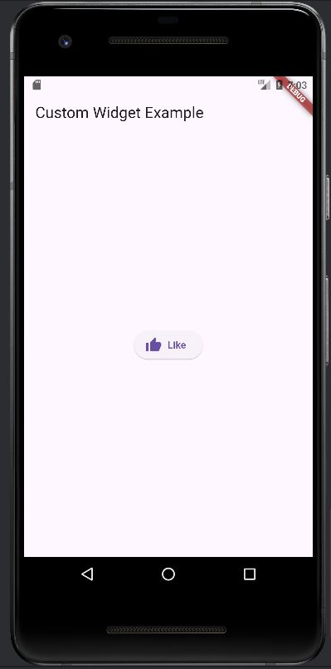

**6 b) Apply styling using themes and custom styles.**

import 'package:flutter/material.dart';  
  
void main() {  
 runApp(MyApp());  
}  
  
class MyApp extends StatelessWidget {  
 const MyApp({super.key});  
  
 @override  
 Widget build(BuildContext context) {  
 return MaterialApp(  
 home: HomeScreen(),  
 );  
 }  
}  
  
*//Home screen - class*class HomeScreen extends StatelessWidget {  
 const HomeScreen({super.key});  
  
 @override  
 Widget build(BuildContext context) {  
 return Scaffold(  
 appBar: AppBar(  
 title: Text("Custom Widget Example"),  
 ),  
 body: Center(  
 child: IconTextButton(  
 icon: Icons.*thumb_up*, *//variable 1* text: 'Like', *//variable 2* onPressed: () {  
 *//variable 3* print('Button Pressed!');  
 }),  
 ),  
 );  
 }  
}  
  
*//IconTextButton- class*class IconTextButton extends StatelessWidget {  
 *//variable declarations* final IconData icon; *//var-1 declaration* final String text; *//var-2 declration* final VoidCallback onPressed; *//var-3 declaration  
 //constructor* IconTextButton({  
 required this.icon,  
 required this.text,  
 required this.onPressed,  
 });  
  
 @override  
 Widget build(BuildContext context) {  
 return ElevatedButton.icon(  
 onPressed: onPressed,  
 icon: Icon(icon),  
 label: Text(text),  
 style: ElevatedButton.*styleFrom*(  
 backgroundColor: Colors.*pink*,  
 foregroundColor: Colors.*black*,  
 *//padding: EdgeInsets.symmetric(horizontal: 16.0, vertical: 8.0),* ),  
 );  
 }  
}

**OUTPUT**

