**D12B_01_SANJANA ASRANI_EXP-07_ALOHA**

1. **SLOTTED ALOHA**

Open netsim

Simulation -> new -> legacy network -> slotted aloha

Click on

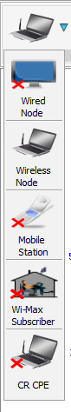

Select n wireless nodes and drag them anywhere on the grid.

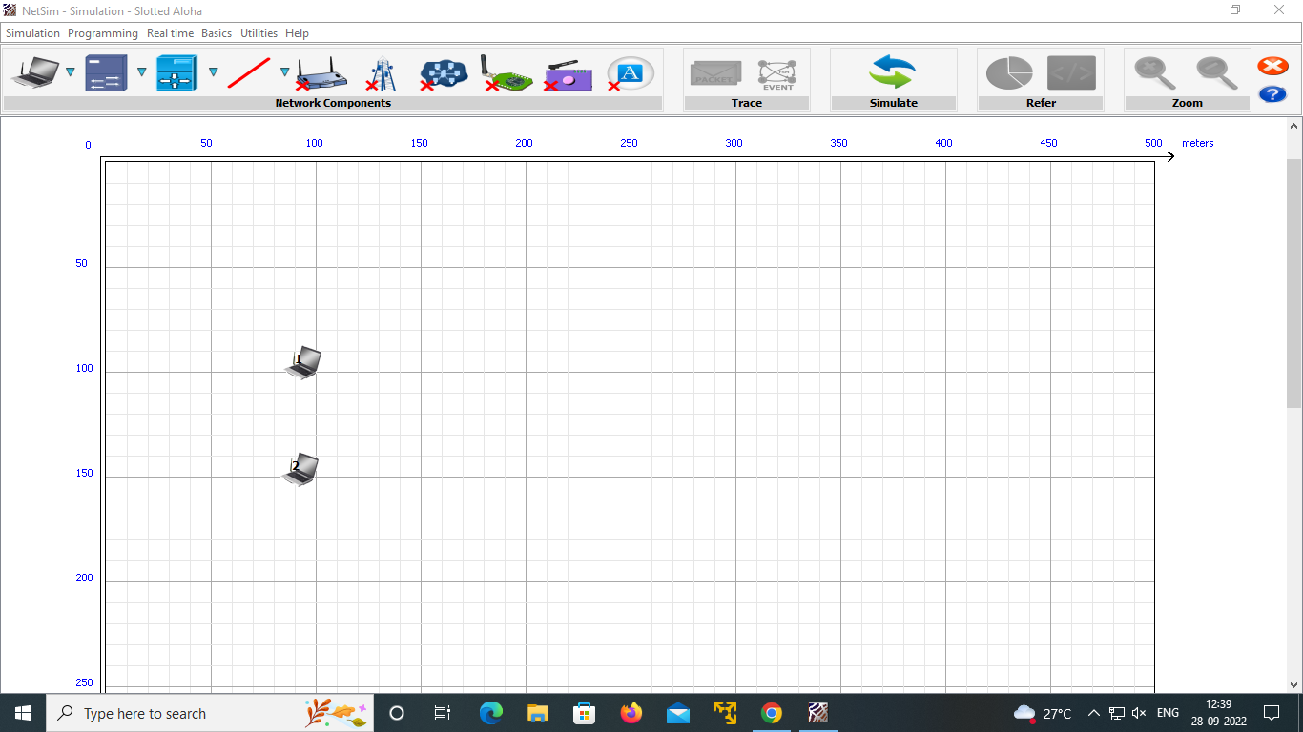

Right click on any node -> properties

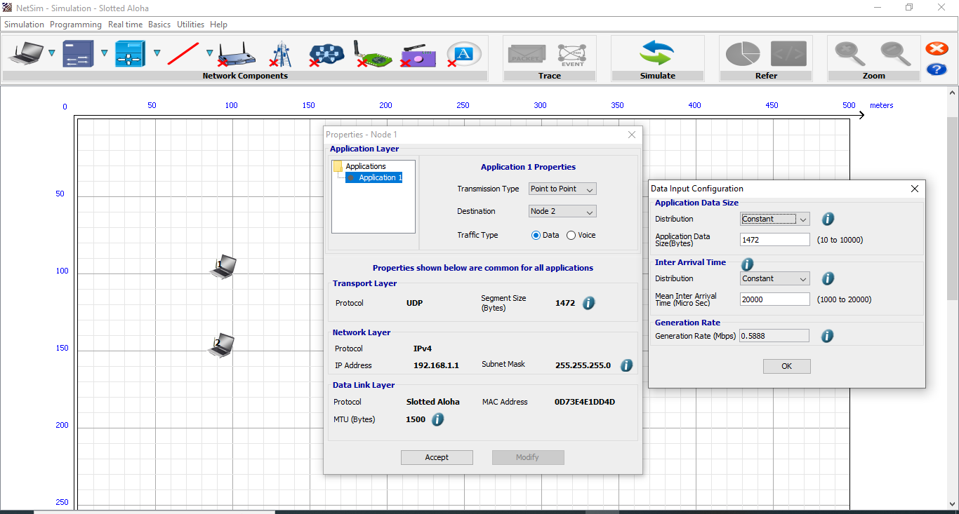

Click on simulate after setting up the properties for the PCs

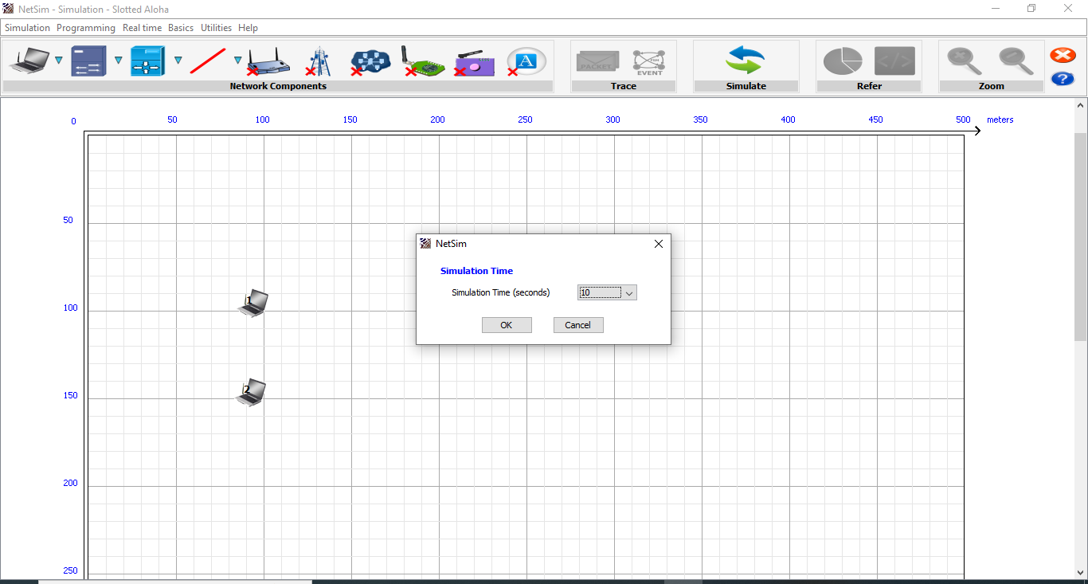

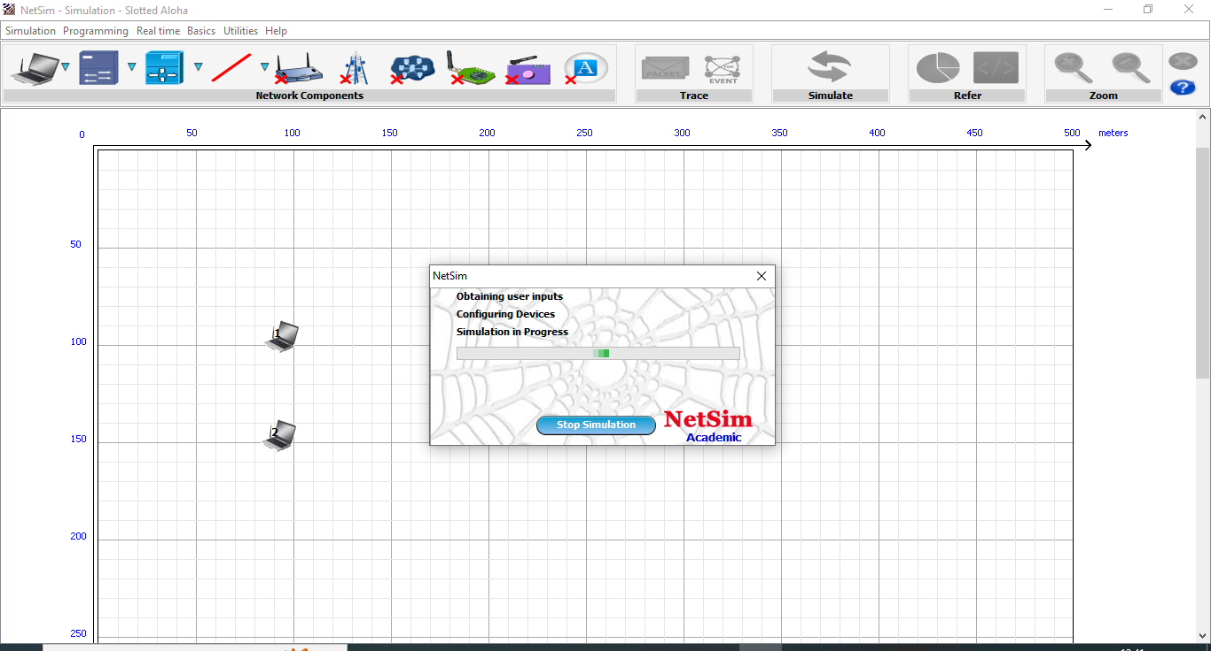

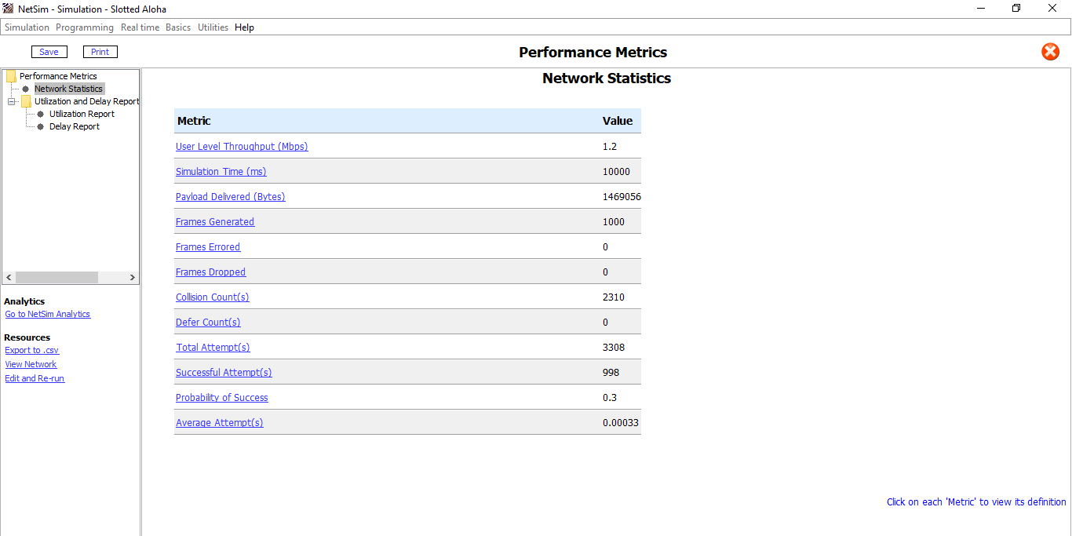

(User level throughput = throughput)

Save the experiment

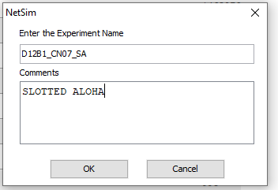



Now for n=3 … click on 

Dest for node 1 : node 2

Dest for node 2 : node 3….(modify it)

Dest for node 3 : node 1

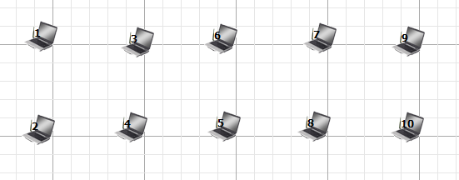

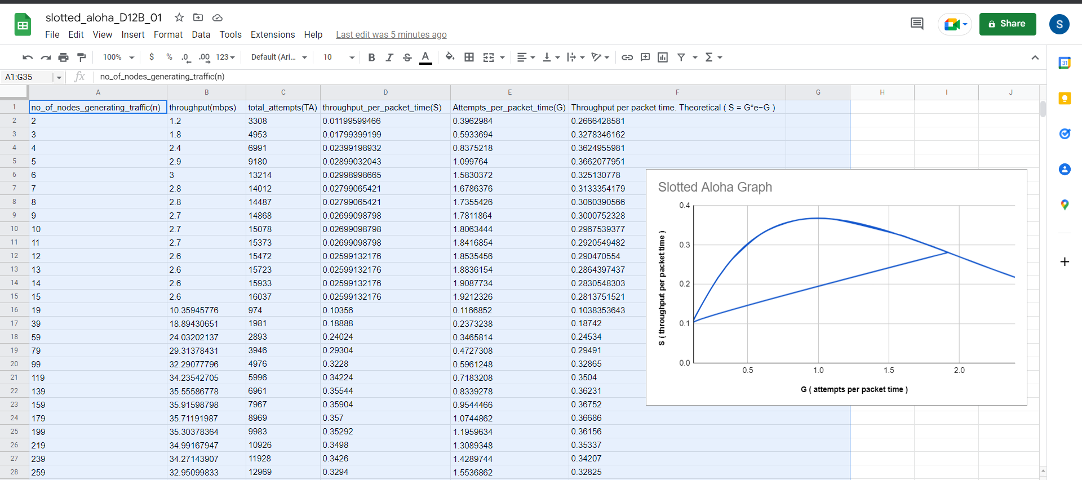

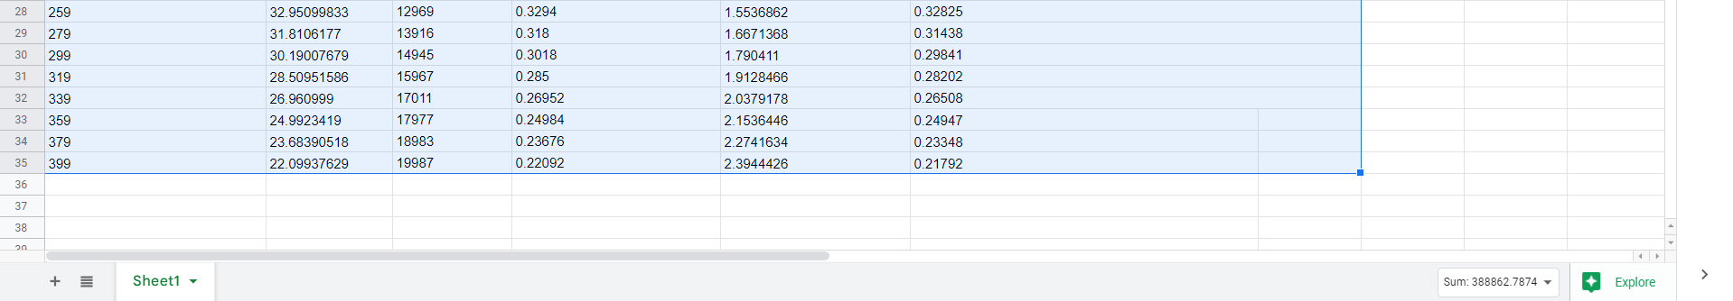







1. **PURE ALOHA**

