01_D7B__SANJANA ASRANI

DBMS

* JOINS
* NATURAL JOIN

SELECT * FROM STUDENTS

NATURAL JOIN STUDENT_MARKS

;

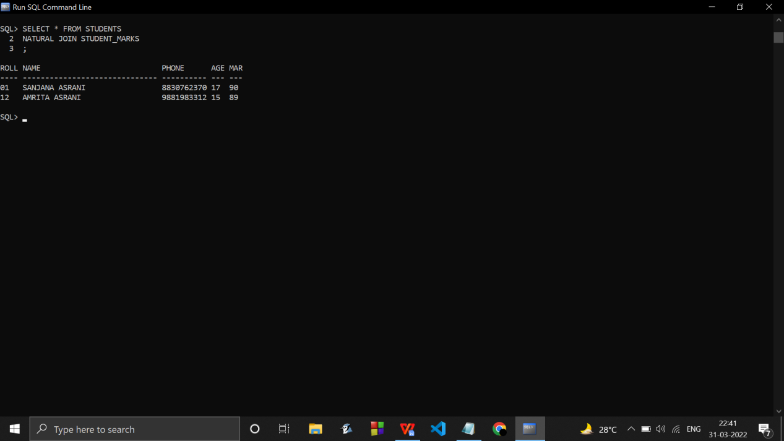

* SELF JOIN

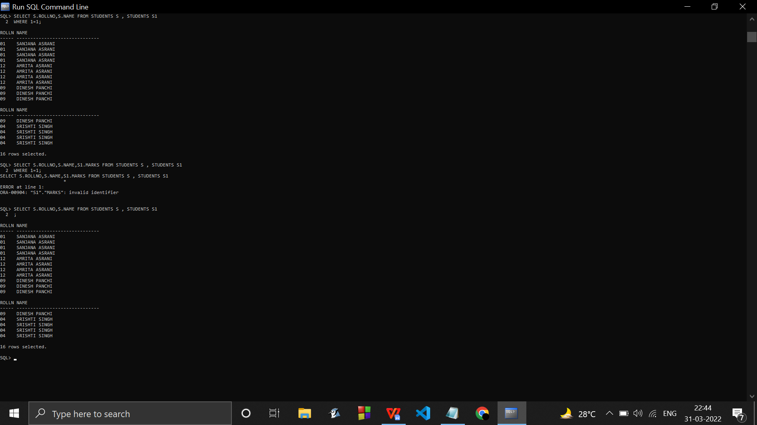

* INNER JOIN / JOIN

SELECT STUDENTS.ROLLNO , STUDENTS.NAME FROM STUDENTS

INNER JOIN STUDENT_MARKS

ON STUDENTS.ROLLNO=STUDENT_MARKS.ROLLNO

;

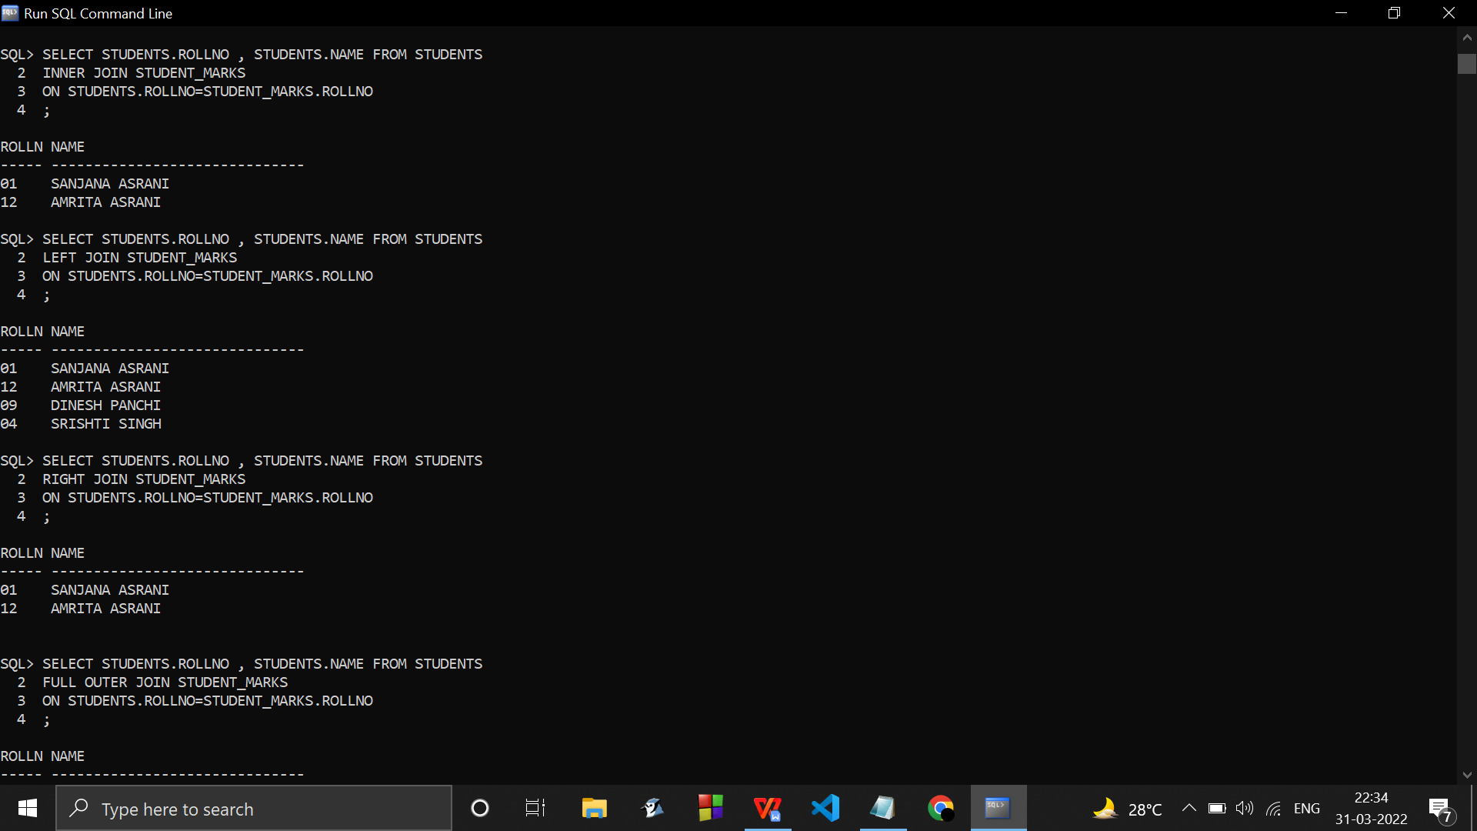

* RIGHT JOIN

SELECT STUDENTS.ROLLNO , STUDENTS.NAME FROM STUDENTS

RIGHT JOIN STUDENT_MARKS

ON STUDENTS.ROLLNO=STUDENT_MARKS.ROLLNO

;



* LEFT JOIN



SELECT STUDENTS.ROLLNO , STUDENTS.NAME FROM STUDENTS

LEFT JOIN STUDENT_MARKS

ON STUDENTS.ROLLNO=STUDENT_MARKS.ROLLNO

;

* FULL OUTER JOIN / FULL JOIN

SELECT STUDENTS.ROLLNO , STUDENTS.NAME FROM STUDENTS

FULL OUTER JOIN STUDENT_MARKS

ON STUDENTS.ROLLNO=STUDENT_MARKS.ROLLNO

;

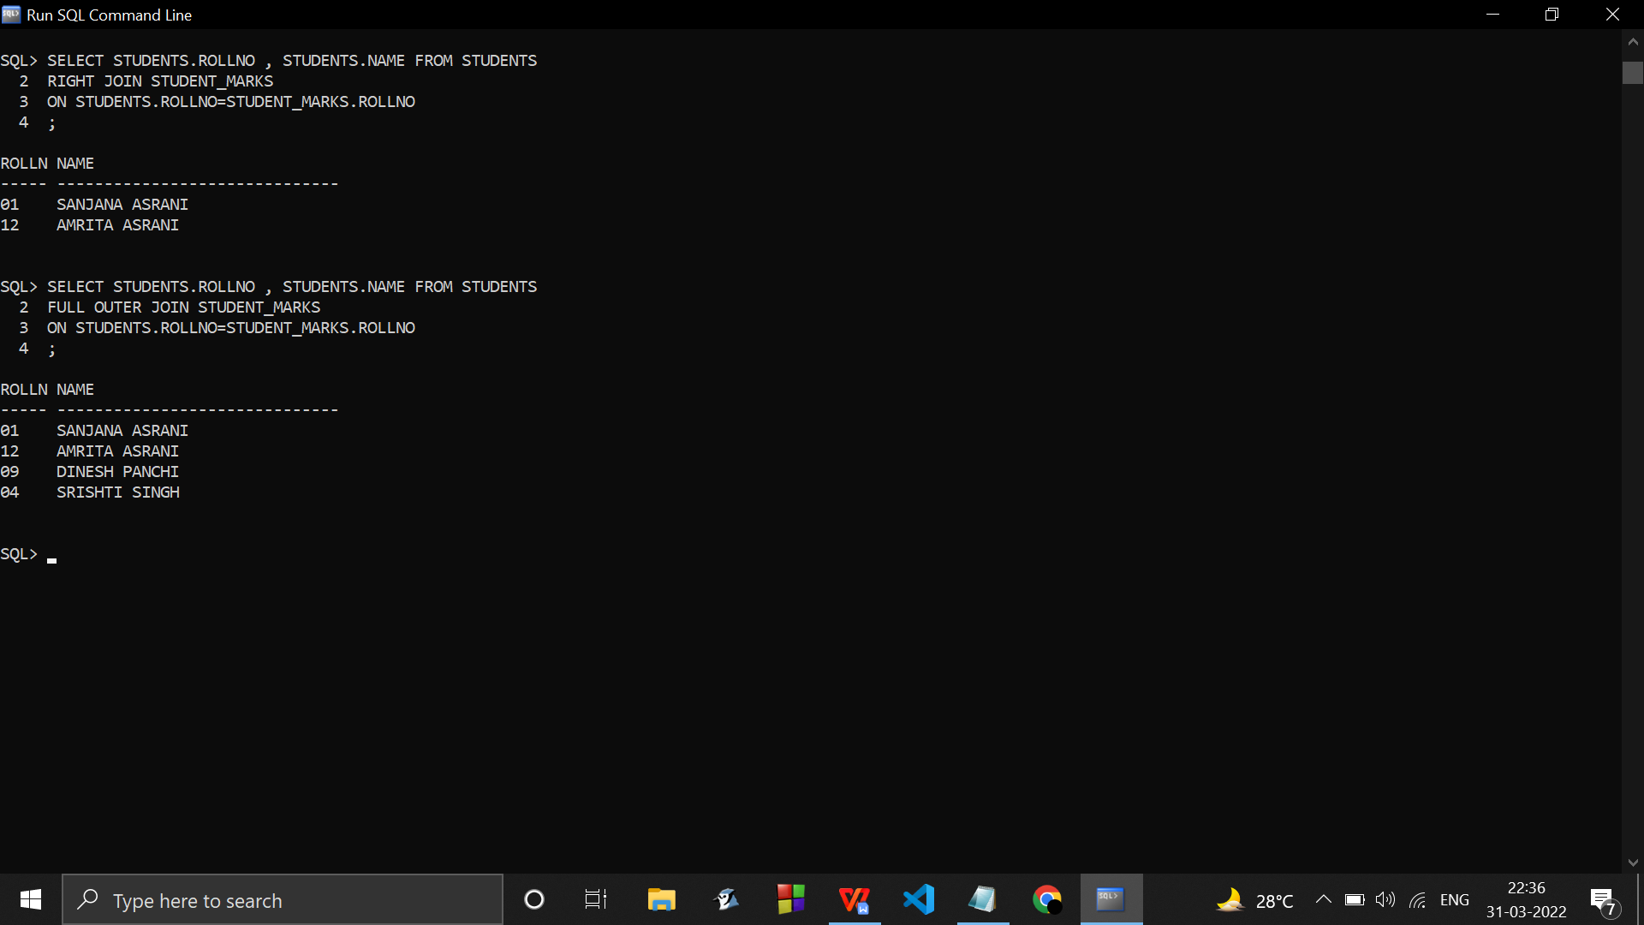

* LEFT OUTER JOIN

SELECT STUDENTS.ROLLNO , STUDENTS.NAME FROM STUDENTS

LEFT OUTER JOIN STUDENT_MARKS

ON STUDENTS.ROLLNO=STUDENT_MARKS.ROLLNO

;

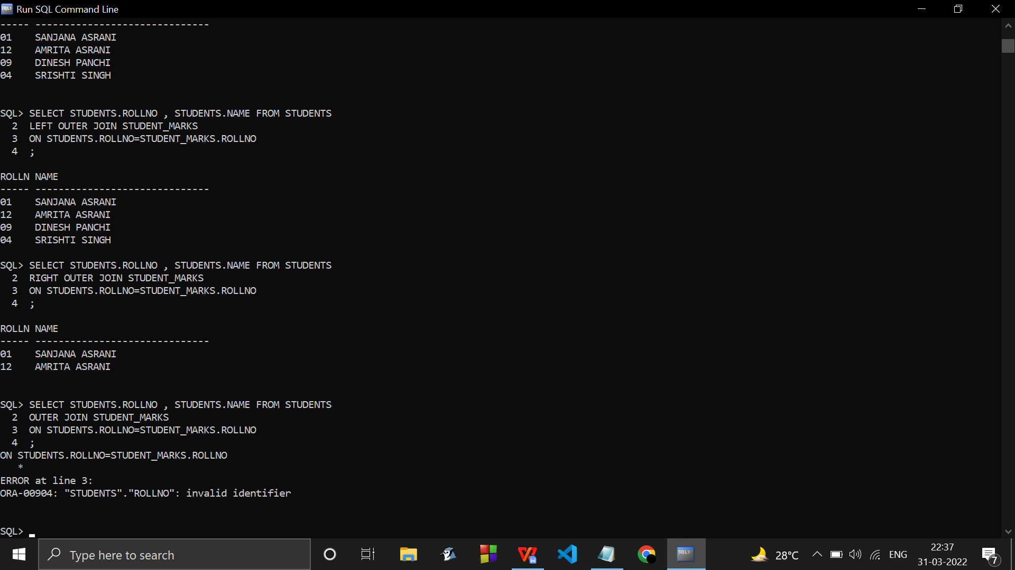

* RIGHT OUTER JOIN

SELECT STUDENTS.ROLLNO , STUDENTS.NAME FROM STUDENTS

RIGHT OUTER JOIN STUDENT_MARKS

ON STUDENTS.ROLLNO=STUDENT_MARKS.ROLLNO

;



* CROSS PRODUCT
* CROSS JOIN

select * from students,student_marks;

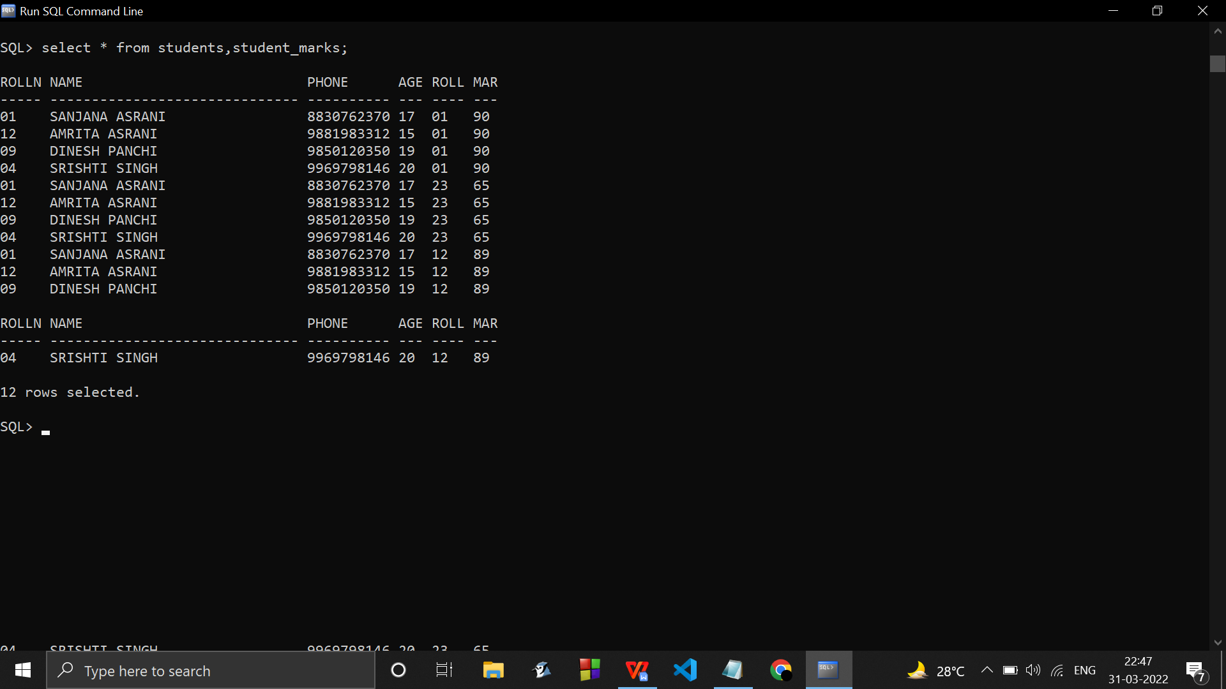

….…………………………………………………………………………………………………………………………………………………..

CREATE TABLE STUDENTS(

ROLLNO VARCHAR(5),

NAME VARCHAR(30),

PHONE VARCHAR(10),

AGE VARCHAR(3)

);

CREATE TABLE STUDENT_MARKS(

ROLLNO VARCHAR(4),

MARKS VARCHAR(3)

);

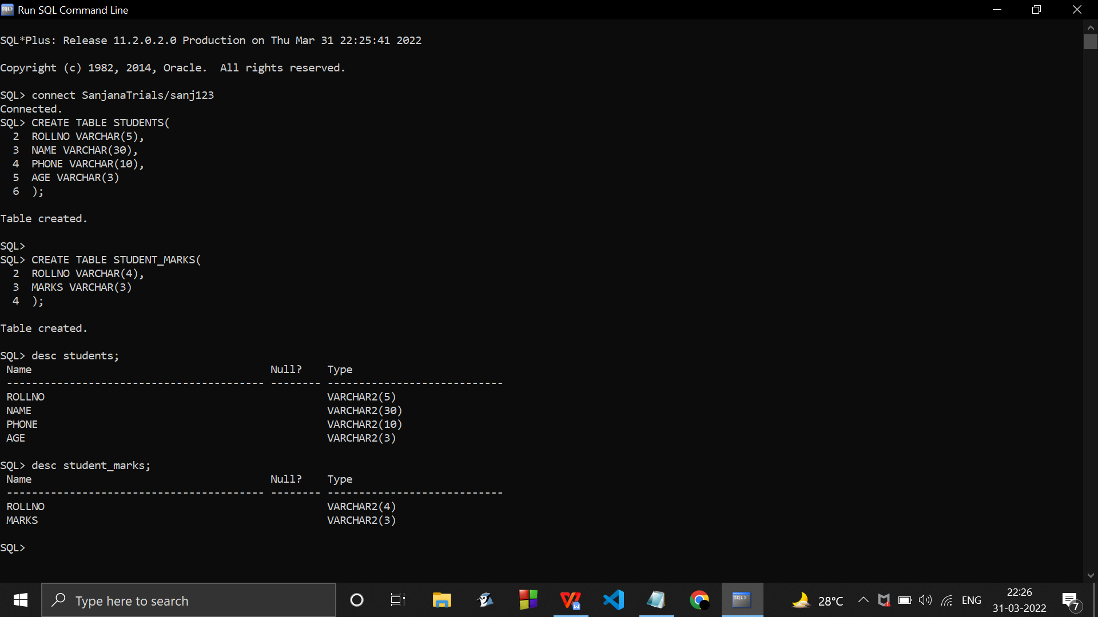

INSERT INTO STUDENTS VALUES('01','SANJANA ASRANI','8830762370','17');

INSERT INTO STUDENTS VALUES('12','AMRITA ASRANI','9881983312','15');

INSERT INTO STUDENTS VALUES('09','DINESH PANCHI','9850120350','19');

INSERT INTO STUDENTS VALUES('04','SRISHTI SINGH','9969798146','20');

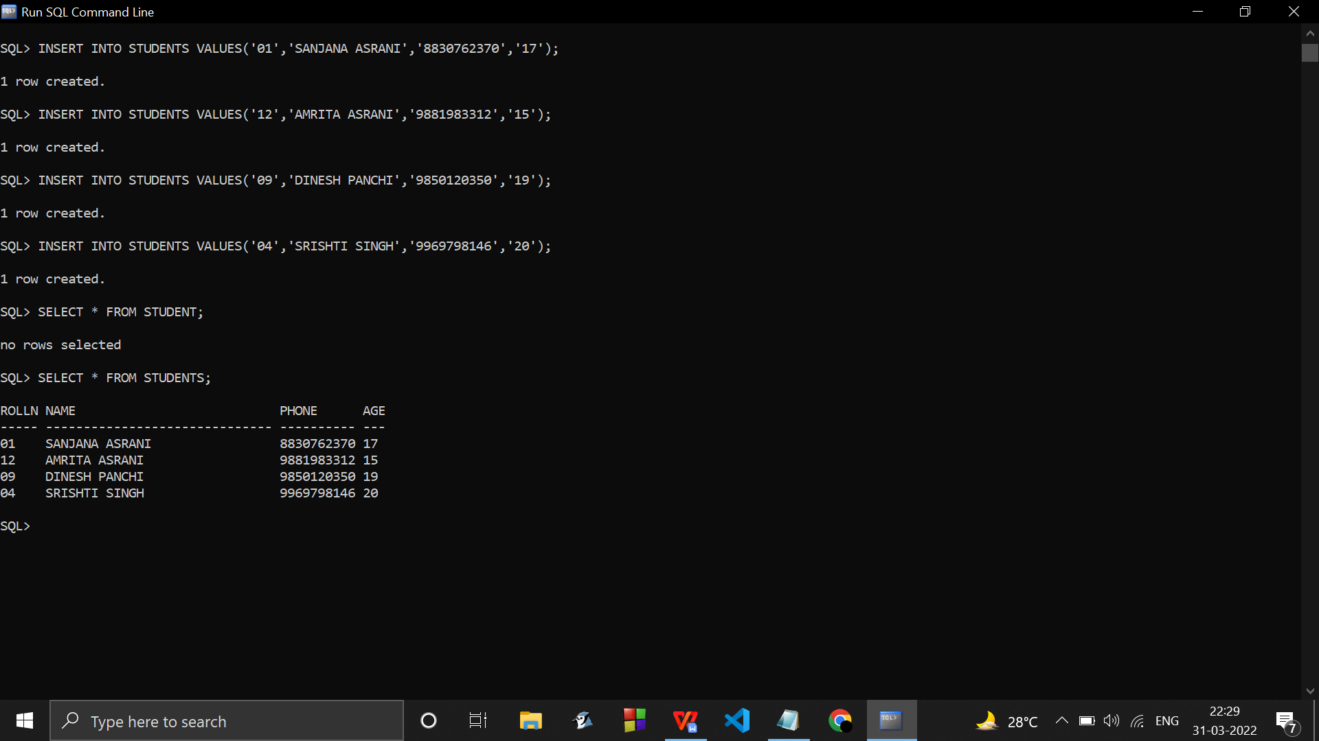

INSERT INTO STUDENT_MARKS VALUES('01','90');

INSERT INTO STUDENT_MARKS VALUES('23','65');

INSERT INTO STUDENT_MARKS VALUES('12','89');

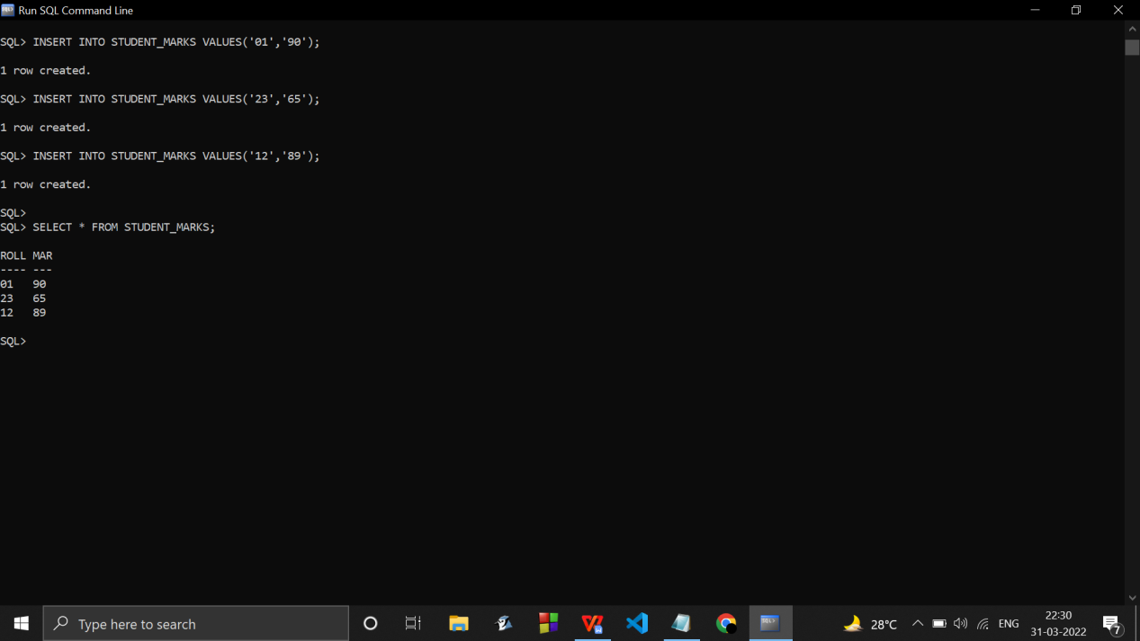

….…………………………………………………………………………………………………………………………………………………

* Transactions

Schedule 1

Serial & parallel ……