NAME : SANJANA ASRANI

DIV : D7B

ROLL NO. : 01

COMPANY DATABASE ERD :

User : SanjanaP/sanj123

SQL data definition statements for defining the COMPANY schema :

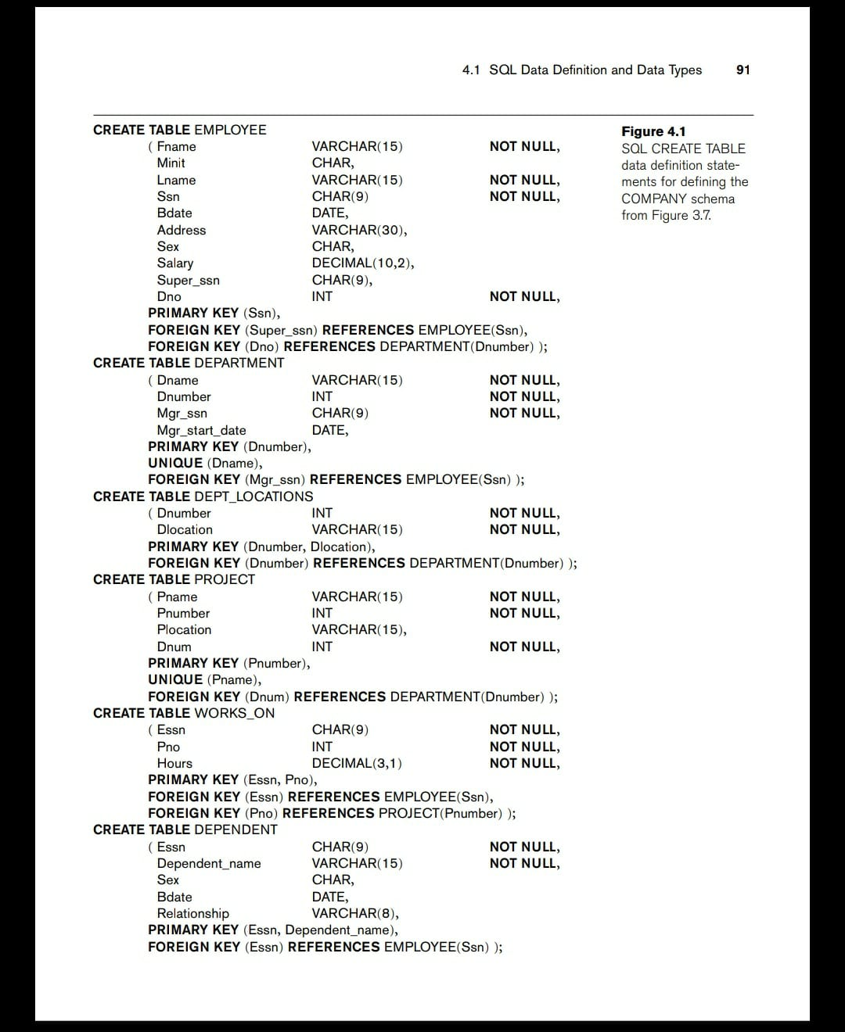

COMMANDS TO CREATE ALL THE TABLES :

CREATE TABLE EMPLOYEE

(

EMP_ID NUMBER(5) NOT NULL,

Fname VARCHAR(15) NOT NULL,

SSN CHAR(9) PRIMARY KEY,

DOB DATE,

ADDRESS VARCHAR(30),

GENDER CHAR,

SALARY DECIMAL(10,2),

Super_ssn CHAR(9),

Dno INT NOT NULL

);

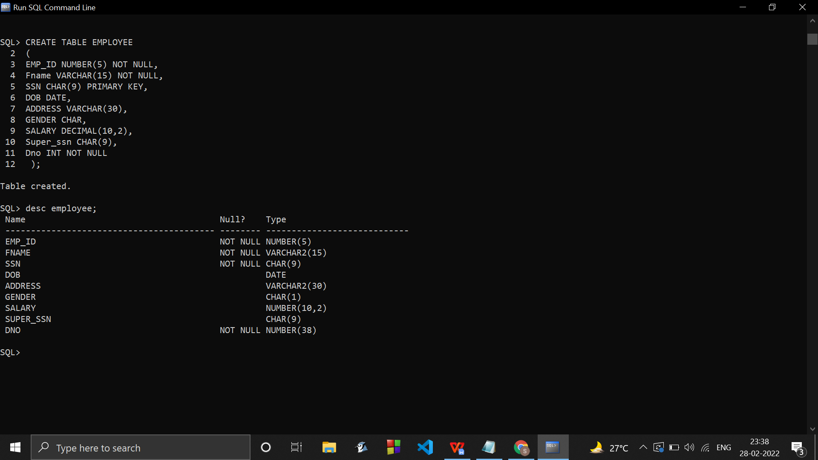

CREATE TABLE DEPARTMENT

(Dname VARCHAR(15) NOT NULL,

Dnumber INT NOT NULL,

Mgr_ssn CHAR(9) NOT NULL,

Mgr_start_date DATE,

PRIMARY KEY (Dnumber),

UNIQUE (Dname)

);

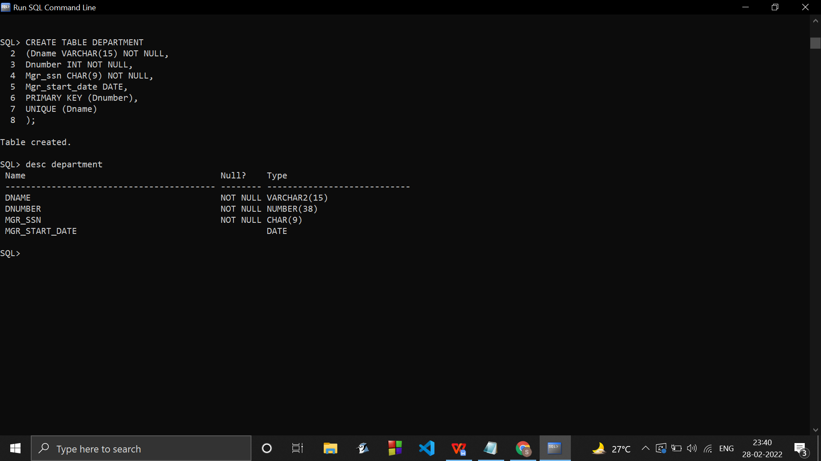

CREATE TABLE DEPT_LOCATIONS

(Dnumber INT NOT NULL,

Dlocation VARCHAR(15) NOT NULL,

PRIMARY KEY (Dnumber, Dlocation)

);

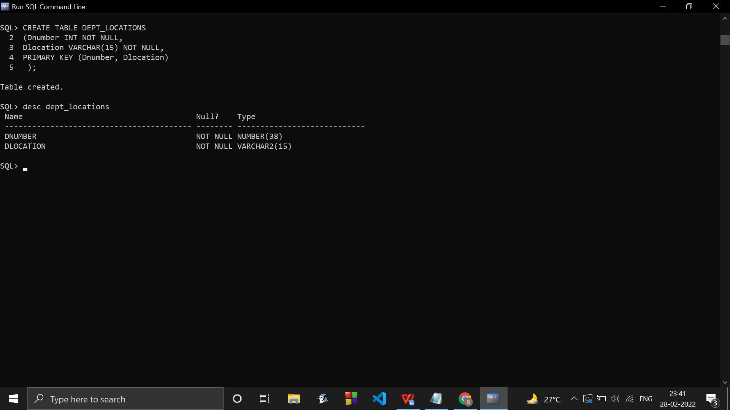

CREATE TABLE PROJECT

( Pname VARCHAR(15) NOT NULL,

Pnumber INT NOT NULL,

Plocation VARCHAR(15),

Dnum INT NOT NULL,

PRIMARY KEY (Pnumber),

UNIQUE (Pname)

);

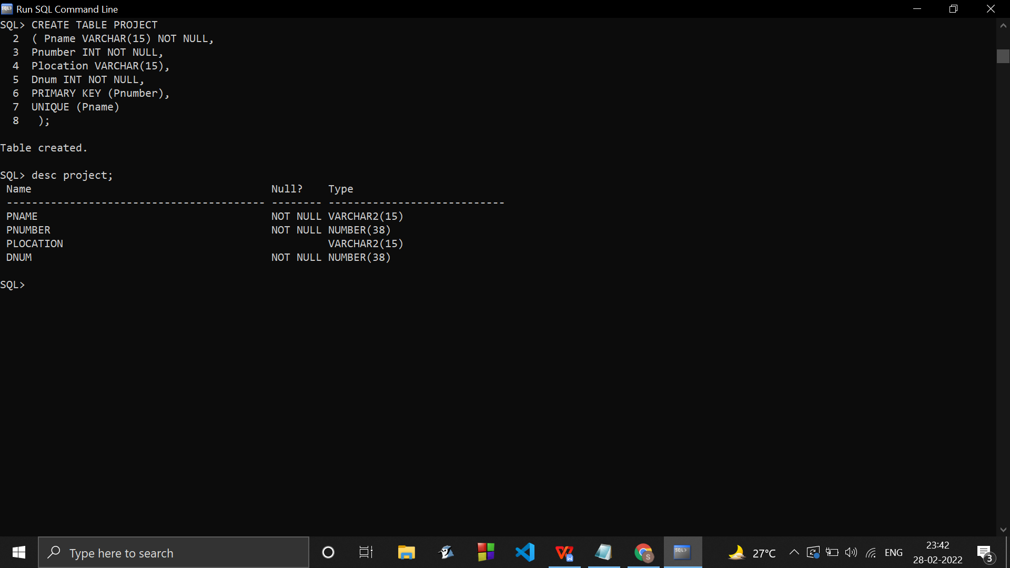

CREATE TABLE WORKS_ON

( Essn CHAR(9) NOT NULL,

Pno INT NOT NULL,

Hours DECIMAL (3,1) NOT NULL,

PRIMARY KEY (Essn, Pno)

);

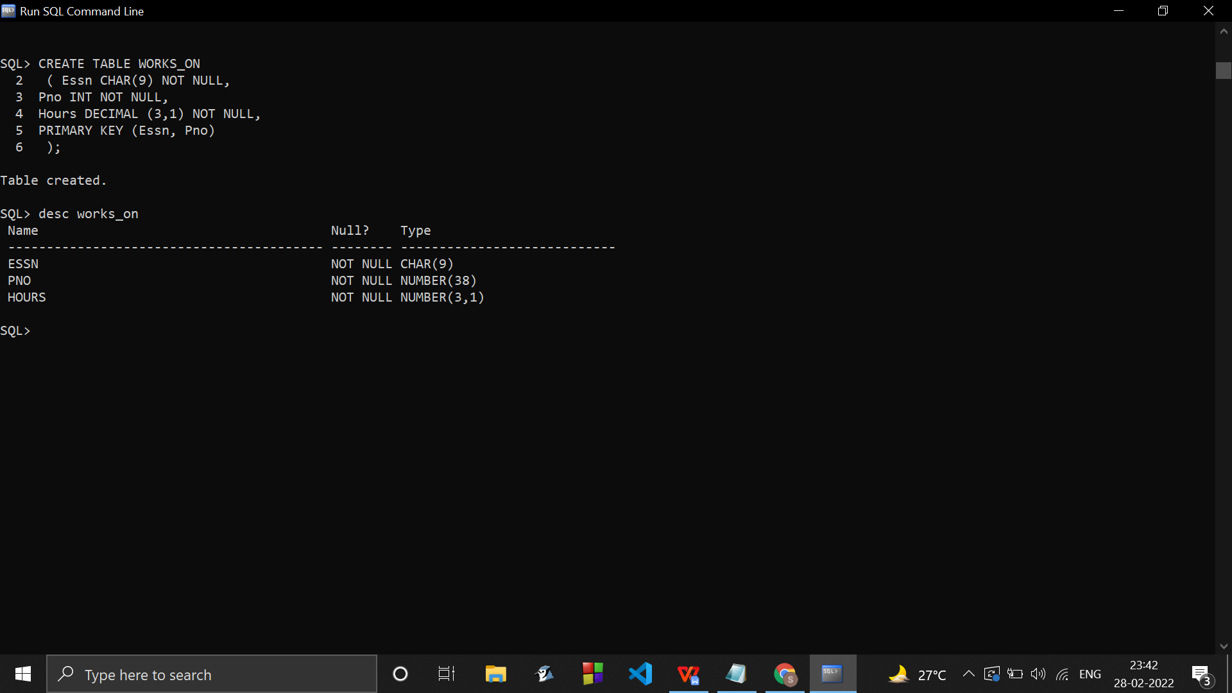

CREATE TABLE DEPENDENT

(Essn CHAR(9) NOT NULL,

Dependent_name VARCHAR(15) NOT NULL,

GENDER CHAR,

Bdate DATE,

Relationship VARCHAR(8),

PRIMARY KEY (Essn, Dependent_name)

);

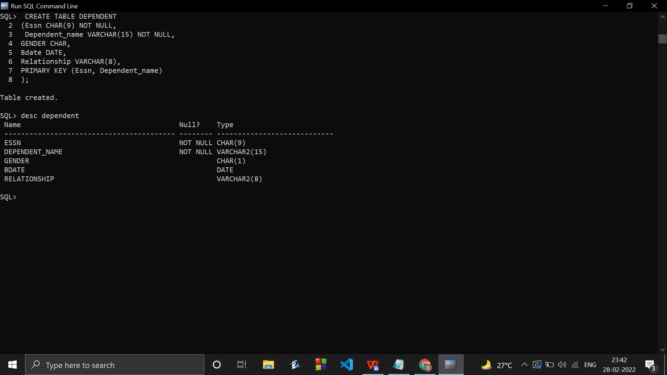

While dropping/deleting the tables :

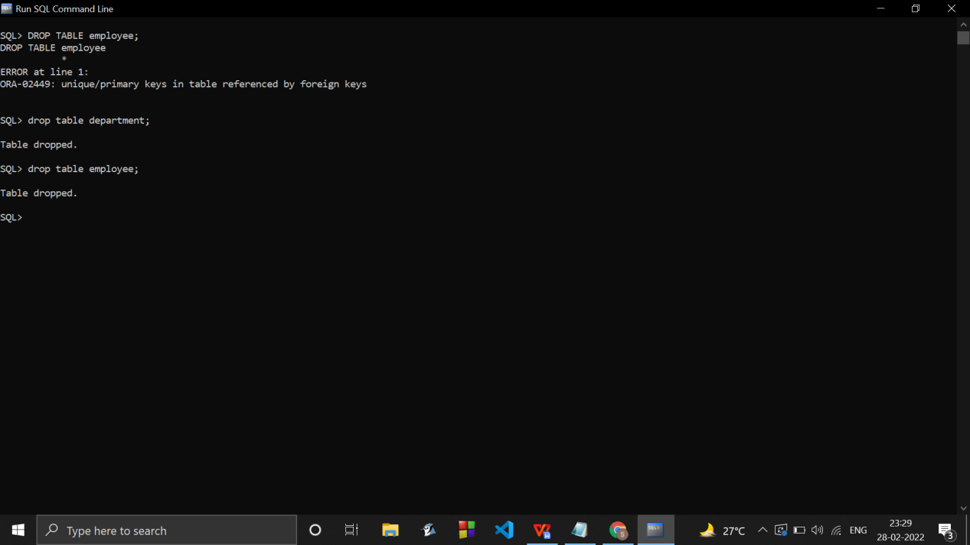

First delete the table which has foreign keys from other tables.

COMMANDS TO ADD FOREIGN KEYS TO ALL TABLES :

ALTER TABLE employee

ADD FOREIGN KEY (Dno) REFERENCES DEPARTMENT(Dnumber);

ALTER TABLE employee

ADD FOREIGN KEY (Super_Ssn ) REFERENCES EMPLOYEE(SSN);

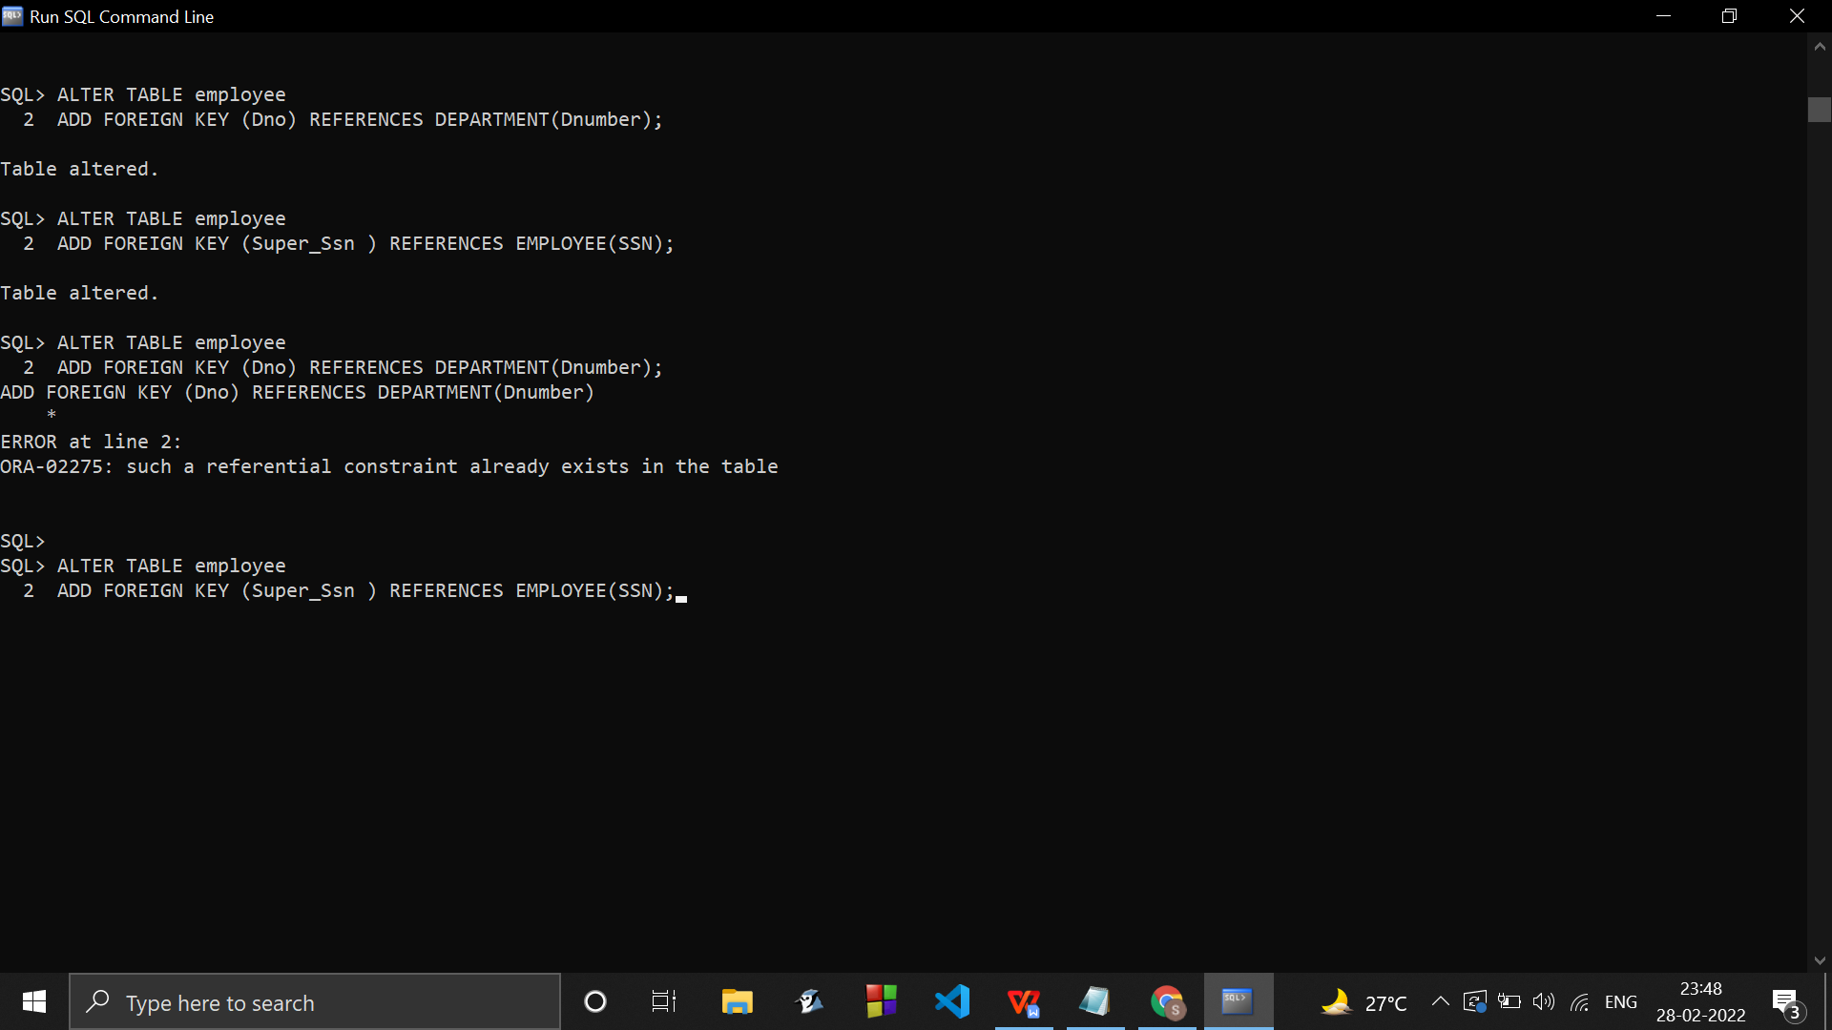

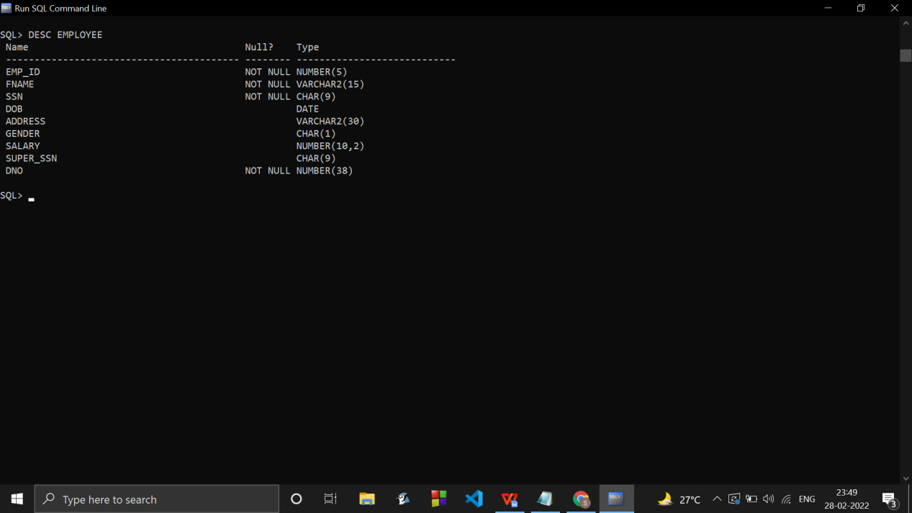

ALTER TABLE department

ADD FOREIGN KEY (Mgr_ssn) REFERENCES EMPLOYEE(SSN);

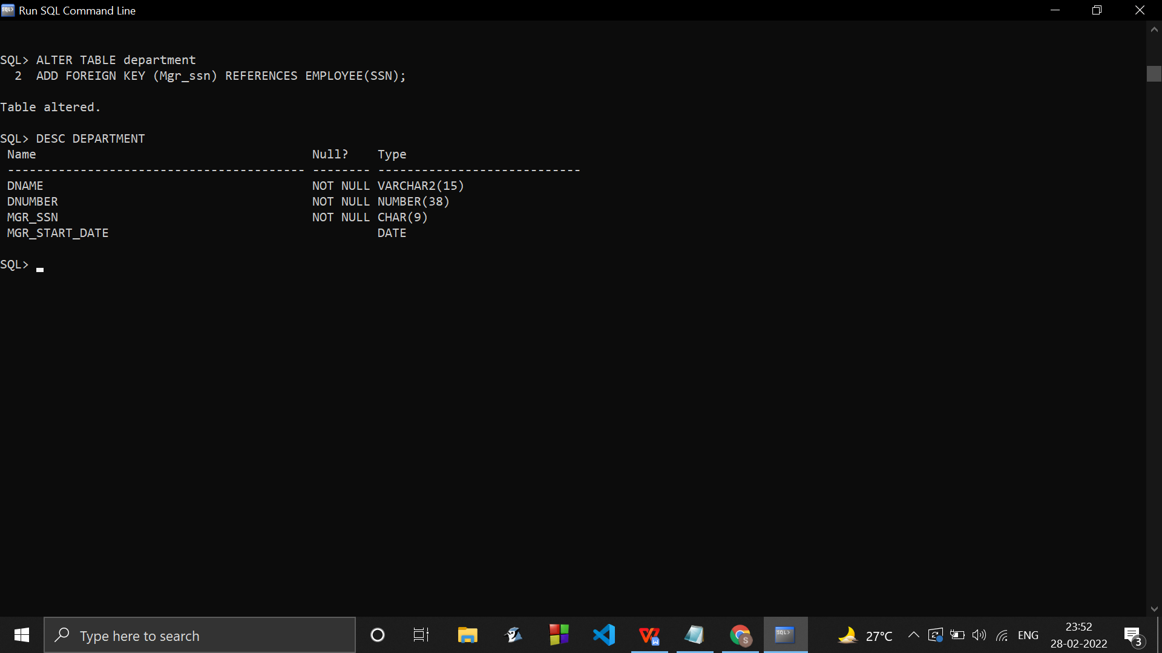

ALTER TABLE DEPT_LOCATIONS

ADD FOREIGN KEY (Dnumber) REFERENCES DEPARTMENT(Dnumber) ;

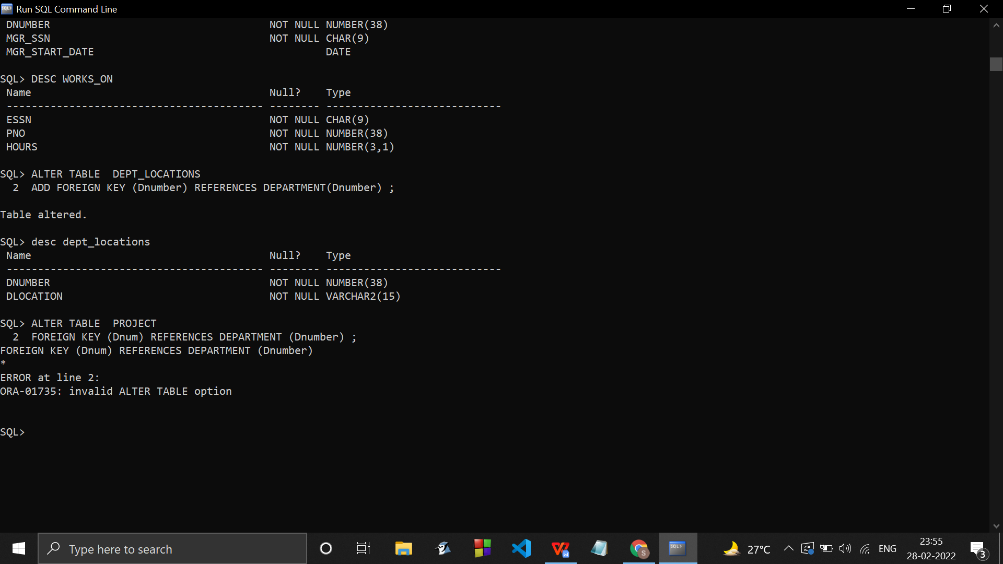

ALTER TABLE PROJECT

ADD FOREIGN KEY (Dnum) REFERENCES DEPARTMENT (Dnumber) ;

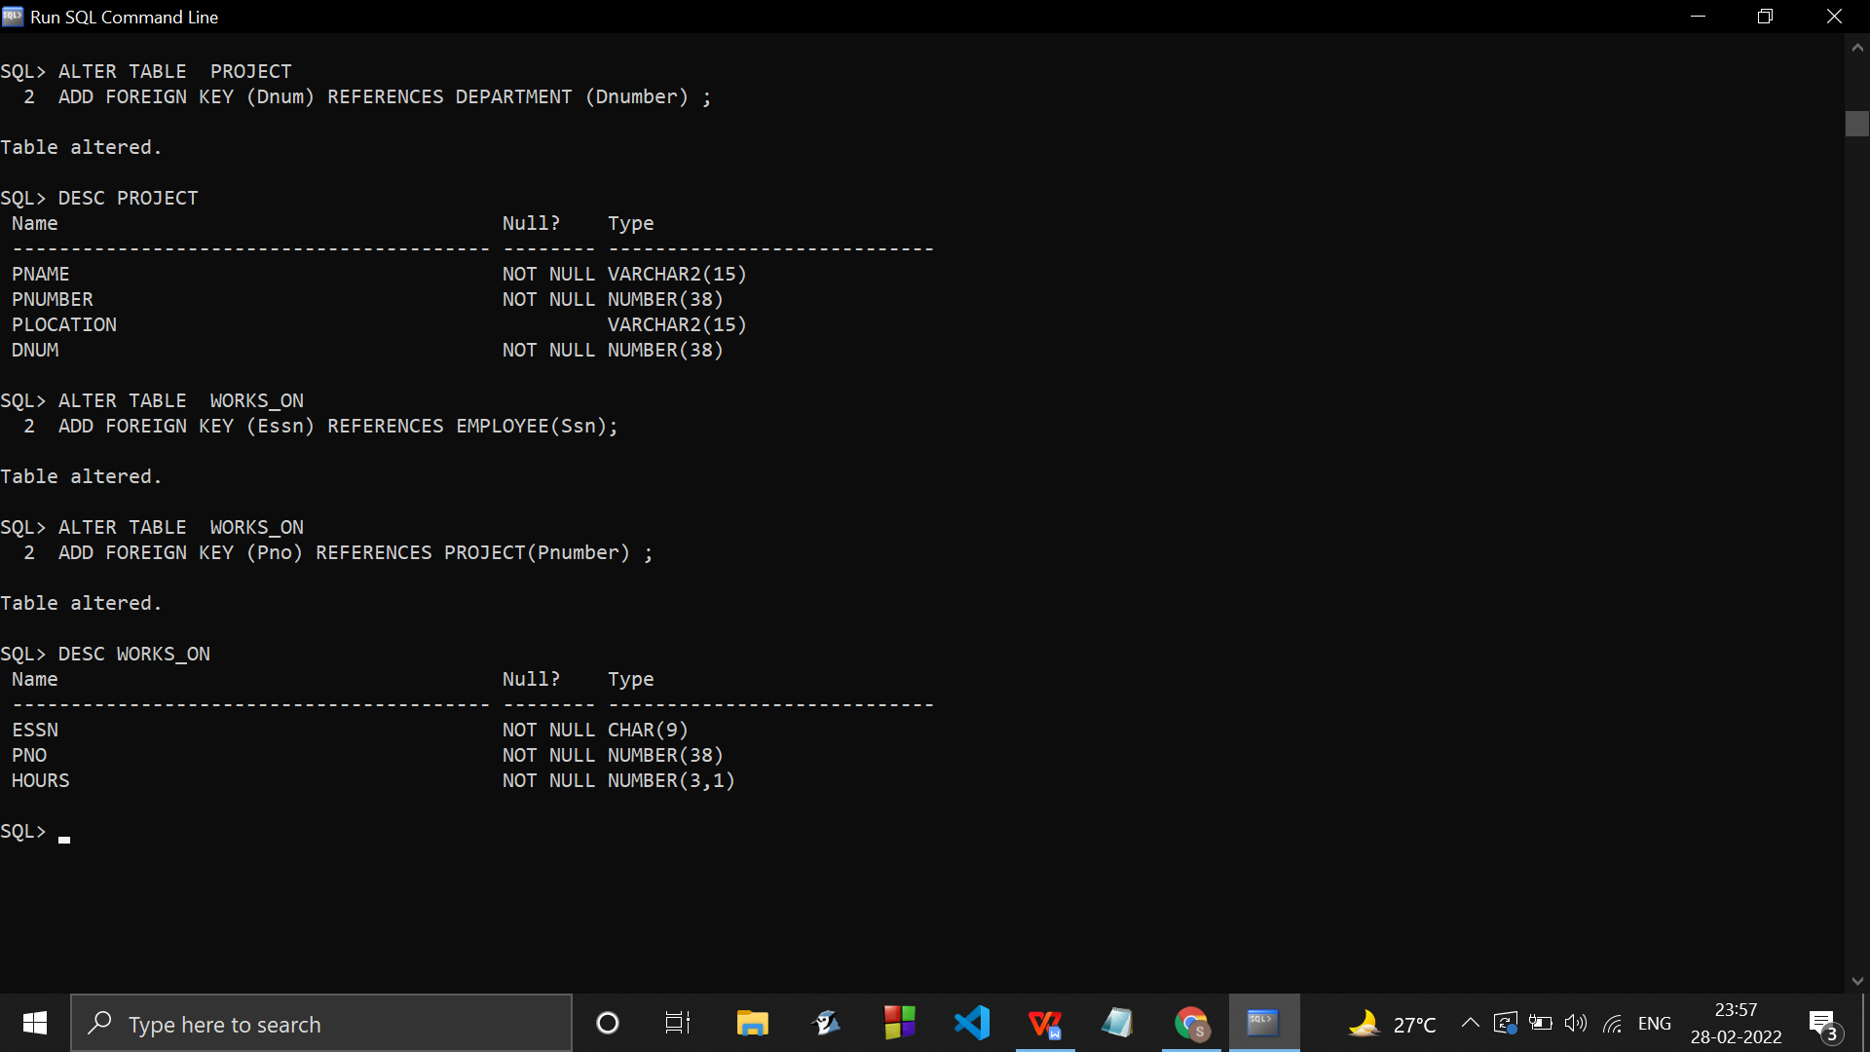

ALTER TABLE WORKS_ON

ADD FOREIGN KEY (Essn) REFERENCES EMPLOYEE(Ssn);

ALTER TABLE WORKS_ON

ADD FOREIGN KEY (Pno) REFERENCES PROJECT(Pnumber) ;



ALTER TABLE DEPENDENT

ADD FOREIGN KEY (Essn) REFERENCES EMPLOYEE(SSN);

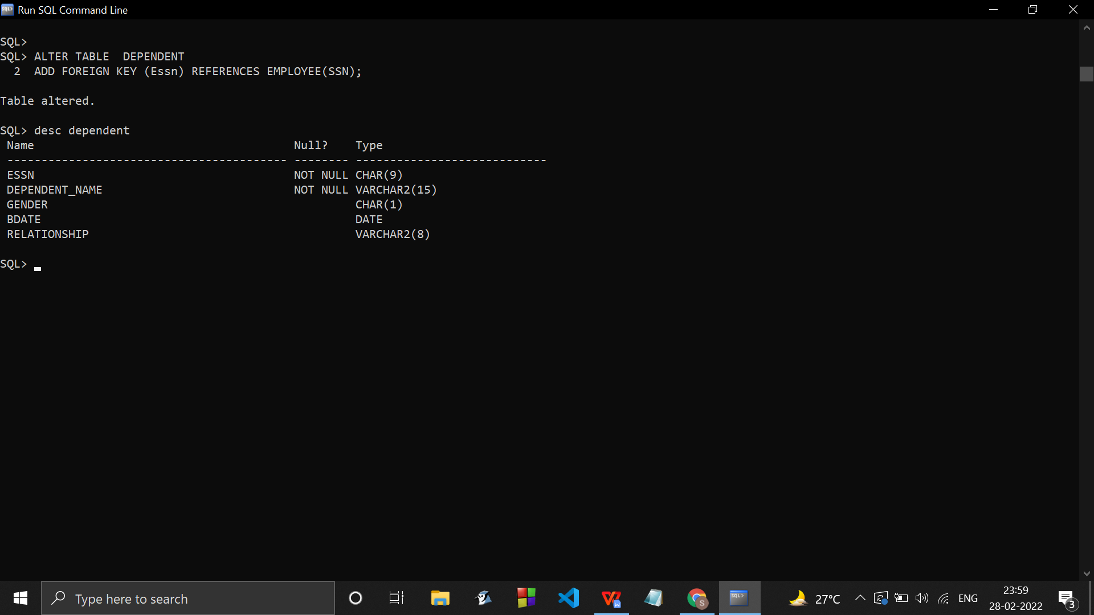

///////////////////////////////////////////////////////////////////////////////////////////////////////////

INSERTING SOME TUPLES :

Insert into EMPLOYEE(EMP_ID ,Fname,SSN ,DOB ,ADDRESS ,GENDER , SALARY ,Dno) values

(001,'Sanjana Asrani','167316730','16-jul-2003','Guru Atman','F',63476239,1);

Insert into DEPARTMENT(Dname, Dnumber ,Mgr_ssn ,Mgr_start_date) values('AMRITA ASRANI',01,'24852485','24-jul-2012');

WE CANT DIRECTLY WRITE LIKE THIS BECAUSE THE TABLES THE FOREIGN KEYS ARE BEING REFERED FROM ARENTED CREATED YET.

CREATE TABLE EMPLOYEE

(

EMP_ID NUMBER(5) NOT NULL,

Fname VARCHAR(15) NOT NULL,

SSN CHAR(9) PRIMARY KEY,

DOB DATE,

ADDRESS VARCHAR(30),

GENDER CHAR,

SALARY DECIMAL(10,2),

Super_ssn CHAR(9),

Dno INT NOT NULL,

FOREIGN KEY (Dno) REFERENCES DEPARTMENT(Dnumber),

);

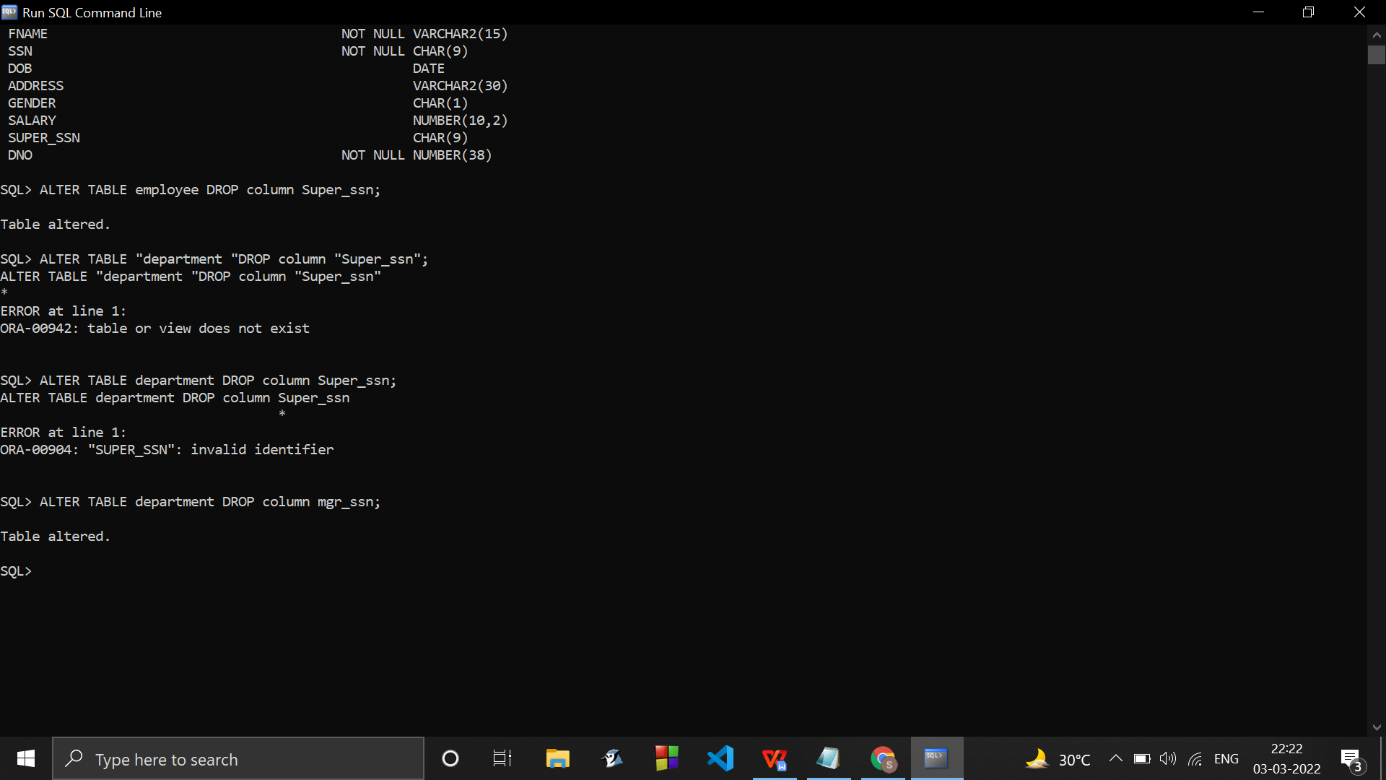

CREATE TABLE DEPARTMENT

(Dname VARCHAR(15) NOT NULL,

Dnumber INT NOT NULL,

Mgr_ssn CHAR(9) NOT NULL,

Mgr_start_date DATE,

PRIMARY KEY (Dnumber),

UNIQUE (Dname),

FOREIGN KEY (Mgr_ssn) REFERENCES EMPLOYEE(SSN));



CREATE TABLE DEPT_LOCATIONS

(Dnumber INT NOT NULL,

Dlocation VARCHAR(15) NOT NULL,

PRIMARY KEY (Dnumber, Dlocation),

FOREIGN KEY (Dnumber) REFERENCES DEPARTMENT(Dnumber) );

CREATE TABLE PROJECT

( Pname VARCHAR(15) NOT NULL,

Pnumber INT NOT NULL,

Plocation VARCHAR(15),

Dnum INT NOT NULL,

PRIMARY KEY (Pnumber),

UNIQUE (Pname),

FOREIGN KEY (Dnum) REFERENCES DEPARTMENT (Dnumber) );

CREATE TABLE WORKS_ON

( Essn CHAR(9) NOT NULL,

Pno INT NOT NULL,

Hours DECIMAL (3,1) NOT NULL,

PRIMARY KEY (Essn, Pno),

FOREIGN KEY (Essn) REFERENCES EMPLOYEE(Ssn),

FOREIGN KEY (Pno) REFERENCES PROJECT(Pnumber) );

CREATE TABLE DEPENDENT

(Essn CHAR(9) NOT NULL,

Dependent_name VARCHAR(15) NOT NULL,

GENDER CHAR,

Bdate DATE,

Relationship VARCHAR(8),

PRIMARY KEY (Essn, Dependent_name),

FOREIGN KEY (Essn) REFERENCES EMPLOYEE(SSN));