NAME : SANJANA ASRANI

DIV : D7B

ROLL NO. : 01

DBMS EXP 2

Mapping ER/EER to the Relational schema model and creating a schema diagram for your system.

‘HOSTEL MANAGEMENT SYSTEM’ SanjanaC/sanj123

DBMS EXP 3

Create a database using Data Definition Language (DDL) and apply Integrity constraints for your specified System

//ROOM_ID WILL ALWAYS BE LIKE 1,2,3,4,5….

//BUT ROOM_NO CAN BE 200,343,102…

SEQUENCE OF CREATION OF TABLES :

department

staff

room

student

id of students in a room

visitor

looks after

CREATE TABLE DEPARTMENT

(

DEPT_ID VARCHAR(2) PRIMARY KEY,

ADMIN_NAME VARCHAR(30) NOT NULL

);

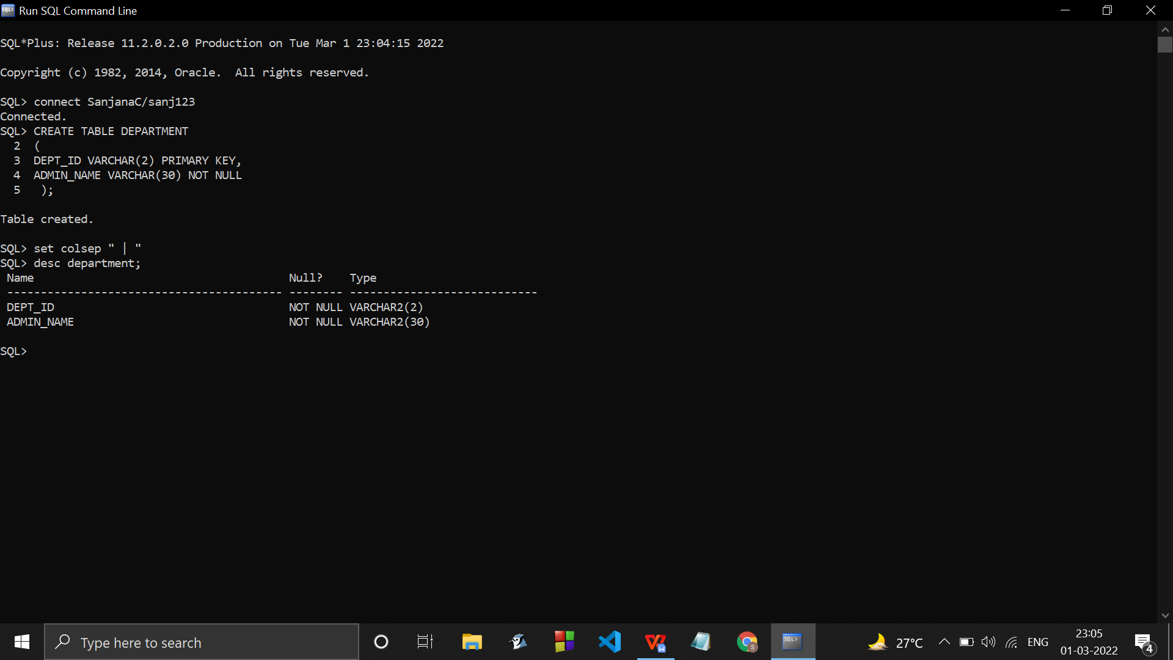

ALTER TABLE DEPARTMENT

ADD DEPT_NAME VARCHAR(5) NOT NULL;

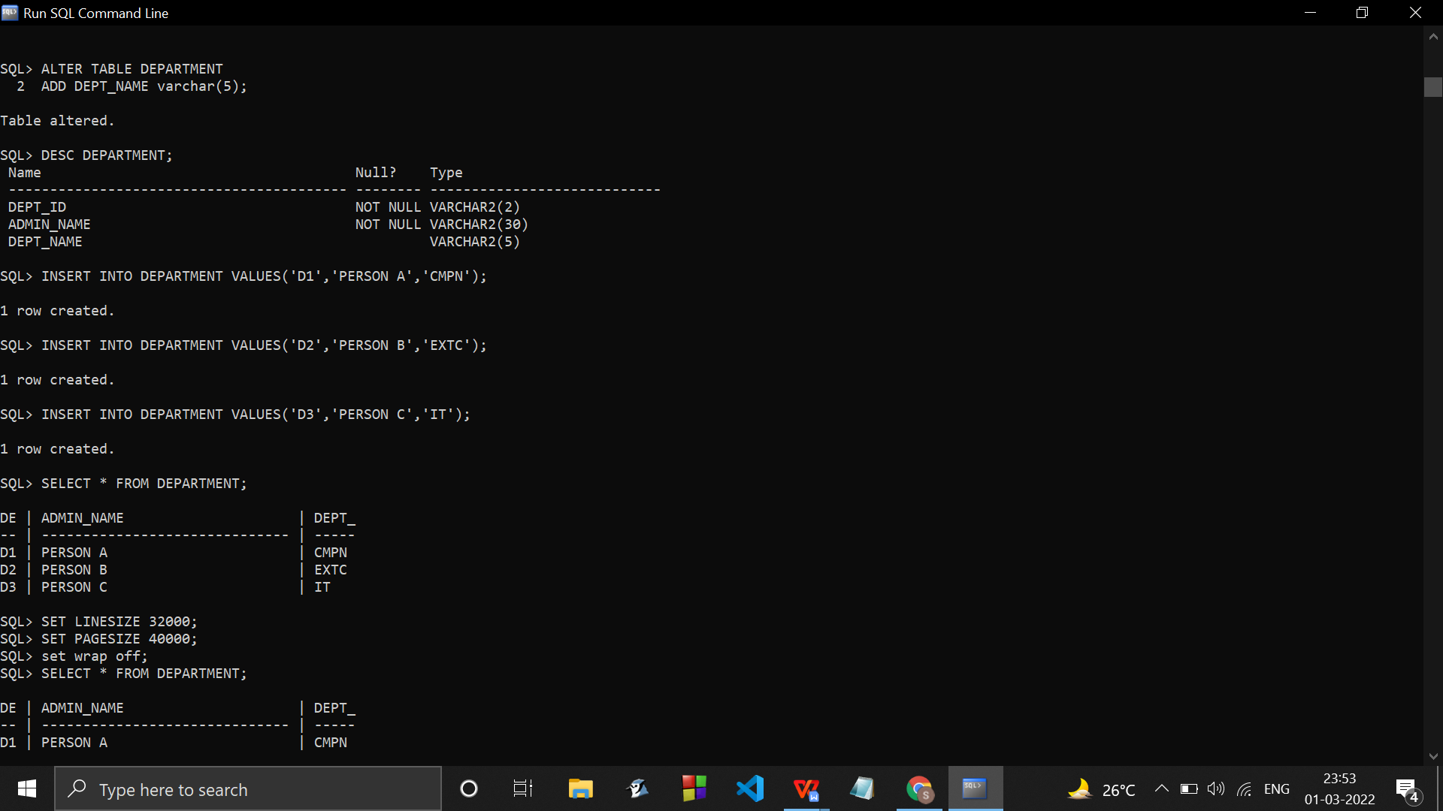

ALTER TABLE department

MODIFY dept_id varchar(5);

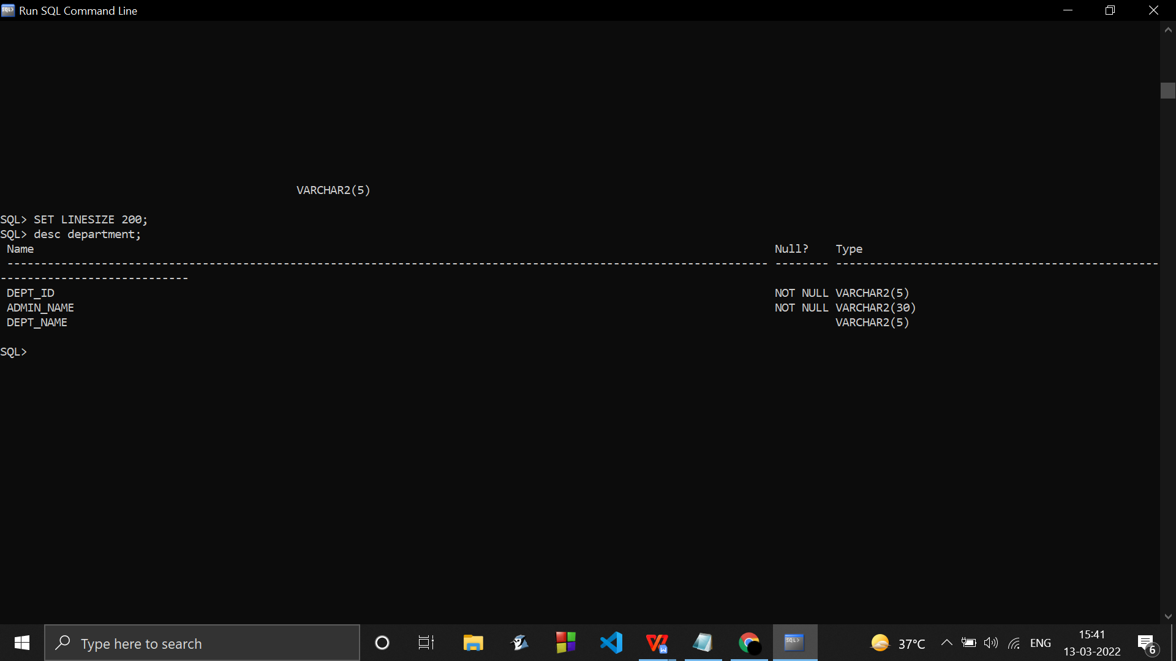

INSERT INTO DEPARTMENT VALUES('D1','PERSON A','CMPN');

INSERT INTO DEPARTMENT VALUES('D2','PERSON B','EXTC');

INSERT INTO DEPARTMENT VALUES('D3','PERSON C','IT');

CREATE TABLE STAFF

(

STAFF_ID VARCHAR(5) PRIMARY KEY,

STAFF_NAME VARCHAR(30) NOT NULL,

STAFF_CONTACT_NO NUMBER(10) ,

STAFF_SALARY NUMBER(8),

STAFF_ROLE_NAME VARCHAR(30) NOT NULL,

dept_id VARCHAR(2) NOT NULL,

FOREIGN KEY(dept_id) REFERENCES DEPARTMENT(DEPT_ID)

);

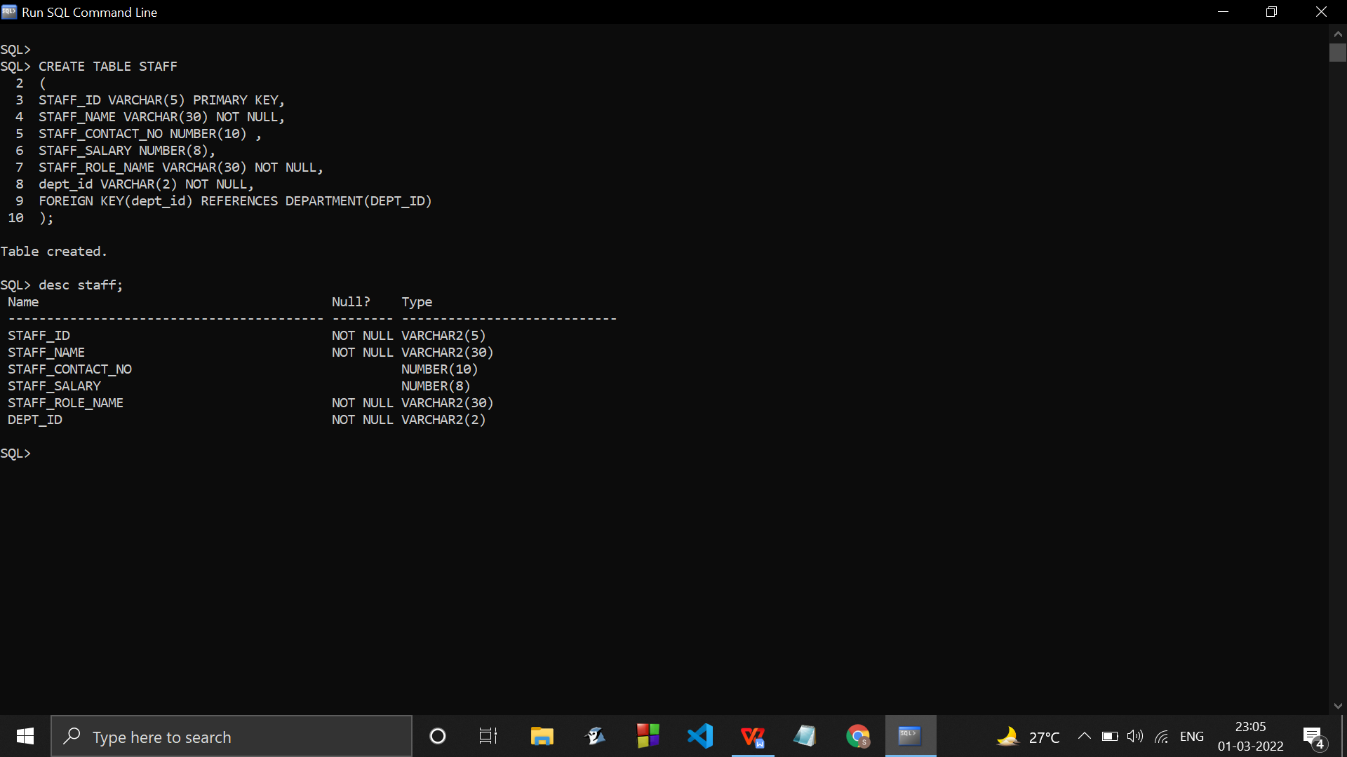

INSERT INTO STAFF VALUES('S001','Jose Sellers',1234567890,5000,'Janitor','D1');

INSERT INTO STAFF VALUES('S002','Atticus Turner',9876543210,7000,'Manager','D1');

INSERT INTO STAFF VALUES('S003','Jessie Mcknight',1357924680,9000,'Receiptionist','D3');

INSERT INTO STAFF VALUES('S007','Sonia Pruitt',2468135790,6000,'Gatekeeper','D2');

INSERT INTO STAFF VALUES('S004','Kyler Whitney',2424242424,5000,'Warden','D3');

INSERT INTO STAFF VALUES('S005','Emmanuel Lloyd',1616161616,2000,'Mess Employee','D2');

INSERT INTO STAFF VALUES('S006','Nigel Jennings',5555555555,9098,'Councellor','D1');

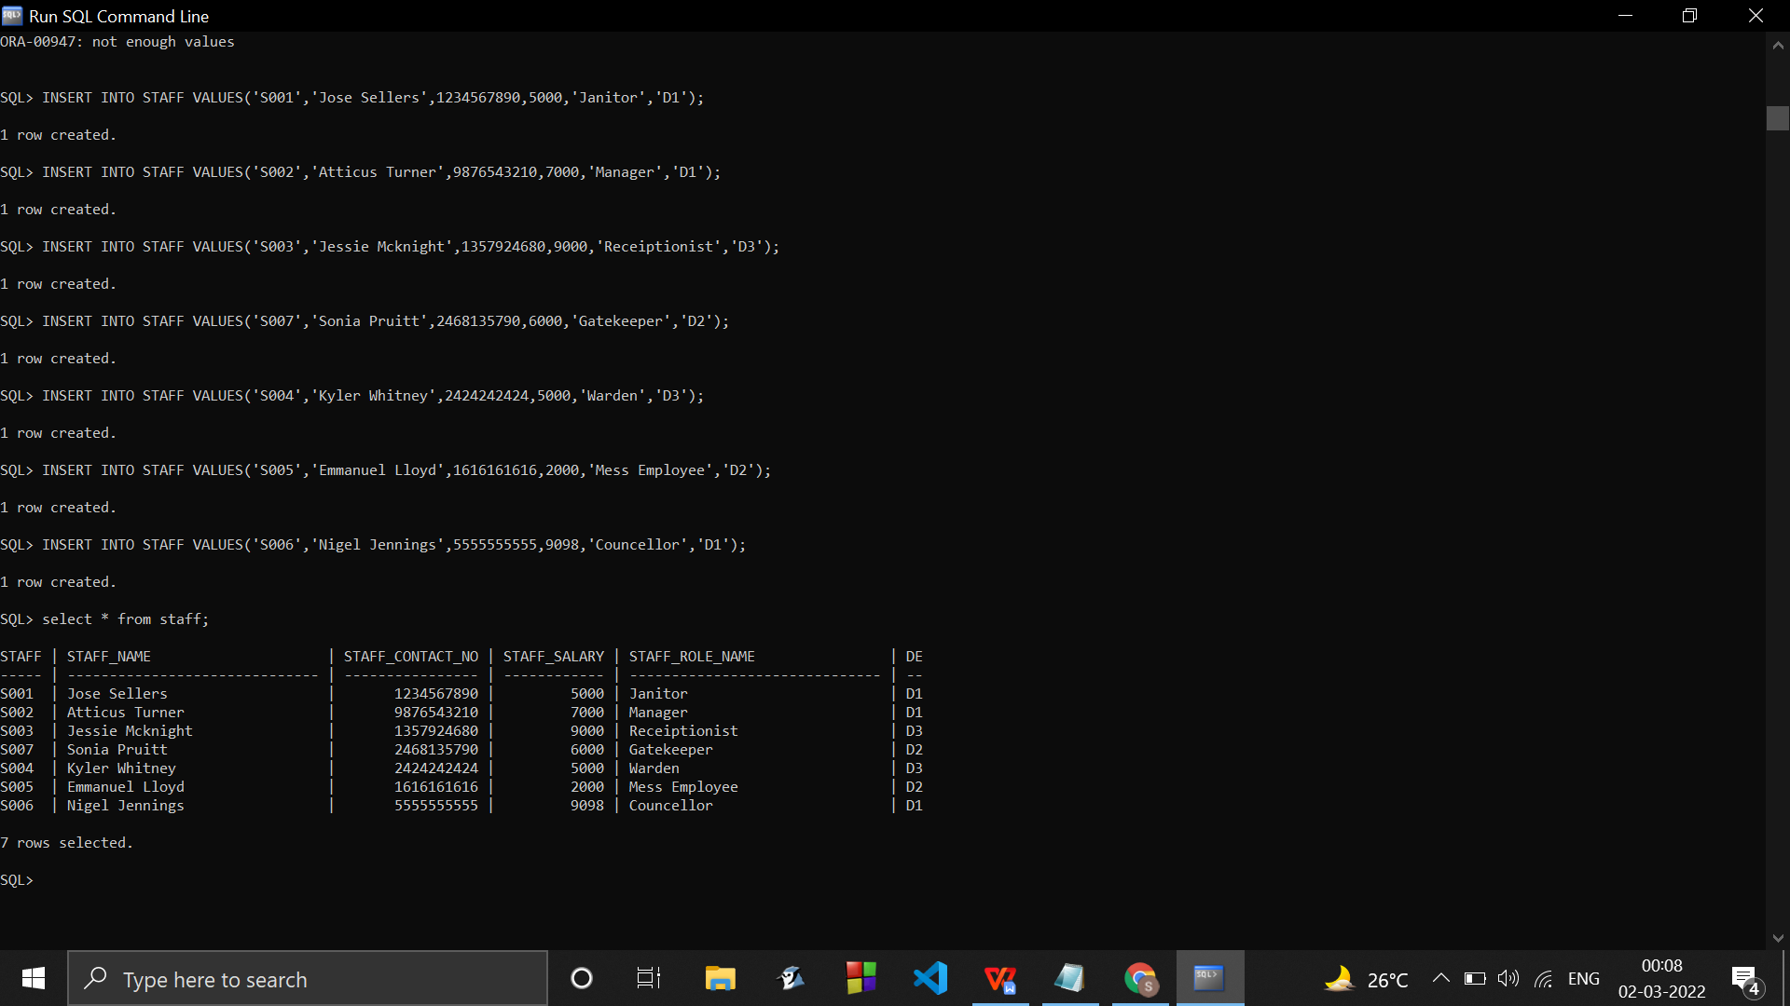

ALTER TABLE STAFF

MODIFY dept_id varchar(5);

CREATE TABLE STUDENT

(

STUD_ID VARCHAR(5) PRIMARY KEY,

STUD_NAME VARCHAR(30) NOT NULL,

STUD_ADHAR_NO NUMBER(10) ,

STUD_STAY_PERIOD NUMBER(8),

STUD_GENDER CHAR(1),

STUD_DEPT VARCHAR(4) NOT NULL,

STUD_DOB DATE,

room_id VARCHAR(5) NOT NULL,

FEE_STATUS VARCHAR(6) NOT NULL,

ALLOTED_ROOM_ID VARCHAR(5) NOT NULL,

FOREIGN KEY(room_id) REFERENCES ROOM (ROOM_ID)

FOREIGN KEY(STUD_DEPT) REFERENCES DEPARTMENT(DEPT_ID)

);

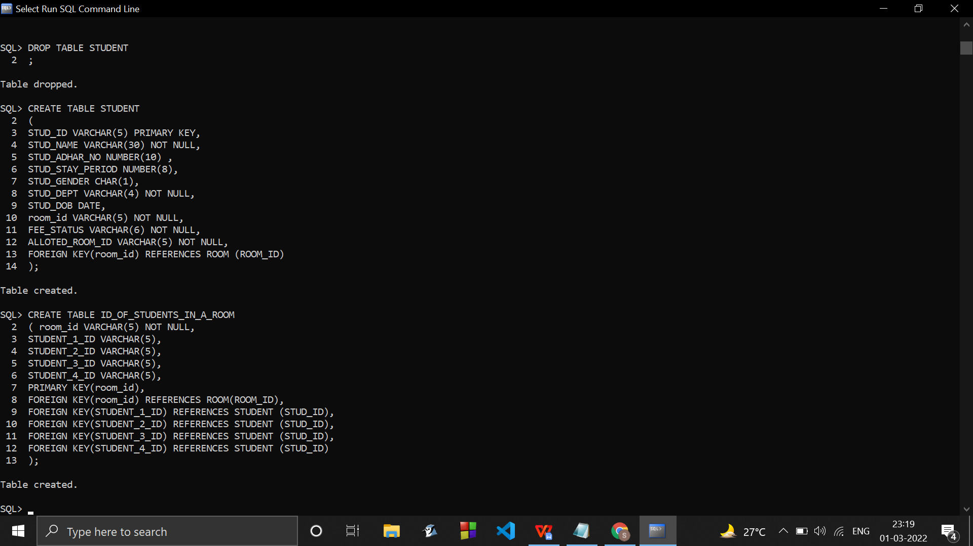

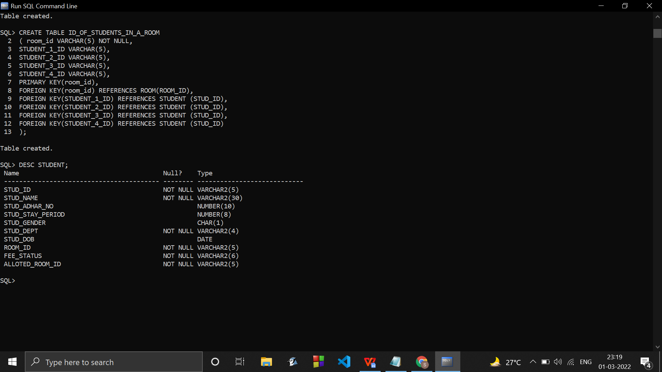

ALTER TABLE STUDENT

2 DROP COLUMN ROOM_ID;

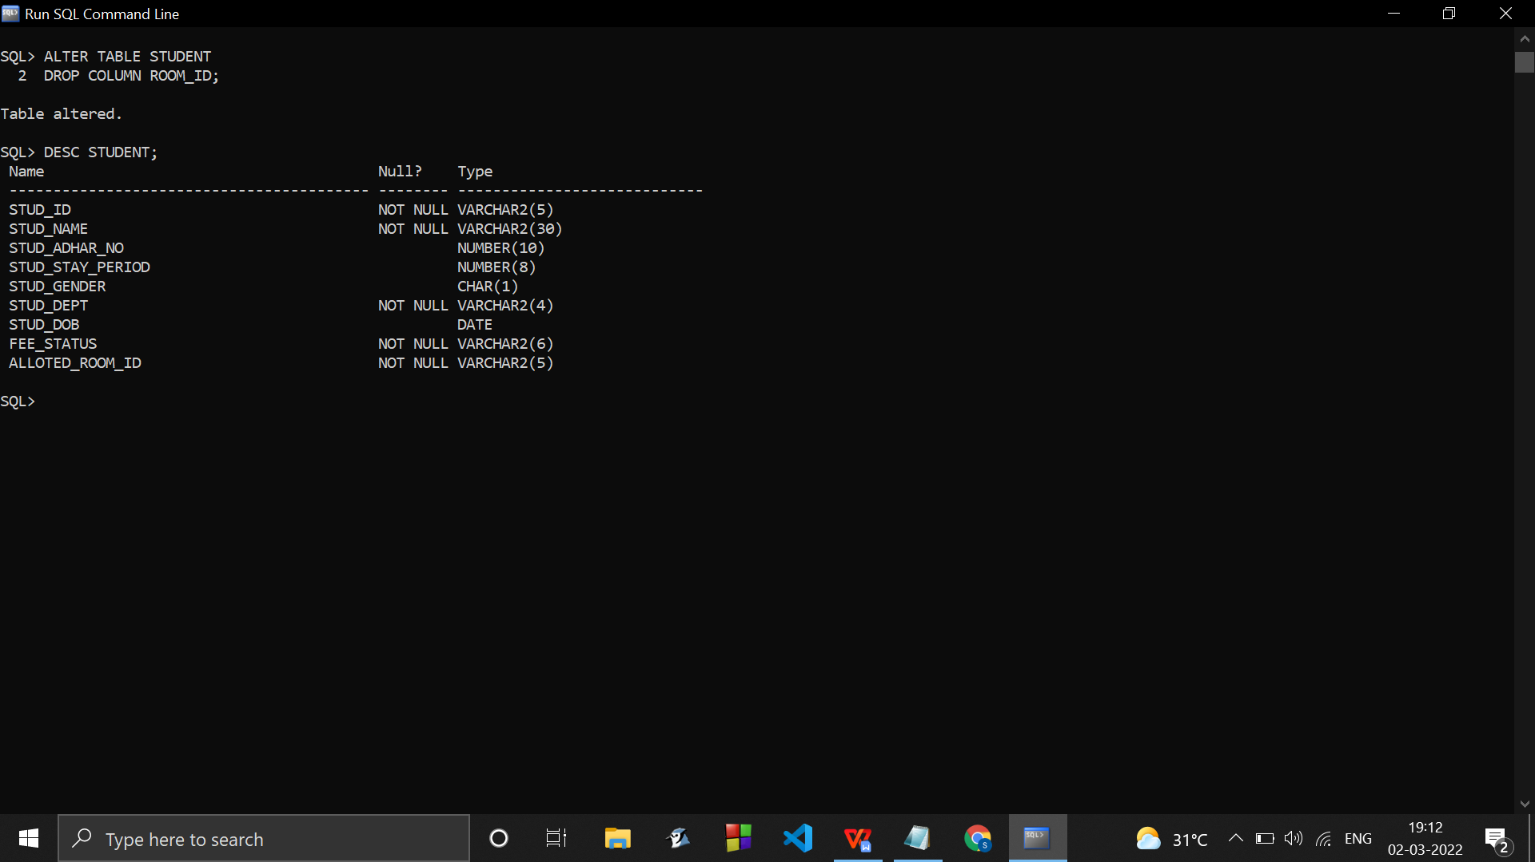

.alter table student to have 12 characters in adhar no

.alter table student to have DATATYPE VARCHAR(30) IN STAY PERIOD.

ALTER TABLE student

MODIFY STUD_ADHAR_NO number(12);

ALTER TABLE STUDENT

MODIFY STUD_STAY_PERIOD varchar(30);

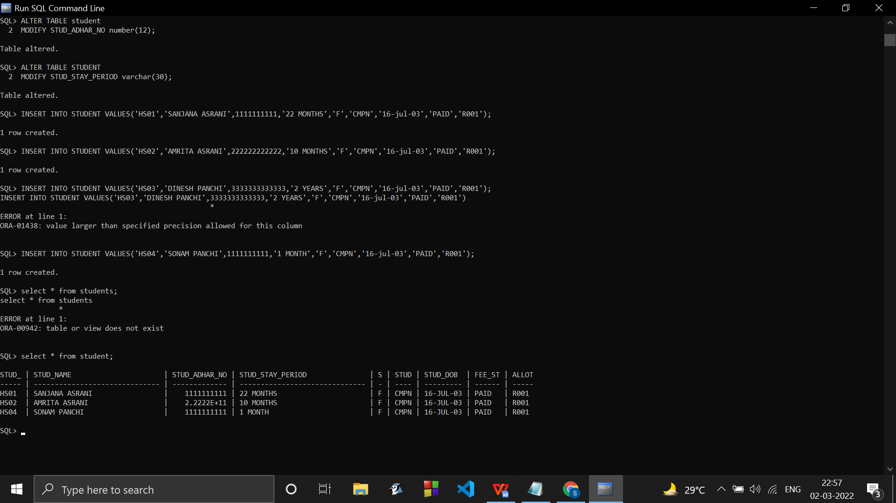

INSERT INTO STUDENT VALUES('HS01','SANJANA ASRANI',1111111111,'22 MONTHS','F','CMPN','16-jul-03','PAID','R001');

INSERT INTO STUDENT VALUES('HS02','AMRITA ASRANI',222222222222,'10 MONTHS','F','IT','24-aug-05','PAID','R001');

INSERT INTO STUDENT VALUES('HS03','DINESH PANCHI',333333333333,'2 YEARS','M','INST','25-oct-96','PAID','R002');

INSERT INTO STUDENT VALUES('HS04','SONAM PANCHI',1111111111,'1 MONTH','F','EXTC','09-nov-97','PAID','R001');

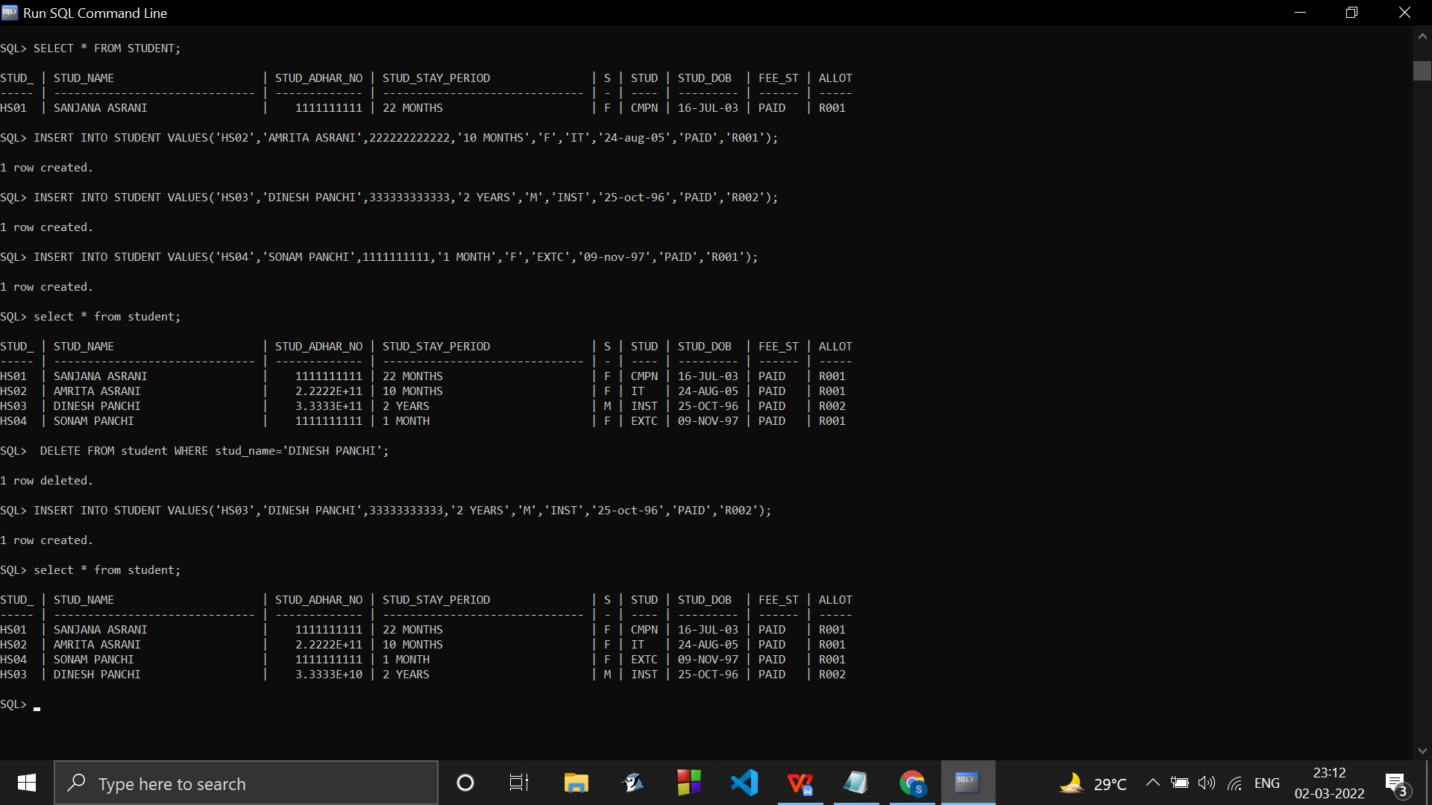

//VISIT_NO AUTO INCREMENT(IDENTITY)

VISIT_NO int NOT NULL AUTO_INCREMENT PRIMARY KEY,

CREATE TABLE VISITOR

(

VISIT_NO NUMBER(5) PRIMARY KEY,

VISITOR_ID VARCHAR(5) ,

VISITOR_NAME VARCHAR(30) NOT NULL,

IN_TIME VARCHAR(9),

OUT_TIME VARCHAR(9),

VISIT_DATE DATE,

CURRENT_TIME VARCHAR(20),

CURRENT_DATE VARCHAR(20),

VISITING_STUD_ID VARCHAR(5) NOT NULL,

FOREIGN KEY(VISITING_STUD_ID) REFERENCES STUDENT(STUD_ID)

);

INSERT INTO VISITOR VALUES(1,'V001','JESSICA LALCHANDANI','02:03','04:00','12-JAN-2022',to_char(sysdate,'hh24:mi:ss'),sysdate,'HS01');

INSERT INTO VISITOR VALUES(2,'V001','Mahek Budhrani','11:43 AM','04:38 PM','19-JUN-2022',to_char(sysdate,'hh24:mi:ss'),sysdate,'HS01');

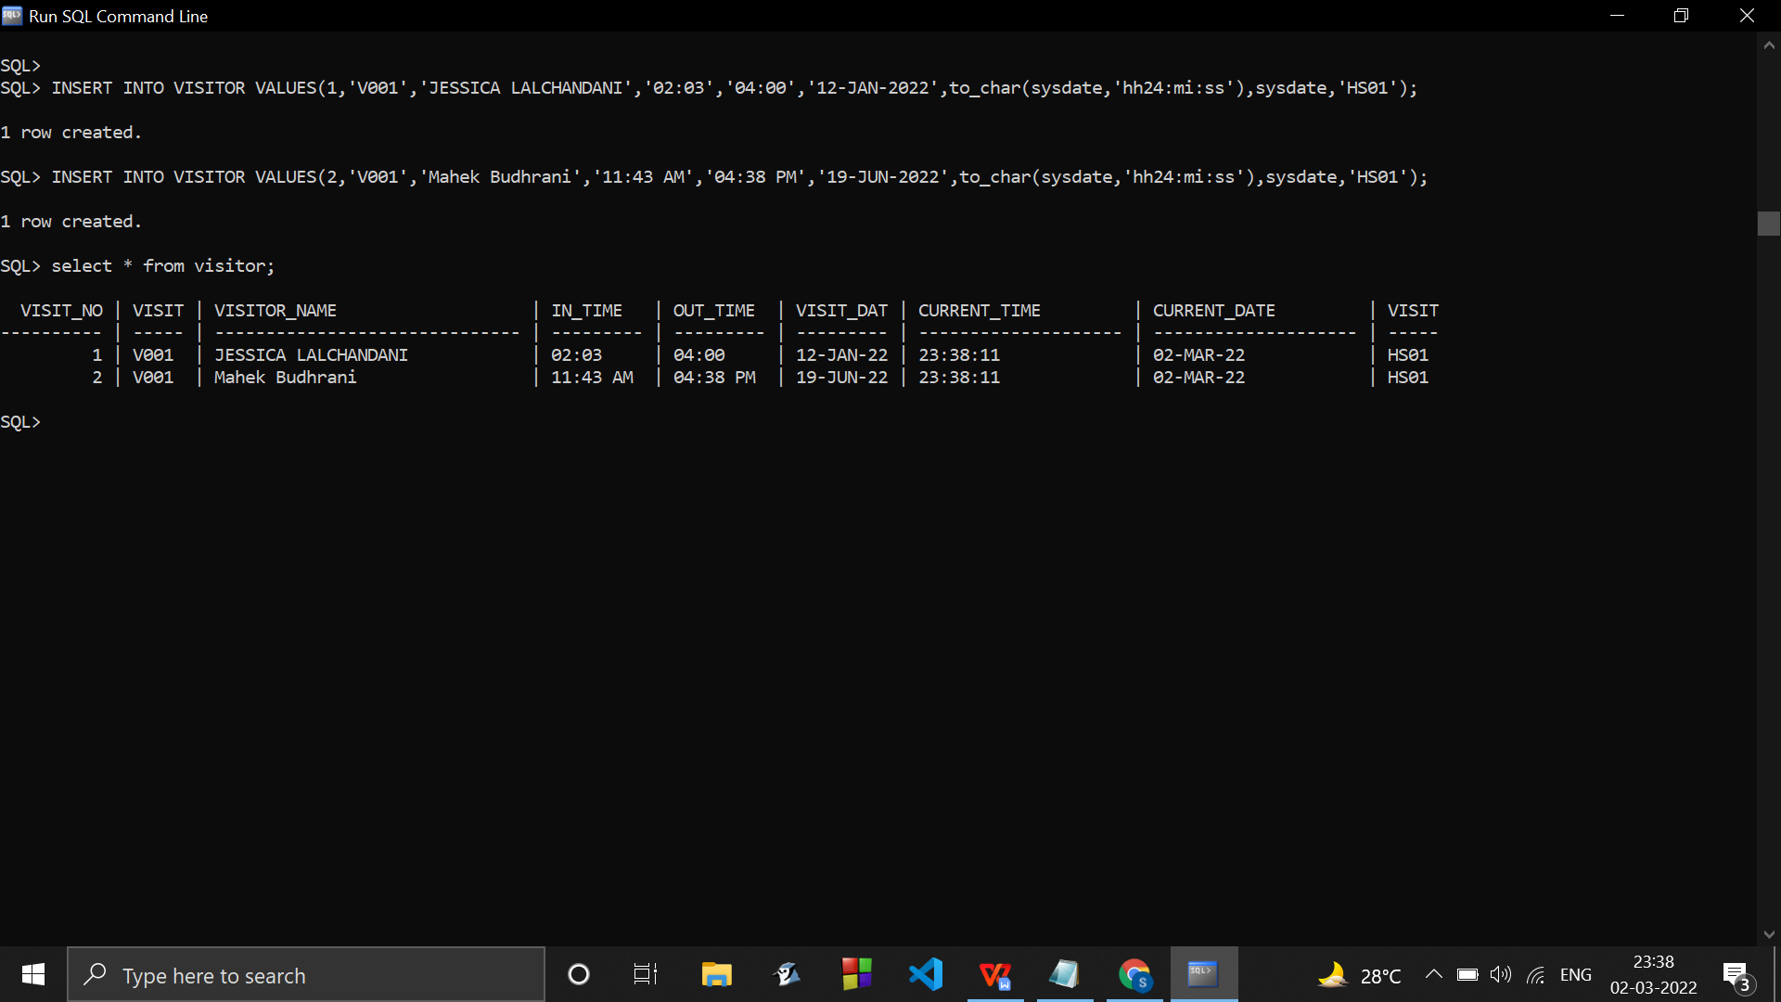

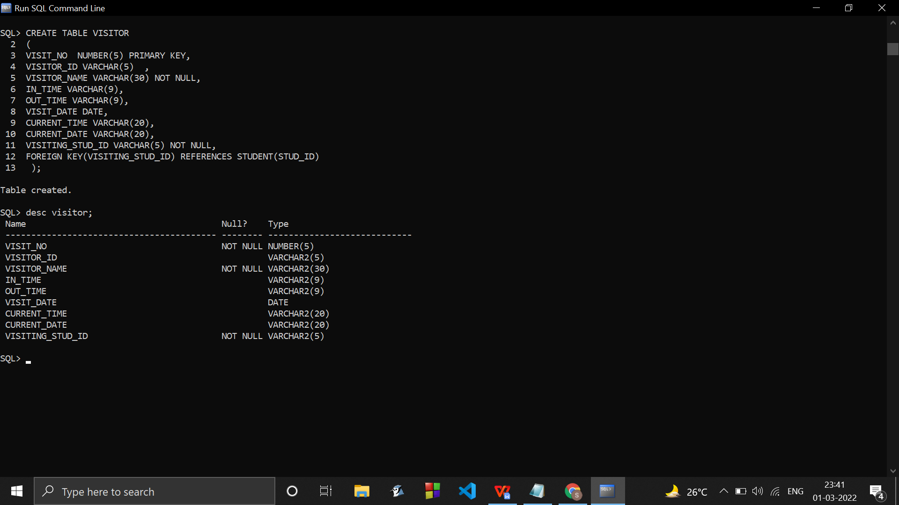

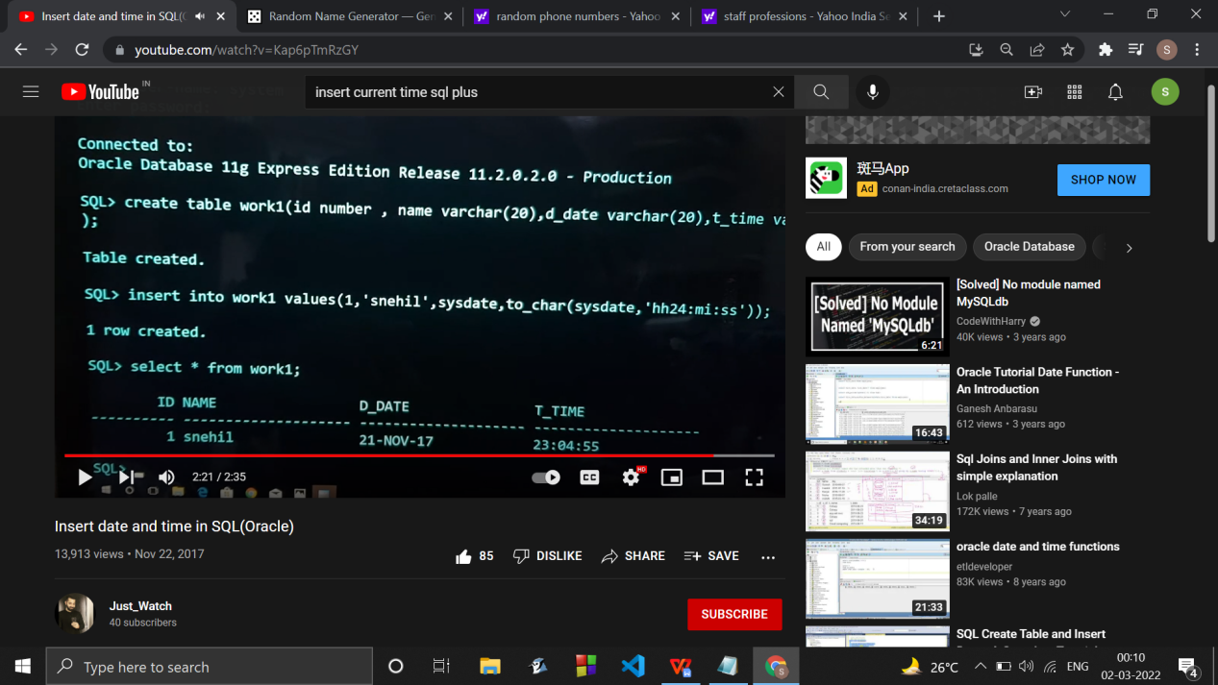

alter table visitor to have auto increment visit no.

ALTER TABLE visitor

MODIFY visit_no varchar(20) IDENTITY(1, 1);

CREATE TABLE ROOM

( ROOM_ID VARCHAR(5) PRIMARY KEY,

ROOM_NO NUMBER(5) ,

ROOM_OCCUPIED VARCHAR(3),

MONTHLY_BILL NUMBER(5),

{ID_OF_STUDENTS_IN_A_ROOM},

);

INSERT INTO ROOM VALUES('R001',102,'YES',8000);

INSERT INTO ROOM VALUES('R002',403,'YES',600);

INSERT INTO ROOM VALUES('R003',102,'YES',9800);

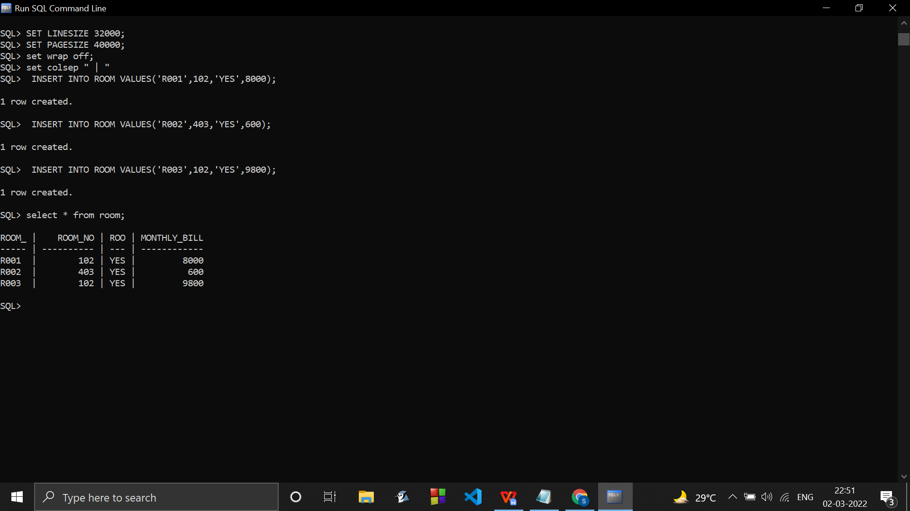

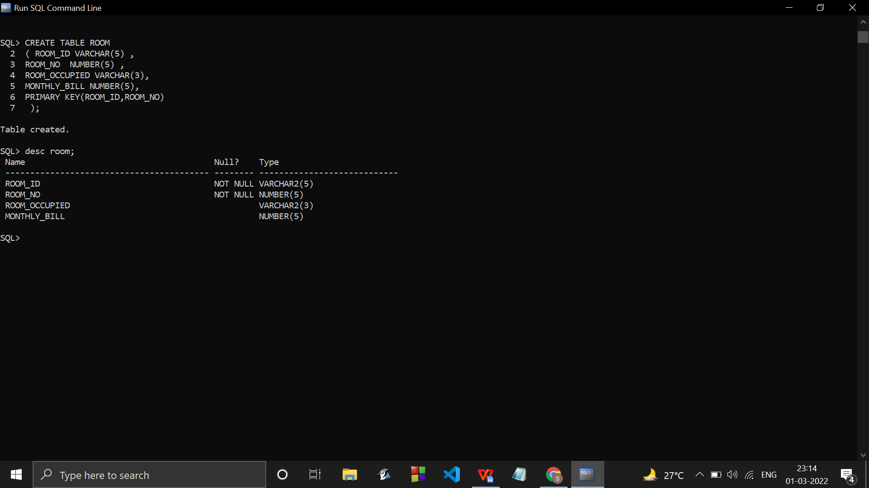

CREATE TABLE ID_OF_STUDENTS_IN_A_ROOM

( room_id VARCHAR(5) NOT NULL,

STUDENT_1_ID VARCHAR(5),

STUDENT_2_ID VARCHAR(5),

STUDENT_3_ID VARCHAR(5),

STUDENT_4_ID VARCHAR(5),

PRIMARY KEY(room_id),

FOREIGN KEY(room_id) REFERENCES ROOM(ROOM_ID),

FOREIGN KEY(STUDENT_1_ID) REFERENCES STUDENT (STUD_ID),

FOREIGN KEY(STUDENT_2_ID) REFERENCES STUDENT (STUD_ID),

FOREIGN KEY(STUDENT_3_ID) REFERENCES STUDENT (STUD_ID),

FOREIGN KEY(STUDENT_4_ID) REFERENCES STUDENT (STUD_ID)

);

INSERT INTO ID_OF_STUDENTS_IN_A_ROOM VALUES('R001','HS01',NULL,NULL,NULL);

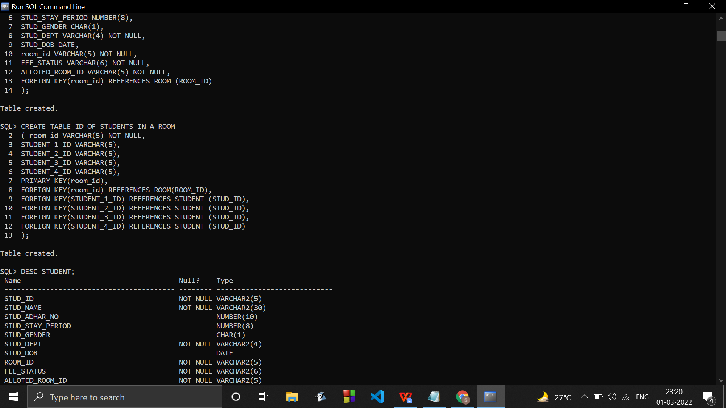

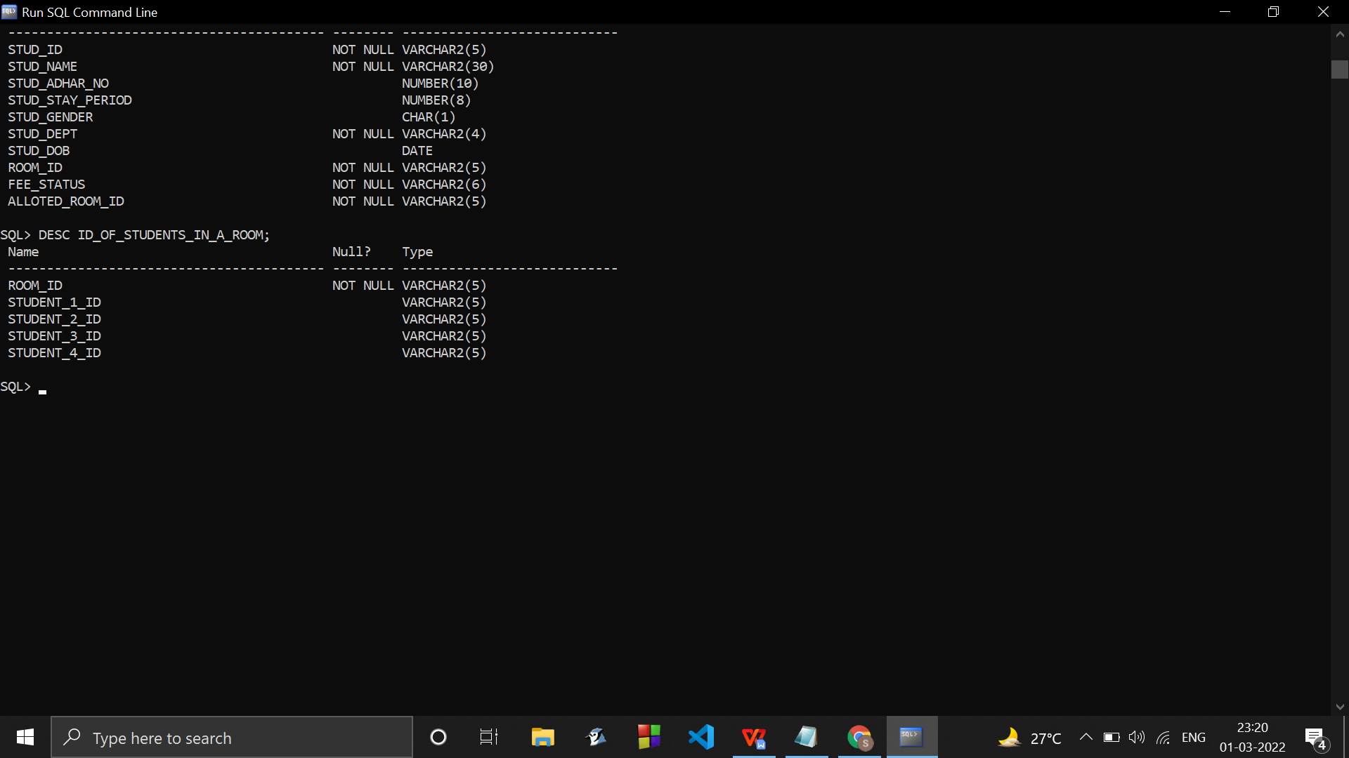

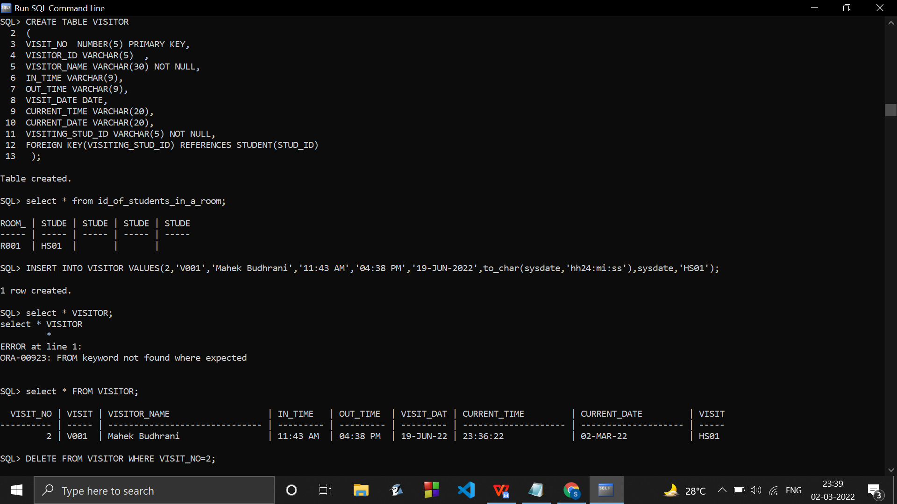

CREATE TABLE LOOKS_AFTER

( ASSIGNED_STAFF_ID VARCHAR(5) NOT NULL,

CORRESPONDING_ROOM_ID VARCHAR(5) NOT NULL,

FOREIGN KEY(ASSIGNED_STAFF_ID) REFERENCES STAFF(STAFF_ID),

FOREIGN KEY(CORRESPONDING_ROOM_ID) REFERENCES ROOM(ROOM_ID)

);

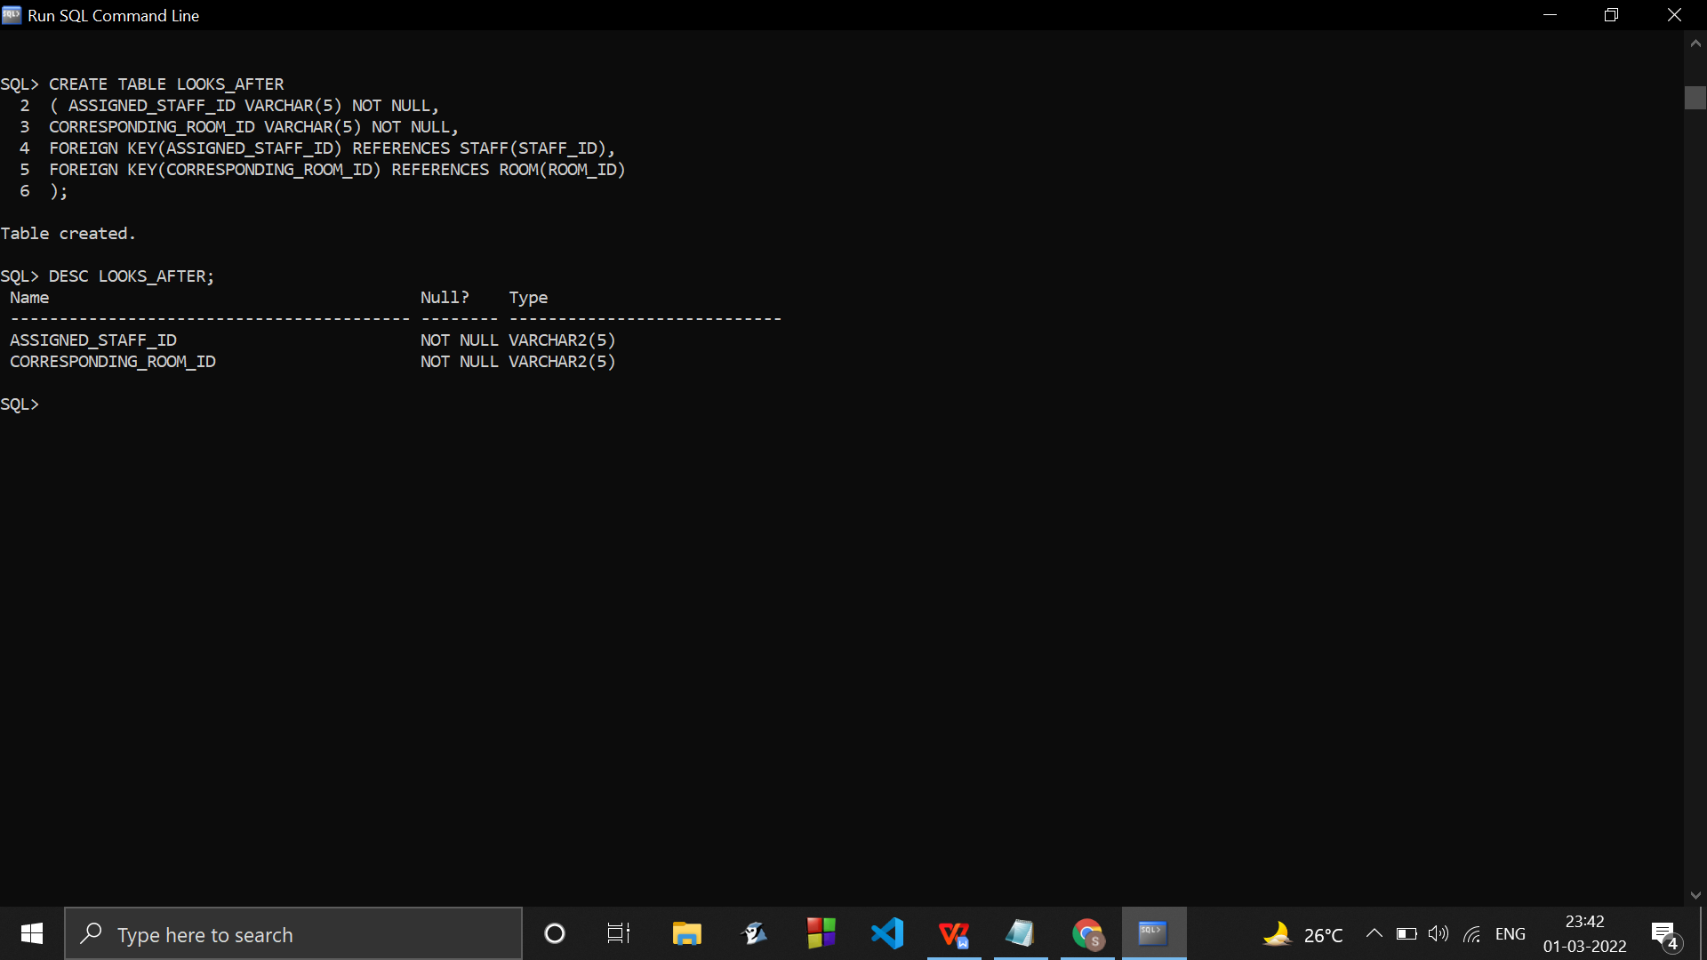

//MAX CAPACITY OF A ROOM IS 4 STUDENTS.

INSERT INTO LOOKS_AFTER VALUES('S001','R001');

INSERT INTO LOOKS_AFTER VALUES('S003','R002');

INSERT INTO LOOKS_AFTER VALUES('S004','R005');

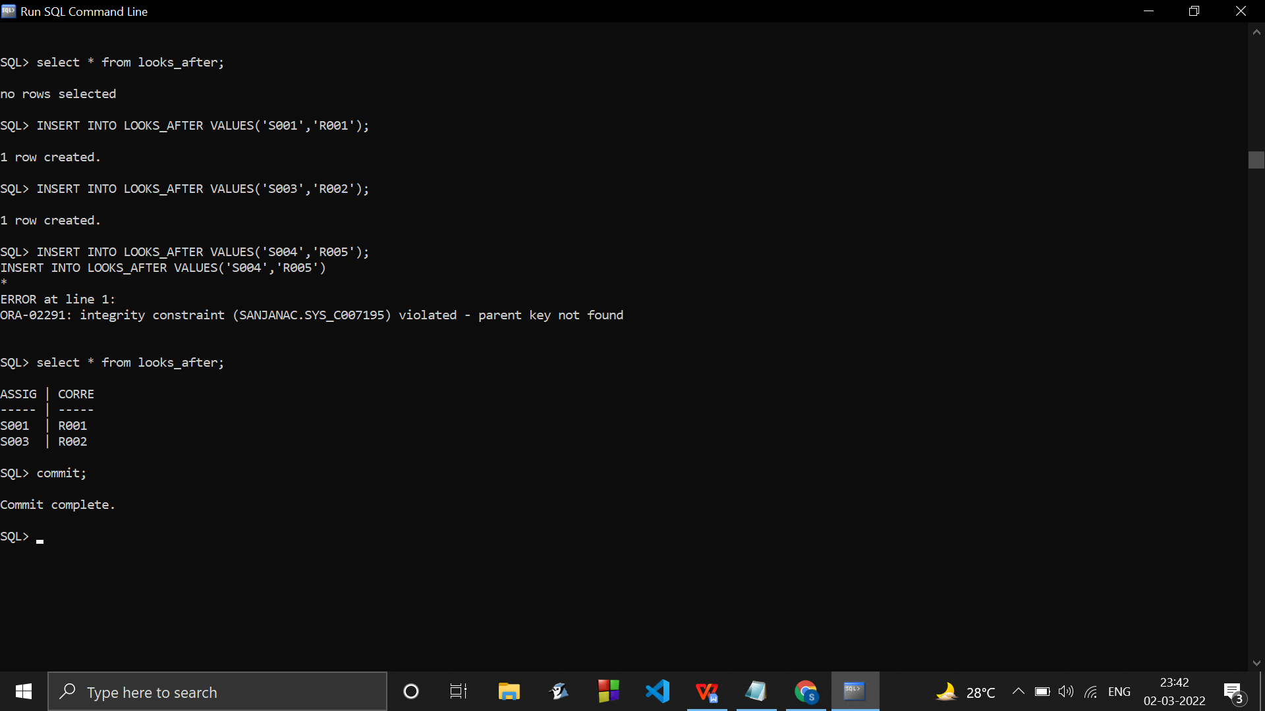

TRIALSS

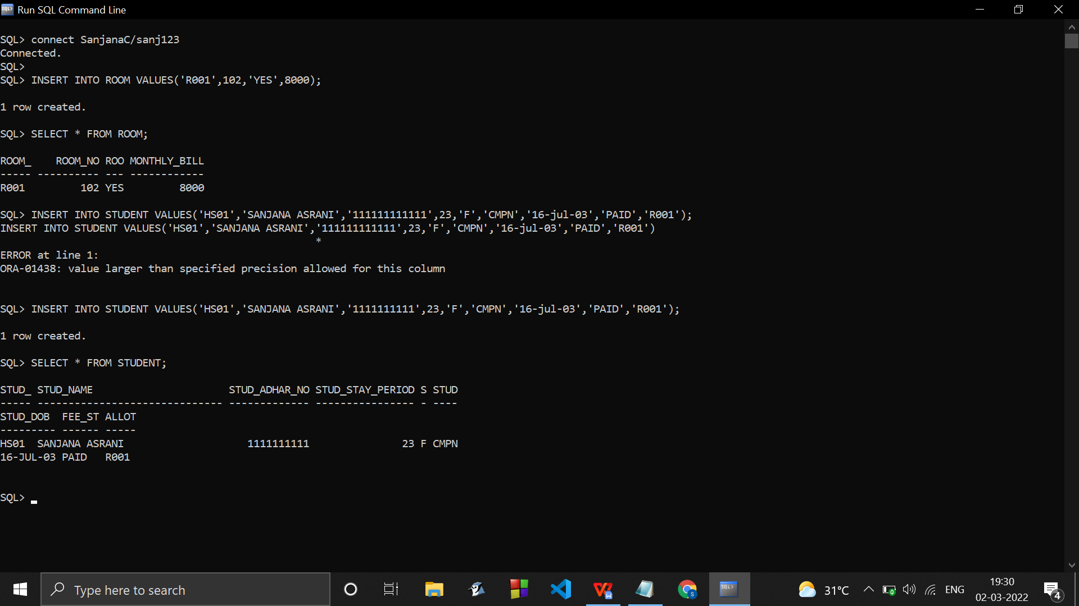

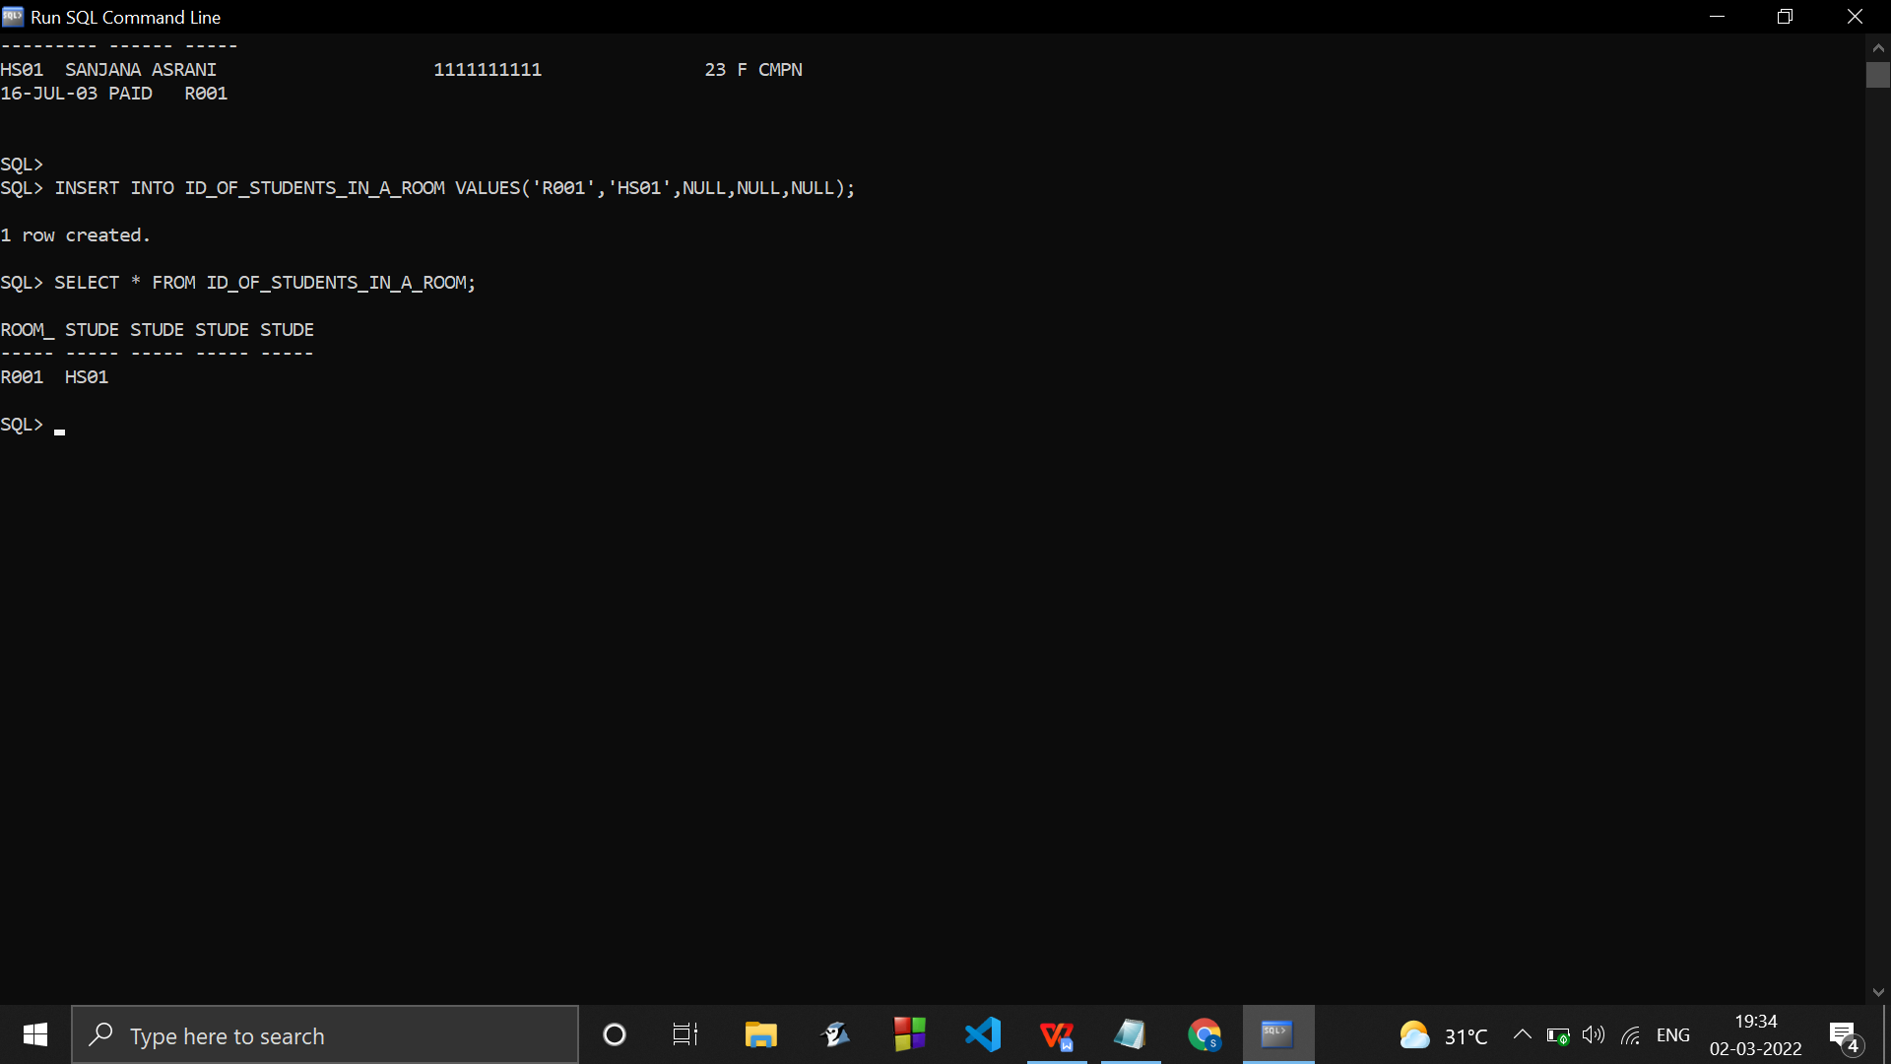

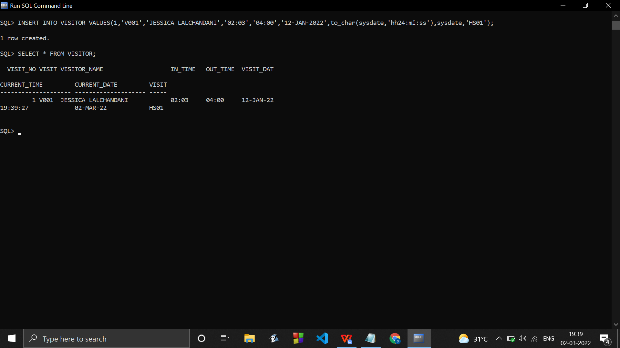

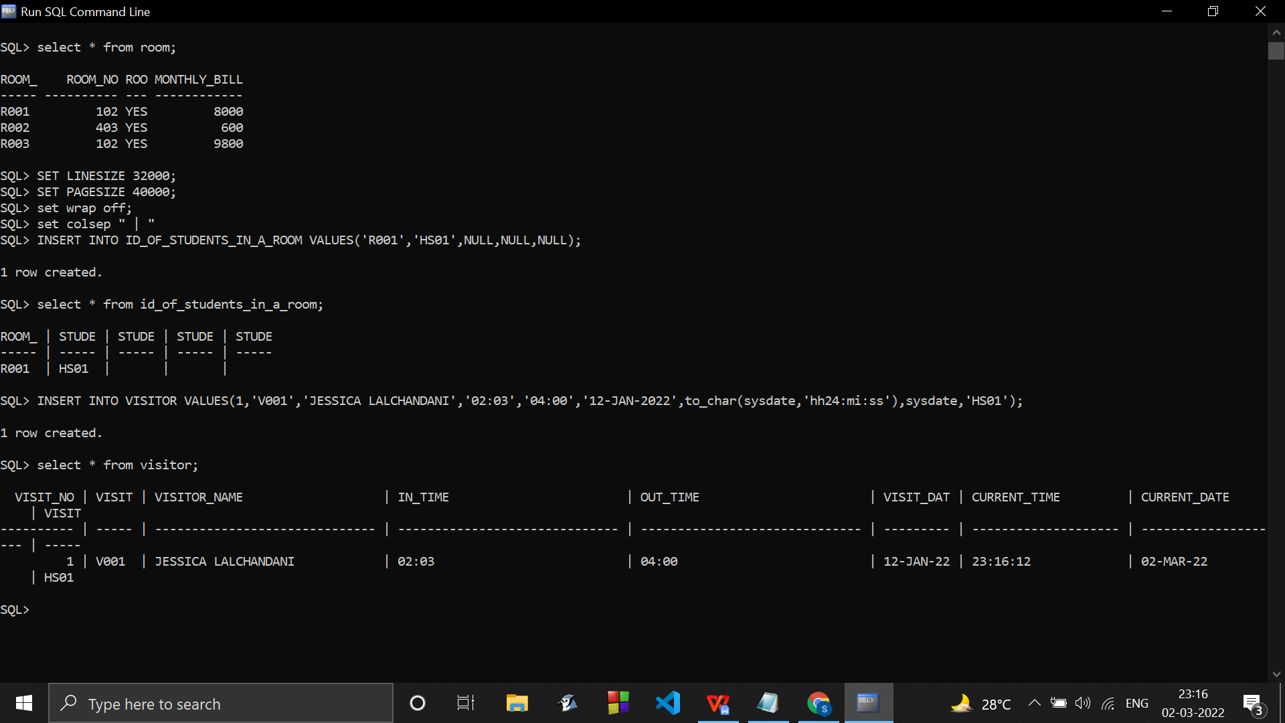

CHANGING SOME CONSTRAINTS/DOMAINS OF SOME ATTRIBUTES

ALTER TABLE visitor

add constraint chk_visitdate CHECK(VISIT_DATE>'04-mar-2019');

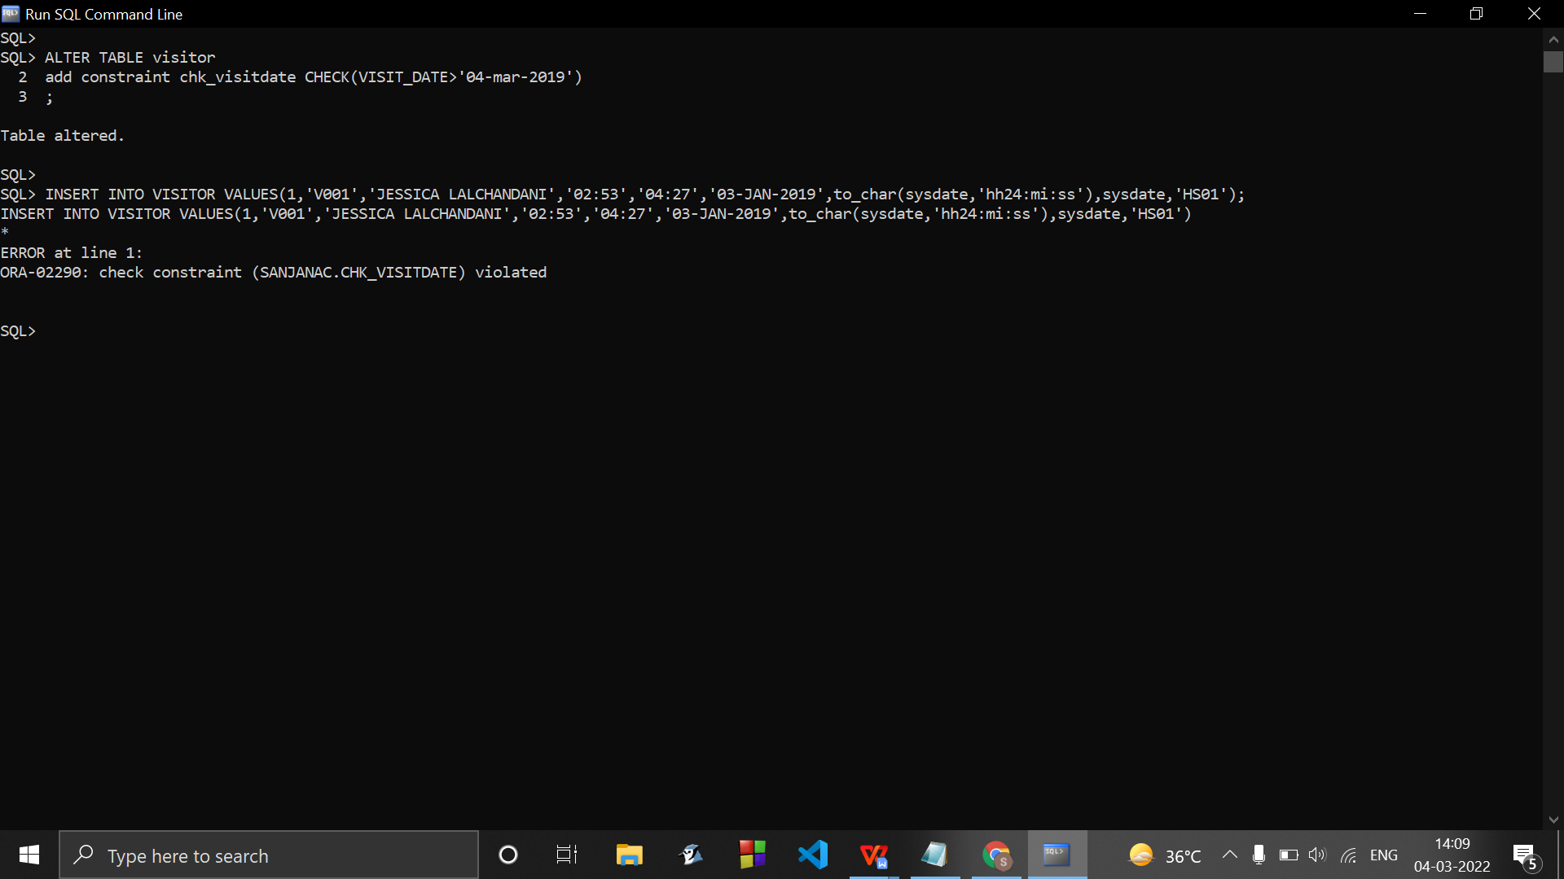

ALTER TABLE visitor

DROP CONSTRAINT chk_visitdate;

….…………………………………………………………………………………………………………………………………………………….

….……………………………………………………………………………………………………………………………………………….…...….…………………………………………………………………………………………………………………………………………………….

**.....to print the id of students in the same room.…**

**…..create a view/table and copy records of above table in that…(id_of_students_in_a_room)….**

**SELECT DISTINCT s.alloted_room_id,s.stud_id**

**FROM student s,student s1**

**WHERE s.alloted_room_id=s1.alloted_room_id**

**ORDER BY s.alloted_room_id;**

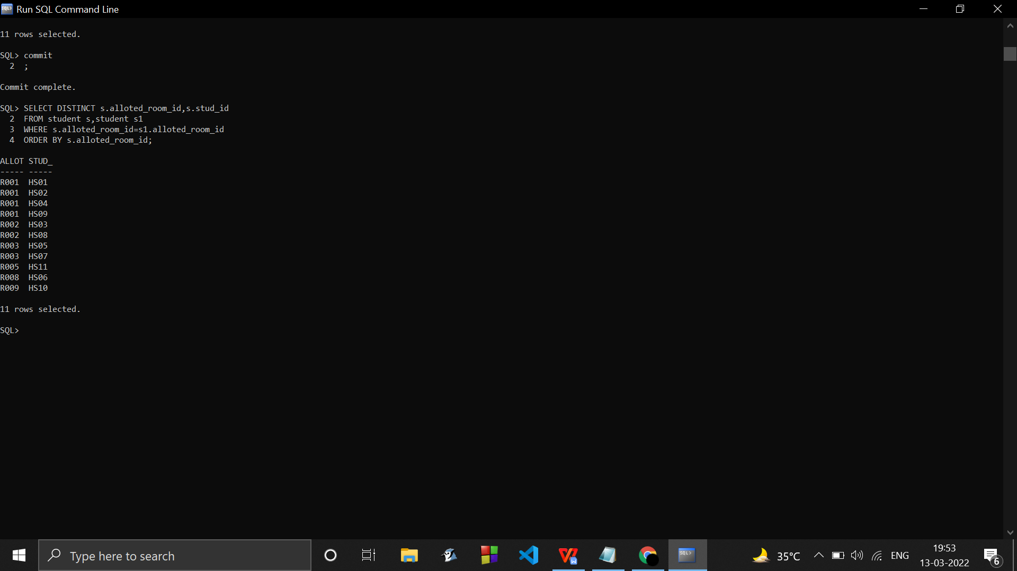

**.....to print the id and name of students in the same dept.…**

**SELECT DISTINCT s.stud_id,s.stud_name,s.stud_dept**

**FROM student s,student s1**

**WHERE s.stud_dept=s1.stud_dept**

**ORDER BY s.stud_dept;**

**CREATE VIEW IDDEPT AS**

**SELECT DISTINCT s.stud_id,s.stud_name,s.stud_dept**

**FROM student s,student s1**

**WHERE s.stud_dept=s1.stud_dept**

**ORDER BY s.stud_dept;**

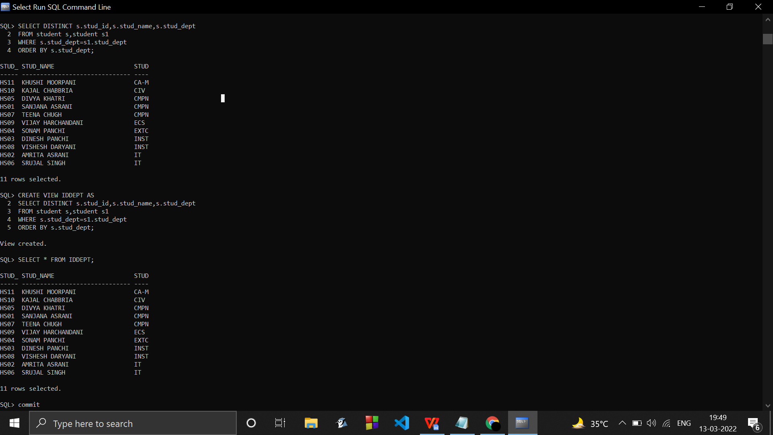

SQL> SELECT DISTINCT s.stud_id,s.stud_name,s.stud_dept

2 FROM student s,student s1

3 WHERE s.stud_dept=s1.stud_dept

4 AND s.stud_id!=s1.stud_id

5 ORDER BY s.stud_dept;

