**NAME : SANJANA ASRANI**

**DIV : D7B**

**ROLL NO. : 01**

**DBMS ASSIGNMENT 1**

Date of Preparation : 27-02-2022

Submission Date : 07-03-2022

1. For the allocated problem statement , do the following .
2. Create an ER diagram .
3. Design relational schema.
4. Write corresponding DDL and DML statements.
5. Write SQL queries for the given statements, execute and add prints of executions..

Problem statement 1 ( Roll no. 01 - 12 )

Q.1. A database is being constructed for storing sales information systems. A product can be described with a unique product number, product name, selling price, manufacturer name. The product can be sold to a particular client and each client has its own unique client number, client name, client address, city, pin code, state and total balance to be required to pay. Each client orders a product from the salesman. In the order, it has a unique sales order number, sales order date, client number, salesman number (unique), billed whole payment by the party or not and its delivery date. The salesman has the name, addresses, city, pin code, state, salary of the salesman, delivery date, total quantity ordered, product rate.

ERD FOR SALES INFORMATION SYSTEM :

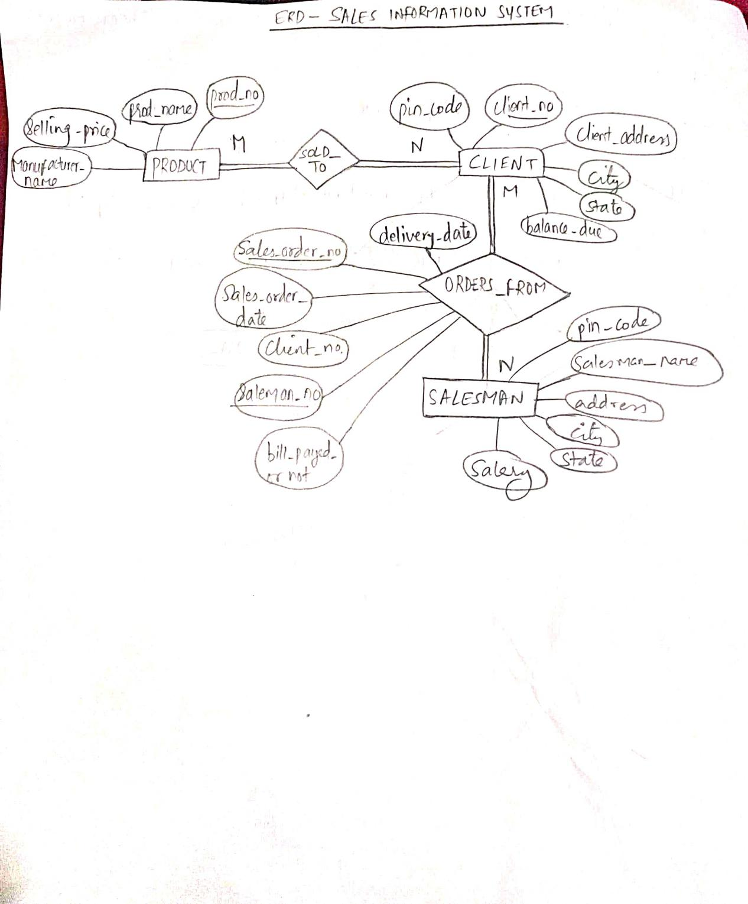

RELATIONAL SCHEMA FOR SALES INFORMATION SYSTEM :

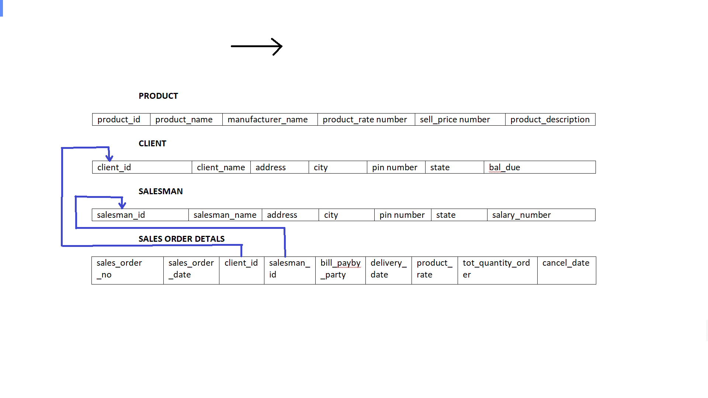

TABLES FOR SALES INFORMATION SYSTEM :

**PRODUCT**

|  |  |  |  |  |  |
| --- | --- | --- | --- | --- | --- |
| product_id | product_name | manufacturer_name | product_rate number | sell_price number | product_description |

**CLIENT**

|  |  |  |  |  |  |  |
| --- | --- | --- | --- | --- | --- | --- |
| client_id | client_name | address | city | pin number | state | bal_due |

**SALESMAN**

|  |  |  |  |  |  |  |
| --- | --- | --- | --- | --- | --- | --- |
| salesman_id | salesman_name | address | city | pin number | state | salary |

**SALES ORDER DETALS**

|  |  |  |  |  |  |  |  |  |  |
| --- | --- | --- | --- | --- | --- | --- | --- | --- | --- |
| sales_order  _no | sales_order  _date | client_id  (FK) | salesman_  Id (FK) | Prod_id  (FK) | bill_payby  _party | delivery_  date | product_  rate | tot_quantity_order | cancel_date |

(some more columns have been added into tables assuming and considering the process & need of the sales system tables).

Client id and salesman_id prod_id are foreign keys .

CREATING A USER SanjanaSales /sanj123 :

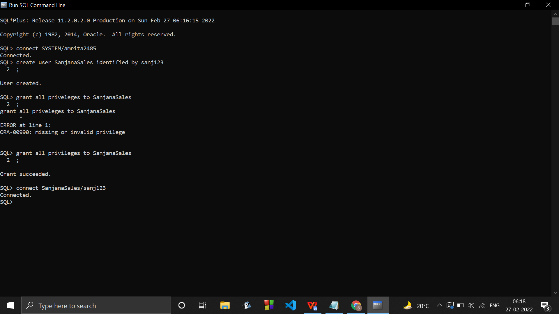

CREATING THE TABLES :

1. product

Create table product (product_id varchar(10) primary key, product_name varchar(20), manufacturer_name

char(20),product_rate number(9,4), sell_price number(9,4),product_description varchar(25));

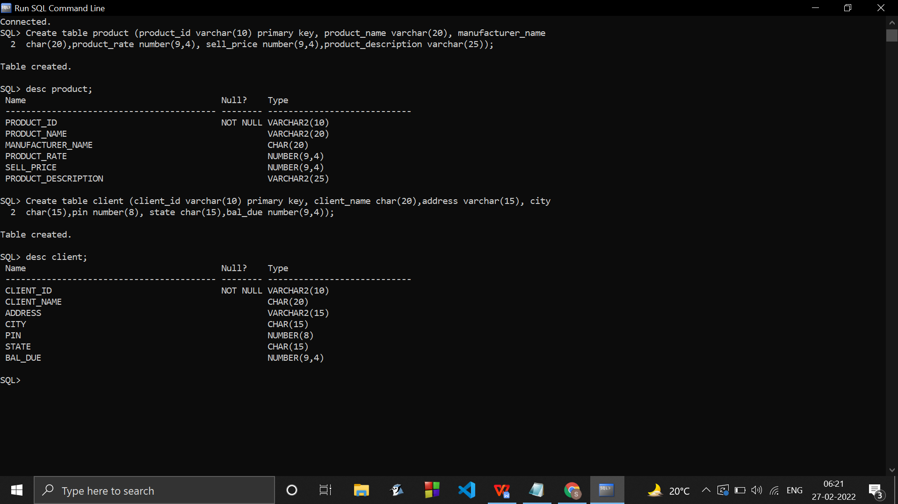

ALTER TABLE sales_order_details

ADD prod_id varchar(10);

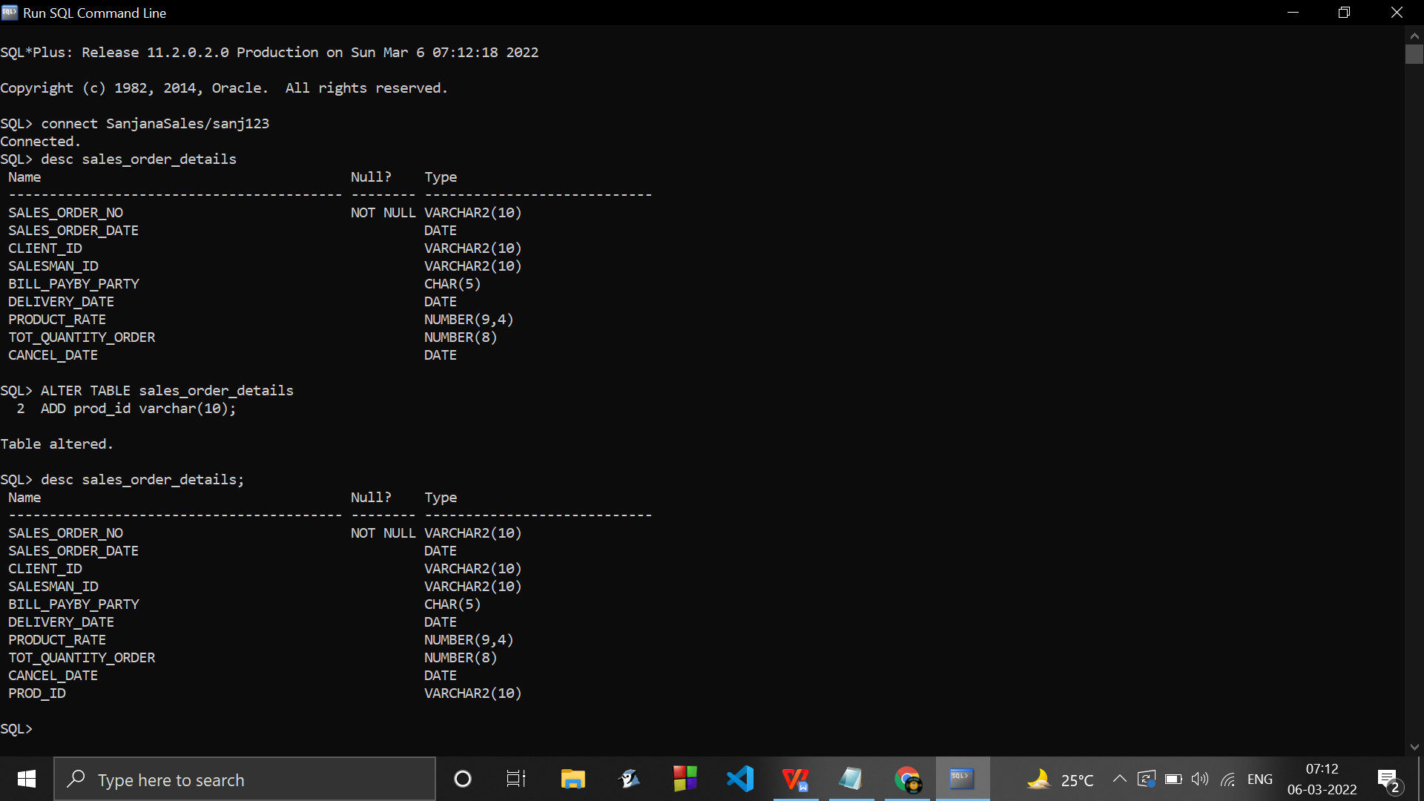

1. client

Create table client(client_id varchar(10) primary key, client_name char(20),address varchar(15), city

char(15),pin number(8), state char(15),bal_due number(9,4));



1. salesman

Create table salesman (salesman_id varchar(10) primary key, salesman_name char(20),address varchar(15), city

char(15),pin number(8), state char(15),salary number(9,4));

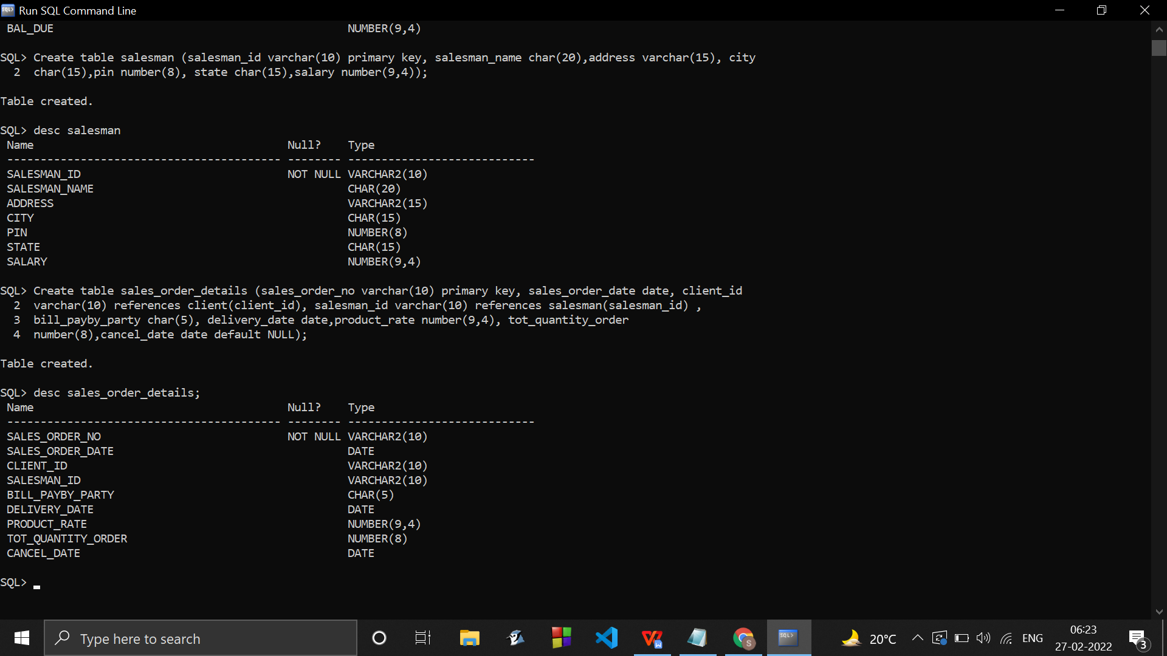

1. sales_order_details

Create table sales_order_details (sales_order_no varchar(10) primary key, sales_order_date date, client_id

varchar(10) references client(client_id), salesman_id varchar(10) references salesman(salesman_id) ,

bill_payby_party char(5), delivery_date date,product_rate number(9,4), tot_quantity_order

number(8),cancel_date date default NULL);



INSERTING SOME TUPLES/RECORDS/VALUES :

Insert into product values('p001','Hyundai Elantra','Sedan Manufactures','15000','20.43','cars');

Insert into product values('p002','Nike shoes','OEM manufacturers','14.80','160.40','comfy footwears');

Insert into product values('p003','diary and chocolates','amul','2218.80','200.40','icecreams,butter,etc');

Insert into product values('p004','butterflow pens','Aurstationary','2015.67','21.43','smooth blue inkpens');

Insert into product values('p005','OEbook','bookworm org','5104.80','516.40','ebooks+hardcopies');

Insert into product values('p006','Mj gold','marisha jewellers','5118.80','5120.40','accessories and jewellery');

Insert into product values('p007','Zohi hardware','Zo_world','5104.80','5116.40','HDD1034');

Insert into product values('p008','dvd player','frontec_org','5118.80','9120.40',' DVDRW');

Insert into product values('p009','instant ramen','Yippee Maggi','7148.80','20','2 min to cook noodles');

Insert into product values('p010','Aloo bhujia','Haldiram','3518.80','12.40','ready to eat snacks');

Insert into client values('cn01001','sanjana asrani','unr,gandhi road','mumbai','421305','maharashtra','390.9');

Insert into client values('cn01002','dinesh panchi',' puk para','agartala','799102','tripura','2390.9');

Insert into client values('cn01003','vishesh kapoor',' pachmile','hyderabad','799152','telangana','9990.9');

Insert into client values('cn01004','amrita singh',' chora para','mumbai','799301','maharashtra','1390.9');

Insert into client values('cn01005','jannat rehmani',' kamal para','agra','799721','uttar pradesh','190.9');

Insert into client values('cn01006','srujal srivastav',' bircity','sonitpur','799141','assam','110.9');

Insert into client values('cn01007','anweesta roy',' nappam','jaipur','799152','rajasthan','190.9');

Insert into client values('cn01008','sara khan',' city_dos','jaipur','799141','rajasthan','110.9');

Insert into client values('cn01009','vashu tibrewal',' pachmile','tezpur','799152','assam','190.9');

Insert into client values('cn01010','ayush srivastav',' pachmile','tezpur','799152','assam','2990.9');

Insert into client values('cn01011','pratik sarang','kalyan,gurudevs','mumbai','421301','maharashtra','3990.9');

Insert into salesman values('s001','Sanjana Asrani','kalyan subway','mumbai ','421305','Maharashtra','10000');

Insert into salesman values('s002','Rohan das','nappam','Tezpur','799170','Assam','8000');

Insert into salesman values('s003','arshi gosh','nirjuli','itanagar','799701','Arunachal','9000');

Insert into salesman values('s004','karina asrani','nappam','Tezpur','799703','Assam','8500');

Insert into salesman values('s005','vashdev panchi','borbota ','sonitpur','795970','assam','9600');

Insert into salesman values('s006','Priya agarwal','gandhi road ','32 district','799750','delhi','9900');

Insert into salesman values('s007','mahek verani','turfies,kalyan','mumbai ','421301','Maharashtra','8900');

Insert into sales_order_details values('on01001','01-jan-2007','cn01001','s001','yes','20-aug-2008',

'2220.40','50','');

Insert into sales_order_details values('on01002','12-aug-2008','cn01004','s001', 'yes','23-aug-2008',

'2220.40','15','');

Insert into sales_order_details values('on01003','16-jul-2003','cn01005','s003', 'yes','25-august-2003',

'2220.40','10','');

Insert into sales_order_details values('on01004','13-aug-2010','cn01004','s001', 'yes','20-aug-2010',

'2220.40','15','');

Insert into sales_order_details values('on01005','10-feb-2006','cn01002','s002', 'no','30-aug-2008',

'2220.40','52', '28-march-2008');

Insert into sales_order_details values('on01006','29-mar-1999','cn01001','s001', 'yes','31-aug-2000',

'2220.40','53','');

Insert into sales_order_details values('on01007','16-jan-2008','cn01003','s004', 'yes','28-aug-2008',

'2220.40','54','');

Insert into sales_order_details values('on01008','01-feb-2008','cn01004','s003', 'no','28-aug-2008',

'8220.40','54', '18-march-2008');

* Insertion of records in table product :

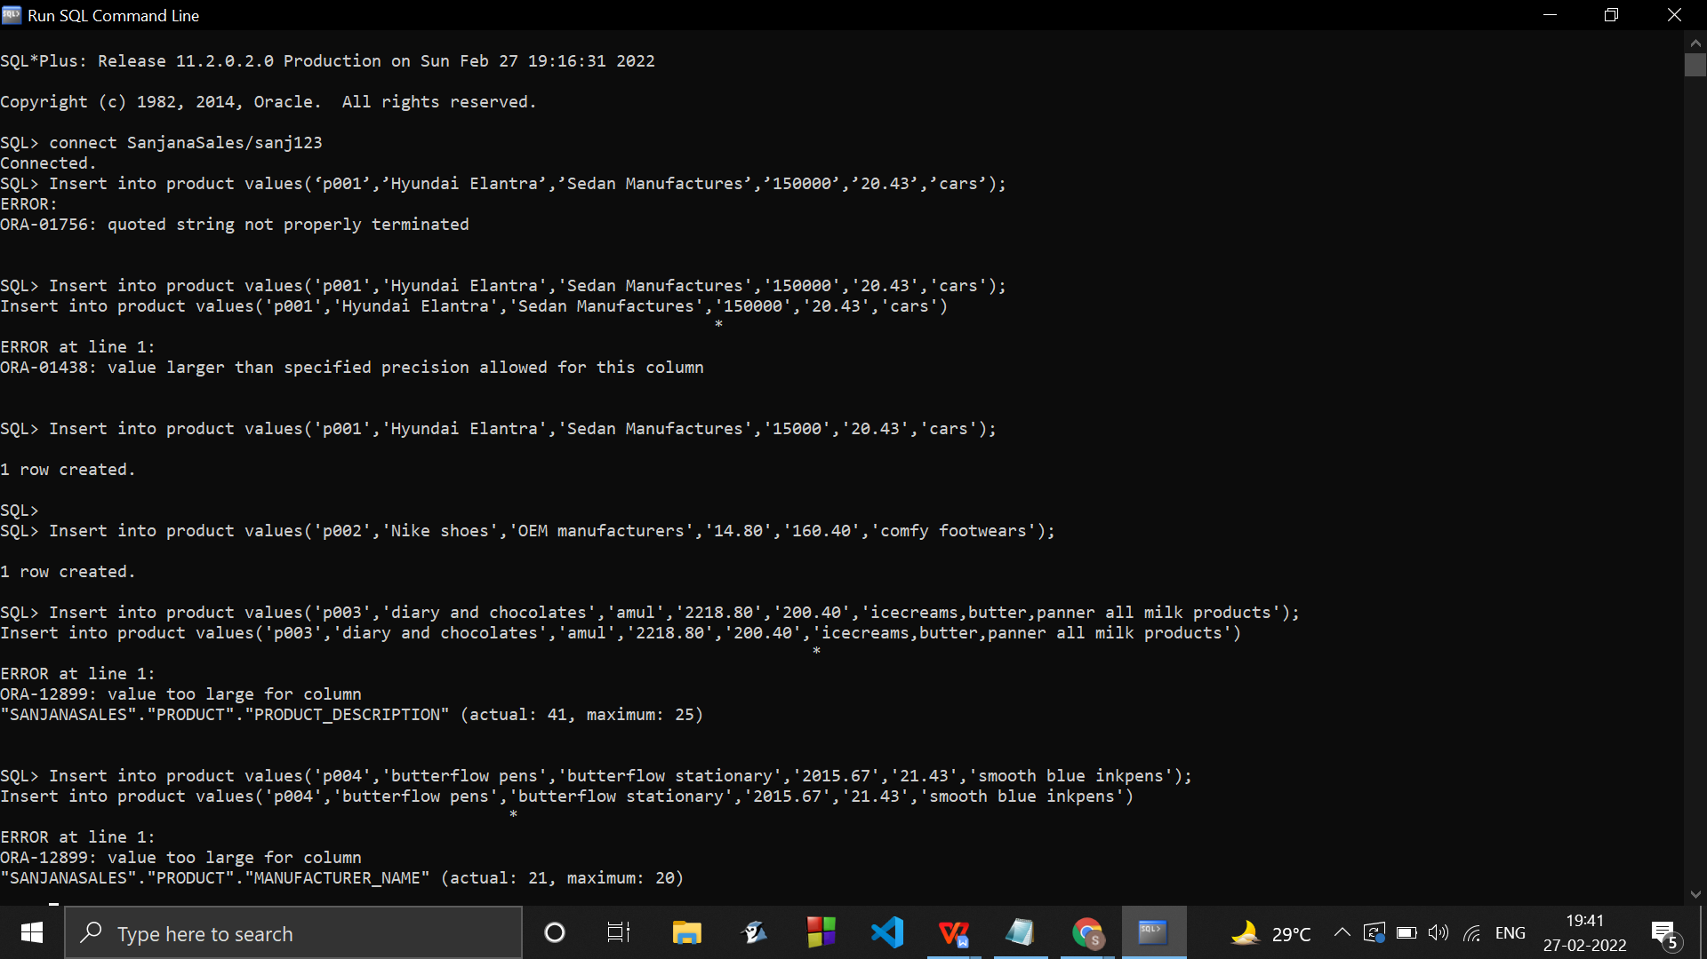

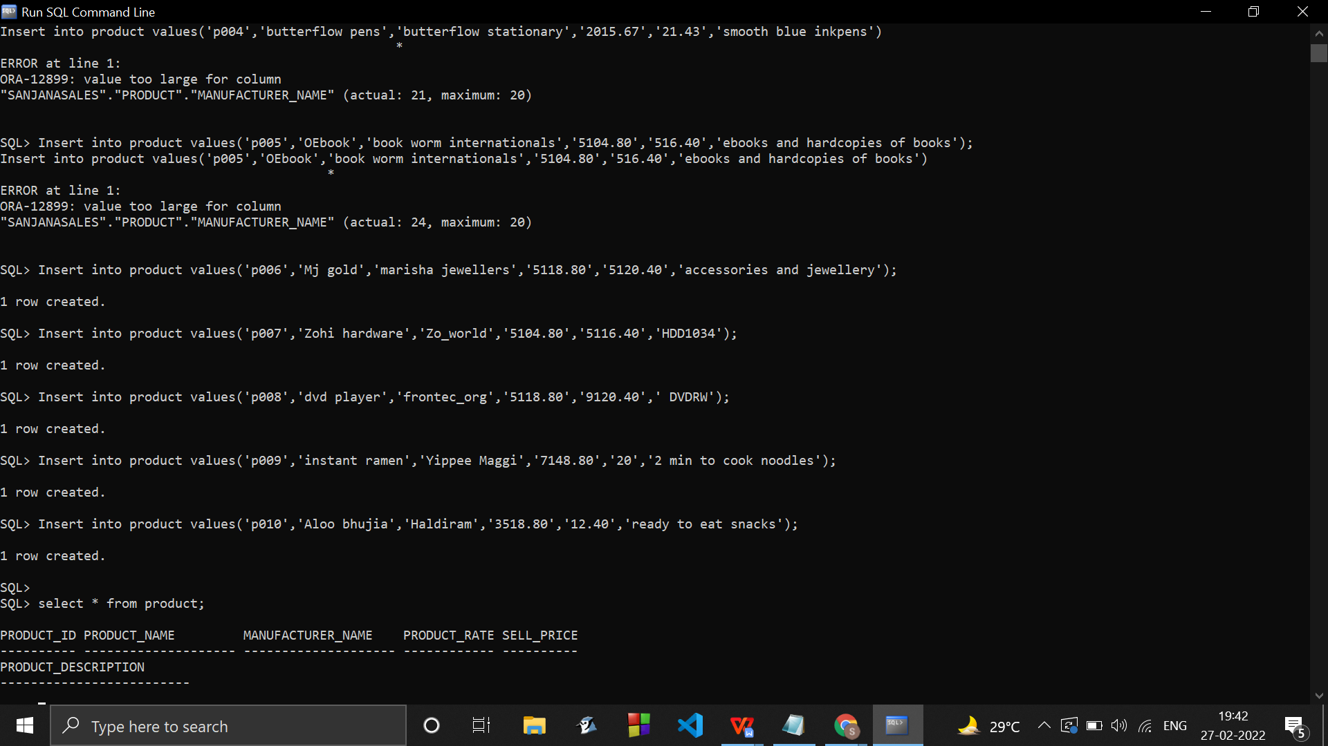

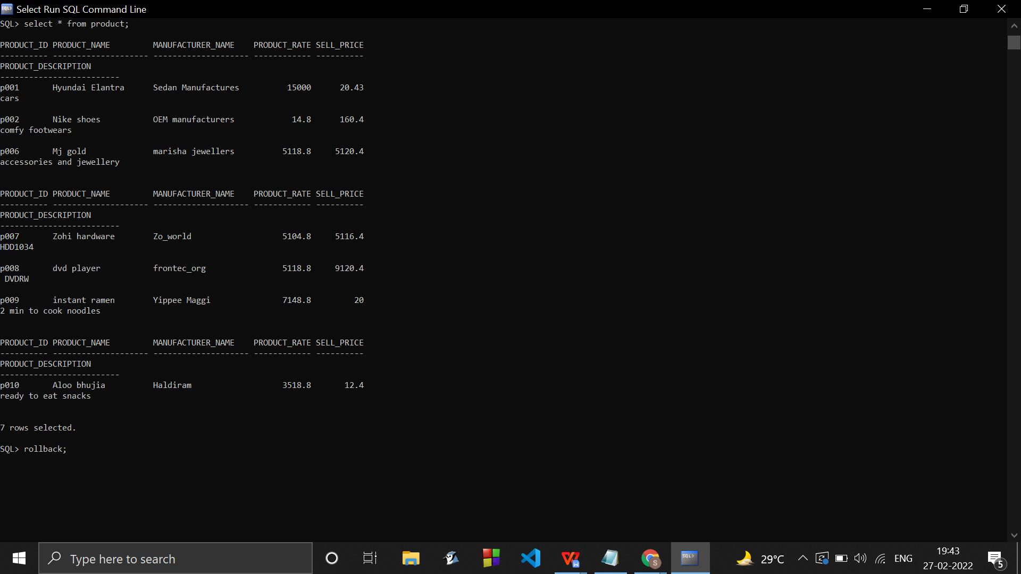

We can see here , some of the entries here are violating some constraints . Hence to avoid improper seqence of records , Rollback was performed so now the table has no records :

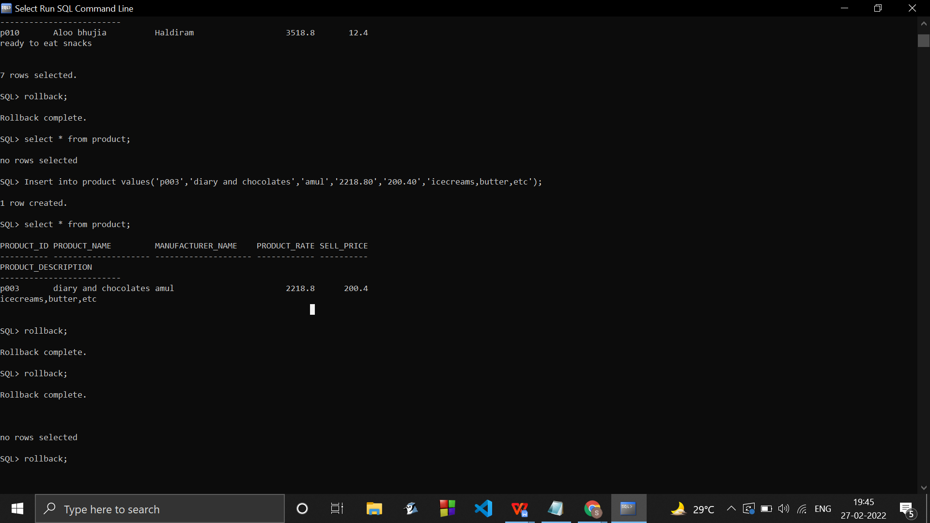

Arranging/formatting the table results to be displayed in a sorted manner by doing these :

SET LINESIZE 32000;

SET PAGESIZE 40000;

set wrap off;

set colsep " | "

But this will mess up the viewing format of desc tablename :

Hence doing SET LINESIZE 100; is necessary before doing desc. And then again doing SET LINESIZE 32000; before doing select query.

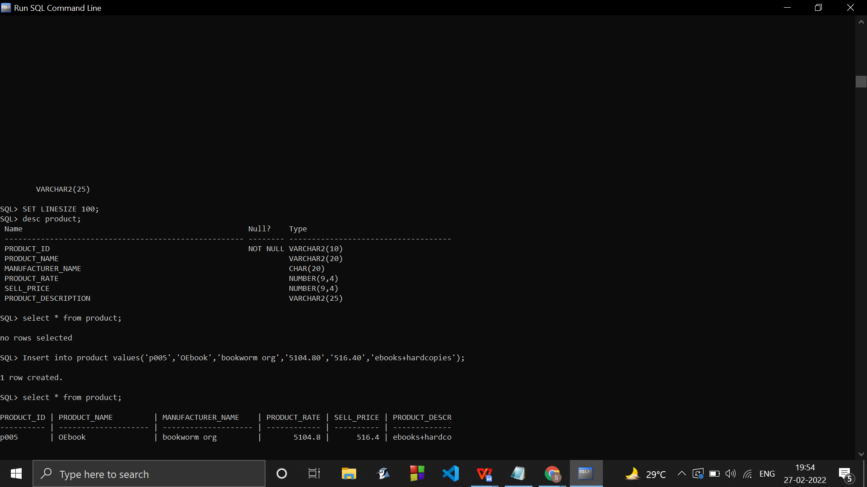

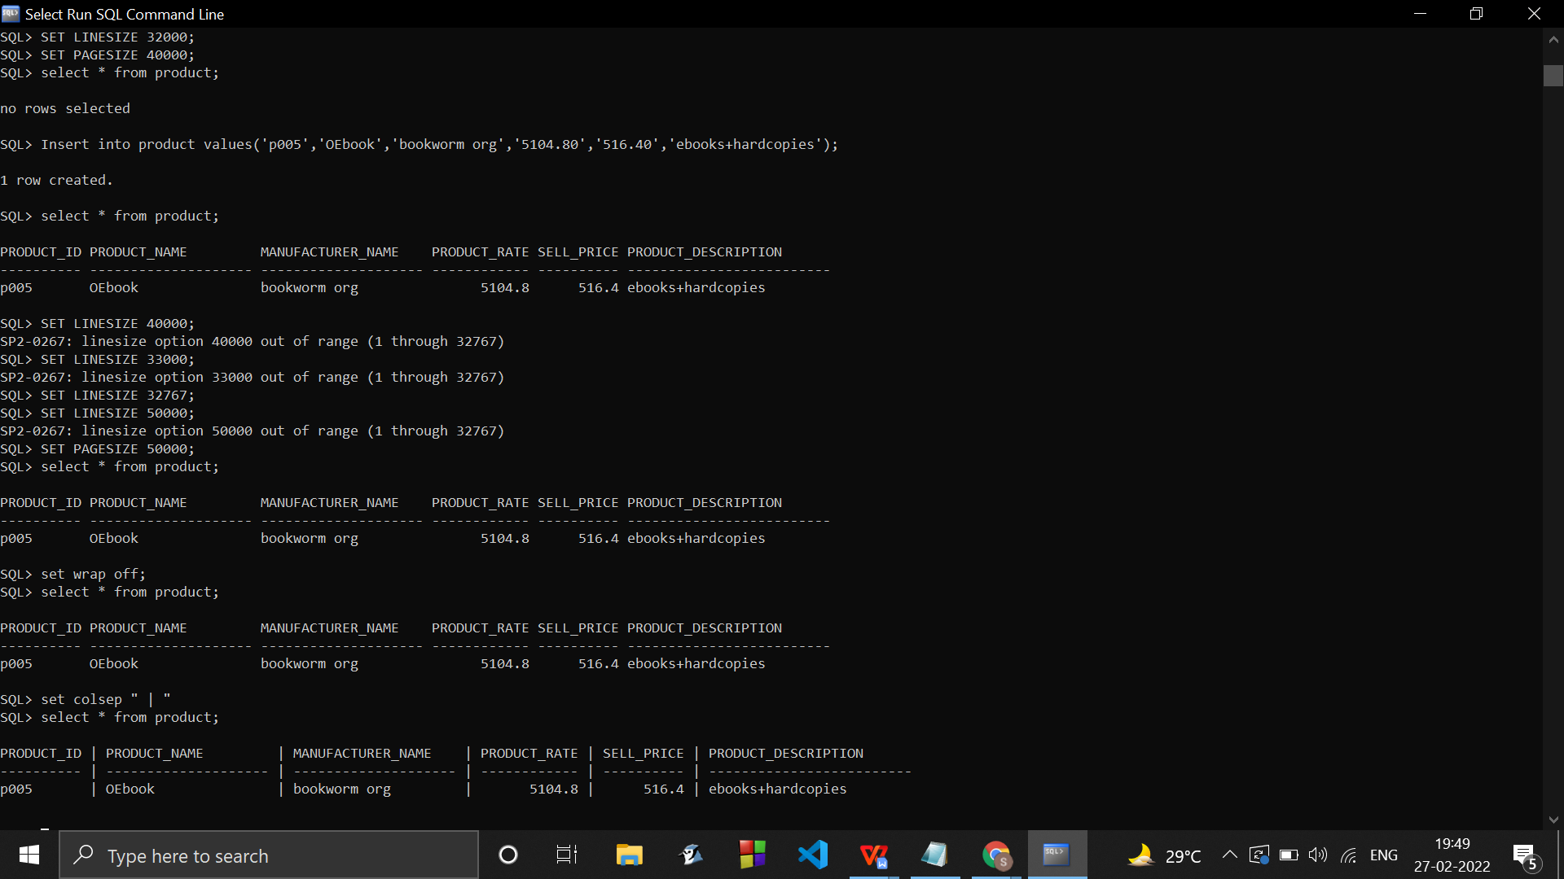

All the values violating the constraints/not following the length specifications were corrected by inserting and performing rollback to correct them and re-insert them.

RE-INSERTING ALL RECORDS IN PRODUCT TABLE :

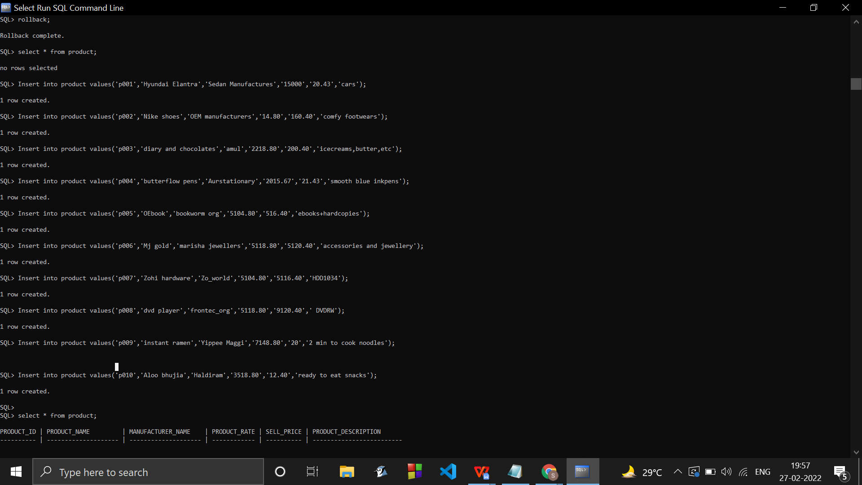

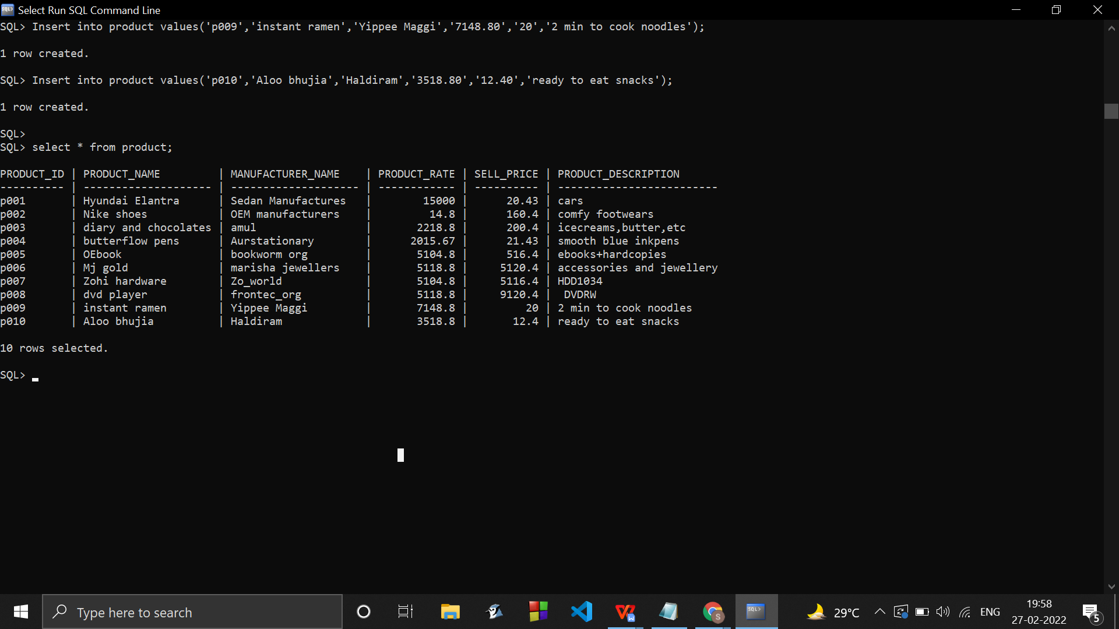

Similarly inserting records for other tables …

CLIENT TABLE :

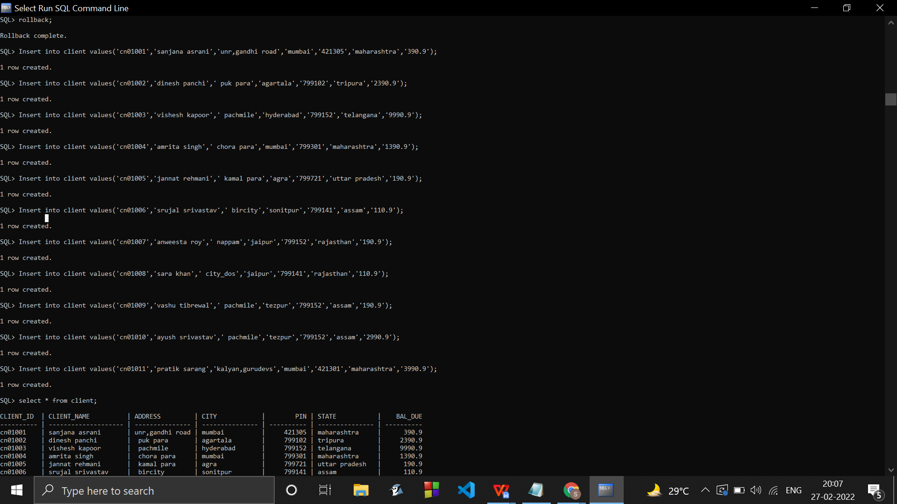

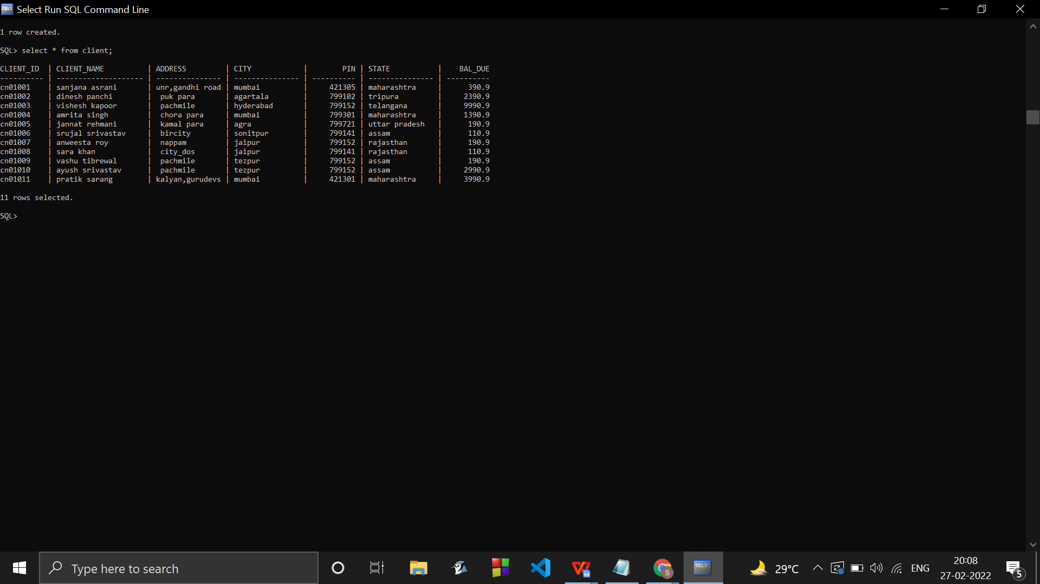

SALESMAN TABLE :

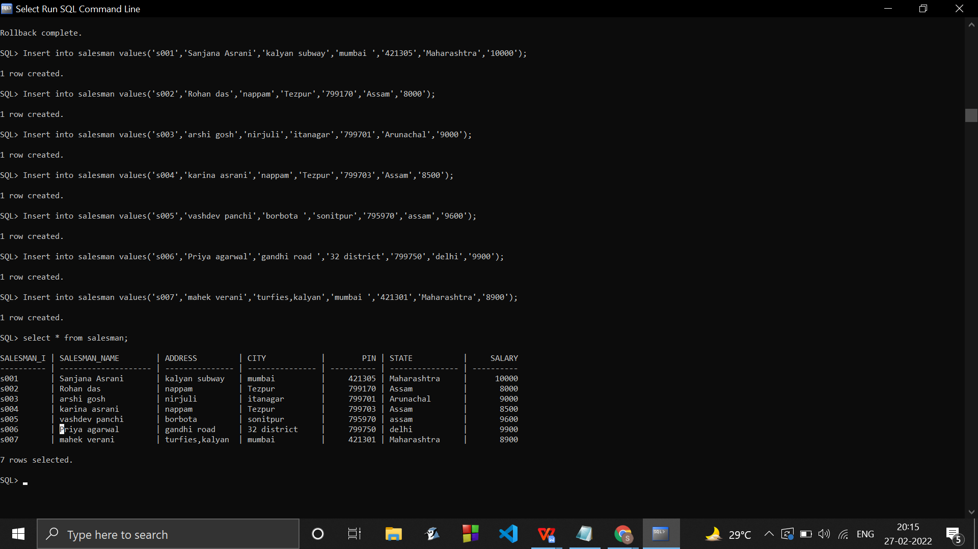

SALES_ORDER_DETAILS TABLE :

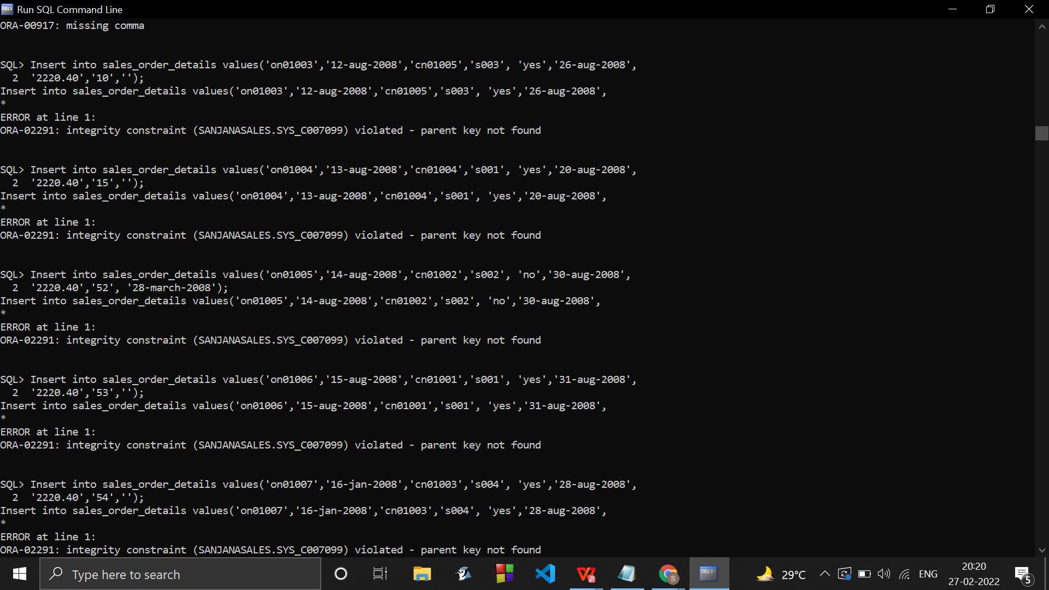

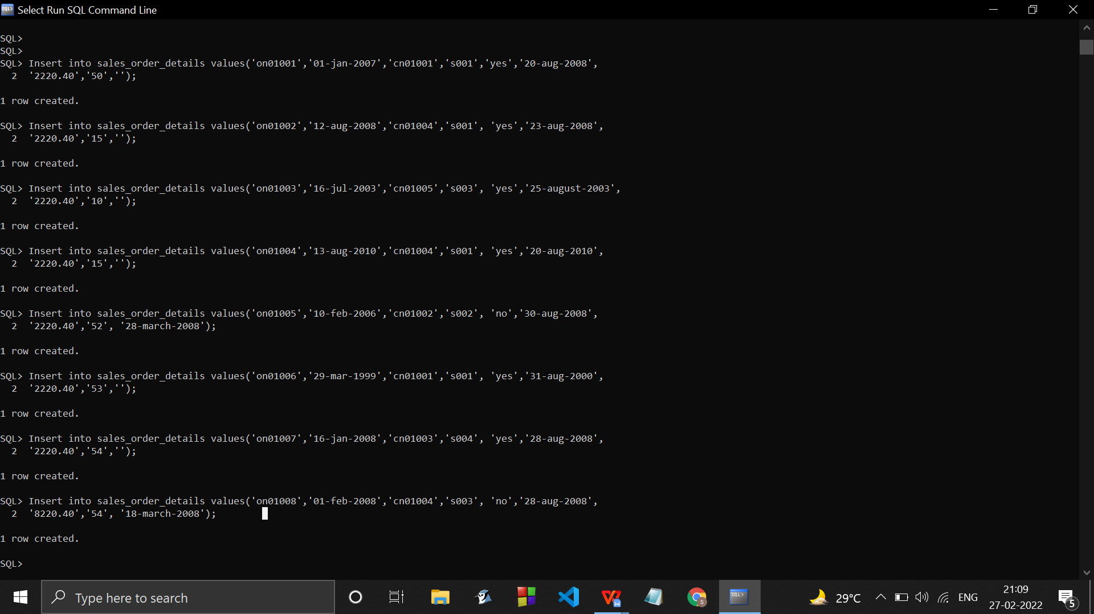

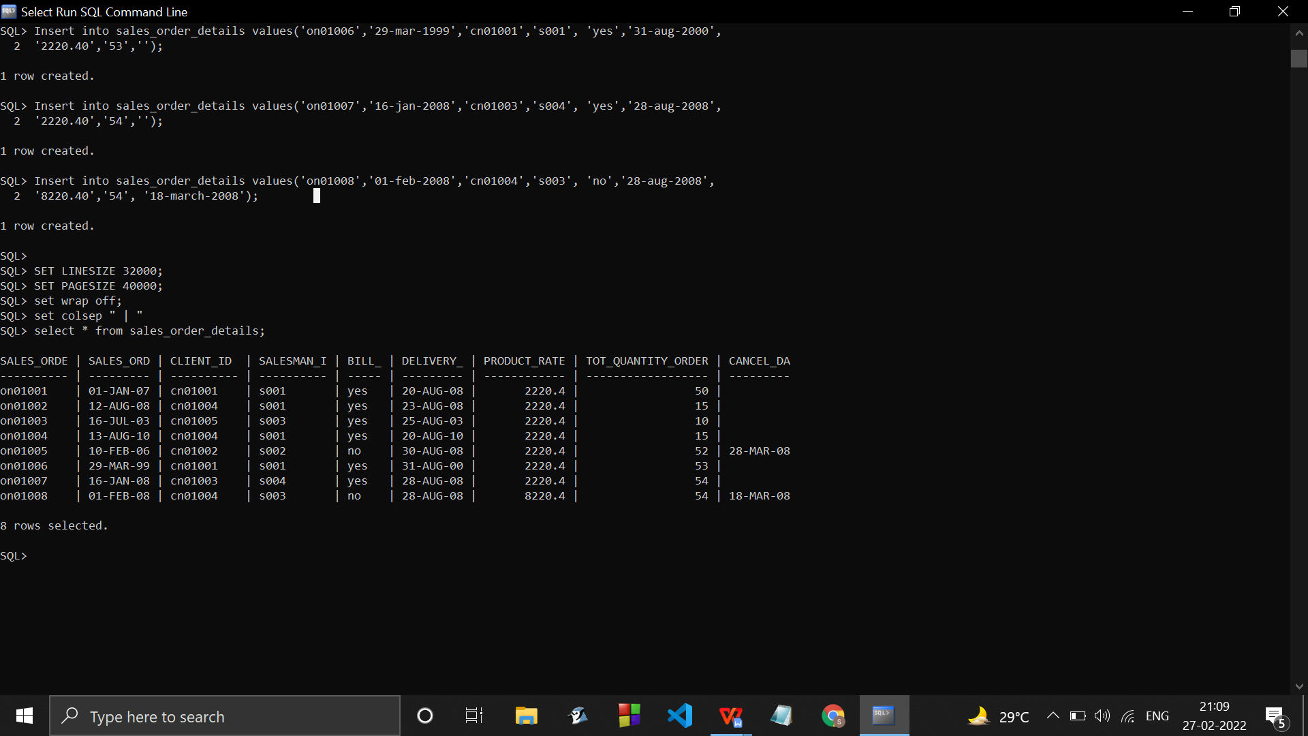

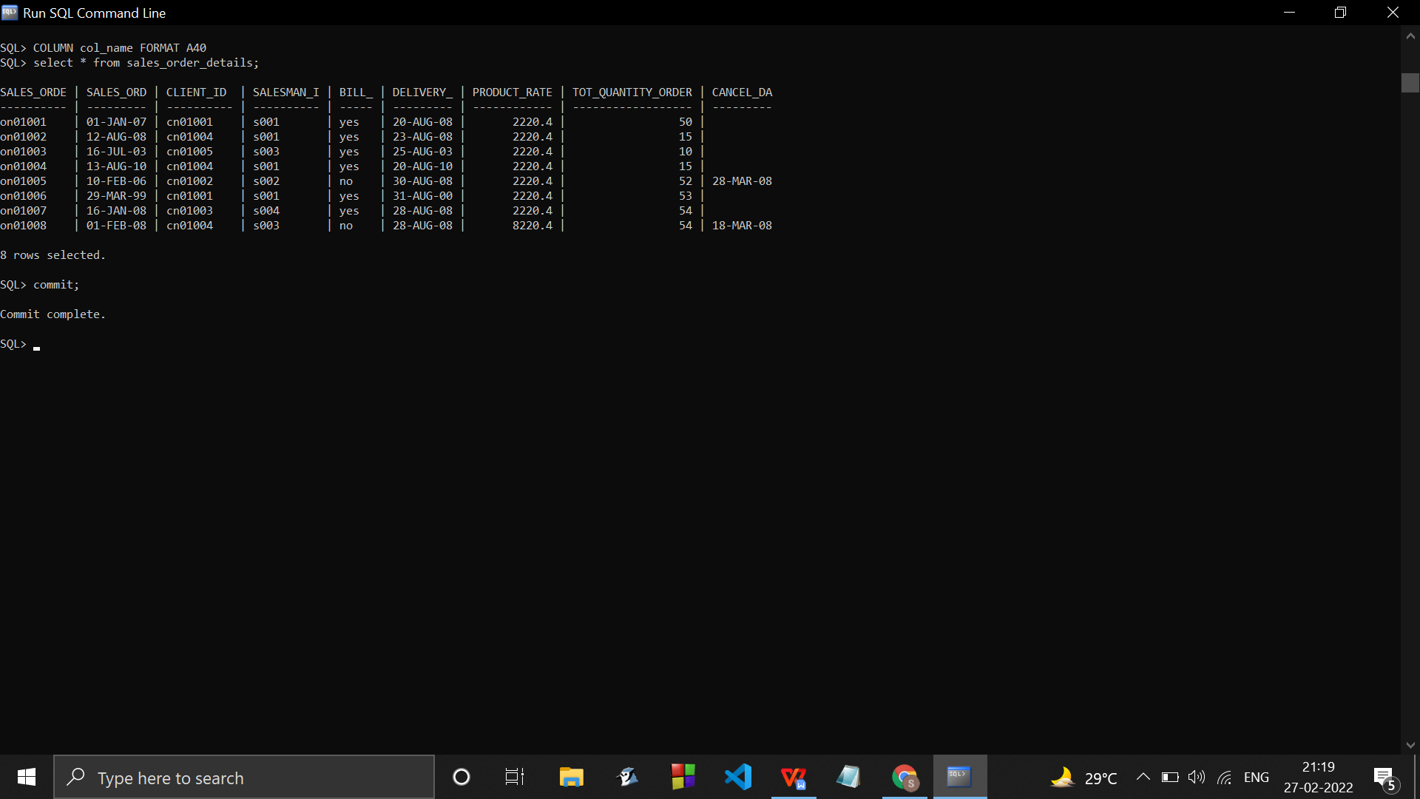

Insertion in table sales_order_details after altering it :

Insert into sales_order_details values('on01009','02-feb-200','cn01004','s003', 'no','28-aug-2008',

'9210.30','54', '16-jul-08','p001');

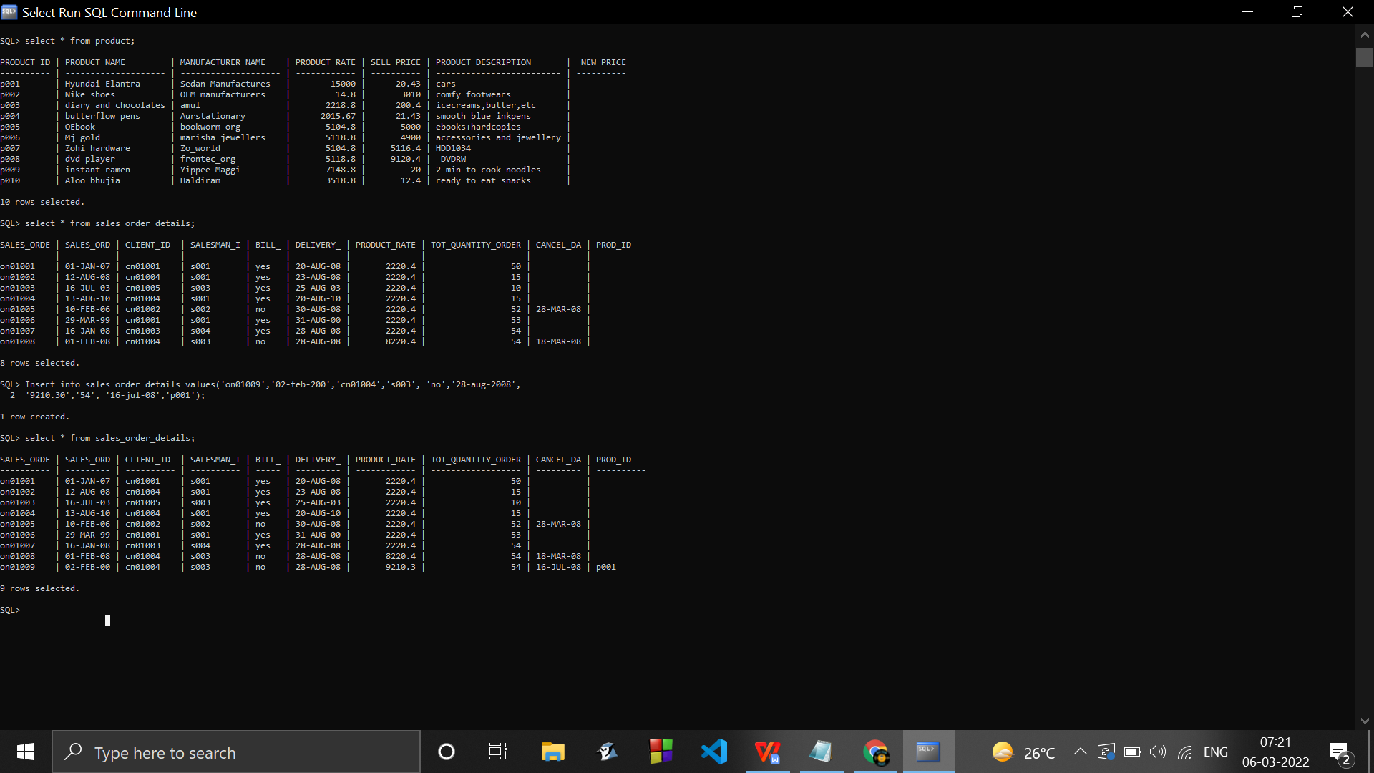

Salary/price formatting so that the rate of product is separated by commas :

Column product_rate format 99,999.99 hea 'RATE OF PRODUCT' :

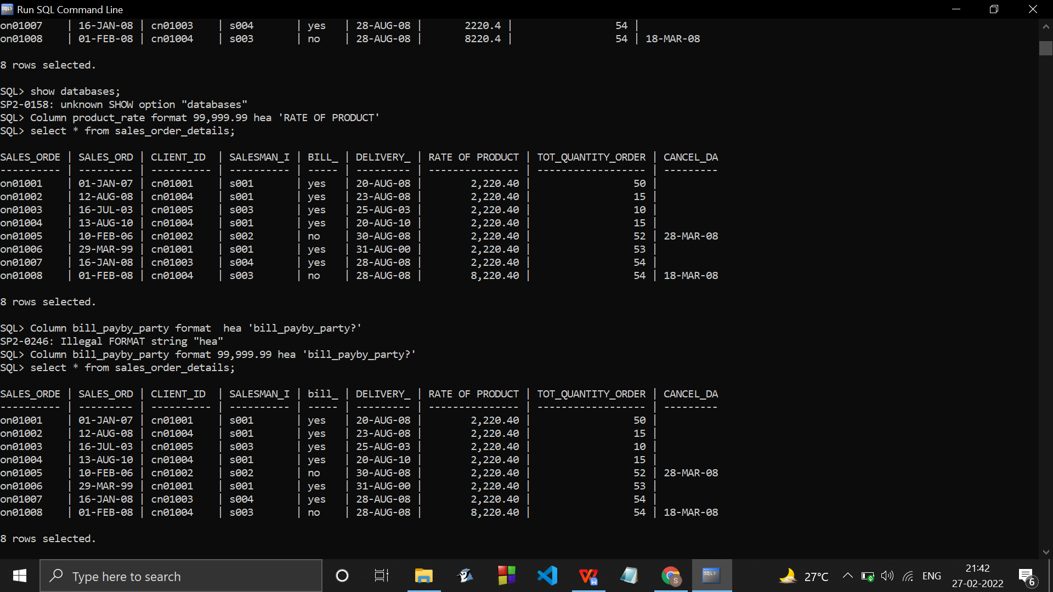

1. **Write the SQL queries for the following** –
2. Retrieve the list of names and the cities of all the clients.

Select client_name, city from client;

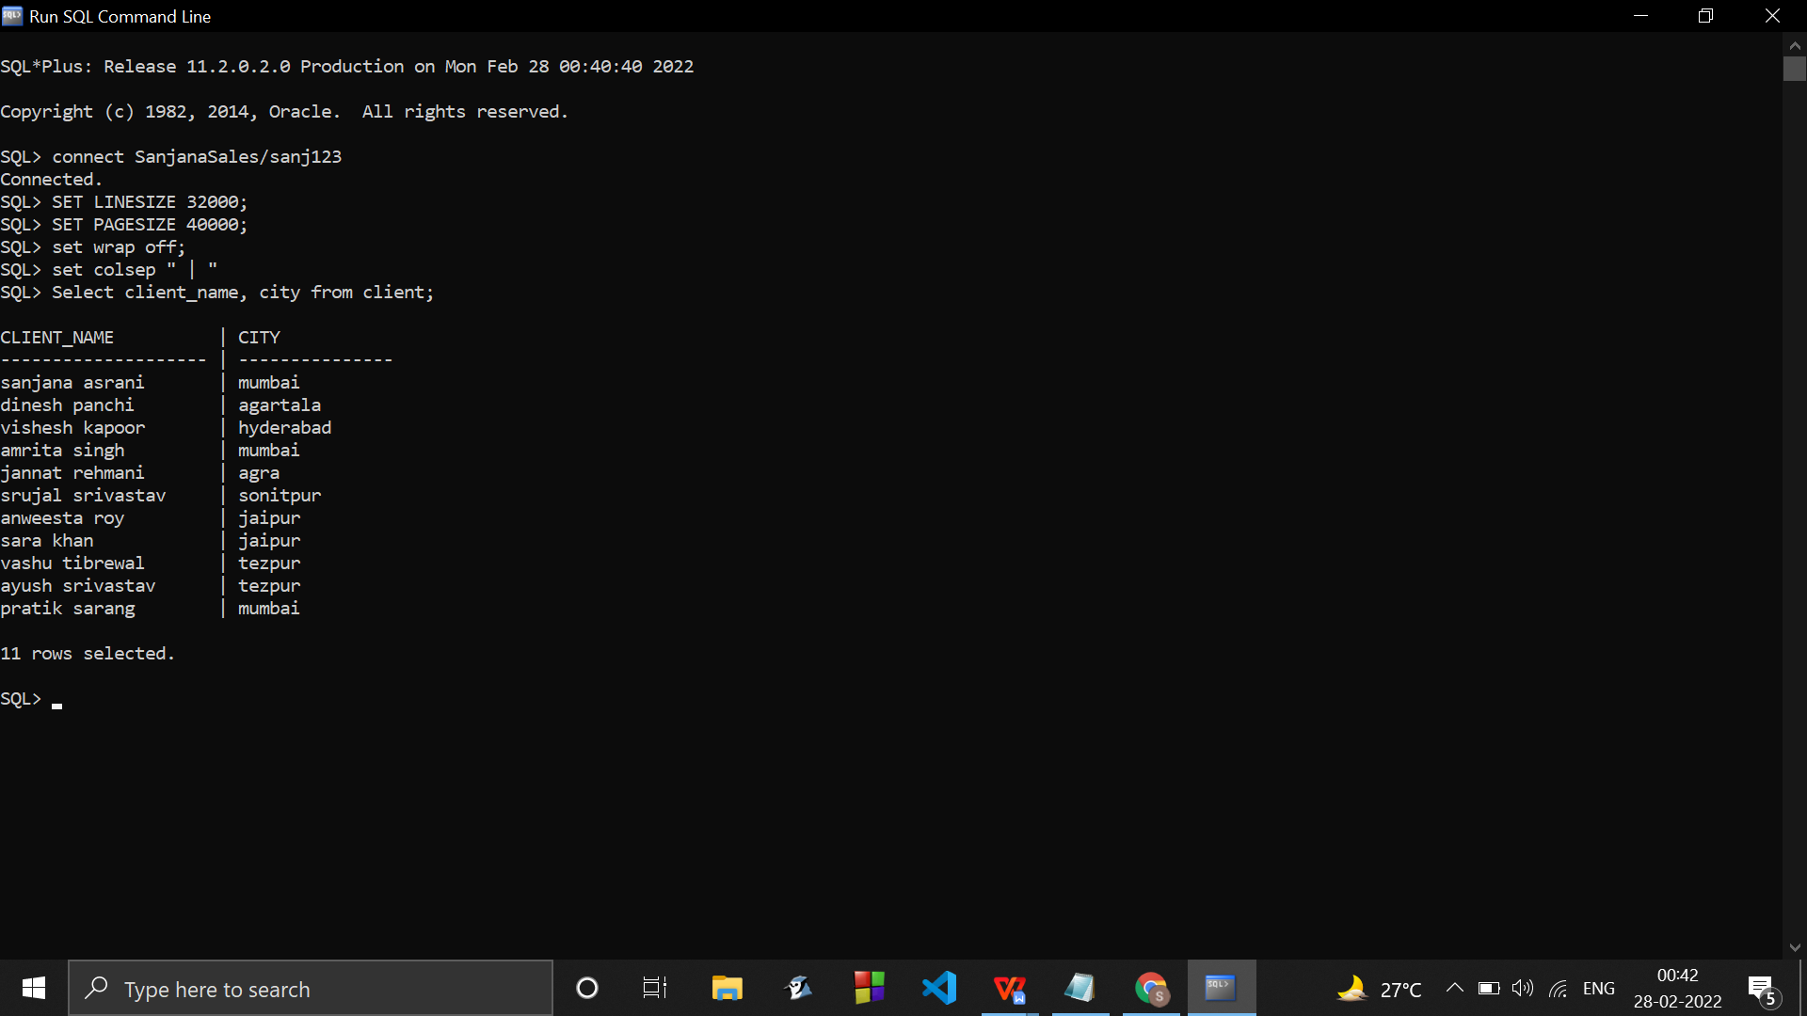

1. Find the names of all clients having ‘a’ as the second letter in their names.

SELECT client_name FROM client WHERE client_name LIKE '_a%';

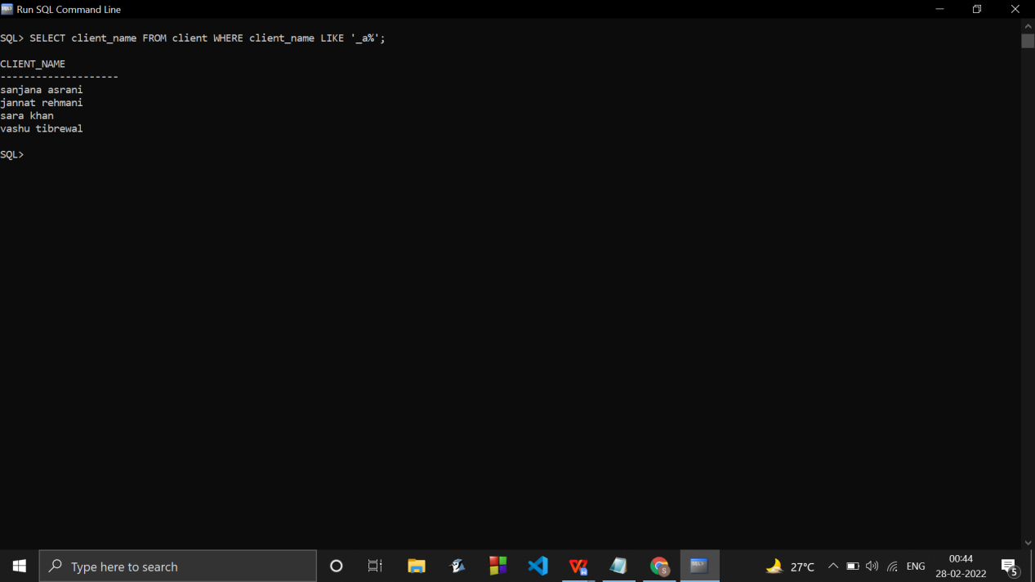

1. List all the clients who are located in Mumbai.

SELECT * FROM client WHERE upper(city) ='MUMBAI';

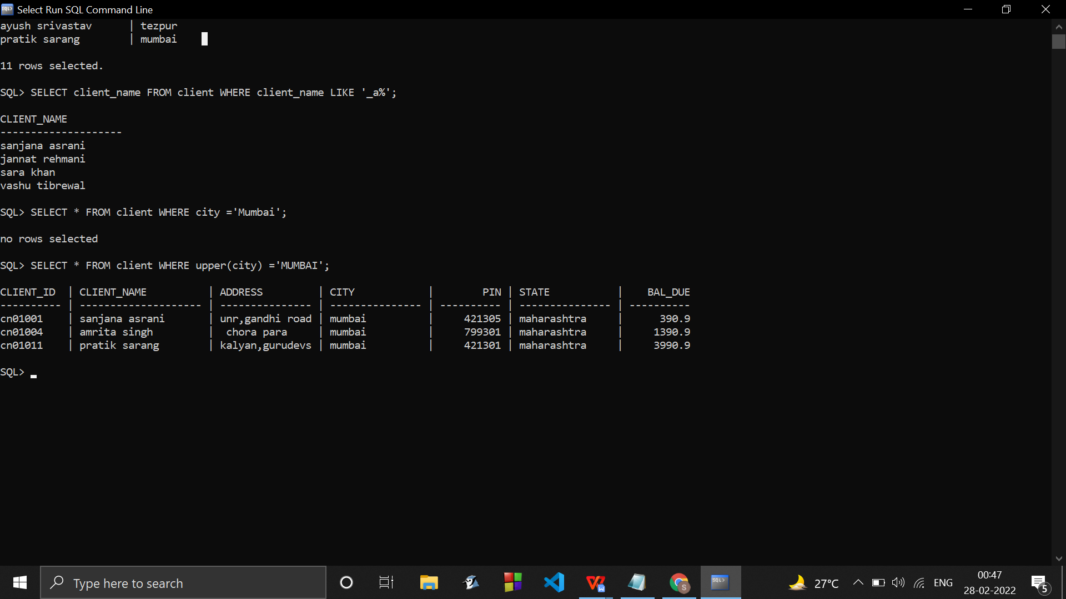

Since some records might have MUMBAI/Mumbai/mumbai/.. its better to use upper function.

1. Find the products whose selling price is greater than 2000 and less than or equal to 5000

SELECT * FROM product WHERE sell_price > 2000 AND (sell_price < 5000 OR sell_price = 5000);

Since there were no products within the sell price range 2000 and 5000 : no rows were selected.

Updating sell price of some products …

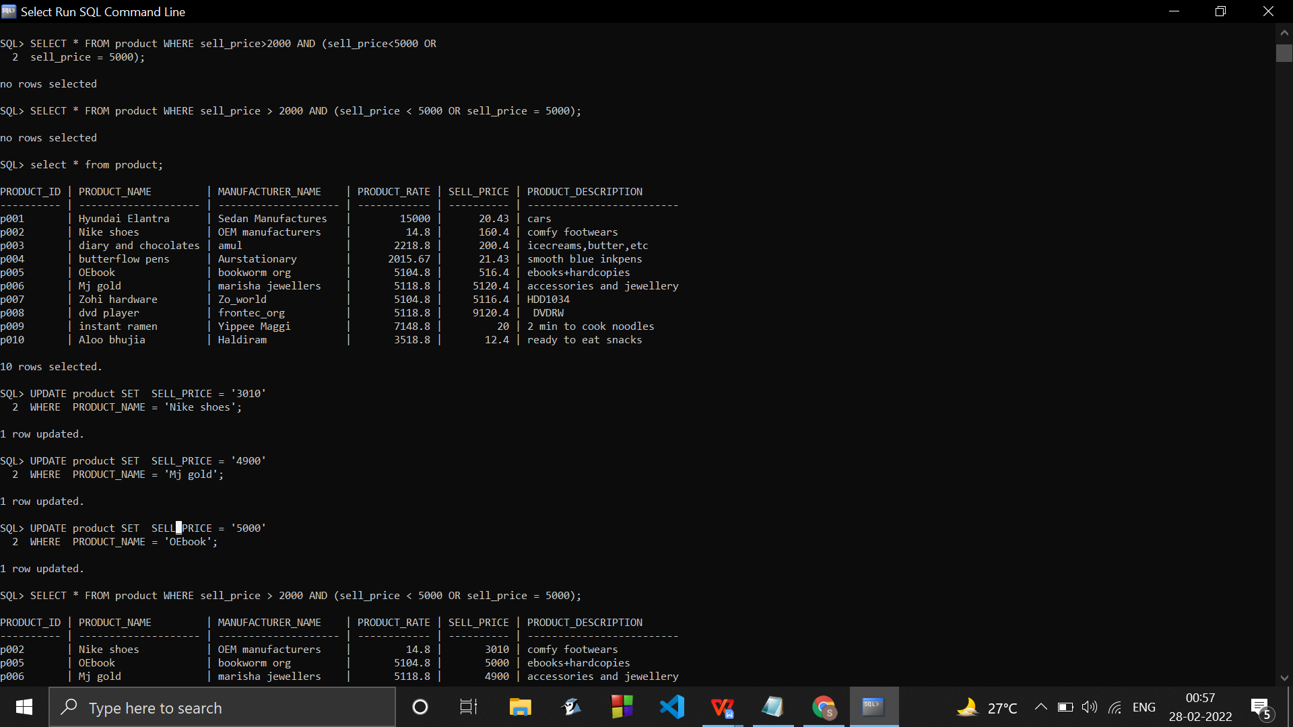

1. Add a new column NEW_PRICE into the product_master table.

ALTER TABLE product ADD (new_price number(9,4));

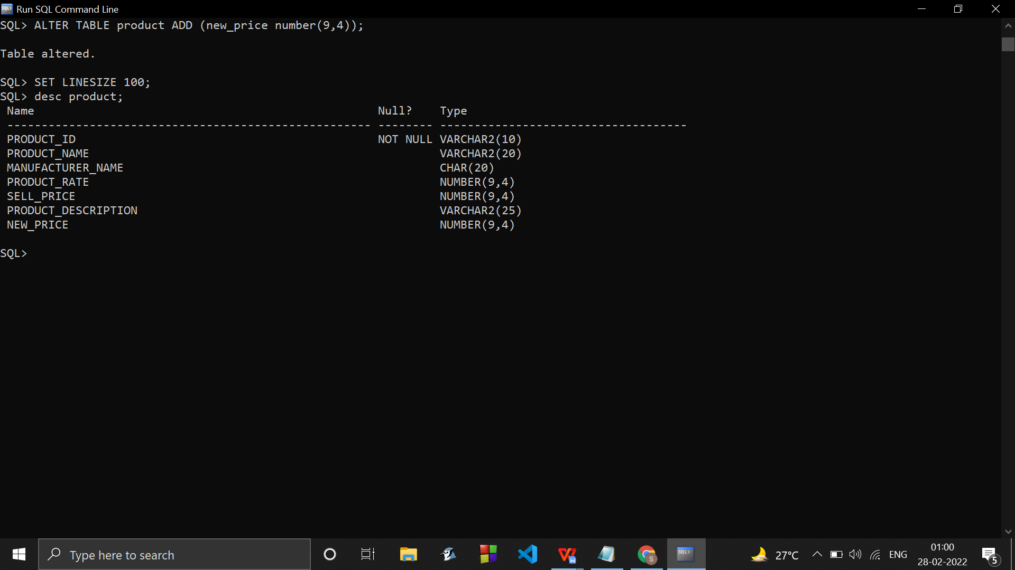

1. List the products in sorted order of their description.

SELECT * FROM product ORDER BY PRODUCT_DESCRIPTION ASC;

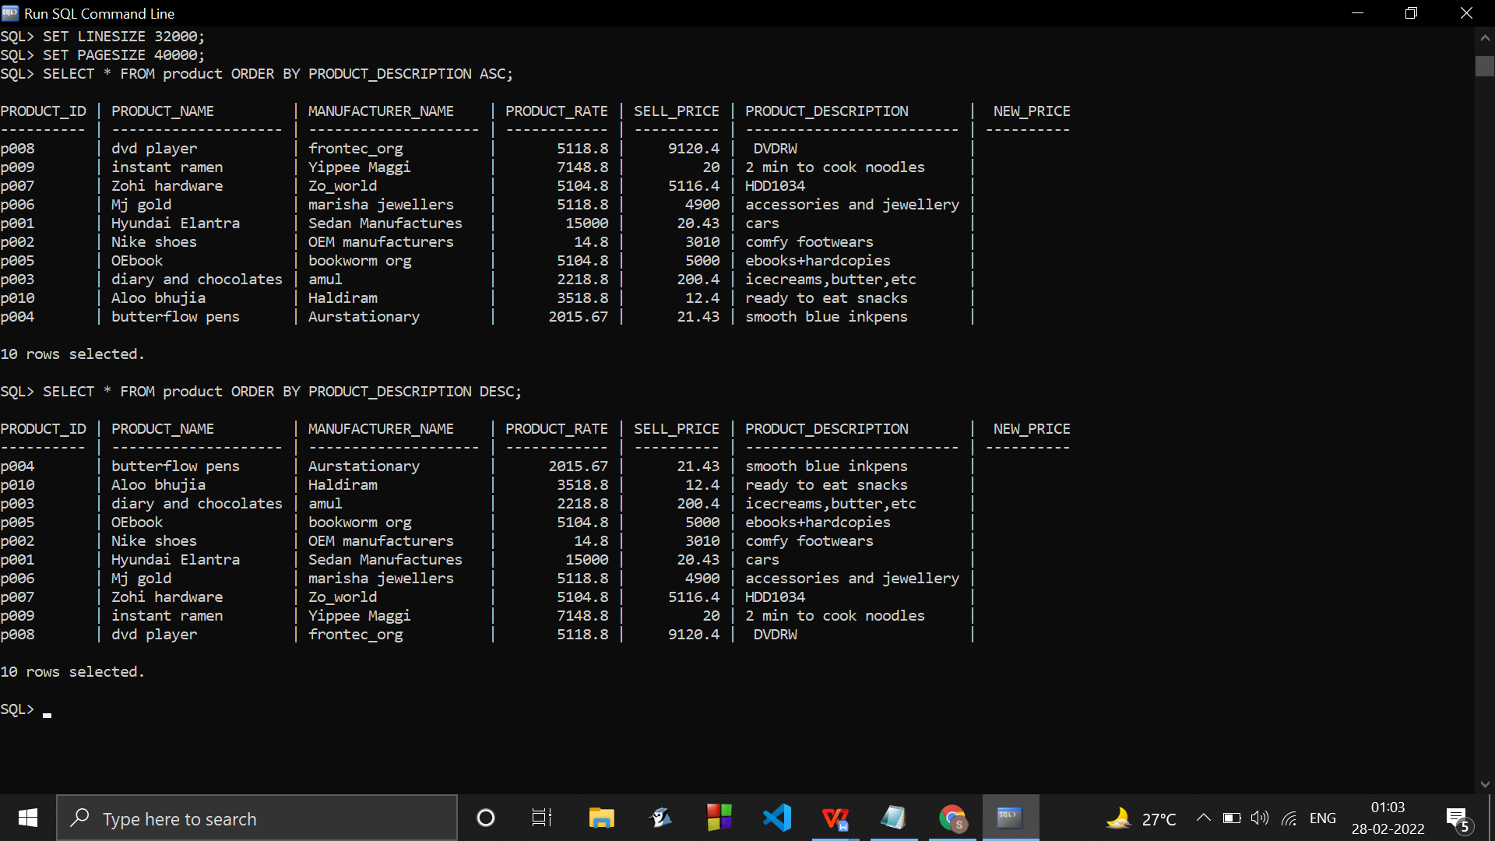

1. Display the order number and date on which the clients placed their order.

SELECT sales_order_no, sales_order_date FROM Sales_Order_Details;

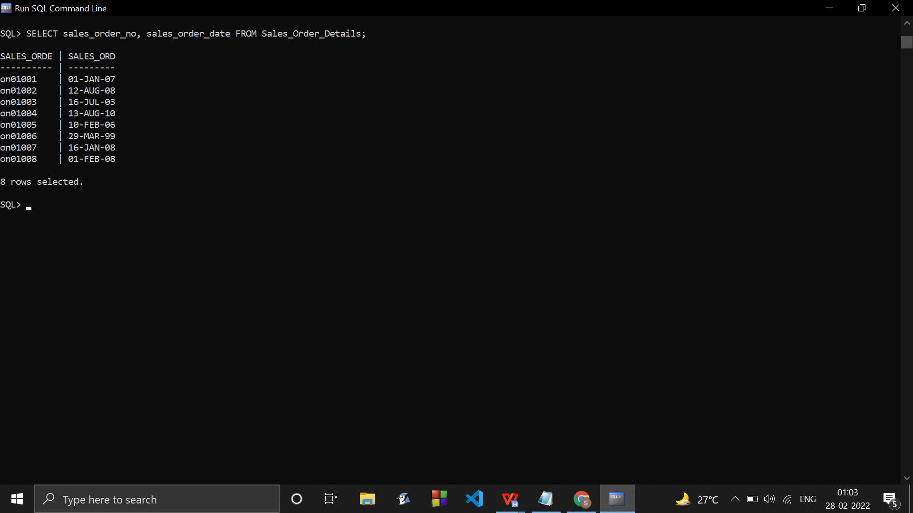

1. Delete all the records having delivery date before 25th August, 2008.

DELETE FROM sales_order_details WHERE delivery_date < '25-aug-2008';

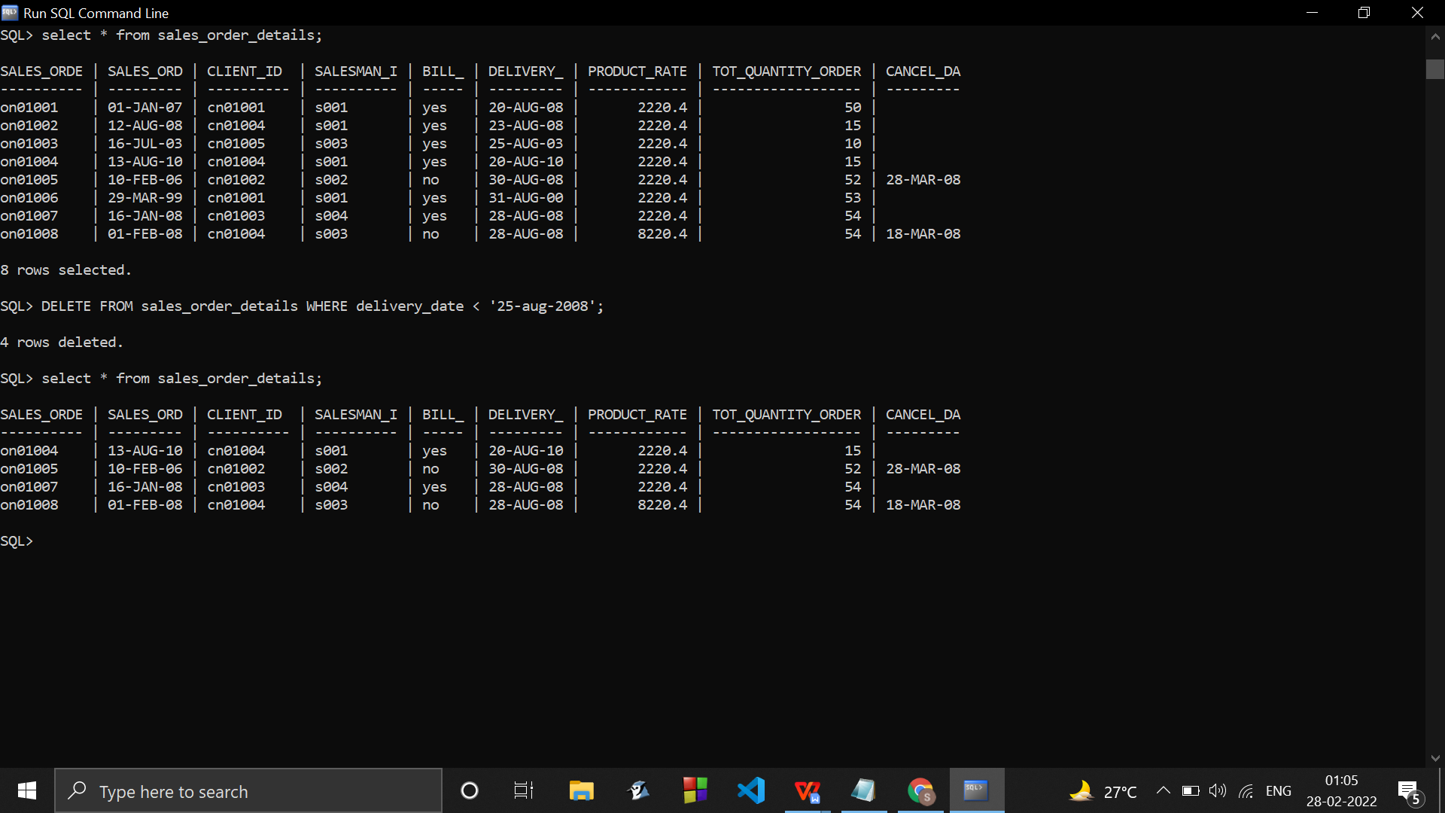

1. Change the bal_due of client_no CN01003 to 1200

UPDATE client SET bal_due = '1200' WHERE client_id = 'cn01003';

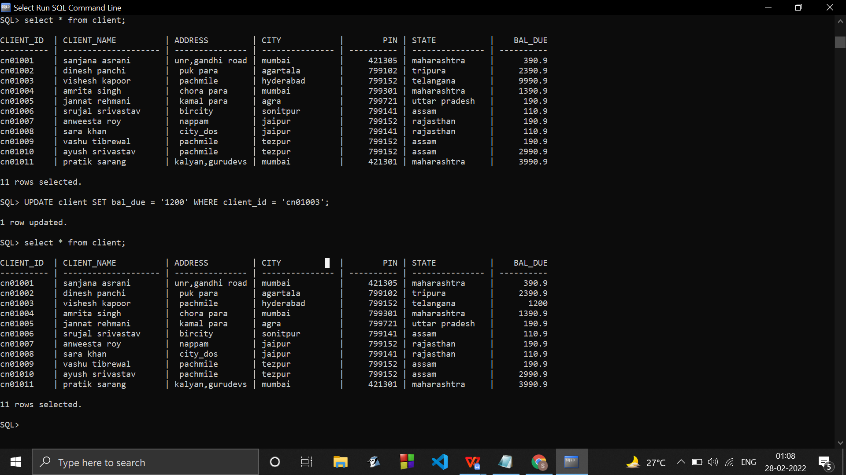

1. Find the product with description as ‘HDD1034’ and ‘DVDRW’

SELECT * FROM product where product_description='HDD1034' OR product_description='

DVDRW';

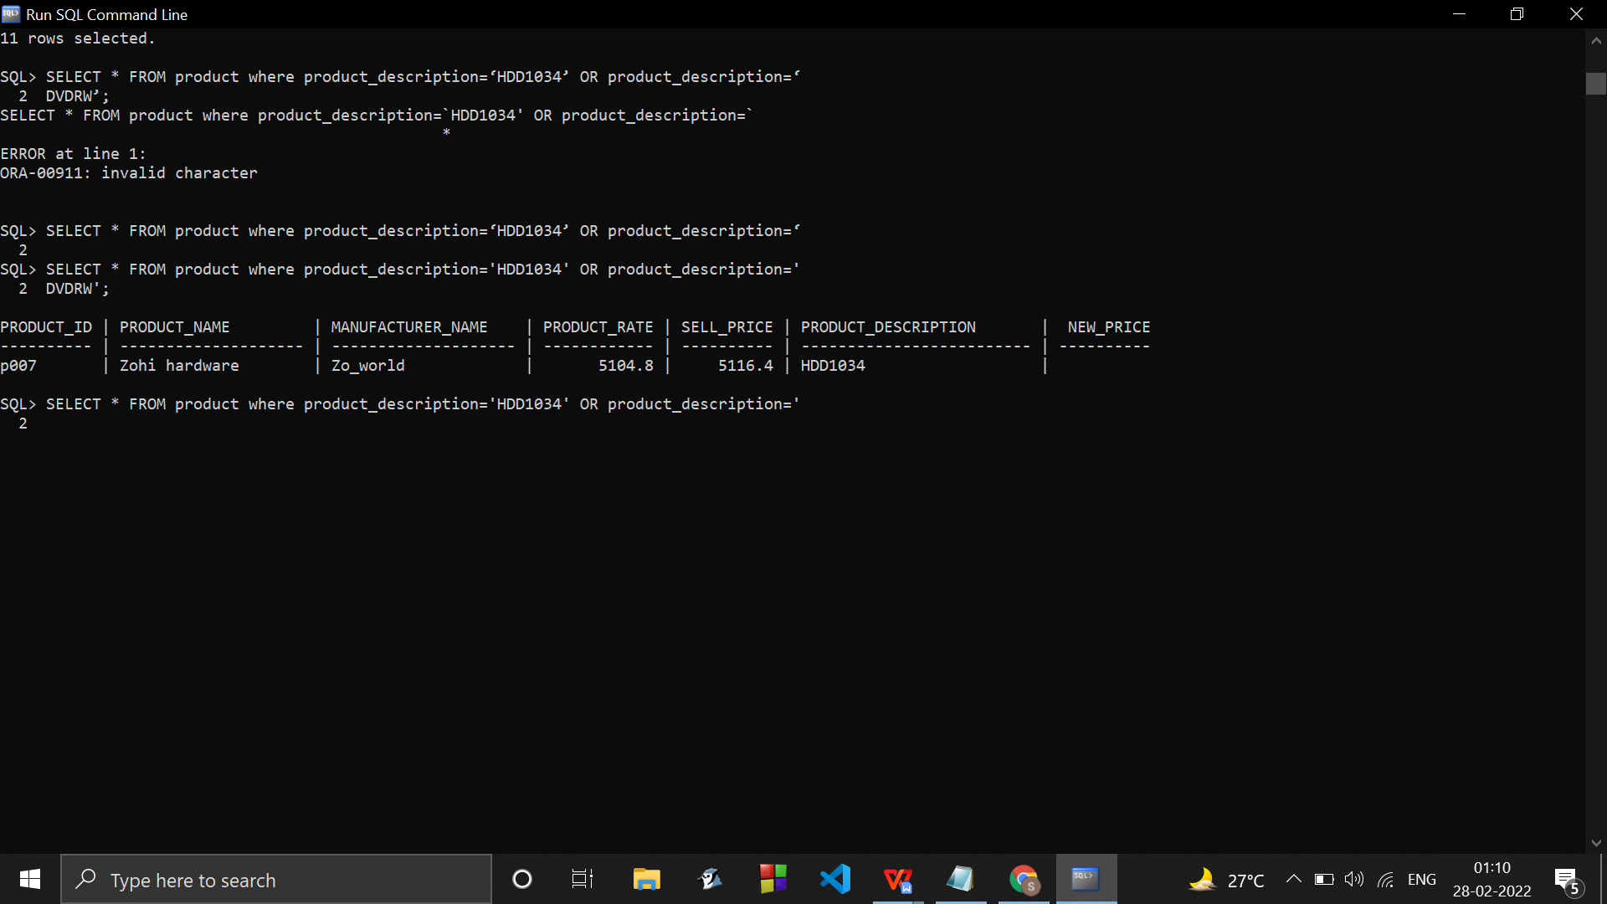

(k) List the names, city and state of the clients not in the state of ‘ASSAM’

SELECT client_name,city,state FROM client WHERE NOT state ='assam';

