**D12B_01_SANJANA ASRANI_DWM_EXP-05_DBSCAN**

Dataset :

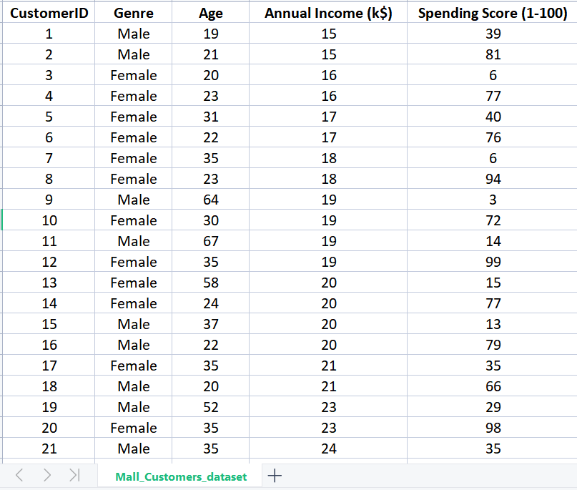

Code in python :

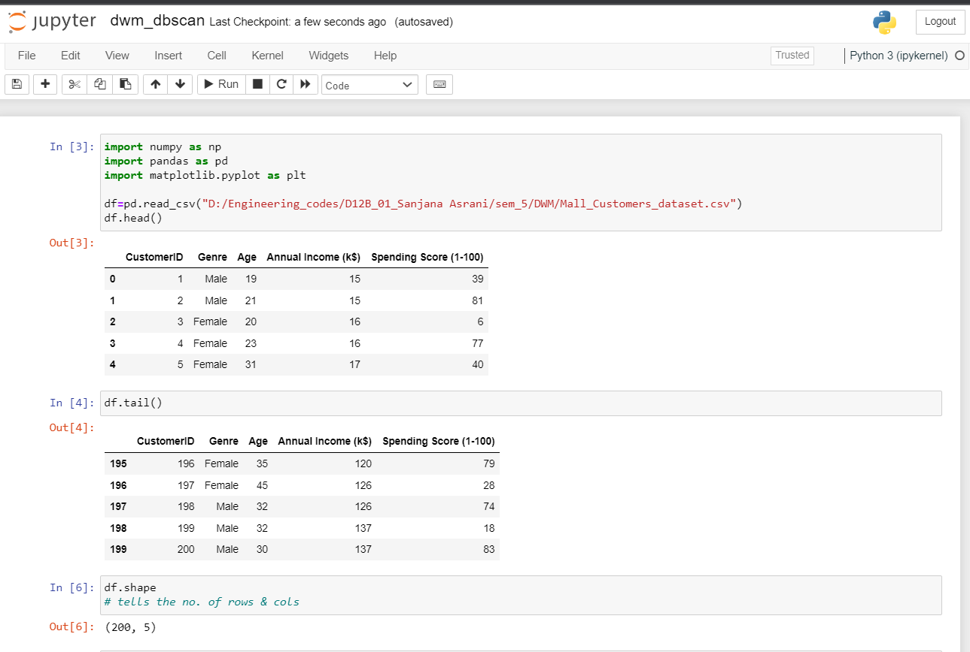

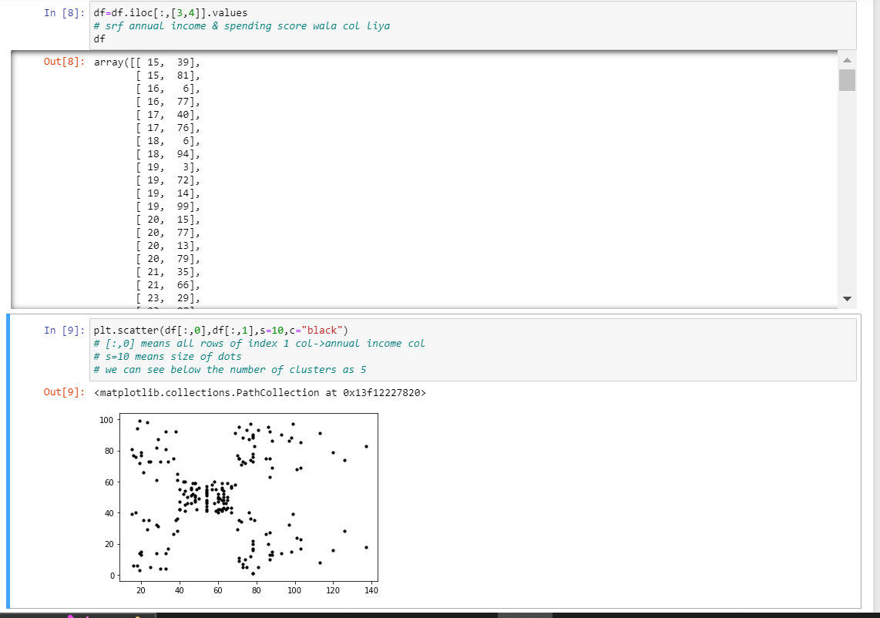

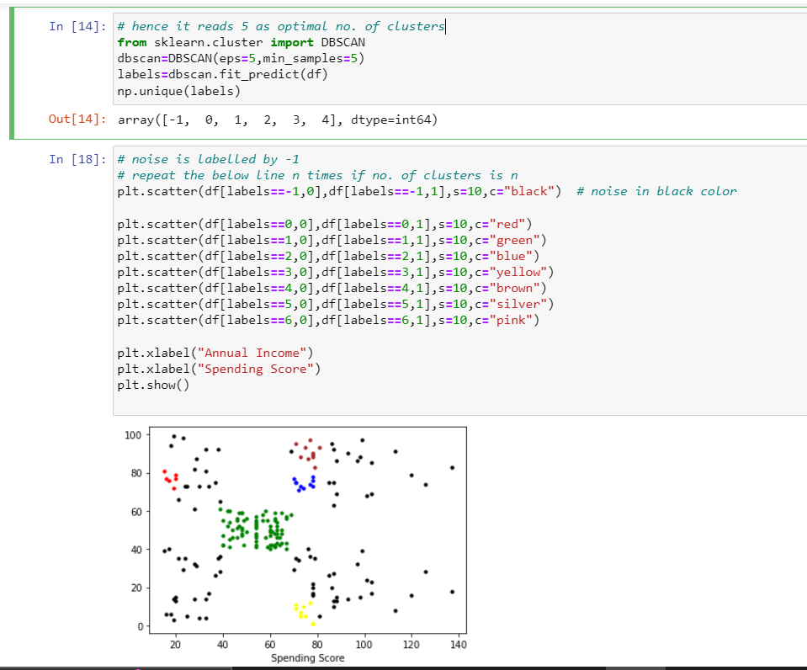

**D12B_01_SANJANA ASRANI_DWM_EXP-07_APRIORI ALGORITHM**

pip install apyori

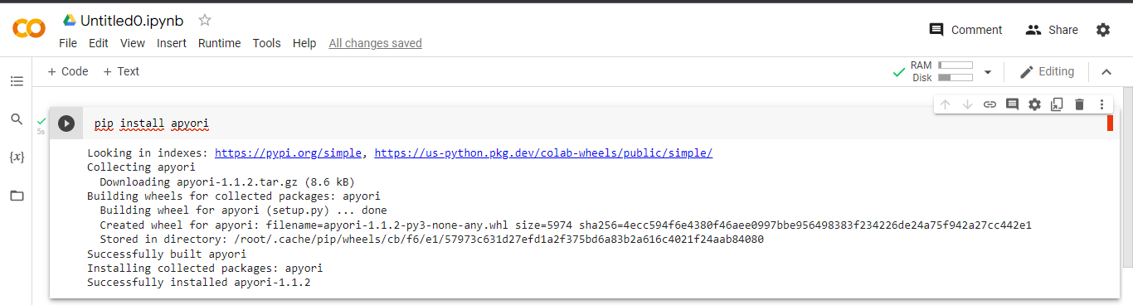

import numpy as np # linear algebra

import pandas as pd # data processing

import plotly.express as px

import apyori

from apyori import apriori

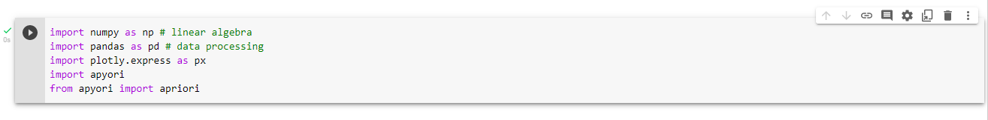

data = pd.read_csv("Groceries_dataset.csv")

data.head()

………………………https://thecleverprogrammer.com/2020/11/16/apriori-algorithm-using-python/