A **financial year**, also known as a **fiscal year**

Q1: April, May, June

Q2: July, August, September

Q3: October, November, December

Q4: January, February, March

**save**

**lend**

**borrow**

**invest**

**forecast**

**budget**

**2 main regulatory bodies are rbi, sebi**

**they lay down some policies guidelines**

**Banking institutions, like banks, offer traditional financial services such as deposits, loans, and investments, heavily regulated to ensure stability. Non-banking institutions, including credit unions and fintech firms, provide similar services but often with more flexibility and innovation, operating outside conventional banking regulations, often focusing on niche markets or technological advancements. non banking dont create credit**

**Commercial banks primarily serve individual customers and small to medium-sized businesses, offering basic banking services like savings accounts, loans, and mortgages. Cooperative banks, on the other hand, are owned and operated by their members, who are often customers and shareholders, focusing on community-oriented banking and mutual support, typically serving specific localities or groups**

**trade financial products, thus make financial transactions, mobilize/hold financial resources, allocation of em**

**Assets**: Assets are resources owned by a company that have economic value and are expected to provide future benefit.

**#Tangible assets** are physical assets that have a physical form and can be touched or seen. Property, Plant, and Equipment (PP&E): Buildings, machinery, equipment, land, vehicles.

Inventory: Raw materials, work-in-progress inventory, finished goods.

Cash: Physical currency, coins, and cash equivalents like petty cash.

Investments: Marketable securities, such as stocks and bonds, that the company intends to hold for the long term.

**#Intangible assets** are non-physical assets that lack a physical form but have value to the company.

Goodwill: Represents the premium paid for acquiring another company above its book value.

Intellectual Property: Patents, trademarks, copyrights, and trade secrets.

Brand Recognition: Reputation and brand value associated with the company's products or services.

Software: Developed software for internal use or purchased software licenses.

**#Current Assets/ Short term assets:** Current assets are assets that are expected to be converted into cash or used up WITHIN ONE YEAR or one operating cycle, whichever is longer. Thus used in formulation of liquidity rations (conversion of stuff to money). They are resources that are readily convertible into cash or are expected to be sold, consumed, or used up in the near future. Common examples of current assets include cash and cash equivalents, accounts receivable (money owed to the company by customers), inventory, and short-term investments.

**#Non-current assets/long-term assets/fixed assets**, are resources owned by a company that are not expected to be converted into cash or used up within one year or one operating cycle, whichever is longer. These assets are held for long-term use in the business and are not intended for resale. Non-current assets typically provide long-term economic benefits to the company. Here are some common examples:

**#Total Assets:** Total assets represent the entire value of all resources owned by the company, both current and non-current. It includes all tangible and intangible assets that the company possesses.

------------------------------------

**Liabilities**: Liabilities are obligations or debts that a company owes to external parties.Liabilities can include loans, accounts payable (money owed to suppliers), accrued expenses (expenses incurred but not yet paid), and bonds payable.

**#Current Liabilities:** Current liabilities are obligations that are due and payable within one year or one operating cycle, whichever is longer. They represent debts or obligations that the company needs to settle in the short term. Common examples of current liabilities include accounts payable, short-term loans, accrued expenses, and current portions of long-term debt, EMI (Equated Monthly Installment)

**#Non-Current Liabilities:** Obligations that are due beyond one year. Examples include:

Long-Term Loans: Loans with repayment terms longer than one year.

Bonds Payable: Long-term debt securities issued by the company.

**#Total Liabilities:** Total liabilities represent the total obligations or debts owed by the company to external parties, both current and non-current. It encompasses all liabilities that the company needs to fulfill, including both short-term and long-term obligations. total liabilities will be the sum of all current and non-current items respectively.

**#Profit:** When a company generates revenue that exceeds its expenses, it earns a profit. Profit increases the company's equity, specifically the retained earnings account. Retained earnings represent the cumulative net earnings of the company that have been retained and reinvested into the business rather than distributed to shareholders as dividends.

**#Loss:** Conversely, when a company's expenses exceed its revenue, it incurs a loss. This loss decreases the company's equity, specifically the retained earnings account. It represents a reduction in the accumulated earnings of the company.

**#Equity:**

Valuation: 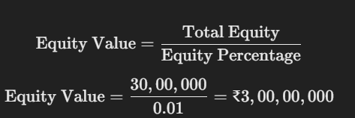

**#Dividend:** Money paid regularly by a company to its shareholders out of its profits or reserves.

**#Retained Earnings:** The portion of net income that a company keeps or retains after paying dividends to shareholders.

**#Shareholders' Equity:** The value of a company to its shareholders, calculated by subtracting total liabilities from total assets.

**#Revenue:** The total income generated by a business from its normal activities, such as sales of goods or services.

**#Expenses:** The costs incurred by a business in its normal operations to generate revenue, such as wages, rent, and supplies.

**#Depreciation:** The decrease in the value of an asset over time, reflecting its wear and tear, obsolescence, or other factors.

When investors put money into a company, they typically acquire ownership in the form of shares of stock. In return for their investment, investors expect to receive various forms of value, including:

1. **Dividends**: As mentioned earlier, dividends are periodic payments made by a company to its shareholders out of its profits. Investors expect to receive dividends as a share of the company's earnings, providing them with a regular income stream.

2. **Capital Appreciation**: Investors also expect the value of their shares to increase over time through capital appreciation. If the company performs well and its stock price rises, investors can sell their shares at a higher price than they paid, realizing a capital gain.

3. **Voting Rights**: Shareholders typically have the right to vote on important company matters, such as the election of the board of directors, approval of mergers and acquisitions, and changes to the company's bylaws. This gives investors a say in how the company is run and helps protect their interests.

4. **Ownership Stake**: By owning shares of stock, investors become partial owners of the company and share in its profits and losses. This ownership stake gives investors a claim on the company's assets and earnings proportional to the number of shares they own.

5. **Information and Transparency**: Investors expect companies to provide accurate and timely information about their financial performance, operations, and future prospects. Transparency and disclosure help investors make informed decisions and assess the risks and potential rewards of their investment.

**Dividends** are payments made by a corporation to its shareholders as a distribution of profits. When a company earns a profit, it can choose to reinvest that profit back into the business for growth or distribute a portion of it to shareholders in the form of dividends. Dividends represent a reward for owning shares of the company and provide investors with a regular income stream.

dividends are typically distributed out of a company's profits. If a company does not generate profits or has insufficient profits to cover dividend payments, it may choose not to pay dividends or reduce the amount of dividends paid.

* **Cash dividends** are the most common form of dividend payment, where shareholders receive a certain amount of cash for each share they own. For example, if a company declares a dividend of $0.50 per share and you own 100 shares, you would receive a total of $50 in dividend payments.
* additional shares of stock (known as **stock dividends**), or other property.

Dividends are typically paid on a regular basis, such as quarterly, semi-annually, or annually, although some companies may also issue special dividends on an irregular basis. The decision to pay dividends and the amount of dividends paid are determined by the company's board of directors, based on factors such as the company's financial performance, cash flow, capital needs, and growth prospects.

Dividends are an important source of income for many investors, especially those seeking stable and predictable returns. They are also considered a sign of financial health and stability, as companies that consistently pay dividends demonstrate their ability to generate profits and return value to shareholders. However, it's important to note that dividend payments are not guaranteed, and companies may choose to reduce, suspend, or omit dividends in response to changes in business conditions or financial constraints.

**Mod1**

A financial system refers to the network of institutions, markets, regulations, and mechanisms that facilitate the flow of funds (allocate resources) between savers and borrowers within an economy while managing risks and providing liquidity to support economic activities.

It encompasses various components such as

* financial institutions (banks, insurance companies, mutual funds)
* financial markets (stock market, bond market, commodity markets
* regulators (central banks, securities commissions)
* financial instruments (stocks, bonds, loans)

SAVERS - SURPLUS

BORROWERS - DEFICIT

Liquidity refers to the ease with which an asset can be converted into cash without significantly affecting its price. In simpler terms, it's about how quickly and easily you can turn something you own into money.

* Cash is the most liquid asset because it can be used immediately for transactions.
* highly liquid assets include stocks that are traded frequently on active markets, as they can be sold relatively quickly without causing a significant change in their market price.
* BTC, ETH have high liquidity in world of cryptocurrency exchanges.
* assets like real estate or collectibles may have lower liquidity because they can take more time and effort to sell, and their sale may require finding the right buyer willing to pay the desired price.

scheduled banks are those included in the Second Schedule of the RBI Act and enjoy certain privileges and benefits

unscheduled banks are those not included in the Schedule and may face limitations in their operations and access to certain facilities

The two criteria you've mentioned are part of the eligibility requirements for a bank to be classified as a scheduled bank in India. Let's break them down:

1. Paid-Up Capital and Collected Fund of the Bank Should Not Be Less Than Rs. 5 Lakh:

This criterion specifies that for a bank to be considered as a scheduled bank, it must have a minimum paid-up capital and collected fund of at least Rs. 5 lakh. The paid-up capital refers to the amount of capital that has been contributed by the bank's shareholders and has been fully paid for their shares. The collected fund includes the paid-up capital as well as other reserves and funds accumulated by the bank.

The rationale behind this requirement is to ensure that the bank has a sufficient capital base to support its operations, absorb potential losses, and meet regulatory capital adequacy standards. Adequate capitalization is essential for maintaining the financial health and stability of the bank, protecting depositors' interests, and safeguarding the overall integrity of the banking system.

2. Any Activity of the Bank Will Not Adversely Affect the Interests of the Depositors:

This criterion emphasizes the importance of protecting the interests of depositors, who entrust their funds to the bank for safekeeping and expect to be able to access their deposits when needed. It requires that any activity undertaken by the bank should not pose undue risks or harm to the interests of depositors.

Banks are financial intermediaries that play a critical role in the economy by accepting deposits from the public and providing various banking services, including lending and investment activities. The prudent management of bank assets and liabilities, adherence to sound banking practices, and effective risk management are essential to ensure the safety and security of depositors' funds.

By imposing this requirement, regulators aim to promote the stability and confidence in the banking system, mitigate risks to depositors, and maintain the overall integrity of the financial system.

In summary, these eligibility criteria underscore the importance of adequate capitalization and depositor protection in the banking sector. They are designed to ensure the financial soundness, stability, and resilience of scheduled banks, thereby enhancing depositor confidence and maintaining the trust and credibility of the banking system.

Activities of a bank that can adversely affect the interests of depositors include actions or decisions that jeopardize the safety, security, accessibility, transparency, or stability of depositors' funds. Here are some examples:

1. Risk-taking Behavior: Engaging in excessive or inappropriate risk-taking activities, such as speculative trading, lending to high-risk borrowers without adequate safeguards, or investing in risky financial instruments, can put depositors' funds at risk.

2. Poor Risk Management Practices: Inadequate risk management practices, such as lax credit underwriting standards, weak internal controls, or insufficient capital buffers, can expose the bank to financial losses and impair its ability to honor depositor withdrawals.

3. Financial Mismanagement: Mismanagement of funds, fraud, embezzlement, or other financial misconduct within the bank can lead to the misappropriation or loss of depositors' funds, eroding trust and confidence in the banking institution.

4. Insolvency or Bankruptcy: Financial distress, insolvency, or bankruptcy of the bank can result in the loss of depositors' funds if the bank is unable to meet its obligations to depositors or if deposit insurance coverage is insufficient to compensate depositors for their losses.

5. Operational Disruptions: Operational disruptions, such as system failures, cyberattacks, or disruptions in banking services, can impede depositors' access to their funds and disrupt normal banking operations, causing inconvenience and financial hardship for depositors.

6. Non-compliance with Regulations: Violations of banking regulations, such as failure to comply with capital adequacy requirements, liquidity requirements, anti-money laundering laws, or consumer protection regulations, can result in regulatory sanctions, financial penalties, or reputational damage that affects depositors' confidence in the bank.

7. Poor Customer Service: Inadequate customer service, such as long wait times, delays in processing transactions, or lack of responsiveness to customer inquiries or complaints, can undermine depositors' trust and satisfaction with the bank, leading to attrition of depositors.

8. Fraud or Scams: Participation in fraudulent schemes, Ponzi schemes, or other financial scams that involve the misappropriation of depositors' funds or deceptive practices can result in financial losses for depositors and damage to the bank's reputation.

Overall, any activity of the bank that compromises the safety, security, accessibility, transparency, or stability of depositors' funds can adversely affect the interests of depositors and erode confidence in the banking institution. Regulatory authorities closely monitor banks to ensure compliance with regulations and protect depositors' interests.

**Mod2**

**Returns** refer to the rewards or profits earned from an investment over a certain period of time. It represents the increase in value of an investment, typically expressed as a percentage of the initial investment amount. Returns can come from various sources such as:

* **Capital Gains**: Profits earned from the increase in the value of an asset or investment over time. For example, if you buy a stock for $100 and sell it for $150, your capital gain is $50.
* **Dividends**: Payments made by a company to its shareholders as a share of its profits. Dividends provide a regular income stream to investors, especially in the case of stocks and mutual funds.
* **Interest**: Income earned from lending money or investing in fixed-income securities such as bonds, treasury bills, or savings accounts. Interest payments represent the compensation for the use of funds over a specified period.

Overall, returns are a measure of the success of an investment and are crucial for investors to assess the performance and profitability of their investment portfolio.

**Risks**:

Risks, on the other hand, refer to the possibility of loss or uncertainty associated with an investment. All investments involve some degree of risk, and understanding and managing risks is essential for investors to protect their capital and achieve their financial goals. Some common types of risks include:

* **Market Risk:** Also known as systematic risk, market risk refers to the risk of losses due to factors affecting the overall market, such as economic conditions, interest rates, inflation, or geopolitical events. Market risk cannot be eliminated through diversification but can be mitigated to some extent.
* **Credit Risk:** Credit risk, also known as default risk, is the risk of loss due to the failure of a borrower or issuer to fulfill their financial obligations. It is particularly relevant for investments in bonds, loans, or other debt securities.
* **Liquidity Risk:** Liquidity risk refers to the risk of not being able to sell an investment quickly or at a fair price due to a lack of market demand or liquidity. Illiquid investments may result in delays or losses when attempting to convert them into cash.
* **Inflation Risk:** Inflation risk is the risk that the purchasing power of money will decline over time due to inflation. Investments that do not keep pace with inflation may result in a loss of real value over time.
* **Business Risk:** Business risk refers to the risk associated with the specific operations, financial health, or performance of a company. Factors such as competition, regulatory changes, technological advancements, or management decisions can affect the profitability and stability of a company.

A **single security** refers to an individual financial instrument or investment product, such as a stock, bond, mutual fund, or exchange-traded fund (ETF). It represents a single asset or security that an investor can purchase to potentially generate returns or income.

A **portfolio** refers to a collection of investments or assets held by an individual, institution, or entity. It consists of multiple securities or financial instruments that are grouped together to achieve specific investment goals or objectives.

A portfolio can consist of investments in various companies, industries, sectors, asset classes, or geographic regions, depending on the investor's preferences, investment objectives, risk tolerance, and market outlook. The purpose of building a portfolio is to achieve diversification, manage risk, and optimize returns by spreading investments across different assets with different risk and return characteristics.

For example, if you have invested in stocks of multiple companies, bonds, and mutual funds, collectively, these holdings represent your investment portfolio. Each individual investment within the portfolio contributes to its overall composition and performance.

Managing a portfolio involves making decisions about asset allocation, diversification, risk management, and rebalancing to align with the investor's goals and objectives. Investors may adjust their portfolios over time in response to changes in market conditions, economic outlook, and personal circumstances.

**Historical returns** refer to the past performance of an investment or portfolio over a specific period of time. It provides insights into how an investment has performed in the past and can help investors assess its risk and potential future returns. Historical returns are typically expressed as a percentage and can be calculated using various metrics such as average annual return, compound annual growth rate (CAGR), or total return.

Return on an asset or single security portfolio refers to the gain or loss generated by holding that particular asset or security over a certain period of time. It measures the profitability of the investment relative to its initial cost.

For example, if you purchase a stock for $100 and it is now worth $120, the return on the asset would be:

Return on Asset (%)=(120−100)/(100)×100%=20%

The average rate of return (ARR) is a measure used to assess the average performance or profitability of an investment over a specific period of time. It calculates the average annual return earned on an investment, taking into account the investment's initial value, final value, and the time period over which the return was earned.

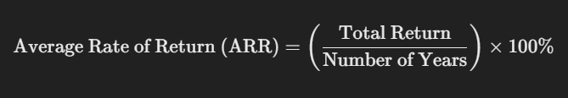

The **holding period return (HPR)** is a measure used to calculate the return earned on an investment over the period it was held. It represents the total percentage gain or loss realized by an investor from buying and holding an investment for a specific duration.

Ending Value is the value of the investment at the end of the holding period.

Beginning Value is the value of the investment at the beginning of the holding period



HPR VS ROA

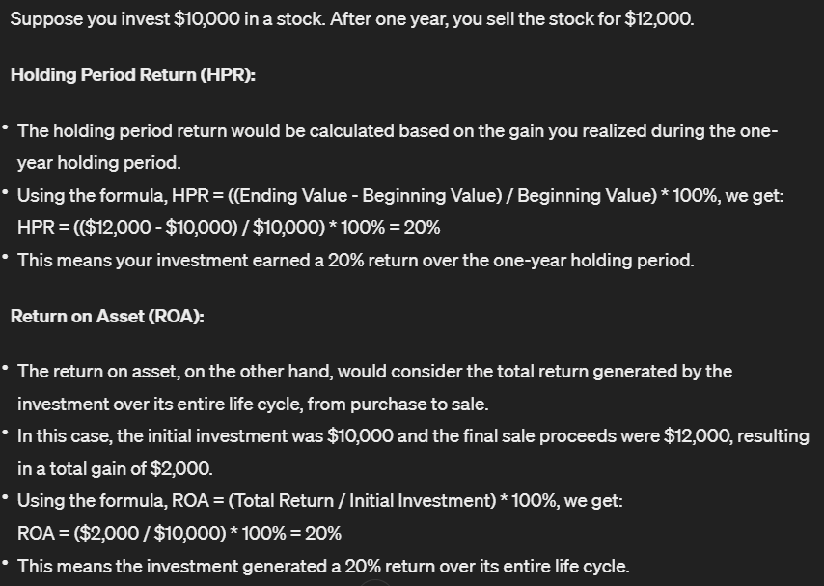

**Beta**: Beta measures the sensitivity of a security's returns to changes in the overall market. A beta of 1 indicates that the security's returns move in line with the market, while a beta greater than 1 suggests higher volatility and risk, and a beta less than 1 indicates lower volatility and risk compared to the market

**Value at Risk (VaR)**: VaR measures the maximum potential loss that an investor could experience with a certain level of confidence over a specific time horizon. It provides an estimate of the worst-case scenario for the security's returns.

Diversification refers to the strategy of spreading investments across multiple assets or securities within a portfolio to reduce overall risk. The goal of diversification is to minimize the impact of individual asset or security performance on the overall portfolio by investing in a variety of assets with different risk and return characteristics. By diversifying, investors can potentially improve their risk-adjusted returns and reduce the volatility of their portfolio.

Here's how diversification helps in reducing risk:

1. Spread of Risk: Diversification spreads investment capital across different asset classes, industries, sectors, and geographic regions. This helps to reduce the impact of adverse events or poor performance in any single investment on the overall portfolio. If one asset or security underperforms, gains in other areas of the portfolio can help offset losses, leading to a smoother overall investment experience.

2. Reduced Volatility: Different assets and securities may respond differently to market conditions and economic events. By holding a diversified portfolio, investors can potentially reduce portfolio volatility because the performance of one asset may not be closely correlated with the performance of others. This helps to stabilize portfolio returns over time and reduces the likelihood of experiencing large fluctuations in portfolio value.

3. Improved Risk-Adjusted Returns: Diversification can potentially improve the risk-adjusted returns of a portfolio. By spreading investments across different assets with varying risk levels, investors can achieve a more optimal balance between risk and return. Diversification allows investors to pursue their investment objectives while managing risk within acceptable levels, leading to a more efficient use of investment capital.

4. Protection Against Specific Risks: Diversification helps protect against specific risks associated with individual assets or sectors. For example, if an investor holds a diversified portfolio that includes stocks from various industries, they are less exposed to risks specific to any single industry, such as regulatory changes, competition, or technological disruptions.

Overall, diversification is a fundamental principle of investment management that helps investors manage risk and build resilient portfolios. By spreading investments across a range of assets, investors can potentially improve the stability and long-term performance of their investment portfolios.

Sure, let's break down these concepts in a simple and clear way:

Money Market:

- The money market is where short-term debt securities (usually less than a year) are traded.

- Financial instruments in the money market include Treasury bills, certificates of deposit (CDs), commercial paper, and repurchase agreements (repos).

- Money market instruments are used by governments, financial institutions, and corporations to manage short-term cash needs.

Capital Market:

- The capital market is where long-term debt and equity securities (more than a year) are bought and sold.

- Financial instruments in the capital market include stocks, bonds, debentures, and derivatives.

- The capital market helps companies raise funds for long-term investments and provides investors opportunities for long-term investment growth.

Types of Capital Market:

1. Industrial Securities Market: Deals with the issue and trading of equity shares and debentures of companies.

2. Government Securities Market: Involves trading of securities issued by the government, including G-secs (Government Securities) and Treasury bills.

Primary Market:

- The primary market is where new securities are issued and sold for the first time.

- Initial Public Offering (IPO) is when a company offers its shares to the public for the first time, raising capital.

Secondary Market:

- The secondary market is where previously issued securities are bought and sold among investors.

- Stock exchanges facilitate trading in the secondary market, allowing investors to buy and sell shares of publicly listed companies.

Call Money:

- Call money refers to short-term loans in the money market, usually lent for one day between banks and financial institutions.

- It helps banks manage their liquidity needs on a daily basis.

Financial Institutions:

- Cooperative Banks: Owned and operated by their members to provide banking services, focusing on local communities.

- Commercial Banks: For-profit institutions that offer a wide range of banking services to individuals, businesses, and governments.

- Non-Banking Financial Institutions (NBFIs): Institutions that provide financial services but do not have a full banking license, such as insurance companies, mutual funds, and pension funds.

Instruments:

- Financial instruments are contracts that represent a value and can be traded. They include stocks, bonds, options, futures, and various types of derivatives.

- Money market instruments are short-term debt securities used for borrowing and lending in the money market.

- Capital market instruments are long-term securities used for raising capital and investment in the capital market.

Sure, let's break down these concepts:

Financial Instruments:

Financial instruments are contracts that represent a financial value and can be traded. They serve as a way for investors to buy, sell, or hedge their investments. Here are some types of financial instruments:

1. Stocks (Equities): Represent ownership in a company and entitle the holder to a share of the company's profits.

2. Bonds: Debt securities issued by governments or corporations to raise capital. Bondholders are creditors and receive periodic interest payments until the bond matures, at which point the principal is repaid.

3. Mutual Funds: Pooled investment vehicles that invest in a diversified portfolio of stocks, bonds, or other assets. Investors buy shares of the mutual fund, which are managed by professional fund managers.

4. Exchange-Traded Funds (ETFs): Similar to mutual funds but traded on stock exchanges like individual stocks. ETFs track an index, commodity, or basket of assets and provide diversification at a lower cost.

5. Derivatives: Financial contracts whose value is derived from an underlying asset, index, or rate. Examples include options, futures, swaps, and forwards.

Financial Services:

Financial services refer to the services provided by financial institutions to individuals, businesses, and governments to manage their financial assets and liabilities. These services include:

1. Banking Services: Deposit-taking, lending, and other financial services offered by banks, such as checking accounts, savings accounts, loans, and mortgages.

2. Investment Services: Services provided by investment banks, brokerage firms, and financial advisors to help clients invest in stocks, bonds, mutual funds, and other financial instruments.

3. Insurance Services: Protection against financial losses due to unforeseen events, such as illness, accidents, or natural disasters. Insurance companies offer various types of insurance policies, including life insurance, health insurance, property insurance, and liability insurance.

4. Wealth Management: Comprehensive financial planning and investment management services provided to high-net-worth individuals and families to help them grow and preserve their wealth.

Types of Capital Market:

1. Industrial Securities Market: Also known as the stock market, where equities (stocks) and corporate bonds are bought and sold. Investors can invest in shares of publicly traded companies to gain ownership and potentially earn dividends and capital appreciation.

2. Government Securities Market: Involves trading of securities issued by the government. This includes:

- Government Securities (G-Secs): Long-term debt securities issued by the government to finance its fiscal deficit. G-Secs include treasury bonds and treasury notes.

- Treasury Bills: Short-term debt securities issued by the government with maturities ranging from a few days to one year. Treasury bills are used to meet short-term financing needs and are sold at a discount to their face value, with the difference representing the interest earned by investors.

Primary Market:

The primary market is where new securities are issued and sold for the first time. Companies raise capital by issuing stocks or bonds to investors directly through initial public offerings (IPOs) or debt offerings. Investment banks often underwrite these offerings and help companies navigate the process.

Secondary Market:

The secondary market is where previously issued securities are bought and sold among investors. This includes stock exchanges where shares of publicly traded companies are traded, as well as over-the-counter (OTC) markets where securities are traded directly between parties without a centralized exchange. Trading in the secondary market allows investors to buy and sell securities after their initial issuance.

Certainly, let's delve into each of these topics:

1. IPO (Initial Public Offering):

- An IPO is the first time a private company offers its shares to the public to raise capital.

- It allows the company to sell ownership stakes (shares) to investors in exchange for capital investment.

- IPOs are often underwritten by investment banks, which help determine the offering price and facilitate the sale of shares to investors.

- Going public through an IPO provides companies with access to additional capital, liquidity for existing shareholders, and increased visibility and credibility in the market.

2. Call Money:

- Call money refers to short-term loans in the money market that are typically lent between banks or financial institutions.

- These loans have a very short duration, often just one day, and are used by banks to manage their short-term liquidity needs.

- Call money rates fluctuate based on demand and supply dynamics in the money market and are influenced by factors such as central bank policies and market conditions.

3. Financial Instruments:

- Financial instruments are contracts or documents that represent a financial asset and can be traded.

- They include various types of securities, such as stocks, bonds, derivatives, and money market instruments.

- Financial instruments serve as investment vehicles that allow investors to allocate capital, manage risk, and earn returns.

4. Money Market Instruments:

- Money market instruments are short-term debt securities that have high liquidity and low risk.

- Examples include Treasury bills (T-bills), certificates of deposit (CDs), commercial paper, repurchase agreements (repos), and short-term government and corporate bonds.

- Money market instruments are typically used for short-term borrowing, lending, and investment by governments, financial institutions, and corporations.

5. Capital Market Instruments:

- Capital market instruments are long-term securities that facilitate the raising of capital and investment for periods exceeding one year.

- They include stocks (equities), bonds (fixed-income securities), mutual funds, exchange-traded funds (ETFs), and derivatives.

- Capital market instruments provide investors with opportunities for long-term investment growth and income generation.

6. Cooperative vs. Commercial Banks:

- Cooperative Banks: Owned and operated by their members (depositors and borrowers) to provide banking services, focusing on serving specific communities or groups.

- Commercial Banks: For-profit institutions that offer a wide range of banking services to individuals, businesses, and governments. They focus on profitability and serving a broad customer base.

7. Non-Banking Financial Institutions (NBFIs):

- NBFIs are financial institutions that provide financial services but do not have a full banking license.

- They include entities such as insurance companies, mutual funds, pension funds, finance companies, and investment banks.

- NBFIs play a crucial role in the financial system by offering specialized services, such as insurance, asset management, and investment banking, complementing the services provided by traditional banks.

**Mod3**

Liquidity ratio analysis involves evaluating a company's ability to meet its short-term financial obligations (thus formulates CURRENT assets and liabilities) using liquidity ratios. These ratios provide insights into the company's ability to convert its assets into cash quickly to cover its short-term liabilities. Here are some common liquidity ratios:

**1. Current Ratio:** This ratio measures the company's ability to meet its short-term liabilities with its short-term assets. It is calculated by dividing current assets by current liabilities. A higher current ratio indicates a stronger ability to cover short-term obligations.

**2. Quick Ratio (Acid-Test Ratio):** The quick ratio is a more stringent measure of liquidity that excludes inventory from current assets, as inventory may not be easily convertible into cash in the short term.

**3. Cash Ratio:** This ratio focuses solely on the company's most liquid assets, specifically cash and cash equivalents, relative to its current liabilities. It provides an even more conservative measure of liquidity.

These liquidity ratios help assess a company's short-term financial health and its ability to withstand financial challenges or unexpected expenses. Higher ratios generally indicate better liquidity, but excessively high ratios may suggest underutilization of assets. It's essential to compare these ratios with industry benchmarks and analyze trends over time for a comprehensive assessment of a company's liquidity position.

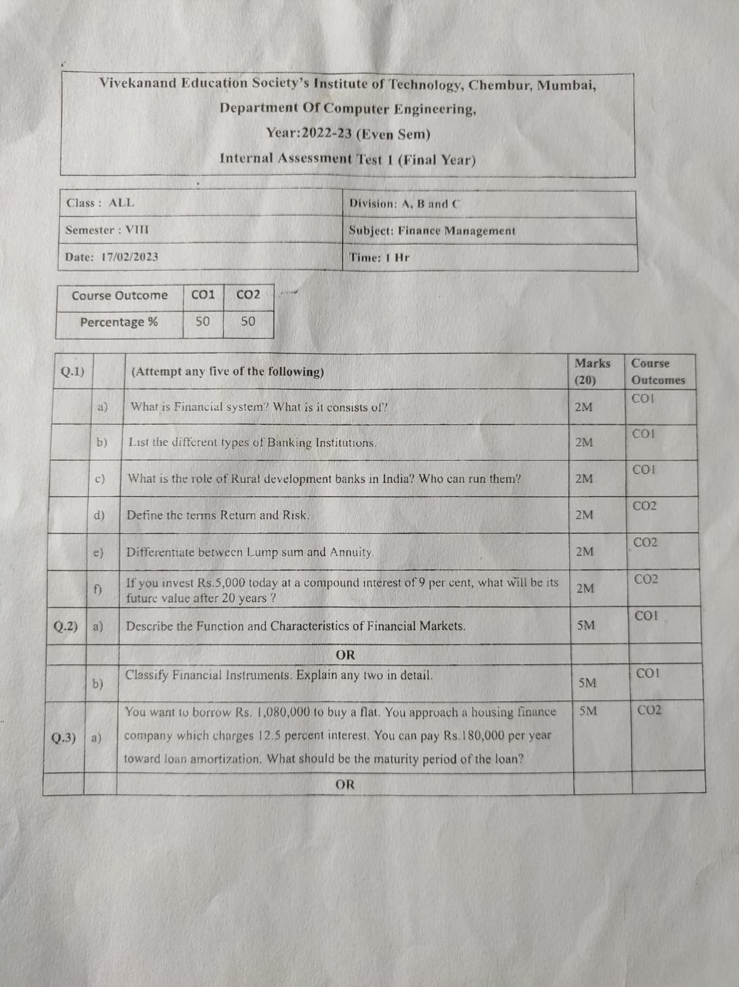

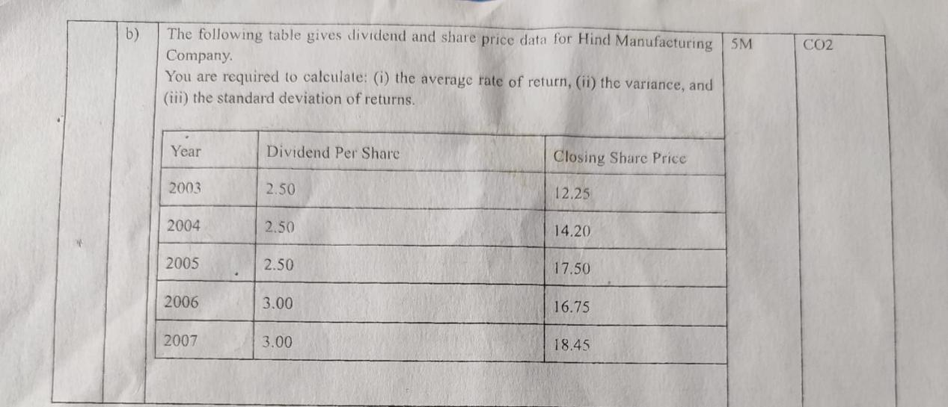

Of course! "Shareholder value" refers to the value that a company creates for its shareholders, who are the owners of the company. When a company's actions result in an increase in shareholder value, it means that the shareholders' investment in the company has become more valuable over time.

In essence, creating shareholder value involves making decisions and taking actions that lead to an increase in the price of the company's stock or an increase in the dividends paid to shareholders. This can be achieved through various means, such as generating profits, achieving growth in revenue and earnings, improving operational efficiency, making strategic investments, and effectively managing risks.

Ultimately, the goal of corporate finance is to maximize shareholder value by making decisions that enhance the financial well-being and long-term prosperity of the company, thereby benefiting its shareholders.

*Overview of Corporate Finance:*

Corporate finance is the field of finance that deals with the financial decisions made by corporations to maximize shareholder value. It encompasses various activities aimed at managing a company's financial resources efficiently and effectively.

*Objectives of Corporate Finance:*

1. *Maximizing Shareholder Wealth:* The primary objective of corporate finance is to increase the wealth of shareholders through wise financial decision-making.

2. *Value Creation:* Corporate finance aims to create value for shareholders by investing in projects that generate positive returns and optimizing the company's capital structure.

3. *Risk Management:* Another objective is to manage financial risks effectively to safeguard the interests of shareholders and other stakeholders.

*Functions of Corporate Finance:*

Corporate finance involves three main functions:

1. *Investment Decision:* This function involves determining which projects or investments the company should undertake to achieve its strategic objectives. It includes evaluating potential investment opportunities, analyzing their risks and returns, and selecting the most profitable ones.

2. *Financing Decision:* The financing decision revolves around determining how the company should raise funds to finance its investment projects. This includes choosing between debt and equity financing, issuing stocks or bonds, and structuring the company's capital to optimize its cost of capital and minimize the weighted average cost of capital (WACC).

3. *Dividend Decision:* The dividend decision focuses on how much of the company's earnings should be distributed to shareholders as dividends and how much should be retained for reinvestment in the business. This decision is influenced by factors such as the company's profitability, growth opportunities, and shareholder preferences.

By effectively managing these functions, corporate finance aims to enhance the long-term financial performance and sustainability of the company while maximizing shareholder wealth.

*Overview of Financial Statements:*

Financial statements are formal records of a company's financial activities, performance, and position. They provide valuable insights into the financial health and operational efficiency of a business. The three main types of financial statements are:

1. *Balance Sheet:* This statement provides a snapshot of a company's financial position at a specific point in time, typically at the end of a reporting period (such as a quarter or fiscal year). It presents the company's assets, liabilities, and shareholders' equity, showing how assets are financed (either through debt or equity).

2. *Profit and Loss Account (Income Statement):* The income statement summarizes a company's revenues, expenses, gains, and losses over a specific period, such as a quarter or fiscal year. It shows the company's profitability by calculating its net income (revenues minus expenses) and provides insights into its operating performance.

3. *Cash Flow Statement:* This statement tracks the flow of cash into and out of a company during a specific period, typically a quarter or fiscal year. It categorizes cash flows into operating activities (such as sales and expenses), investing activities (such as purchases of assets), and financing activities (such as borrowing or repaying debt). The cash flow statement helps assess a company's liquidity, solvency, and ability to generate cash.

*Balance Sheet:*

The balance sheet is divided into two main sections:

1. *Assets:* Assets represent what the company owns or controls and include tangible assets (such as property, plant, and equipment), intangible assets (such as patents and trademarks), investments, and cash and cash equivalents.

2. *Liabilities and Shareholders' Equity:* Liabilities represent what the company owes to external parties, such as loans, accounts payable, and accrued expenses. Shareholders' equity represents the residual interest in the company's assets after deducting its liabilities and reflects shareholders' ownership in the company.

*Profit and Loss Account (Income Statement):*

The income statement typically includes the following components:

1. *Revenues:* Revenues are the amounts earned from the sale of goods or services during the reporting period.

2. *Expenses:* Expenses are the costs incurred by the company in generating revenues, such as operating expenses, cost of goods sold, depreciation, and interest expenses.

3. *Gains and Losses:* Gains and losses represent non-operating items that affect the company's profitability, such as gains or losses from the sale of assets or investments.

The bottom line of the income statement shows the company's net income or net loss, which is calculated by subtracting total expenses from total revenues.

*Cash Flow Statement:*

The cash flow statement is divided into three main sections:

1. *Operating Activities:* This section includes cash flows from the company's primary business operations, such as cash receipts from sales and cash payments for expenses.

2. *Investing Activities:* This section includes cash flows related to the purchase or sale of long-term assets, investments in securities, or loans made to other entities.

The dividend relevance theory suggests that investors consider dividends when evaluating a company's value. They view dividends positively as a signal of financial health and stability, influencing stock prices. In contrast, the dividend irrelevance theory posits that investors are indifferent to dividends; they focus on total returns, regardless of how earnings are distributed, as they can replicate desired cash flows through selling shares if needed.

after fulfuling upcoming capital expenditure requirements, the left over money = residual payout

firms, usually, create a ‘Reserve for Dividend Equalisation’ to enable them to pay the fixed dividend even in the year when the

earnings are not sufficient or when there are losses.

if regularly distribute ni kiye dividends, sh might have to pay greater tax on the bulk dividend payout. regularly milne pe trust and day to day short term funds mil jate h. shows proof of strength ki dekh i have paise to sh

The payment of dividends results in cash outflow from the firm. A firm may have adequate earnings, but it may not have sufficient cash to pay dividends. It is, therefore, important for the management to take into account the cash position and the overall liquidity position of the firm before and after payment of dividends while taking the dividend decision.

build up/retain earnings to absorb shock/loss

retain for reinvestment for growth/ expansion activities or other financial needs of company.

capital gain mtlb khareeda share 20 me becha 40 me. so hold em for a while then selll ur capital investment

3. *Financing Activities:* This section includes cash flows related to the company's financing activities, such as issuing or repurchasing equity, borrowing or repaying debt, and payment of dividends.

The bottom line of the cash flow statement shows the net increase or decrease in cash and cash equivalents during the reporting period, which helps assess the company's liquidity and cash management.

While ratio analysis is a valuable tool for evaluating a company's financial performance, it has several limitations that should be considered:

1. *Dependence on Historical Data:* Ratio analysis relies on historical financial data, which may not accurately reflect current or future market conditions, economic trends, or changes in business strategy.

2. *Limited Comparison:* Ratios are most useful when comparing a company's performance over time or against industry benchmarks. However, differences in accounting methods, industry norms, and company size can limit the usefulness of comparisons.

3. *Not Accounting for External Factors:* Ratio analysis does not consider external factors such as changes in regulations, technological advancements, competitive pressures, or macroeconomic conditions, which can significantly impact a company's financial performance.

4. *Subjectivity:* The interpretation of ratios can be subjective, as there is no universally accepted standard for what constitutes good or bad performance. Different analysts may interpret the same ratios differently, leading to inconsistent conclusions.

5. *Manipulation of Financial Statements:* Companies may manipulate their financial statements to improve certain ratios artificially, such as by changing accounting methods, deferring expenses, or recognizing revenue prematurely. This can distort the true financial position of the company.

6. *Inflationary Effects:* Inflation can distort the values of financial ratios, especially those involving historical cost accounting methods, making it difficult to accurately assess a company's performance over time.

7. *Focus on Quantitative Data:* Ratio analysis focuses primarily on quantitative financial data and may overlook qualitative factors such as management quality, brand reputation, innovation, and customer satisfaction, which can also influence a company's performance.

8. *Industry Differences:* Different industries have unique operating characteristics and financial metrics, making it challenging to compare ratios across industries. What may be considered a good ratio in one industry may not hold true for another.

Despite these limitations, ratio analysis remains a valuable tool for assessing a company's financial health, identifying trends, and making informed investment or lending decisions. However, it should be used in conjunction with other financial analysis techniques and qualitative assessments to gain a comprehensive understanding of a company's performance and prospects.

They assures a claim of the repayment of a invested sum of money at the end of a specified period together

with interest or dividend if applicable. Therefore, the are also called as financial securities.

There are two categories of financial securities,

– Primary or Direct securities.

Primary Securities: These are securities directly issued by the ultimate borrower to the ultimate

investor.

For example, shares and debentures issued directly to the public

beta less than 1, less risk

Distribution of profits to shareholders or reinvest all earnings baack into business

In form of cash, a certain amt on certain time

Amt depends on finanacial position of the company

Time is decided using a policy

Helps attaining desired capital structure for the company.

Tells how much dividend income wil the equity sh will earn

Hence make a dividend policy, build trust w sh and make expectation vs reality dividend payout clear.

Increasing dividend payout will mean company is expecting profits.

Changing dividend payout changes stock share prices and value

A good policy balanced will attrack big financial institutional investors.

* Residual Dividend Policy: Here, dividends are paid from the residual earnings left after financing capital expenditures, working capital, and any other investment needs.
* Stable Dividend Policy: This policy aims to provide shareholders with a predictable dividend payout, usually by maintaining a constant dividend per share over time. It's often favored by mature companies with stable earnings.
* Constant Payout Ratio Policy: Under this policy, a fixed percentage of earnings is paid out as dividends. As earnings fluctuate, so do dividends.
* Regular Dividend Plus Extra Dividend Policy: This policy involves paying a regular dividend along with an extra dividend whenever the company's earnings are exceptionally high.
* Irregular: company has no schedule planned for distribution or even a fixed amt. It is to discretion of management
* No dividend policy: company retains all profits and not distribution of profit

Factors affecting dividend ratio:

1. Profitability
2. C.fs / financial state of company
3. Future investments karni hogi toh inko dividend payment postpone or decrease and reinvest in em: for growth stage companies

No investment oppurtunity: payouts bigger. In a mature stage of a business

1. Law compliance regulation as per Companies act 2013, lays rules for distribution of dividends
2. Sh’s expectations line up
3. Tax implication influences it , inflation
4. If company has a stability of earnings, no fluctuations: larger dividend payout

If periodic investment required, divident payout kept low for uncertainity.

1. Contractual restrictions: loan agreements with lenders restricts dividend payment to sh. Comply w these restrictions

Fixed assets refer to tangible assets held by a company or institution for long-term use in generating income.

Organized non-banking institutions are structured entities that provide financial services but are not regulated as traditional banks. Examples include credit unions, microfinance institutions, and cooperatives.

Unorganized non-banking institutions typically refer to informal or unregulated financial entities, such as money lenders,

Scheduled banks are those financial institutions listed in the Second Schedule of the Reserve Bank of India Act, 1934. They are subject to the regulations of the Reserve Bank of India (RBI) and are eligible to receive deposits from the public.

Internal finance+ retained earnings

Balance firms need for funds for growth and sh’s desire of returns

