AIM :

Write shell scripts Display current shell, home directory, operating system type, current path setting, current working directory.

THEORY :

Basic unix commands:

1. who : The ‘$ who’ command displays all the users who have logged into the system currently.As shown above on my system I am the only user currently logged in.The thing tty2 is terminal line the user is using and the next line gives the current date and time

$ who

Output: harssh tty2 2017-07-18 09:32 (:0)

2. pwd : The ‘$pwd’ command stands for ‘print working directory’ and as the name says,it displays the directory in which we are currently (directory is same as folder for Windows OS users).

In the output we are harssh directory(folder for Windows OS that are moving to Linux),which is present inside the home directory

1. Built-in pwd (pwd)
2. Binary pwd (/bin/pwd):

pwd -L: Prints the symbolic path.

pwd -P: Prints the actual path.

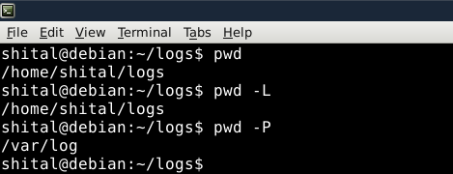

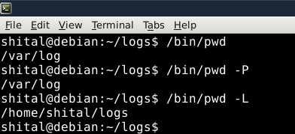

$ pwd

Output: /home/harssh

3. mkdir : The ‘$ mkdir’ stands for ‘make directory’ and it creates a new directory.We have used ‘$ cd’ (which is discussed below) to get into the newly created directory and again on giving ‘$ pwd’ command,we are displayed with the new ‘newfolder’ directory.

$ mkdir newfolder

$ cd newfolder

$ pwd

Output: /home/harssh/newfolder

4. rmdir : The ‘$ rmdir’ command deletes any directory we want to delete and you can remember it by its names ‘rmdir’ which stands for ‘remove directory’.

$ rmdir newfolder

5. cd : The ‘$ cd’ command stands for ‘change directory’ and it changes your current directory to the ‘newfolder’ directory.You can understand this a double-clicking a folder and then you do some stuff in that folder.

cd /: this command is used to change directory to the root directory, The root directory is the first directory in your filesystem hierarchy.

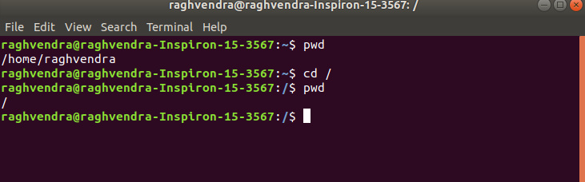

Above, / represents the root directory.

cd dir_1/dir_2/dir_3: This command is used to move inside a directory from a directory

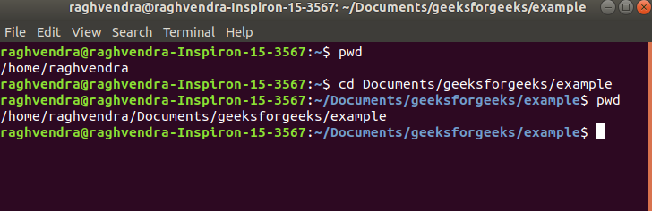

cd ~: this command is used to change directory to the home directory.

cd : this command also work same as cd ~ command.

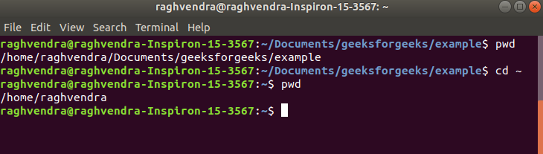

cd .. : this command is used to move to the parent directory of current directory, or the directory one level up from the current directory. “..” represents parent directory.

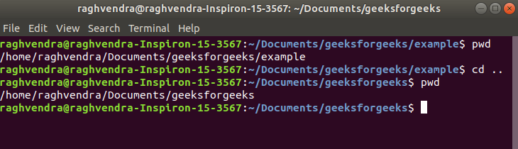

cd “dir name”: This command is used to navigate to a directory with white spaces.Instead of using double quotes we can use single quotes then also this command will work.

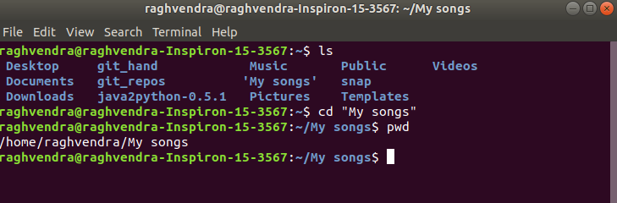

$ cd newfolder (assuming that there is a directory named 'newfolder' on your system)

6. ls : The ‘ls’ command simply displays the contents of a directory.

$ ls -a : To show all the hidden files in the directory, use ‘-a option’. Hidden files in Unix starts with ‘.’ in its file name.It will show all the files including the ‘.’ (current directory) and ‘..’ (parent directory).

Display All Information About Files/Directories Using ls -l

$ ls -l : To show long listing information about the file/directory.

$ ls

Output: Desktop Documents Downloads Music Pictures Public Scratch Templates Videos

7. touch : The ‘$ touch’ command creates a file(not directory) and you can simple add an extension such as .txt after it to make it a Text File.

$ touch example

$ ls

Output: Desktop Documents Downloads Music Pictures Public Scratch Templates Videos example

Note: It is important to note that according to the Unix File structure, Unix treats all the stuff it has as a ‘file’, even the directories(folders) are also treated as a file.You will get to know more about this as you will further use Linux/Unix based OS

8. cp : This ‘$ cp ‘ command stands for ‘copy’ and it simply copy/paste the file wherever you want to.In the above example, we are copying a file ‘file.txt’ from the directory harssh to a new directory new.

$ cp /home/harssh/file.txt /home/harssh/new/

cp Src_file Dest_file

cp Src_file1 Src_file2 Src_file3 Dest_directory

First and second syntax is used to copy Source file to Destination file or Directory.

Third syntax is used to copy multiple Sources(files) to Directory.

1. mv : The ‘$ mv’ command stands for ‘move’ and it simply move a file from a directory to anothe directory.In the above example a file named ‘file.txt’ is being moved into a new directory ‘new’

mv stands for move. mv is used to move one or more files or directories from one place to another in a file system like UNIX. It has two distinct functions:

(i) It renames a file or folder.

(ii) It moves a group of files to a different directory.

$ mv /home/harssh/file.txt /home/harssh/new

mv [Option] source destination

10. rm : The ‘$ rm ‘ command for remove and the ‘-r’ simply recursively deletes file. Try ‘$ rm filename.txt’ at your terminal 🙂

$ rm file.txt

11. chmod : The ‘$ chmod’ command stands for change mode command.As there are many modes in Unix that can be used to manipulate files in the Unix environment.Basically there are 3 modes that we can use with the ‘chmod’ command

1. +w (stands for write and it changes file permissions to write)

2. +r (stands for read and it changes file permissions to read)

3. +x (generally it is used to make a file executable)

$ chmod +w file.txt

$ chmod +r file.txt

$ chmod +x file.txt

In Unix-like operating systems, the chmod command is used to change the access mode of a file.

The name is an abbreviation of change mode.

Syntax :

chmod [reference][operator][mode] file...

The references are used to distinguish the users to whom the permissions apply i.e. they are list of letters that specifies whom to give permissions. The references are represented by one or more of the following letters:

Reference Class Description

u owner file's owner

g group users who are members of

the file's group

o others users who are neither the

file's owner nor members of

the file's group

a all All three of the above, same as ugo

The operator is used to specify how the modes of a file should be adjusted. The following operators are accepted:

Operator Description

+ Adds the specified modes to the

specified classes

- Removes the specified modes from

the specified classes

= The modes specified are to be made

the exact modes for the specified

classes

Note : Putting blank space(s) around operator would make the command fail.

The modes indicate which permissions are to be granted or removed from the specified classes. There are three basic modes which correspond to the basic permissions:

r Permission to read the file.

w Permission to write (or delete) the file.

x Permission to execute the file, or, in

the case of a directory, search it.

Types of permissions which we will be changing using chmod command :

In linux terminal, to see all the permissions to different files, type ls -l command which lists the files in the working directory in long format. The figure below shows an example to use ls -l and its output :

Let us take a look at above figure. To make things easy to understand some columns and rows are eliminated and extra spaces are added to the permissions column to make it easier to read as shown below:

- rw- rw- r-- mik mik assgn1_client.c

- rw- rw- r-- mik mik assgn1_server.c

d rwx rwx r-x mik mik EXAM

- rw- rw- r-- mik mik raw.c

- rwx r-x r-x mik mik header.sh

... so on...

The very first column represents the type of the file i.e. is it a normal file or a

directory where d represents a directory and – represents a normal file.

The first set three letters after the file type tell what the Owner of the file, have permissions to do. For example: In assgn1_client.c, has owner’s permission as rw-, which means the owner mik can only read(r) and write(w) the file but cannot execute(x).

Note: The 3rd and 4th columns represents the name of the owner of the file and the group to which the owner belongs respectively.

The next three letters after the user’s permission are the group’s permissions.

For example: header.sh has group permissions as r-x, which means Other people in the mik group can not write(w) the header.sh script but can only read(r) or execute(x) it.

Note that when a directory has the x set, this takes the special meaning of “permitted to search this directory”.

The last three letters in the permissions column tell us what the “others” may do. The general practice is to protect the files from external access so that others can’t write any files or directories. They may read(r) or execute(x) it. For example: The assgn1_client.c has others permission as r- – which means it can only be read by other(external) access but cannot be written or executed by them.

Now, let us see how chmod command can be used to change the access mode of a file.

Example 1 :

Let’s change the assgn1_client.c permission so that the owner cannot write(w) in the file but can only read it.

BEFORE: -rw-rw-r-- mik mik assgn1_client.c

COMMAND: chmod u=r assgn1_client.c

AFTER: -r--rw-r-- mik mik assgn1_client.c

Before :

After :

Example 2 :

Let’s restrict the permission such that the user cannot search the directory EXAM.

BEFORE: drwxrwxr-x mik mik EXAM

COMMAND: chmod u=rw EXAM

AFTER: drw-rwxr-x mik mik EXAM

After applying the chmod u=rw EXAM command, the user (owner) cannot change the directory. If the user tries to change the directory, then it shows the message “Permission denied” as shown in the figure below :

12. cal : The ‘$ cal’ means calendar and it simply display calendar on to your screen.

$ cal

Output : July 2017

Su Mo Tu We Th Fr Sa

1

2 3 4 5 6 7 8

9 10 11 12 13 14 15

16 17 18 19 20 21 22

23 24 25 26 27 28 29

30 31

13. file : The ‘$ file’ command displays the type of file.As I mentioned earlier Linux treats everything as a file so on executing the command file on a directory(Downloads) it displays directory as the output

$ ls

Output: Desktop Documents Downloads Music Pictures Public Scratch Templates Videos

$ file Downloads

Output: Downloads: directory

14. sort : As the name suggests the ‘$ sort’ sorts the contents of the file according to the ASCII rules.

$ sort file

15. grep : grep is an acronym for ‘globally search a regular expression and print it’.The ‘$ grep’ command searches the specified input fully(globally) for a match with the supplied pattern and displays it.

In the example, this would search for the word ‘picture’ in the file newsfile and if found,the lines containing it would be displayed on the screen.

$ grep picture newsfile

16. man : The ‘$ man’ command stands for ‘manual’ and it can display the in-built manual for most of the commands that we ever need.In the above example, we can read about the ‘$ pwd’ command.

$ man pwd

17. lpr : The ‘$ lpr’ command send a file to the printer for printing.

$ lpr new.txt

18. passwd : The ‘$ passwd’ command simply changes the password of the user.In above case ‘harssh’ is the user.

$ passwd

Output: Changing password for harssh.

(current) UNIX password:

1. clear : The ‘$ clear’ command is used to clean up the terminal so that you can type with more accuracy

….……………………………………………………………………………………………………………………………………………………….

EXP 04

….……………………………………………………………………………………………………………………………………………………….