OS

LINUX UBUNTU OS SHELL SCRIPTING

Shell : Interprets user commands which are directly entered by user or are read from shell script or shell program. There are different shell terminals , we will learn about bash shell.

To search what shell types my OS supports , use this command :

Cat /etc/shells

Bash means born again shell

To see where bash is located , use this command :

Which bash

Clear command will clear the history of all commands.

After installing vscode

Go to file->open folder->either make a new folder or select one. Click on ok on top right and it gets opened in vscode.

Run the file in vscode terminal .

cd Desktop/ cd Desktop cd hello/

Code code .

These above 2 commands will open vscode from command prompt

When u run the file from command prompt , it says permission denied because it was created using touch . hence it has only read and write permission and not execute permission.

Before ls -al command resulted in -rw-rw-r--

Now after the permissions are changed , ls -al gives -rwxrwxr

PROCESSES CURRENLT RUNNING

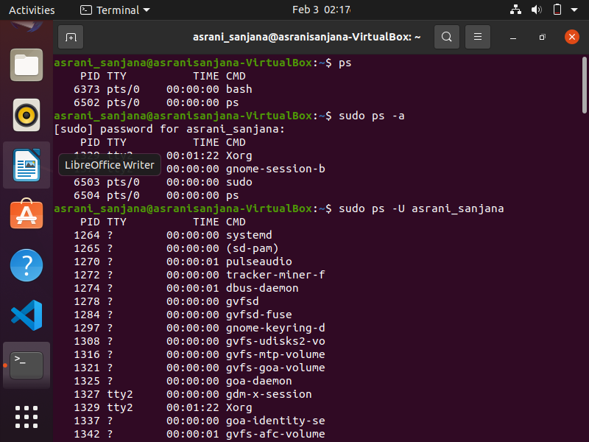

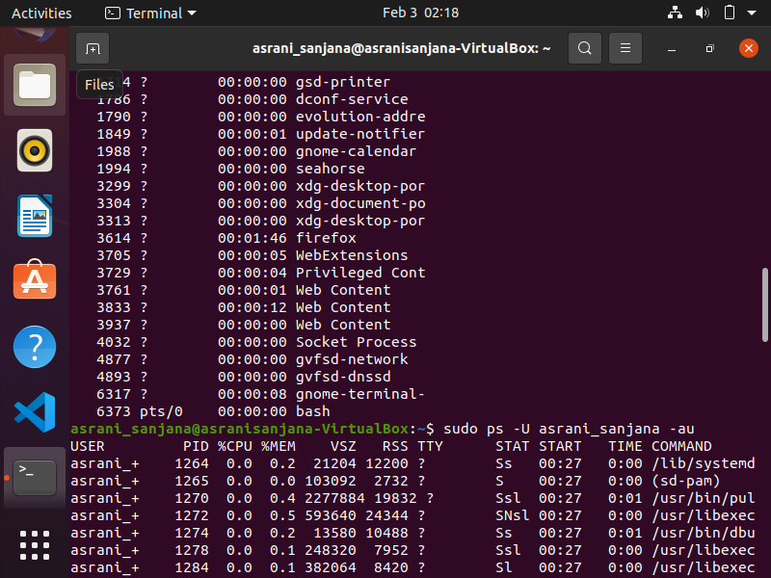

DISPLAY TOP 10 PROCESSES IN DESCENDING ORDER.

DISPLAY PROCESSES WITH HIGHEST MEMORY USAGE.

(highest values first -)

ps aux : for currently running processes.

sort -nk +4 : 4 (coumn no.) is memory usage in ps aux command

tail : is last one

ps aux according to process id(lower to higher number)

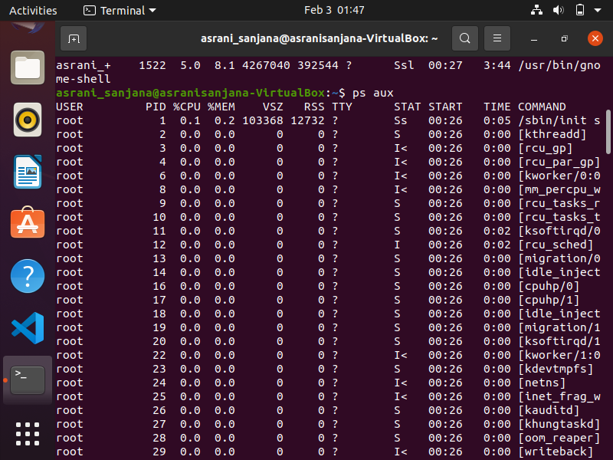

ps aux --sort -rss highest to lowest basis of rss

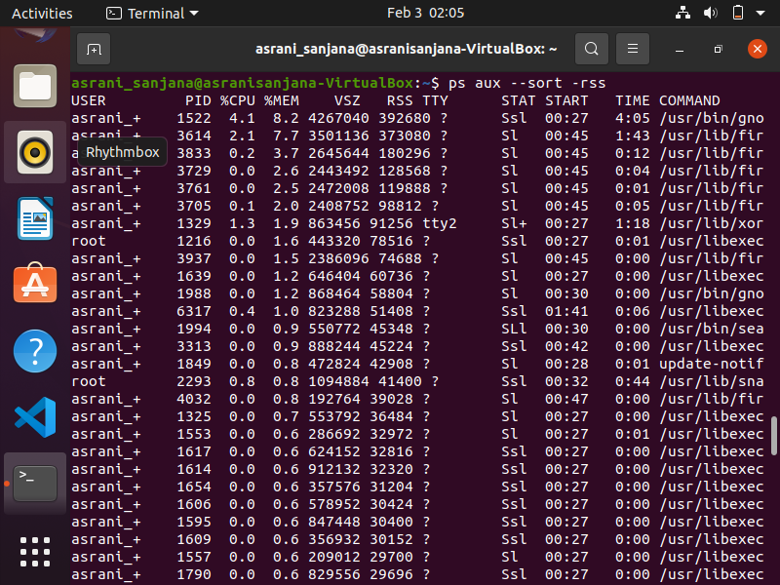

ps aux | sort -nk +4 | tail lowest to highest basis of memory usage

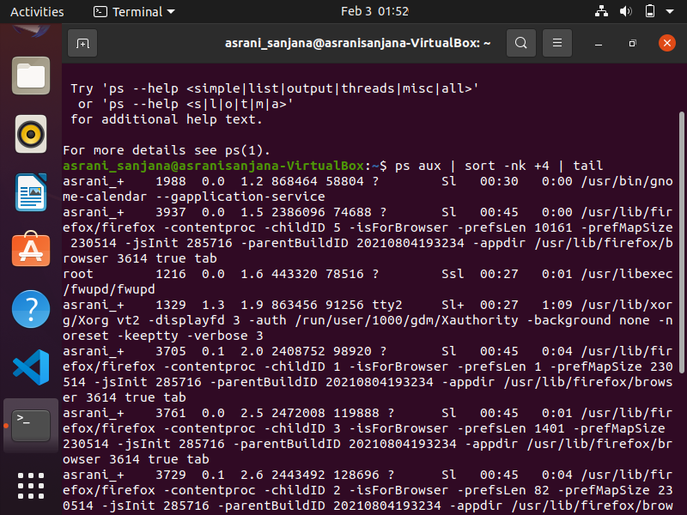

Top 2 highest:

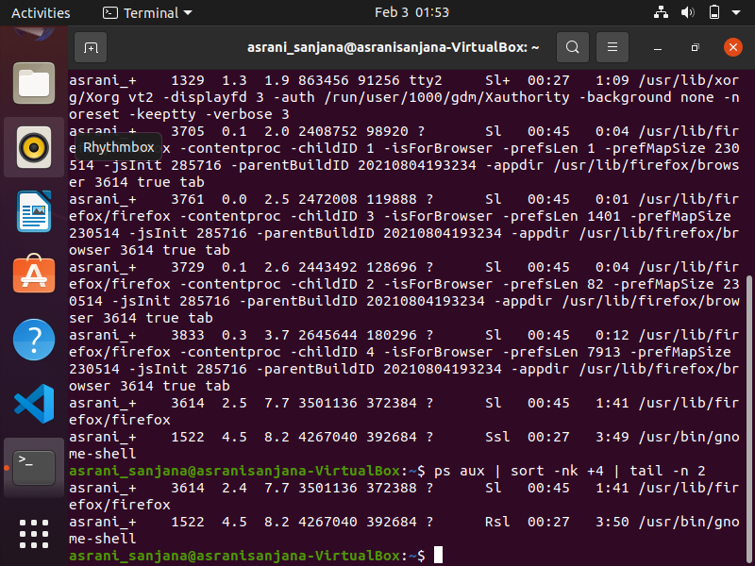

$ ps aux --sort=-%mem highest to lowest

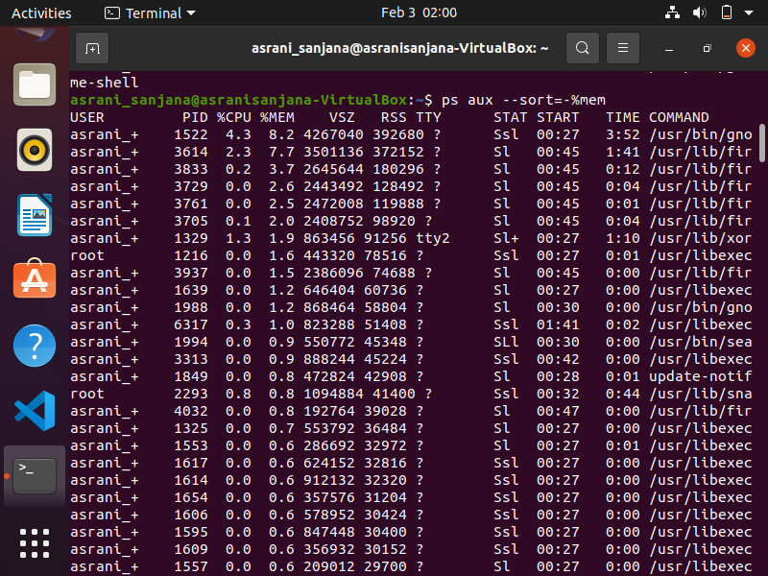

$ ps aux --sort=%mem Lowest to highest memory

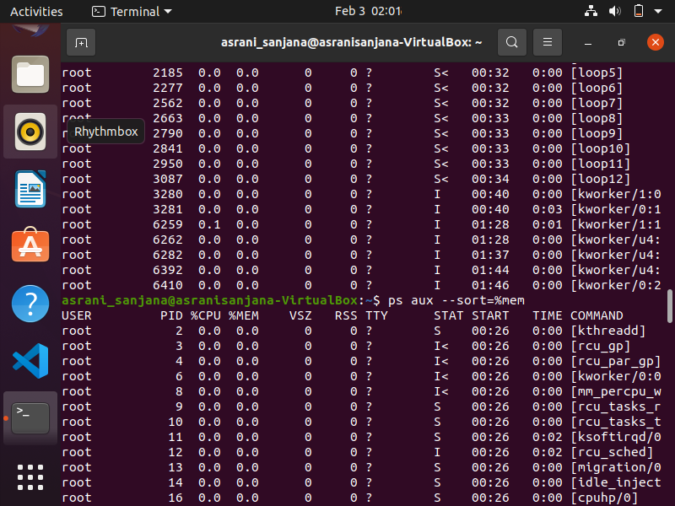

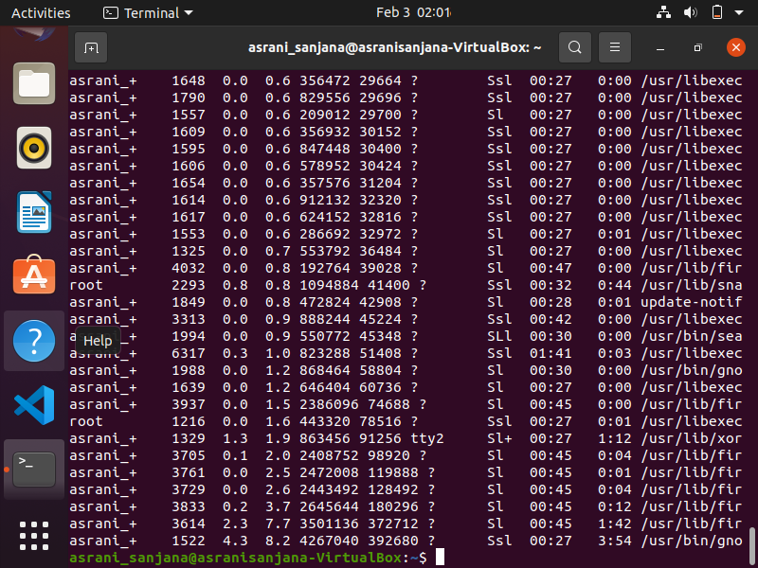

DISPLAY CURRENT LOGGED IN USER , LOG NAME & NUMBER OF USERS CURRENTLY LOGGED IN.

DISPLAY CURRENT SHELL , HOME DIRECTORY , OPERATING SYSTEM TYPE , CURRENT WORKING DIRECTORY.

DISPLAY KERNEL VERSION(3 WAYS)

5 KERNEL VERSION

15 IS MAJOR REVISION

0 IS MINOR REVISION

28 IS BUG FIX

3rd commands opens a nano editor . press control x to exit it.