A spider or crawler which is a component of a SE gathers listings by

automatically "crawling" the web

⚫The spider follows links to web pages, makes copies of the pages and

stores them in the SE’s index

⚫Based on this data, the SE then indexes the pages and ranks the websites

serp direct propn to TRAFFIC

LOCAL AND GLOBAL SE

⚫Local search engines are embedded within a

specific website and only search the content of that

website (sake of scope)

1. web crawl , index, search

2. directories (submission to google)

3. Metasearch Engines

Google Fusion Tables is a web service to geo-tag, store, share,

query, and visualize tabular business data overlaid on Google

Maps.

Social Media Data Driven Location Analytics

● Recommendation Purposes

● Customer Segmentation -Tweepsmap (https://tweepsmap.com/), can be used to geo-locate your

Twitter followers by country, state, or city.

● Advertisement-Location-based advertisement allows targeted marketing and promotion campaign

mostly delivered through mobile devices to reach specific target audiences.

● Information Request- Based on their current location, customers can request a product, service, or

resource (e.g., the nearest coffee shop, restaurant, or parking lot).

● Alerts - Location data can be used to send and receive alerts and notifications, such as sales and

promotion alerts traffic congestion alerts, speed limit warnings, and storm warnings etc.

● Search and Rescue - Location data is vital in search and rescue operations e.g. disaster

management.

● Navigation - Mobile and GPS-based navigation services and apps can help users find addresses. An

example of this is the BE-ON-ROAD app for Android devices, which offers offline turn-by-turn GPS

navigation.

Two common sources:

• GPS

• IP

physical maps of imagica vs online

Examples of how this can be used include recommending the nearest convenience store or

taxi, or making decisions about the best potential location for a business warehouse.

business driven locn analytics vs sm based

Search engine analytics can be used to track the effectiveness of SEO efforts and guide future SEO strategies to improve their website's performance by showing up more in results

SERPs(Search Engine Results Page) have both organic and nonorganic results, with organic resultsbeing based on relevance to the user's query and nonorganic results being paid advertisements. tell website's ranking on a SERP by its PageRank

indexing: labelling in such a way that easier to store and grp

searching: using keywords in query

Local search engines are embedded within a specific website and only search

the content of that website

● Global search engines search the entire web and can be localized to specific

websites

learn abt impact of weather on search trends, trending events, social media, new product launch, advertising campaigns, seasonality, news event. Compare search volumes for different languages.

-------------------

Based on its scope, location analytics can be broadly classified

into two categories:

1) Business data-driven location analytics ( recommending the nearest

convenience store or taxi )

2) Social media data- driven location analytics: OFFER DISCOUNT NOTIF, FUN FRI SALES, R.S., cust segmentation (cny, indians like what content, canadian indians) , ad

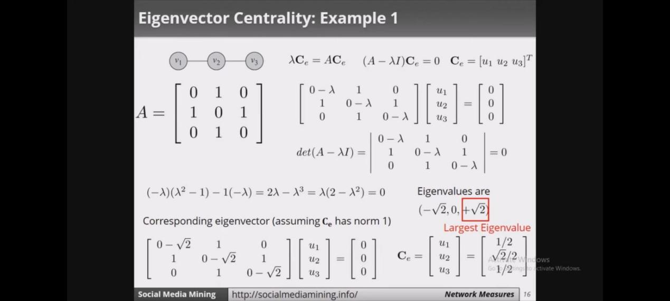

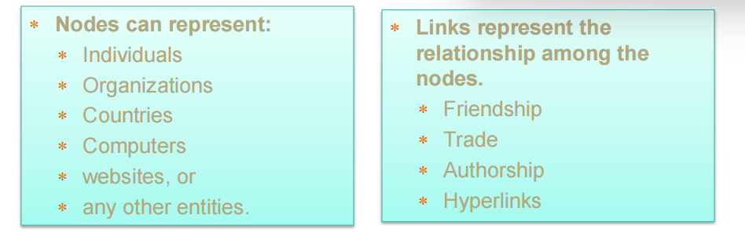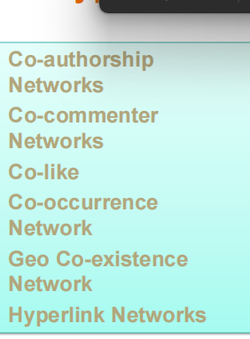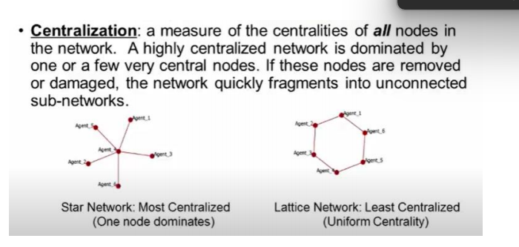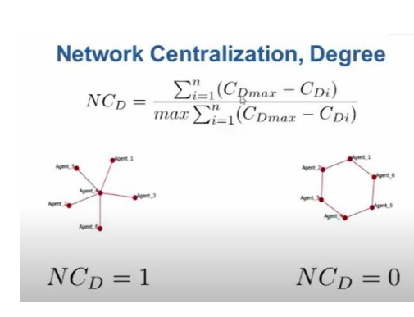

STAR VS RING 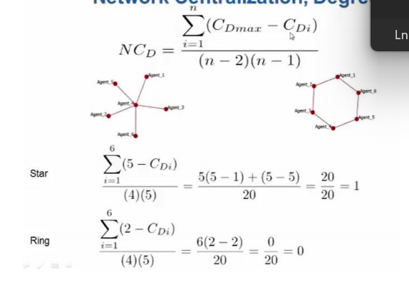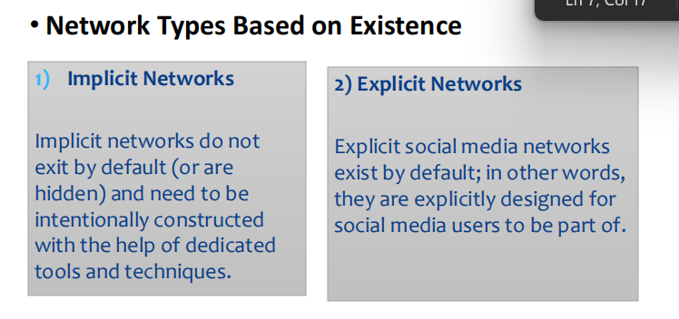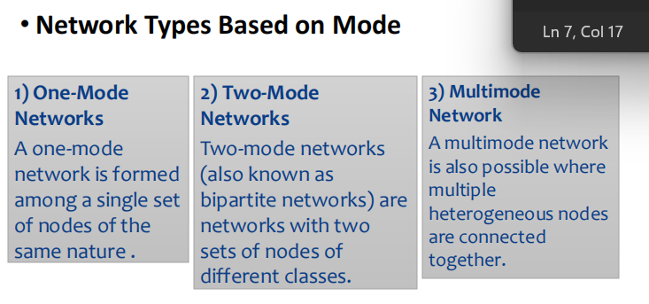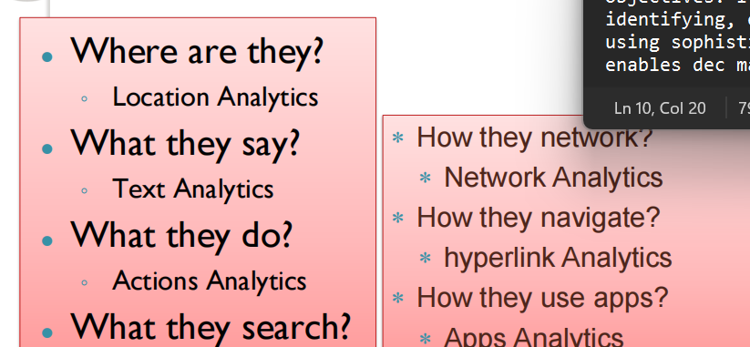

geospatial or location analytics

predictive analysis on a solution to a problem or possible problems and solutions

brand24 pe projs bana keyboard based

Google Trends is a website by Google

that analyzes the popularity of top search

queries in Google Search across various

regions and languages

Varieties of text mining algorithms are applied to the text, such as:

• Clustering similar non overlapping grps

• Association

• Classification... similarity index. email as spam

• predictive analysis, and

• sentiment analysis

• Association or association mining is a data-mining technique used to determine the probability of the cooccurrence of items in a collection of documents. The elationships between cooccurring items are expressed as association rules.

actions are symobollic reactions and expressions

# unique visitor

# left after this

# stayed for this much time

Common Social Media Actions

•Uploading and Downloading

• Endorsement is a features of social media that lets

people endorse and approve other people, products,

and services.

links can be REFERENTIAL FOR NAVIGATION.. go back to home

or INFORMATIONAL.... click here for more details

citation analysis

hyperlink analytics: envi which is in out

and link imapact and diagnosis )tool(

embedded links

webometric H VOSONLINK ANALYSIS: investigate multiplexity

relation bw 2 link types eg. friends vs enemy

co occurence. both brands were forte under 30

co author

co commenter co liker

geo co existence

Social Media Analytics is the art and science of extracting valuable hidden insights from vast amounts of semistructured and unstructured social media data to enable informed and insightful decision making. It is also an art, interpreting and aligning the insights gained with business goals and objectives. It is a science, as it involves ystematically identifying, extracting, and analyzing social media data using sophisticated tools and techniq

enables dec making

traditional data is less volume, specifically fofr 1 domain, formal, less sharing, shared limited within org, structured, fixed, for all.

stats

active sm users

growth in no of active users

avg daily time spent on sm

what device used for surfing: lappy pc phone tablet

crowd source ideas

enhance brand loyalty

reach, engagement, presence, exposure

the forbidden triad

if a and b besties

b and c besties

high possiblitly that a and c atleast know eo

nw analysis tells how resouces flow within a grp of people

1 degree egocentric meaning: nodes only d is connected to

1.5 is when u want to see d's connections a d's neighbours

Paths are used to determine a graph property called connectedness

Strongly connected graphs - every vertex is reachable from every

other vertex.

Weakly connected - If a path cannot be found between all pairs of nodes using the direction of the edges, but paths can be found if the directed edges are treated as undirected, then the graph is called weakly connected.

A bridge is an edge that connects two otherwise separate groups of nodes in the network.a bridge is an edge that, if removed, will increase the number of connected components in a graph

The degree of a node is the number of edges connected to that node. (undirected)

Directed graphs: in-degree (number of edges coming into the node) and out-degree (number of edges originating from the node going outward to other nodes)

degree distribution plot: degree on x, fraction on y

number of possible edgeS: no of edges the node COULD connect to (POTENTIAL CONNECTIONS)

vs

is connected to

is density

since social relationships are complicated, tie strength to determine intensy and strngeth of relationship

● The density of an egocentric network is sometimes referred to as the local clustering coefficient.

dense: a lot of my friends know eo

we remove the ego node as we want to calcualet the relationship between my friends. to see if they know eo

higher degree -> more central node is

importance of a node in connecting others

Betweenness centrality measures how important a node is to the shortest paths through the network

gives points of global influence

ev centrality tells abt nodes importance while keeping in consideration his friends importance as well

closer nodes dont have to travel farther to reach eo

fast communication bw em

cohesion or connectivity: remove a vertex till u get disconnected graph

centralization:

hexagon vs star

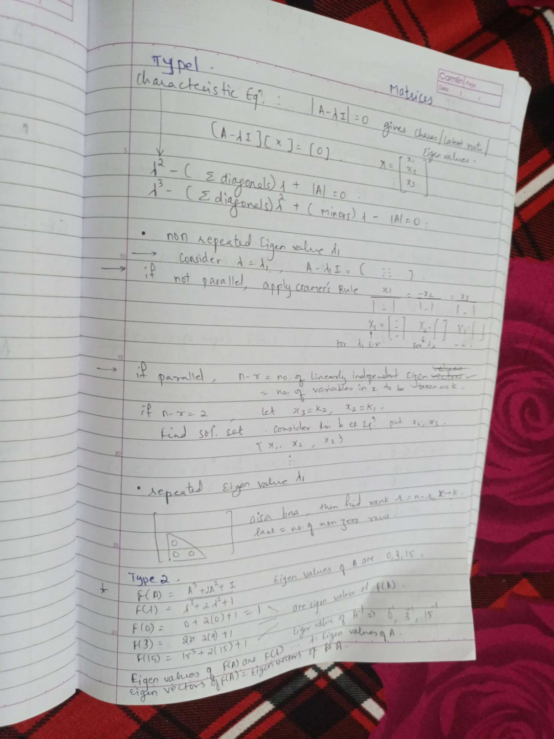after tie strength comes the trust part

you do things u wont do w people u don't trust

imbalanced trust

One trusted other more

for one, helping one another once is enough

i trust u, but would i let u do my operation

subjective

trust w personal property

secrets

emotional support

physical safety

The seven layers of SMA include listening, capturing, measuring, analyzing, reporting,

predicting, and engaging.

traditional focuses on structured data

sma focuses on unstructured

tie strength

refers to the intensity or closeness of connections between nodes.

Egocentric networks focus on the connections of a single individual (ego) and their

immediate connections (alters). Drawing egocentric networks involves depicting the ego at the

center with their connections (alters) radiating outward.

strongly connected graph has a directed path between every pair of nodes, while a weakly

connected graph has a path between every pair of nodes when ignoring edge directions.

*Common social media networks based on structure:*

- Friendship network, Follow-Following network, FAN network, Group network, Professional

network, etc.

sitc .. for text

netlytics

lexanalytics

discover text

action hyperlink text location network/structure

Hyperlink environment analysis: Assessing website connectivity and structure.

- Link impact analysis: Evaluating the influence of hyperlinks on website traffic and authority.

Descriptive analytics: Involves summarizing and visualizing location data to understand

patterns, trends, and relationships.

- Predictive analytics: Utilizes historical location data and statistical models to forecast future

trends, behaviors, or outcomes related to geographic locations.

search engine

local global

On-page analytics: Analyzes data related to individual web pages, such as page views,

bounce rates, and conversion rates.

- Off-page analytics: Analyzes external factors influencing search engine rankings, such as

backlinks, domain authority, and social media signals

Seo ... visibility

Serp

user profiling ...explicit rating

extraction implicit

implicit network one way, following

expl..req

kpi smart

specific

measurable

attainable

relevant

Timely

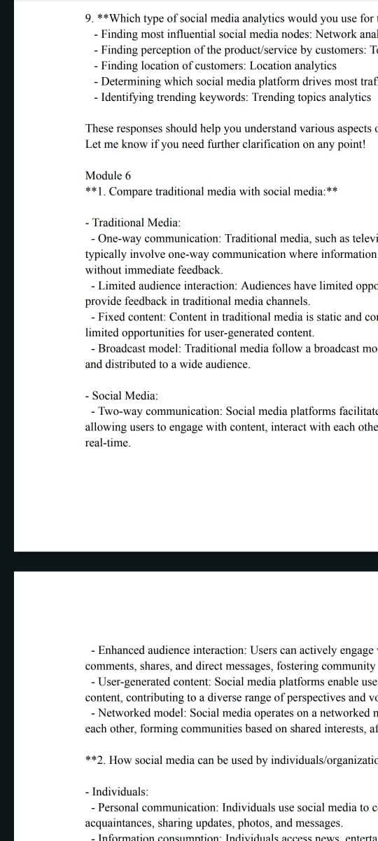

Anthlse

filter relationships requests

filter serp

filter movies to recommend

relevancy

disadv: spread of negative info or misinfo

use keyword matching algos to filter that

traditional rs depend on human judgement for it

trust in ur friends rating:4

give more weight to rating of a highly trusted frnd rather than avg general rating of a movie

give more weight to my own rating than avg general rating of a movie

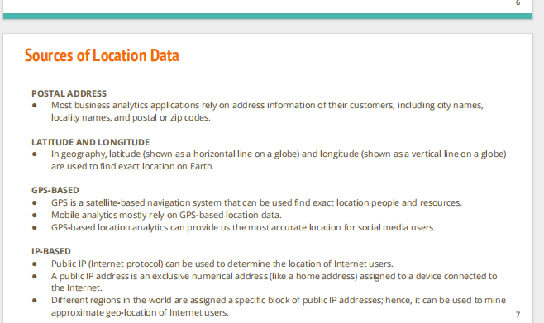

talent recruitment, referrals,

success?

count of shares, +ve comments, likes, engagement, followers, retweeted, even viewed, reach, clicked links, conversation rate from viewed to subscribed,

like importance of pages in seo, importance and influence of people in a sm nw

case studies:

psoting cctv footage of child abduction online to trace down culprint w help of people

getting young generation interested in voting and stuff using sm

will it blend: by BLENDTEC .. blend series to promote their blender

zomatos active engagement in writing lines and comments ... humor + promotion

marketing problems:

email filters block em

skip commercials: if someone recorded the content

caller id on truecaller marks spam or telemarketers

deleting promotion mails wo reading

give sponspors to promote ur brand

word of mouth/ the audience recommends: CONSUMER BASED

discounts offers eg. 1k likes and we'll giveaway

merchandise

types:

email, viral, influencer, seo, online ads paid

promotions thru content, relatable

affiliate: a 3rd party (outsourced) helps u with sales and takes commission.

eg. shark tank, for reach and promotion rather than equity distribution

virtual product placement

youtube ads

apy per click: when someone clicks on ur website, u pay. like buing visits.

optimize seo by

1. having good TEXT quality content on website

2. many people like/comment/share it take an ACTION

3. building a nw

4. page rank high so becoming a hub (HYPERLINKED by several websites)

5. wrt users locations, give more specific offers

sm for knowledge and awareness eg israel vs palastine

vitual gaming

target a specific niche audience with ur usp (unique selling pt)

customer taste behavior pref

competitor: pricing, marketing, their usp

implement and enhance ur strategy that aligns with ur business goals and response on it

disadv of sm:

and sc filters

buying views: unfair to others

bullying and stuff

cult formations, hate communities

blue whale

poonam pandey: attention seeking

bad mindset of youngsters

e dating, grooming, phishing

send me money from contact

