**Department of Computer Engineering**

**Academic Year: 2021-22**

**S.E Mini Project Synopsis**

**Group No. : 42 Domain Name: Product Design and Development Mentor Name: Richa Sharma**

**Sustainable Goal: Provide Authentic Information about COVID patients.**

| **Name of the Project** | **COVID Patient Tracker** |
| --- | --- |
| **Objective/ Vision** | The objective of our project is to track the COVID patients and maintain the statistical data of the active cases, recovered patients and the vaccinated ones. It will provide data and updates about the current situation, thereby helping in analyzing the extent of COVID-19. Also, it will create social awareness about the disease by accessing the right  information. |
| **Users of the System** | Anyone accessing the website. |
| **Review** | Data is procured from authenticated sources like WHO, Indian Journal of Medical Research and thoroughly updated. |
| **Functional Requirements (Atleast Eight)** | * Registration and login feature. * Platform Independent. * User can perform self-diagnosis with the help of questionnaire. |

|  | * User friendly page . * Visual Representation for effective comparison. * Categorizing patients into vaccinated and non-vaccinated. * Latest news updates about the situation. * Directs towards important sources for further information. |
| --- | --- |
| **Non-functional requirements (At least Four)** | * Provision for emergency help. * Guides about post-covid care. * Reliable data and Scalable. * Secure website * Data integrity and usability. |
| **Optional features** | Highlighting the **Red Zone** areas (areas with the higher number of covid patients). |
| **User interface priorities** | User friendly website. |
| **Reports** | Reports the analyzed statistical data into the graphical format. |
| **Other important issues** | Predicting the severity of the disease based on the symptoms of  self-diagnosis. |
| **Team Size** | 4 members |
| **Technologies to be used** | Python, JavaScript, HTML, CSS, PHP. |
| **Tools to be Used** | * MySQL * Firebase |

| **Final Deliverable must include** | * Number of affected patients till date. * Number of deceased patients and recovered patients. * Graphs to compare and analyze the stored data. * Guidelines to ensure better health. |
| --- | --- |
| **Example scenarios** | * Displaying COVID cases statistics. * Number of Patients recovered. * Vaccination statistics. * Data Analysis on overall covid cases. |

**Conceptual Diagram -** (System Architecture / Block Diagram / Modular Diagram)

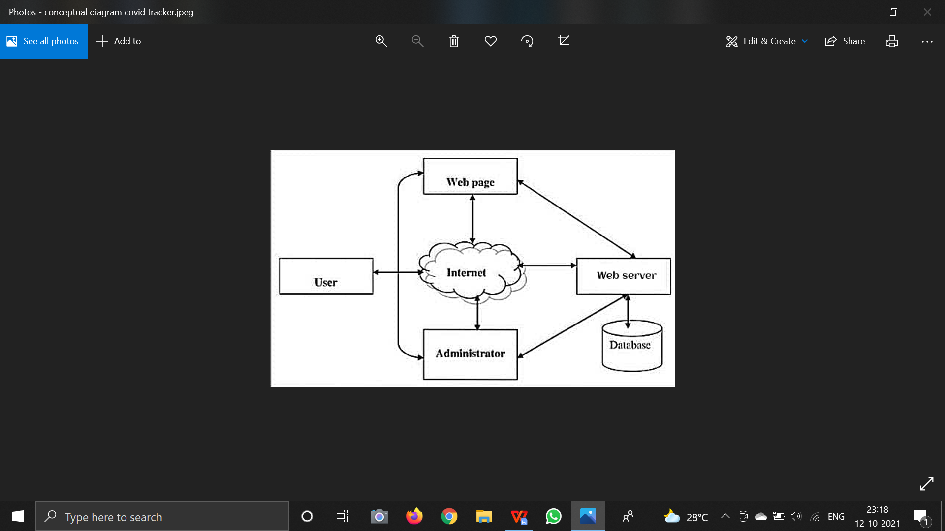

**Date: 12/10/2021**

**Mentor Name and Signature: RICHA SHARMA**

**Group Members (Roll.no & Name of the Student) D7B 55 Sakshi Rane**

**D7B 01 Sanjana Asrani D7B 36 Dimple Madhwani D7B 49 Divyang Patel**