Cmds:

npm install express body-parser cors dotenv

npm init -y

node index.js

The IV (Initialization Vector) is a random or pseudorandom value used in conjunction with a secret key to ensure that identical plaintexts encrypt to different ciphertexts. This is crucial for security, especially to avoid patterns in encrypted data which could be exploited.

Verification of code working with an online AES calculator:

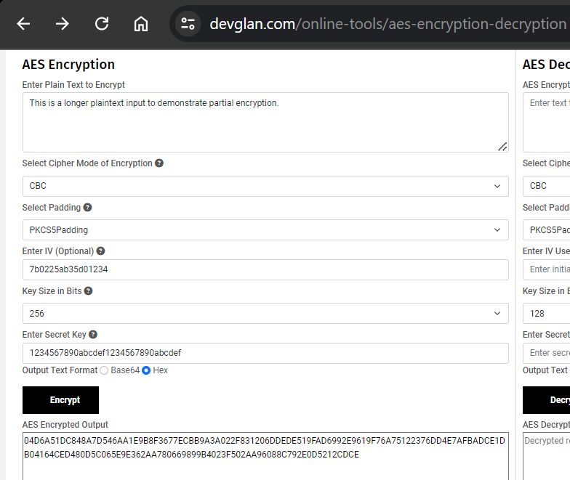

My output:

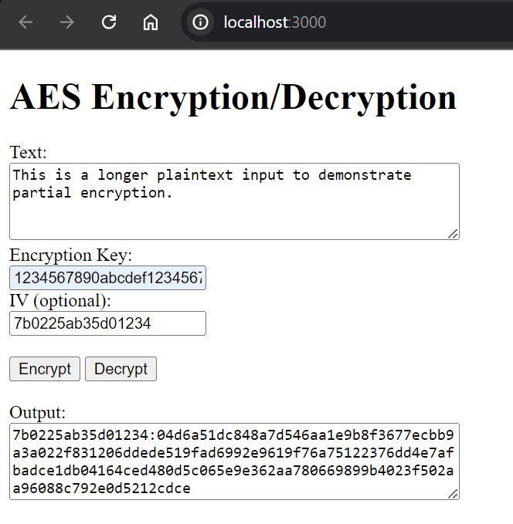

If iv is not inputted, a random iv is generated:

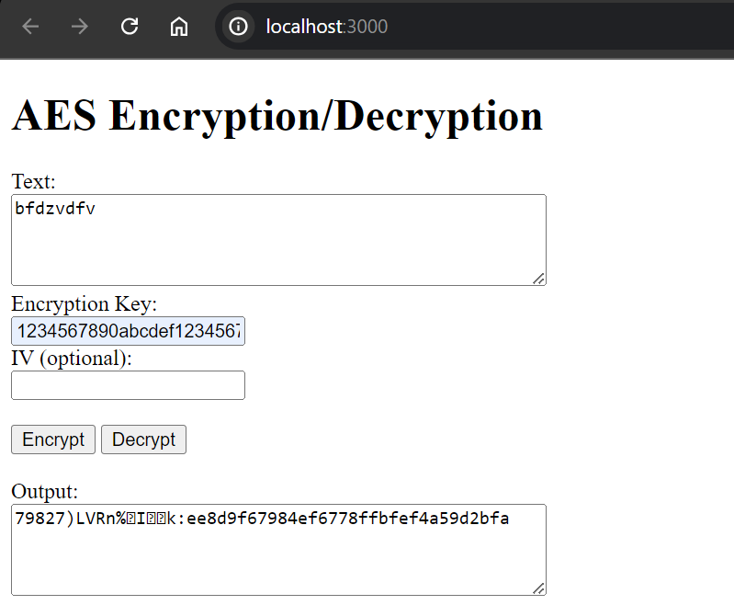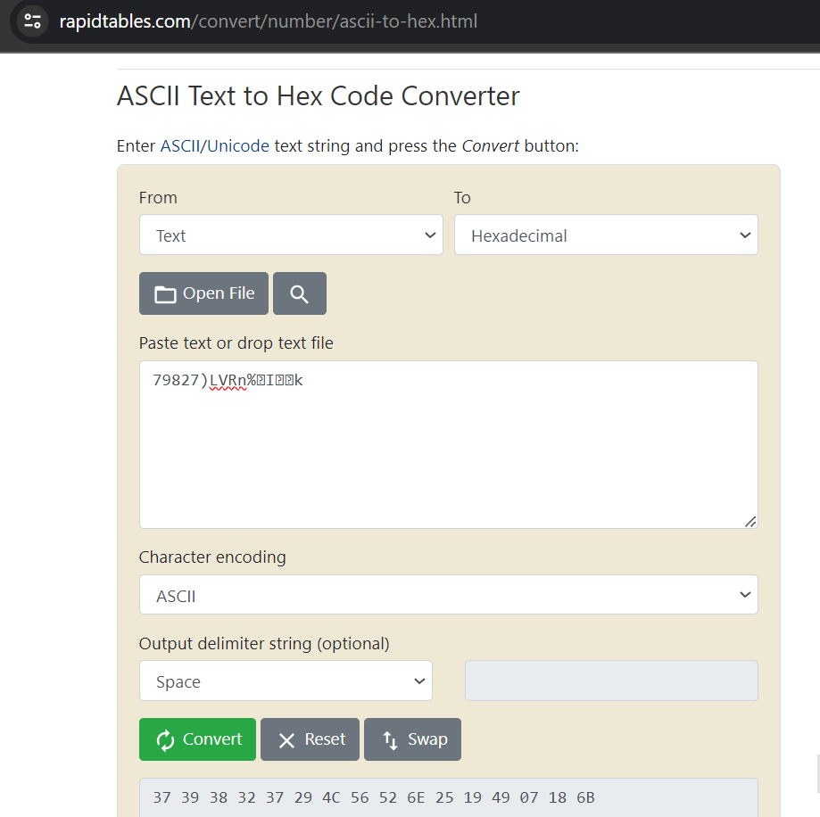

Decryption working:

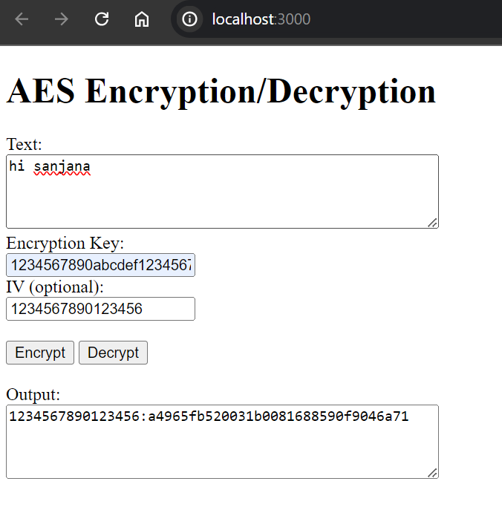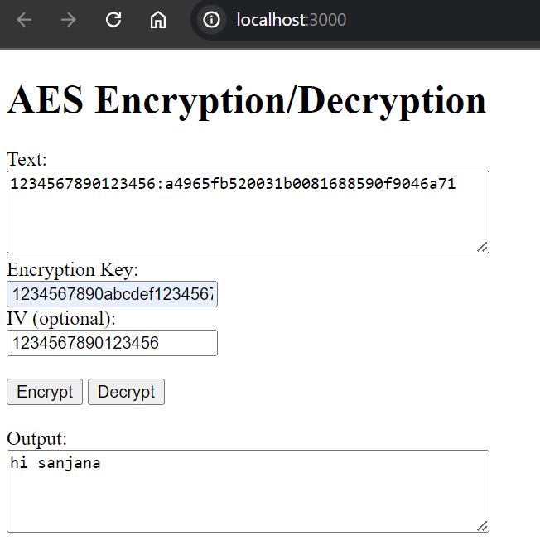

Progress of this code at <https://github.com/AsraniSanjana/aes-des-practice>