Starting the game,

Enter player name and room code:

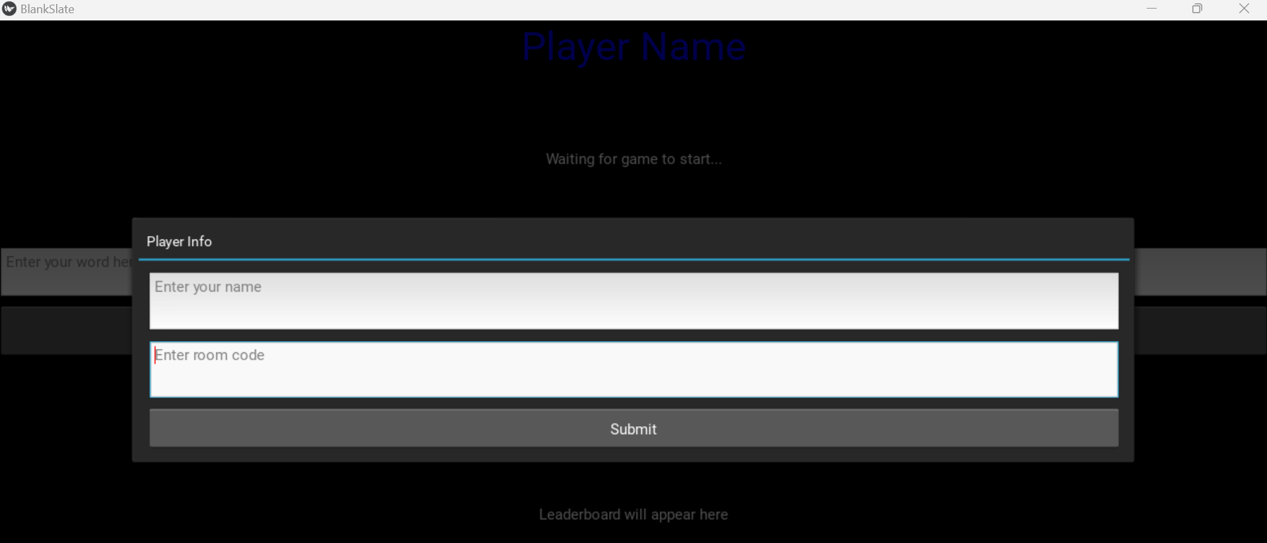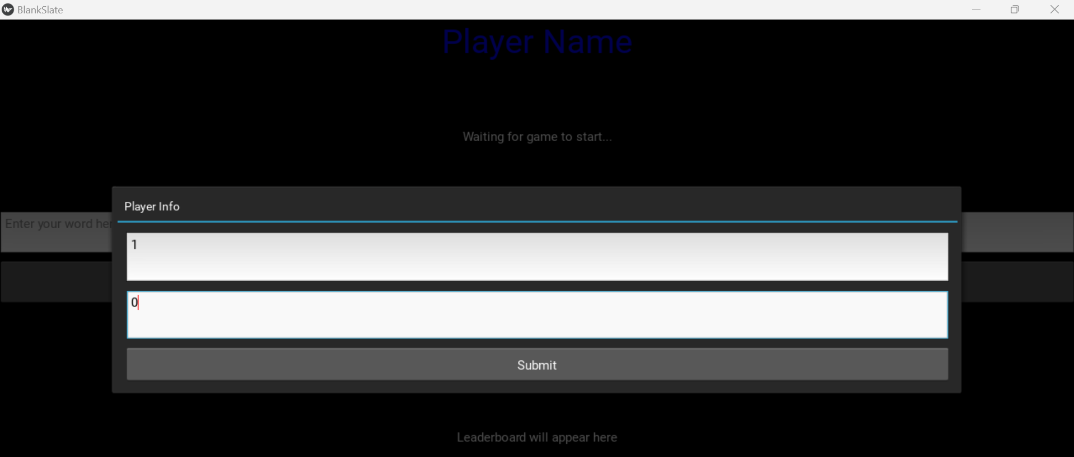

Which gets logged on the server:

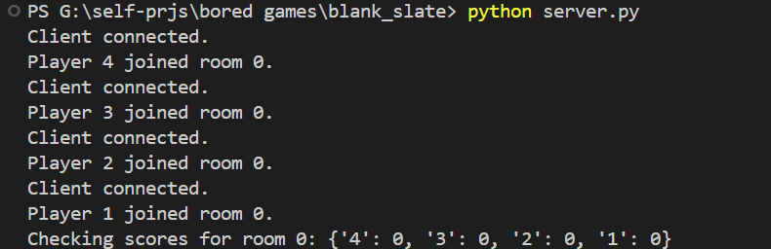

Scores of each player in that room are logged on server after every round and even in beginning when they have newly joined.

(each terminal/client is another player) so run the server first with python server.py and run 4 new terminals with python client.py

One room mandates 4 players.

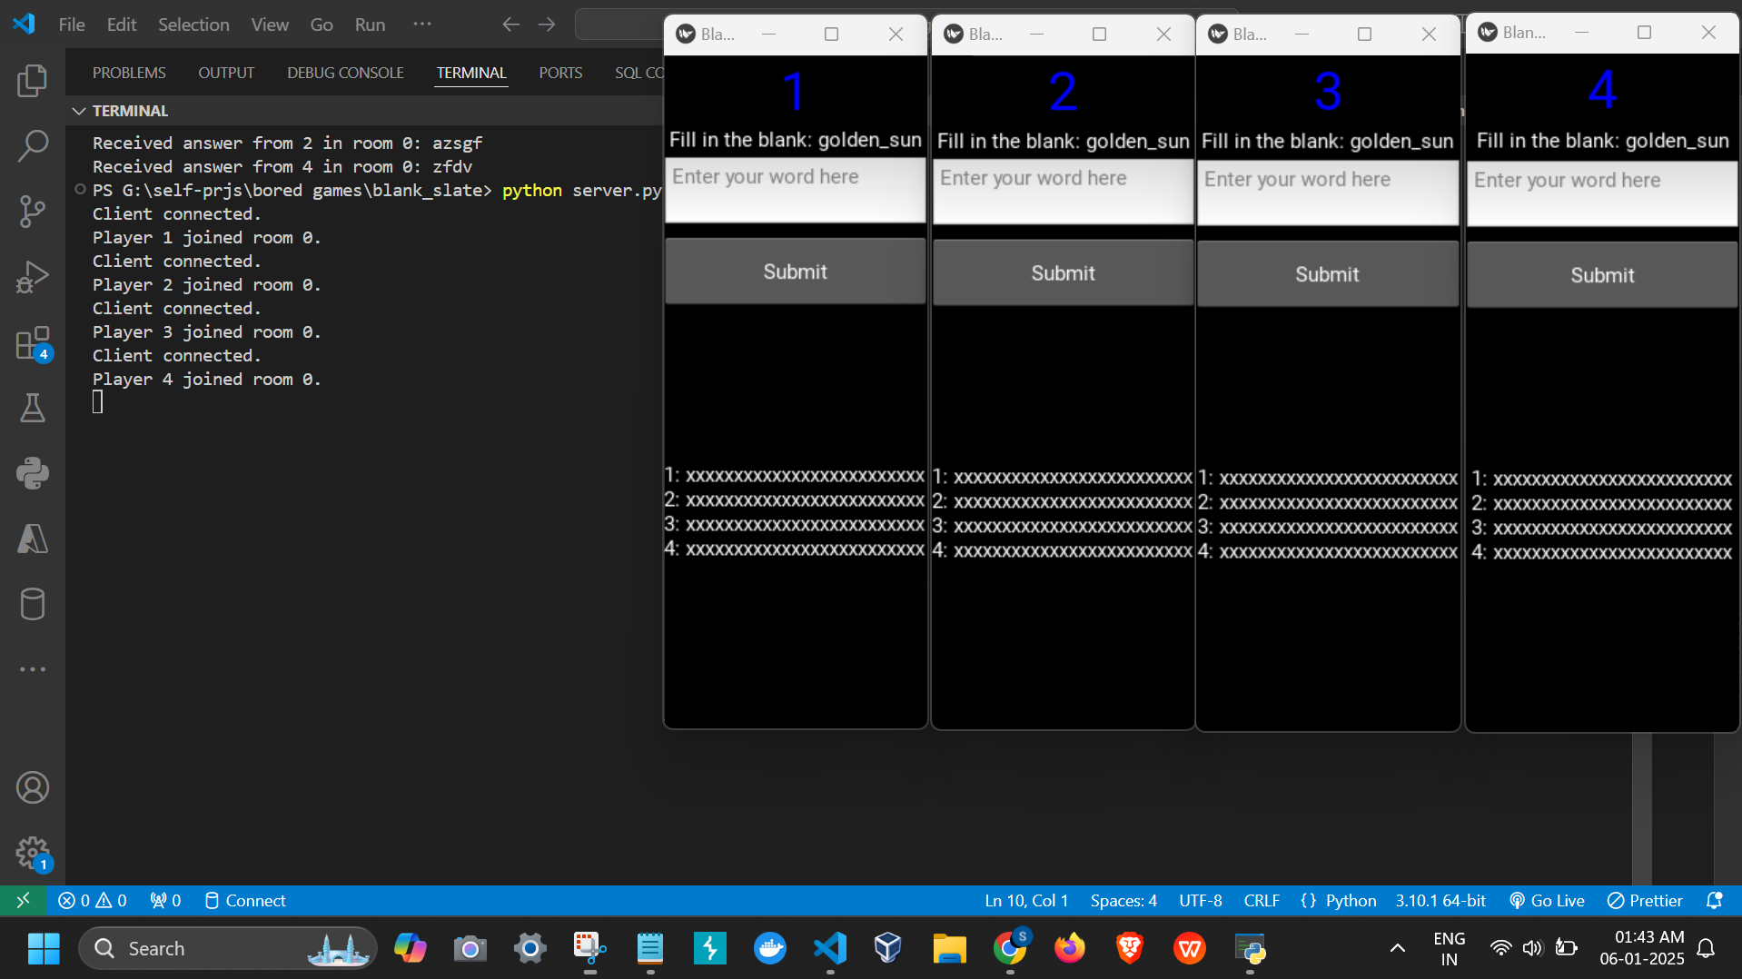

Each of the player’s words are also logged on server:

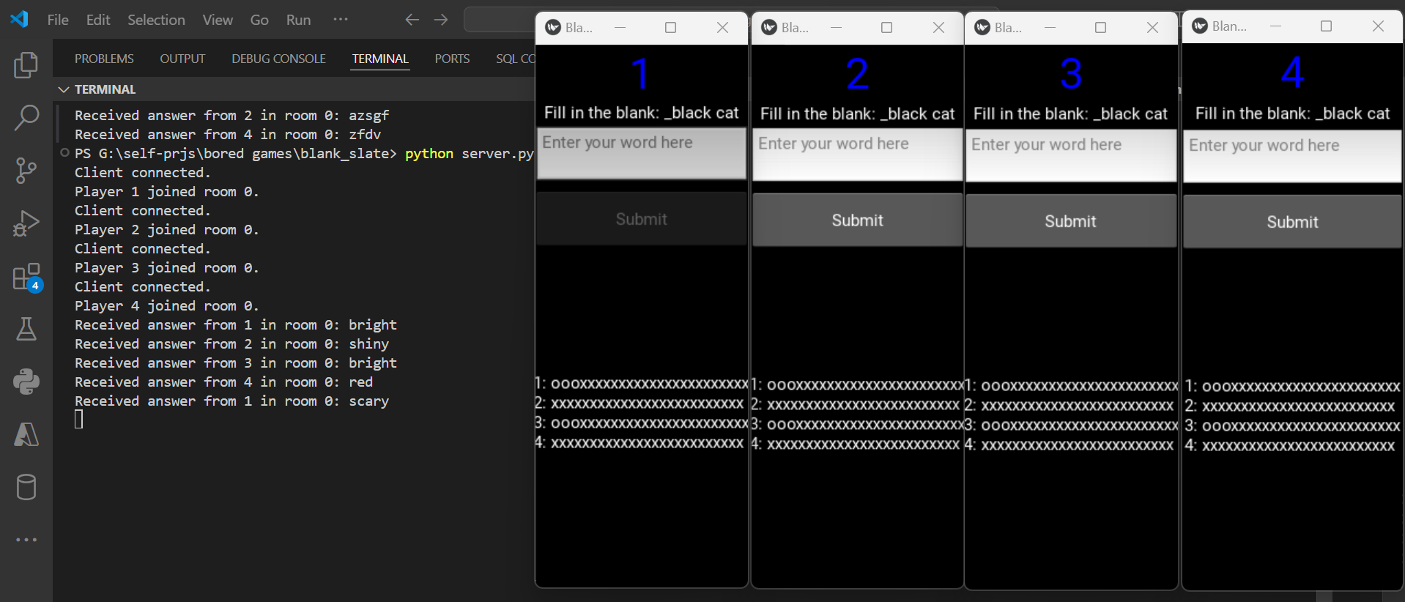

Now as per rules of blank slate i.e.

If exactly two players write the same word, each of them earns 3 points.  
If more than two players write the same word, each of them earns 1 point.  
All other players get 0 points

If all of the players write the same word, all players get 0 points.

Once a player has reached 25 points, they win!

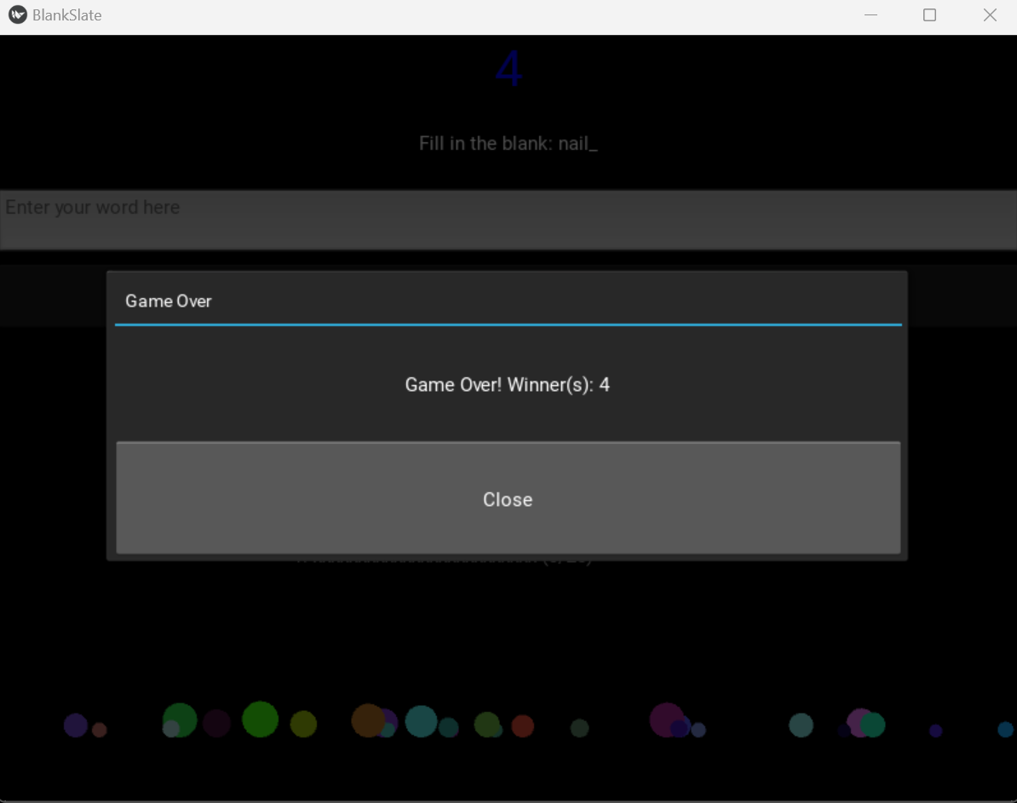

A player cannot submit words for a round twice/change their words, hence the input is disabled once they’ve submitted a word for that round