Ping

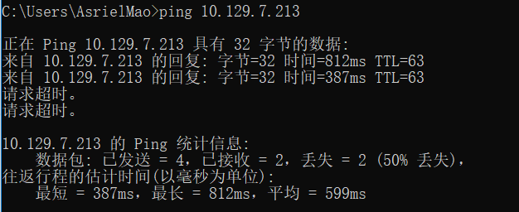

Tracert

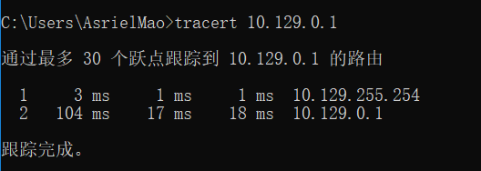

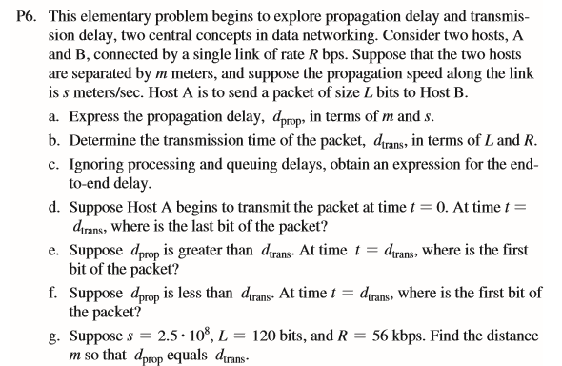

Answers:

1. d-prop = m/s
2. d-trans = L/R
3. d-end-to-end = d-prop + d-trans = m/s +L/R
4. It just leaves Host A.
5. It’s on the link.
6. It has arrived Host B.
7. d-prop = d-trans => L/R = m/s => m = Ls/R = 5.36\*10^5m

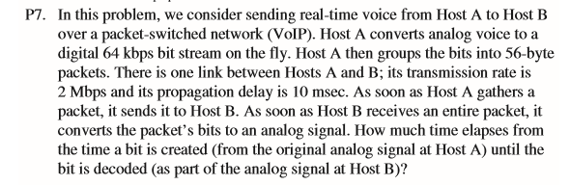

Answers:

t-A = 56\*8b / 64kbps = 7ms

t-trans = 56/8b / 2Mbps = 0.224ms

t-total = t-A + t-trans + t-prop = 17.224ms

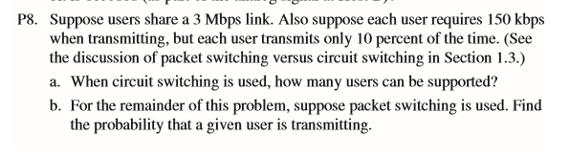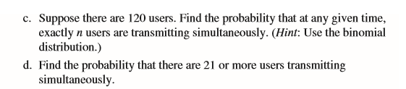

Answers:

1. users-num = 3Mbps/150kbps = 20
2. P = 0.1

$C_{n}^{120}p^{n}p^{120-n}$

$1-\sum_{0}^{20}{C_{n}^{120}p^{n}p^{120-n}}$