1. telnet whu.edu.cn 25

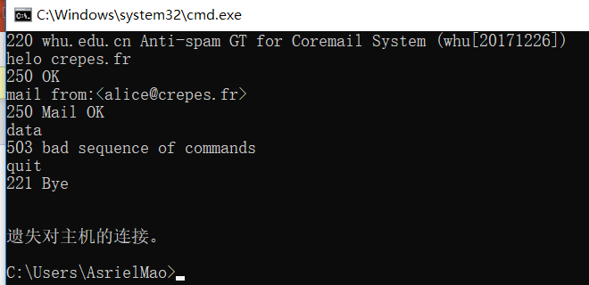

**Chapter2：**

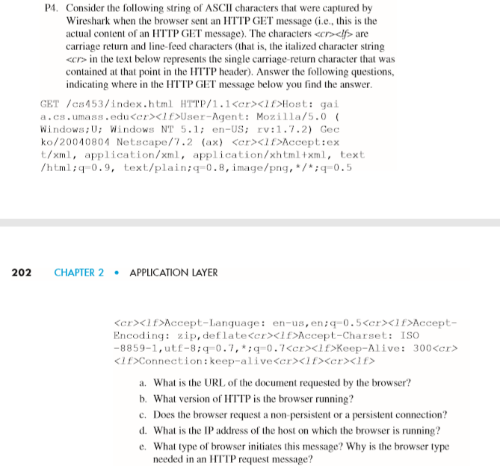

1. Host: gaia.cs.umass.edu

GET /cs453/index.html

URL: <http://gaia.cs.umass.edu/cs453/index.html>

1. HTTP/1.1(after “get” request)
2. Connection: keep-alive

It’s a persistent connection.

1. There’s no IP message here.
2. Mozilla/5.0

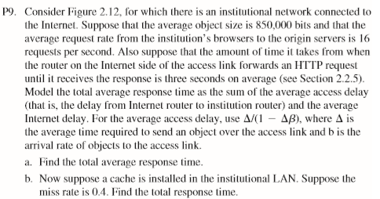

a.

Δ = 850000b / 15Mbps = 0.0567s

β = 16/s

t-receive = Δ/1-Δβ = 0.61s

t-total = t-receive + t-inter = 3.61s

b.

β2= 16 /s * 0.4

t-receive2= Δ/1-Δβ = 0.12s

t-hit = 850000b / 100Mbps = 0.0085s

t-total2= 0.4 * 0.0085 + 0.6(t-receive2 + t-inter) = 1.8754s

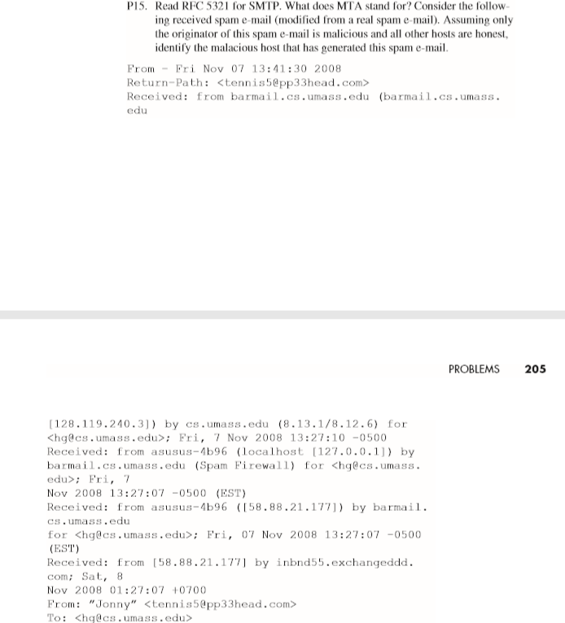

MTA(Mail Transfer Agents) is an SMTP server and client providing Mail Transfer services.

When a message is forwarded to or from the Internet, the gateway must add a “Received” line, and it can’t be changed in any way.

So, the first “Received” message(at the bottom) is the source address, which is 58.88.21.177.

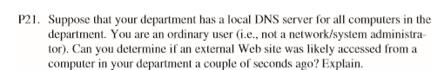

Type "dig server" and change the server to the name of the website you want to test. If Query time is very short, it means that someone may have visited the website recently.

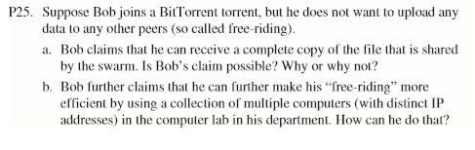

1. It's possible. Because there are vulnerabilities in BitTorrent that prevent uncooperative hitchhiking.
2. He can run clients on any host and give them a free ride, Then aggregate the chunks they collect into one file.