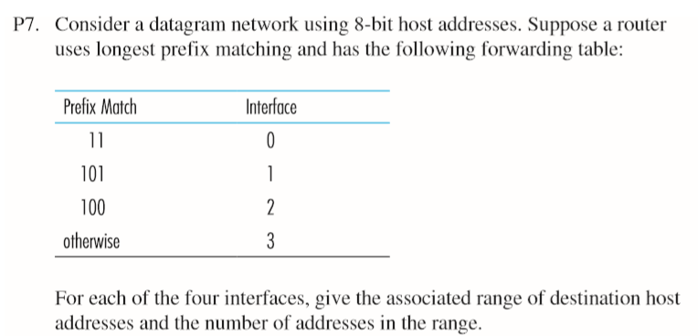

|  |  |  |
| --- | --- | --- |
| Interface | Range | Number |
| 0 | 1100 0000 – 1111 1111 | 2^6 |
| 1 | 1010 0000 – 1011 1111 | 2^5 |
| 2 | 1000 0000 – 1001 1111 | 2^5 |
| 3 | 0000 0000 – 1111 1111  Except the addresses above | 2^8-2^6-2^5-2^5 |

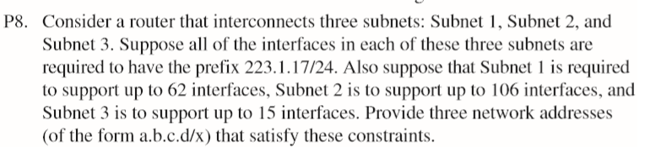

|  |  |
| --- | --- |
| Subnet 1 | 223.1.17.192/26 (193 to 254 = 62) |
| Subnet 2 | 223.1.17.0/25 (1 to 127 = 128) |
| Subnet 3 | 223.1.17.128/28 (129 to 143 = 15) |