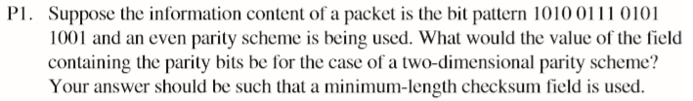

1 1 1 0 1

0 1 1 0 0

1 0 0 1 0

1 1 0 1 1

1 1 0 0 0

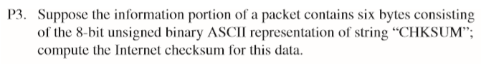

0100 1100 0110 1001

+ 0110 1110 0110 1011

= 1011 1010 1101 0100

+ 0010 0000 0100 1100

= 1101 1011 0010 0000

+ 0110 0001 0111 1001

= 0011 1100 1001 1010

+ 0110 0101 0111 0010

= 1010 0010 0000 1100

so the complement is:

0101 1101 1111 0011



r = 4

G = 10011

D = 1010101010

R = 1010101010 \* 2^4 mod 10011 = 0100

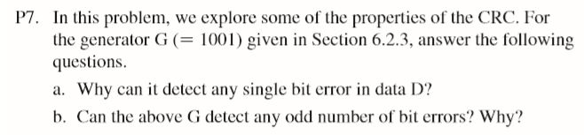

a. Assuming that the ith bit is flipped without loss of generality, where 0<= i <= d+r-1, and the least significant bit is the 0th bit. A bit error means that the data received is K=D\*2r XOR R + 2i. If we divide K by G, the reminder is not zero. Generally, a bit error can always be detected if G contains at least two ones.

b. G is divisible by 11, but any odd number 1 is not divisible by 11. So, the odd bit error sequence can't be divided by 11, so it can't be divided by G.

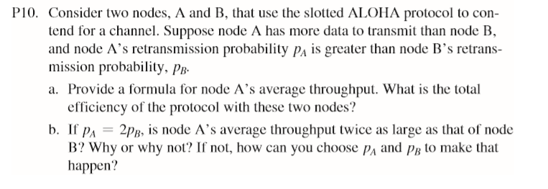

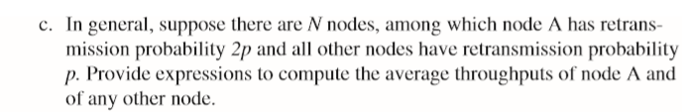

a.

pA (1 - pB)

pA (1 - pB) + pB (1 - pA)

b.

A: pA (1 - pB) = 2pB (1 - pB)

B: pB (1 - pA) = pB (1 - 2pB)

A is not the twice as large as B

pA (1 - pB) = 2pB (1 - pA) => pA = 2 - pA/pB

c.

A: 2p (1 - p) N - 1

Other: p (1 - p) N – 2 (1 - 2p)