JOB MARKET ANALYSIS REPORT
Name: Asritha Nalubala
Project Title: Job Market Analysis for Data Professionals
Tools Used: Python, Pandas, Matplotlib, Jupyter Notebook

1. Introduction
This project analyzes job market trends in the data science and analytics field. The objective is to understand salary patterns, experience requirements, remote work opportunities, and hiring locations.

2. Dataset Description
The dataset was collected from Kaggle and contains 607 job records with 12 attributes including job title, salary, experience level, company size, and location.

3. Methodology
The project followed these steps:
- Data Collection from Kaggle
- Data Cleaning using Pandas
- Removal of duplicates and formatting
- Exploratory Data Analysis (EDA)
- Data Visualization using Matplotlib
- Report Generation

4. Analysis and Findings
4.1 Job Roles
Data Scientist and Data Analyst roles are the most in demand.
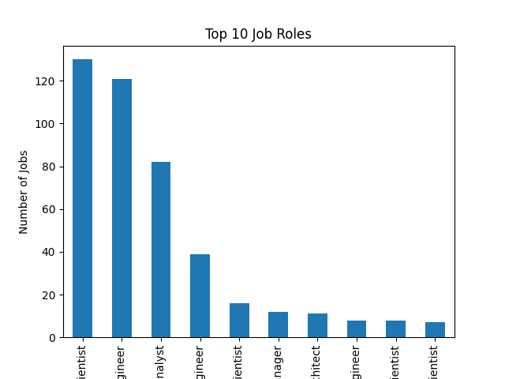
4.2 Salary Analysis
Senior and Executive level positions receive higher salaries.
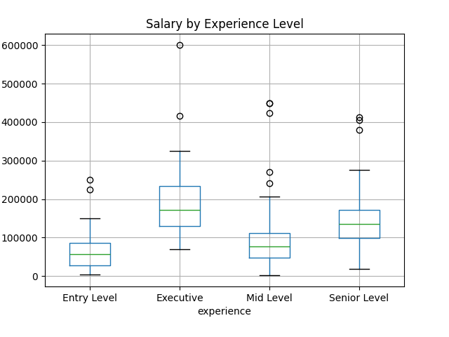
4.3 Remote Work
Most jobs offer remote or hybrid opportunities.
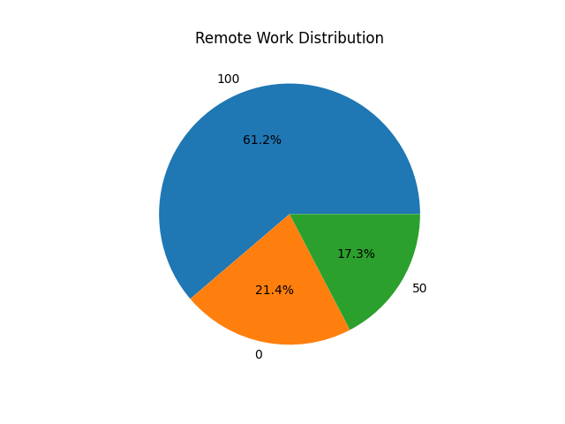 (Insert Remote Chart Here)

5. Key Insights
- Salary increases with experience
- Remote jobs are growing
- Medium and Large companies pay better
- Global demand for data professionals

6. Conclusion
This project provides useful insights for job seekers and recruiters. It helps understand current industry trends and supports data-driven career planning.

7. Future Scope
- Web scraping live job data
- Salary prediction using machine learning
- Interactive dashboards

