**ANGULAR Handson Solutions**

**Date:**29-06-2021

**Name:**Asritha Cherukuri

**EmpId:** 916179

**Angular Intro Handson**

**Session1:**

*Appcomponent.html:*

<h1>Hello World</h1>

<strong>Id:</strong>{{Id}}<br><br>

<strong>Name:</strong>{{Name}}<br><br>

<strong>Salary:</strong>{{Salary}}

<br><br>

<span *ngIf="Permanent"><strong>Permanent:</strong>Yes</span>

<br><br>

<strong>Department Id:</strong>{{Department_Id}}

<br><br>

<strong>Department Name:</strong>{{Department_Name}}

<br><br>

<strong>Skills</strong>

<br><br>

<span><strong>Skill Id Skill Name</strong></span>

<ol type="1">

<li *ngFor="let item of Skills">{{item}}</li>

</ol>

<strong>Date Of Birth: </strong>{{DateofBirth}}

<br><br>

<h1>Using Pipes</h1>

<strong>Id: </strong>{{Id}}<br><br>

<strong>Name: </strong>{{Name}}<br><br>

<strong>Salary: </strong>{{Salary | currency:"INR"}}

<br><br>

<span *ngIf="Permanent"><strong>Permanent:</strong>Yes</span>

<br><br>

<strong>Department Id: </strong>{{Department_Id}}

<br><br>

<strong>Department Name: </strong>{{Department_Name}}

<br><br>

<strong>Skills</strong>

<br><br>

<span><strong>Skill Id Skill Name</strong></span>

<ol type="1">

<li *ngFor="let item of Skills">{{item}}</li>

</ol>

<strong>Date Of Birth:</strong>{{DateofBirth | date}}

<router-outlet></router-outlet>

*Appcomponebnt.ts:*

title = 'angular-Intro';

  public Titles:string = "Employee Details";

  public Id:number=1;

  public Name:string="John";

  public Salary:number=10000;

  public Permanent:boolean=true;

  public Department_Id:number=1;

  public Department_Name:string="payroll";

  public Skills:string[]=["Html","Css","JavaScripts"];

  public DateofBirth:Date=new Date('12/31/2000');

}

*Output:*

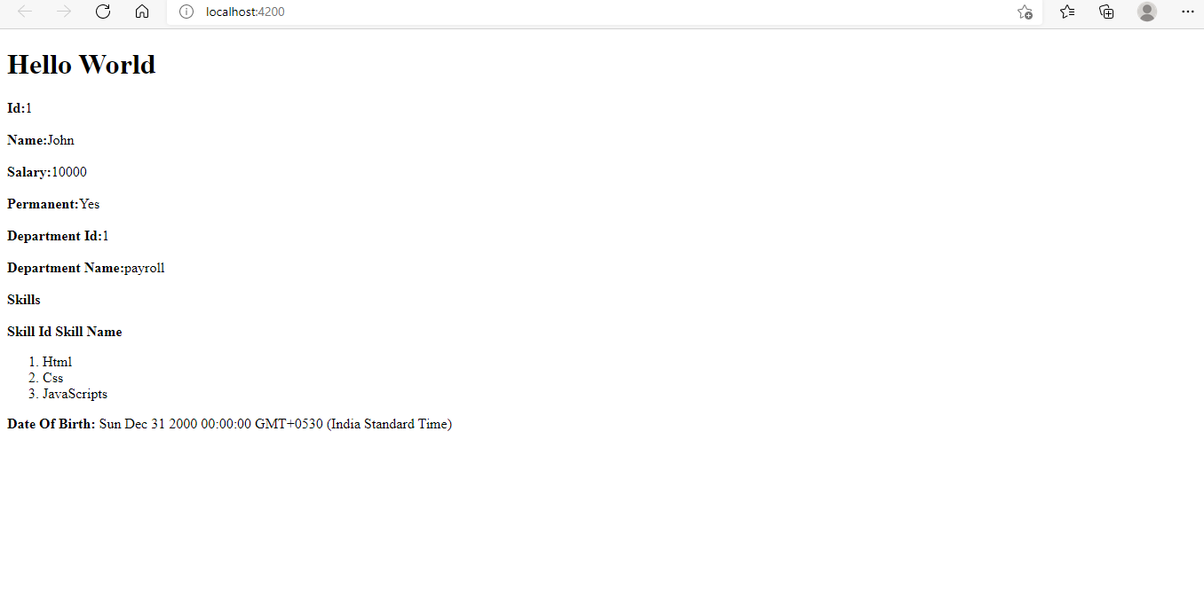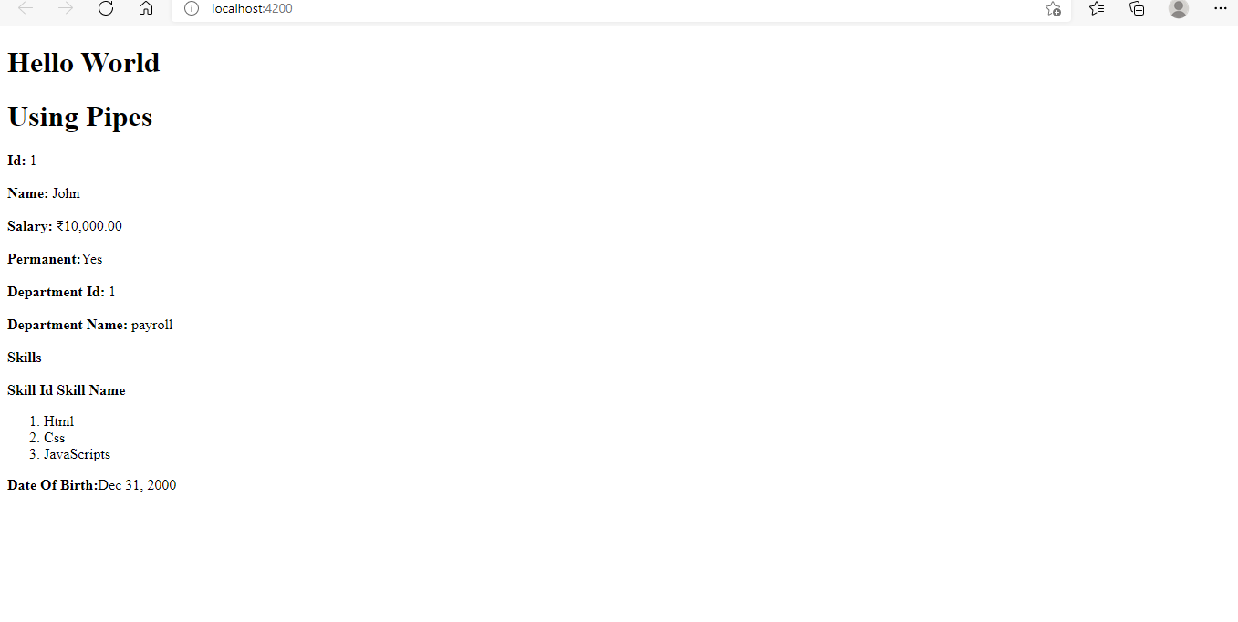

**Session2:**

*Appcomponent.html:*

<div style="text-align:center">

  <h1>

  Angular

  </h1>

  <nav>

    <a routerLink="/view">ViewEmployee</a><br>

    <a routerLink="/edit">EditEmployee</a>

    <a routerLink="/quantity">Quantity Increment</a>

    <a></a>

  </nav>

</div>

<router-outlet></router-outlet>

*Appcomponet.Ts:*

import { NgModule } from '@angular/core';

import { BrowserModule } from '@angular/platform-browser';

import { AppRoutingModule } from './app-routing.module';

import { AppComponent } from './app.component';

import { DepartmentListComponent } from './department-list/department-list.component';

import { EditEmployeeComponent } from './edit-employee/edit-employee.component';

import { EmployeeListComponent } from './employee-list/employee-list.component';

import { QuantityComponent } from './quantity/quantity.component';

import { ViewEmployeeComponent } from './view-employee/view-employee.component';

@NgModule({

  declarations: [

    AppComponent,

    ViewEmployeeComponent,

    EditEmployeeComponent,

    QuantityComponent

  ],

  imports: [

    BrowserModule,

    AppRoutingModule

  ],

  providers: [],

  bootstrap: [AppComponent]

})

export class AppModule { }

*Appcomponent.Routing*

import { NgModule } from '@angular/core';

import { RouterModule, Routes } from '@angular/router';

import { DepartmentListComponent } from './department-list/department-list.component';

import { EditEmployeeComponent } from './edit-employee/edit-employee.component';

import { EmployeeListComponent } from './employee-list/employee-list.component';

import { QuantityComponent } from './quantity/quantity.component';

import { ViewEmployeeComponent } from './view-employee/view-employee.component';

const routes: Routes = [

  {path:'view',component:ViewEmployeeComponent},

  {path:'edit',component:EditEmployeeComponent},

  {path:'quantity',component:QuantityComponent}

];

@NgModule({

  imports: [RouterModule.forRoot(routes)],

  exports: [RouterModule]

})

export class AppRoutingModule { }

*EditComponent.html*

<p>edit-employee works!</p>

*EditComponent.Ts*

import { Component, OnInit } from '@angular/core';

@Component({

  selector: 'app-edit-employee',

  templateUrl: './edit-employee.component.html',

  styleUrls: ['./edit-employee.component.css']

})

export class EditEmployeeComponent implements OnInit {

  constructor() { }

  ngOnInit(): void {

  }

}

*ViewComponent.html*

<strong>Id:</strong>{{Id}}<br><br>

<strong>Name:</strong>{{Name}}<br><br>

<strong>Salary:</strong>{{Salary | currency:"INR"}}

<br><br>

<span *ngIf="Permanent"><strong>Permanent:</strong>Yes</span>

<br><br>

<strong>Department Id:</strong>{{Department_Id}}

<br><br>

<strong>Department Name:</strong>{{Department_Name}}

<br><br>

<strong>Skills</strong>

<br><br>

<span><strong>Skill Id Skill Name</strong></span>

<ol type="1">

    <li *ngFor="let item of Skills">{{item}}</li>

</ol>

<br>

<br>

<strong>Date Of Birth:</strong>{{DateofBirth | date}}

*ViewComponent.Ts*

public Id:number=1;

  public Name:string="John";

  public Salary:number=10000;

  public Permanent:boolean=true;

  public Department_Id:number=1;

  public Department_Name:string="payroll";

  public Skills:string[]=["Html","Css","JavaScripts"];

  public DateofBirth:Date=new Date('12/31/2000');

*QualityIncreamentComponent.html*

<p>Simple Button click Event!!</p>

<button (click)="firstbutton()">Click Me</button>

<br>

<br>

{{result}}

<br>

<input type="text" value={{num}}><button (click)="Add()">add</button>

<br>

<br>

<input type="submit" value="sub" (click)="sub1()" [disabled]="flag"><input type="text" value={{addandsub}}><input type="submit" value="add" (click)="add1()">

*QualityIncreamentComponent.Ts*

import { Component, OnInit } from '@angular/core';

@Component({

  selector: 'app-quantity',

  templateUrl: './quantity.component.html',

  styleUrls: ['./quantity.component.css']

})

export class QuantityComponent implements OnInit {

  constructor() { }

  ngOnInit(): void {

  }

  public result:string="";

  public firstbutton():void{

    this.result="click me button clicked";

  }

  public num:number=0;

  public Add():void{

    this.num++;

  }

  public addandsub:number=0;

  public flag:boolean=true;

  public add1():void{

    this.addandsub++;

    if(this.addandsub>0){

      this.flag=false;

    }

    else{

      this.flag=true;

    }

  }

  public sub1():void{

    this.addandsub--;

    if(this.addandsub>0){

      this.flag=false;

    }

    else{

      this.flag=true;

    }

  }

}

*Output*

