**ANGULAR Handson Solutions**

**Date:**28-06-2021

**Name:**Asritha Cherukuri

**EmpId:** 916179

**Handson**

*Given:*

JavaScript Object - Define JavaScript object for employee Create a JavaScript object variable and display the content in console using console.log() method.

*Implementation:*

<script>

  var emp = {firstName:"John",lastName:"Stoke", salary:5000, permanentStaff:false};

  console.log(emp);

  </script>

*Output:*

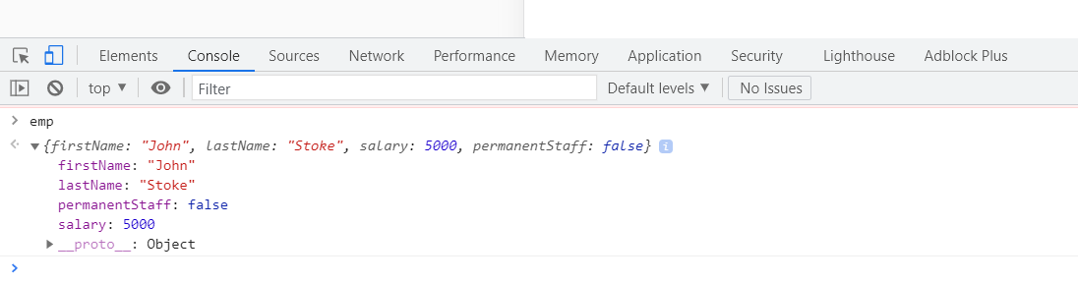

JSON - Define JSON for employee details and parse

<script>

var emp = JSON.parse('{"firstName":"John", "lastName":"Stoke", "salary":"5000","permanentStaff":"false"}');

console.log("firstName : "+emp.firstName);

console.log("lastName : "+emp.lastName);

console.log("salary : "+emp.salary);

console.log("permanentStaff : "+emp.permanentStaff);

</script>

JSON - Add skill details to employee

<script>

const data = '{"firstName":"John", "lastName":"Stoke", "salary":"5000", "permanentStaff":"false", "Department":[{"id":"3","name":"payroll"}], "skill":[{"id":"1", "value":"HTML"},{"id":"2", "value":"CSS"},{"id":"2", "value":"Javascript"}]}';

var emp = JSON.parse(data);

console.log("firstName : "+emp.firstName);

console.log("lastName : "+emp.lastName);

console.log("salary : "+emp.salary);

console.log("permanentStaff : "+emp.permanentStaff)

console.log("Department id : "+emp.Department[0].id);

console.log("Department name : "+emp.Department[0].name);

for(var i=0; i<emp.skill.length; i++)

{

console.log("Skill "+(i+1)+" : "+emp.skill[i].id+", "+emp.skill[i].value);

}

</script>

**Handson**

**Session2:**

*Given:*

JavaScript Object - Define JavaScript object for employee Create a JavaScript object variable and display the content in console using console.log() method.

*Implementation:*

*Test.ts:*

import { Component, OnInit } from '@angular/core';

import { Employee } from '../emp/emp.component';

import { Department } from '../dept/dept.component';

import { Skill } from '../skills/skills.component';

var em:Employee = {

id:3,

name:"John",

salary:5000,

permanent:true,

}

console.log("id : "+em.id);

console.log("name : "+em.name);

console.log("salary : "+em.salary);

console.log("permanent : "+em.permanent);

var dept:Department = {

  id:1,

  name:"Payroll",

  }

  console.log("Department id : "+dept.id);

  console.log("Department name : "+dept.name);

@Component({

  selector: 'app-test',

  templateUrl: './test.component.html',

  styleUrls: ['./test.component.css']

})

export class TestComponent implements OnInit {

  constructor() { }

  ngOnInit(): void {

  }

}

*Employee.ts*

import { Component, OnInit } from '@angular/core';

import { Department } from '../dept/dept.component';

import { Skill } from '../skills/skills.component';

@Component({

  selector: 'app-emp',

  templateUrl: './emp.component.html',

  styleUrls: ['./emp.component.css']

})

export class EmpComponent implements OnInit {

  constructor() { }

  ngOnInit(): void {

  }

}

export interface Employee {

  id:number;

  name:string;

  salary:number;

  permanent:boolean;

  }

  var dept:Department = {

    id:1,

    name:"Payroll",

    }

  var skill1:Skill = {

    id:1,

    name:"HTML",

    }

var skill2:Skill = {

    id:2,

    name:"CSS",

    }

var skill3:Skill = {

    id:3,

    name:"JavaScript",

    }

console.log("Skill[0]:"+skill1.id+", "+skill1.name);

console.log("Skill[1]:"+skill2.id+", "+skill2.name);

console.log("Skill[2]:"+skill3.id+", "+skill3.name);

*Dept.ts*

import { Component, OnInit } from '@angular/core';

@Component({

  selector: 'app-dept',

  templateUrl: './dept.component.html',

  styleUrls: ['./dept.component.css']

})

export class DeptComponent implements OnInit {

  constructor() { }

  ngOnInit(): void {

  }

}

export interface Department{

  id:number;

  name:string;

  }

*Skills.ts*

import { Component, OnInit } from '@angular/core';

@Component({

  selector: 'app-skills',

  templateUrl: './skills.component.html',

  styleUrls: ['./skills.component.css']

})

export class SkillsComponent implements OnInit {

  constructor() { }

  ngOnInit(): void {

  }

}

  export interface Skill{

    id:number;

    name:string;

    }

*Output:*

