**ASP.NET Core Handson Solutions**

**Date:**23-06-2021

**Name:**Asritha Cherukuri

**EmpId:** 916179

**Handson**

*Given:*

Create a Razor view to list few employee details using Model data binding

Description: Create a model class ‘Employee’ to be used for Employee details. Create properties

· Id – datatype Int

· Name – datatype string

· Salary – datatype decimal

· IsPermanent – datatype bool

Create a new Action method ‘GetEmployeeList’ in the Home controller and add a new View. Use the data provided below to feed the data to a list of Employee model class

*Implementation:*

*Employee.cs*

using System;

using System.Collections.Generic;

using System.Linq;

using System.Threading.Tasks;

namespace WebApplication1.Models

{

public class Employee

{

public int Id { get; set; }

public string Name { get; set; }

public decimal Salary { get; set; }

public bool IsPermanent { get; set; }

}

}

*GetEmployeeList.cshtml*

@{

ViewData["Title"] = "EmployeeList";

}

<h1>EmployeeDetails</h1>

@model List<WebApplication1.Models.Employee>

@{

ViewData["Title"] = "EmployeeList";

<div class="row">

<span class="col-md-4">Name</span>

<span class="col-md-4">Salary</span>

<span class="col-md-4">IsPermanent</span>

</div>

}

@foreach (var employee in Model)

{

<div class="row">

@if (employee.IsPermanent.Equals(true))

{

<span class="col-md-4"><b>@employee.Name</b></span>

<span class="col-md-4"><b>@employee.Salary</b></span>

<span class="col-md-4"><b>@employee.IsPermanent</b></span>

}

else

{

<span class="col-md-4">@employee.Name</span>

<span class="col-md-4">@employee.Salary</span>

<span class="col-md-4">@employee.IsPermanent</span>

}

</div>

}

*Layout*

<!DOCTYPE html>

<html lang="en">

<head>

<meta charset="utf-8" />

<meta name="viewport" content="width=device-width, initial-scale=1.0" />

<title>@ViewData["Title"] - ITOrganization</title>

<link rel="stylesheet" href="~/lib/bootstrap/dist/css/bootstrap.min.css" />

<link rel="stylesheet" href="~/css/site.css" />

</head>

<body>

<header>

<nav class="navbar navbar-expand-sm navbar-toggleable-sm navbar-light bg-white border-bottom box-shadow mb-3">

<div class="container">

<a class="navbar-brand" **asp-area**="" **asp-controller**="Home" **asp-action**="Index">EmployeeList</a>

<button class="navbar-toggler" type="button" data-toggle="collapse" data-target=".navbar-collapse" aria-controls="navbarSupportedContent"

aria-expanded="false" aria-label="Toggle navigation">

<span class="navbar-toggler-icon"></span>

</button>

<div class="navbar-collapse collapse d-sm-inline-flex flex-sm-row-reverse">

<ul class="navbar-nav flex-grow-1">

<li class="nav-item">

<a class="nav-link text-dark" **asp-area**="" **asp-controller**="Home" **asp-action**="Index">Home</a>

</li>

<li class="nav-item">

<a class="nav-link text-dark" **asp-area**="" **asp-controller**="Home" **asp-action**="Privacy">Privacy</a>

</li>

<li class="nav-item">

<a class="nav-link text-dark" **asp-area**="" **asp-controller**="Home" **asp-action**="GetEmployeeList">EmployeeList</a>

</li>

</ul>

</div>

</div>

</nav>

</header>

<div class="container">

<main role="main" class="pb-3">

@RenderBody()

</main>

</div>

<footer class="border-top footer text-muted">

<div class="container">

&copy; 2021 - EMPLOYEELIST - <a **asp-area**="" **asp-controller**="Home" **asp-action**="Privacy">Privacy</a>

</div>

</footer>

<script src="~/lib/jquery/dist/jquery.min.js"></script>

<script src="~/lib/bootstrap/dist/js/bootstrap.bundle.min.js"></script>

<script **src**="~/js/site.js" **asp-append-version**="true"></script>

@RenderSection("Scripts", required: false)

</body>

</html>

*Homecontroller*

using Microsoft.AspNetCore.Mvc;

using Microsoft.Extensions.Logging;

using System;

using System.Collections.Generic;

using System.Diagnostics;

using System.Linq;

using System.Threading.Tasks;

using WebApplication1.Models;

namespace WebApplication1.Controllers

{

public class HomeController : Controller

{

private readonly ILogger<HomeController> _logger;

public HomeController(ILogger<HomeController> logger)

{

_logger = logger;

}

public IActionResult Index()

{

return View();

}

public IActionResult Privacy()

{

return View();

}

public IActionResult GetEmployeeList()

{

List<Employee> employeeList = new List<Employee>();

employeeList.Add(new Employee()

{

Id = 1,

Name = "Asritha",

Salary = 10800,

IsPermanent = true

});

employeeList.Add(new Employee()

{

Id = 2,

Name = "Anvitha",

Salary = 7000,

IsPermanent = false

});

employeeList.Add(new Employee()

{

Id = 3,

Name = "Vancita",

Salary = 5000,

IsPermanent = false

});

employeeList.Add(new Employee()

{

Id = 4,

Name = "Harika",

Salary = 10800,

IsPermanent = true

});

return View(employeeList);

}

[ResponseCache(Duration = 0, Location = ResponseCacheLocation.None, NoStore = true)]

public IActionResult Error()

{

return View(new ErrorViewModel { RequestId = Activity.Current?.Id ?? HttpContext.TraceIdentifier });

}

}

}

*Output:*

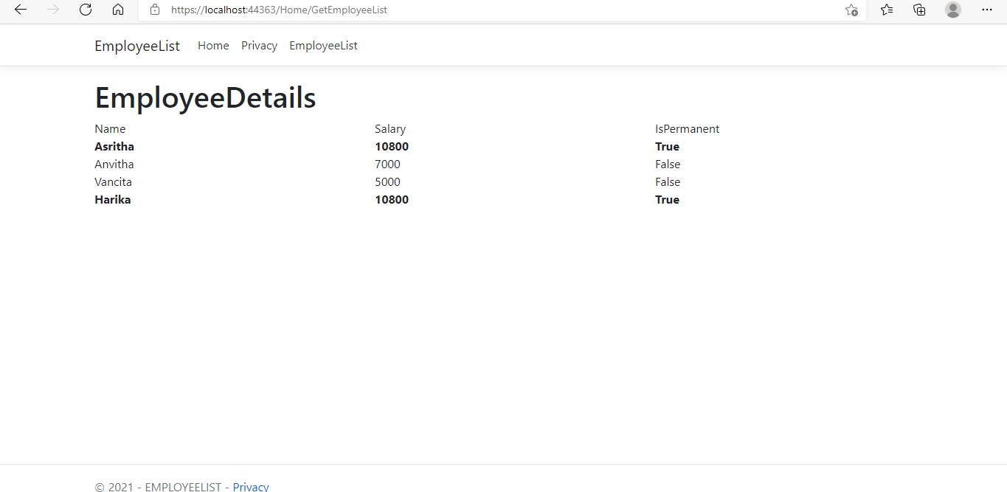

**Handson**

*Given:*

Demonstrate partial view usage

Create a partial view to have the Employee list table data that could be reused in Employee list view.

*Implementation:*

*Employee.cs*

using System;

using System.Collections.Generic;

using System.Linq;

using System.Threading.Tasks;

namespace WebApplication1.Models

{

public class Employee

{

public int Id { get; set; }

public string Name { get; set; }

public decimal Salary { get; set; }

public bool IsPermanent { get; set; }

}

}

*GetEmployeeList.cshtml*

@{

ViewData["Title"] = "EmployeeList";

}

<**partial** **name**="PartialGetEmployeeList" />

*PartialGetEmployeeList.cshtml*

@{

ViewData["Title"] = "EmployeeList";

}

<h1>EmployeeDetails</h1>

@model List<WebApplication1.Models.Employee>

@{

ViewData["Title"] = "EmployeeList";

<div class="row">

<span class="col-md-4">Name</span>

<span class="col-md-4">Salary</span>

<span class="col-md-4">IsPermanent</span>

</div>

}

@foreach (var employee in Model)

{

<div class="row">

@if (employee.IsPermanent.Equals(true))

{

<span class="col-md-4"><b>@employee.Name</b></span>

<span class="col-md-4"><b>@employee.Salary</b></span>

<span class="col-md-4"><b>@employee.IsPermanent</b></span>

}

else

{

<span class="col-md-4">@employee.Name</span>

<span class="col-md-4">@employee.Salary</span>

<span class="col-md-4">@employee.IsPermanent</span>

}

</div>

}

*Layout*

<!DOCTYPE html>

<html lang="en">

<head>

<meta charset="utf-8" />

<meta name="viewport" content="width=device-width, initial-scale=1.0" />

<title>@ViewData["Title"] - ITOrganization</title>

<link rel="stylesheet" href="~/lib/bootstrap/dist/css/bootstrap.min.css" />

<link rel="stylesheet" href="~/css/site.css" />

</head>

<body>

<header>

<nav class="navbar navbar-expand-sm navbar-toggleable-sm navbar-light bg-white border-bottom box-shadow mb-3">

<div class="container">

<a class="navbar-brand" **asp-area**="" **asp-controller**="Home" **asp-action**="Index">EmployeeList</a>

<button class="navbar-toggler" type="button" data-toggle="collapse" data-target=".navbar-collapse" aria-controls="navbarSupportedContent"

aria-expanded="false" aria-label="Toggle navigation">

<span class="navbar-toggler-icon"></span>

</button>

<div class="navbar-collapse collapse d-sm-inline-flex flex-sm-row-reverse">

<ul class="navbar-nav flex-grow-1">

<li class="nav-item">

<a class="nav-link text-dark" **asp-area**="" **asp-controller**="Home" **asp-action**="Index">Home</a>

</li>

<li class="nav-item">

<a class="nav-link text-dark" **asp-area**="" **asp-controller**="Home" **asp-action**="Privacy">Privacy</a>

</li>

<li class="nav-item">

<a class="nav-link text-dark" **asp-area**="" **asp-controller**="Home" **asp-action**="GetEmployeeList">EmployeeList</a>

</li>

</ul>

</div>

</div>

</nav>

</header>

<div class="container">

<main role="main" class="pb-3">

@RenderBody()

</main>

</div>

<footer class="border-top footer text-muted">

<div class="container">

&copy; 2021 - EMPLOYEELIST - <a **asp-area**="" **asp-controller**="Home" **asp-action**="Privacy">Privacy</a>

</div>

</footer>

<script src="~/lib/jquery/dist/jquery.min.js"></script>

<script src="~/lib/bootstrap/dist/js/bootstrap.bundle.min.js"></script>

<script **src**="~/js/site.js" **asp-append-version**="true"></script>

@RenderSection("Scripts", required: false)

</body>

</html>

*Homecontroller*

using Microsoft.AspNetCore.Mvc;

using Microsoft.Extensions.Logging;

using System;

using System.Collections.Generic;

using System.Diagnostics;

using System.Linq;

using System.Threading.Tasks;

using WebApplication1.Models;

namespace WebApplication1.Controllers

{

public class HomeController : Controller

{

private readonly ILogger<HomeController> _logger;

public HomeController(ILogger<HomeController> logger)

{

_logger = logger;

}

public IActionResult Index()

{

return View();

}

public IActionResult Privacy()

{

return View();

}

public IActionResult GetEmployeeList()

{

List<Employee> employeeList = new List<Employee>();

employeeList.Add(new Employee()

{

Id = 1,

Name = "Asritha",

Salary = 10800,

IsPermanent = true

});

employeeList.Add(new Employee()

{

Id = 2,

Name = "Anvitha",

Salary = 7000,

IsPermanent = false

});

employeeList.Add(new Employee()

{

Id = 3,

Name = "Vancita",

Salary = 5000,

IsPermanent = false

});

employeeList.Add(new Employee()

{

Id = 4,

Name = "Harika",

Salary = 10800,

IsPermanent = true

});

return View(employeeList);

}

[ResponseCache(Duration = 0, Location = ResponseCacheLocation.None, NoStore = true)]

public IActionResult Error()

{

return View(new ErrorViewModel { RequestId = Activity.Current?.Id ?? HttpContext.TraceIdentifier });

}

}

}

*Output:*

**