Exhaustive Analysis of Indian Agriculture Sector Using Power BI

**WEEK-1**

________________________________________________________

**STEP 1: ACESSING THE POWER BI**

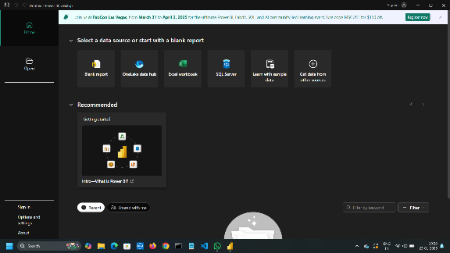 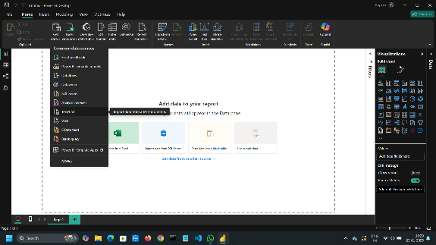

* Open power BI and create a blank file.

* Now click on the GET DATA and select TEST/CSV to import the data set into the power BI.

**STEP 2: View and updating the Data set**

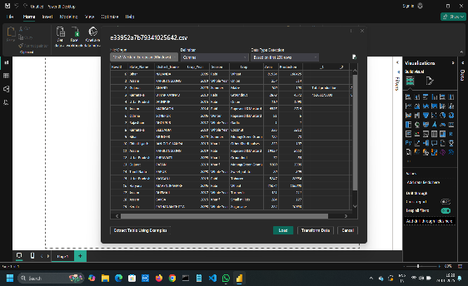 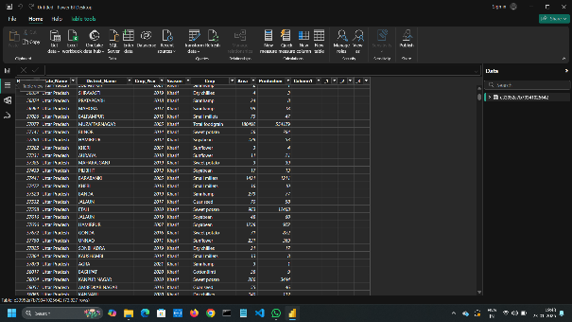

*After importing the file, click on the LOAD option

*Now you can see the file on the right side of the window

*now on the left side, click on the TABLE VIEW.

**STEP 3:TRANSFORM AND DELETING ROWS AND COLUMNS**

Go back to home and click on the transform Data then a new window POWER QUERY EDITOR is opened

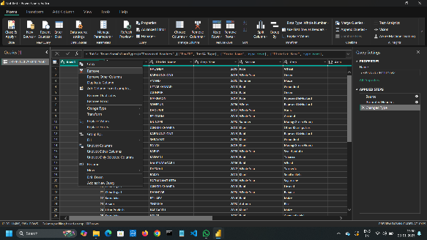 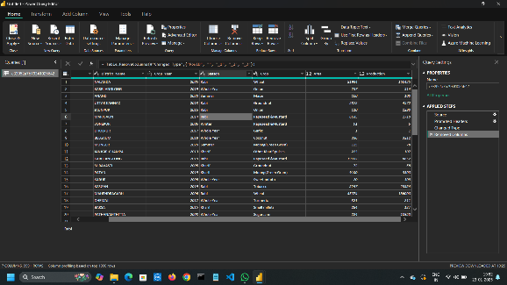

BEFORE AFTER

*we can delete unwanted columns and row .

*select particular row or columns and click delete .

*we can undo the process by clicking cross mark ,on the right side of the window

**STEP 4: CHECKING THE ERROR AND NULL VALUES**

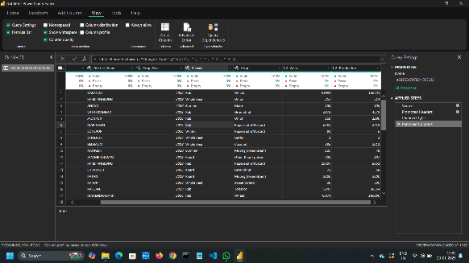 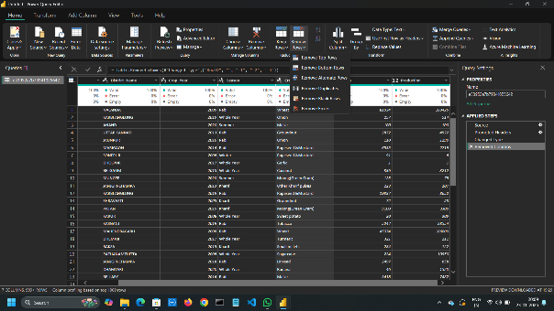

*Go to view ,click on the columns quality ,a box will appear with the data

**STEP 5 : SAVING THE FILE**

Go to the home,click on CLOSE AND APPLY ,AGAIN ON CLOSE AND APPLY to save all the changes on power bi .

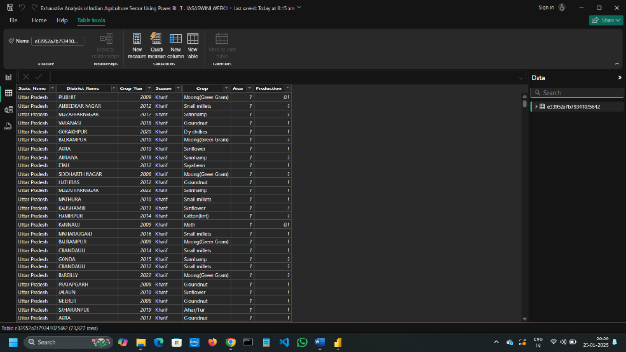

FINAL OUTPUT