Lab 13 – Code Refactoring Using AI Assistance
Name : Asritha
Hall Ticket No.: 2303A51288
Batch No.:05

Task 1: Refactoring – Removing Code Duplication Prompt
Refactor the following legacy Python code by removing duplicated logic and creating a reusable function to calculate the area and perimeter of rectangles. Add proper docstrings.

Legacy Code
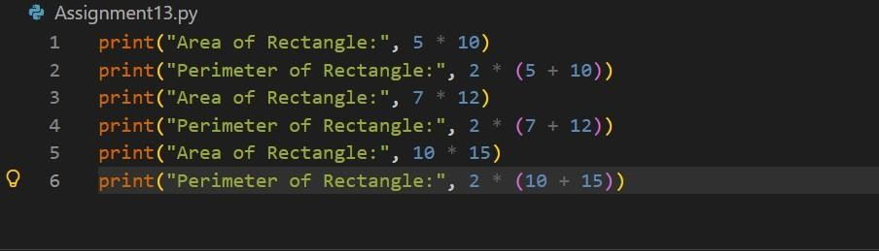
OUTPUT :
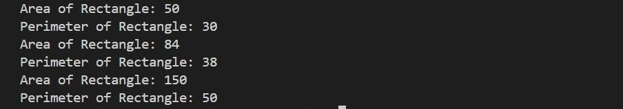

Refactored Code def rectangle_details(length, width):
"""
Calculates and prints the area and perimeter of a rectangle.
Parameters: length (int or float): Length of the rectangle
width (int or float): Width of the rectangle
""" area = length * width perimeter = 2 * (length + width) print("Area of Rectangle:", area) print("Perimeter of Rectangle:", perimeter) rectangle_details(5, 10) rectangle_details(7, 12) rectangle_details(10,
15)
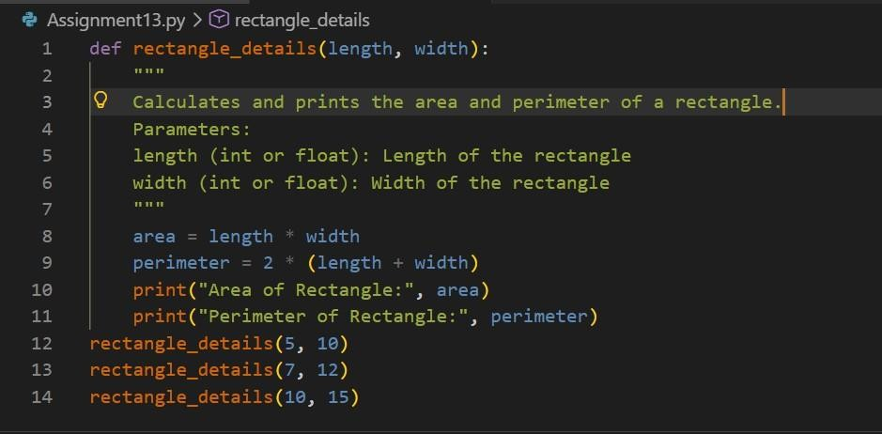
OUTPUT :
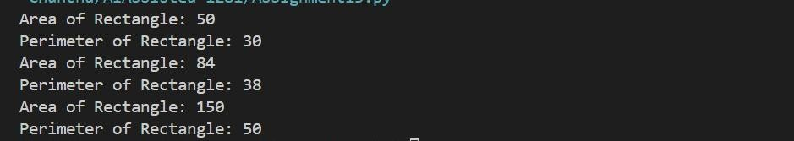

Explanation
- Repeated code blocks were identified.
- A reusable function rectangle_details() was created.
- This improves readability and maintainability.
- If calculations change later, only the function needs modification.

Task 2: Refactoring – Optimizing Loops and Conditionals Prompt
Optimize the following code by replacing inefficient nested loops with a faster data structure such as a set.
Legacy Code
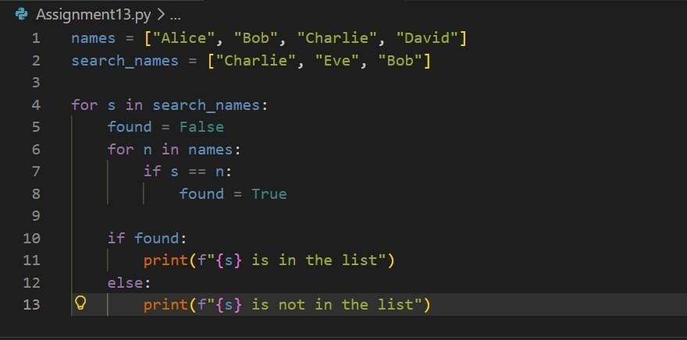
OUTPUT :

Refactored Code
names = ["Alice", "Bob", "Charlie", "David"]
search_names = ["Charlie", "Eve", "Bob"] name_set = set(names) for name in search_names: if name in name_set: print(f"{name} is in the list") else: print(f"{name} is not in the list")
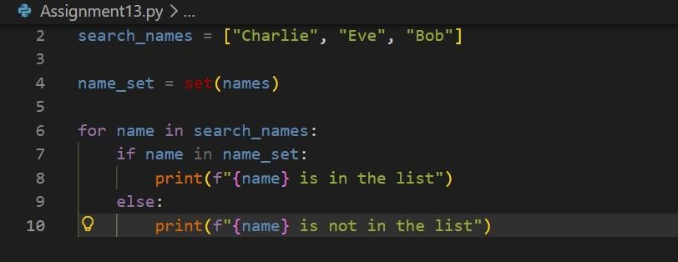
OUTPUT :
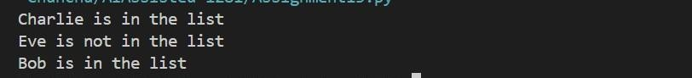

Explanation
- Nested loops have O(n²) complexity.
- Using a set provides O(1) lookup time.
- This improves performance significantly for large datasets.

Performance Comparison
Method Time Complexity
Nested Loop O(n × m)
Set Lookup O(n + m)

Task 3: Refactoring – Extracting Reusable Functions Prompt
Refactor the following script by extracting price and tax calculations into a reusable function called calculate_total(price).

Legacy Code
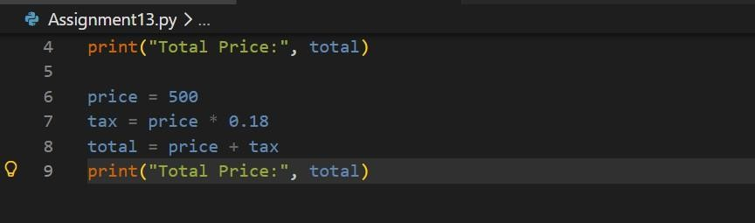
OUTPUT :

Refactored Code
def calculate_total(price):
"""
Calculates total price including tax.

Parameters: price (float): Base price of the product

Returns: float: Total price including tax
""" tax = price * 0.18
total = price + tax return total

print("Total Price:", calculate_total(250)) print("Total
Price:", calculate_total(500))
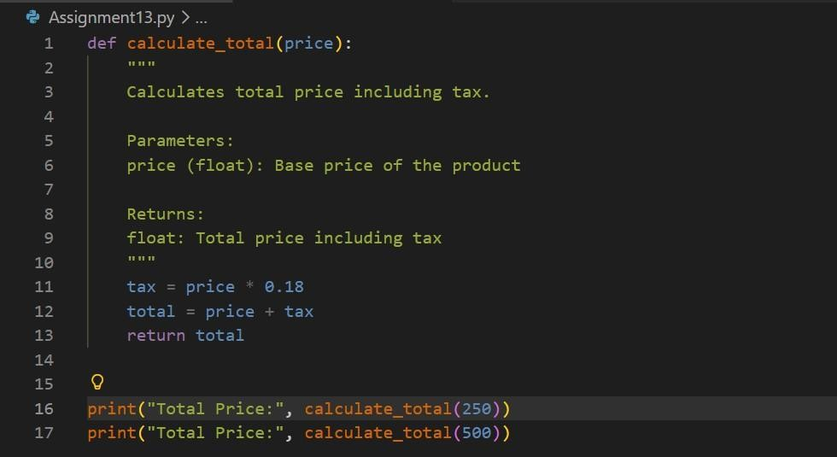
OUTPUT :
Explanation
- Repeated logic moved into calculate_total().
- Improves reusability and clean code structure.
- Function can be reused across different modules.

Task 4: Refactoring – Replacing Hardcoded Values with Constants Prompt Identify magic numbers in the code and replace them with named constants.

Legacy Code
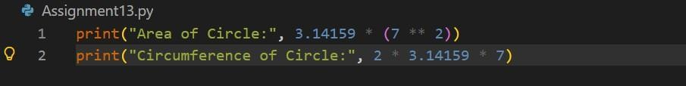
OUTPUT :
Refactored Code PI = 3.14159 RADIUS = 7 area = PI * (RADIUS ** 2) circumference = 2 * PI * RADIUS print("Area of Circle:", area) print("Circumference of Circle:", circumference)
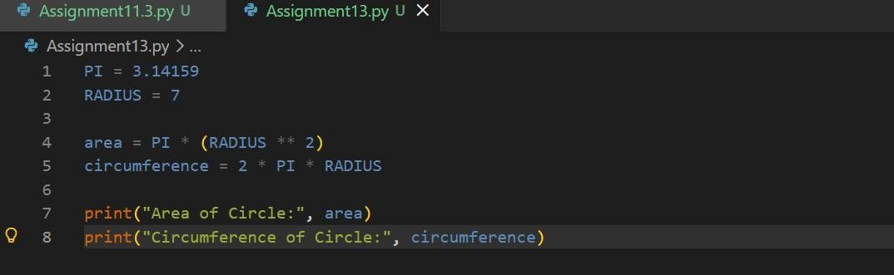
OUTPUT :

Explanation
- Hardcoded values are called magic numbers.
- Replacing them with constants improves readability.
- Constants allow easy updates in one place.

Task 5: Refactoring – Improving Variable Naming and Readability Prompt Improve the readability of the following code by using descriptive variable names and comments.

Legacy Code
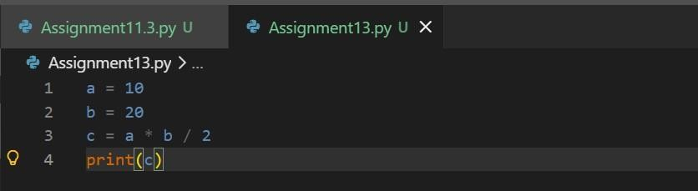
OUTPUT:

Refactored Code
# Base and height of a triangle base = 10 height = 20
# Formula for area of triangle triangle_area
= (base * height) / 2 print(triangle_area)
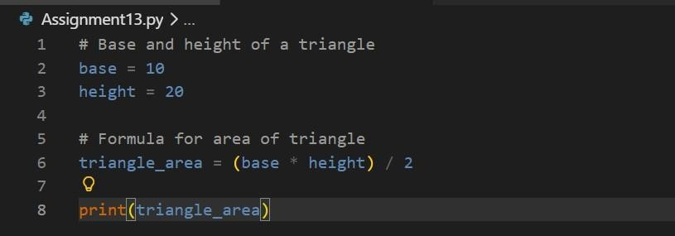
OUTPUT :

Explanation
- Variables a, b, c were unclear.
- Renamed them to base, height, triangle_area.
- Added comments explaining the logic.

