WEEK-8
Aim: Maintaining the transactional history of any user is very important. Explore the various session tracking mechanisms (Cookies, HTTP Session).

Learning Objectives:
• Understand the concept of transactional history and its importance in web applications for tracking user activities and maintaining data consistency across multiple requests.
• Learn about HTTP session tracking mechanisms including server-side session management, session identifiers, and session storage strategies.
• Learn about client-side cookies including cookie attributes, security considerations, persistence, and how they enable stateful communication in stateless HTTP protocols.
• Compare Cookies vs HTTP Sessions by analyzing their differences in storage location, security, scalability, performance, and appropriate use cases.
• Develop practical implementation skills by creating working examples of session management using both cookies and HTTP sessions in real web applications.
• Understand real-world application scenarios where session tracking is critical including user authentication, shopping carts, preference management, and transaction history maintenance.

app.js
const express = require('express');
const session = require('express-session');
const cookieParser = require('cookie-parser');
const app = express();

app.use(express.json());
app.use(express.urlencoded({ extended: true }));
app.use(cookieParser());

app.use(session({
secret: process.env.SESSION_SECRET || 'defaultSecretKey',
resave: false,
saveUninitialized: false,
cookie: {
secure: process.env.NODE_ENV === 'production',
httpOnly: true,
maxAge: 1000*60*60*24
}
}));

app.get('/', (req, res)=>{
try {
let cookieVisits=parseInt(req.cookies.visits) || 0;
cookieVisits++;
res.cookie('visits', cookieVisits, { maxAge: 1000*60*60*24*7 });

req.session.views=(req.session.views || 0)+1;

const sessionStartTime=req.session.startTime || new Date();
if (!req.session.startTime) {
req.session.startTime=sessionStartTime;
}

const sessionDuration=Math.floor((new Date()-sessionStartTime)/1000);

res.send(`
<!DOCTYPE html>
<html lang="en">
<head>
<meta charset="UTF-8">
<meta name="viewport" content="width=device-width, initial-scale=1.0">
<title>Session & Cookie Tracking</title>
<style>
body { font-family: Arial, sans-serif; margin: 40px; background: #f5f5f5; }
.container { background: white; padding: 30px; border-radius: 8px; box-shadow: 0 2px 10px rgba(0,0,0,0.1); max-width: 600px; }
h2 { color: #333; border-bottom: 2px solid #007bff; padding-bottom: 10px; }
.info { margin: 15px 0; padding: 10px; background: #f9f9f9; border-left: 4px solid #007bff; }
.info b { color: #007bff; }
a { display: inline-block; margin-top: 20px; padding: 10px 20px; background: #dc3545; color: white; text-decoration: none; border-radius: 4px; }
a:hover { background: #c82333; }
</style>
</head>
<body>
<div class="container">
<h2>🔍 Session & Cookie Tracking Demo</h2>
<div class="info">
<b>Cookie Visits (Client-Side):</b> ${cookieVisits}
</div>
<div class="info">
<b>Session Visits (Server-Side):</b> ${req.session.views}
</div>
<div class="info">
<b>Session Duration:</b> ${sessionDuration} seconds
</div>
<div class="info">
<b>Session ID:</b> ${req.sessionID.substring(0, 20)}...
</div>
<a href="/logout">🚪 Logout (Destroy Session)</a>
</div>
</body>
</html>
`);
} catch (error) {
res.status(500).send(`<h2>Error: ${error.message}</h2>`);
}
});

app.get('/logout', (req, res)=>{
const sessionID=req.sessionID;
req.session.destroy((err)=>{
if (err) {
return res.status(500).send(`<h2>Error destroying session: ${err.message}</h2>`);
}
res.clearCookie('visits');
res.send(`
<!DOCTYPE html>
<html lang="en">
<head>
<style>
body { font-family: Arial, sans-serif; margin: 40px; background: #f5f5f5; }
.container { background: white; padding: 30px; border-radius: 8px; box-shadow: 0 2px 10px rgba(0,0,0,0.1); max-width: 600px; }
h2 { color: #28a745; }
a { display: inline-block; margin-top: 20px; padding: 10px 20px; background: #007bff; color: white; text-decoration: none; border-radius: 4px; }
</style>
</head>
<body>
<div class="container">
<h2>✅ Session Destroyed Successfully</h2>
<p>Session ID ${sessionID.substring(0, 20)}... has been cleared.</p>
<a href="/">🏠 Go Home</a>
</div>
</body>
</html>
`);
});
});

app.use((err, req, res, next)=>{
console.error(err.stack);
res.status(500).send('<h2>Something went wrong!</h2>');
});

const PORT=process.env.PORT || 3000;
app.listen(PORT, ()=>{
console.log(`✨ Server running at http://localhost:${PORT}`);
});OUTPUT:
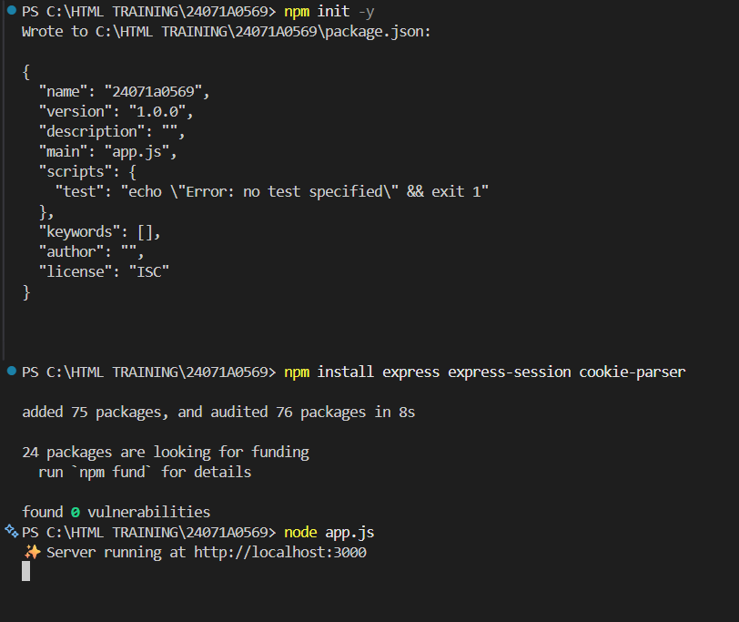
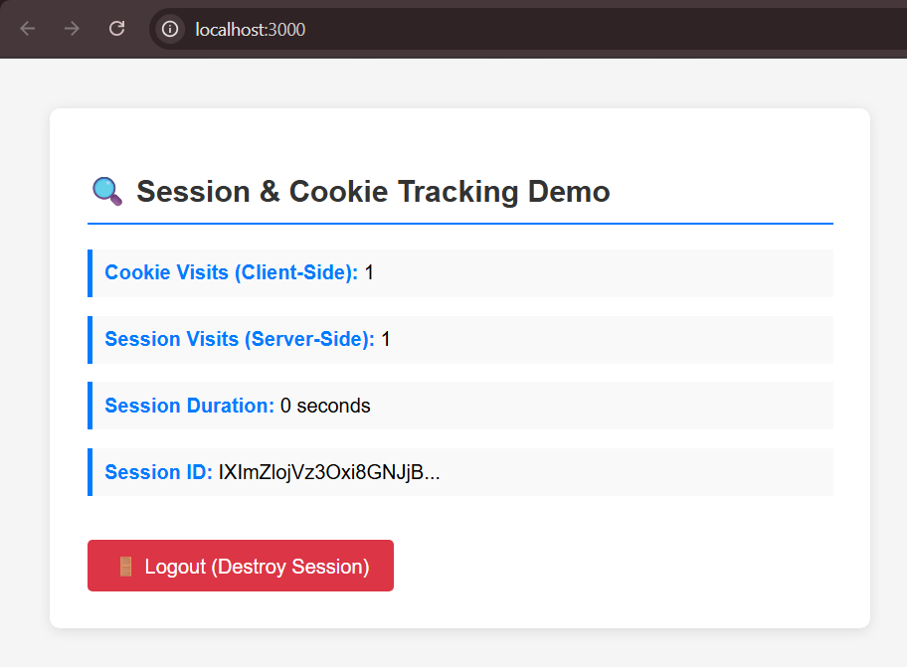

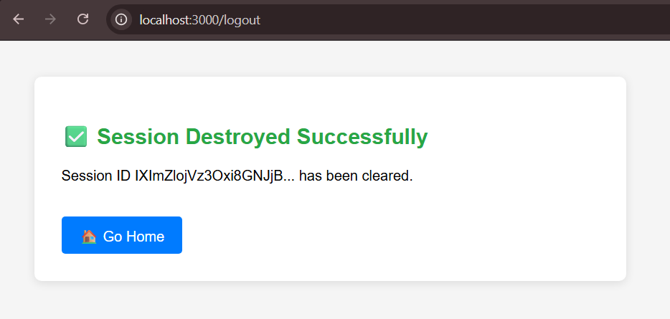

WEEK-9
Aim: Create a custom server using the HTTP module and explore the other modules of NodeJS like OS, path, and events to understand core functionalities and their integration in real-world applications.
Learning Objectives:
- Understand the HTTP module by learning how to create custom web servers, handle incoming requests, process different HTTP methods, and send appropriate responses without relying on frameworks.
- Explore the OS module to retrieve system information including platform details, CPU architecture, available memory, uptime, and other machine-specific data that can be useful for server monitoring and diagnostics.
- Explore the path module to work with file and directory paths in a cross-platform manner, including path joining, resolution, normalization, and extraction of path components like filename and extension.
- Explore the events module to understand the event-driven architecture of NodeJS, create custom event emitters, listen to events, and implement publish-subscribe patterns for asynchronous communication.
- Integrate multiple Node.js core modules by combining HTTP, OS, path, and events modules in a single application to demonstrate how different modules work together seamlessly.
- Develop problem-solving skills by implementing practical scenarios such as server monitoring dashboards, file routing systems, and event-based request handling mechanisms.
- Prepare for real-world applications by understanding how core modules form the foundation of popular frameworks like Express and how they are used in production environments for building scalable and efficient applications.
server.js
const http=require('http');
const os=require('os');
const path=require('path');
const EventEmitter=require('events');

const emitter=new EventEmitter();

emitter.on('requestReceived', (url, method, timestamp)=>{
console.log(`[${timestamp}] ${method} request received for: ${url}`);
});

emitter.on('errorOccurred', (error)=>{
console.error(`Error: ${error}`);
});

const server=http.createServer((req, res)=>{
const timestamp=new Date().toLocaleTimeString();

if (req.url==='/favicon.ico') {
res.writeHead(204);
res.end();
return;
}

emitter.emit('requestReceived', req.url, req.method, timestamp);
if (req.url==='/') {
res.writeHead(200, {'Content-Type': 'text/html; charset=utf-8'});
res.end(`
<!DOCTYPE html>
<html>
<head>
<title>Node.js Core Modules Demo</title>
<style>
body { font-family: Arial; margin: 40px; background: #f5f5f5; }
.container { background: white; padding: 30px; border-radius: 8px; box-shadow: 0 2px 10px rgba(0,0,0,0.1); }
h1 { color: #333; }
a { display: inline-block; margin: 10px 10px 10px 0; padding: 10px 20px; background: #007bff; color: white; text-decoration: none; border-radius: 4px; }
a:hover { background: #0056b3; }
</style>
</head>
<body>
<div class="container">
<h1>🚀 Node.js Core Modules Demo</h1>
<p>Explore the different modules:</p>
<a href="/system">📊 System Information</a>
<a href="/path">📂 Path Information</a>
<a href="/events">⚡ Events Demo</a>
<a href="/performance">⏱️ Performance Info</a>
</div>
</body>
</html>
`);
}

else if (req.url==='/system') {
res.writeHead(200, {'Content-Type': 'text/html; charset=utf-8'});
const cpuInfo=os.cpus();
const cpuModel=cpuInfo[0].model;
const freeMemoryGB=(os.freemem()/(1024**3)).toFixed(2);
const totalMemoryGB=(os.totalmem()/(1024**3)).toFixed(2);

res.end(`
<!DOCTYPE html>
<html>
<head>
<title>System Information</title>
<style>
body { font-family: Arial; margin: 40px; background: #f5f5f5; }
.container { background: white; padding: 30px; border-radius: 8px; max-width: 600px; }
.info-box { margin: 15px 0; padding: 15px; background: #f0f0f0; border-left: 4px solid #007bff; }
.info-box b { color: #007bff; }
a { display: inline-block; margin-top: 20px; padding: 10px 20px; background: #28a745; color: white; text-decoration: none; border-radius: 4px; }
</style>
</head>
<body>
<div class="container">
<h2>📊 System Information (OS Module)</h2>
<div class="info-box">
<b>Platform:</b> ${os.platform()}
</div>
<div class="info-box">
<b>Architecture:</b> ${os.arch()}
</div>
<div class="info-box">
<b>CPU Model:</b> ${cpuModel}
</div>
<div class="info-box">
<b>CPU Cores:</b> ${os.cpus().length}
</div>
<div class="info-box">
<b>Free Memory:</b> ${freeMemoryGB} GB
</div>
<div class="info-box">
<b>Total Memory:</b> ${totalMemoryGB} GB
</div>
<div class="info-box">
<b>Uptime:</b> ${(os.uptime()/3600).toFixed(2)} hours
</div>
<div class="info-box">
<b>Hostname:</b> ${os.hostname()}
</div>
<a href="/">🏠 Go Home</a>
</div>
</body>
</html>
`);
}

else if (req.url==='/path') {
res.writeHead(200, {'Content-Type': 'text/html; charset=utf-8'});
const filePath=path.join(__dirname, 'src', 'demo.txt');
const fileName=path.basename(filePath);
const dirName=path.dirname(filePath);
const extension=path.extname(filePath);
const parsed=path.parse(filePath);

res.end(`
<!DOCTYPE html>
<html>
<head>
<title>Path Information</title>
<style>
body { font-family: Arial; margin: 40px; background: #f5f5f5; }
.container { background: white; padding: 30px; border-radius: 8px; max-width: 600px; }
.info-box { margin: 15px 0; padding: 15px; background: #f0f0f0; border-left: 4px solid #28a745; }
.info-box b { color: #28a745; }
code { background: #e0e0e0; padding: 2px 6px; border-radius: 3px; }
a { display: inline-block; margin-top: 20px; padding: 10px 20px; background: #28a745; color: white; text-decoration: none; border-radius: 4px; }
</style>
</head>
<body>
<div class="container">
<h2>📂 Path Information (Path Module)</h2>
<div class="info-box">
<b>Full Path:</b><br><code>${filePath}</code>
</div>
<div class="info-box">
<b>Filename:</b> ${fileName}
</div>
<div class="info-box">
<b>Directory:</b><br><code>${dirName}</code>
</div>
<div class="info-box">
<b>Extension:</b> ${extension}
</div>
<div class="info-box">
<b>Root:</b> ${parsed.root}
</div>
<div class="info-box">
<b>Base Name:</b> ${parsed.base}
</div>
<a href="/">🏠 Go Home</a>
</div>
</body>
</html>
`);
}

else if (req.url==='/events') {
res.writeHead(200, {'Content-Type': 'text/html; charset=utf-8'});

const eventData={
requestCount: 0,
timestamp: new Date().toLocaleString()
};

emitter.emit('pageViewed', '/events');

res.end(`
<!DOCTYPE html>
<html>
<head>
<title>Events Demo</title>
<style>
body { font-family: Arial; margin: 40px; background: #f5f5f5; }
.container { background: white; padding: 30px; border-radius: 8px; max-width: 600px; }
.info-box { margin: 15px 0; padding: 15px; background: #f0f0f0; border-left: 4px solid #ffc107; }
.info-box b { color: #ffc107; }
a { display: inline-block; margin-top: 20px; padding: 10px 20px; background: #28a745; color: white; text-decoration: none; border-radius: 4px; }
</style>
</head>
<body>
<div class="container">
<h2>⚡ Events Module Demo</h2>
<div class="info-box">
<b>Event Name:</b> pageViewed
</div>
<div class="info-box">
<b>Current Time:</b> ${eventData.timestamp}
</div>
<div class="info-box">
<b>Status:</b> Event emitted successfully
</div>
<div class="info-box">
<b>Description:</b> The Events module allows you to emit and listen to custom events. Check the console for event logs.
</div>
<a href="/">🏠 Go Home</a>
</div>
</body>
</html>
`);
}

else if (req.url==='/performance') {
res.writeHead(200, {'Content-Type': 'text/html; charset=utf-8'});
const uptime=process.uptime();
const uptimeHours=(uptime/3600).toFixed(2);
const memoryUsage=process.memoryUsage();
const heapUsedMB=(memoryUsage.heapUsed/(1024**2)).toFixed(2);
const heapTotalMB=(memoryUsage.heapTotal/(1024**2)).toFixed(2);

res.end(`
<!DOCTYPE html>
<html>
<head>
<title>Performance Info</title>
<style>
body { font-family: Arial; margin: 40px; background: #f5f5f5; }
.container { background: white; padding: 30px; border-radius: 8px; max-width: 600px; }
.info-box { margin: 15px 0; padding: 15px; background: #f0f0f0; border-left: 4px solid #dc3545; }
.info-box b { color: #dc3545; }
a { display: inline-block; margin-top: 20px; padding: 10px 20px; background: #28a745; color: white; text-decoration: none; border-radius: 4px; }
</style>
</head>
<body>
<div class="container">
<h2>⏱️ Server Performance</h2>
<div class="info-box">
<b>Server Uptime:</b> ${uptimeHours} hours
</div>
<div class="info-box">
<b>Heap Used:</b> ${heapUsedMB} MB
</div>
<div class="info-box">
<b>Heap Total:</b> ${heapTotalMB} MB
</div>
<div class="info-box">
<b>Node Version:</b> ${process.version}
</div>
<div class="info-box">
<b>PID:</b> ${process.pid}
</div>
<a href="/">🏠 Go Home</a>
</div>
</body>
</html>
`);
}

else {
res.writeHead(404, {'Content-Type': 'text/html; charset=utf-8'});
res.end(`
<!DOCTYPE html>
<html>
<head>
<style>
body { font-family: Arial; margin: 40px; background: #f5f5f5; }
.container { background: white; padding: 30px; border-radius: 8px; max-width: 600px; }
h2 { color: #dc3545; }
a { display: inline-block; margin-top: 20px; padding: 10px 20px; background: #007bff; color: white; text-decoration: none; border-radius: 4px; }
</style>
</head>
<body>
<div class="container">
<h2>❌ 404 - Page Not Found</h2>
<p>The requested page does not exist.</p>
<a href="/">🏠 Go Home</a>
</div>
</body>
</html>
`);
}
});

emitter.on('pageViewed', (page)=>{
console.log(`Page viewed: ${page} at ${new Date().toLocaleTimeString()}`);
});

server.listen(3000, ()=>{
console.log('🚀 Server running at http://localhost:3000/');
console.log('Available routes: /, /system, /path, /events, /performance');
});

OUTPUT:
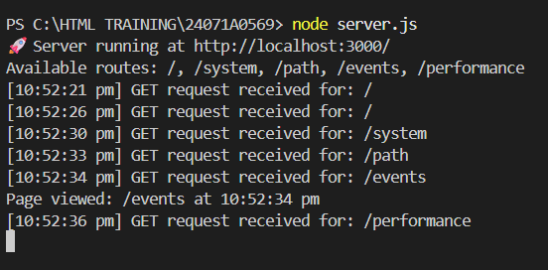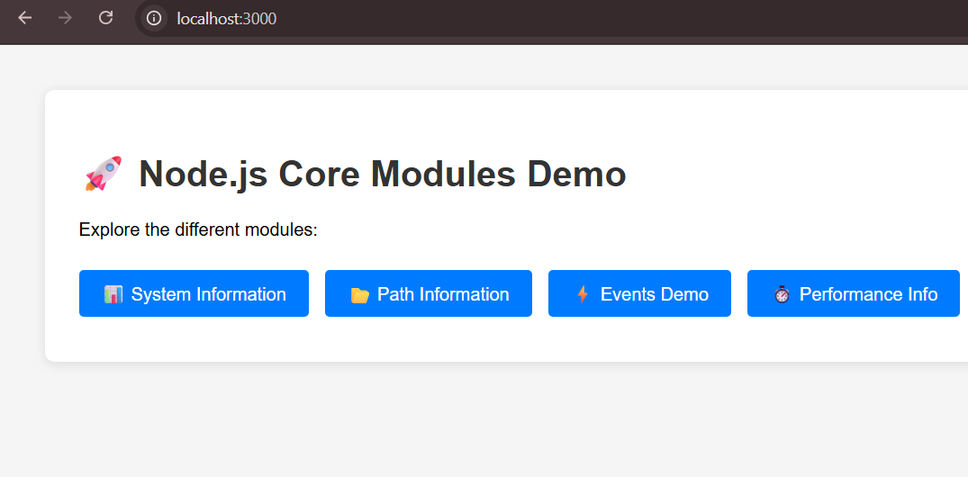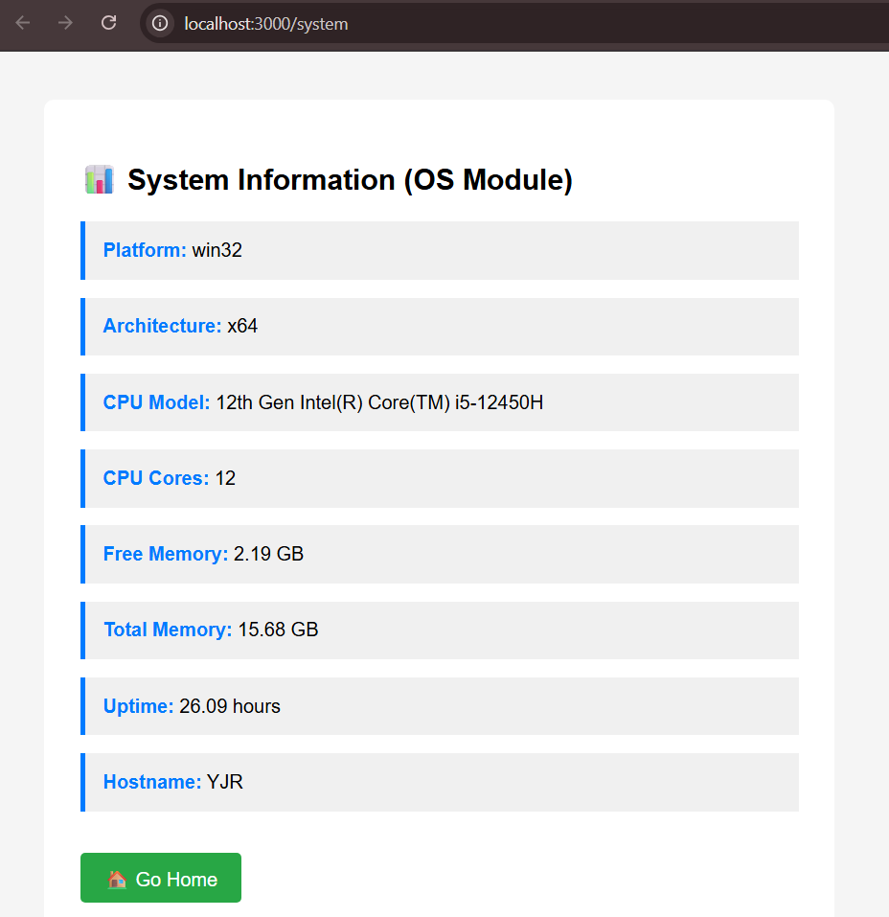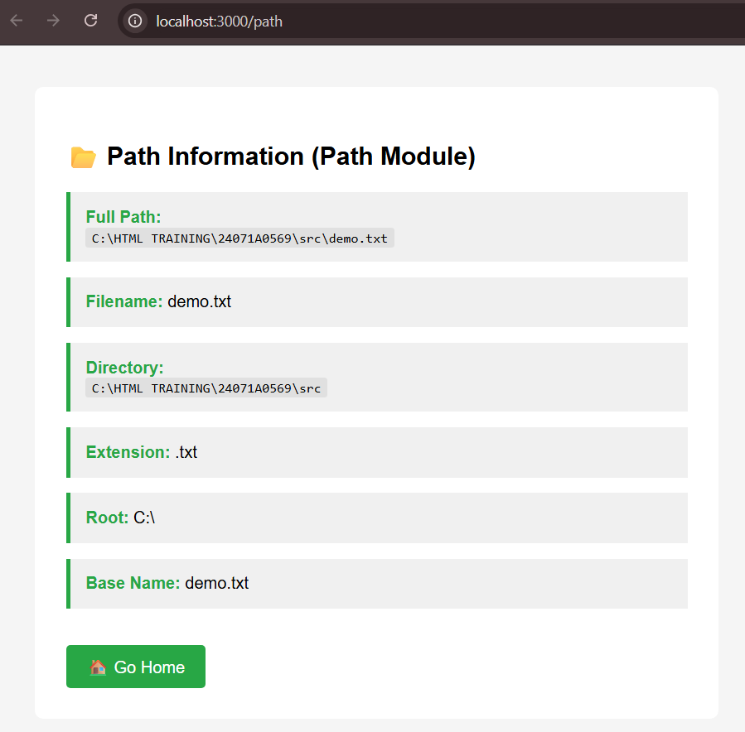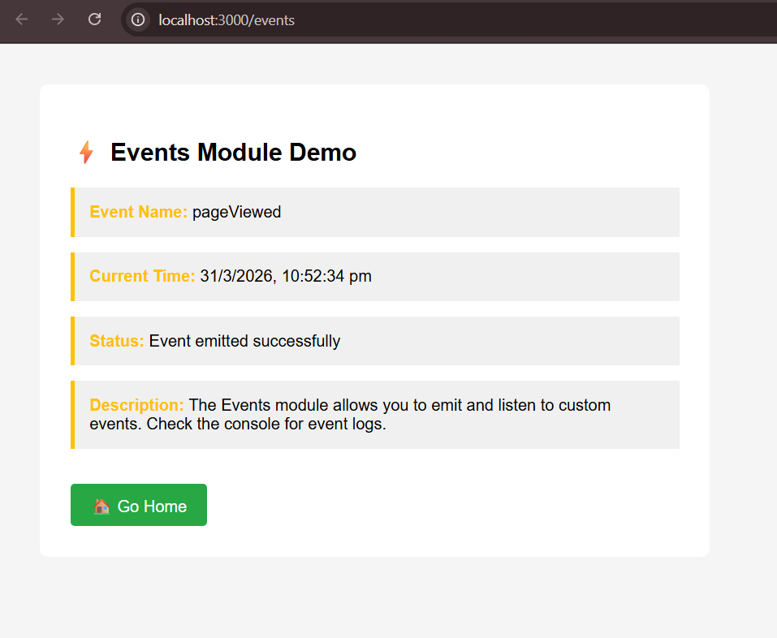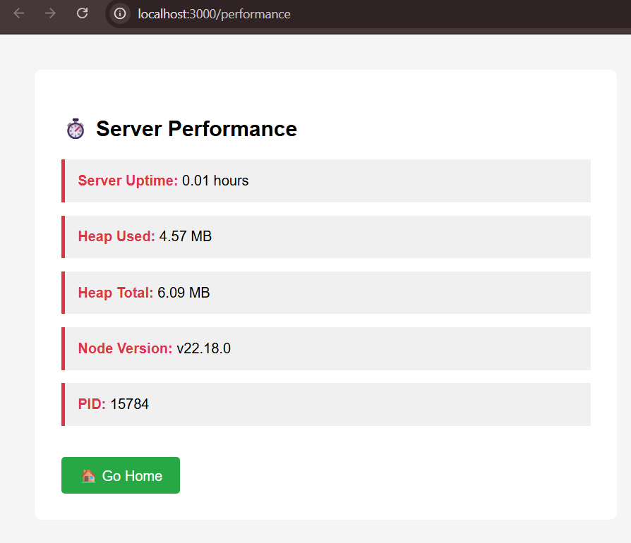

WEEK-3
Aim: Use JavaScript for Doing Client-Side Validation of the Pages Implemented in Experiment 1 and Experiment 2
Objectives of JavaScript:
- To understand the purpose of JavaScript in making web pages interactive and dynamic by enabling real-time user feedback, form validation, event handling, DOM manipulation, and asynchronous communication without page reloads.
- To understand JavaScript syntax, variables, data types, operators, and control structures including variable declarations with var, let, and const, primitive data types such as string, number, boolean, null, and undefined, complex data types like objects and arrays, arithmetic and logical operators, and conditional statements using if-else and switch.
- To understand how to define and use functions, including scope and parameters by creating function declarations and expressions, using arrow functions for concise syntax, understanding function parameters and arguments, utilizing return statements, grasping function scope and closure concepts, and working with callback functions for asynchronous operations.
- To understand how to handle events such as clicks, key presses, and form submissions by using event listeners like onclick, onchange, onsubmit, oninput, onkeypress, and onkeydown to capture user interactions and trigger appropriate JavaScript functions.
- To understand how to work with arrays and objects for storing and organizing data by creating arrays with literals and constructors, using array methods such as map, filter, reduce, forEach, push, pop, shift, and unshift, creating objects with literals and constructors, accessing properties with dot notation and bracket notation, and iterating through collections.
- To understand debugging techniques and error handling using browser developer tools by utilizing console.log for output messages, console.error for error reporting, using browser inspector for examining HTML and CSS, setting breakpoints for step-by-step execution, monitoring network requests in the network tab, and viewing error messages in the console.
- To understand how to build simple interactive applications by combining HTML, CSS, and JavaScript by creating semantic HTML structures, styling with CSS for visual appeal and responsiveness, implementing JavaScript for interactivity and validation, handling user input effectively, providing immediate visual feedback to users, and managing application state throughout the user experience.

Index.html
<!DOCTYPE html>
<html lang="en">
<head>
<meta charset="UTF-8">
<meta name="viewport" content="width=device-width, initial-scale=1.0">
<title>User Registration</title>
<link rel="stylesheet" href="./UserRegistration.css">
</head>
<body>

<h1>User Registration</h1>

<form id="userregform" action="./UserLogin.html">

<label>FIRST NAME</label>
<input type="text" id="fname">

<label>MIDDLE NAME</label>
<input type="text" id="mname">

<label>LAST NAME</label>
<input type="text" id="lname">

<label>Email</label>
<input type="email" id="email">

<label>Age</label>
<input type="number" id="age">

<label>Address</label>
<textarea id="address"></textarea>

<label>Gender</label>
<select id="gender">
<option value="">Select</option>
<option>M</option>
<option>F</option>
<option>Prefer not to say</option>
</select>

<label>Username</label>
<input type="text" id="username">

<label>Password</label>
<input type="password" id="password">

<label>Confirm Password</label>
<input type="password" id="cpassword">

<input type="submit" value="Submit">
</form>

<script>
const form = document.getElementById("userregform");

form.addEventListener("submit", function (e) {
e.preventDefault();

let errors = [];

const fn = document.getElementById("fname").value.trim();
const mn = document.getElementById("mname").value.trim();
const ln = document.getElementById("lname").value.trim();
const em = document.getElementById("email").value.trim();
const age = Number(document.getElementById("age").value);
const address = document.getElementById("address").value.trim();
const g = document.getElementById("gender").value;
const usr = document.getElementById("username").value.trim();
const pwd = document.getElementById("password").value;
const cpwd = document.getElementById("cpassword").value;

const nameRegex = /^[A-Za-z]{3,20}$/;
const emailRegex = /^[^\s@]+@[^\s@]+\.[^\s@]+$/;
const usernameRegex = /^[A-Za-z0-9_]{5,15}$/;
const passwordRegex = /^(?=.*[A-Z])(?=.*\d).{8,}$/;

if (fn === "") errors.push("First Name is required");
if (ln === "") errors.push("Last Name is required");
if (address === "") errors.push("Address is required");

if (fn.length < 3) errors.push("First Name must be at least 3 characters");
if (usr.length < 5 || usr.length > 20)
errors.push("Username must be 5–20 characters long");

if (!nameRegex.test(fn)) errors.push("First Name must contain only letters");
if (!nameRegex.test(mn) && mn !== "")
errors.push("Middle Name must contain only letters");
if (!nameRegex.test(ln)) errors.push("Last Name must contain only letters");

if (isNaN(age) || age < 18 || age > 99)
errors.push("Age must be between 18 and 99");

if (!emailRegex.test(em))
errors.push("Invalid email format");
if (!usernameRegex.test(usr))
errors.push("Username can contain letters, numbers, underscore only");

if (pwd !== cpwd)
errors.push("Password and Confirm Password do not match");

if (usr === pwd)
errors.push("Username and Password cannot be the same");

if (!passwordRegex.test(pwd))
errors.push("Password must contain 1 uppercase letter and 1 number");

if (g === "")
errors.push("Please select Gender");

if (errors.length > 0) {
alert(errors.join("\n"));
return;
}

form.submit();
});
</script>

</body>
</html>
Style.Css
@import url('https://fonts.googleapis.com/css2?family=Poppins:wght@300;400;500;600&display=swap');
* {
margin: 0;
padding: 0;
box-sizing: border-box;
font-family: 'Poppins', sans-serif;
}
body{
position: relative;
min-height: 1000px;
display:flex;
justify-content: center;
align-items: center;
background: linear-gradient(180deg, #69c3ff, #ffffff);
}
form {
background: #ffffff;
width: 450px;
padding: 60px 45px;
border-radius: 15px;
margin-top: 120px;
box-shadow: 0 15px 35px rgba(8, 216, 243, 0.25);
}
h1 {
position:absolute;
text-align: center;
top: 40px;
color: #ffffff;
letter-spacing: 1px;
font-weight: 600;
}
label{
display: block;
margin: 15px 6px;
font-weight: 400;
}

input, select, textarea {
width: 100%;
border-radius: 10px;
border: 1px solid #333;
padding: 10px 12px;
background: #ffffff;
}

input[type="submit"] {
margin-top: 25px;
background: linear-gradient(90deg, #69c3ff, #ffffff);
color: #fff;
border: black;
padding: 12px;
font-size: 15px;
font-weight: 500;
cursor: pointer;
border-radius: 8px;
transition: transform 0.2s ease, box-shadow 0.2s ease;
}
OUTPUT:
