Homework 2

Assad Ahmed

2023-05-22

Table of Contents

#loading in the data

## Rows: 125  
## Columns: 14  
## $ case <chr> "Oxford High School shooting", "San Jose VTA shoo…  
## $ year <dbl> 2021, 2021, 2021, 2021, 2021, 2021, 2020, 2020, 2…  
## $ month <chr> "Nov", "May", "Apr", "Mar", "Mar", "Mar", "Mar", …  
## $ day <dbl> 30, 26, 15, 31, 22, 16, 16, 26, 10, 6, 31, 4, 3, …  
## $ location <chr> "Oxford, Michigan", "San Jose, California", "Indi…  
## $ summary <chr> "Ethan Crumbley, a 15-year-old student at Oxford …  
## $ fatalities <dbl> 4, 9, 8, 4, 10, 8, 4, 5, 4, 3, 7, 9, 22, 3, 12, 5…  
## $ injured <dbl> 7, 0, 7, 1, 0, 1, 0, 0, 3, 8, 25, 27, 26, 12, 4, …  
## $ total_victims <dbl> 11, 9, 15, 5, 10, 9, 4, 5, 7, 11, 32, 36, 48, 15,…  
## $ location_type <chr> "School", "Workplace", "Workplace", "Workplace", …  
## $ male <lgl> TRUE, TRUE, TRUE, TRUE, TRUE, TRUE, TRUE, TRUE, T…  
## $ age_of_shooter <dbl> 15, 57, 19, NA, 21, 21, 31, 51, NA, NA, 36, 24, 2…  
## $ race <chr> NA, NA, "White", NA, NA, "White", NA, "Black", "B…  
## $ prior_mental_illness <chr> NA, "Yes", "Yes", NA, "Yes", NA, NA, NA, NA, NA, …

## # A tibble: 6 × 14  
## case year month day location summary fatalities injured total_victims  
## <chr> <dbl> <chr> <dbl> <chr> <chr> <dbl> <dbl> <dbl>  
## 1 Oxford Hi… 2021 Nov 30 Oxford,… Ethan … 4 7 11  
## 2 San Jose … 2021 May 26 San Jos… Samuel… 9 0 9  
## 3 FedEx war… 2021 Apr 15 Indiana… Brando… 8 7 15  
## 4 Orange of… 2021 Mar 31 Orange,… Aminad… 4 1 5  
## 5 Boulder s… 2021 Mar 22 Boulder… Ahmad … 10 0 10  
## 6 Atlanta m… 2021 Mar 16 Atlanta… Robert… 8 1 9  
## # ℹ 5 more variables: location_type <chr>, male <lgl>, age_of_shooter <dbl>,  
## # race <chr>, prior_mental_illness <chr>

| column(variable) | description |
| --- | --- |
| case | short name of incident |
| year, month, day | year, month, day in which the shooting occurred |
| location | city and state where the shooting occcurred |
| summary | brief description of the incident |
| fatalities | Number of fatalities in the incident, excluding the shooter |
| injured | Number of injured, non-fatal victims in the incident, excluding the shooter |
| total_victims | number of total victims in the incident, excluding the shooter |
| location_type | generic location in which the shooting took place |
| male | logical value, indicating whether the shooter was male |
| age_of_shooter | age of the shooter when the incident occured |
| race | race of the shooter |
| prior_mental_illness | did the shooter show evidence of mental illness prior to the incident? |

* Generate a data frame that summarizes the number of mass shootings per year.

#Create a new dataframe for mass shootings per year called mass_shootings_yearly  
  
mass_shootings_yearly<- mass_shootings %>%   
 #Filter out any NA's  
 filter(!is.na(year)) %>%   
 #group by year and summarize the count of mass shootings  
 group_by(year) %>%   
 summarize(Count = n())  
  
mass_shootings_yearly

## # A tibble: 37 × 2  
## year Count  
## <dbl> <int>  
## 1 1982 1  
## 2 1984 2  
## 3 1986 1  
## 4 1987 1  
## 5 1988 1  
## 6 1989 2  
## 7 1990 1  
## 8 1991 3  
## 9 1992 2  
## 10 1993 4  
## # ℹ 27 more rows

* Generate a bar chart that identifies the number of mass shooters associated with each race category. The bars should be sorted from highest to lowest and each bar should show its number.

#Creating a barchart for number of mass shooters with each race catagory  
mass_shootings %>%   
 #replace NA race entries with 'Unknown'  
 #reorder from most to least frequent race  
 mutate(race= case_when( !is.na(race) ~ race, TRUE ~ 'Other'),race=fct_infreq(race)) %>%  
 #use GGplot to produce a bar char, initialse x variable and aes  
 ggplot(aes(x=race)) +  
 #plot on a barchart  
 geom_bar(fill='#09A1B5',color="#523886") +  
 #add asthetic label  
 geom_text(aes(label = after_stat(count)), stat = "count", vjust = 1.1, colour = "white")

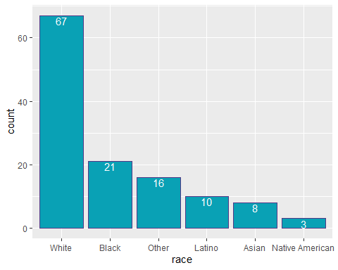

* Generate a boxplot visualizing the number of total victims, by type of location.

#assume total victims means to exclude the shooter from the total  
#manipulate data for the boxplot  
mass_shootings %>%   
 #Filter out for victim count NA  
 filter(!is.na(total_victims)) %>%   
 #replace NA race entries with 'Unknown'  
 mutate(location= case_when( !is.na(location_type) ~ location_type, TRUE ~ 'Other')) %>%  
 #Create a plot  
 ggplot(aes(x=location_type,y=total_victims)) +  
 geom_boxplot(color='darkblue') +  
 #facet zoom to better see the plots on a more reasonable scale due to the outlier  
 facet_zoom(ylim = c(0, 150))

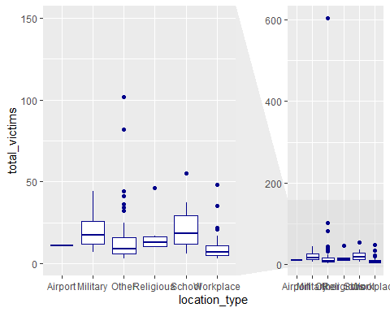

* Redraw the same plot, but remove the Las Vegas Strip massacre from the dataset.

#View data set for las vegas strip massacre only  
mass_shootings %>%   
 #only filter for las vegas strip  
 filter(grepl("Las Vegas Strip",case))

## # A tibble: 1 × 14  
## case year month day location summary fatalities injured total_victims  
## <chr> <dbl> <chr> <dbl> <chr> <chr> <dbl> <dbl> <dbl>  
## 1 Las Vegas… 2017 Oct 1 Las Veg… "Steph… 58 546 604  
## # ℹ 5 more variables: location_type <chr>, male <lgl>, age_of_shooter <dbl>,  
## # race <chr>, prior_mental_illness <chr>

#only shows the 1 entry as required  
  
#assume total victims means to exclude the shooter from the total  
#manipulate data for the boxplot  
mass_shootings %>%   
 #Filter out for victim count NA and for the las vegas strip massacre  
 filter(!is.na(total_victims) & !grepl("Las Vegas Strip",case)) %>%   
 #replace NA race entries with 'Unknown'  
 mutate(location= case_when( !is.na(location_type) ~ location_type, TRUE ~ 'Other')) %>%  
 #Create a plot  
 ggplot(aes(x=location_type,y=total_victims)) +  
 geom_boxplot()

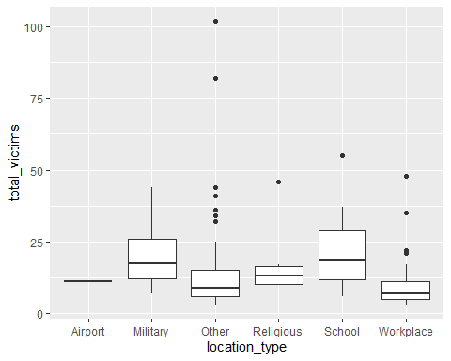

* How many white males with prior signs of mental illness initiated a mass shooting after 2000?

Prior_Mental_2000 <- mass_shootings %>%   
 #Filter for year>= 2000, for white males only  
 filter (year>=2000 & race=='White' & male==TRUE) %>%   
 #Convert NA's to a new category 'Unknown'  
 #this will allow us to see what proportion of mass shooters have a hidden history in terms of mental illness which will help to validate/invalidate any conclusions  
 mutate(prior_mental_illness= case_when( !is.na(prior_mental_illness)   
 ~ prior_mental_illness, TRUE ~ 'Unknown'),  
 #add an arbitary weighting clumn  
 n=1,   
 #add column calculating the % share each case has to the total based on current equal weighting  
 percent=n/sum(n)) %>%  
 #grup by prior_mental_illness  
 group_by(prior_mental_illness) %>%   
 #summarise data for count of each  
 summarize(Count = n(),  
 percent = sum(percent))  
  
Prior_Mental_2000

## # A tibble: 3 × 3  
## prior_mental_illness Count percent  
## <chr> <int> <dbl>  
## 1 No 4 0.0889  
## 2 Unknown 18 0.4   
## 3 Yes 23 0.511

#>50% of white males had a history of prior mental illness since 2000, however >40% also had an unknown history  
#hence it would be be unreliable to draw a conclusion from the data, given the unknoen portion representa a significant portion of the data.  
  
#instead lets exclude the unknowns and see of the cases with known mental health histry what the proportions are if we assume the unknonwn data behaviours can be assimilated by the behaviour ofthe known dataset  
  
Prior_Mental_2000_v2 <- mass_shootings %>%   
 #Filter for year>= 2000, for white males only & exlcude NA values in prior mental ilness  
 filter (year>=2000 & race=='White' & male==TRUE & !is.na(prior_mental_illness)) %>%   
 mutate( #add an arbitary weighting clumn  
 n=1,   
 #add column calculating the % share each case has to the total based on current equal weighting  
 percent=n/sum(n)) %>%  
 #grup by prior_mental_illness  
 group_by(prior_mental_illness) %>%   
 #summarise data for count of each  
 summarize(Count = n(),  
 percent = sum(percent))  
  
Prior_Mental_2000_v2

## # A tibble: 2 × 3  
## prior_mental_illness Count percent  
## <chr> <int> <dbl>  
## 1 No 4 0.148  
## 2 Yes 23 0.852

#of cases with a known history of mental illness for white males since 2000, almost 85% were perpetrated by individuals with a history of mental health issues.  
#We could extrapolate this relation ship and assume the 85% of cases that have a history of prior mental ilness holds  
  
#overall i belive the prior_mental_illness field has too many NA values to produce a strong conclusion on the relationship between cases and mental ilness. However, we can clearly see that a large proportion of cases (>50% at the minimum) show a history of mental illness which shows it is a significant factor, but a valid conclusion on the full extent of the relationship cannot be understood due to the limited data.

* Which month of the year has the most mass shootings? Generate a bar chart sorted in chronological (natural) order (Jan-Feb-Mar- etc) to provide evidence of your answer.

mass_shootings %>%   
 #Filter for any month data missing  
 filter(!is.na(month)) %>%   
 #Group by month  
 group_by(month) %>%   
 #create bar chart  
 ggplot(aes(x=month)) +  
 geom_bar(fill="#2A944D") +   
 #order chronologically  
 scale_x_discrete(limits = month.abb)

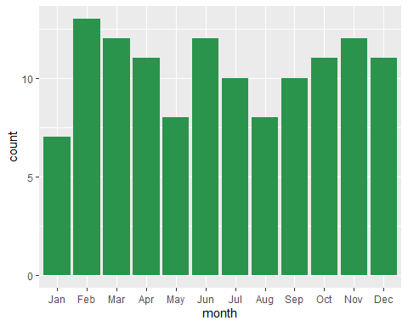

#It can clearly be seen from the bar chart that February is the most dangerous month in term sof number of shootings

* How does the distribution of mass shooting fatalities differ between White and Black shooters? What about White and Latino shooters?

#Create list of races to be compared  
R <- c('Latino','White', 'Black')  
  
#Create a range of bar charts to compare distribution by month  
mass_shootings %>%   
 #Filter for any total victims data missing  
 #Exclude las vegas strip case as it is a large outlier which will inflate the mean  
 filter(!is.na(total_victims) & race %in% R & !grepl("Las Vegas Strip",case)) %>%   
 #create box plot as it is easy to compare IQR and means side by side  
 ggplot(aes(x=race,y=total_victims)) +  
 geom_boxplot(color="darkred",fill="lightblue") +  
 facet_zoom(ylim = c(0, 30))

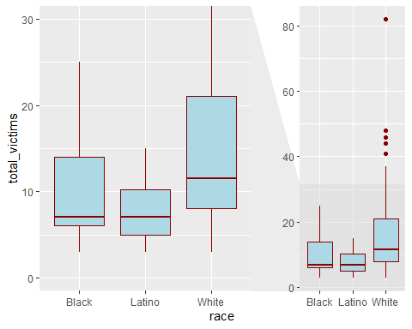

#Black shooters have a lower median and narrower distribution of victims as compared to white shooters  
#Lation shooters also have a lower median number of victims than white shooters, and a significantly narrower IQR vs white shooters.  
#Overall white shooters appear to have a larger number of victims on average, with mass shootings from white shooters covering a wider range of vitim totals as comapred to Balck/Lation  
  
### Very open-ended  
  
#- Are mass shootings with shooters suffering from mental illness different from mass shootings with no #signs of mental illness in the shooter?  
   
#utilise dataframe created earlier comparing Yes/No mental health issues, excuding cases where mental health histroy was unknown  
  
mass_shootings %>%   
 #create unknown catagory for NA's  
 mutate(prior_mental_illness= case_when(!is.na(prior_mental_illness) ~ prior_mental_illness, TRUE ~ 'Unknown')) %>%   
 #group by prior_mental_illness  
 group_by(prior_mental_illness) %>%   
 ggplot(aes(x=prior_mental_illness,y=total_victims)) +  
 geom_boxplot(fill="white",color="red") +  
 facet_zoom(ylim = c(0, 30))

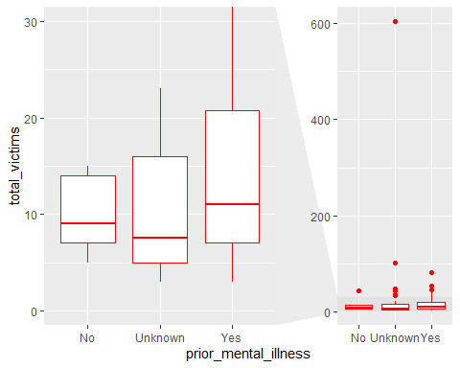

#From the limited data we have on prior mental ilness, we can clearly see that shootings with a history of mental ilness for the shooter on average have a higher total victim count, and a significantly wider range/IQR in the total number of victimis Vs those without a history of mental illness.  
#Again however,we can see from the plot of the cases with an unknown histroy of mental illness that they exhibit a lower median and intermediate IQR when comapred to Yes/No, which could skew the conclusion depending on how those unknown datapoints are catagorised.

* Assess the relationship between mental illness and total victims, mental illness and location type, and the intersection of all three variables.

#Mental ilness and total victims comparison  
mass_shootings %>%   
 #create unknown catagory for NA's  
 mutate(prior_mental_illness= case_when(!is.na(prior_mental_illness) ~ prior_mental_illness, TRUE ~ 'Unknown')) %>%   
 #group by prior_mental_illness  
 group_by(prior_mental_illness) %>%   
 ggplot(aes(x=prior_mental_illness,y=total_victims)) +  
 geom_boxplot() +  
 facet_zoom(ylim = c(0, 30))

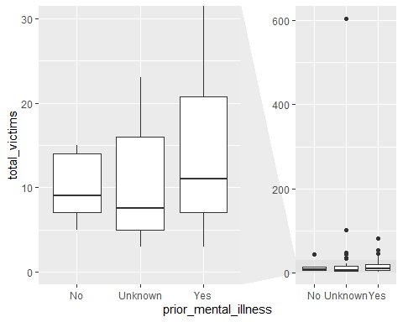

#Explanation from previous  
#From the limited data we have on prior mental ilness, we can clearly see that shootings with a history of mental ilness for the shooter on average have a higher total victim count, and a significantly wider range/IQR in the total number of victimis Vs those without a history of mental illness.  
#Again however,we can see from the plot of the cases with an unknown histroy of mental illness that they exhibit a lower median and intermediate IQR when comapred to Yes/No, which could skew the conclusion depending on how those unknown datapoints are catagorised.   
  
  
#Mental illness and location type comparison  
mass_shootings %>%   
 #create unknown catagory for NA's  
 mutate(prior_mental_illness= case_when(!is.na(prior_mental_illness) ~ prior_mental_illness, TRUE ~ 'Unknown')) %>%   
 #group by prior_mental_illness  
 group_by(location_type, prior_mental_illness) %>%   
 #Summarise count for each catagory  
 summarise(count=n()) %>%   
 #multiple bar chart  
 ggplot(aes(location_type, count, fill = prior_mental_illness)) +  
 geom_bar(stat="identity", position = "dodge")

## `summarise()` has grouped output by 'location_type'. You can override using the  
## `.groups` argument.

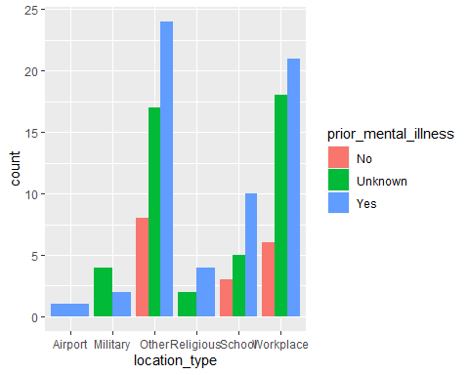

#consistent trend with prior mental illness producing more cases in each location, except in the military where interestingly unknown history of mental illness was the most cases.  
  
#intersection of mental ilness, location, total victims comparison  
mass_shootings %>%   
 #create unknown catagory for NA's  
 mutate(prior_mental_illness= case_when(!is.na(prior_mental_illness) ~ prior_mental_illness, TRUE ~ 'Unknown')) %>%   
 #group by prior_mental_illness  
 group_by(location_type, prior_mental_illness) %>%   
 #multiple bar chart  
 ggplot(aes(location_type, total_victims, fill = prior_mental_illness)) +  
 geom_bar(stat="identity", position = "dodge") +  
 facet_zoom(ylim = c(0, 100))

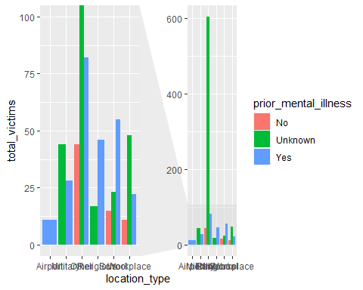

#a consistent trend across all location with a history of mental illness leading to a higher total victim count Vs no history of mental illness.  
#Additonally, cases where prior mental health history is unknown also appear to have a high total victim count which could imply a significant portion of that population may also have a history of mental illness. Although, there is not enough data/information on the data to draw such a conclusion currently.

## Obtain the data

The dataset is too large to be hosted on Canvas or Github, so please download it from dropbox <https://www.dropbox.com/sh/q1yk8mmnbbrzavl/AAAxzRtIhag9Nc_hODafGV2ka?dl=0> and save it in your dsb repo, under the data folder

## Rows: 671,028  
## Columns: 14  
## $ trans_date_trans_time <dttm> 2019-02-22 07:32:58, 2019-02-16 15:07:20, 2019-…  
## $ trans_year <dbl> 2019, 2019, 2019, 2019, 2019, 2019, 2019, 2020, …  
## $ category <chr> "entertainment", "kids_pets", "personal_care", "…  
## $ amt <dbl> 7.79, 3.89, 8.43, 40.00, 54.04, 95.61, 64.95, 3.…  
## $ city <chr> "Veedersburg", "Holloway", "Arnold", "Apison", "…  
## $ state <chr> "IN", "OH", "MO", "TN", "CO", "GA", "MN", "AL", …  
## $ lat <dbl> 40.1186, 40.0113, 38.4305, 35.0149, 39.4584, 32.…  
## $ long <dbl> -87.2602, -80.9701, -90.3870, -85.0164, -106.385…  
## $ city_pop <dbl> 4049, 128, 35439, 3730, 277, 1841, 136, 190178, …  
## $ job <chr> "Development worker, community", "Child psychoth…  
## $ dob <date> 1959-10-19, 1946-04-03, 1985-03-31, 1991-01-28,…  
## $ merch_lat <dbl> 39.41679, 39.74585, 37.73078, 34.53277, 39.95244…  
## $ merch_long <dbl> -87.52619, -81.52477, -91.36875, -84.10676, -106…  
## $ is_fraud <dbl> 0, 0, 0, 0, 0, 0, 0, 0, 0, 0, 0, 0, 0, 0, 0, 0, …

## # A tibble: 6 × 14  
## trans_date_trans_time trans_year category amt city state lat long  
## <dttm> <dbl> <chr> <dbl> <chr> <chr> <dbl> <dbl>  
## 1 2019-02-22 07:32:58 2019 entertainment 7.79 Veede… IN 40.1 -87.3  
## 2 2019-02-16 15:07:20 2019 kids_pets 3.89 Hollo… OH 40.0 -81.0  
## 3 2019-12-27 22:25:34 2019 personal_care 8.43 Arnold MO 38.4 -90.4  
## 4 2019-03-03 10:11:39 2019 grocery_net 40 Apison TN 35.0 -85.0  
## 5 2019-02-09 17:14:54 2019 food_dining 54.0 Red C… CO 39.5 -106.   
## 6 2019-09-09 01:19:59 2019 shopping_net 95.6 Irwin… GA 32.8 -83.2  
## # ℹ 6 more variables: city_pop <dbl>, job <chr>, dob <date>, merch_lat <dbl>,  
## # merch_long <dbl>, is_fraud <dbl>

The data dictionary is as follows

| column(variable) | description |
| --- | --- |
| trans_date_trans_time | Transaction DateTime |
| trans_year | Transaction year |
| category | category of merchant |
| amt | amount of transaction |
| city | City of card holder |
| state | State of card holder |
| lat | Latitude location of purchase |
| long | Longitude location of purchase |
| city_pop | card holder’s city population |
| job | job of card holder |
| dob | date of birth of card holder |
| merch_lat | Latitude Location of Merchant |
| merch_long | Longitude Location of Merchant |
| is_fraud | Whether Transaction is Fraud (1) or Not (0) |

* In this dataset, how likely are fraudulent transactions? Generate a table that summarizes the number and frequency of fraudulent transactions per year.

card_fraud %>%   
 #Filter out transactions without a fraud flag  
 filter(!is.na(is_fraud)) %>%   
 #Group by transaction year  
 group_by(trans_year) %>%   
 #add a count of transactions and calculate frequency as total count/365 days  
 summarise(No_Frauds = n(),  
 Freq_Fraud_per_day = No_Frauds/365,  
 Freq_per_mins= No_Frauds/(365*24*60))

## # A tibble: 2 × 4  
## trans_year No_Frauds Freq_Fraud_per_day Freq_per_mins  
## <dbl> <int> <dbl> <dbl>  
## 1 2019 478646 1311. 0.911  
## 2 2020 192382 527. 0.366

* How much money (in US$ terms) are fraudulent transactions costing the company? Generate a table that summarizes the total amount of legitimate and fraudulent transactions per year and calculate the % of fraudulent transactions, in US$ terms.

Summary_One <- card_fraud %>%   
 #Filter out transactions without a fraud flag or amt  
 filter(!is.na(is_fraud) & !is.na(amt)) %>%   
 #mutate 2 new columns for fraudulent/none fraudulent transaction amt in USD  
 mutate(Amt_Non_Fraudulent = case_when(is_fraud==1 ~ 0, TRUE ~ amt),  
 Amt_Fraudulent = case_when(is_fraud == 0 ~ 0, TRUE ~ amt)) %>%   
 #Group by transaction year  
 group_by(trans_year) %>%   
 #summaries total amount for non-fraudulent, fraudulent transactions, and the % share for fraudulent transactions in term sof value  
 summarise(Total_Non_Fraudulent = sum(Amt_Non_Fraudulent),  
 Total_Fraudulent = sum(Amt_Fraudulent),  
 percent_fraud= Total_Fraudulent/(Total_Non_Fraudulent+Total_Fraudulent))  
  
Summary_One

## # A tibble: 2 × 4  
## trans_year Total_Non_Fraudulent Total_Fraudulent percent_fraud  
## <dbl> <dbl> <dbl> <dbl>  
## 1 2019 32182901. 1423140. 0.0423  
## 2 2020 12925914. 651949. 0.0480

* Generate a histogram that shows the distribution of amounts charged to credit card, both for legitimate and fraudulent accounts. Also, for both types of transactions, calculate some quick summary statistics.

card_fraud %>%   
 #Filter out transactions without a fraud flag or amt  
 filter(!is.na(is_fraud) & !is.na(amt) ) %>%   
 #Group by is fraud  
 group_by(is_fraud) %>%   
 #Create histogram plot  
 ggplot(aes(x=amt)) +  
 geom_histogram() +  
 facet_wrap(~is_fraud, scales = "free")

## `stat_bin()` using `bins = 30`. Pick better value with `binwidth`.

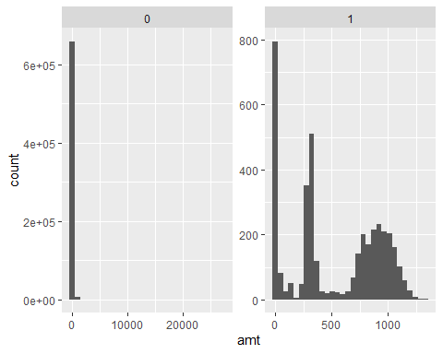

#Summary statistics  
  
#Summary for fraudulent  
skim(card_fraud %>%   
 #Filter out transactions without a fraud flag or amt  
 filter(!is.na(is_fraud) & !is.na(amt) & is_fraud==1 ))

Data summary

|  |  |
| --- | --- |
| Name | %>%(…) |
| Number of rows | 3936 |
| Number of columns | 14 |
| _______________________ |  |
| Column type frequency: |  |
| character | 4 |
| Date | 1 |
| numeric | 8 |
| POSIXct | 1 |
| ________________________ |  |
| Group variables | None |

**Variable type: character**

| skim_variable | n_missing | complete_rate | min | max | empty | n_unique | whitespace |
| --- | --- | --- | --- | --- | --- | --- | --- |
| category | 0 | 1 | 4 | 14 | 0 | 14 | 0 |
| city | 0 | 1 | 3 | 25 | 0 | 699 | 0 |
| state | 0 | 1 | 2 | 2 | 0 | 51 | 0 |
| job | 0 | 1 | 3 | 53 | 0 | 441 | 0 |

**Variable type: Date**

| skim_variable | n_missing | complete_rate | min | max | median | n_unique |
| --- | --- | --- | --- | --- | --- | --- |
| dob | 0 | 1 | 1925-08-29 | 2005-01-29 | 1971-08-20 | 749 |

**Variable type: numeric**

| skim_variable | n_missing | complete_rate | mean | sd | p0 | p25 | p50 | p75 | p100 | hist |
| --- | --- | --- | --- | --- | --- | --- | --- | --- | --- | --- |
| trans_year | 0 | 1 | 2019.31 | 0.46 | 2019.00 | 2019.00 | 2019.00 | 2020.00 | 2020.00 | ▇▁▁▁▃ |
| amt | 0 | 1 | 527.21 | 391.29 | 1.06 | 240.49 | 368.83 | 900.94 | 1334.07 | ▇▇▃▇▂ |
| lat | 0 | 1 | 38.65 | 5.10 | 20.03 | 35.06 | 39.43 | 41.84 | 66.69 | ▁▆▇▁▁ |
| long | 0 | 1 | -89.91 | 14.29 | -165.67 | -96.70 | -86.69 | -79.99 | -68.56 | ▁▁▂▆▇ |
| city_pop | 0 | 1 | 94096.13 | 328508.72 | 23.00 | 741.00 | 2526.00 | 19803.00 | 2906700.00 | ▇▁▁▁▁ |
| merch_lat | 0 | 1 | 38.64 | 5.16 | 19.53 | 35.12 | 39.42 | 41.92 | 67.44 | ▁▆▇▁▁ |
| merch_long | 0 | 1 | -89.91 | 14.30 | -166.40 | -96.72 | -86.88 | -79.91 | -67.57 | ▁▁▂▆▇ |
| is_fraud | 0 | 1 | 1.00 | 0.00 | 1.00 | 1.00 | 1.00 | 1.00 | 1.00 | ▁▁▇▁▁ |

**Variable type: POSIXct**

| skim_variable | n_missing | complete_rate | min | max | median | n_unique |
| --- | --- | --- | --- | --- | --- | --- |
| trans_date_trans_time | 0 | 1 | 2019-01-02 01:06:37 | 2020-06-21 03:59:46 | 2019-09-29 05:54:09 | 3936 |

#Summary for Non-fraudulent  
skim(card_fraud %>%   
 #Filter out transactions without a fraud flag or amt  
 filter(!is.na(is_fraud) & !is.na(amt) & is_fraud==0 ))

Data summary

|  |  |
| --- | --- |
| Name | %>%(…) |
| Number of rows | 667092 |
| Number of columns | 14 |
| _______________________ |  |
| Column type frequency: |  |
| character | 4 |
| Date | 1 |
| numeric | 8 |
| POSIXct | 1 |
| ________________________ |  |
| Group variables | None |

**Variable type: character**

| skim_variable | n_missing | complete_rate | min | max | empty | n_unique | whitespace |
| --- | --- | --- | --- | --- | --- | --- | --- |
| category | 0 | 1 | 4 | 14 | 0 | 14 | 0 |
| city | 0 | 1 | 3 | 25 | 0 | 836 | 0 |
| state | 0 | 1 | 2 | 2 | 0 | 50 | 0 |
| job | 0 | 1 | 3 | 59 | 0 | 475 | 0 |

**Variable type: Date**

| skim_variable | n_missing | complete_rate | min | max | median | n_unique |
| --- | --- | --- | --- | --- | --- | --- |
| dob | 0 | 1 | 1924-10-30 | 2005-01-29 | 1975-11-30 | 894 |

**Variable type: numeric**

| skim_variable | n_missing | complete_rate | mean | sd | p0 | p25 | p50 | p75 | p100 | hist |
| --- | --- | --- | --- | --- | --- | --- | --- | --- | --- | --- |
| trans_year | 0 | 1 | 2019.29 | 0.45 | 2019.00 | 2019.00 | 2019.00 | 2020.00 | 2020.00 | ▇▁▁▁▃ |
| amt | 0 | 1 | 67.62 | 155.29 | 1.00 | 9.60 | 47.17 | 82.41 | 27119.77 | ▇▁▁▁▁ |
| lat | 0 | 1 | 38.54 | 5.08 | 20.03 | 34.62 | 39.35 | 41.89 | 65.69 | ▁▅▇▁▁ |
| long | 0 | 1 | -90.23 | 13.75 | -165.67 | -96.80 | -87.48 | -80.16 | -67.95 | ▁▁▂▆▇ |
| city_pop | 0 | 1 | 88875.59 | 302715.77 | 23.00 | 741.00 | 2456.00 | 20328.00 | 2906700.00 | ▇▁▁▁▁ |
| merch_lat | 0 | 1 | 38.53 | 5.11 | 19.03 | 34.73 | 39.37 | 41.95 | 66.68 | ▁▅▇▁▁ |
| merch_long | 0 | 1 | -90.23 | 13.77 | -166.67 | -96.90 | -87.44 | -80.23 | -66.95 | ▁▁▂▆▇ |
| is_fraud | 0 | 1 | 0.00 | 0.00 | 0.00 | 0.00 | 0.00 | 0.00 | 0.00 | ▁▁▇▁▁ |

**Variable type: POSIXct**

| skim_variable | n_missing | complete_rate | min | max | median | n_unique |
| --- | --- | --- | --- | --- | --- | --- |
| trans_date_trans_time | 0 | 1 | 2019-01-01 00:00:51 | 2020-06-21 12:12:32 | 2019-10-03 16:40:52 | 661249 |

* What types of purchases are most likely to be instances of fraud? Consider category of merchants and produce a bar chart that shows % of total fraudulent transactions sorted in order.

card_fraud %>%   
 #Filter out transactions without a fraud flag or amt  
 filter(!is.na(is_fraud) & !is.na(amt)) %>%   
 #Group by transaction year  
 group_by(category ) %>%   
 #summaries total amount for non-fraudulent, fraudulent transactions, and the % share for fraudulent transactions in term sof value  
 summarise(Total_Fraudulent = sum(is_fraud),  
 Total_Non_Fraudulent = length(is_fraud) -sum(is_fraud),  
 percent_fraud= Total_Fraudulent/(Total_Non_Fraudulent+Total_Fraudulent)) %>%   
 #Order by most to least likely for fraudulent transaction  
 mutate(category =fct_rev(fct_reorder(category,percent_fraud))) %>%   
 #bar chart plot  
 ggplot(aes(x=category, percent_fraud)) +  
 #plot on a barchart  
 geom_col(fill="black") +  
 scale_y_continuous(labels = scales::percent_format()) +  
 theme_economist()

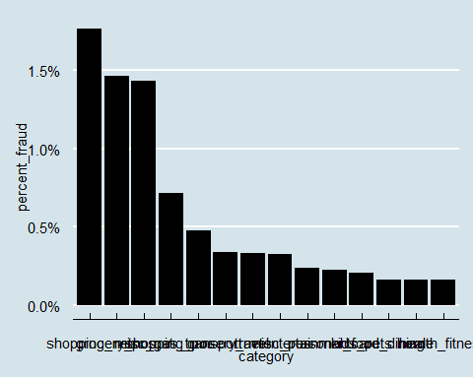 mutate( date_only = lubridate::date(trans_date_trans_time), month_name = lubridate::month(trans_date_trans_time, label=TRUE), hour = lubridate::hour(trans_date_trans_time), weekday = lubridate::wday(trans_date_trans_time, label = TRUE) )

- Are older customers significantly more likely to be victims of credit card fraud? To calculate a customer's age, we use the `lubridate` package and the following code

mutate( age = interval(dob, trans_date_trans_time) / years(1), )

```r  
#When is fraud most prevalent - day,month,year  
  
card_fraud %>%   
#Filter out transactions without a fraud flag or amt  
 filter(!is.na(is_fraud) & !is.na(amt) & is_fraud==1) %>%   
#Seperate trabsaction date into individual fields  
mutate(  
 date_only = lubridate::date(trans_date_trans_time),  
 month_name = lubridate::month(trans_date_trans_time, label=TRUE),  
 hour = lubridate::hour(trans_date_trans_time),  
 weekday = lubridate::wday(trans_date_trans_time, label = TRUE)  
 ) %>%   
#Group by Day & summarise count  
 group_by(weekday) %>%   
 summarise(count=n()) %>%   
#arrange descending  
 arrange(desc(count))

## # A tibble: 7 × 2  
## weekday count  
## <ord> <int>  
## 1 Mon 639  
## 2 Sat 626  
## 3 Sun 608  
## 4 Fri 557  
## 5 Thu 542  
## 6 Tue 496  
## 7 Wed 468

#monday the day with most fraud cases  
  
card_fraud %>%   
#Filter out transactions without a fraud flag or amt  
 filter(!is.na(is_fraud) & !is.na(amt) & is_fraud==1) %>%   
#Seperate trabsaction date into individual fields  
mutate(  
 date_only = lubridate::date(trans_date_trans_time),  
 month_name = lubridate::month(trans_date_trans_time, label=TRUE),  
 hour = lubridate::hour(trans_date_trans_time),  
 weekday = lubridate::wday(trans_date_trans_time, label = TRUE)  
 ) %>%   
#Group by Day & summarise count  
 group_by(month_name) %>%   
 summarise(count=n()) %>%   
#arrange descending to see the most fraudulent months  
 arrange(desc(count))

## # A tibble: 12 × 2  
## month_name count  
## <ord> <int>  
## 1 Mar 472  
## 2 May 472  
## 3 Jan 461  
## 4 Feb 434  
## 5 Jun 387  
## 6 Apr 349  
## 7 Dec 301  
## 8 Nov 226  
## 9 Sep 219  
## 10 Oct 218  
## 11 Aug 213  
## 12 Jul 184

#March and may are tied for the most fraudulent months with 472 cases  
  
card_fraud %>%   
#Filter out transactions without a fraud flag or amt  
 filter(!is.na(is_fraud) & !is.na(amt) & is_fraud==1) %>%   
#Seperate trabsaction date into individual fields  
mutate(  
 date_only = lubridate::date(trans_date_trans_time),  
 month_name = lubridate::month(trans_date_trans_time, label=TRUE),  
 hour = lubridate::hour(trans_date_trans_time),  
 weekday = lubridate::wday(trans_date_trans_time, label = TRUE)  
 ) %>%   
#Group by Day & summarise count  
 group_by(trans_year) %>%   
 summarise(count=n()) %>%   
#arrange descending to see the most fraudulent year  
 arrange(desc(count))

## # A tibble: 2 × 2  
## trans_year count  
## <dbl> <int>  
## 1 2019 2721  
## 2 2020 1215

#2019 had the most fraud cases

* Is fraud related to distance? The distance between a card holder’s home and the location of the transaction can be a feature that is related to fraud. To calculate distance, we need the latidue/longitude of card holders’s home and the latitude/longitude of the transaction, and we will use the [Haversine formula](https://en.wikipedia.org/wiki/Haversine_formula) to calculate distance. I adapted code to [calculate distance between two points on earth](https://www.geeksforgeeks.org/program-distance-two-points-earth/amp/) which you can find below

# distance between card holder's home and transaction  
# code adapted from https://www.geeksforgeeks.org/program-distance-two-points-earth/amp/  
  
  
card_fraud <- card_fraud %>%  
 mutate(  
   
 # convert latitude/longitude to radians  
 lat1_radians = lat / 57.29577951,  
 lat2_radians = merch_lat / 57.29577951,  
 long1_radians = long / 57.29577951,  
 long2_radians = merch_long / 57.29577951,  
   
 # calculate distance in miles  
 distance_miles = 3963.0 * acos((sin(lat1_radians) * sin(lat2_radians)) + cos(lat1_radians) * cos(lat2_radians) * cos(long2_radians - long1_radians)),  
  
 # calculate distance in km  
 distance_km = 6377.830272 * acos((sin(lat1_radians) * sin(lat2_radians)) + cos(lat1_radians) * cos(lat2_radians) * cos(long2_radians - long1_radians))  
   
 )

Plot a boxplot or a violin plot that looks at the relationship of distance and is_fraud. Does distance seem to be a useful feature in explaining fraud?

#Explore relationship for distance of fraud by plotting count of fraud cases by distance_km  
card_fraud %>%  
 mutate(  
   
 # convert latitude/longitude to radians  
 lat1_radians = lat / 57.29577951,  
 lat2_radians = merch_lat / 57.29577951,  
 long1_radians = long / 57.29577951,  
 long2_radians = merch_long / 57.29577951,  
   
 # calculate distance in miles  
 distance_miles = 3963.0 * acos((sin(lat1_radians) * sin(lat2_radians)) + cos(lat1_radians) * cos(lat2_radians) * cos(long2_radians - long1_radians)),  
  
 # calculate distance in km  
 distance_km = 6377.830272 * acos((sin(lat1_radians) * sin(lat2_radians)) + cos(lat1_radians) * cos(lat2_radians) * cos(long2_radians - long1_radians))   
 )%>%   
 ggplot(aes(x=is_fraud,y=distance_km)) +  
 geom_boxplot()

## Warning: Continuous x aesthetic  
## ℹ did you forget `aes(group = ...)`?

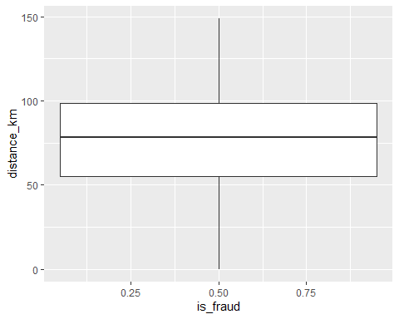

# Exploring sources of electricity production, CO2 emissions, and GDP per capita.

There are many sources of data on how countries generate their electricity and their CO2 emissions. I would like you to create three graphs:

## 1. A stacked area chart that shows how your own country generated its electricity since 2000.

You will use

geom_area(colour="grey90", alpha = 0.5, position = "fill")

## 2. A scatter plot that looks at how CO2 per capita and GDP per capita are related

## 3. A scatter plot that looks at how electricity usage (kWh) per capita/day GDP per capita are related

We will get energy data from the Our World in Data website, and CO2 and GDP per capita emissions from the World Bank, using the wbstatspackage.

# Download electricity data  
url <- "https://nyc3.digitaloceanspaces.com/owid-public/data/energy/owid-energy-data.csv"  
  
energy <- read_csv(url) %>%   
 filter(year >= 1990) %>%   
 drop_na(iso_code) %>%   
 select(1:3,  
 biofuel = biofuel_electricity,  
 coal = coal_electricity,  
 gas = gas_electricity,  
 hydro = hydro_electricity,  
 nuclear = nuclear_electricity,  
 oil = oil_electricity,  
 other_renewable = other_renewable_exc_biofuel_electricity,  
 solar = solar_electricity,  
 wind = wind_electricity,   
 electricity_demand,  
 electricity_generation,  
 net_elec_imports, # Net electricity imports, measured in terawatt-hours  
 energy_per_capita, # Primary energy consumption per capita, measured in kilowatt-hours Calculated by Our World in Data based on BP Statistical Review of World Energy and EIA International Energy Data  
 energy_per_gdp, # Energy consumption per unit of GDP. This is measured in kilowatt-hours per 2011 international-$.  
 per_capita_electricity, # Electricity generation per capita, measured in kilowatt-hours  
 )

## Rows: 21890 Columns: 129  
## ── Column specification ────────────────────────────────────────────────────────  
## Delimiter: ","  
## chr (2): country, iso_code  
## dbl (127): year, population, gdp, biofuel_cons_change_pct, biofuel_cons_chan...  
##   
## ℹ Use `spec()` to retrieve the full column specification for this data.  
## ℹ Specify the column types or set `show_col_types = FALSE` to quiet this message.

# Download data for C02 emissions per capita https://data.worldbank.org/indicator/EN.ATM.CO2E.PC  
  
co2_percap <- wb_data(country = "countries_only",   
 indicator = "EN.ATM.CO2E.PC",   
 start_date = 1990,   
 end_date = 2022,  
 return_wide=FALSE) %>%   
 filter(!is.na(value)) %>%   
 #drop unwanted variables  
 select(-c(unit, obs_status, footnote, last_updated)) %>%   
 rename(year = date,  
 co2percap = value)  
  
  
# Download data for GDP per capita https://data.worldbank.org/indicator/NY.GDP.PCAP.PP.KD  
  
gdp_percap <- wb_data(country = "countries_only",   
 indicator = "NY.GDP.PCAP.PP.KD",   
 start_date = 1990,   
 end_date = 2022,  
 return_wide=FALSE) %>%   
 filter(!is.na(value)) %>%   
 #drop unwanted variables  
 select(-c(unit, obs_status, footnote, last_updated)) %>%   
 rename(year = date,  
 GDPpercap = value)  
   
#glimpse the new dataframes  
glimpse(energy)

## Rows: 6,951  
## Columns: 18  
## $ country <chr> "Afghanistan", "Afghanistan", "Afghanistan", "A…  
## $ year <dbl> 1990, 1991, 1992, 1993, 1994, 1995, 1996, 1997,…  
## $ iso_code <chr> "AFG", "AFG", "AFG", "AFG", "AFG", "AFG", "AFG"…  
## $ biofuel <dbl> NA, NA, NA, NA, NA, NA, NA, NA, NA, NA, 0, 0, 0…  
## $ coal <dbl> NA, NA, NA, NA, NA, NA, NA, NA, NA, NA, 0, 0, 0…  
## $ gas <dbl> NA, NA, NA, NA, NA, NA, NA, NA, NA, NA, 0, 0, 0…  
## $ hydro <dbl> NA, NA, NA, NA, NA, NA, NA, NA, NA, NA, 0.31, 0…  
## $ nuclear <dbl> NA, NA, NA, NA, NA, NA, NA, NA, NA, NA, 0, 0, 0…  
## $ oil <dbl> NA, NA, NA, NA, NA, NA, NA, NA, NA, NA, 0.16, 0…  
## $ other_renewable <dbl> NA, NA, NA, NA, NA, NA, NA, NA, NA, NA, 0, 0, 0…  
## $ solar <dbl> NA, NA, NA, NA, NA, NA, NA, NA, NA, NA, 0.00, 0…  
## $ wind <dbl> NA, NA, NA, NA, NA, NA, NA, NA, NA, NA, 0, 0, 0…  
## $ electricity_demand <dbl> NA, NA, NA, NA, NA, NA, NA, NA, NA, NA, 0.57, 0…  
## $ electricity_generation <dbl> NA, NA, NA, NA, NA, NA, NA, NA, NA, NA, 0.47, 0…  
## $ net_elec_imports <dbl> NA, NA, NA, NA, NA, NA, NA, NA, NA, NA, 0.10, 0…  
## $ energy_per_capita <dbl> 2968.316, 1293.862, 760.342, 650.207, 570.403, …  
## $ energy_per_gdp <dbl> 2.430, 1.154, 0.723, 0.926, 1.113, 0.604, 0.604…  
## $ per_capita_electricity <dbl> NA, NA, NA, NA, NA, NA, NA, NA, NA, NA, 24.050,…

glimpse(gdp_percap)

## Rows: 5,898  
## Columns: 7  
## $ indicator_id <chr> "NY.GDP.PCAP.PP.KD", "NY.GDP.PCAP.PP.KD", "NY.GDP.PCAP.PP…  
## $ indicator <chr> "GDP per capita, PPP (constant 2017 international $)", "G…  
## $ iso2c <chr> "AF", "AF", "AF", "AF", "AF", "AF", "AF", "AF", "AF", "AF…  
## $ iso3c <chr> "AFG", "AFG", "AFG", "AFG", "AFG", "AFG", "AFG", "AFG", "…  
## $ country <chr> "Afghanistan", "Afghanistan", "Afghanistan", "Afghanistan…  
## $ year <dbl> 2021, 2020, 2019, 2018, 2017, 2016, 2015, 2014, 2013, 201…  
## $ GDPpercap <dbl> 1516.306, 1968.341, 2079.922, 2060.699, 2096.093, 2101.42…

glimpse(co2_percap)

## Rows: 5,729  
## Columns: 7  
## $ indicator_id <chr> "EN.ATM.CO2E.PC", "EN.ATM.CO2E.PC", "EN.ATM.CO2E.PC", "EN…  
## $ indicator <chr> "CO2 emissions (metric tons per capita)", "CO2 emissions …  
## $ iso2c <chr> "AF", "AF", "AF", "AF", "AF", "AF", "AF", "AF", "AF", "AF…  
## $ iso3c <chr> "AFG", "AFG", "AFG", "AFG", "AFG", "AFG", "AFG", "AFG", "…  
## $ country <chr> "Afghanistan", "Afghanistan", "Afghanistan", "Afghanistan…  
## $ year <dbl> 2019, 2018, 2017, 2016, 2015, 2014, 2013, 2012, 2011, 201…  
## $ co2percap <dbl> 0.16085016, 0.16536691, 0.13418691, 0.15312098, 0.1761799…

#Join the tables  
energy_GDP <- left_join(energy,gdp_percap,by= c("iso_code"="iso3c","year"))  
energy_gdp_co <- left_join(energy_GDP,co2_percap,by= c("iso_code"="iso3c","year"))  
  
#view joined table  
head(energy_gdp_co)

## # A tibble: 6 × 28  
## country.x year iso_code biofuel coal gas hydro nuclear oil  
## <chr> <dbl> <chr> <dbl> <dbl> <dbl> <dbl> <dbl> <dbl>  
## 1 Afghanistan 1990 AFG NA NA NA NA NA NA  
## 2 Afghanistan 1991 AFG NA NA NA NA NA NA  
## 3 Afghanistan 1992 AFG NA NA NA NA NA NA  
## 4 Afghanistan 1993 AFG NA NA NA NA NA NA  
## 5 Afghanistan 1994 AFG NA NA NA NA NA NA  
## 6 Afghanistan 1995 AFG NA NA NA NA NA NA  
## # ℹ 19 more variables: other_renewable <dbl>, solar <dbl>, wind <dbl>,  
## # electricity_demand <dbl>, electricity_generation <dbl>,  
## # net_elec_imports <dbl>, energy_per_capita <dbl>, energy_per_gdp <dbl>,  
## # per_capita_electricity <dbl>, indicator_id.x <chr>, indicator.x <chr>,  
## # iso2c.x <chr>, country.y <chr>, GDPpercap <dbl>, indicator_id.y <chr>,  
## # indicator.y <chr>, iso2c.y <chr>, country <chr>, co2percap <dbl>

Specific questions:

1. How would you turn energy to long, tidy format?

Utilise Pivot Longer and create an electricity type filed to collapse the multiple columns down to 2 (electricty type and then amount)

1. You may need to join these data frames
   * Use left_join from dplyr to [join the tables](http://r4ds.had.co.nz/relational-data.html)
   * To complete the merge, you need a unique *key* to match observations between the data frames. Country names may not be consistent among the three dataframes, so please use the 3-digit ISO code for each country
2. Write a function that takes as input any country’s name and returns all three graphs. You can use the patchwork package to arrange the three graphs as shown below

# Details

* Who did you collaborate with: NA
* Approximately how much time did you spend on this problem set: 4.5H
* What, if anything, gave you the most trouble: Visual editor stopped working partway thorugh, unable to see previes of code run. Ran out of time to try the grsphs on energy data, initially the code would not work to populate the CO2/GDP data frames (unsure why). i ended up reopenining everything and managed to get it to work,