# Login page

1. Two types of login is here. One for User and another for customer.

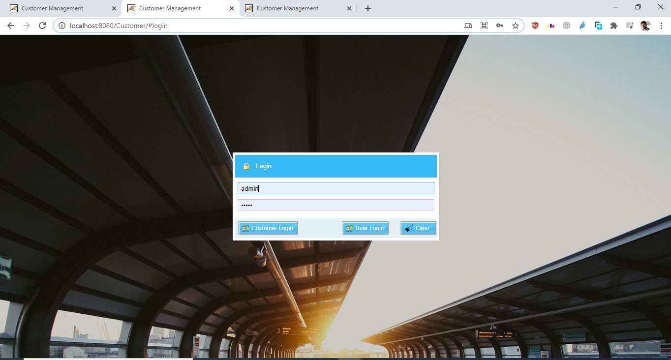

# General User View

1. Showing All existing customer on Home page. You can double click on grid item and update or delete.

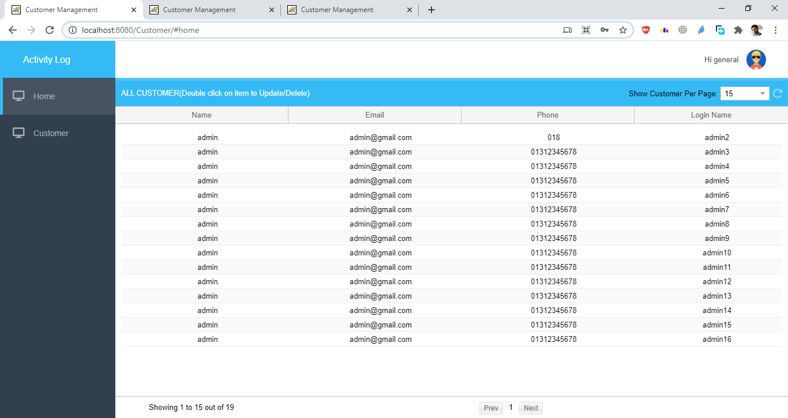

1. Search a customer by login-name. You can double click on grid item and update or delete.

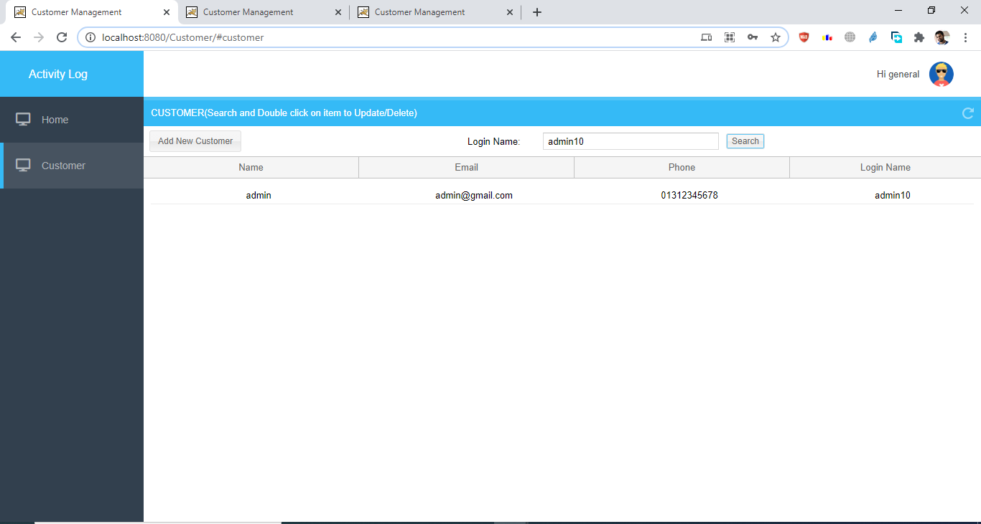

1. You can update or delete from the new window.

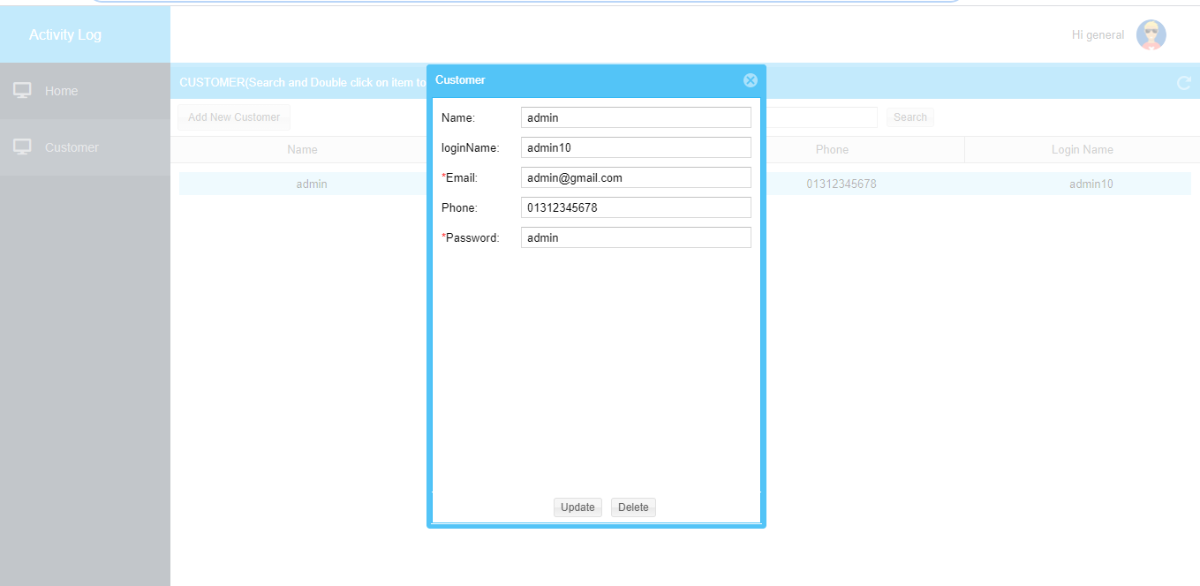

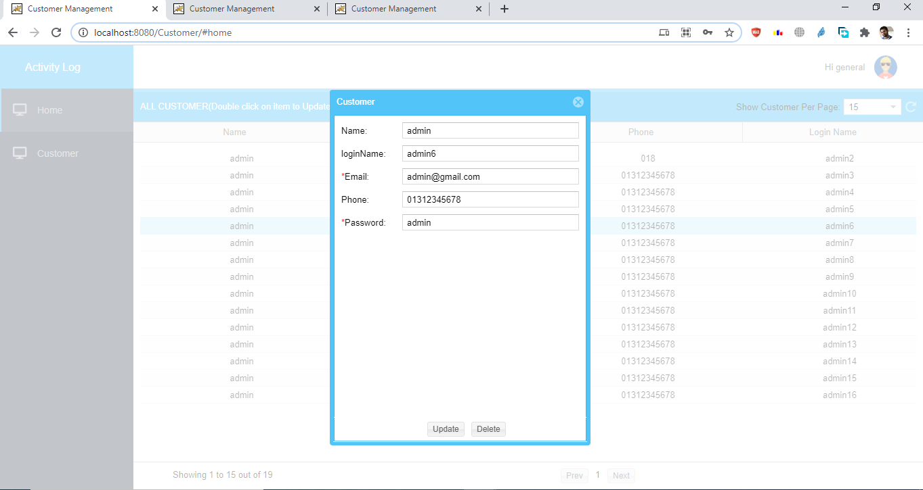

# Admin User View

*** Same fetures of general user. Also Admin will able to see Activity Logs.

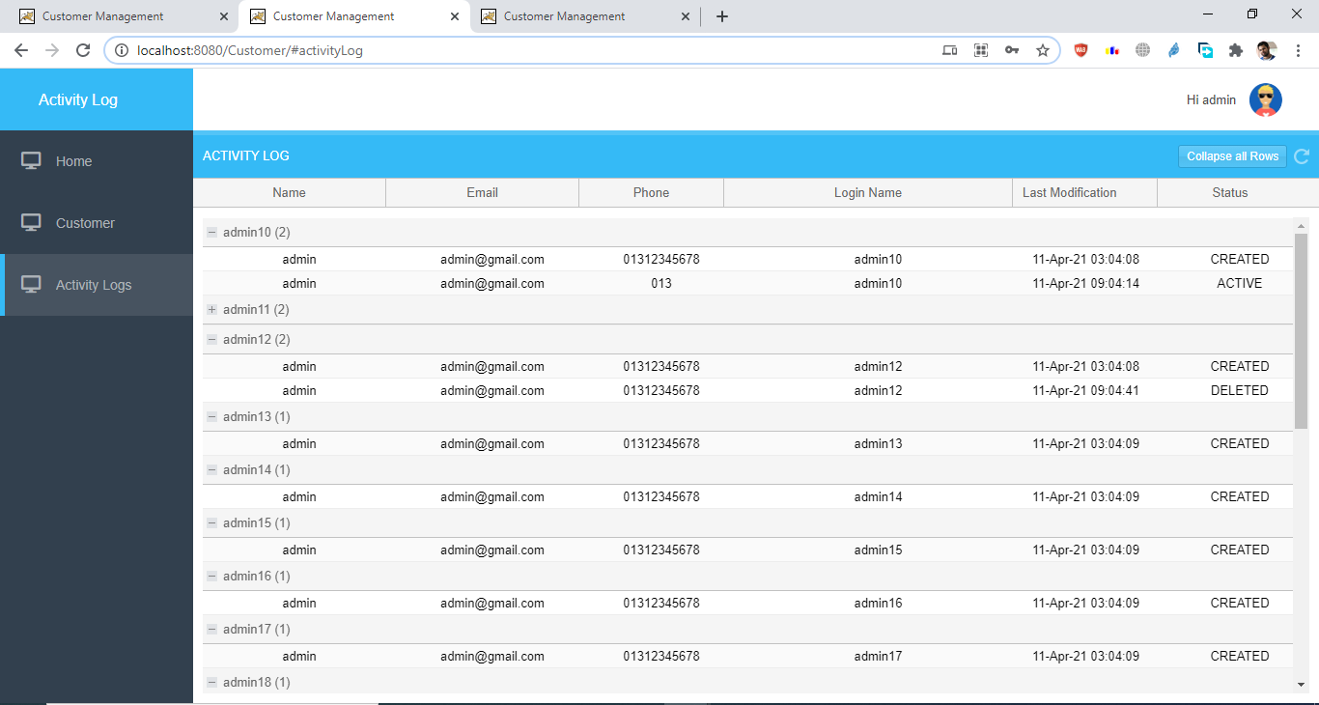

# Customer View

1. Only able to see own information and can only Update , no delete.

