CGS frontend

Software Design Document

|  |  |
| --- | --- |
| Document Owner: | Dafna Kalla |
| Document File: | CGS_frontend_SDD.docx |
| Document Location: | [link](http://turtle.timetoknow.local:8080/svn/dev/t2kdev/trunk/cgs/doc/design/architecture) |

# 

# Revisions

|  |  |  |  |
| --- | --- | --- | --- |
| Revision | Author | Description | Date |
| 0 | Dafna Kalla | First draft | 16/10/12 |
| 1 |  |  |  |
| 2 |  |  |  |

# Table of Contents

Revisions 1

Table of Contents 2

1 Solution, Product Component or Feature Overview 4

1.1 Definitions & Abbreviations 4

1.2 Feature Description 4

1.3 QA Requirements for the Feature 4

1.4 Functionality Overview 4

1.4.1 Behavior/Appearance 4

1.4.2 User Experience and Compliance Requirements 4

1.4.3 Configurability 4

1.4.4 Usage and Procedures 4

1.4.5 Error Handling 4

1.4.6 Database Changes 4

1.4.7 Internalization/Localization 4

1.4.8 Performance 4

1.4.9 Compatibility & Migration 5

1.4.10 Supportability 5

1.4.11 Portability and Platform-Specific Requirements 5

1.4.12 Security 5

1.4.13 Installer Changes 5

1.5 Testing & Exit Criteria 5

1.6 External Dependencies 5

1.6.1 Other T2K applications 5

1.6.2 3rd party libraries 5

1.7 Assumptions 5

2 Architecture 6

2.1 Architectural Block Diagram 6

3 Solution, Product Component or Feature Design 6

3.1 Design Overview 6

3.1.1 Class Diagrams 7

3.2 CGS frontend 8

3.2.1 Class Diagrams 8

3.2.2 CGS init flow 8

3.2.3 CGS Open Book Flow 8

3.2.4 Repo 10

4 Traceability to Requirements 11

5 Open Issues and Future Enhancements 11

6 Risks 11

6.1 Impact 11

6.2 External Risks 11

7 References 11

7.1 3rd party libraries 11

# Solution, Product Component or Feature Overview

## Definitions & Abbreviations

|  |  |
| --- | --- |
| CGS | Content Generation Studio |
| TOC | Table of Content |
| LA | Learning Activity |
| LO | Learning Object |
| DL | Dynamic Layouts |

## Feature Description

The new CGS is a one-stop shop for all T2K content authoring needs. It contains two main editing facilities: The TOC (Curriculum/ book/ course) level editor, and the lesson editor.

## QA Requirements for the Feature

Naming convention for DOM elements should be clear and stable.

## Functionality Overview

### Behavior/Appearance

TBD.

### User Experience and Compliance Requirements

LTR full support and RTL support readiness.

### Configurability

N/A.

### Usage and Procedures

N/A.

### Error Handling

Errors would be reported to console error log.

### Database Changes

N/A.

### Internalization/Localization

I18N should be supported; formatting or style, LTR and RTL language special needs, Language based Strings should be externalized to a file on server.

### Performance

TBD.

### Compatibility & Migration

#### Backward Compatibility

N/A.

#### Platform Compatibility

* OS: Windows/Mac.
* Browsers: only Chrome

#### Migration/Upgrade Requirements

N/A.

### Supportability

N/A.

### Portability and Platform-Specific Requirements

N/A.

### Security

TBD.

### Installer Changes

N/A.

## Testing & Exit Criteria

UnitTesting will be written using Selenium.

## External Dependencies

### Other T2K applications

* CGS Backend - Data is loaded & saved by CGS Backend, the front-End convert data format to the Repo structure.
* DL – The CGS front-End convert the data while packaging to DL data format.
* Assets Catalogue – for fetching assets and embedding them into the book.

### 3rd party libraries

* backbone.js
* bootstrap.js
* require.js
* rivets.js

## Assumptions

N/A.

# Architecture

## Architectural Block Diagram

*User Action*

|  |  |  |
| --- | --- | --- |
| Router | | |
| Screen | Editor |  |
| Tree | Menu | Props |
| Repo | | |

*DB (CGS Backend)*

# 

# Solution, Product Component or Feature Design

## Design Overview

The design is based on MVC design pattern using the *Backbone* library, where the Backbone Router class behaves as the controller.

### Class Diagrams



Global classes:

Repo – The repository of all Book Data. The data is saved in JSON file of this format:

Id: type, data, parentID, childrenIDsArr.

Events – Global event handler class. Used by all inner classes for binding/firing events.

Router – Routes between screens and editors according to editor-id.

Screen classes:

The BookScreen is composited by these classes: Tree, Props, Menu.

These classes compose the structure of relevant Screen.

When retrieving data from repository, each type of data has its relevant editor which has specific menu & properties configuration.

## CGS frontend

### Class Diagrams

### CGS init flow

#### CGS init Description

User opens the CGS.

#### CGS init Sequence Diagram



### CGS Open Book Flow

#### CGS Open Book Description

User presses the "open book" button in the menu to open an existing Book.

#### CGS Open Book Sequence Diagrams

 classes: 

### Repo

#### Repo Description

Following sequence describes 3 useCases:

1. User presses a node in the tree (1-2)
2. User updates existing data (3-5)
3. User asks to see data which contains exterior data inside it, e.g: lesson data containing reference to standards which were defined in book level. (6-8)

#### Repo Sequence Diagrams

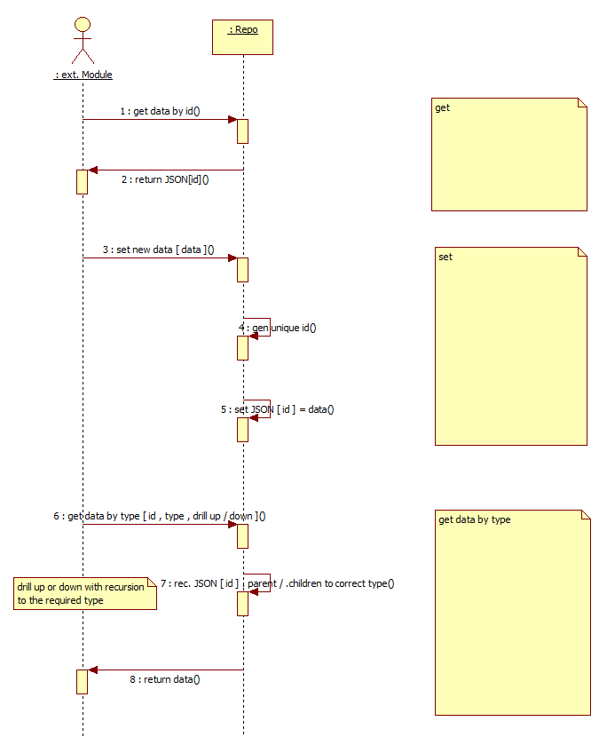

# Traceability to Requirements

| # | Requirement Description | Reference to PRD | Release |
| --- | --- | --- | --- |
| 1 |  |  |  |
| 2 |  |  |  |
| 3 |  |  |  |

# Open Issues and Future Enhancements

N/A.

# Risks

## Impact

N/A.

## External Risks

N/A.

# References

## 3rd party libraries

backbone – <http://backbonejs.org/>

bootstrap – <http://twitter.github.com/bootstrap/>

rivets – <http://rivetsjs.com/>