T2K System Requirements

For CGS 7.0

General Information

|  |  |
| --- | --- |
| File Name | T2K System Requirements for CGS 7.0 |
| Owner | Moshe Kaplan |

Revision History

|  |  |  |
| --- | --- | --- |
| **Rev.** | **Description** | **Date** |
| 1.0 | Initial Version | 04/02/2013 |

# System Requirements

This section summarizes the Hardware and Software requirements for installing and operating the Time to know system. Where possible, the requirements include the Minimal Requirements that ensure the system functions correctly, and Recommended Requirements that improve the system performance.

## User Workstation

|  |  |  |
| --- | --- | --- |
| **Parameter** | **Value** | **Recommended** |
| **Network Configurations Requirements** | | |
| **General** | Ability to connect to local on premises CGS servers. | A 100/1000 Mbps Ethernet based connectivity LAN connectivity |
| **TCP Ports** | Required TCP ports | The following TCP ports should be accessible:  Outbound: 80, 443 |
| ***Hardware Requirements*** | | |
| **Hardware** | **CPU** | *at least Intel i3 (3 GHz)* |
| **Memory** | *4GB* |
| **Disk Space (free)** | *100GB* |
| **Network** | *Ethernet 100/1000 Mbps* |
| **Screen Size** | *Minimum 14'* |
| **Screen Resolution** | *1440*900 (minimum resolution)* |
| **Mouse and Keyboard** | √ |
| **Headphones** | √ |
| **Software Requirements** | | |
| **Software** | **Browser** | Google Chrome Latest |
| **Operating System** | Any supported by Google Chrome Browser |
| **PDF Reader (*)** | Adobe Reader only 8+  * When PDF2Course module is used |

## System Architecture

1. CGS Servers:
   1. Primary server that holds a copy of the database and assets
   2. Secondary server that has a copy of the application and the data and can take control immediately
   3. Arbiter machine that enables secondary machine take over
2. Enterprise server connectivity
   1. Organizational LDAP that is used for users authentication
   2. Assets catalog
   3. Courses Catalog
   4. DNS that includes A records for both Primary and Secondary machines.

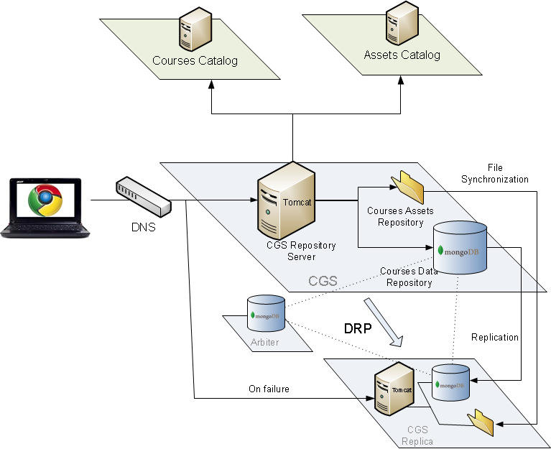

## Enterprise Infrastructure

### LDAP

The CGS login module requires integration to the organization LDAP.

|  |  |
| --- | --- |
| **Item** | **Specification** |
| Manufacturer + Model | 1. Microsoft Active Directory (Windows 2003 or 2008)  2. LDAP compliant directory |

## Cloud servers

### Hardware

**Primary and Secondary Machines**:

|  |  |
| --- | --- |
| **Item** | **Specification** |
| Manufacturer + Model | VM Machine |
| CPU | 1 CPU with 4 cores (equivalent to 4 Amazon EC2 Compute Units) |
| Memory | 8 GB |
| OS | CentOS 6.2.  64 bit operation system. |
| I/O performance | Moderate |
| Hard disk | 60 GB SAS 10K RPM for system partitions  And, assets data and mongoDB data |

**Arbiter Machine**:

|  |  |
| --- | --- |
| **Item** | **Specification** |
| Manufacturer + Model | VM Machine |
| CPU | 1 CPU with 1 cores (equivalent to 1 Amazon EC2 Compute Units) |
| Memory | 0.5 GB |
| OS | CentOS 6.2.  64 bit operation system. |
| IO/ performance | Moderate |
| Hard disk | 6 GB SAS 10K RPM for system partitions and mongoDB configuration and basic data |