# Documentation Shared v1.1.0

The Shared Unity Asset Pack is used in our other Game Framework modules (Unity Asset Packs) to share scripts, materials, prefabs and more across the different projects.

# 

## Features

* Universal Quit function for the Unity Editor and game builts
* Simple capsule dummy prefab for player and enemy

## Demo

You can find the demo scene under Assets/Demo/DemoScenes/Shared.

## Integrating

Check <https://github.com/Assambra/Shared/blob/main/UNITYPACKAGEMANAGER.md> if you need to install additionally packages via the Unity Package Manager.

Get the latest Asset Pack <https://github.com/Assambra/Shared/releases> and add it into your Unity Project.

## Folder Structure

We always use the same folder structure in all asset packs, so that the modules can integrate seamlessly.

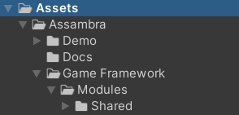

Demo

There you will find all demo related assets. If you don't need the demo, you can simply delete this folder.

### Docs

Documentations folder for the Game Framework and Modules

### Game Framework

Under the Modules folder are modules like this one (Shared) with their respective module assets.