# uMMORPG_HeadInfo

HeadInfo shows the name of the entity in a WorldSpace Canvas/Panel instead the text mesh. If the entity is a player character the guild name is shown. Optional the healthbar is permanently shown on player character. It also displays health if the entity is the player's target. If the entity is a Npc the quest signs are shown over the head Info. In addition, you can attack the target with the Q key, if you press again the attack mode will be terminated and the attack will be stopped. The HeadInfo panel has three different states.

1. The name is always displayed.
2. The target is selected, a white target icon and the health bar is displayed.
3. The target is attacked by the player, the target icon changes the color to red and the health bar is still displayed.

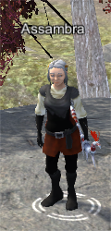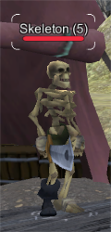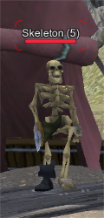

## Read this passage carefully!

I'm not a professional programmer, programming is just a hobby for me. This addon is free, but use is made without guarantee and at your own risk. Bad things happen and they will! I suggest you try and test it out first in a new uMMORPG project. If not always backup your existing project!

## How to use it easy way

If you have made no changes to your player and monster prefabs you can use these from the addon.

### Monster prefabs:

Simply place monster entities in the hierarchy and change the position.

### Player Prefabs:

Use the addon player entities instead of the old one. (NetworkManagerMMO Spawn Info -> Registered Spawnable Prefabs).

## How to use it hard way

If you have made any changes to your prefabs or want to use other prefabs using this HeadInfo panel.

In our example we take the Skeleton it has the Monster.cs script component. For a Player = Player.cs and so on.

Duplicate an existing prefab or use your own to add the HeadInfo. Drag it into the hierarchy and add the CanvasHeadInfo prefab to your prefab. That you can find in Addons / Assambra / HeadInfo / Prefabs / UI. You can adjust the position in the y axis of the CanvasHeadInfo with changing the values of Adjustment Head Info Y in the UIHeadInfo script component.

Insert into the Head Info field (Monster script component in your Skeleton Giant Prefab) the HeadInfo from your Skeleton Giant Prefab.

Now go to the HeadInfo (UIHeadInfo script component in your Skeleton Giant Prefab) and put the Skeleton Giant in the field ThisEntity.

Find the 3D Model from you prefab and insert into the Model3D slot from the UIHeadInfo script component. This is to adjust automatically the hight of the Head Info panel. If you plan to scale your model for example a buff that increase the size, then scale the 3D Model not the whole entity GameObject so it works properly.

UIHeadInfo and Monster script component should look like this:

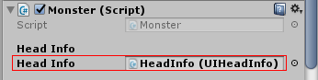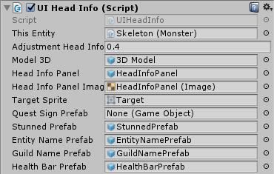

Disable NameOverlay and GuildOverlay in the Skeleton Giant Prefab (for Npc you need to disable QuestOverlay). That we do not have to make any core changes, in our case Monster.cs look for the header text meshes and set them all to none(null).

Do not forget to save the prefab and delete it from the hierarchy.

Last thing uMMORPG use Q for the quest window. You have two choices change what I prefer the value in the uMMORPG Canvas/Quests UIQuests script component Hot Key.

Or Search for Input.GetKeyDown(KeyCode.Q) in the Addon Player.cs two times and change it.