**JAVA编程进阶上机报告**



**学 院 智能与计算学部**

**专 业 软件工程**

**班 级 五班**

**学 号 3018216235**

**姓 名 赵浩喆**

1. **实验内容**

# JAVA进阶第四次实验：矩阵相乘

第四次实验是使用多线程编程技术，编写矩阵乘法。

## 要求

* 编写矩阵随机生成类 MatrixGenerator 类，随机生成任意大小的矩阵，矩阵单元使用 double 存储。
* 使用串行方式实现矩阵乘法。
* 使用多线程方式实现矩阵乘法。
* 比较串行和并行两种方式使用的时间，利用第三次使用中使用过的 jvm状态查看命令，分析产生时间差异的原因是什么。

## 说明

矩阵乘法的方式不再赘述，由于矩阵乘法具有独立性，故可以使用多个线程来分别计算。

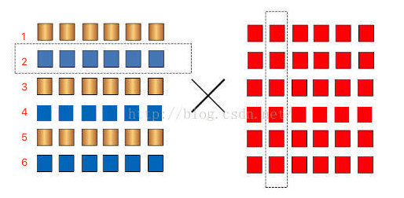

如图，图中的矩阵1可以分块成黄色和蓝色两部分，黄色：1， 3， 5。蓝色：2、4、6。于是我们可以使用两个线程对两种颜色分别计算，最后合并成一个结果。

分块的方式有很多种，这里可以按照行分，也可以按照列分，也可以分成四个3*3的子矩阵。

实验中需要大家分析不同的矩阵大小，不同的线程数，其时间产生的影响，同时也要保证结果的正确性，可以使用串行方法的结果作为标准，与多线程的方法进行比较。（可以使用断言进行判断：assert func1.res == func2.res;，断言开启方式在VM options 加上 -ea 即可）

注意，生成的两个矩阵相乘需要有意义（a * b · b * c）

**二、UML图：**

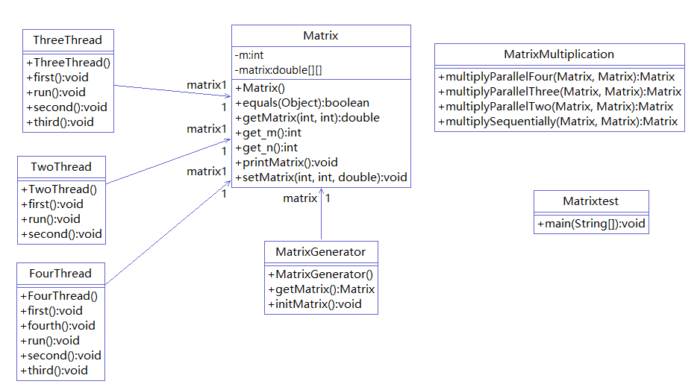

三、源代码：

**import** java.util.Arrays;

**public** **class** Matrix

{

**private** **double** [][] matrix;

**private** **int** m, n;

**public** Matrix(**int** m, **int** n)

{

**this**.m = m;

**this**.n = n;

**this**.matrix = **new** **double**[m][n];

}

**public** **double**[][] getMatrix()

{

**return** matrix;

}

**public** **double** getMatrix(**int** m, **int** n)

{

**return** matrix[m][n];

}

**public** **void** setMatrix(**int** i, **int** j, **double** a)

{

**if** (i <= **this**.m && j <= **this**.n)

{

**this**.matrix[i][j] = a;

}

}

**public** **void** printMatrix()

{

**for** (**int** i = 0; i < **this**.m; i++)

{

**for** (**int** j = 0; j < **this**.n; j++)

{

System.***out***.print(**this**.matrix[i][j] + " ");

}

System.***out***.println();

}

}

**public** **int** get_m()

{

**return** m;

}

**public** **int** get_n()

{

**return** n;

}

@Override

**public** **boolean** equals(Object obj)

{

**if** (obj == **null**)

{

**return** **false** ;

}

**else**

{

**if** (obj **instanceof** Matrix)

{

Matrix c = (Matrix) obj;

**if** (**this**.m != c.get_m() || **this**.n != c.get_n())

{

**return** **false**;

}

**else**

{

**for** (**int** i = 0; i < **this**.m; i++)

{

**for** (**int** j = 0; j < **this**.n; j++)

{

**if** (**this**.matrix[i][j] != c.getMatrix(i, j))

{

**return** **false**;

}

}

}

**return** **true**;

}

}

**else**

{

**return** **false**;

}

}

}

}

**import** java.util.Random;

**public** **class** MatrixGenerator

{

**private** Matrix matrix;

**public** MatrixGenerator(**int** m, **int** n)

{

**this**.matrix = **new** Matrix(m, n);

**this**.initMatrix();

}

**public** **void** initMatrix()

{

Random r = **new** Random();

**for** (**int** i = 0; i < **this**.matrix.get_m(); i++)

{

**for** (**int** j = 0; j < **this**.matrix.get_n(); j++)

{

**this**.matrix.setMatrix(i, j, r.nextInt(100));

}

}

}

**public** Matrix getMatrix()

{

**return** **this**.matrix;

}

}

**public** **class** MatrixMultiplication

{

**public** **static** Matrix multiplySequentially(Matrix x, Matrix y)//串行

{

**int** a = x.get_m();

**int** b1 = x.get_n();

**int** b2 = y.get_m();

**int** c = y.get_n();

**if** (b1 == b2)

{

Matrix result = **new** Matrix(a, c);

**for** (**int** i = 0; i < a; i++)

{

**for** (**int** j = 0; j < c; j++)

{

**double** sum = 0;

**for** (**int** k = 0; k < b1; k++)

{

sum += x.getMatrix(i, k) * y.getMatrix(k, j);

}

result.setMatrix(i, j, sum);

}

}

**return** result;

}

**else**

{

**return** **null**;

}

}

**public** **static** Matrix multiplyParallelTwo(Matrix x, Matrix y) **throws** InterruptedException//二线程

{

**int** a = x.get_m();

**int** b1 = x.get_n();

**int** b2 = y.get_m();

**int** c = y.get_n();

**if** (b1 == b2)

{

Matrix result = **new** Matrix(a, c);

TwoThread tt = **new** TwoThread(x, y, result);

Thread thread1 = **new** Thread(tt, "线程1");

Thread thread2 = **new** Thread(tt, "线程2");

thread1.start();

// thread1.join();

thread2.start();

// thread2.join();

**while** (thread1.isAlive() || thread2.isAlive()){}

**return** result;

}

**else**

{

**return** **null**;

}

}

**public** **static** Matrix multiplyParallelThree(Matrix x, Matrix y) **throws** InterruptedException//三线程

{

**int** a = x.get_m();

**int** b1 = x.get_n();

**int** b2 = y.get_m();

**int** c = y.get_n();

**if** (b1 == b2)

{

Matrix result = **new** Matrix(a, c);

ThreeThread tt = **new** ThreeThread(x, y, result);

Thread thread1 = **new** Thread(tt, "线程1");

Thread thread2 = **new** Thread(tt, "线程2");

Thread thread3 = **new** Thread(tt, "线程3");

thread1.start();

// thread1.join();

thread2.start();

// thread2.join();

thread3.start();

// thread3.join();

**while** (thread1.isAlive() || thread2.isAlive() || thread3.isAlive()){}

**return** result;

}

**else**

{

**return** **null**;

}

}

**public** **static** Matrix multiplyParallelFour(Matrix x, Matrix y) **throws** InterruptedException//四线程

{

**int** a = x.get_m();

**int** b1 = x.get_n();

**int** b2 = y.get_m();

**int** c = y.get_n();

**if** (b1 == b2)

{

Matrix result = **new** Matrix(a, c);

FourThread tt = **new** FourThread(x, y, result);

Thread thread1 = **new** Thread(tt, "线程1");

Thread thread2 = **new** Thread(tt, "线程2");

Thread thread3 = **new** Thread(tt, "线程3");

Thread thread4 = **new** Thread(tt, "线程4");

thread1.start();

// thread1.join();

thread2.start();

// thread2.join();

thread3.start();

// thread3.join();

thread4.start();

// thread4.join();

**while** (thread1.isAlive() || thread2.isAlive() || thread3.isAlive() || thread4.isAlive()){}

**return** result;

}

**else**

{

**return** **null**;

}

}

}

**class** TwoThread **implements** Runnable

{

Matrix matrix1, matrix2, result;

**public** TwoThread(Matrix matrix1, Matrix matrix2, Matrix result)

{

**this**.matrix1 = matrix1;

**this**.matrix2 = matrix2;

**this**.result = result;

}

@Override

**public** **void** run()

{

**if** (Thread.*currentThread*().getName().equals("线程1"))

{

first();

}

**else** **if** (Thread.*currentThread*().getName().equals("线程2"))

{

second();

}

}

**public** **void** first()

{

**for** (**int** i = 0; i < matrix1.get_m(); i += 2)

{

**for** (**int** j = 0; j < matrix2.get_n(); j++)

{

**double** sum = 0;

**for** (**int** k = 0; k < matrix1.get_n(); k++)

{

sum += matrix1.getMatrix(i, k) * matrix2.getMatrix(k, j);

}

result.setMatrix(i, j, sum);

}

}

}

**public** **void** second()

{

**for** (**int** i = 1; i < matrix1.get_m(); i += 2)

{

**for** (**int** j = 0; j < matrix2.get_n(); j++)

{

**double** sum = 0;

**for** (**int** k = 0; k < matrix1.get_n(); k++)

{

sum += matrix1.getMatrix(i, k) * matrix2.getMatrix(k, j);

}

result.setMatrix(i, j, sum);

}

}

}

}

**class** ThreeThread **implements** Runnable

{

Matrix matrix1, matrix2, result;

**public** ThreeThread(Matrix matrix1, Matrix matrix2, Matrix result)

{

**this**.matrix1 = matrix1;

**this**.matrix2 = matrix2;

**this**.result = result;

}

@Override

**public** **void** run()

{

**if** (Thread.*currentThread*().getName().equals("线程1"))

{

first();

}

**else** **if** (Thread.*currentThread*().getName().equals("线程2"))

{

second();

}

**else** **if** (Thread.*currentThread*().getName().equals("线程3"))

{

third();

}

}

**public** **void** first()

{

**for** (**int** i = 0; i < matrix1.get_m(); i += 3)

{

**for** (**int** j = 0; j < matrix2.get_n(); j++)

{

**double** sum = 0;

**for** (**int** k = 0; k < matrix1.get_n(); k++)

{

sum += matrix1.getMatrix(i, k) * matrix2.getMatrix(k, j);

}

result.setMatrix(i, j, sum);

}

}

}

**public** **void** second()

{

**for** (**int** i = 1; i < matrix1.get_m(); i += 3)

{

**for** (**int** j = 0; j < matrix2.get_n(); j++)

{

**double** sum = 0;

**for** (**int** k = 0; k < matrix1.get_n(); k++)

{

sum += matrix1.getMatrix(i, k) * matrix2.getMatrix(k, j);

}

result.setMatrix(i, j, sum);

}

}

}

**public** **void** third()

{

**for** (**int** i = 2; i < matrix1.get_m(); i += 3)

{

**for** (**int** j = 0; j < matrix2.get_n(); j++)

{

**double** sum = 0;

**for** (**int** k = 0; k < matrix1.get_n(); k++)

{

sum += matrix1.getMatrix(i, k) * matrix2.getMatrix(k, j);

}

result.setMatrix(i, j, sum);

}

}

}

}

**class** FourThread **implements** Runnable

{

Matrix matrix1, matrix2, result;

**public** FourThread(Matrix matrix1, Matrix matrix2, Matrix result)

{

**this**.matrix1 = matrix1;

**this**.matrix2 = matrix2;

**this**.result = result;

}

@Override

**public** **void** run()

{

**if** (Thread.*currentThread*().getName().equals("线程1"))

{

first();

}

**else** **if** (Thread.*currentThread*().getName().equals("线程2"))

{

second();

}

**else** **if** (Thread.*currentThread*().getName().equals("线程3"))

{

third();

}

**else** **if** (Thread.*currentThread*().getName().equals("线程4"))

{

fourth();

}

}

**public** **void** first()

{

**for** (**int** i = 0; i < matrix1.get_m(); i += 4)

{

**for** (**int** j = 0; j < matrix2.get_n(); j++)

{

**double** sum = 0;

**for** (**int** k = 0; k < matrix1.get_n(); k++)

{

sum += matrix1.getMatrix(i, k) * matrix2.getMatrix(k, j);

}

result.setMatrix(i, j, sum);

}

}

}

**public** **void** second()

{

**for** (**int** i = 1; i < matrix1.get_m(); i += 4)

{

**for** (**int** j = 0; j < matrix2.get_n(); j++)

{

**double** sum = 0;

**for** (**int** k = 0; k < matrix1.get_n(); k++)

{

sum += matrix1.getMatrix(i, k) * matrix2.getMatrix(k, j);

}

result.setMatrix(i, j, sum);

}

}

}

**public** **void** third()

{

**for** (**int** i = 2; i < matrix1.get_m(); i += 4)

{

**for** (**int** j = 0; j < matrix2.get_n(); j++)

{

**double** sum = 0;

**for** (**int** k = 0; k < matrix1.get_n(); k++)

{

sum += matrix1.getMatrix(i, k) * matrix2.getMatrix(k, j);

}

result.setMatrix(i, j, sum);

}

}

}

**public** **void** fourth()

{

**for** (**int** i = 3; i < matrix1.get_m(); i += 4)

{

**for** (**int** j = 0; j < matrix2.get_n(); j++)

{

**double** sum = 0;

**for** (**int** k = 0; k < matrix1.get_n(); k++)

{

sum += matrix1.getMatrix(i, k) * matrix2.getMatrix(k, j);

}

result.setMatrix(i, j, sum);

}

}

}

}

**public** **class** Matrixtest

{

**public** **static** **void** main(String[] args) **throws** InterruptedException

{

**int** size = 20;

Matrix matrix1 = **new** MatrixGenerator(size, size).getMatrix();

Matrix matrix2 = **new** MatrixGenerator(size, size).getMatrix();

**long** time1 = System.*nanoTime*();

Matrix resultSequentially = MatrixMultiplication.*multiplySequentially*(matrix1, matrix2);

**long** time2 = System.*nanoTime*();

Matrix resultParallelTwoThread = MatrixMultiplication.*multiplyParallelTwo*(matrix1, matrix2);

**long** time3 = System.*nanoTime*();

Matrix resultParallelThreeThread = MatrixMultiplication.*multiplyParallelThree*(matrix1, matrix2);

**long** time4 = System.*nanoTime*();

Matrix resultParallelFourThread = MatrixMultiplication.*multiplyParallelFour*(matrix1, matrix2);

**long** time5 = System.*nanoTime*();

**assert** resultSequentially.equals(resultParallelTwoThread);

**assert** resultSequentially.equals(resultParallelThreeThread);

**assert** resultSequentially.equals(resultParallelFourThread);

System.***out***.println("==============================================");

System.***out***.print("size of Matrix: " + size + " * " + size +"\n");

System.***out***.print("serial method : " + (time2 - time1) + "ns\n");

System.***out***.print("Two threads : " + (time3 - time2) + "ns\n");

System.***out***.print("Three threads: " + (time4 - time3) + "ns\n");

System.***out***.print("Four threads: " + (time5 - time4) + "ns\n");

System.***out***.println("==============================================");

}

}

**四、实验结果：**

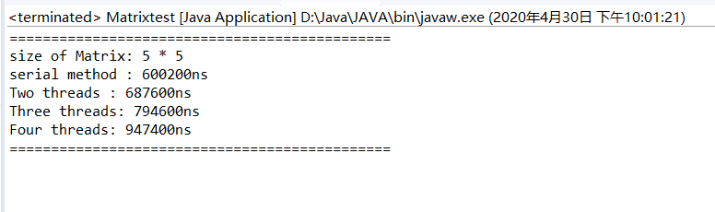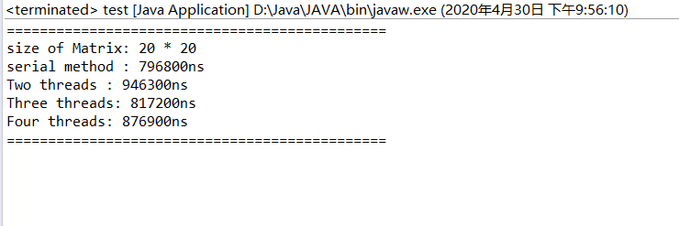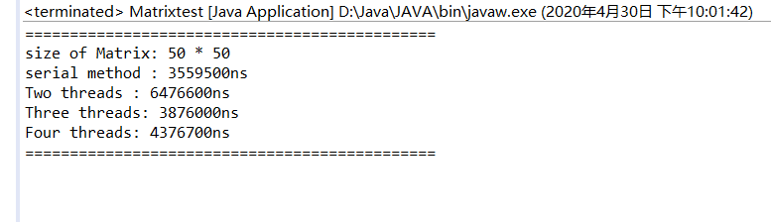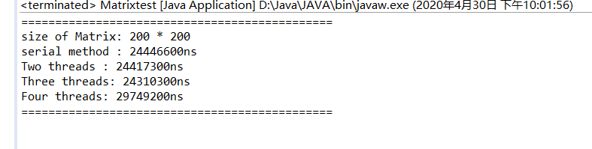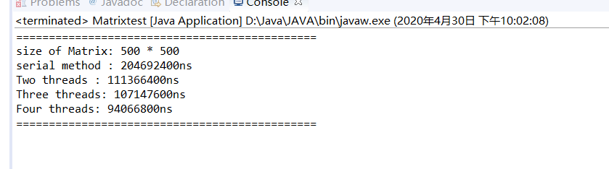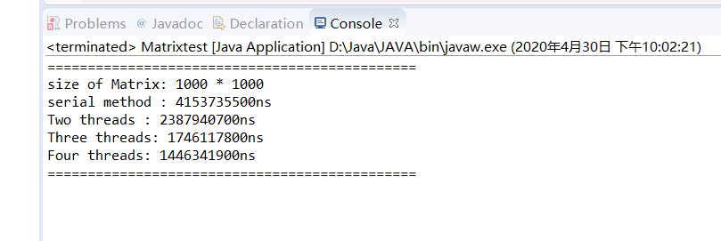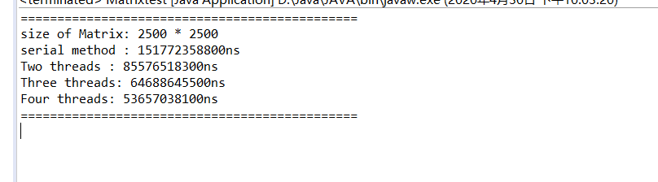

**五、结果分析**

依次将矩阵按照：5*5, 20*20, 50*50 ,200*200, 500*500, 2500*2500的大小作为样例进行测试。可知：

* 当矩阵规模相对较小时，并行比串行效率低，并且效率随着线程数的增加而降低；
* 当矩阵规模相对较大时，并行比串行效率高，并且效率随着线程数的增加而升高。

调用 java 监视与管理控制台进行结果分析如下，以矩阵样例大小为2500*2500为例，可知当矩阵规模较大时，多线程并发方法会占用更多的堆内存、CPU 等资源，所以这虽然使得乘法执行速度相较于串行方法更快，但会占用更多的资源。程序运行的效率随着线程数的增加而升高。表现为并行方法使用时间相较于串行方法而言越来越短。

而对于规模较小的矩阵，多线程的方法相较于串行方法会有更多的线程创建与调度上的开销，同时较小矩阵的计算对 CPU 等资源的要求相对而言不是特别高，所以使得多线程的方法效率比串行方法低。表现为串行方法使用时间较短。

