Devlog Flight Simulator

How does flight physics work and how does one implement it in a game.

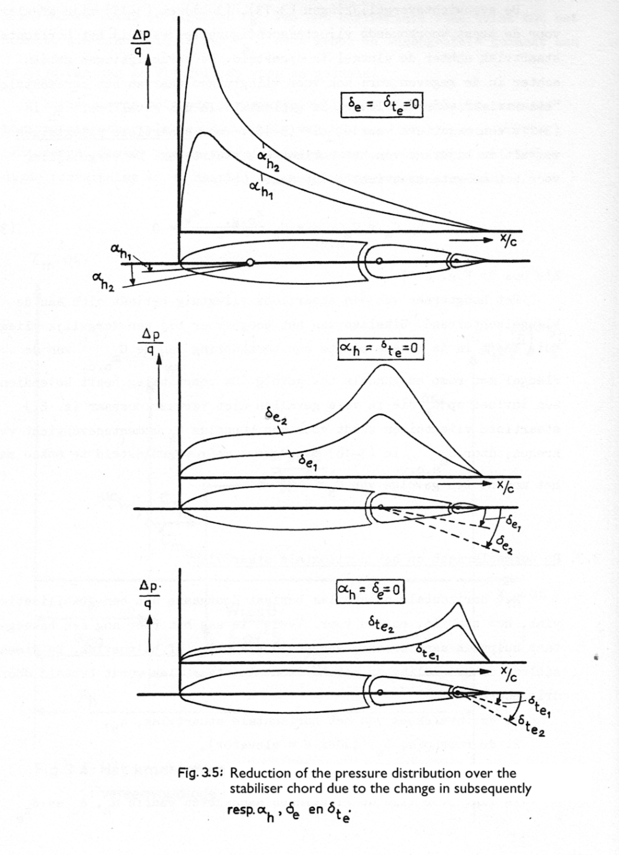

Table of Contents

Introduction 3

Why am I doing this? 3

How will I do this? 3

What is this document? 4

Research Section 4

Dev-log 4

Research 5

Introduction 5

Physics simplified 5

Control of an aircraft 6

Control surfaces 6

Ailerons 6

Lift 7

The wings - Airfoils 7

Correct explanation of lift 7

# 

# Introduction

## Why am I doing this?

For my course Personal Branding & Portfolio I have decided to try and create a flight simulator with real-time realistic physics.

I have in the past 2 years really come to like a game called WarThunder, where you can fly, drive and control multiple forms of vehicles used in a military setting, the vehicles ranging from the biplanes of the inter-bellum to the iconic M1 Abrams MBT from the cold war times.

The game consists mainly of 3 different modes: Arcade, Realistic and Simulator. The mode that I currently play the most frequent is Simulator mode. This is due to the way that you have the realism of the mechanics; flat spins, wing stall, the need to trim and the overall scale, while still maintaining the casual playstyle due to not having to know the entire startup sequence of that vehicle, unlike a game such as DCS for example, where you have to memorize the entire start-up sequence, which can take up to 5 minutes at times. My main vehicle type that I have interest in is as you might have been able to guess by the title of the document, planes.

I have had quiet an interest in the physics principals behind flight, and even more how that is implemented in games. Therefore, since starting the study CMGT, I’ve wanted to try and create my own flight simulator, even if just purely as a simulator, and not specifically a game with a play loop and all else that’s necessary for a game.

## How will I do this?

The project is made out of two parts, both targeting one of my learning goals from this project.

The first part is research into general flight physics, as well as how it’s implemented in other solutions/games. Questions can be, but are not limited to; What is the formula for lift, drag, thrust and gravity? How do certain properties of a wing, engine, fuselage change the overall characteristics of the aircraft they are a part of? How do well known games implement the physics? If they simplified a formula or system, how and why? How could I best go about implementing the systems and physics? How would I go about designing the systems and simulator to be able to expand it in the future? If possible, how were a few aircraft designed, what was kept in mind or focused on?[1]

The second part of the project is the actual making of the simulator. I will be making use of the Unity Engine. This will most likely be the main part of the Dev-log, as it will be the part of the project where I will run into the most situations where I have to make choices, try to solve issues that come up during development for whatever reason. And generally, the easier part to reflect and log as it’s actual development, instead of just writing stuff down on a piece of paper or in a document.

## What is this document?

This document is the dev-log for this project. It will also act as a summary area for the things I’ve researched in the first half of the project. The document will be separated into 2 parts, one for each stage. The first part will be a conglomeration of research that I have done, while the second part will be the Devlog of the actual project.

### Research Section

The research part will be separated into 3 sections: Real life physics and game implementations. The first part I will try to form an understanding of the basic principles behind flight, what important variables there are when it comes to calculating different forces, and how to calculate a few of the dynamic constant’s e.g. Lift/Drag Coefficient. The second part of the research will be about current implementations of real time flight physics in established games. I will mainly be looking at Microsoft Flight Simulator as they have a publicly available APK that can give me quiet deep insight into how they have their model’s setup, what variables they don’t dynamically calculate but instead hard set, and possibly things that they tried and found wouldn’t work. The latter will help me avoid getting stuck with a problem or issue that isn’t actually resolvable, or at least not in the time frame that I have. The final part is less research and more software architecture. I will be thinking about how I want to set things up. This will also be the first part of the Devlog, as it’s a more intricate part of the development process.

I will finish off the research part with a index containing important terms/jargon and simple explanations.

### Dev-log

The Devlog will have day entries, where I explain what I did that day, what problems I ran into, how I solved them, if I did, and if I didn’t, what I did to circumvent/avoid the problem. I will try to attach images and gifs showcasing any visible changes. I will also add a reference to the commit in the repository so you can see the exact changes yourself and know which git commits are part of which phase of the development.

# 

# Research

## Introduction

### Physics simplified

To understand how an aircraft flies, you need to understand what air is. Air consists of thinly spread molecules. This means that as you move through air, you are going through, and against, molecules. These molecules provide resistance, as well as pressure. This resistance, as well as the presence of molecules in air, is what flight is dependent on. Flying can be broken into 4 forces; **Lift**, **Gravity**, **Drag** and **Thrust**.

*Gravity* should be a something you are familiar with, so I will give a simple explanation. Gravity is a force that’s applied to anything with a mass. On earth the force applied is about 9.8 N/Kg. This means that for every kilogram of mass an object has, it will experience 9.8 N of force directed to the ground.

*Lift* is the force that counteracts gravity. Lift is created by the wings of an aircraft as air flows past them. There are a few different explanations that try to explain this simply, but they are all lacking one way or another, so provided will be the one which is the easiest to explain in a paragraph.

As airflow passes by the wing, at the front of the wing the airflow gets split in half. The top half of the airflow goes over the wing, when it does so it first faces upwards, and when it leaves the wing, the air flow is directed downwards. According to the 2nd law of newton, this requires the wing to exert force on the air pulling it down, and according to newtons 3rd law, every action has a reaction, so the air puts a force on the wing, pulling it up in a sense. The airflow under the wing is diverted downwards, pushing the wing up. This is the pressure/force you feel if you stick your hand out the window while driving in a car. If you hold your hand at a 45° angle, you will feel the wind pushing your hand up.

Thrust is the name for the force that the engine(s) on an aircraft applies in a forward direction. The way that thrust creates force depends on the type of engine (propellor, jet, rocket). A propellor creates thrust by pushing air backwards, the same way a boat screw pushes water back to propel a boat forwards. An aircraft propellor does this at a higher RPM (rotations per minute) due to the lower density of air compared to water. A jet engine creates thrust by making a lot of air move quicker out of the engine that it comes into the engine, cause the air to push back on the engine, moving it forwards. A rocket engine creates thrust by burning a fuel, which leaves the engine at high speed, pushing the engine forwards. These are very simple explanations, of which only the propellor engine I will dive deeper into.

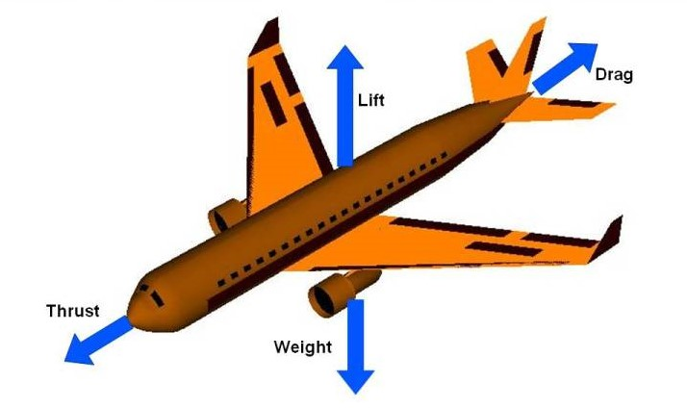

Figure 1- The different forces applied on a plane. Parallel to the fuselage are Thrust and Drag, while perpendicular are Gravity (Weight) and Lift.

Drag is the resistance that air provides against the aircraft and counteracts thrust. Molecules inherently try to stay close to each other, the degree to which they achieve that decides the density. When air passes the aircraft, it will try to stick to the aircraft, this will create a form of friction with the other air molecules.

These four forces together decide how an aircraft behaves in flight. As seen in *Figure 1*, the forces are in the horizontal and vertical planes. As long as these two directions forces are balanced, the aircraft will not change speed or altitude. If, however, the lift force goes up for example, then the aircraft will have a positive force directing up, meaning that the aircraft will gain altitude. The unbalance of these forces is how a pilot can control the altitude and speed of an aircraft.

## Control of an aircraft

Now we know how the 4 forces applied during flight work, but not how a pilot could actually change the forces in a way that allows them to manoeuvre the aircraft. This is where the control surfaces and other systems and mechanics come into play. There is a barrage of controls in modern aircraft that allows a pilot to change course, speed, altitude and attitude. However, seeing as the scope of this project is not so big as to simulate all the bells and whistles that modern airliners and fighter jets have, we will keep it simple and stick to common control types which is present on nearly every aircraft.

### Control surfaces

The pilot tends to have access to three different control surfaces, each influencing a certain axis of rotation (see Figure 2). The three control surfaces are ailerons, elevators and the rudder(s). Ailerons are present on the wings, usually favouring the wing tips compared to the wing root (where the wing goes ‘into’ the fuselage), and they control the roll of the aircraft. The tail of the aircraft hosts the remaining two control surfaces. On the horizontal stabilizers you will find the elevators, which control the pitch of the aircraft. Finally, you have the rudder which controls the yaw of the aircraft.

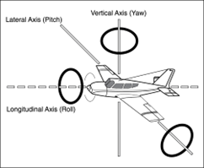

Figure 2 - The three axis of rotation of a plane.

### Ailerons

The ailerons is one of the more important control surfaces, namely on larger aircraft, as they control the roll of the aircraft, and thereby the direction that you fly to. Ailerons are mounted on the trailing edge of each wing, near the wingtips and deflect in opposite directions. When a pilot moves the aileron control to the left for example, the left aileron deflects up and the right aileron deflects down. A raised aileron lowers the lift produced by the wing and a lowered aileron raises the lift, so in the example the right wing will drop, and the left wing will rise. This causes the aircraft to roll and therefore turn to the right. Centring the aileron controls then returns the ailerons to the neutral position, maintaining the roll angle. The aircraft will remain in that roll until a opposite aileron motion is induced to return the aircraft back to a level flight.

## Lift

### The wings - Airfoils

As said earlier, wings generate the lift of the aircraft. But how do they do this? That’s where the term airfoil (aerofoil) comes in. The definition of an airfoil is as follows: *“An airfoil is a streamlined body that is capable of generating significantly more lift than drag.”* One can regard an aerofoil as a slice of a wing, leaving you with a 2D shape. The shape here dictates the lift the airfoil generates at a certain angle of attack (AoA). A symmetrical foil, as seen in Figure 3, does **not** generate lift at a 0° AoA. This means that the pilot would have to pitch the aircraft up to generate lift, or the wing would need to be installed with an angle relative to the fuselage. However, if you make use of an asymmetrical airfoil, also known as a cambered airfoil, then the wing can possibly generate lift even at a 0° AoA. The way the airfoil is cambered decides if it produces positive or negative lift at a 0° AoA. The shape of the airfoil and its camber, along with a few other things, dictates most of the flight characteristics of a aircraft.

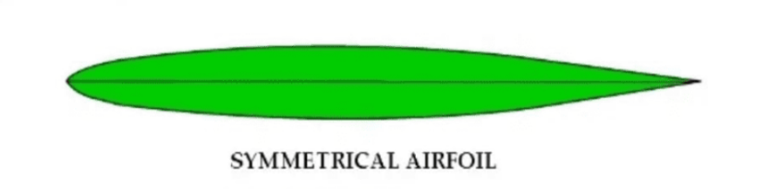

Figure 3 - A symmetrical aerofoil

### Correct explanation of lift

The correct explanation for lift is more complex than the simplified version I gave in the introduction. Many basic explanations rely solely on either Bernoulli’s principle or Newton’s laws of motion, the second being the way I explained it in the introduction, while in reality both play a role. Lift is generated through a combination of Newton’s 2nd and 3rd laws and the forces caused by pressure differences around the wing.

As air flows over the wing, the angle of attack and shape of the airfoil deflect the air downwards. According to Newton’s third law, this downward force on the air results in an upward force on the wing – this is one component of lift. At the same time, the wing alters the speed of the 2 airflows around the wing; the air above the wing speeds up, while the air below slows down. This difference in speed creates a pressure difference, low above, high below, which results in a net upwards force. These pressure differences however are not limited to just the surface – they extend into the space around the wing, forming what’s known as a pressure field (see *Figure 4).*

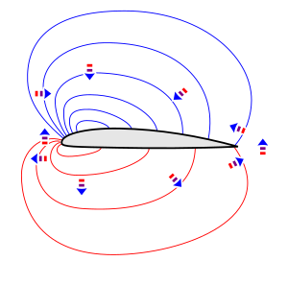

Figure 4 - Pressure fields around an airfoil. The lines are isobars of equal pressure along their length. Arrows indicate the acceleration of air in that direction, due to pressure differences between high (red) and low (blue).

For instance, incoming air is slowed and deflected downwards by the high-pressure region under the wing that it collides with. Meanwhile, air above the wing accelerates as it’s drawn into the low-pressure region. These changes in velocity and direction are not passive, they actively maintain the pressure field, which in turn keeps redirecting and altering the speed of the airflow. This feedback loop, where pressure gradients accelerate the flow and the flow sustains those same gradients, is fundamental to maintaining lift in a real aerodynamic system.

1. This question is mainly something for if I have time and am able to easily find information on it, as it’s more a question out of interest then necessity.